EXPERIMENT 4
ROLL NO: 240701408 NAME: M.K.RAGHAVAN
Create a prototype with familiar and unfamiliar navigation elements. Evaluate ease of use with different user groups using proto.io

Screen 1:
Index page for travel booking.
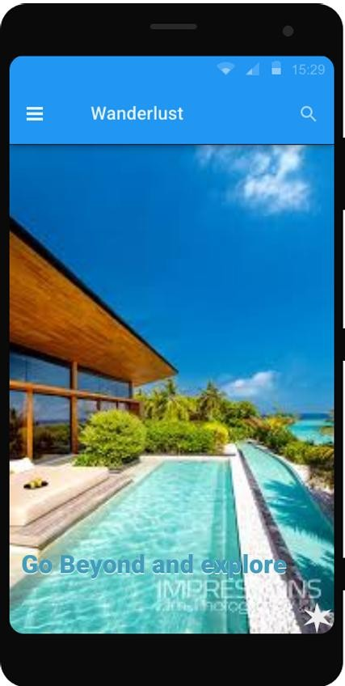

Screen: Home / Main Page (Wanderlust) ✅ Familiar Elements
- Hamburger Menu (☰) – Top Left o A widely used navigation icon.
  - Users expect it to open a sidebar containing options like Home, Profile, or Settings.
- Search Icon (🔍) – Top Right o Commonly used in mobile applications.
  - Allows users to search destinations, resorts, or content inside the app.
- Top App Bar / Header o Displays the app name “Wanderlust”.
  - Standard mobile UI pattern that helps users identify the current page.
- Status Indicators (Time, Signal, Battery) o Familiar phone interface elements. o Help users understand device status while using the app.

⚠️ Unfamiliar Elements
- Text Overlay (“Go Beyond and explore”) o Looks like a heading but does not clearly indicate an action.
  - Users may be unsure whether it is informational or interactive.
- Star Icon at Bottom Corner o Function is not clearly labeled.
  - Users may not know if it represents favourites, rating, or a shortcut action.

Screen 2:
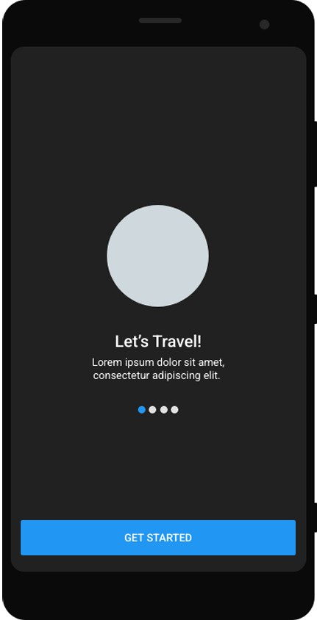

Screen: Travel Introduction / Get Started Page Familiar Elements
- Pagination Dots (● ● ● ●) – Center Bottom o Commonly used in onboarding or introduction screens.
  - Indicates multiple slides/screens.
- “GET STARTED” Button – Bottom o A standard Call-To-Action (CTA) button.
  - Widely used in mobile apps to begin using the application.

Centered Layout Design
- Title and description placed in the middle.
- Familiar onboarding pattern used in many apps.

Unfamiliar Elements
- Circular Placeholder Image (Grey Circle) o May represent an illustration or profile/feature icon.
  - Since no icon or image is shown, users may not clearly understand its purpose.
- Swipe Navigation (Implicit Interaction) o No arrows or labels indicating swipe action.
  - New users may not immediately realize the screen is swipeable.
- Minimal Navigation Controls o No back button or skip option visible.
  - Some users may feel unsure how to exit or move quickly.

Screen 3:

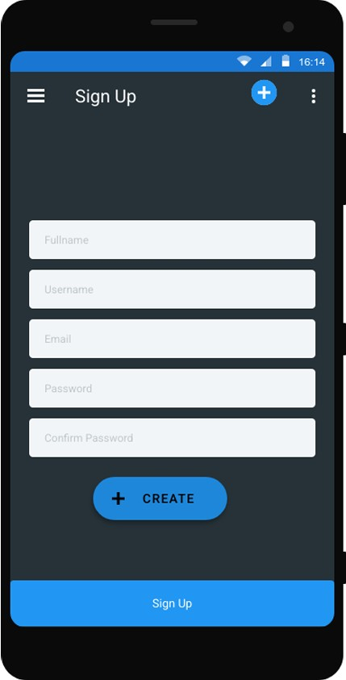

Screen: Sign Up Page ✅ Familiar Elements 1. Hamburger Menu (☰) – Top Left
o Common navigation icon used to open menu options.
- Input Fields (Fullname, Username, Email, Password, Confirm Password) o Standard form layout used in most registration pages.
o Users easily understand where to enter details.
- Sign Up Button – Bottom o A common call-to-action button used to create an account.

⚠️ Unfamiliar Elements
- Plus (+) Icon Near Header o Function is not clearly defined.
  - Users may not understand whether it creates an account or adds something else.
- “CREATE” Button with Plus Symbol o Similar purpose as Sign Up button, which may confuse users.
  - Two action buttons for the same task reduce clarity.

Screen 4:
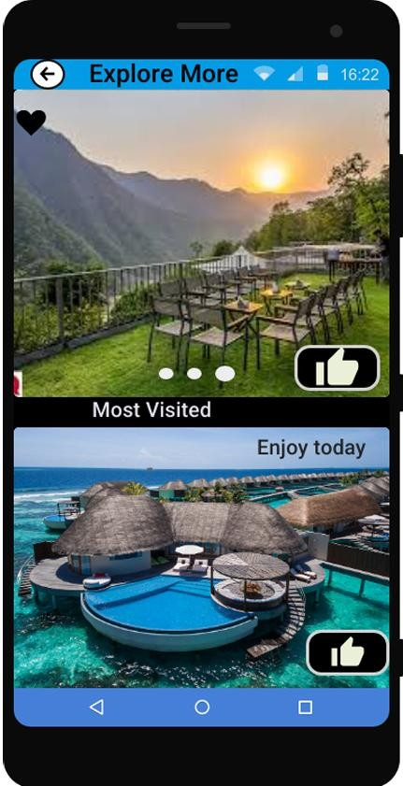

Screen: Explore More Page ✅ Familiar Icons
- Back Arrow (←) – Top Left o Common navigation icon used to return to the previous screen.
- Heart Icon (❤️) – Top Corner o Universally used to mark favourites or liked items.
- Pagination Dots (● ● ●) – Below Image o Indicates multiple images or slides that users can swipe.
- Like / Thumbs Up Icon (👍) o Commonly used to show user likes or popularity.
- Status Bar Icons (Time, Signal, Battery) o Standard mobile phone indicators.

⚠️ Unfamiliar Icons 1. Large Thumbs-Up Button Placement
o Positioned over images; users may not immediately know if it is for rating or selection.
- Image Sections Without Clear Buttons o Images look clickable but no clear action label is provided.
- Minimal Navigation Indicators o Swipe interaction is implied but not clearly explained to new users.
- Screen 5:

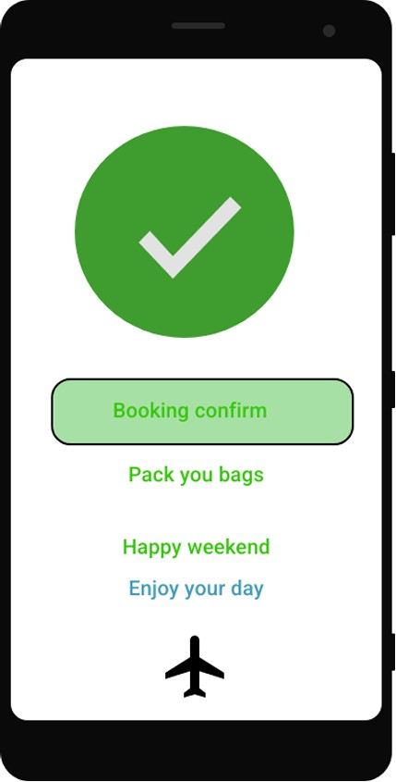

Screen: Booking Confirmation Page ✅ Familiar Icons
- Checkmark Icon (✔) – Center o Universally recognized symbol for success or confirmation.
o Indicates booking completed successfully.
- Confirmation Button (“Booking confirm”) o Common confirmation message/button used after completing an action.
- Airplane Icon (✈) – Bottom o Widely associated with travel or trip completion.

⚠️ Possibly Unfamiliar Icons
- Airplane Icon Placement o Positioned alone at the bottom without label.
  - Users may not clearly understand if it is decorative or clickable.
- Multiple Text Messages (“Pack your bags”, “Happy weekend”) o Motivational text but not interactive.
  - Users may expect them to be buttons or links.
Prototype Link:
https://pr.to/AECXX7/

