EXPERIMENT-3
NAME: M.K.RAGHAVAN ROLL NO:240701408

1.COMMAND LINE INTERFACE:
PYTHON CODE:
import os
import sys

def rename_file(old_name, new_name): try:
os.rename(old_name, new_name) print(f"File renamed from {old_name} to {new_name}")
except FileNotFoundError:
print(f"Error: {old_name} not found.")
except Exception as e:
print(f"An error occurred: {e}")

if __name__ == "__main__": if len(sys.argv) != 3:
print("Usage: python rename_file_cli.py <old_filename> <new_filename>") else:
rename_file(sys.argv[1], sys.argv[2])

OUTPUT :

2.GRAPHICAL USER INTERFACE:
PYTHON CODE:

import tkinter as tk from tkinter import messagebox import os

# Function to rename the file def rename_file():
old_name = old_filename_entry.get().strip() new_name
= new_filename_entry.get().strip()

# Check if input fields are empty
if not old_name or not new_name:
messagebox.showwarning("Warning", "Please enter both filenames!")
return

# Check if the old file exists if
not os.path.exists(old_name):
messagebox.showerror("Error", f"File '{old_name}' not found.")
return

# Check if the new file already exists if os.path.exists(new_name):
overwrite = messagebox.askyesno("Warning", f"'{new_name}' already exists. Overwrite?")
if not overwrite:
return

try:
os.rename(old_name, new_name) messagebox.showinfo("Success", f"File renamed from '{old_name}' to '{new_name}'") except Exception as e: messagebox.showerror("Error", f"An error occurred: {e}")

# Create main window
root = tk.Tk()
root.title("File Renamer") root.geometry("400x150"
)
root.resizable(False, False) # Fixed window size

# Labels
tk.Label(root, text="🗂️ Old Filename:", font=("Arial", 10)).grid(row=0, column=0, padx=10, pady=5, sticky="w")
tk.Label(root, text="📝 New Filename:", font=("Arial", 10)).grid(row=1, column=0, padx=10, pady=5, sticky="w")

# Entry fields old_filename_entry = tk.Entry(root, width=40) old_filename_entry.grid(row=0, column=1, padx=10, pady=5)

new_filename_entry = tk.Entry(root, width=40) new_filename_entry.grid(row=1, column=1, padx=10, pady=5)

# Styled Button
rename_button = tk.Button(root, text="✅ Rename File", bg="green", fg="white", font=("Arial", 10,
"bold"), command=rename_file) rename_button.grid(row=2, column=0, columnspan=2, pady=10)

# Run the GUI event loop root.mainloop()

OUTPUT :

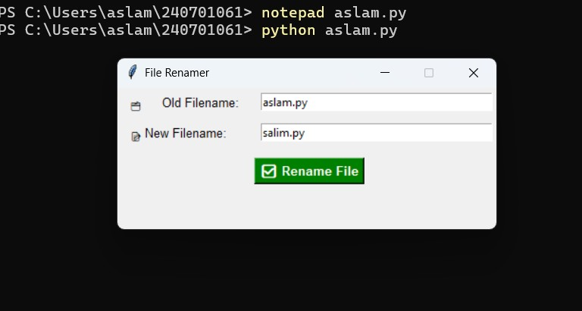
3.VOICE USER INTERFACE:
PYTHON CODE:
import speech_recognition as sr import
os

def rename_file_from_voice_command(command):
try:
words = command.lower().split(" ") if "rename" in words and "to" in words: rename_index = words.index("rename") to_index = words.index("to")

# Extract old and new filenames
old_name = words[rename_index + 1] new_name
= words[to_index + 1]

# Check if file exists if
not os.path.exists(old_name):
print(f"Error: File '{old_name}' not found.")
return

# Rename file os.rename(old_name, new_name) print(f"✅ File renamed from '{old_name}' to '{new_name}'")

else:
print("Invalid command format. Say: 'Rename oldfile.txt to newfile.txt'")

except Exception as e:
print(f"Error: {e}")

def listen_for_command(): recognizer
= sr.Recognizer() mic
= sr.Microphone()

print("🎤 Listening for command to rename a file...") with mic as source:
recognizer.adjust_for_ambient_noise(source) audio
= recognizer.listen(source)

try:
command = recognizer.recognize_google(audio) print(f"🎙️ Command received: {command}") rename_file_from_voice_command(command) except sr.UnknownValueError:
print("❌ Sorry, I couldn't understand the command.") except sr.RequestError as e:
print(f"⚠️ Could not request results from Google Speech Recognition service; {e}")

if __name__ == "__main__": listen_for_command()

OUTPUT :
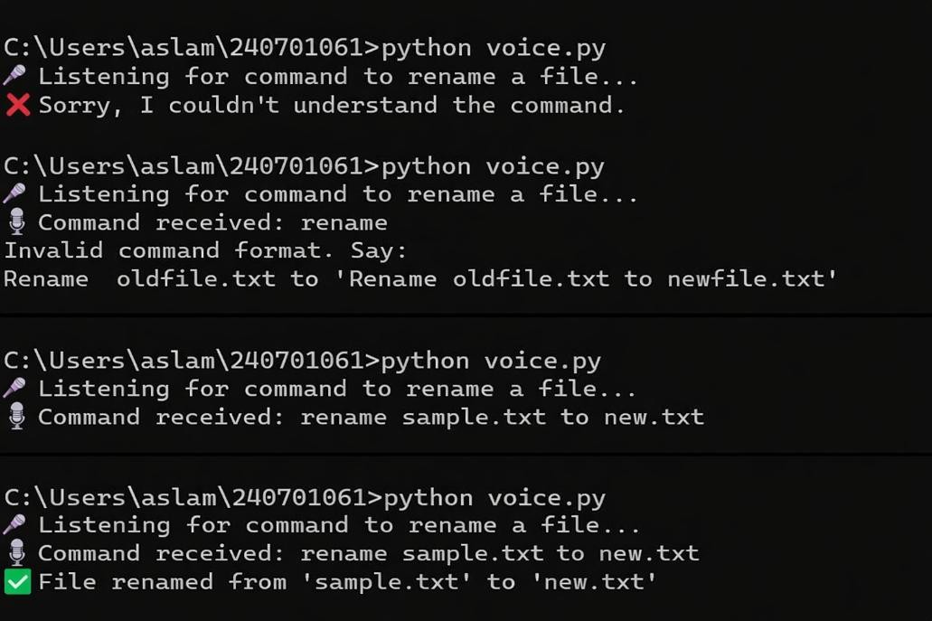
4.USER SATISFACTION COMPARISON:
PYTHON CODE:
def survey():
print("Rate your satisfaction with the following interfaces (1-5):")

# Get user input for each interface
try:
cli_satisfaction = int(input("CLI (1-5): ")) gui_satisfaction = int(input("GUI (1-5): ")) vui_satisfaction
= int(input("VUI (1-5): "))

# Ensure valid ratings if not (1 <= cli_satisfaction <= 5 and 1 <= gui_satisfaction <= 5 and
1 <= vui_satisfaction <= 5): print("Please enter ratings between 1 and 5 only.")
return

# Display the ratings print("\nYour satisfaction ratings:") print(f"CLI:
{cli_satisfaction}") print(f"GUI:
{gui_satisfaction}") print(f"VUI:
{vui_satisfaction}")

# Calculate the average satisfaction avg_satisfaction =
(cli_satisfaction + gui_satisfaction + vui_satisfaction) / 3 print(f"\nAverage Satisfaction Score: {avg_satisfaction:.2f}")

except ValueError:
print("Invalid input! Please enter numbers between 1 and 5.")
# Run the survey function if
__name__ == "__main__":
survey()

OUTPUT :

