EXPERIMENT-6
NAME: M.K.Raghavan ROLL NO: 240701408

FoodieDash is a mobile-based food delivery application that allows users to browse food items, add them to cart, and place orders with secure payment options.

The system is developed using the Rapid Application Development (RAD) model, which focuses on fast prototyping, user feedback, and quick iterations.

Key Characteristics of RAD
- Focus on working prototypes instead of heavy documentation
- Continuous user involvement
- Fast development and iteration cycles
- Reusable UI components
- Best suited for mobile apps like food delivery systems

Phase 1: Requirements Planning
Navigation:
- Login / Sign Up
- Home
- Categories
- Product Listing
- Product Details
- Cart
- Payment
- Order Confirmation

User Actions:
- Sign in / Sign up
- Browse food items
- Search food
- Add to cart
- Modify quantity
- Checkout
- Make payment
- Track orders

Requirements:
- User login (email/social)
- View categories
- View food items
- View product details
- Manage cart
- View total cost
- Select payment method 8. Order confirmation

Phase 2: User Design
Tools Used: Axure RP 11

Wireframes:
- Login Page
- Home Page
- Product Details Page
- Cart Page
- Payment Page
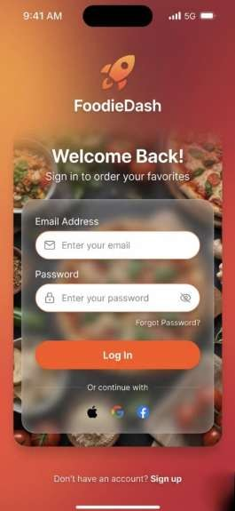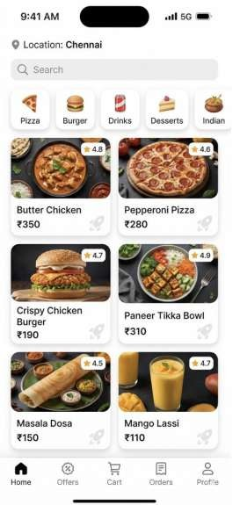
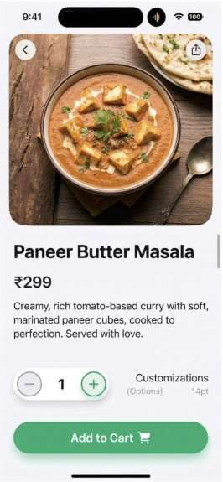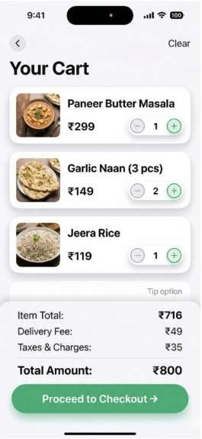
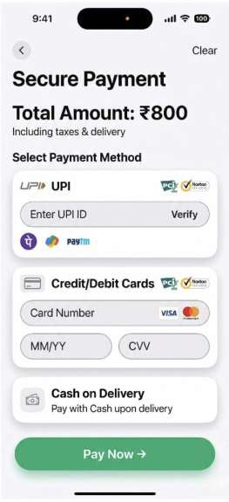

Phase 3: Construction
- Interactive prototypes using Axure RP 11
- Navigation flow: Login → Home → Product → Cart → Payment → Confirmation
- Dynamic features like add to cart, quantity update
- Testing and feedback improvements

Phase 4: Cutover
- Final UI shared via Axure 11
- Ready for development
- User training and documentation provided Conclusion
The FoodieDash app was successfully designed using RAD, ensuring fast development and a user-friendly experience.

