Instructor Operating Manual  Kiki Pickleball Business Simulation  Detailed classroom operations guide for instructors and TAs | Updated for Kiki branding, finance detail, team tracker, product pipeline, and factory reset. | 
What this file is: A practical runbook for setting up accounts, controlling rounds, explaining the UI, validating submissions, running the engine, and debriefing results. It is intentionally more detailed than the quick-start checklist.
Manual section | What it helps you do
Setup | Deploy/open the app, create accounts, confirm roles, test the database, and prepare the first market report.
Round control | Open submissions, monitor teams, close submissions, run the round, and advance to the next market report.
Teaching support | Use dashboards, finance detail, team tracker, formula guide, and big-picture figures to connect outcomes to OM/SCM concepts.
Troubleshooting | Know what to do when students miss forecasts, supplier mix is invalid, teams cannot log in, or a reset is needed.
Important: Students should use the hosted Render URL during class, not http://localhost:8501. Localhost only works on the computer running Streamlit.

1. Simulator Purpose and Teaching Goals
Kiki is a classroom business simulation, not just a scoreboard game. Teams run paddle companies and learn how decisions interact over repeated rounds.
Concept | What students practice | Typical discussion question
Demand forecasting | Estimate product demand before production and compare forecast vs actual. | Did the team forecast demand or simply guess a production number?
Market segmentation | Compete in premium, mid, and beginner segments with different price/quality/tech expectations. | Which segment fit the team strategy best this round?
Product portfolio | Manage up to three active product slots with different lifecycle, price, QC, and production choices. | Did the portfolio contain the right products for the market?
Lifecycle management | Products move from launch to growth to maturity to decline. | Which product should be invested in, maintained, retired, or replaced?
Capacity planning | Balance installed capacity, overtime, and expansion. | Did growth create capability or just cost and debt?
Supply chain | Choose raw-material quantity, supplier mix, and expedited share. | Did cheaper supply create hidden quality or service risk?
Quality control | Spend QC budget to lower defects with diminishing returns. | Was quality worth the cost in this market?
Inventory/backlog | Carry finished goods, raw materials, and unmet demand across rounds. | Did inventory protect service or tie up too much cash?
Cash and debt | Manage revenue, costs, planned borrowing, automatic borrowing, and interest. | Was the team profitable but still financially fragile?
NPD and technology | Invest in future products, wait for readiness, and launch/replace when ready. | Did the team innovate early enough without starving current operations?

2. User Roles and Login Workflow
Role | Access | What they can do | What they cannot do
admin | All pages. | Create users, set market report, view all teams, open/close submissions, run rounds, reset game data, inspect finance/results. | Should not be shared with students.
team_leader | Student-safe pages only. | Submit only their assigned team decisions, view public report, view own tracker/finance/results and safe rankings. | Cannot run rounds, reset data, manage users, or edit other teams.
- First-run setup appears only when no active admin exists. After an admin is created, normal login is used.
- Passwords are hashed. The admin can reset a password but cannot view an old password later.
- Each team should use its own team_leader account so decisions and results remain separated.
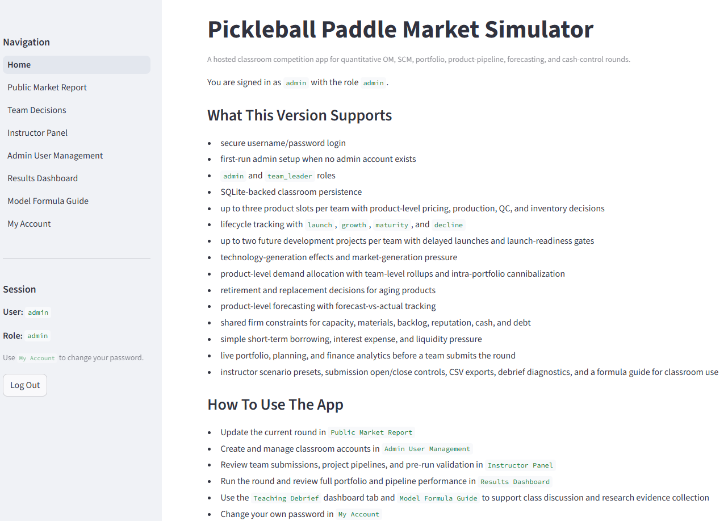
Figure 1. Home page after login. The sidebar shows navigation, logged-in user, role, and logout.
Home page | Explanation
Purpose | Orient the instructor and confirm that the correct account is logged in.
How to read it | The left sidebar is the control rail. Home explains app capabilities and points instructors to the pages used each round.
Teaching/use | At the start of class, project this page briefly to show students that the app is a central hosted classroom tool.

3. Local Testing vs Hosted Classroom Deployment
Mode | Typical URL | Who should use it | Notes
Local testing | http://localhost:8501 | Instructor/developer on the same computer. | Good for testing. Students on other devices usually cannot use this URL.
Hosted classroom | https://your-render-service.onrender.com | Instructor and students from browsers. | Use this for class. Students can join from school Wi-Fi, conference Wi-Fi, home, or cellular data.
- Render deployment uses one central Streamlit service and a persistent SQLite database path, usually SIMULATOR_DB_PATH=/var/data/simulator.db.
- Use one hosted app instance for the class. SQLite is appropriate for a small single-instance classroom deployment, not multiple replicas writing to separate disks.
- After pushing code to GitHub, Render redeploys from the repo/blueprint. The live class URL is the Render service URL, not the GitHub repo URL.

4. Instructor Pre-Class Setup Checklist
Done | Task | Why it matters
[ ] | Open the hosted URL and log in as admin. | Confirms the deployment is alive.
[ ] | Verify database path uses persistent Render disk. | Avoids losing data after restart.
[ ] | Create or verify team_leader accounts. | Every team needs its own login and team assignment.
[ ] | Test one student account in a private/incognito browser. | Confirms student restrictions and login work.
[ ] | Set Public Market Report for Round 1. | Defines the environment before decisions.
[ ] | Open submissions. | Allows teams to save decisions.
[ ] | Run one private test round before live use. | Catches deployment/data/account issues early.

5. Page-by-Page Instructor Guide
Page | Admin use | Student/team_leader view
Home | Confirm version, role, database, and page navigation. | Orientation, assigned team, student workflow.
Public Market Report | Edit market, demand, tech, quality, supply, and event text. | Read-only market conditions.
Team Decisions | Can inspect/enter any team if needed. | Only their assigned team; submit firm, product, forecast, and pipeline decisions.
Instructor Panel | Admin-only validation, submissions, run round, factory reset. | No access.
Admin User Management | Admin-only account creation, reset, deactivate, bulk import. | No access.
Results Dashboard | All teams, rankings, product results, debrief tabs, downloads. | Own team details plus safe public rankings.
Finance Detail | Detailed finance by team/round; cash bridge and cost buckets. | Own finance only.
My Team Tracker | Admin can inspect a selected team history. | Own decisions/results history.
Game Big Picture Guide | Use as teaching intro/debrief visual guide. | Student-friendly system explanation.
Model Formula Guide | Explain deterministic formulas and coefficients. | Student reference for how outcomes are calculated.
My Account | Change own password. | Change own password.

6. Public Market Report Setup
Set or apply the market scenario before teams submit decisions. This page defines the world all teams compete in for the round.
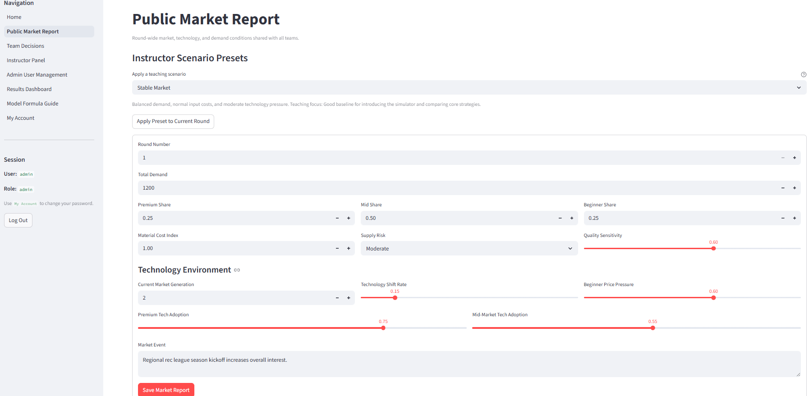
Figure 2. Public Market Report page: demand, segment shares, supply/cost pressure, quality sensitivity, technology pressure, and market event.
Public Market Report | Explanation
Purpose | Create the shared environment for the round.
How to read it | Demand and segment shares create market size. Material cost index and supply risk affect operations. Technology and adoption settings change how valuable newer products are.
Teaching/use | Use the event text to tell a story: recession, boom, technology shift, price war, quality scandal, or beginner growth.
Control | Meaning | Instructor guidance
Round Number | The round being configured. | After Run Round, the app automatically prepares the next round.
Total Demand | Total potential market units before competition allocation. | Higher values create growth/boom conditions; lower values create recession.
Premium/Mid/Beginner Share | How demand is split across customer segments. | Shares should sum close to 1.0. Changing shares changes which strategies are advantaged.
Material Cost Index | Multiplier on material costs. | Use high values for inflation or supply cost shock.
Supply Risk | Low/Moderate/High risk pressure on defects/reliability. | High supply risk rewards robust sourcing, QC, and conservative planning.
Quality Sensitivity | How strongly customers/reputation react to quality. | Higher values reward QC and punish defects.
Current Market Generation | Technology generation customers expect. | Higher generation makes old tech less attractive, especially premium/mid.
Technology Shift Rate | How quickly the market moves toward newer products. | Use high values to reward NPD and innovation timing.
Premium/Mid Tech Adoption | How much premium/mid customers care about newer tech. | Premium usually cares more than beginner.
Beginner Price Pressure | How strongly beginner customers react to price. | High values reward low-cost/value strategies.
Market Event | Narrative text shown to all teams. | Use it to explain the scenario and guide student interpretation.
Save Market Report | Stores the environment for the round. | Save before teams submit. If you change it mid-round, tell the class.

7. Team Decisions Page Guide
Students submit a coherent plan, not isolated high/low choices. The instructor can use this page to explain what a good decision sequence looks like.
- Read the Public Market Report.
- Review current team state.
- Set firm-level operations and finance.
- Review and update active product slots.
- Enter product-level forecasts, prices, production, QC, and inventory targets.
- Invest in or manage development projects.
- Review Planning Analytics Preview and warnings.
- Click Save Portfolio and Pipeline Decision.
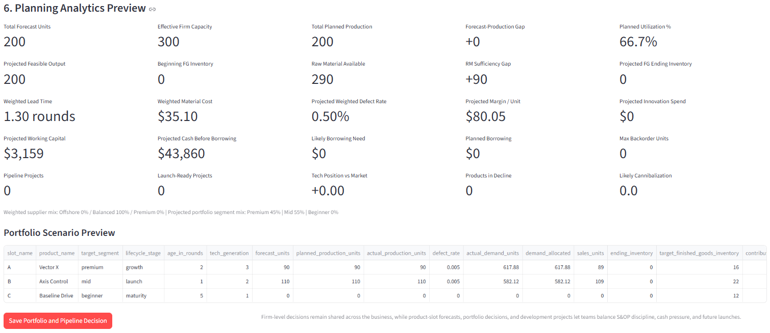
Figure 3. Team Decisions upper section: identity, current state, firm-level operations and finance.
Team Decisions upper section | Explanation
Purpose | Shows where students start and what resources they carry into the round.
How to read it | Installed capacity, FG/RM inventory, backlog, reputation, cash, debt, and tech position are state variables from prior rounds. Firm controls affect the whole company, not one product.
Teaching/use | Use this section to teach capacity, materials, borrowing, and supplier mix as shared constraints across products.
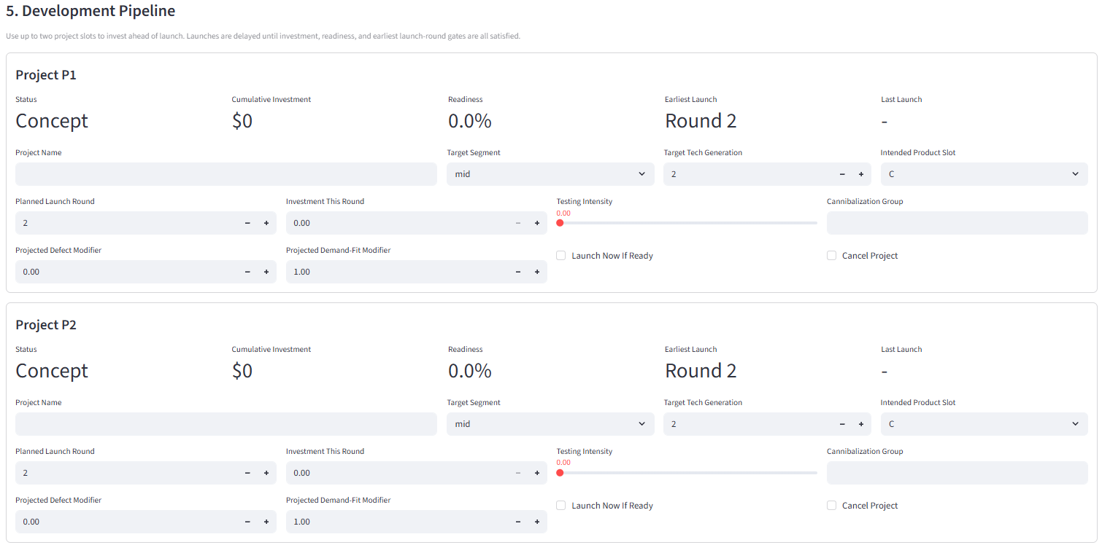
Figure 4. Active Product Portfolio and Forecasts: product A/B/C decisions.
Active portfolio | Explanation
Purpose | Each active product has its own forecast, price, production, QC, target inventory, lifecycle, and tech generation.
How to read it | Products compete at the product level, then results roll up to the firm. Retire After Round flags an aging product for retirement after the round logic runs.
Teaching/use | Ask teams why each product exists: premium margin, mid-market volume, beginner volume, or replacement bridge.
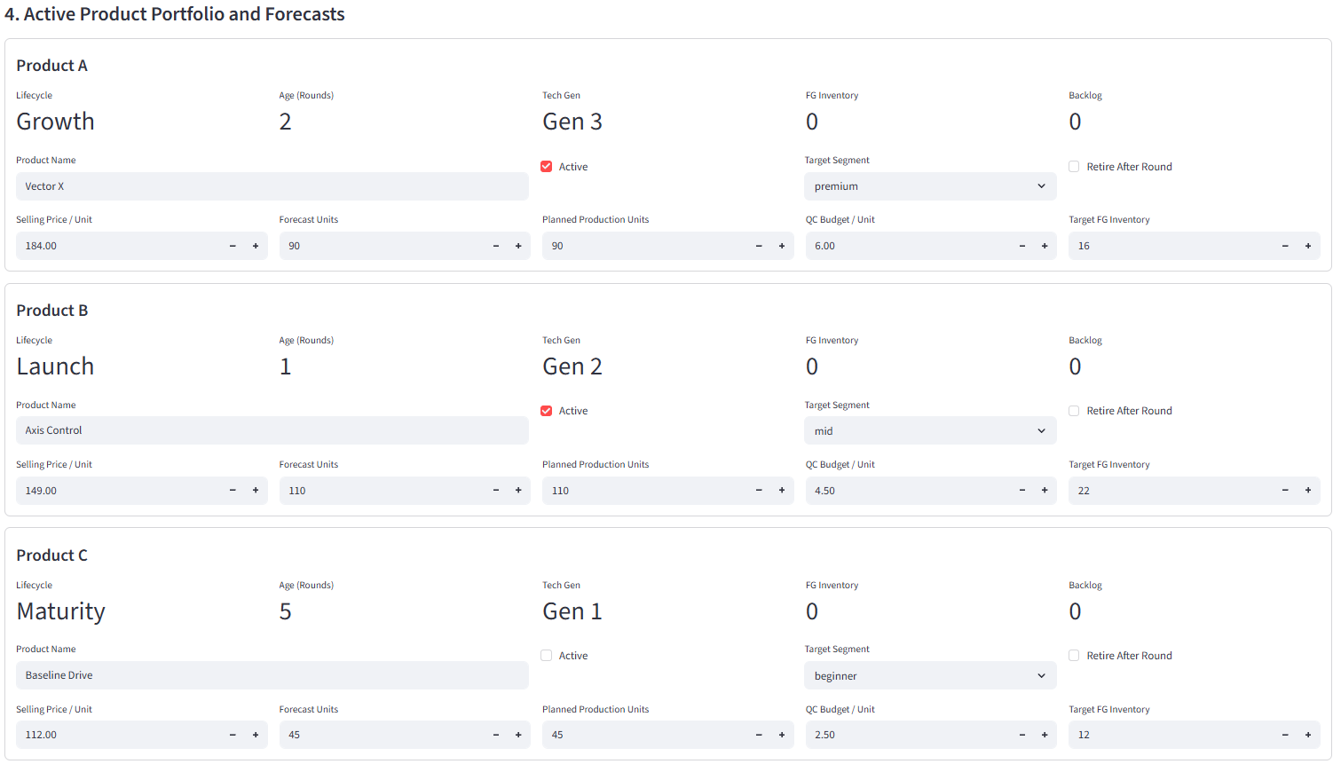
Figure 5. Development Pipeline: two project slots for future products.
Development pipeline | Explanation
Purpose | Future products require investment, readiness, and launch timing before they are sellable.
How to read it | Fixed project settings lock once a project begins: name, segment, target technology generation, intended slot, and launch timing. Round controls remain adjustable: investment, testing intensity, launch now if ready, or cancel.
Teaching/use | Emphasize that more money can speed funding progress, but readiness also needs testing and timing gates.
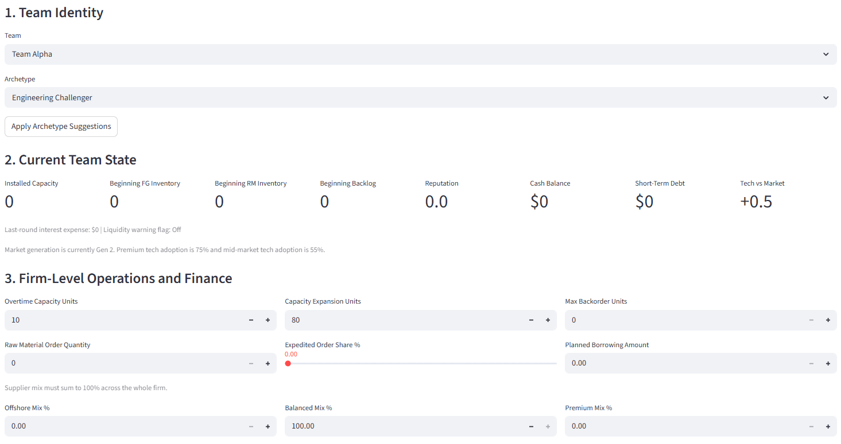
Figure 6. Planning Analytics Preview: pre-submit diagnostics.
Planning preview | Explanation
Purpose | The page translates inputs into planning signals before save.
How to read it | Forecast-production gap, utilization, raw material sufficiency, weighted cost, defect estimate, projected margin, cash before borrowing, and warnings tell students whether the plan fits together.
Teaching/use | Tell students: if the preview is warning you, fix the plan before saving.
Student input | Why it exists | Instructor teaching point
Forecast Units | Demand estimate for each active product. | Forecast does not create demand; it measures planning discipline.
Planned Production Units | Attempted production by product. | Production is capped by capacity and raw materials.
Selling Price / Unit | Revenue per unit and price competitiveness. | Price affects both margin and demand attractiveness.
QC Budget / Unit | Quality investment that lowers defects with diminishing returns. | Quality is valuable but not free.
Target FG Inventory | Desired finished-goods buffer. | Inventory protects service but ties up working capital.
Overtime Capacity | Short-term capacity above installed base. | Can help service but creates cost/stress.
Capacity Expansion | Future installed capacity investment. | Growth takes cash before it pays off.
Raw Material Order | New material supply for production. | Low materials can cap output; too much ties cash.
Supplier Mix | Offshore/balanced/premium shares. | Cost, lead time, risk, and defect pressure trade off.
Planned Borrowing | Intentional short-term cash injection. | Debt helps liquidity now but creates interest.

8. Development Pipeline Guide
Project concept | Rule in Kiki | How to explain it
Fixed project settings | After investment/testing begins, project name, target segment, target tech generation, intended slot, and planned launch timing lock. | This models product concept freeze. Teams can still execute the project, but not rewrite the original concept every round.
Controllable project decisions | Investment this round, testing intensity, launch now if ready, and cancel project remain adjustable. | These are managerial control decisions during development.
Readiness | Readiness increases with cumulative investment and testing; higher tech requires more funding and usually more effort. | Money alone may not instantly finish a project. Testing and timing gates matter.
Launch gate | Project must be sufficiently funded, readiness-ready, and eligible by timing before launch. | Students should plan ahead; waiting until the market shifts may be too late.
Replacement | A launched project can fill or replace an intended product slot. | Replacement refreshes the portfolio but can cannibalize older products.
Retirement | Retired products stop competing for demand after retirement is processed. | Retire products that are old, low-tech, low-margin, or no longer strategic.
Instructor tip: If students say readiness is stuck, ask whether funding is enough for the tech generation, whether testing intensity is meaningful, whether the timing gate has arrived, and whether they checked Launch Now If Ready.

9. Instructor Panel and Round Execution
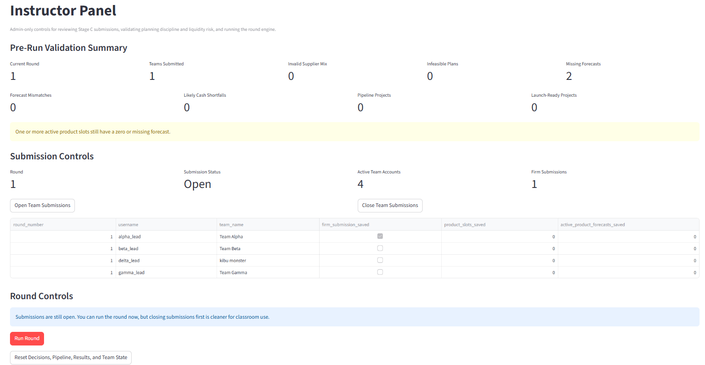
Figure 7. Instructor Panel top: validation metrics, submission controls, and round controls.
Instructor Panel top | Explanation
Purpose | Run the classroom round safely.
How to read it | The top metrics warn about invalid supplier mix, infeasible plans, missing forecasts, forecast mismatches, cash shortfalls, pipeline projects, and launch-ready projects.
Teaching/use | Use this as the pre-flight checklist before clicking Run Round.
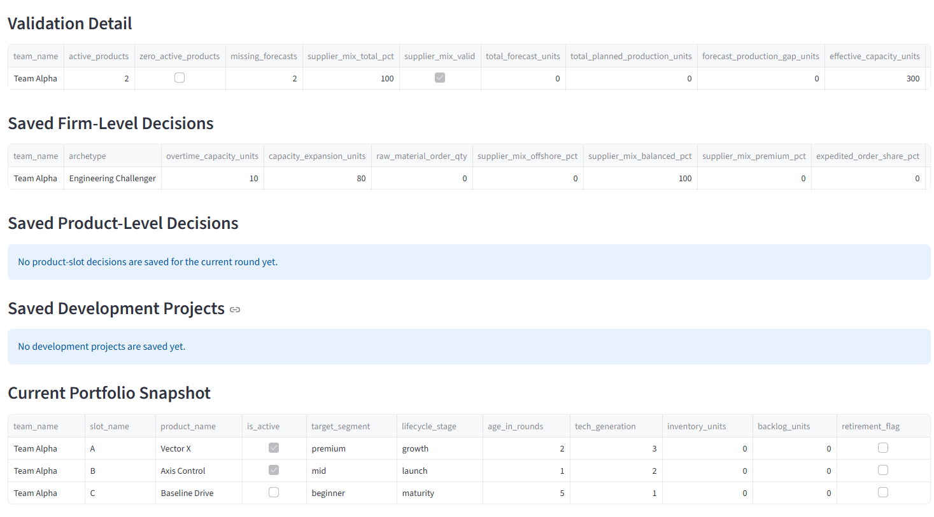
Figure 8. Instructor Panel detail: validation detail, saved decisions, projects, and portfolio snapshot.
Instructor Panel detail | Explanation
Purpose | Audit exactly what has been submitted before running the engine.
How to read it | Saved Firm-Level Decisions confirms shared operations choices. Saved Product-Level Decisions shows product/forecast inputs. Saved Development Projects shows pipeline state. Portfolio Snapshot shows current products.
Teaching/use | When students dispute a result, start here: did they actually save what they thought they saved?
Control/metric | Meaning | Action
Teams Submitted | Number of teams with saved firm-level decisions. | Check against expected active teams.
Invalid Supplier Mix | Supplier shares do not sum to 100%. | Ask team to fix; engine can normalize, but it is a planning error.
Infeasible Plans | Production exceeds shared capacity/material feasibility. | Warn team that output may be capped.
Missing Forecasts | Active products have zero/missing forecasts. | Require teams to enter forecasts before run if forecasting is graded.
Likely Cash Shortfalls | Submission likely requires borrowing. | Use as finance teaching moment; not always an error.
Open Team Submissions | Lets teams save decisions. | Use at start of decision period or for late fixes.
Close Team Submissions | Locks normal submission window. | Use before final pre-run check.
Run Round | Executes the OM/SCM/portfolio/finance engine. | Click after submissions are acceptable; app opens next round automatically.
Factory Reset Game | Erases game progress but keeps accounts. | Use only for testing or intentional restart.
Warning: Factory Reset erases game progress, market report history, decisions, product portfolios, pipeline progress, results, and team states. It keeps user accounts. Do not use during a live class unless you intentionally want to restart the game.

10. Admin User Management
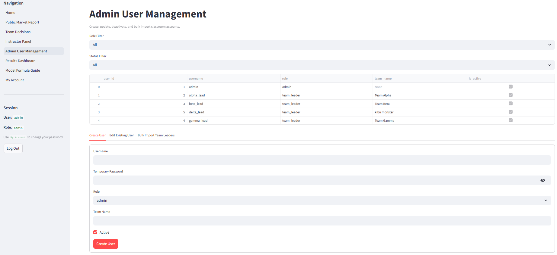
Figure 9. Admin User Management: account table, filters, create/edit/bulk import tabs.
Admin User Management | Explanation
Purpose | Create and maintain instructor and team leader accounts.
How to read it | The table lists usernames, role, team name, and active status but never password hashes or old passwords. Use Create User for one account, Edit Existing User to reset/deactivate, and Bulk Import for many teams.
Teaching/use | One account per team is cleaner than everyone sharing admin or one shared class account.
Task | How to do it | Important note
Create admin | Create User tab, role=admin, blank team name. | Only trusted instructors/TAs should be admin.
Create team leader | Create User tab, role=team_leader, assign team name. | Team name is required and drives data filtering.
Reset password | Edit Existing User tab, enter a new temporary password. | Password is shown only at reset/create time; it is not retrievable later.
Deactivate user | Edit Existing User, uncheck Active. | Deactivated users cannot log in.
Bulk import teams | Upload CSV with username,password,team_name,is_active. | Good for creating 6-12 teams quickly.
Remove team | Deactivate the account or use reset/cleanup workflow depending on classroom need. | Keep account history if you need audit trail. Factory reset keeps accounts but clears game data.

11. Results Dashboard and Teaching Debrief
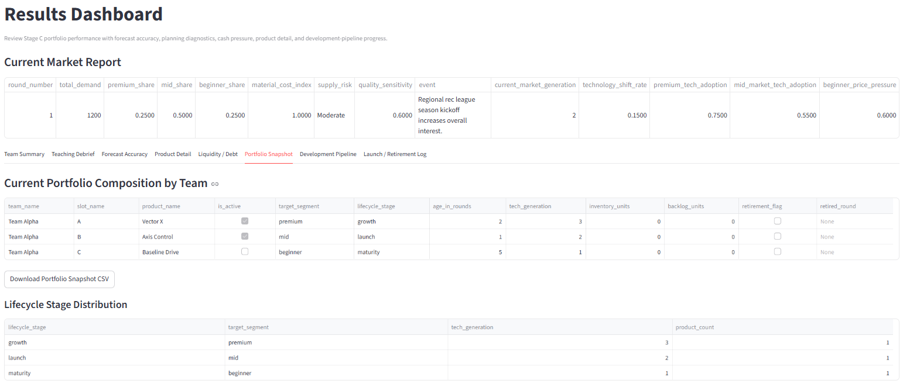
Figure 10. Results Dashboard: market report, tabs, portfolio snapshot, lifecycle distribution, and downloads.
Results Dashboard | Explanation
Purpose | Debrief results after the round.
How to read it | The top repeats the market report. Tabs separate team summary, teaching debrief, forecast accuracy, product detail, liquidity/debt, portfolio snapshot, development pipeline, and launch/retirement log.
Teaching/use | Use it to explain why winners won, not just who won.
Dashboard tab | What it shows | Debrief question
Team Summary | Team-level revenue, cost, profit, service, cash, debt, and rankings. | Was the winner profitable, balanced, or just lucky in one dimension?
Teaching Debrief | Plain-English diagnostic patterns and class discussion prompts. | What tradeoff does this round best illustrate?
Forecast Accuracy | Forecast vs actual by product/team, error, WAPE/bias. | Which teams planned based on demand, and which teams guessed?
Product Detail | Product-level demand, sales, defects, inventory, backlog, profit contribution. | Which product carried the company? Which product should be retired?
Liquidity / Debt | Cash, debt, interest, borrowing, liquidity stress. | Did growth create cash pressure?
Portfolio Snapshot | Current active/inactive products, lifecycle, tech generation, inventory/backlog. | Is the portfolio aging or ready for the next market?
Development Pipeline | NPD project status, investment, readiness, launch eligibility. | Who is investing ahead of the next technology shift?
Launch / Retirement Log | Products launched or retired this round. | Did replacement timing help or hurt?

12. Finance Detail, My Team Tracker, Game Big Picture, and Formula Guide
Page | Purpose | How to use in class
Finance Detail | Shows cash bridge, cost breakdown, product contribution, debt, interest, and liquidity diagnostics. | Use when students ask why profit and cash differ, or why a high-sales team has debt.
My Team Tracker | Shows a team round-by-round history of saved decisions, product decisions, results, forecasts, portfolio, projects, and launch history. | Use for student reflection: what changed from Round 1 to Round 5?
Game Big Picture Guide | Student-facing visual system guide using the eight Kiki diagrams. | Use before the first round and again after students feel overwhelmed.
Model Formula Guide | Transparent formula reference: demand allocation, attractiveness, cost, forecast, finance, development, and scoring logic. | Use to explain the model is deterministic and rule-based, not an AI black box.
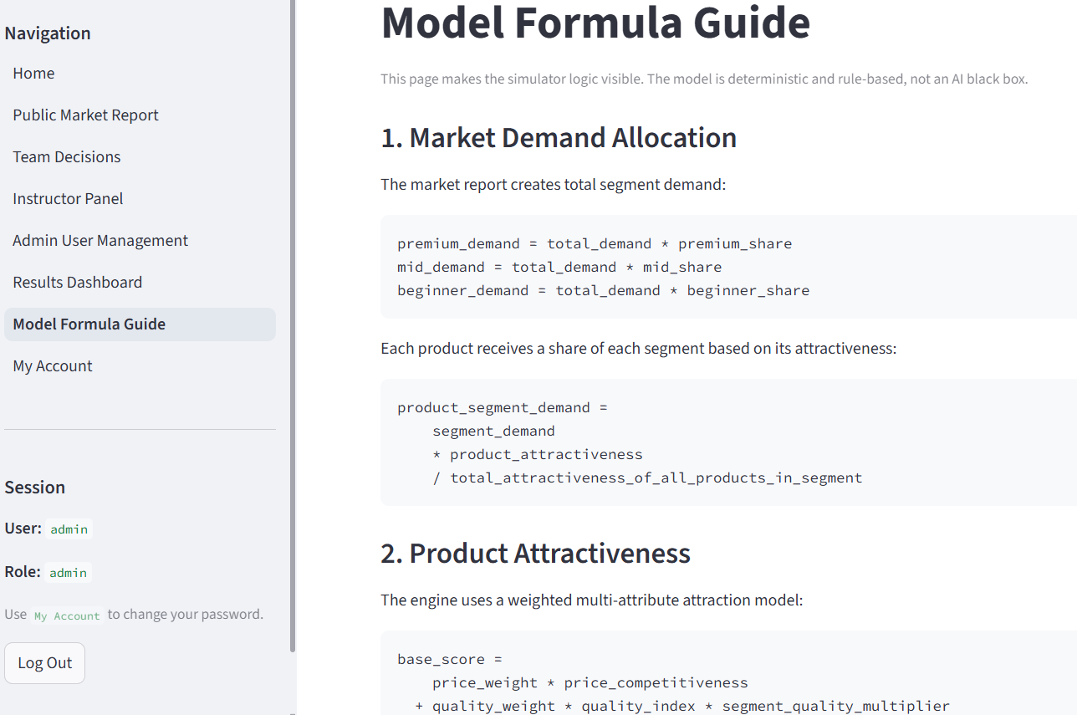
Figure 11. Model Formula Guide: formula explanation page for deterministic engine logic.
Model Formula Guide | Explanation
Purpose | Make the model visible so students can debate assumptions and learn the formulas.
How to read it | The page shows segment demand, proportional allocation, attractiveness score families, and the logic behind financial and operations outputs.
Teaching/use | Use it to shift discussion from gaming the app to reasoning about managerial tradeoffs.
Screenshot status: Current screenshots cover the main v6 UI plus Team Decisions, Instructor Panel, Results Dashboard, Admin Management, Public Market Report, Home, and Formula Guide. New screenshots would be useful only if you want the manual to show the latest Kiki-branded Login page, Finance Detail page, My Team Tracker page, or Game Big Picture page exactly.

13. Recommended Classroom Round Routine
Phase | Instructor actions | Student actions
Before class | Open hosted app, verify DB path, create accounts, set market report, open submissions, test one student login. | None or review account credentials.
Decision time | Ask teams to read market report; monitor Instructor Panel validation; remind teams to save. | Forecast, set firm/product/pipeline decisions, read preview warnings, save.
Before run | Close submissions; check missing forecasts, invalid mix, infeasible plans, cash shortfalls; decide on late fixes. | Make final fixes if allowed.
Run/debrief | Click Run Round; open Results Dashboard, Finance Detail, and Teaching Debrief. | Compare decisions vs outcomes; explain forecast, service, cash, product, and pipeline results.
Prepare next round | Public Market Report is ready for next round; adjust scenario; open submissions. | Review prior result and adapt strategy.

14. Common Student Mistakes
Mistake | Likely outcome | Instructor coaching response
Using zero forecasts | Forecast accuracy meaningless or poor; validation warning. | Forecast first, then plan production.
Supplier mix not 100% | Engine normalizes; indicates poor planning. | Make them explain sourcing strategy.
Price below variable cost | High sales can still lose money. | Ask for unit margin, not just units sold.
Overproducing demand | Inventory, holding cost, working capital pressure. | Ask whether inventory was a buffer or a mistake.
Ignoring cash while expanding/NPD | Debt, interest, liquidity warning. | Separate profit from cash.
Never retiring products | Aging tech/lifecycle drag. | Ask which product should be replaced.
Launching too late | Market tech moves before product is ready. | Plan NPD lead time earlier.
Focusing only on profit rank | Misses forecast, service, cash, and innovation learning. | Use balanced score/debrief prompts.

15. Troubleshooting Guide
Problem | Likely cause | Fix
Student cannot log in | Wrong username/password, inactive user, wrong URL. | Check Admin User Management; reset password; confirm hosted URL.
Student sees wrong team | Account assigned to wrong team_name. | Edit user team assignment.
Team Decisions not saving | Submissions closed, validation issue, session stale. | Open submissions; refresh; check warnings; save again.
Round will not run | No team decisions saved. | At least one team must save firm-level decision.
Public Market Report still old | Round not advanced or page not refreshed. | After Run Round, report advances; refresh page if needed.
Need complete restart | Testing/class restart. | Use Factory Reset Game; accounts remain.
Render site has database column error | Old SQLite persistent disk schema vs new code. | Run migrations/redeploy; if needed reset data or recreate persistent DB after backup.
Students use localhost | They copied local testing URL. | Give Render URL only.

16. Quick Start Checklist
- Before class: hosted URL works, admin login works, teams exist, Round 1 market report saved, submissions open.
- During decisions: teams read market report, enter forecasts, align production/material/cash, save final decision.
- Before run: close submissions, check validation metrics, decide whether late fixes are allowed.
- After run: dashboard debrief, finance detail discussion, team tracker reflection, next round market report adjustment.

