Student Guidebook  Kiki Pickleball Business Simulation  Detailed student-facing guide for making decisions, reading analytics, understanding products, finance, forecasts, and strategy. | 
Your mission: Run a paddle company across repeated rounds. You forecast demand, set prices, produce products, manage quality and suppliers, control cash, invest in future products, and learn from results.

1. The Big Picture
What you manage | Why it matters
Market demand | You compete for premium, mid, and beginner customers. The market changes by round.
Operations | Capacity, production, materials, quality, inventory, and backlog decide what you can actually sell.
Portfolio | Product A/B/C can target different segments and age through lifecycle stages.
Development pipeline | Future products need investment, testing, readiness, and launch timing.
Finance | Revenue is good, but cash can disappear through procurement, production, inventory, expansion, NPD, warranty, backlog, and interest.
Learning | Winning depends on the environment and scoring. There is no one permanent best strategy.

2. What to Do Each Round
- Read Public Market Report first.
- Review current team state: capacity, inventory, backlog, reputation, cash, debt, and tech position.
- Forecast demand by product.
- Choose product prices, production, QC budget, and target finished-goods inventory.
- Set firm-level operations: overtime, expansion, raw materials, supplier mix, expedited share, max backorders, and borrowing.
- Manage development projects: invest, test, launch when ready, or cancel if strategy changes.
- Read the Planning Analytics Preview and warnings.
- Save Portfolio and Pipeline Decision before the deadline.
- After the round, review Results Dashboard, Finance Detail, and My Team Tracker to adjust next round.

3. Team Decision Variables
Variable | Meaning | What to think about
Forecast Units | Your estimate of product demand. | Forecast does not create demand; it helps align the plan and is graded after actual demand happens.
Selling Price / Unit | Price customers pay if units sell. | Higher price raises margin but can lower demand attractiveness.
Planned Production Units | Units you try to make for that product. | Production can be capped by capacity and raw materials.
QC Budget / Unit | Quality spending per produced unit. | Reduces defects with diminishing returns. Too little QC can create warranty/reputation damage.
Target FG Inventory | Desired finished-goods inventory buffer. | Protects service but creates holding/working-capital cost.
Overtime Capacity Units | Extra short-term production capacity. | Can help meet demand but usually increases cost/stress.
Capacity Expansion Units | Investment in future installed capacity. | Mostly helps later rounds and costs cash now.
Raw Material Order Qty | Materials ordered for production. | Too low caps production; too high ties cash/inventory.
Supplier Mix % | Offshore, balanced, premium sourcing shares. | Must sum to 100%; trades cost, speed, risk, and defects.
Expedited Share % | Share of orders expedited. | Shorter lead time but higher cost.
Max Backorder Units | How much unmet demand can carry forward. | Backlog can preserve demand but creates penalty and service pressure.
Planned Borrowing Amount | Money borrowed intentionally. | Gives cash now but increases debt and interest.

4. Product Portfolio and Product Slots
Before editing products: Think portfolio first, then product by product. Ask which slot is supposed to win premium demand, which slot protects mid or beginner volume, and which slot may need retirement or replacement.
Portfolio question | Why it matters
Which product is our profit engine? | High-margin products can carry profit even with lower volume.
Which product is our service/volume engine? | Mid or beginner products may protect market share and fill rate.
Which product is aging or obsolete? | Old products can lose attractiveness when lifecycle or technology pressure rises.
Which product should be replaced? | A new launch can refresh the portfolio but may cannibalize old products.
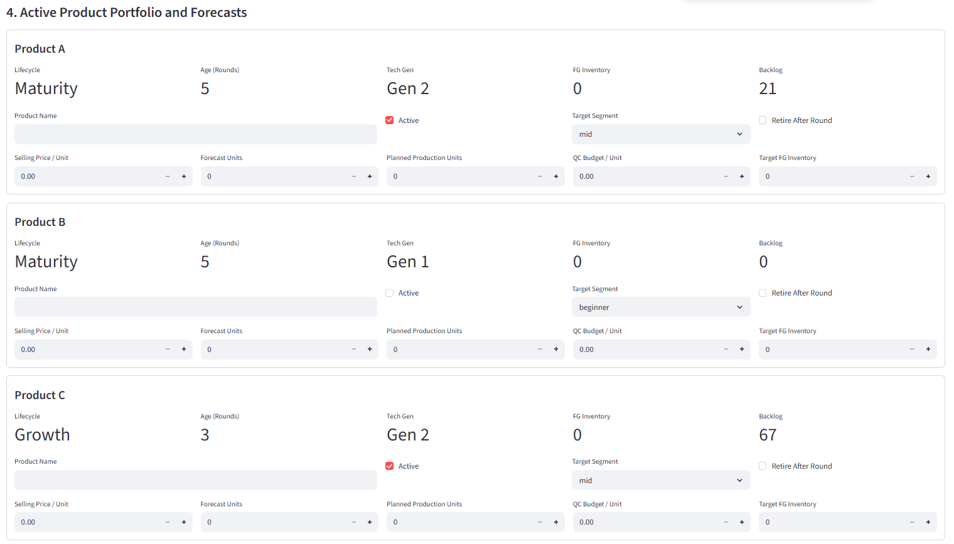
Figure A. Active Product Portfolio and Forecasts: each active slot has its own product decisions.
Active product slots | Explanation
Purpose | Product A/B/C are the products your company can sell now.
How to read it | For each active product, set forecast, price, production, QC, target inventory, and optionally retire after the round. Lifecycle, age, tech generation, inventory, and backlog come from prior rounds.
Teaching/use | Use the portfolio to avoid being a one-product company. Different products can target premium, mid, or beginner demand.
Student note | Inactive products do not compete for demand unless launched/reactivated later.
Field | Meaning | Advice
Lifecycle | Launch, growth, maturity, or decline. | Growth products often have stronger demand; decline products may need replacement.
Age (Rounds) | How many rounds the product has been active. | Older products may move toward decline.
Tech Gen | Product technology generation. | Higher generation helps when the market values tech.
FG Inventory | Finished units carried into the round. | Inventory can serve demand before new production is sold.
Backlog | Unfilled demand carried from previous round. | Backlog means service problems and future pressure.
Retire After Round | Signals product should leave the portfolio after processing. | Use for old, low-margin, low-tech, or strategically obsolete products.

5. Development Pipeline and Launch Readiness
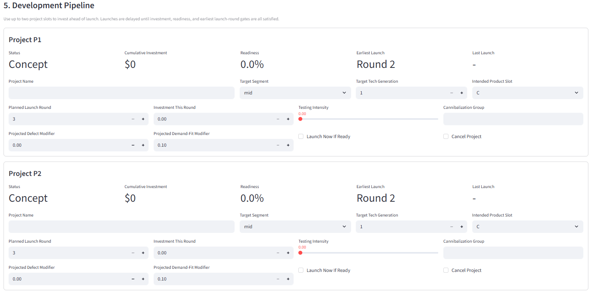
Figure B. Development Pipeline: up to two future product projects.
Development pipeline | Explanation
Purpose | Projects are future products, not sellable products yet.
How to read it | Once you begin investing/testing, fixed project settings lock: project name, segment, target tech generation, intended slot, and launch timing. You can still adjust investment this round, testing intensity, launch now if ready, or cancel.
Teaching/use | Spend money and testing effort early enough so the product becomes ready before the market moves.
Student note | If readiness stalls, check required funding, testing intensity, tech generation difficulty, and launch timing gates.
Pipeline field | Meaning | How it affects launch
Project Name | Name of future product. | Locks after project starts.
Target Segment | Premium/mid/beginner product target. | Affects later demand fit. Locks after project starts.
Target Tech Generation | Technology generation you are developing. | Higher gen can improve demand but costs more and may be harder to ready. Locks after project starts.
Intended Product Slot | A/B/C slot the project should fill or replace. | Defines replacement plan. Locks after project starts.
Planned Launch Round | When you planned to launch. | Past planned launch should not block launching later if readiness is reached.
Investment This Round | Money spent now. | Raises cumulative investment and can speed progress but consumes cash.
Testing Intensity | Effort to stabilize/validate product. | Improves readiness and may reduce launch risk.
Launch Now If Ready | Team decision to launch eligible project. | Launch occurs only if gates are satisfied.
Cancel Project | Stop the project. | Use if strategy changes or cash is too tight.

6. Planning Analytics Preview
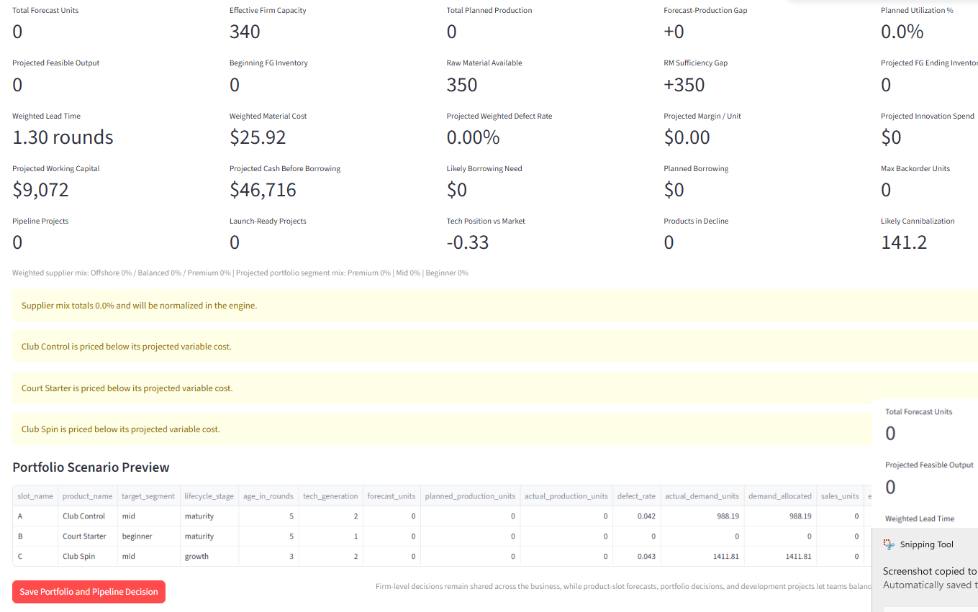
Figure C. Planning Analytics Preview: decision-quality checkpoint before saving.
Planning preview | Explanation
Purpose | This is your pre-submit dashboard.
How to read it | It estimates total forecast, capacity, production, utilization, raw material sufficiency, defect rate, margin/unit, working capital, projected cash, borrowing need, pipeline status, tech position, decline products, and cannibalization.
Teaching/use | Do not ignore yellow warnings. They usually tell you where the plan is incoherent.
Student note | Preview values are estimates, not guaranteed results, because competitors and final demand allocation still matter.
Preview metric | Meaning | If it looks bad...
Total Forecast Units | Your total expected demand across active products. | Recheck product forecasts and market report.
Effective Firm Capacity | Installed capacity plus overtime. | Add overtime/expansion or reduce production.
Total Planned Production | All product production combined. | Compare to forecast and capacity.
Forecast-Production Gap | Production minus forecast. | Large positive gap risks inventory; large negative gap risks stockout.
Planned Utilization % | How much capacity you plan to use. | Very high utilization can raise stress/defects.
Raw Material Available | Beginning RM plus new material position used in planning. | Order more or reduce production if insufficient.
Projected Margin / Unit | Selling price minus estimated unit cost. | If negative, selling more can lose more money.
Projected Cash Before Borrowing | Cash estimate before emergency borrowing. | If negative, expect debt.
Likely Borrowing Need | Estimated automatic borrowing need. | Reduce spending or intentionally plan borrowing.
Likely Cannibalization | How much your products may steal from each other. | Avoid launching products that only replace your own demand unless strategically needed.

7. How Profit, Cost, Cash, and Debt Happen
Term | What it means in the game
Revenue | Units sold times selling price. More demand only helps if you have sellable units.
Procurement cost | Cost of raw material orders, affected by supplier mix, material index, and expedite decisions.
Production cost | Cost of making actual units, including conversion/overtime/QC logic.
Holding cost | Cost of leftover finished goods and raw materials.
Warranty cost | Cost caused by defects on units sold.
Backlog cost | Penalty for demand you could not serve and carried forward.
Expansion cost | Cash spent to add future capacity.
Innovation investment | Cash spent on development pipeline.
Interest expense | Cost of debt. Debt is not free money.
Profit | Revenue minus costs.
Cash | Money available after revenue, spending, borrowing, and debt effects. You can be profitable but cash-constrained.
Automatic borrowing | If cash would go below zero, the simulator adds short-term debt so your cash does not become negative.

8. Big-Picture Figures
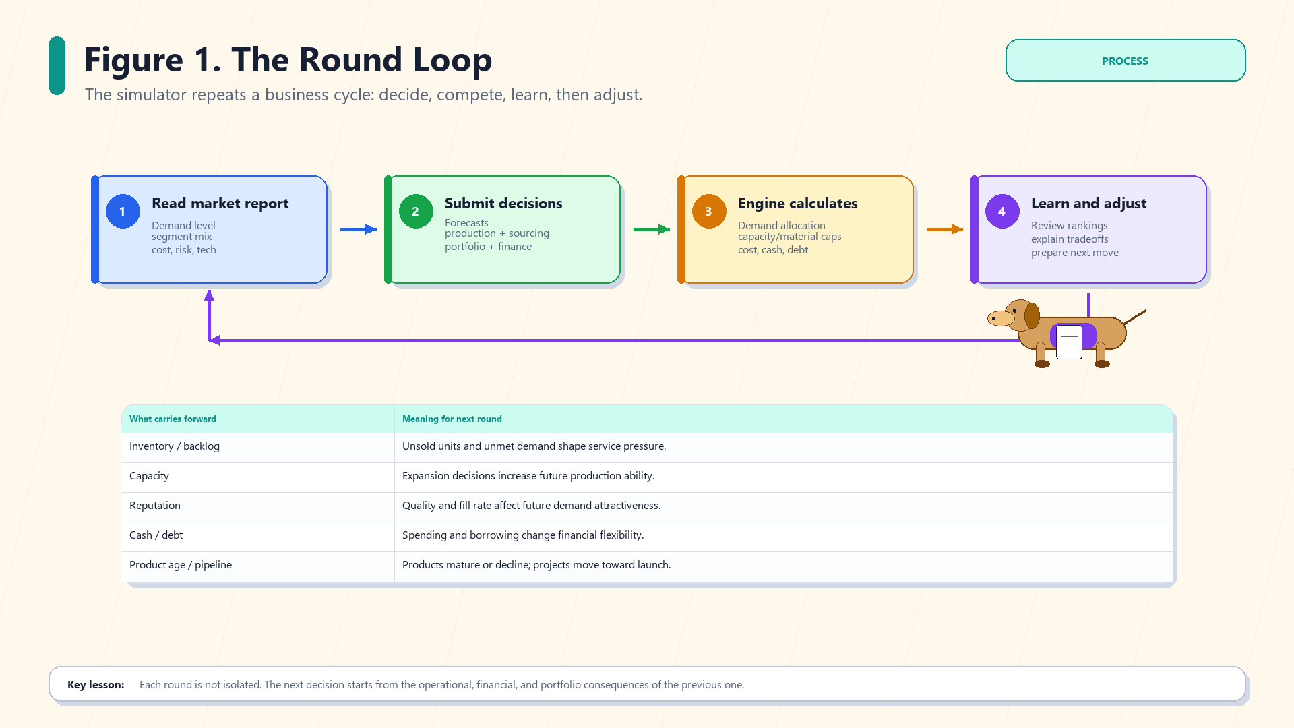
The Round Loop. Classroom infographic for Kiki Pickleball Business Simulation.
The Round Loop | Explanation
Purpose | Shows the repeated cycle: read market, submit decisions, engine calculates results, learn and adjust.
How to read it | Inventory, backlog, capacity, reputation, cash, debt, product age, and pipeline readiness carry forward.
Teaching/use | Use after every round: what did we learn and what must change next?
Student note | Use the figure as a conversation tool, not as a rule sheet. Your decisions still need numbers that fit the current market.
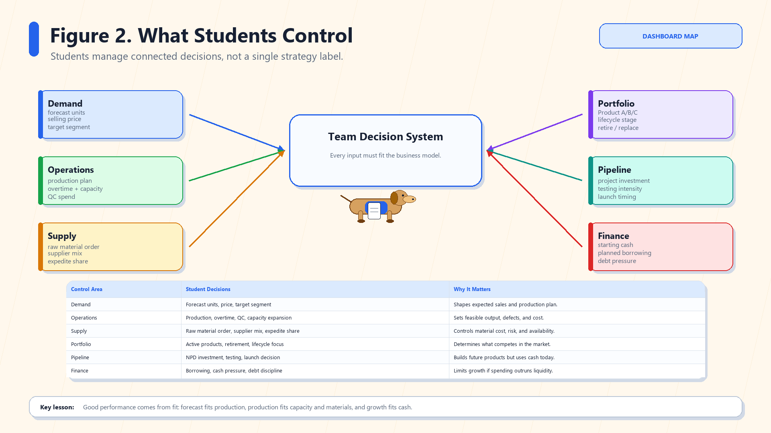
What Students Control. Classroom infographic for Kiki Pickleball Business Simulation.
What Students Control | Explanation
Purpose | Maps six decision areas: demand, operations, supply, portfolio, pipeline, finance.
How to read it | No single control wins alone; the plan must fit together.
Teaching/use | Before saving, ask whether each decision area supports the same strategy.
Student note | Use the figure as a conversation tool, not as a rule sheet. Your decisions still need numbers that fit the current market.
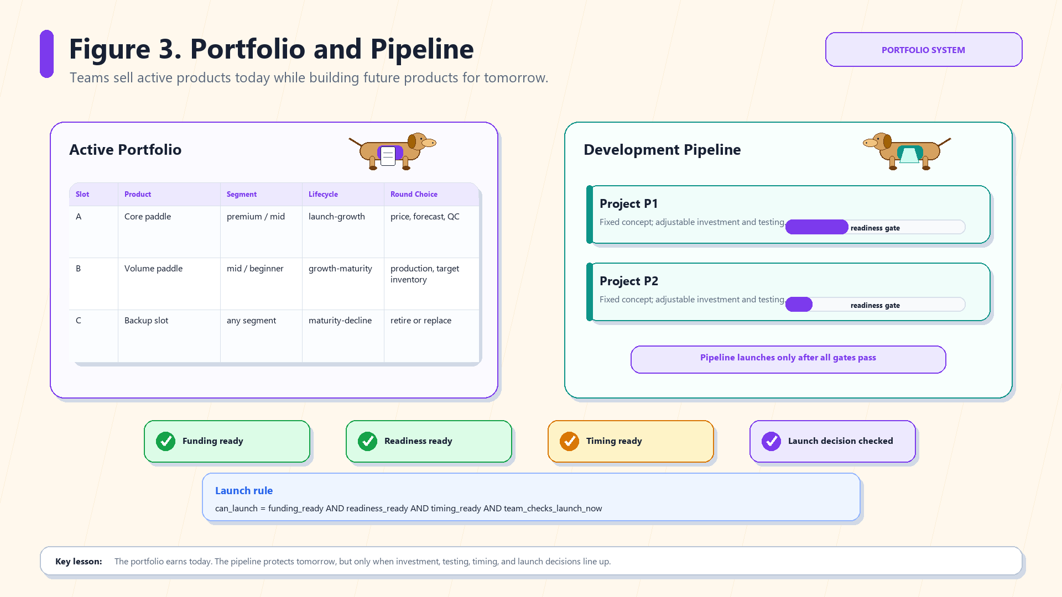
Portfolio and Pipeline. Classroom infographic for Kiki Pickleball Business Simulation.
Portfolio and Pipeline | Explanation
Purpose | Separates active products from future development projects and launch gates.
How to read it | Active products earn now; pipeline projects prepare future competitiveness.
Teaching/use | Use this to decide whether to exploit current products or invest in future products.
Student note | Use the figure as a conversation tool, not as a rule sheet. Your decisions still need numbers that fit the current market.
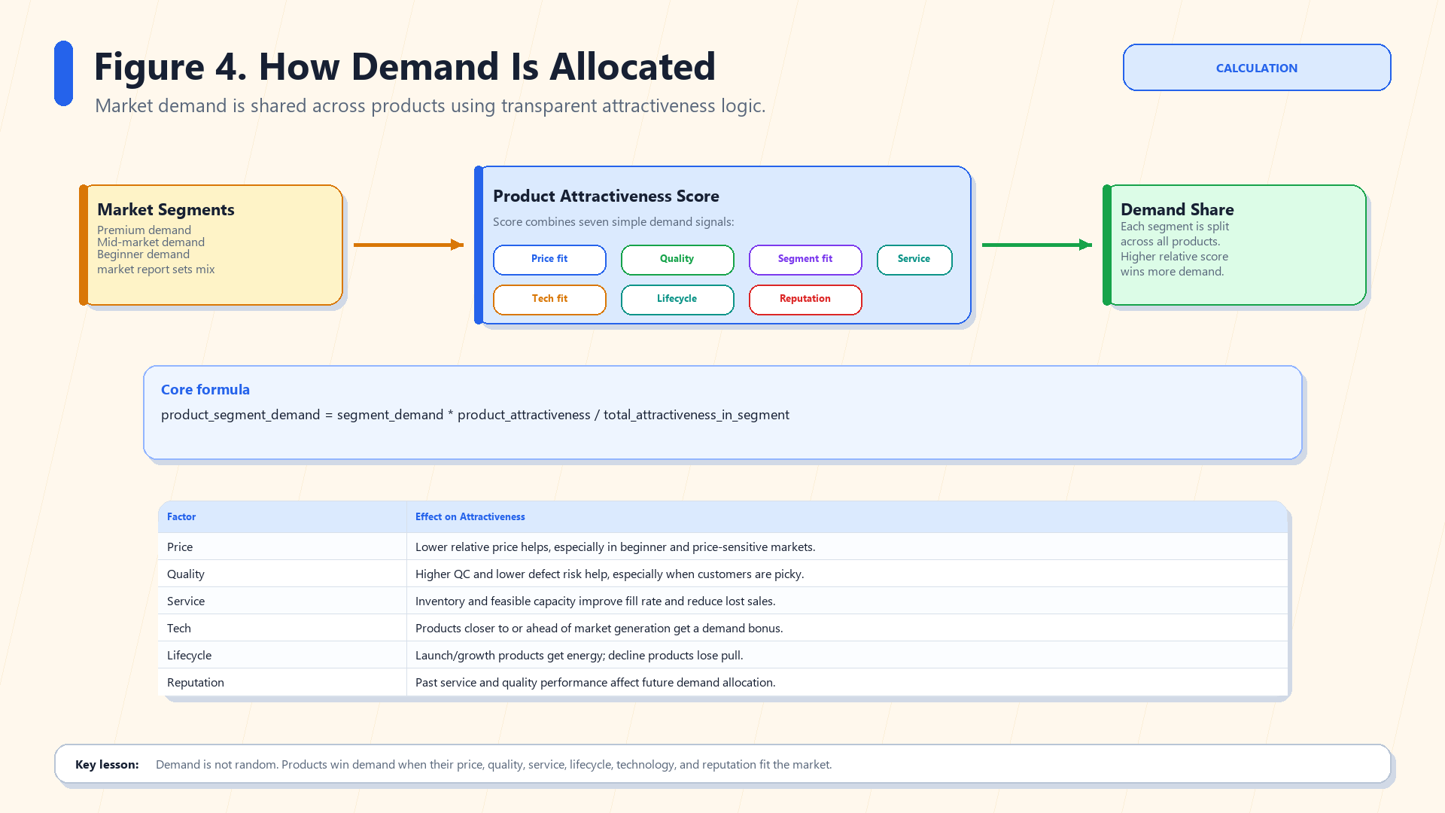
Demand Allocation. Classroom infographic for Kiki Pickleball Business Simulation.
Demand Allocation | Explanation
Purpose | Explains market segments, attractiveness scores, and proportional demand share.
How to read it | You do not receive fixed demand; you earn relative demand against competitors.
Teaching/use | Improve attractiveness through price fit, quality, service, technology, lifecycle, reputation, and segment alignment.
Student note | Use the figure as a conversation tool, not as a rule sheet. Your decisions still need numbers that fit the current market.
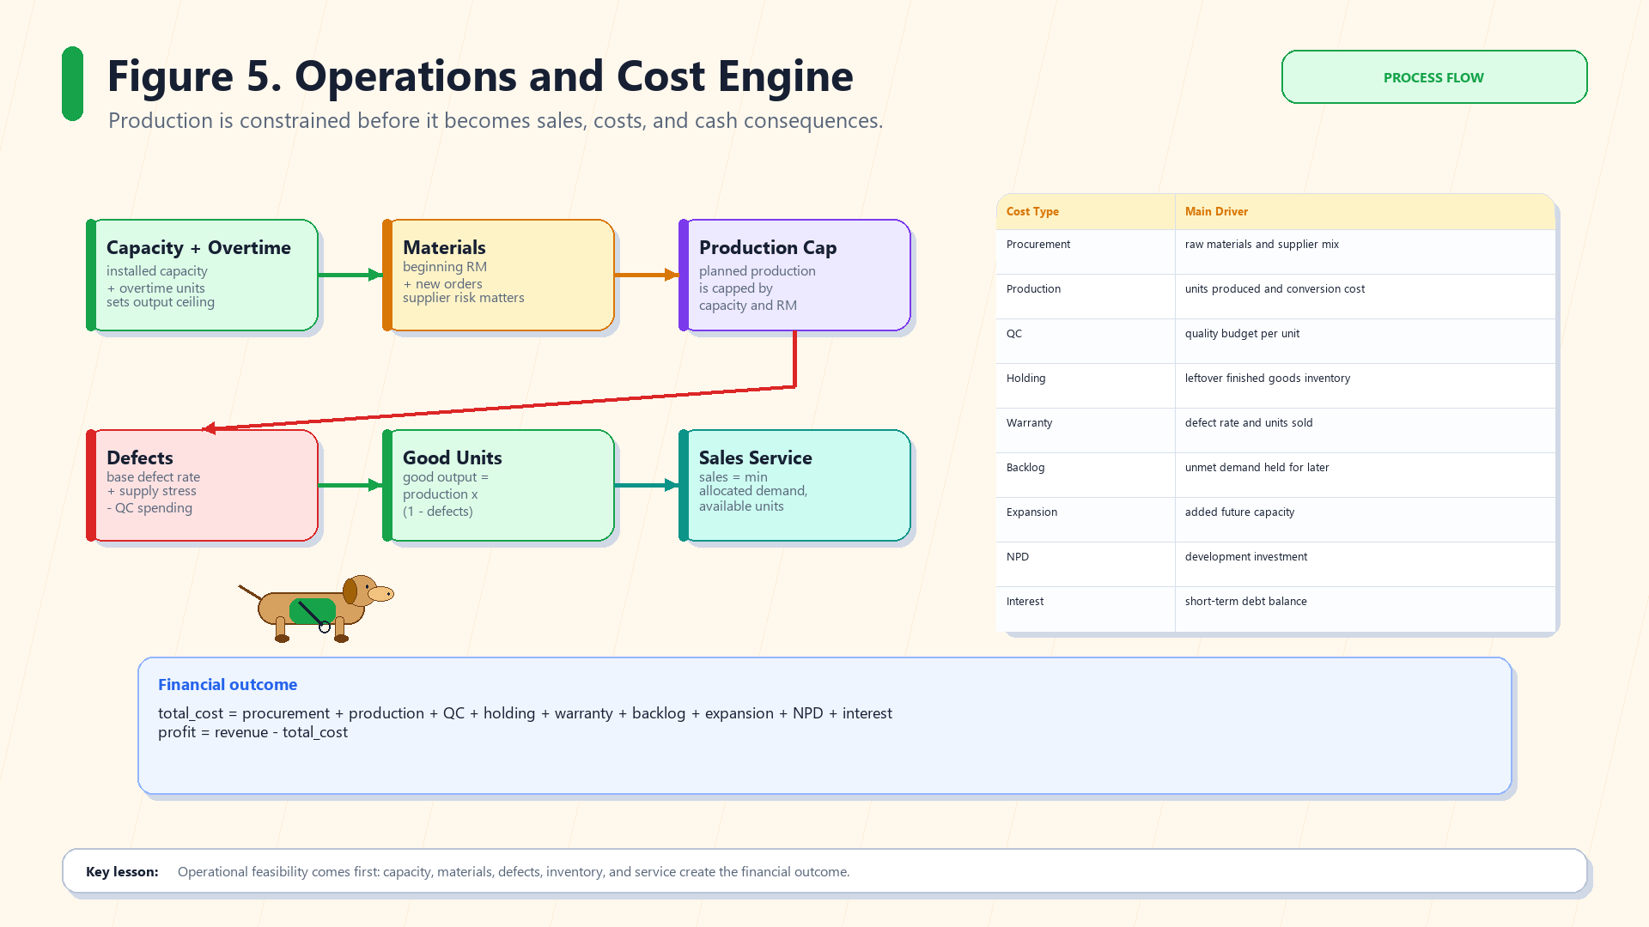
Operations and Cost Engine. Classroom infographic for Kiki Pickleball Business Simulation.
Operations and Cost Engine | Explanation
Purpose | Shows capacity/material constraints, defects, good units, sales service, and cost buckets.
How to read it | Demand is useless without capacity/materials/good units.
Teaching/use | Use it to explain why high demand can still become backlog, lost sales, defects, or cost pressure.
Student note | Use the figure as a conversation tool, not as a rule sheet. Your decisions still need numbers that fit the current market.
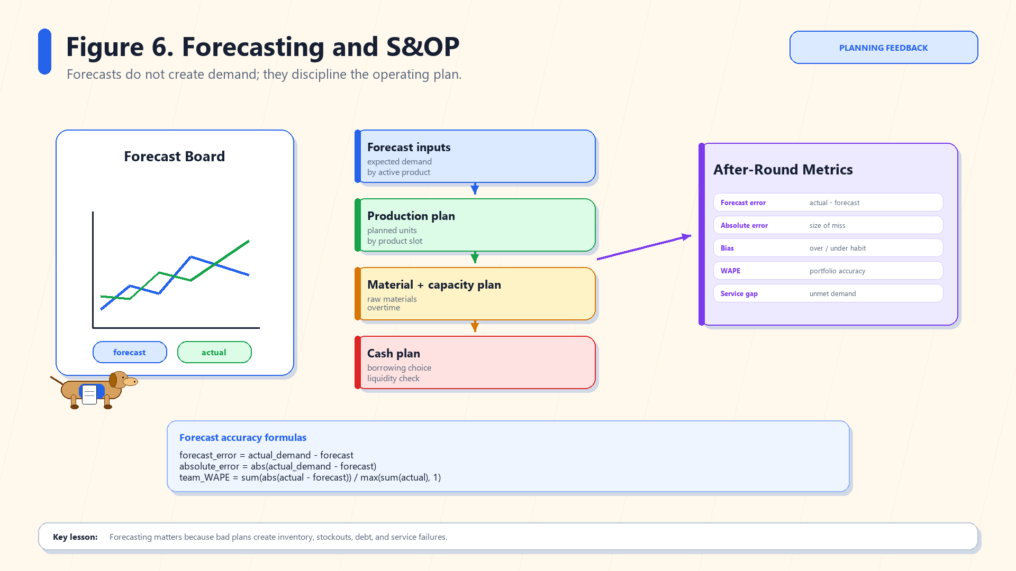
Forecasting and S&OP. Classroom infographic for Kiki Pickleball Business Simulation.
Forecasting and S&OP | Explanation
Purpose | Shows forecast, planning response, and after-round metrics.
How to read it | Forecasting disciplines the plan; it does not create demand.
Teaching/use | Use forecast accuracy to learn whether your team understood the market.
Student note | Use the figure as a conversation tool, not as a rule sheet. Your decisions still need numbers that fit the current market.
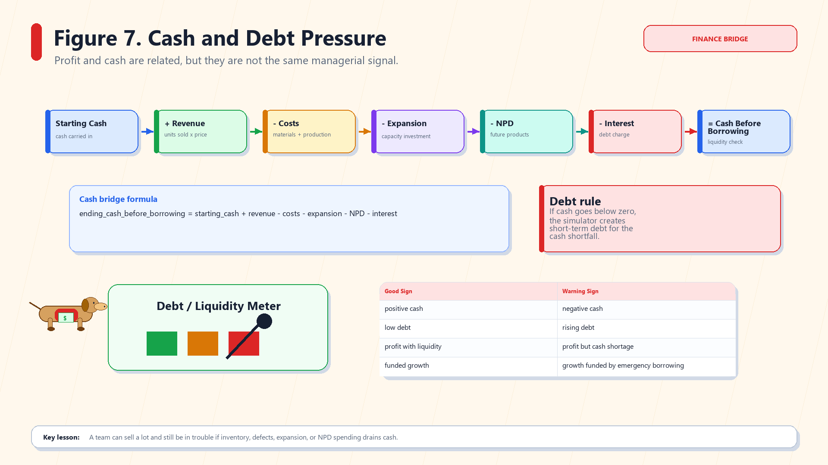
Cash and Debt Pressure. Classroom infographic for Kiki Pickleball Business Simulation.
Cash and Debt Pressure | Explanation
Purpose | Shows cash bridge from starting cash to ending cash and borrowing rule.
How to read it | Profit and cash are different; debt creates interest and liquidity stress.
Teaching/use | Use this when deciding expansion/NPD/inventory spending.
Student note | Use the figure as a conversation tool, not as a rule sheet. Your decisions still need numbers that fit the current market.
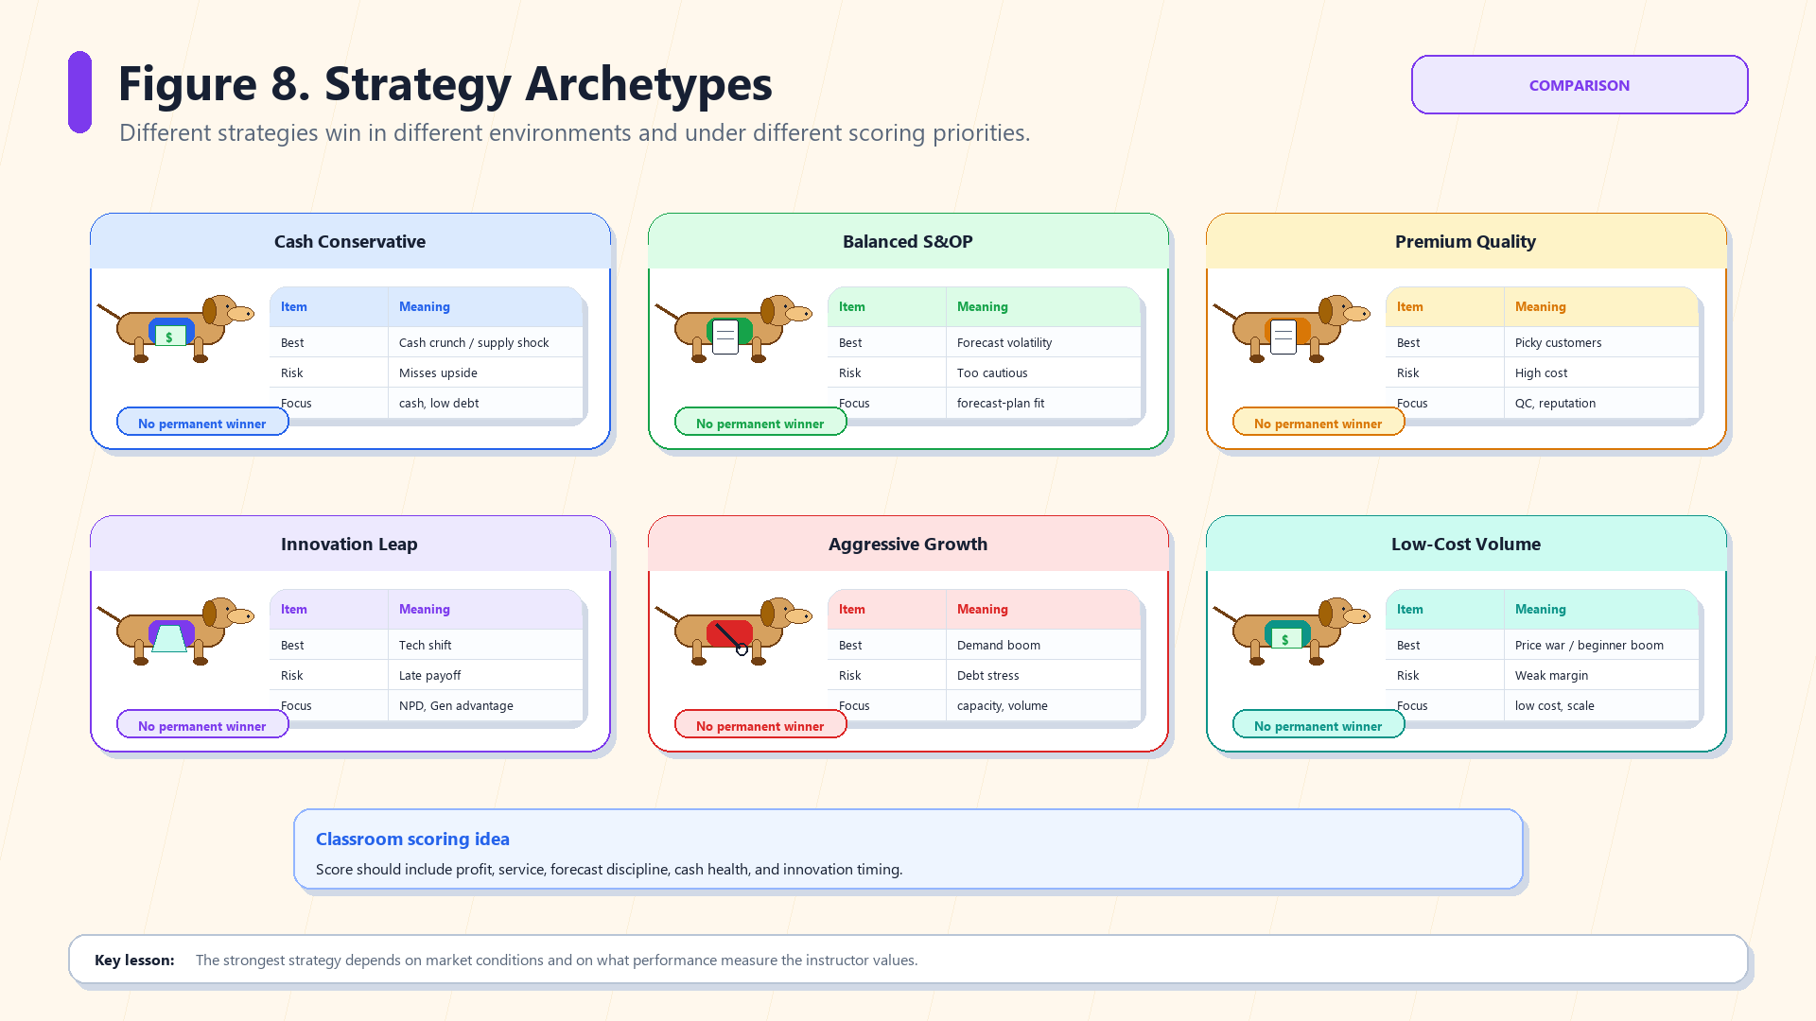
Strategy Archetypes. Classroom infographic for Kiki Pickleball Business Simulation.
Strategy Archetypes | Explanation
Purpose | Compares six common strategies and their strengths/risks.
How to read it | There is no permanent winner; market conditions and scoring weights matter.
Teaching/use | Pick a strategy deliberately, then adapt when the environment changes.
Student note | Use the figure as a conversation tool, not as a rule sheet. Your decisions still need numbers that fit the current market.

9. Strategy Advice
Strategy | Good when... | Main risk
Cash Conservative | Supply/cost shock, recession, cash crunch, inventory risk. | May miss growth or innovation upside.
Balanced S&OP | Forecast volatility, stable markets, balanced scoring. | May be too cautious in boom markets.
Premium Quality | Premium market, picky customers, high quality sensitivity. | Higher QC/cost can hurt if customers become price sensitive.
Innovation Leap | Tech shift, premium tech adoption, fast lifecycle. | Pipeline investment and launch risk can drain cash.
Aggressive Growth | Demand boom, capacity-constrained opportunity. | Debt, inventory, overtime, and cost pressure.
Low-Cost Volume | Beginner boom, price war, price-sensitive market. | Weak margins and quality pressure.
After each round, ask... | Why it matters for the next decision
Did we win demand but lose money? | Check margin, cost buckets, defects, and inventory/working-capital pressure.
Did we forecast accurately? | Use forecast error to adjust next product forecasts before changing production.
Did we stock out or build inventory? | Match production, raw materials, and target inventory to realistic demand.
Did cash fall or debt rise? | Separate profitable growth from liquidity stress.
Did any product age into decline? | Consider retirement, replacement, or a targeted NPD launch.
Did the market generation move? | Re-check whether the portfolio technology still fits customer expectations.
Final save checklist | Complete before deadline
Market report read | [ ]
Supplier mix sums to 100% | [ ]
Every active product has a forecast | [ ]
Production is feasible with capacity and raw materials | [ ]
Price is above projected variable cost unless intentionally strategic | [ ]
Cash/borrowing impact has been checked | [ ]
Pipeline investment/testing choices are intentional | [ ]
Save Portfolio and Pipeline Decision clicked | [ ]
Final student reminder: A strong plan is coherent: forecasts, prices, production, suppliers, QC, inventory, cash, and pipeline investments all support the same strategy for the current market.

