Instructor Operating Manual
Pickleball Paddle Market Simulator
Classroom operations guide for running rounds, managing teams, interpreting results, and connecting simulation outcomes to OM/SCM teaching goals.
Cover Summary
Cover Summary: This manual helps an instructor run the hosted classroom simulator from first login through account setup, submissions, round execution, dashboard debrief, and troubleshooting.
What the simulator teaches | - Forecast demand by product  - Balance capacity, inventory, quality, sourcing, cash, and debt  - Manage product lifecycle, new product development, technology shifts, and cannibalization
How to use this manual | - Start with account setup and market report setup  - Use the page-by-page guide during class  - Use the formula guide and dashboard prompts for debrief and student reflection

Audience | Instructor, teaching assistant, or simulation facilitator
App version covered | Hosted Streamlit app with admin/team_leader login, portfolio, pipeline, forecasting, cash, and debt features
Recommended use | One hosted app URL for the class; one account per team leader
Prepared | April 29, 2026
Important: Students should use the hosted Render URL during class, not http://localhost:8501. Localhost only works on the computer running the app.

Instructor Tip: Run one private test round before class so you can verify login, submissions, round execution, and dashboard results.

1. Simulator Purpose and Teaching Goals
The Pickleball Paddle Market Simulator is a classroom competition platform, but it is not just a game. It is designed to make students practice the managerial trade-offs that appear in a real product business: forecasting demand, setting prices, planning production, managing supplier risk, funding innovation, and keeping enough cash to survive.
Concept | What students practice | Typical instructor prompt
Demand forecasting | Forecast product-level demand before the round result is known. | Which team forecasted closest, and did that help operations?
Market segmentation | Compete in premium, mid-market, and beginner demand pools. | Which segment was attractive this round, and who matched it best?
Product portfolio | Manage up to three active paddle products with different prices, production plans, and lifecycle stages. | Did the team rely too much on one product?
Lifecycle management | Products age through launch, growth, maturity, and decline. | Which products should be protected, refreshed, or retired?
Capacity planning | Balance installed capacity, overtime, expansion, and utilization pressure. | Did expansion create advantage or cash pressure?
Supplier mix | Choose offshore, balanced, and premium sourcing percentages. | Did cheaper supply reduce cost or increase defects/risk?
Quality control | Set QC spend per product to lower defect risk. | Was the quality improvement worth the extra cost?
Inventory and backlog | Decide target inventory and max backorders under uncertain demand. | Who protected service without overstocking?
Cash and debt | Manage cash balance, planned borrowing, automatic debt, and interest. | Did profit translate into liquidity?
NPD and technology | Invest in future projects, manage launch readiness, and handle technology shifts. | Who invested early enough without starving current operations?
S&OP discipline | Connect forecast, production, materials, inventory, and cash. | Where did the plan break before the market did?

Instructor Tip: Do not crown only the highest-profit team. Discuss profit, service level, forecast accuracy, product lifecycle, innovation timing, and cash discipline.

2. User Roles and Login Workflow
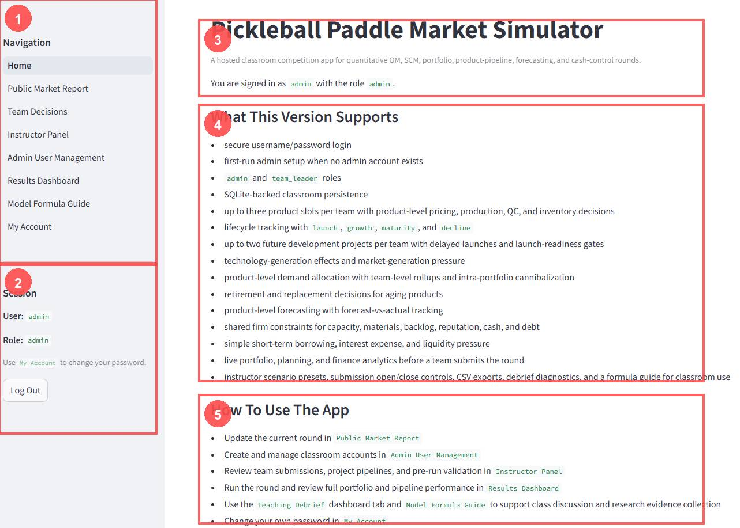
Figure 1. Home page after login. The sidebar shows page navigation, current user, role, and logout controls.
Callout | Area | Instructor meaning
1 | Navigation | Admin users can reach every page. Team leaders see only safe team-facing pages.
2 | Session block | Confirms the logged-in username and role. Use this when students say they cannot see a page.
3 | Home title/status | Confirms this is the hosted classroom simulator, not a local test page.
4 | Supported features | Quick overview of the current simulation scope: portfolio, pipeline, forecasting, cash, and debt.
5 | How to use the app | The instructor workflow: market report, accounts, submissions, run round, dashboard, formula guide.

The app uses two roles for classroom use:
Role | Access | Use this account for
admin | All pages and all data | Instructor or TA only. Runs rounds, manages users, edits market reports, resets data if needed.
team_leader | Home, read-only Market Report, own Team Decisions, safe Dashboard view, My Account | One account per team. The team leader enters and saves that team's decisions.

Important: Students should never share or use the admin account. Admin access can run rounds, reset data, and view all teams.

3. Local Testing vs Hosted Classroom Deployment
Mode | Typical URL | Who should use it | Notes
Local testing | http://localhost:8501 | Instructor/developer on the same computer | Good for testing. Students on other devices usually cannot use this URL.
Hosted classroom | https://your-render-service.onrender.com | Instructor and all student teams | Use this for class. Students can connect from school Wi-Fi, conference Wi-Fi, home Wi-Fi, or cellular data.

For Render deployment, the repo already includes a Render blueprint:
- Build command: pip install -r requirements.txt
- Start command: python run_streamlit.py
- Persistent SQLite database path: SIMULATOR_DB_PATH=/var/data/simulator.db
- Persistent disk: mounted at /var/data so class data survives app restarts.
Important: If students are joining from their own browsers, give them the Render URL. Do not give them localhost.

4. Instructor Pre-Class Setup Checklist
Done | Task | Why it matters
[ ] | Open the hosted app URL and log in as admin. | Confirms the deployed app is alive.
[ ] | Verify the database is using the hosted persistent disk path. | Avoids losing data after restart.
[ ] | Create or verify one team_leader account per student team. | Prevents teams from overwriting each other.
[ ] | Test one team_leader login in a private/incognito browser. | Confirms student-facing access is correct.
[ ] | Set the Public Market Report for Round 1. | Defines the market environment before decisions.
[ ] | Open team submissions. | Allows teams to save decisions.
[ ] | Run a private test round if this is the first class use. | Catches account or deployment issues before students arrive.

5. Page-by-Page Instructor Guide
Page | Primary purpose | Admin access | Team leader access
Home | Orientation and navigation status. | Yes | Yes
Public Market Report | Set or view market demand, segment shares, quality, supply risk, and technology pressure. | Edit/save | Read-only
Team Decisions | Submit firm-level operations, product decisions, forecasts, and pipeline choices. | Can view/use for teams | Own team only
Instructor Panel | Validate submissions, open/close submissions, run round, reset data. | Yes | No
Admin User Management | Create, edit, deactivate, reset, and bulk import accounts. | Yes | No
Results Dashboard | Review results, rankings, forecasts, product detail, liquidity, pipeline, and debrief evidence. | All teams | Filtered/safe view
Model Formula Guide | Explain deterministic formulas and scoring logic. | Yes | Yes
My Account | Change own password and confirm account identity. | Yes | Yes

6. Public Market Report Setup
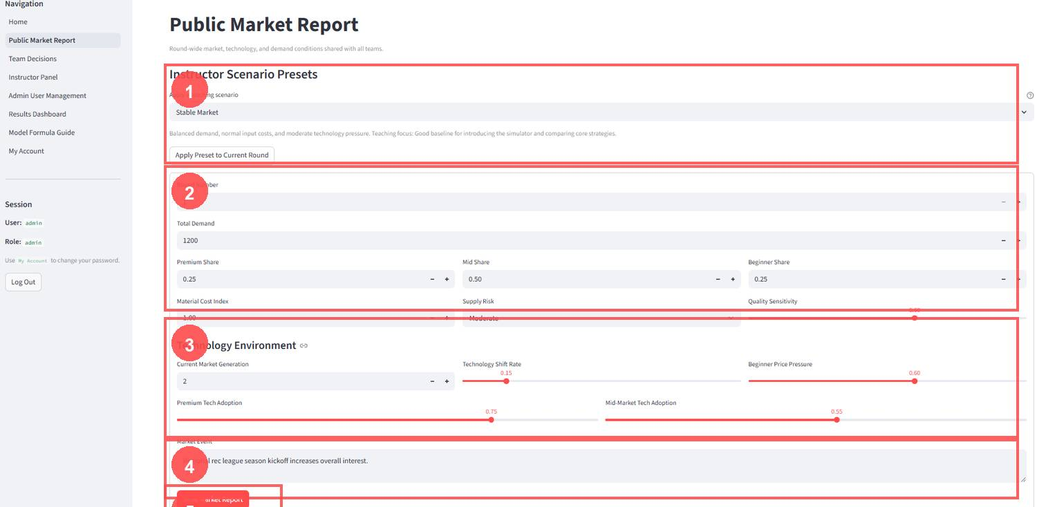
Figure 2. Public Market Report page where the instructor sets demand, segment shares, technology pressure, supply risk, quality sensitivity, and event text.
Field/control | What it does | Instructor guidance
Instructor Scenario Presets | Applies a teaching scenario such as stable market, tech shift, or supply pressure. | Use presets to create consistent class conditions quickly.
Round Number | Identifies the round being played. | Advance this before starting the next decision cycle.
Total Demand | Sets total market size before segmentation. | Higher demand rewards capacity and inventory readiness; lower demand punishes overproduction.
Premium / Mid / Beginner Share | Splits total demand across customer segments. | Shares should sum close to 1.0. Use segment shifts to teach market positioning.
Material Cost Index | Raises or lowers material cost pressure. | Use inflation to test margin discipline and supplier choices.
Supply Risk | Adds supply/defect pressure. | High risk makes cheap sourcing and high utilization more dangerous.
Quality Sensitivity | Controls how much customers and reputation respond to quality problems. | Higher values reward QC discipline and punish defects.
Current Market Generation | Defines the market's expected technology generation. | Products below the market generation lose competitiveness, especially premium/mid products.
Technology Shift Rate | Controls how quickly the market moves toward newer tech. | Higher values reward NPD and launch timing.
Premium Tech Adoption | How strongly premium customers value advanced technology. | Use high values to make innovation matter in premium markets.
Mid-Market Tech Adoption | How strongly mid-market customers value technology. | Use this to show diffusion beyond premium buyers.
Beginner Price Pressure | How strongly beginner customers react to price. | High values can reward low-cost/value strategies.
Market Event | Narrative event text shared with all teams. | Use this to frame the round: tournament boom, cost shock, recession, viral demand, etc.
Save Market Report | Stores the market settings for the current round. | Save before teams submit decisions.

Instructor Tip: Set or apply the market scenario before teams submit decisions. Changing it after submissions can make the round feel unfair.

7. Team Decisions Page Guide

Recommended Student Decision Sequence
Step | Action
1 | Choose or confirm team and archetype.
2 | Review current team state before changing anything.
3 | Set firm-level operations and finance decisions.
4 | Review active product portfolio and lifecycle status.
5 | Enter product forecasts, prices, production, QC, and inventory targets.
6 | Decide whether to invest in development projects.
7 | Review the Planning Analytics Preview.
8 | Click Save Portfolio and Pipeline Decision before the deadline.

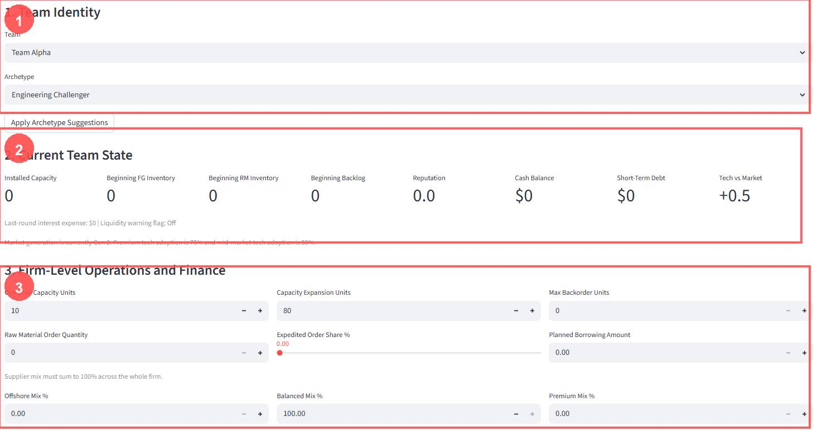
Figure 3. Team Decisions page, upper section. Students review identity, state, and firm-level operations/finance decisions.
Callout | Area | Student action | Instructor note
1 | Team Identity | Choose/check team and archetype; apply suggestions only if appropriate. | Team leaders should normally see only their own team.
2 | Current Team State | Review capacity, inventory, backlog, reputation, cash, debt, and tech position. | Ask students to explain decisions using these starting conditions.
3 | Firm-Level Operations and Finance | Set overtime, expansion, material orders, expedited share, borrowing, max backorders, and supplier mix. | Supplier mix must sum to 100%; excessive expansion/overtime can hurt cash and defects.

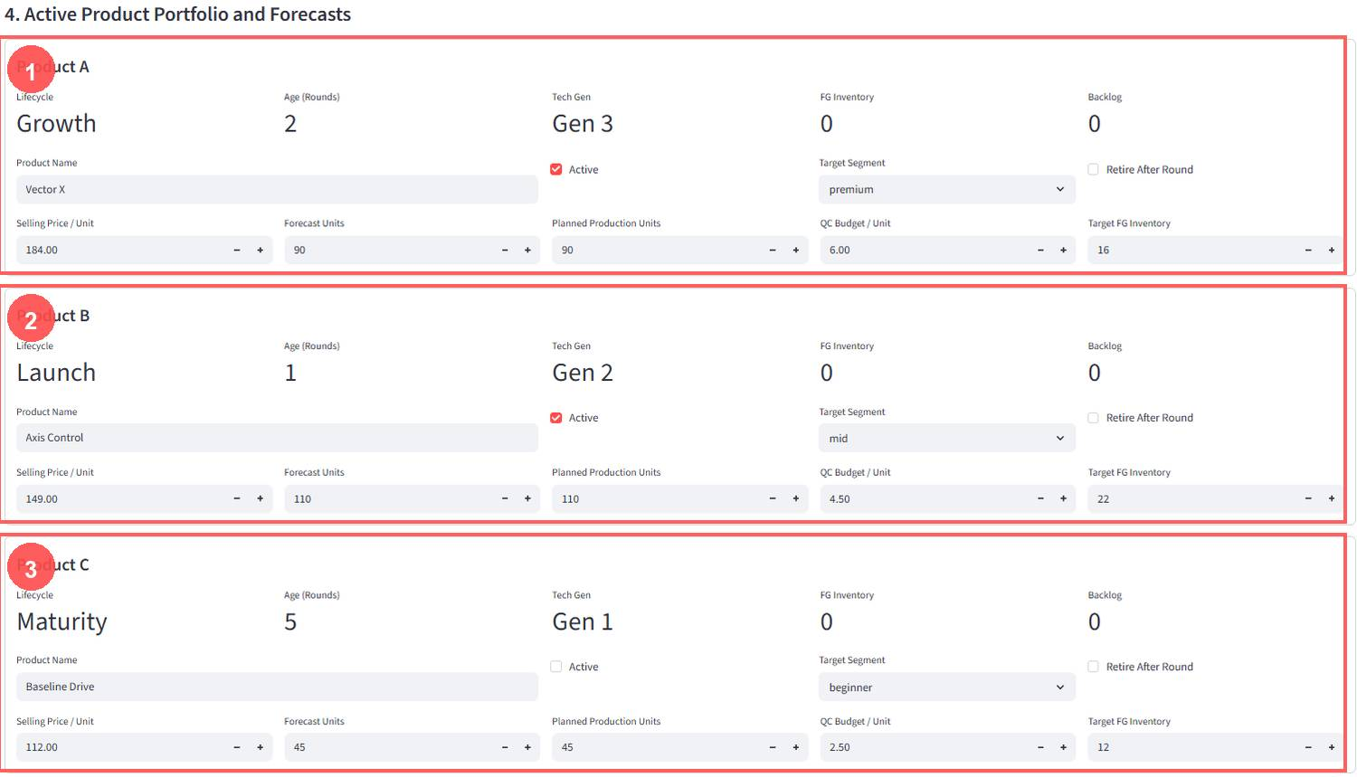
Figure 4. Active Product Portfolio and Forecasts. Each team can manage up to three product slots with forecasts, pricing, production, QC, inventory, and retirement choices.
Product control | Meaning | Common mistake
Active | Determines whether the product is sellable this round. | Leaving no products active creates no sellable portfolio.
Retire After Round | Flags a product for retirement after the round. | Retiring too early may remove a still-profitable product.
Product Name | Student-facing product identity. | Changing names constantly can make debrief confusing.
Target Segment | Premium, mid, or beginner segment focus. | Targeting a segment but pricing badly reduces attractiveness.
Selling Price / Unit | Numeric price used directly in demand allocation and margin. | Price below cost can create sales but destroy profit.
Forecast Units | Product-level demand forecast used for forecast accuracy and S&OP discipline. | Zero or unrealistic forecasts damage planning metrics.
Planned Production Units | Requested production before capacity/material constraints. | Plans above feasible capacity/materials will be capped.
QC Budget / Unit | Quality investment that lowers defect rate with diminishing returns. | Too little QC can create defects; too much can crush margin.
Target FG Inventory | Desired finished goods inventory buffer. | Too much inventory ties up working capital and holding cost.

8. Development Pipeline Guide
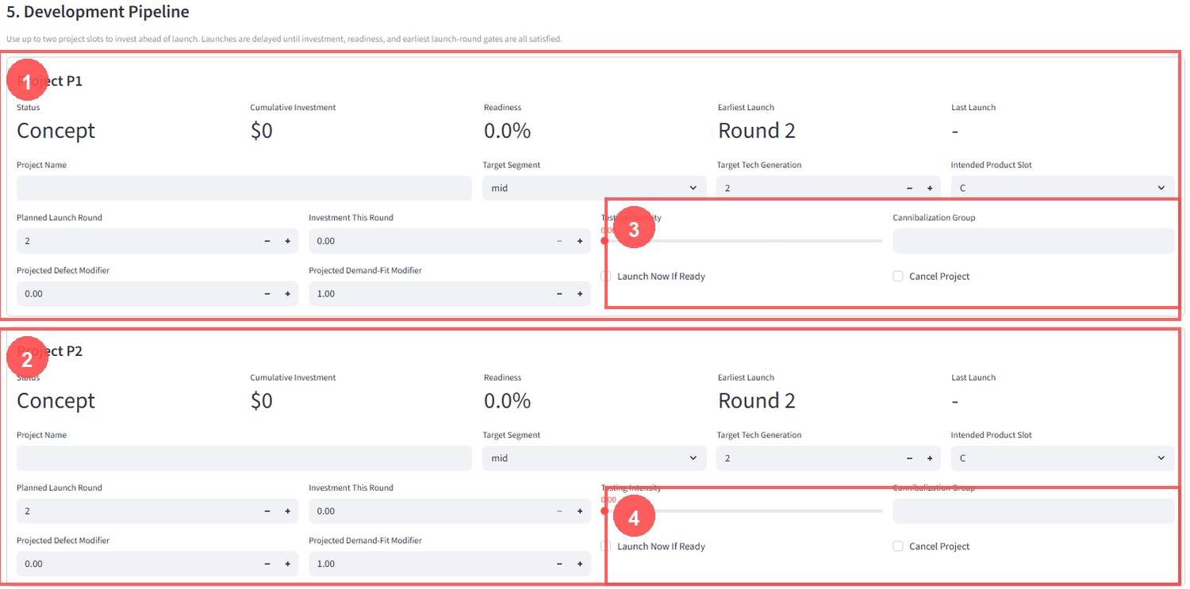
Figure 5. Development Pipeline. Teams can manage up to two future product projects with investment, testing, launch timing, and replacement intent.
Control | Meaning | Teaching use
Status | Project phase: concept, development, pilot, launch-ready, launched, or canceled. | Shows that innovation is a pipeline, not instant magic.
Cumulative Investment | Total investment already placed into the project. | Connects investment burden to future readiness.
Readiness | Launch-readiness score based on investment, testing, and technology complexity. | Ask why a team launched or delayed.
Earliest Launch / Planned Launch Round | Timing gates that delay product launch until conditions are met. | Useful for discussing time-to-market.
Investment This Round | Current round NPD spending. | High investment can help future products but strain current cash.
Testing Intensity | Improves readiness and can reduce launch risk. | Students trade off speed, quality, and cost.
Target Tech Generation | Technology generation of the future product. | Higher tech may attract customers but cost more and carry launch risk.
Intended Product Slot | Slot A/B/C where the product will launch or replace an existing product. | Forces portfolio replacement thinking.
Cannibalization Group | Groups products that may steal demand from one another. | New products can hurt older products in the same portfolio.
Launch Now If Ready | Launch action if readiness gates are satisfied. | Not all launch-ready projects should launch immediately.
Cancel Project | Stops future development. | Useful when market conditions change.

Instructor Tip: Use the pipeline to teach timing. A team can be right about future technology but still fail if it launches too late, too early, or without enough cash.

9. Instructor Panel and Round Execution
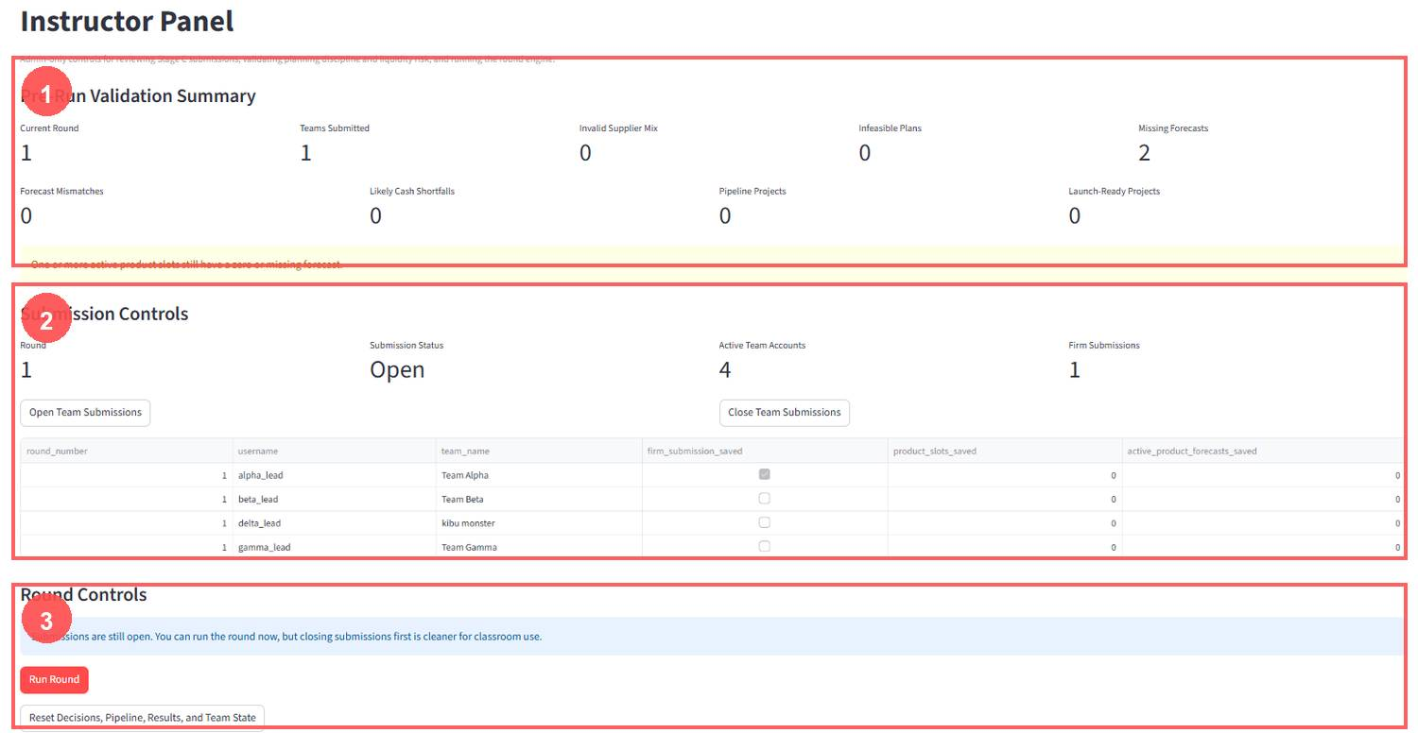
Figure 6. Instructor Panel top section. The instructor validates submissions, opens/closes submissions, runs the round, and can reset data when intentionally restarting.
Area/control | Meaning | Instructor action
Current Round | Round number from the market report. | Confirm this before running.
Teams Submitted | How many firm submissions have been saved. | Use this to monitor progress.
Invalid Supplier Mix | Teams whose supplier percentages do not sum to 100%. | Ask teams to fix before running.
Infeasible Plans | Plans that exceed obvious capacity/material feasibility. | Decide whether to allow correction.
Missing Forecasts | Active product slots with zero or missing forecasts. | Forecasts are required for S&OP learning.
Forecast Mismatches | Plans that are badly disconnected from forecasts. | Use as coaching signal before run.
Likely Cash Shortfalls | Teams whose plan may require borrowing or create liquidity stress. | Warn teams if the exercise allows late fixes.
Pipeline Projects | Number of active NPD projects. | Use to discuss innovation activity.
Launch-Ready Projects | Projects that may be ready to launch. | Ask teams why they launched or waited.
Open Team Submissions | Allows teams to submit or revise decisions. | Open at the start of decision time.
Close Team Submissions | Closes the decision window. | Close before running for cleaner classroom control.
Run Round | Executes the deterministic simulation engine. | Click once after validation.
Reset Decisions, Pipeline, Results, and Team State | Clears runtime simulation progress. | Use only for testing or restarting from scratch.

Warning: Do not use Reset during a live class unless you intentionally want to erase simulation progress and restart.

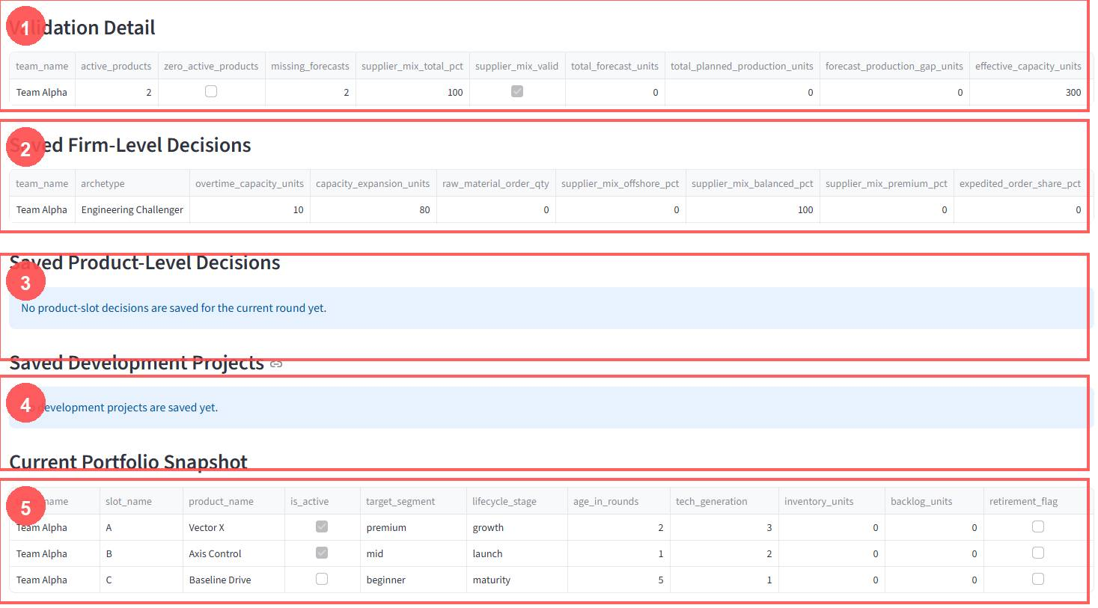
Figure 7. Instructor Panel detail section. Use these tables to inspect validation detail, saved firm decisions, saved product decisions, development projects, and the current portfolio snapshot.

10. Admin User Management
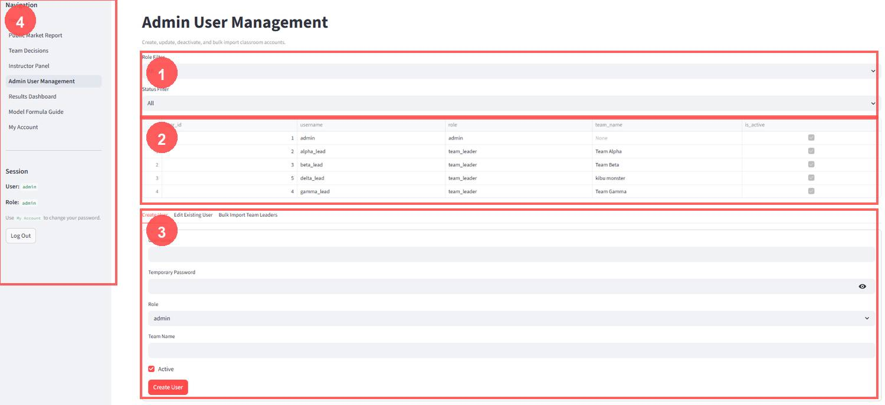
Figure 8. Admin User Management page. Admins create users, reset passwords, assign teams, deactivate users, and bulk import team leaders.
Task | How to do it | Rule
Create admin user | Open Create User, enter username, temporary password, role admin, leave team name blank, Active checked. | Admin is for instructor/TA only.
Create team leader | Enter username, temporary password, role team_leader, assign exact team_name, Active checked. | Team name is required for team_leader.
Reset password | Use Edit Existing User, set a new temporary password, share it once. | Passwords are hashed; existing passwords cannot be viewed later.
Deactivate user | Uncheck Active for users who should not log in. | Inactive users are denied login.
Bulk import team leaders | Use CSV upload with username, password, team_name, is_active. | Use for fast setup of many teams.
Filter users | Use Role Filter and Status Filter. | Helps during class troubleshooting.

Important: Each team should have its own team_leader account. If all students use one account, decisions overwrite each other and results become impossible to interpret.

11. Results Dashboard and Teaching Debrief
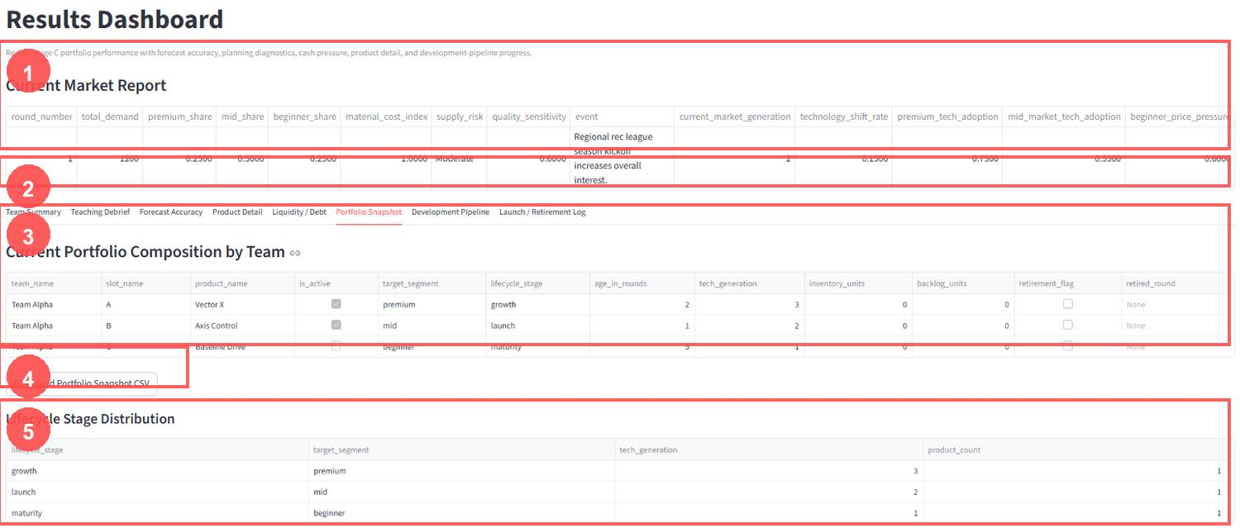
Figure 9. Results Dashboard. The screenshot shows the Market Report, dashboard tabs, Portfolio Snapshot, CSV download, and lifecycle distribution.
Dashboard tab | What it shows | Debrief question
Team Summary | Team-level revenue, cost, profit, service, reputation, cash, and rankings. | Who had the best balance between sales, margin, cash, and innovation?
Teaching Debrief | Instructor-facing interpretation prompts and scenario diagnostics. | What trade-off dominated this round?
Forecast Accuracy | Forecast vs actual demand by team/product. | Which products were over-forecasted or under-forecasted?
Product Detail | Product-level demand, sales, defects, cost, margin, inventory, and profit contribution. | Which product actually created value?
Liquidity / Debt | Cash, borrowing, interest, debt, liquidity pressure. | Did teams grow faster than their cash could support?
Portfolio Snapshot | Current products, lifecycle, tech generation, inventory, backlog, retirement flags. | Which portfolio is positioned for next round?
Development Pipeline | NPD project status, readiness, investment, and launch timing. | Did teams invest too early, too late, or just right?
Launch / Retirement Log | Products launched or retired during the round. | How did replacement choices change competitive position?

Recommended debrief prompts:
- Did high production improve performance or create inventory and cash problems?
- Which teams were hurt by supplier risk, defects, or quality underinvestment?
- How did technology generation affect product competitiveness?
- Which team had the best service level, and what did it cost them?
- Was the most profitable team also the healthiest business?

12. Model Formula Guide
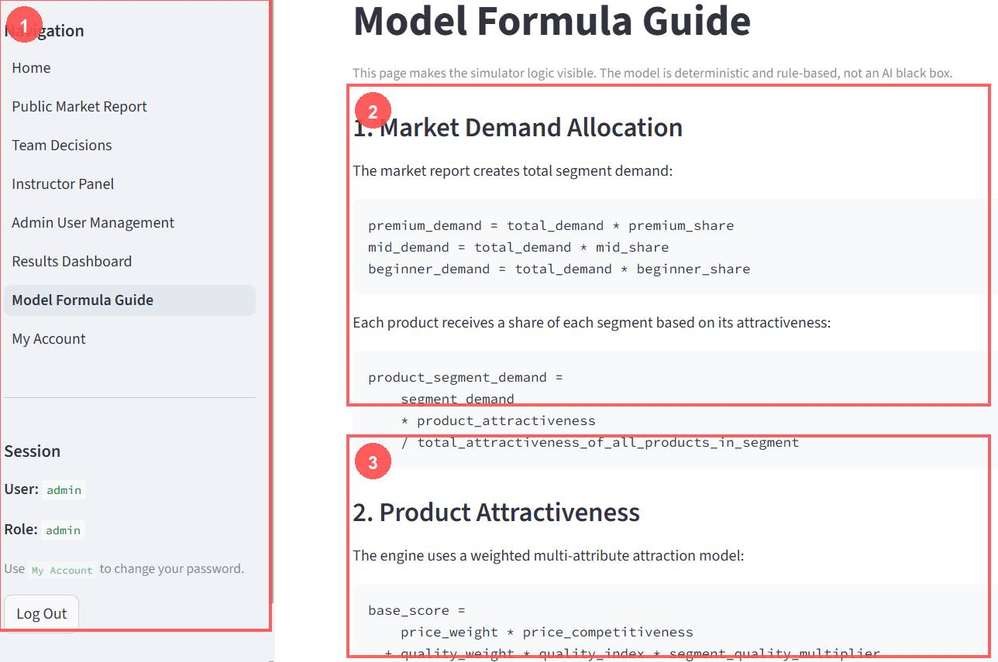
Figure 10. Model Formula Guide. This page makes the deterministic rules visible so the simulator is teachable rather than a black box.
Formula area | Business meaning | Classroom use
Market demand allocation | Total demand is split into premium, mid, and beginner segment demand. | Shows students how the market report becomes customer demand.
Product attractiveness | Products receive demand based on price, quality, segment fit, reputation, service, lifecycle, and technology. | Explain why one product wins demand without using hidden AI.
Forecast accuracy | Forecasts are compared with actual demand using error and accuracy metrics. | Connects S&OP discipline to results.
Capacity/material constraints | Planned production is capped by shared firm capacity and raw material availability. | Shows why plans must be feasible.
Cash/debt logic | Revenue increases cash; costs, investment, holding, warranty, and interest reduce it; deficits create debt. | Connects operations decisions to liquidity.
Balanced score | Performance can be evaluated by profit, service, forecast discipline, and cash health. | Avoids teaching only short-term profit maximization.

13. Recommended Classroom Round Routine

Before Class
- Deploy or open the app and confirm the hosted URL works.
- Confirm the database path uses persistent hosted storage.
- Create or verify team accounts.
- Set the market report and save it.
- Open submissions.
- Test one team_leader account.

During Decision Time
- Ask teams to read the Public Market Report first.
- Teams enter forecasts, production, pricing, sourcing, QC, inventory, finance, and pipeline decisions.
- Instructor monitors validation summary.
- Remind teams to click Save Portfolio and Pipeline Decision.

Before Running the Round
- Close submissions.
- Check missing forecasts, invalid supplier mix, infeasible plans, likely cash shortfalls, and launch-ready projects.
- Decide whether teams may make late corrections.

Run and Debrief
- Click Run Round once.
- Open Results Dashboard.
- Discuss forecast accuracy, cash, product performance, lifecycle position, pipeline, and service level.
- Connect outcomes to course concepts.

Prepare Next Round
- Advance the round number in the Public Market Report.
- Adjust demand, segment shares, supply risk, costs, and technology pressure or apply a scenario preset.
- Save the market report.
- Reopen submissions.

14. Common Student Mistakes
Mistake | What happens | Instructor coaching
Supplier mix does not sum to 100% | The decision is invalid or flagged before running. | Have students fix sourcing percentages first.
Forecasts are left at zero | Forecast accuracy and planning analytics become meaningless. | Require realistic product-level forecasts.
Production ignores capacity/materials | The engine caps production and may create stockouts. | Ask teams to compare planned production with effective capacity and raw materials.
Price below variable cost | High sales may still lose money. | Use contribution margin as the teaching hook.
Too much inventory | Holding cost and working capital rise. | Connect inventory buffers to cash pressure.
Too little QC | Defects, warranty cost, and reputation penalties rise. | Discuss quality as investment, not decoration.
Over-expansion | Capacity increases but cash and debt pressure can damage performance. | Ask whether demand justified expansion.
Late NPD investment | Projects are not ready when market technology shifts. | Discuss launch lead time and innovation timing.
Launching everything immediately | New products can cannibalize old products and strain cash. | Teach portfolio replacement discipline.

15. Troubleshooting Guide
Problem | Likely cause | Fix
Student cannot open app | Using localhost or wrong hosted URL. | Send the Render URL. Localhost is only for the machine running the app.
Student cannot log in | Wrong password, inactive user, typo, or wrong role. | Check Admin User Management, reset password if needed, confirm Active is checked.
Student sees another team | Account has wrong team_name. | Edit user and assign the correct team_name.
Team cannot save | Submissions closed or validation issue. | Open submissions or fix supplier mix/required fields.
Instructor cannot run round | No decisions saved or admin not logged in. | Log in as admin and check submissions.
Results look empty | Round was not run, no products active, or forecasts/production were zero. | Check Instructor Panel validation and product active flags.
Data disappeared after deployment restart | SQLite database not on persistent disk. | Verify SIMULATOR_DB_PATH points to Render persistent disk, e.g. /var/data/simulator.db.
Wrong round repeated | Round number was not advanced. | Update and save Round Number in Public Market Report.
Need to restart the exercise | Live database still contains old state. | Use Reset only when intentionally restarting and after warning class.

16. Quick Start Checklist
Use this condensed routine if you only have a few minutes before class.
Done | Action
[ ] | Open hosted Render URL and log in as admin.
[ ] | Verify team accounts and passwords.
[ ] | Set and save Public Market Report.
[ ] | Open Team Submissions.
[ ] | During decision time, monitor Instructor Panel validation.
[ ] | Close Team Submissions.
[ ] | Check missing forecasts, invalid supplier mix, infeasible plans, and likely cash shortfalls.
[ ] | Click Run Round once.
[ ] | Use Results Dashboard to debrief profit, service, forecast accuracy, cash, product detail, and pipeline.
[ ] | Advance round number, update market report, save, and reopen submissions.

What Students Need to Know: They log in with the assigned username and password, control only their own team, read the Public Market Report first, make realistic forecasts, keep supplier mix at 100%, understand QC and NPD trade-offs, and save before the deadline.

