Student Guidebook
Kiki Pickleball Business Simulation
Audience: team leaders and student teams | Use this before submitting each round.
Big idea: You are not only trying to sell paddles. You are managing a business: forecast demand, make products, control quality, manage cash, invest in future products, and learn from each round.

1. What You Control Each Round
Decision area | Your inputs | What to think about
Market response | Forecast units, selling price, target segment. | What do customers want this round?
Operations | Planned production, overtime, capacity expansion, QC budget. | Can we make enough good units without overspending?
Supply | Raw material order, supplier mix, expedited share. | Do we want low cost, reliability, or speed?
Portfolio | Product A/B/C active status, price, production, QC, inventory, retirement. | Which products should carry our business?
Pipeline | NPD investment, testing intensity, launch now when ready. | Should we spend cash today for future advantage?
Finance | Planned borrowing, cash, debt, working capital. | Can our strategy survive financially?
Decision rhythm: Forecast demand first, then align production, materials, capacity, quality, inventory, pipeline investment, and cash. The best plans fit together.
Before saving | Ask your team
Demand | Are our forecasts realistic for our price, segment, product age, and technology?
Operations | Can capacity and raw materials support the production plan?
Finance | Can cash survive inventory, expansion, borrowing, NPD, and interest?
Future | Are we replacing old products before the market moves away from them?
Common mistake | What usually happens
Forecast is zero or unrealistic | The plan cannot be evaluated well and forecast accuracy suffers.
Production ignores capacity/materials | The engine caps output and demand may become backlog or lost sales.
Price below variable cost | Sales volume can increase while profit gets worse.
Heavy expansion/NPD without cash | Debt and interest rise; liquidity stress can hurt future flexibility.
Old products never retired | Declining lifecycle and outdated technology can drag the portfolio.
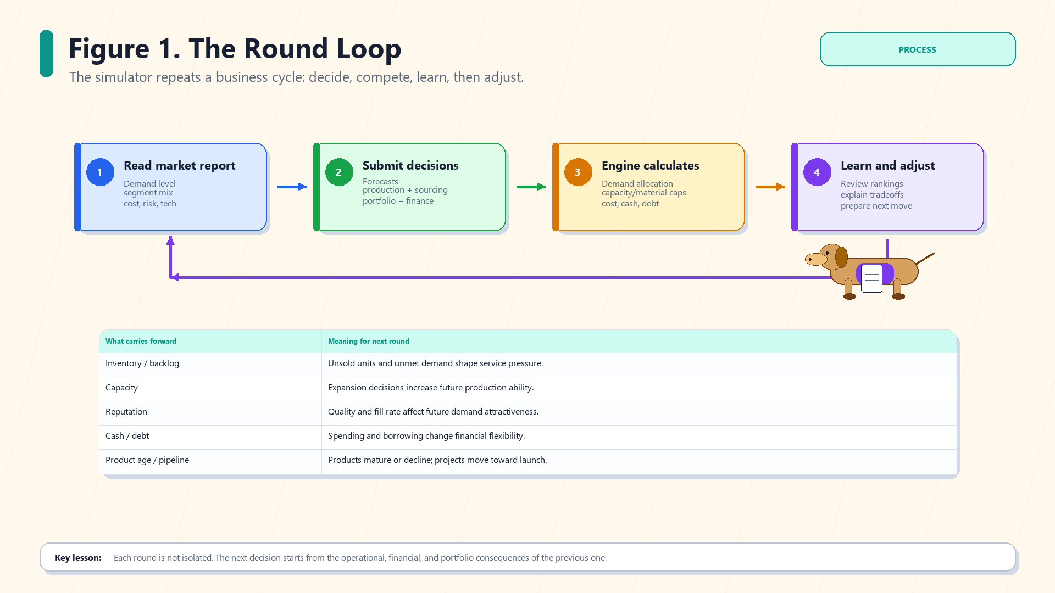
The round loop: read the market, submit decisions, see results, then adjust.
What to remember: Your decisions carry forward. Inventory, backlog, cash, debt, reputation, product age, and pipeline readiness all affect the next round.
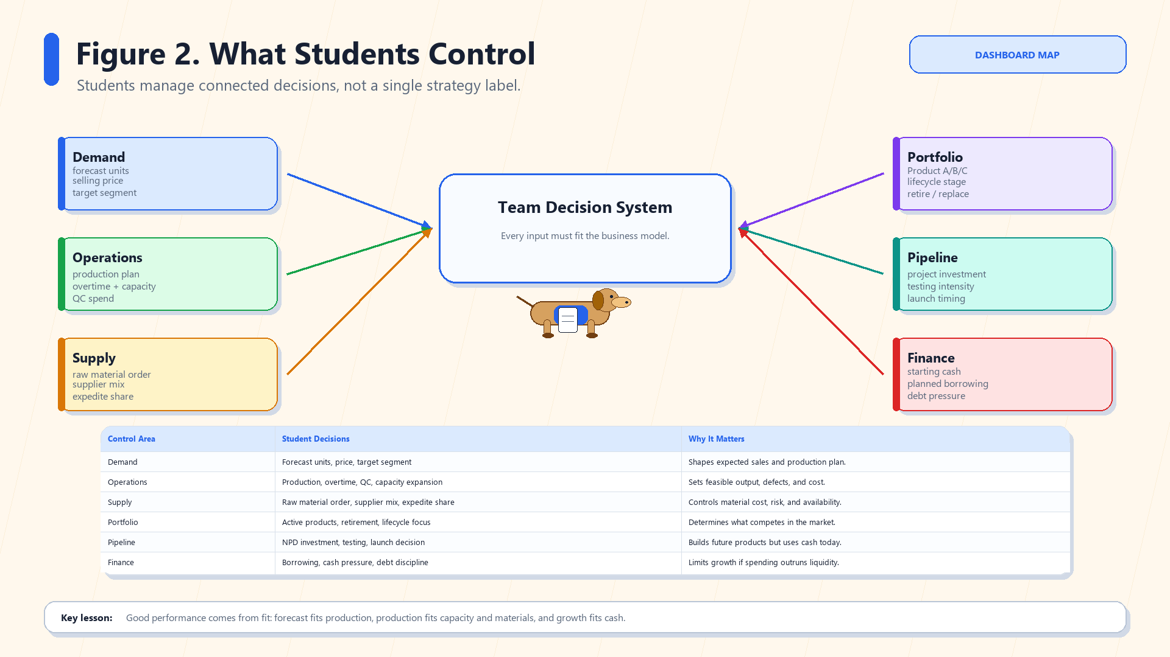
Control map: the six areas of student decision-making.
What to remember: Do not optimize one box alone. A good price is useless if you cannot produce, a big launch is dangerous if cash breaks, and high production can backfire if demand is weak.
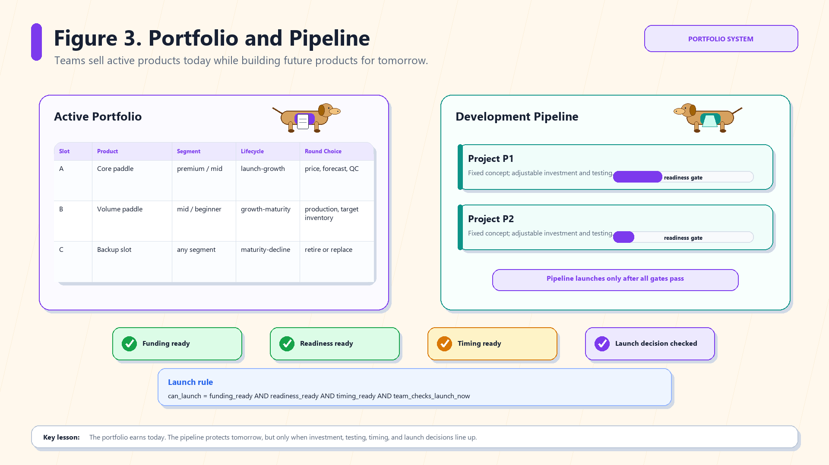
Portfolio and pipeline: active products earn today; projects prepare tomorrow.
What to remember: Active products compete now. Development projects need funding, testing, timing, and a launch decision before they become sellable products.
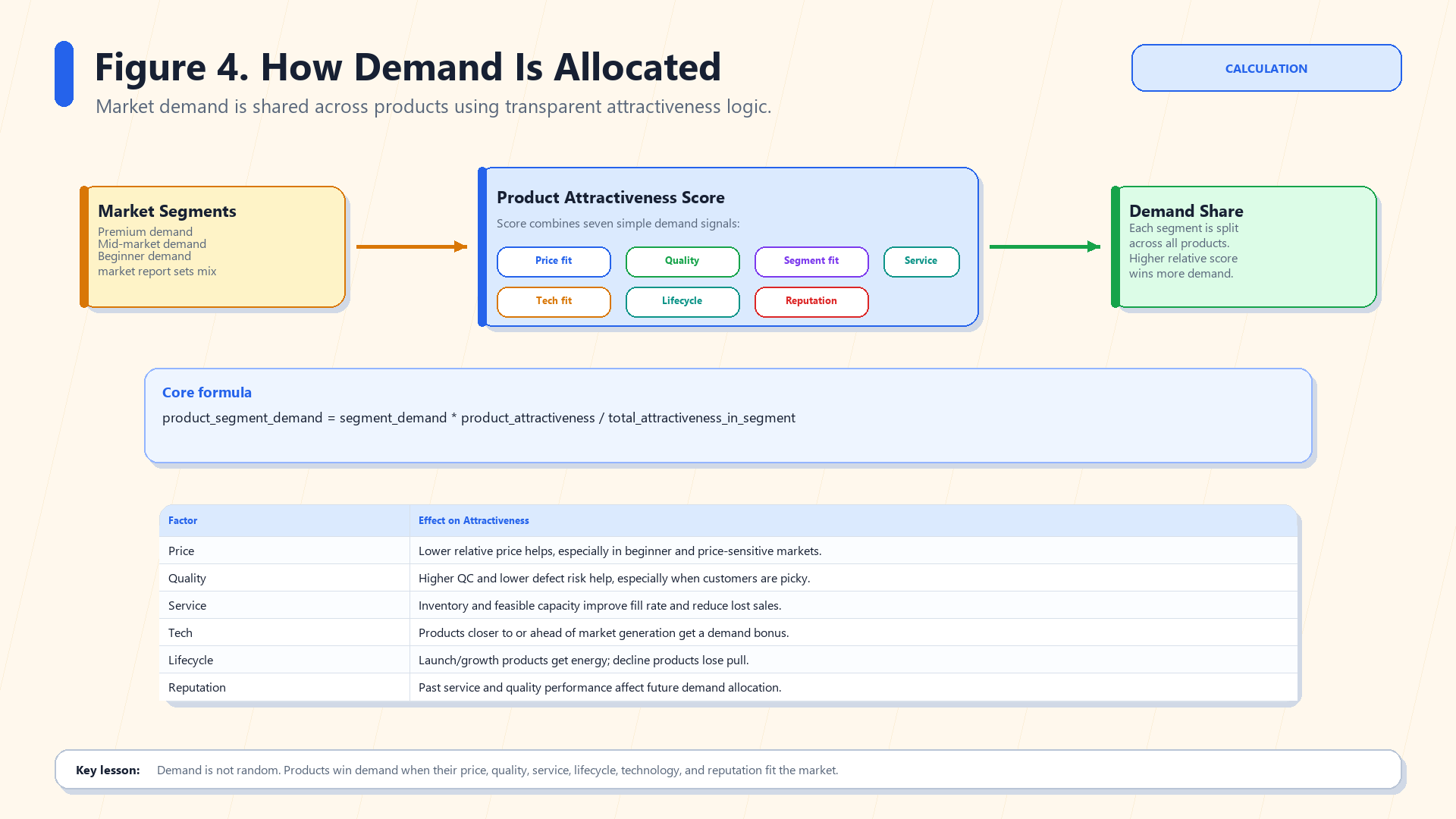
Demand allocation: products win demand through relative attractiveness.
What to remember: Your product earns demand based on price fit, quality, segment fit, service, technology, lifecycle, and reputation compared with competitors.
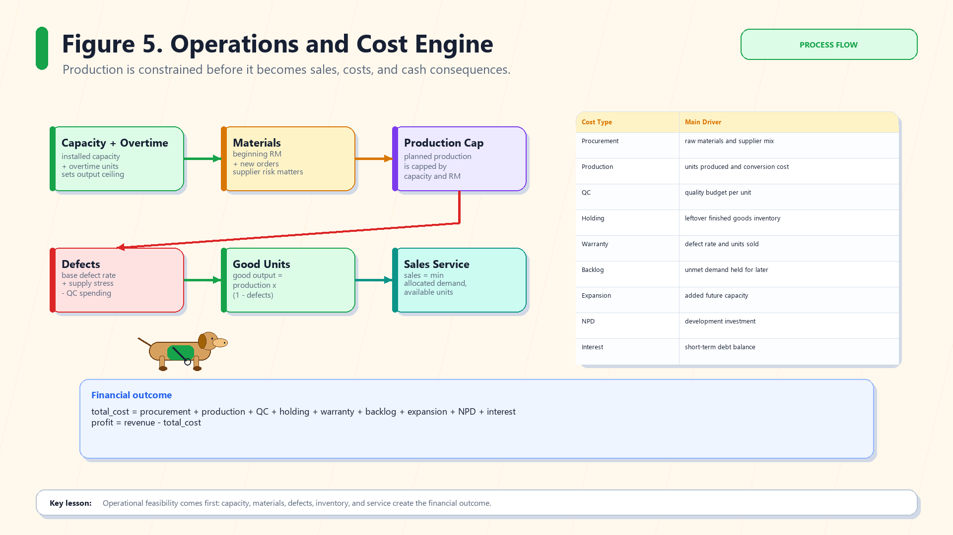
Operations engine: capacity, materials, defects, and sales create cost and profit.
What to remember: Demand is not enough. The simulator caps production by capacity/materials, removes defective units, and then sells only what is available.
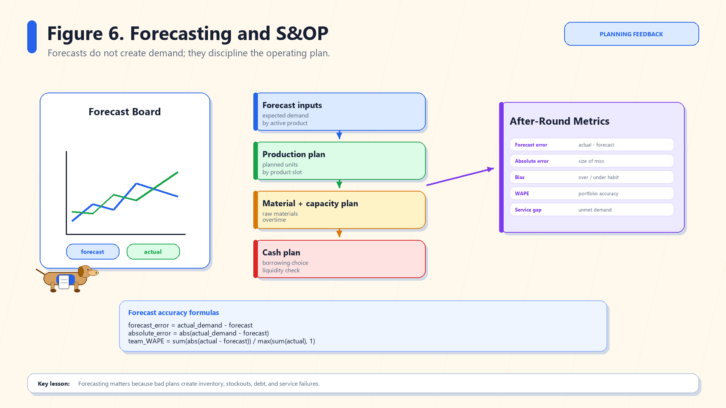
Forecasting and S&OP: forecast does not create demand, but it disciplines the plan.
What to remember: A forecast is your best estimate of demand. If production, materials, capacity, and cash do not match the forecast, your plan may create stockouts, excess inventory, or debt.
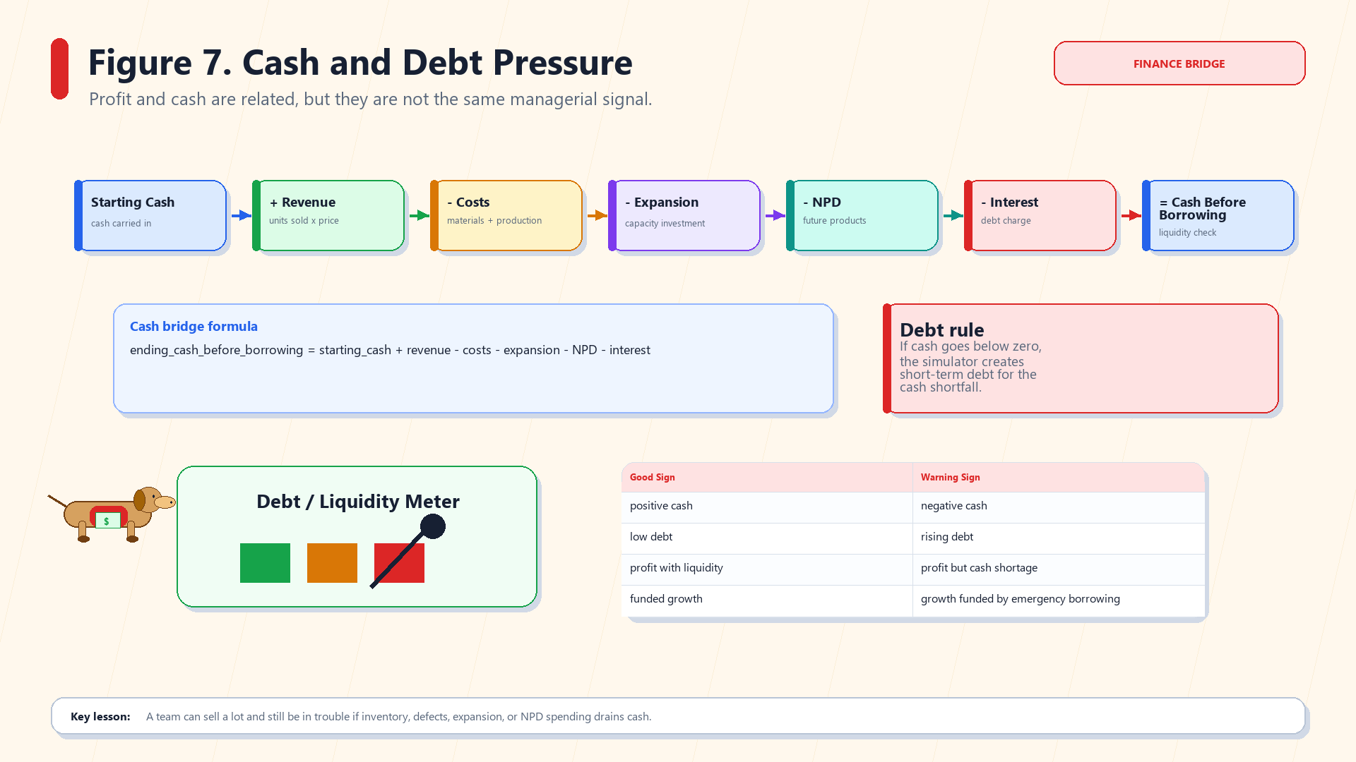
Cash and debt: profit and cash are not the same thing.
What to remember: Borrowing increases cash today but also creates debt and interest. If cash goes negative, the simulator automatically borrows to keep the team alive.
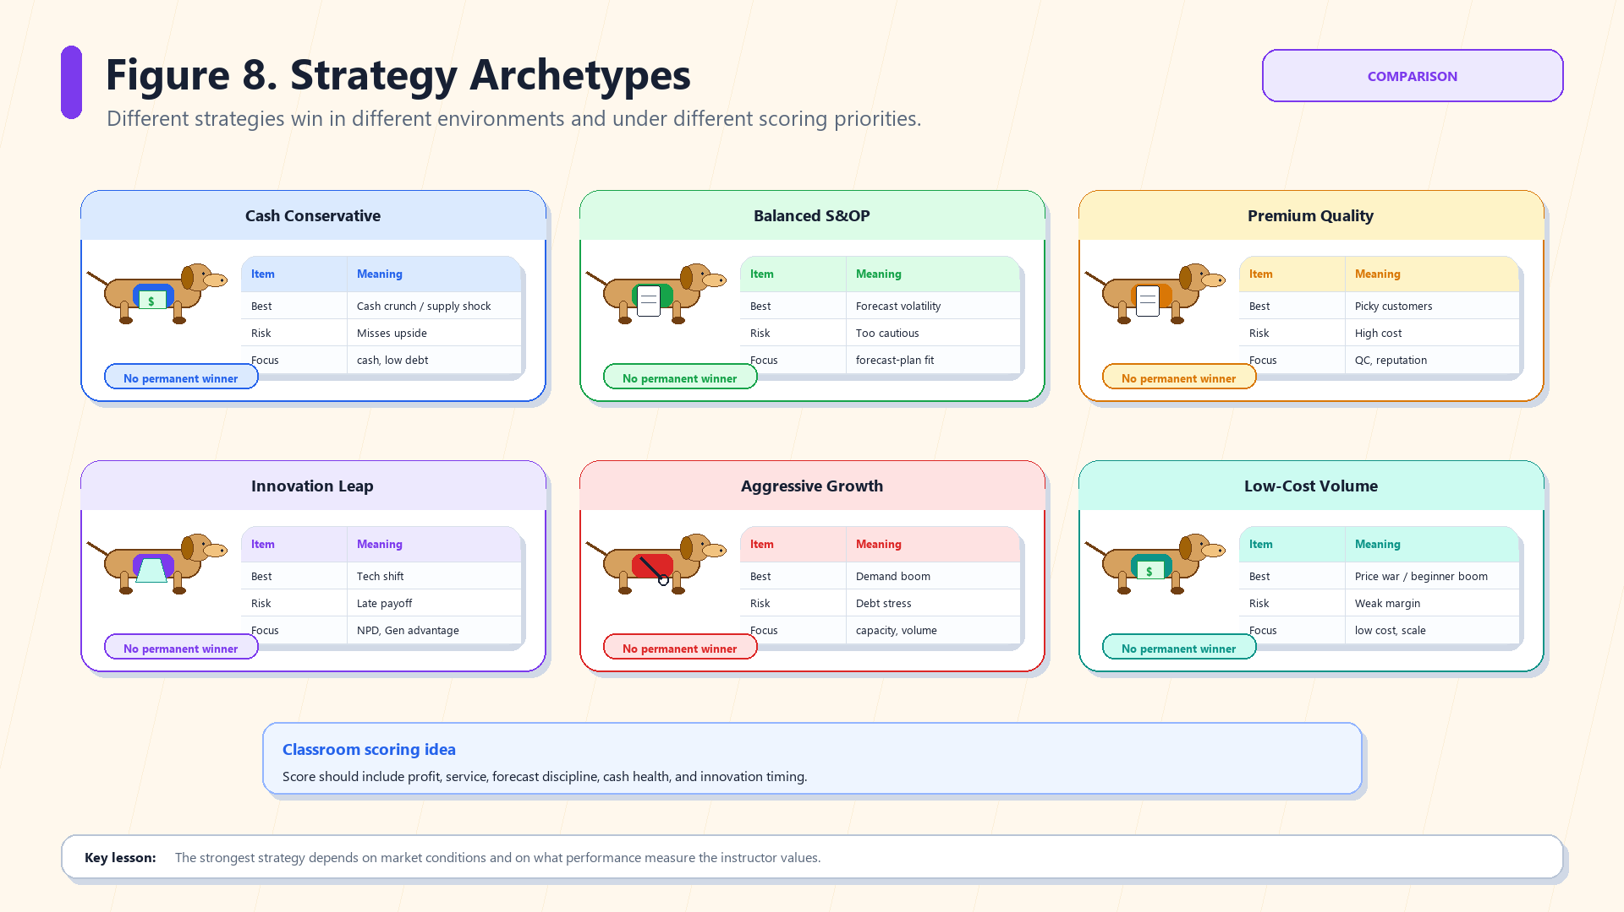
Strategy archetypes: there is no permanent winner.
What to remember: A team can win in one environment and lose in another. The best strategy depends on the market and the scoring method.

2. Decision Page Walkthrough
- Read the Public Market Report first. Total demand, segment shares, material cost, supply risk, quality sensitivity, and technology pressure tell you what kind of round you are entering.
- Review current team state. Installed capacity, inventory, backlog, reputation, cash, debt, and tech position are your starting point.
- Set firm-level operations and finance. Decide overtime, expansion, raw materials, supplier mix, expedited share, max backorders, and planned borrowing.
- Set product-level decisions for Product A/B/C. For each active product, choose price, forecast, production, QC budget, target inventory, and retirement if needed.
- Manage the development pipeline. Once a project begins, fixed project settings lock; investment and testing remain adjustable.
- Read the Planning Analytics Preview. Fix warnings before saving, especially supplier mix, low raw materials, negative margin, high cash shortfall, and missing forecasts.
- Click Save Portfolio and Pipeline Decision before the deadline.

3. Variable Meanings
Variable | What it means | Common student mistake
Forecast units | Your estimate of demand for each active product. | Thinking forecast creates demand. It does not.
Planned production units | How many units you try to make. | Producing far more than forecast and tying up cash.
QC budget per unit | Spending to reduce defects. | Setting it too low in picky/high-quality markets.
Target FG inventory | Desired finished-goods buffer. | Too much inventory creates working-capital pressure.
Supplier mix | Offshore, balanced, and premium shares; must sum to 100%. | Forgetting that cheaper supply may increase risk/defects.
Planned borrowing | Money borrowed intentionally. | Using debt as free money; interest and stress follow.
NPD investment | Money spent on future product development. | Expecting instant launch without readiness/timing gates.
Testing intensity | Managerial effort to improve readiness and launch stability. | Investing money but ignoring testing.

4. How Profit and Cost Are Decided
Component | In plain English
Revenue | Units sold x selling price.
Procurement cost | Raw materials purchased, adjusted by supplier mix and material cost index.
Production cost | Cost of making planned/actual production units.
QC cost | Quality budget per unit times production volume.
Holding cost | Cost of leftover finished goods inventory.
Warranty cost | Cost created by defects on units sold.
Backlog cost | Penalty for unmet demand carried forward.
Expansion cost | Capacity investment that mostly helps future rounds.
NPD cost | Pipeline investment for future products.
Interest | Cost of short-term debt.
Profit | Revenue minus all cost components.
Final reminder: A strong submission is not the highest number in every box. It is a coherent plan where forecast, production, sourcing, portfolio, pipeline, and cash all fit the same strategy.

