Student Decision Guide
Team Decisions, Product Portfolio, Development Pipeline, and Profit Logic
Pickleball Paddle Market Simulator
Big idea
Your team is running a paddle company. Every round, you forecast demand, set product prices, choose production and sourcing, manage quality, decide whether to invest in future products, and protect cash. The winner is not always the team with the highest sales. Strong teams balance profit, service, forecast accuracy, product lifecycle, innovation timing, and liquidity.
Round decision sequence | What you should do
1. Read the Public Market Report | Look at total demand, segment shares, material cost, supply risk, quality sensitivity, and technology pressure.
2. Review current team state | Check capacity, inventory, raw materials, backlog, reputation, cash, debt, and technology position.
3. Plan firm-level operations | Set overtime, expansion, sourcing, raw material order, expedited share, backorder limit, and borrowing.
4. Manage product slots | For each active product, set price, forecast, production, QC budget, inventory target, and retirement choice.
5. Manage future pipeline | Invest in up to two development projects if you need newer technology or a replacement product.
6. Check analytics preview | Fix warnings before saving. The preview tells you if your plan is infeasible, unprofitable, under-sourced, or cash risky.
7. Save before the deadline | Click Save Portfolio and Pipeline Decision. If you do not save, the instructor may not have your current plan.
Student warning
Do not leave active products with a selling price of $0, forecast of 0, and production of 0 unless you truly want to stop selling that product. The engine will treat the numbers literally.

1. Read The Public Market Report First
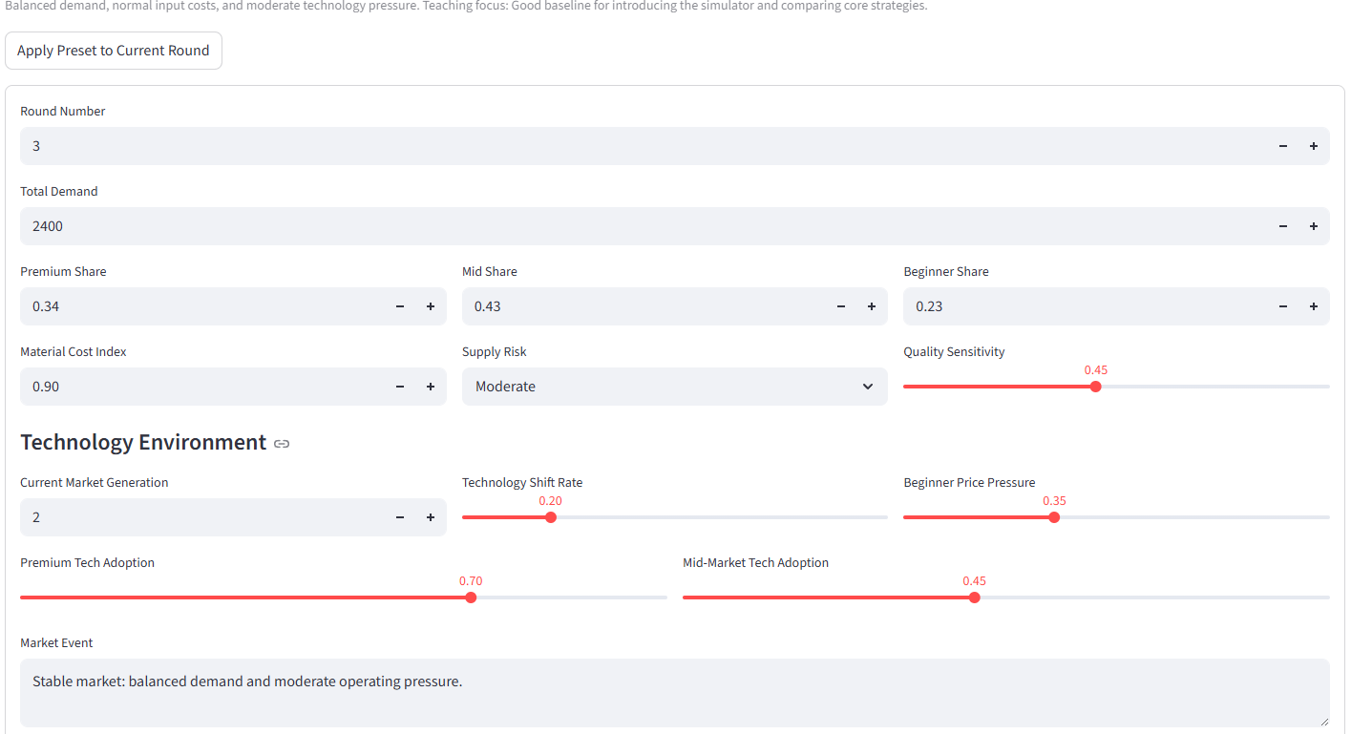
Figure 1. Public Market Report. This tells every team what kind of market environment they are competing in.
Market factor | What it means for your team
Total Demand | Approximate market size for the round before teams compete for shares.
Premium / Mid / Beginner Share | How the market is split across customer segments. Match your product targets to the strongest segments.
Material Cost Index | Input-cost multiplier. High values squeeze margins; low values make production cheaper.
Supply Risk | Higher risk increases pressure on sourcing, lead time, defects, and service reliability.
Quality Sensitivity | Higher values mean customers punish defects more and reward QC/reputation more.
Current Market Generation | Technology generation customers expect. Products below market generation can lose attractiveness.
Technology Shift Rate | How fast customers are moving toward newer technology. High values reward NPD and product refresh.
Premium / Mid Tech Adoption | How much those customer groups value newer technology.
Beginner Price Pressure | How strongly beginner customers respond to lower price.
Market Event | Narrative clue from the instructor. Use it to interpret the numbers, but the numeric fields drive the model.

2. Current Team State and Firm-Level Decisions
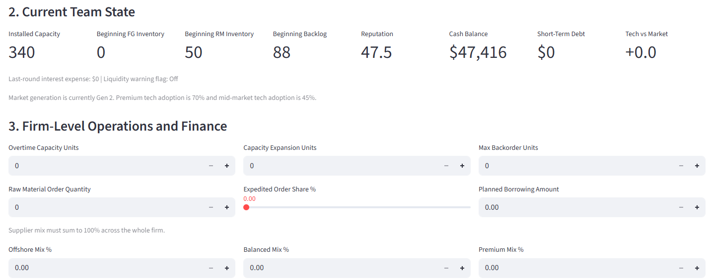
Figure 2. Current team state and firm-level operations/finance controls.
Current state item | What it means | What to think about
Installed Capacity | How many units your firm can normally produce this round before overtime. | If planned production is above capacity, you need overtime or expansion, or production will be capped.
Beginning FG Inventory | Finished goods already available at the start of the round. | Inventory can help service demand, but unsold units create holding cost and tie up working capital.
Beginning RM Inventory | Raw materials available before new material orders arrive. | Production cannot exceed available raw materials. Ordering materials too late can cap production.
Beginning Backlog | Customer demand you promised but did not fill in a previous round. | Backlog competes with new demand for inventory and capacity. Too much backlog hurts service and reputation.
Reputation | Score influenced by quality, fill rate, lost sales, backlog, and liquidity stress. | Higher reputation helps demand attractiveness. Poor service or defects can damage it.
Cash Balance | Money available after prior rounds. | Cash pays for materials, production, QC, expansion, innovation, holding, warranty, and interest.
Short-Term Debt | Borrowed money still outstanding. | Debt creates interest cost and can trigger liquidity stress.
Tech vs Market | Your portfolio technology position compared with the market generation. | Negative means products may be older than customers expect; positive means possible tech advantage.
Firm-level control | What it changes | Good use | Risk
Overtime Capacity Units | Adds temporary production capacity this round. | Use when demand is high but permanent expansion is not necessary. | Overtime is more expensive and can increase defect pressure.
Capacity Expansion Units | Adds installed capacity for future rounds and creates capital cost now. | Use when you expect sustained demand growth. | Overexpansion burns cash and can leave unused capacity.
Max Backorder Units | Maximum unmet demand you are willing to carry into next round. | Useful when demand is real but you cannot fill everything today. | Backlog has penalty cost and can hurt service/reputation.
Raw Material Order Quantity | New material order placed for future receipt based on lead time. | Order enough to support future production plans. | Too low caps future output; too high creates raw material inventory cost.
Expedited Order Share % | Percent of material order expedited. | Use when lead time matters or supply is tight. | Expediting raises procurement cost.
Supplier Mix % | Offshore, Balanced, and Premium supplier percentages. | Use a mix that fits cost, lead time, and quality goals. Must sum to 100%. | Invalid mix is normalized; cheap suppliers can raise defect/supply risk.
Planned Borrowing Amount | Cash borrowed intentionally before the round economics are finalized. | Use if a strong plan needs temporary financing. | Borrowing creates debt and interest. Automatic borrowing may happen if cash goes negative.

3. Active Product Portfolio and Product Slots
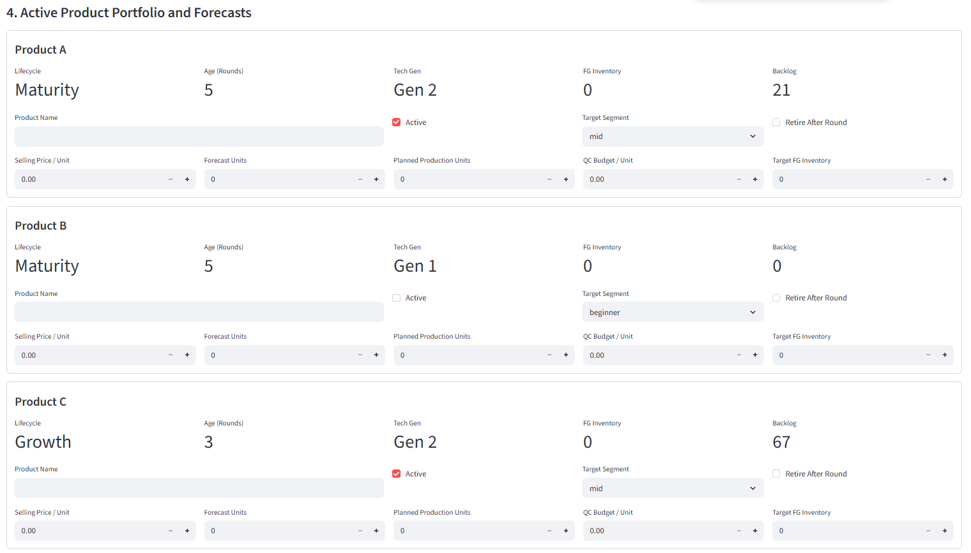
Figure 3. Three product slots. Each team can manage up to Product A, Product B, and Product C.
How product slots work
Each slot is a product line. A slot can be active or inactive. Active products compete for demand and can produce, sell, carry inventory, build backlog, and age through the lifecycle. Inactive products do not compete for new demand, but old backlog or inventory may still matter.
Product-slot question | Good student answer
Is this product active? | If yes, give it a real price, forecast, production plan, QC budget, and inventory target.
Does it fit the market? | Target premium, mid, or beginner based on the Public Market Report, not habit.
Is it aging or behind tech? | If lifecycle is maturity/decline or tech is below market, consider NPD, replacement, retirement, or a lower production plan.
Will it steal from our own products? | If two products target the same segment/group, watch likely cannibalization before saving.
Product variable | Meaning | What to think about
Product Name | Your product line name. | Use a meaningful name so your team can track it across rounds.
Active | Whether the product is currently offered to the market. | Keep active only if you will price, forecast, and support it.
Target Segment | Primary customer segment: premium, mid, or beginner. | Match segment to market report. Segment fit affects demand attractiveness.
Lifecycle | Current stage: launch, growth, maturity, or decline. | Growth products get demand help; decline products lose attractiveness.
Age (Rounds) | How long the product has been active. | Older products move toward maturity and decline.
Tech Gen | Product technology generation, from Gen 1 to Gen 4. | If market generation is higher than your product, demand attractiveness can drop.
FG Inventory | Finished goods inventory for this product at start of round. | Inventory helps fill demand but creates holding cost if unsold.
Backlog | Unfilled customer demand carried for this product. | Backlog must be served or it becomes lost sales/continued penalty.
Retire After Round | Stops the product after the round and liquidates remaining inventory at a discount. | Use for aging products, weak products, or when replacing with a new launch.
Selling Price / Unit | Price customers pay per sold unit. | Higher price raises margin but can reduce attractiveness.
Forecast Units | Your estimate of demand for this product. | Forecast drives S&OP discipline. Unrealistic forecasts hurt forecast accuracy.
Planned Production Units | How many units you request to make. | Should reflect forecast, backlog, beginning inventory, capacity, and raw materials.
QC Budget / Unit | Quality-control spending per unit produced. | Higher QC lowers defect risk, but it is a real cost.
Target FG Inventory | Desired ending finished-goods inventory buffer. | Useful for service resilience, but too high ties up cash and adds holding cost.
Practical rule
A good product plan usually starts with forecast demand plus beginning backlog, then subtracts beginning inventory, then adds a small inventory buffer if the market is risky. Do not simply produce the maximum possible quantity unless demand and cash justify it.

4. Development Pipeline and Future Products
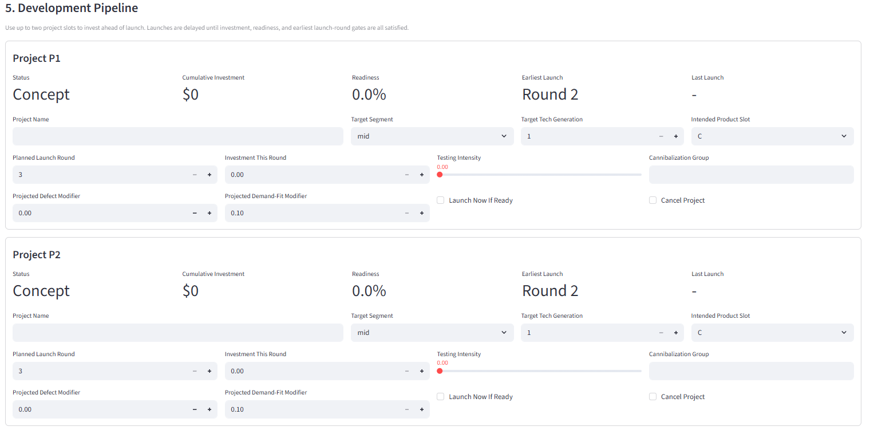
Figure 4. Development pipeline. Each team can manage up to two future product projects.
Pipeline variable | Meaning | What to think about
Project Name | Name of a future product project. | Leave blank if you do not want to start a project.
Status | Project state such as concept, development, pilot, launch_ready, launched, or canceled. | A project cannot sell until it is launch ready and launched.
Cumulative Investment | Total money already spent on the project. | Investment builds progress but reduces cash this round.
Investment This Round | New spending committed to the project now. | Higher investment speeds readiness but can weaken short-term profit/cash.
Testing Intensity | How much testing effort supports launch readiness. | Testing improves readiness and reduces launch risk, but does not replace investment.
Readiness | Percent score showing how close the project is to launch-ready. | Launch is delayed until investment, readiness, and timing gates are satisfied.
Target Segment | Customer segment the new product is designed for. | Choose based on market report and your portfolio gaps.
Target Tech Generation | Technology generation of the future product. | Higher tech can be more attractive, but usually needs more investment and time.
Intended Product Slot | Slot A, B, or C where the new product will launch. | Launching into an occupied slot can replace or retire the old product.
Planned Launch Round | Round you hope to launch. | Planning a launch too early does not guarantee readiness.
Earliest Launch | Earliest allowed launch based on project complexity and rules. | You cannot launch before this gate even if you spend heavily.
Cannibalization Group | Group label identifying products that compete inside your portfolio. | Same-group new products can steal demand from older same-use products.
Projected Defect Modifier | Expected product-specific defect adjustment after launch. | Lower is safer. Higher may mean more warranty/reputation risk.
Projected Demand-Fit Modifier | Expected demand attractiveness multiplier after launch. | Higher can help demand but should be used realistically.
Launch Now If Ready | Requests launch this round if all gates are satisfied. | Only works if the project is actually eligible.
Cancel Project | Stops the project. | Use if the market changed or the project is no longer worth funding.
NPD tradeoff
Innovation is not free. Spending on future products can help you win later when technology shifts, but it reduces current cash and profit. The key question is timing: are you investing early enough to launch before your current products age, but not so early that you starve operations?

5. Planning Analytics Preview
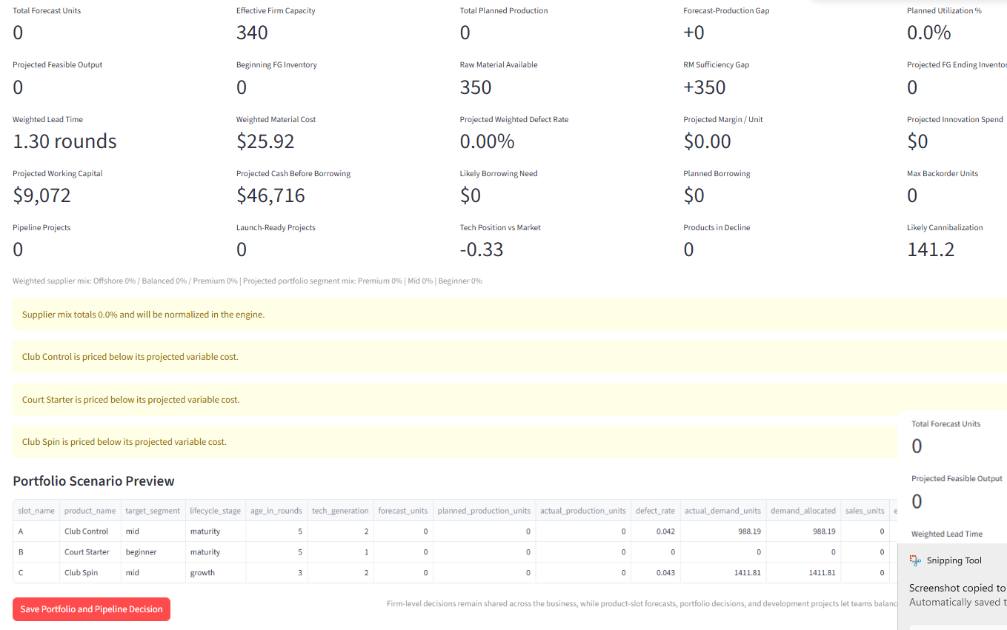
Figure 5. Planning analytics preview and warnings. Use this before saving the round decision.
Preview metric | Meaning | How to use it
Total Forecast Units | Sum of forecast demand across active products. | Compare to planned production and capacity.
Effective Firm Capacity | Installed capacity plus overtime capacity this round. | Total actual production cannot exceed this.
Total Planned Production | Sum of requested production across active product slots. | If above capacity or materials, production will be capped.
Forecast-Production Gap | Planned production minus forecast units. | Large positive means possible overproduction; large negative means possible stockout/backlog.
Planned Utilization % | Planned/feasible production relative to effective capacity. | Very high utilization can increase defect stress; very low utilization may waste capacity.
Projected Feasible Output | Estimated units that can actually be made after constraints. | If lower than plan, revise production, overtime, materials, or product mix.
RM Sufficiency Gap | Raw material available minus planned production. | Negative means material shortage; positive means extra material inventory.
Weighted Lead Time | Supplier-mix lead time after supply risk and expediting. | Long lead time means material orders arrive later.
Weighted Material Cost | Supplier-weighted material cost per unit. | Use to check whether product prices cover variable cost.
Projected Defect Rate | Estimated defect rate from supplier quality, QC, utilization, lifecycle, and tech risk. | High defect rate causes warranty cost and reputation damage.
Projected Margin / Unit | Estimated selling price minus variable unit cost. | If negative, selling more can lose more money.
Projected Working Capital | Cash tied up in inventory, raw materials, and debt burden. | High working capital can create liquidity pressure.
Projected Cash Before Borrowing | Estimated cash after revenue and costs but before automatic rescue borrowing. | Negative value means likely borrowing need.
Likely Borrowing Need | Estimated automatic borrowing required if cash goes negative. | Borrowing adds debt and interest.
Tech Position vs Market | Portfolio technology position relative to current market generation. | Negative tech position can hurt demand, especially premium/mid.
Products in Decline | Number of products in decline lifecycle stage. | Consider retirement, replacement, or price/production changes.
Likely Cannibalization | Expected demand transfer between your own products. | If high, your products may be stealing demand from each other.
How to use warnings
Warnings do not always mean your plan is illegal. They mean the plan has risk. A warning about supplier mix, price below variable cost, forecast-production mismatch, likely cash shortfall, or infeasible production deserves a team discussion before saving.

6. How Demand, Sales, Cost, Cash, and Profit Are Decided
The engine is rule-based
The simulator is not using hidden AI to decide winners. It uses deterministic formulas. Your inputs change demand attractiveness, production feasibility, service performance, costs, cash, and future state.

6.1 Market demand and product demand allocation
premium_demand = total_demand * premium_share
mid_demand = total_demand * mid_share
beginner_demand = total_demand * beginner_share
product_segment_demand = segment_demand * product_attractiveness / total_attractiveness_in_segment
- Product attractiveness depends on price competitiveness, quality/defect outlook, archetype fit, target segment alignment, product demand-fit modifier, reputation, service readiness, lifecycle stage, technology generation, and launch novelty.
- If many teams target the same segment with strong products, they split that segment's demand. If your product is weak or overpriced, it receives less demand.
- Newer/growth products can pull demand away from older products in your own portfolio through cannibalization, especially when they target the same segment or cannibalization group.

6.2 Production feasibility and units available
effective_capacity = installed_capacity + overtime_capacity_units
feasible_total_production = min(total_planned_production, effective_capacity, raw_material_available)
if product plans exceed feasible production, output is capped proportionally across requested product slots
good_units_produced = floor(actual_production_units * (1 - defect_rate))
available_for_sale = beginning_finished_goods_inventory + good_units_produced
- Capacity expansion increases future installed capacity, but it does not magically solve every current-round production problem.
- Raw materials matter. A good sales plan can still fail if the team under-orders materials or has long supplier lead time.

6.3 Sales, backlog, and lost sales
service_demand = demand_allocated + beginning_backlog
sales_units = min(service_demand, available_for_sale)
unmet_units = service_demand - sales_units
backlog_end = min(unmet_units, max_backorder_units)
lost_sales = unmet_units - backlog_end
- Backlog is not free. It can preserve some demand for later, but backlog creates penalty cost and service/reputation pressure.
- Lost sales are demand you could not serve and will not carry forward.

6.4 Costs and profit
revenue = sales_units * selling_price_per_unit + retirement_liquidation_revenue
procurement_cost = raw_material_order_qty * weighted_material_unit_cost
production_cost = actual_production_units * (conversion_cost_per_unit + qc_budget_per_unit)
holding_cost = ending_FG_inventory * holding_cost_per_unit + ending_RM_inventory * RM_holding_cost_per_unit
warranty_cost = sales_units * defect_rate * warranty_cost_factor
backlog_cost = backlog_units_end * backlog_penalty_per_unit
expansion_cost = capacity_expansion_units * expansion_capex_per_unit
innovation_cost = investment_this_round across active development projects
interest_expense = debt_balance * periodic_interest_rate
profit = revenue - total_cost
- High sales are not enough. If price is below variable cost, selling more units can reduce profit.
- QC spending lowers defect risk but raises unit cost. The right QC level depends on quality sensitivity, product segment, and warranty/reputation risk.
- Holding inventory protects service but ties up cash. Excess inventory can make a team look operationally busy but financially weak.

6.5 Cash, borrowing, and liquidity stress
ending_cash_before_borrowing = starting_cash + planned_borrowing + revenue - operating_costs - interest
if ending_cash_before_borrowing < 0: automatic_borrowing = abs(ending_cash_before_borrowing)
ending_debt = starting_debt + planned_borrowing + automatic_borrowing
- Automatic borrowing prevents cash from going below zero, but it is not a win. It increases debt and future interest.
- Liquidity stress can hurt reputation slightly and should be discussed even if profit looks acceptable.

7. Common Mistakes To Avoid
Mistake | Why it hurts | Better approach
Supplier mix does not sum to 100% | The system normalizes it and warns you, but your plan may not reflect your real intent. | Set Offshore + Balanced + Premium = 100%.
Forecast is zero for an active product | Forecast accuracy and planning analytics become misleading; production may not match demand. | Enter a realistic forecast for every active product.
Price is below variable cost | More sales can create larger losses. | Check projected margin per unit before saving.
Production ignores capacity/materials | The engine caps actual production, creating stockouts and backlog. | Use preview metrics before saving.
Too much inventory target | Inventory creates holding cost and working capital burden. | Use inventory buffer only when service risk justifies it.
No NPD investment during tech shift | Products may become old relative to the market. | Invest early enough to launch before decline or obsolescence.
Launching replacement too late | Old products may lose demand before the new one is ready. | Watch lifecycle age, market generation, and readiness gates.
Borrowing without payoff | Debt adds interest and liquidity stress. | Borrow only for a plan with credible demand and margin.

8. Final Pre-Save Checklist
Check | Question
Market fit | Did we choose products and segments that match the Public Market Report?
Forecast realism | Are our product forecasts defensible, not just guesses?
Capacity | Can our capacity and overtime support the planned production?
Materials | Do we have enough raw material available and enough ordered for future rounds?
Margin | Is every active product priced above expected variable cost?
Service | Will we create backlog or lost sales? If yes, is that intentional?
Quality | Is QC spending appropriate for the segment and quality sensitivity?
Cash | Will we end with enough cash, or are we relying on debt?
Innovation | Are we investing early enough in future products if technology is shifting?
Save | Did we click Save Portfolio and Pipeline Decision before the deadline?
Best team behavior
Treat the decision page like a management meeting. One person should read the market, one should own forecast/product decisions, one should check operations feasibility, and one should check cash/profit risk. Then save one coordinated plan.
Student guide for the hosted Pickleball Paddle Market Simulator. Use the classroom URL and your assigned team-leader account.

