LAB Logbook

WEEK 4

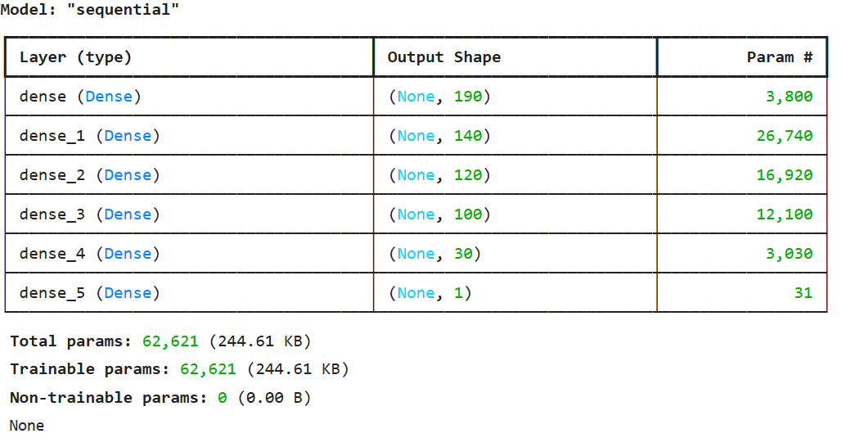

relative prediction error = 7.460117169896349 %

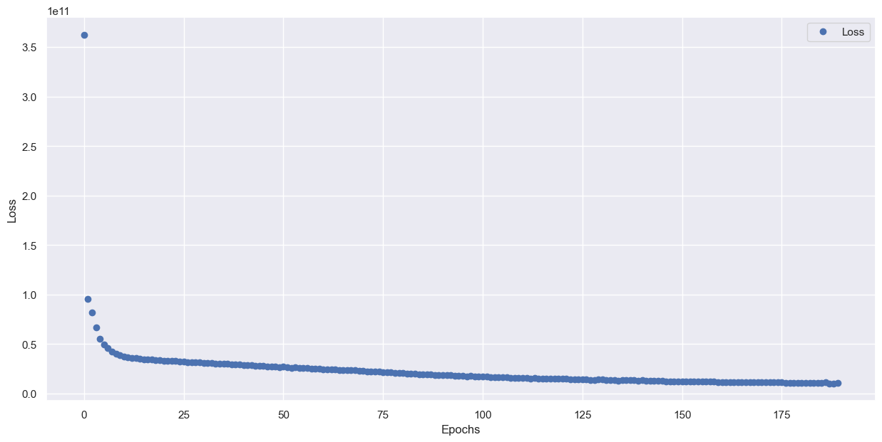

obtained accuracy is 0.897

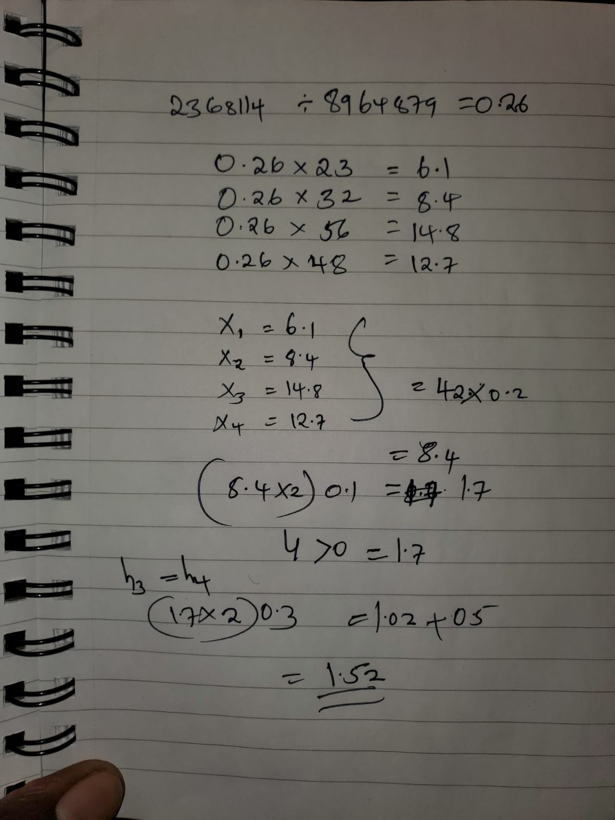

Lab 2

Lab 3

Lab 4

Lab 5

Lab 6

Lab 7

Lab 8

Lab 9

Lab 10

Lab 11

Lab 12