LAB Logbook

WEEK6

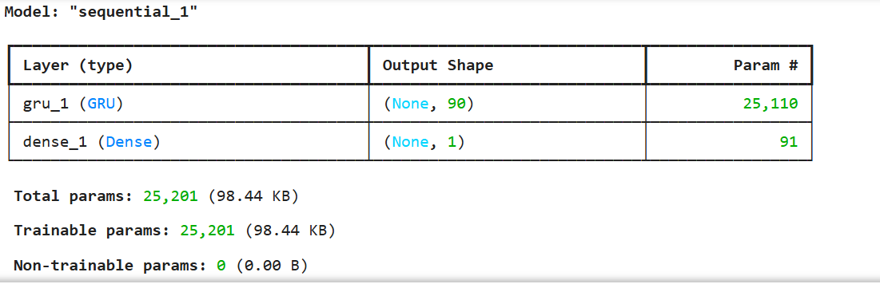

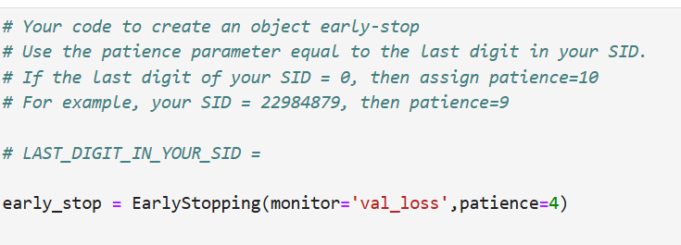

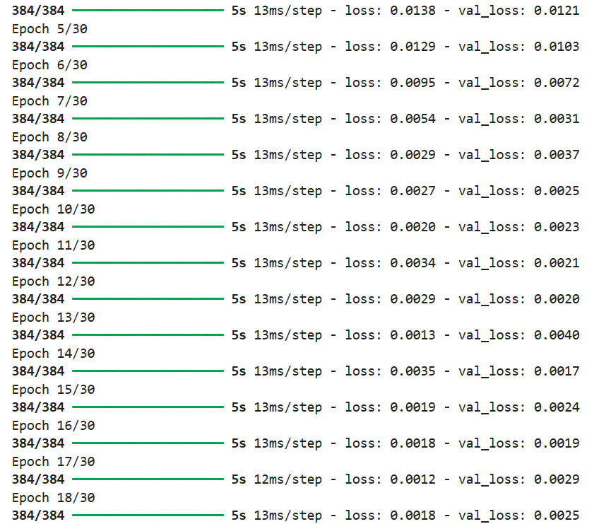

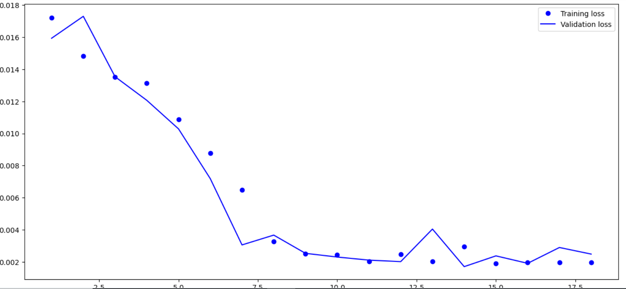

**the optimal number of epochs for training your model.**



Lab 2

Lab 3

Lab 4

Lab 5

Lab 6

Lab 7

Lab 8

Lab 9

Lab 10

Lab 11

Lab 12