PROJECT APPROVAL FORM
This form records departmental approval of the final year project report prior to final submission.

Field | Details
Project Title
Student Name(s)
Seat Number(s)
Supervisor
Department
Date of Approval

ABSTRACT
ReportPeer AI is an intelligent platform designed to help students create and format their Final Year Project reports. The system provides a structured workspace where students can write their report content while required academic formatting is managed automatically. It aims to reduce formatting errors and simplify the report preparation process.

TABLE OF CONTENTS
PROJECT APPROVAL FORM i
ABSTRACT ii
TABLE OF CONTENTS iii
LIST OF FIGURES v
LIST OF TABLES vi
ACKNOWLEDGEMENT vii
CHAPTER 1 1
INTRODUCTION 1
1.1 Overview 1
1.1.1 Background 1
1.1.1.1 Previous Work 1
1.2 Purpose 1
1.3 Stakeholders 1
1.4 Benefits 1
1.5 Background Study 2
CHAPTER 2 3
REQUIREMENTS 3
2.1 Functional Requirements 3
2.2 Non-Functional Requirements 3
CHAPTER 3 4
ANALYSIS AND DESIGN 4
3.1 System Architecture with Diagram 4
3.2 Entity Relationship Diagram 4
3.3 Project Flow Diagram 5
3.4 Use Cases 6
3.5 Activity Diagram 7
3.6 User Interface Design 7
CHAPTER 4 8
PROJECT PLAN 8
4.1 Process Model (Agile) 8
4.2 User Stories 8
4.3 Sprints Planning 8
4.4 Sprints Sizing 8
4.5 Timeline with Milestones 8
CHAPTER 5 9
TEST PLAN 9
5.1 Test Cases 9
5.2 Automated Testing Tools 9
CHAPTER 6 10
IMPLEMENTATION DETAILS 10
6.1 Tools and Technology 10
6.2 Data Dictionary 10
6.3 Version Control 10
6.4 Web APIs / Web Services 10
6.5 Website Development 10
6.6 Mobile Application Development 10
6.7 Deployment 10
CHAPTER 7 11
CONCLUSION AND FUTURE WORK 11
REFERENCES 12
APPENDIX A - SCREENSHOTS 13
APPENDIX B - ABBREVIATION 14

LIST OF FIGURES
Figure 3.1. ERD Diagram 4
Figure 3.2. Flow Diagram 1 5
Figure 3.3. Use case Diagram 1 6
Figure 3.4. Use Case 2 7

LIST OF TABLES
Table 2.1. Table 01 - Caption 3
Table 2.2. Table 2 - Caption 3

ACKNOWLEDGEMENT

CHAPTER 1

INTRODUCTION

Overview
The project focuses on developing a web-based platform for creating structured FYP reports. Students can organize their report into chapters and sections, enter content, and generate a properly formatted Word document according to predefined university requirements.

Background
Sample background

Previous Work
Sample previous work

Purpose
The purpose of ReportPeer AI is to simplify FYP report preparation by separating content creation from document formatting. The system allows students to focus on writing while automatically maintaining headings, numbering, spacing, page layout, and other formatting requirements.

Stakeholders
The main stakeholders of ReportPeer AI include FYP students, project supervisors, universities, and academic departments. Students use the platform to prepare their reports, while supervisors and universities can benefit from consistent report structure and formatting.

Benefits
• Saves time by reducing manual report formatting.
• Maintains consistent headings, spacing, numbering, and page layout.
• Reduces formatting errors and improves report consistency.
• Makes it easier to organize chapters, sections, tables, and figures.
• Automatically manages TOC, list of figures, and list of tables.
• Allows students to focus more on writing and project content.
• Simplifies preparation of university-compliant FYP reports.
1. Number 1
2. Number 2

Background Study

CHAPTER 2

REQUIREMENTS

Functional Requirements

Student Roll No | Column 2 | Column 3 | Column 4
Sample | Sample | Sample | Sample
Sample | Sample | Sample | Sample
Sample | Sample | Sample | Sample
Sample | Sample | Sample | Sample
Sample | Sample | Sample | Sample
Sample | Sample | Sample | Sample
Table 2.1. Table 01 - Caption

Column 1 | Column 2 | Column 3
Table 2.2. Table 2 - Caption

Non-Functional Requirements

CHAPTER 3

ANALYSIS AND DESIGN

System Architecture with Diagram

Entity Relationship Diagram
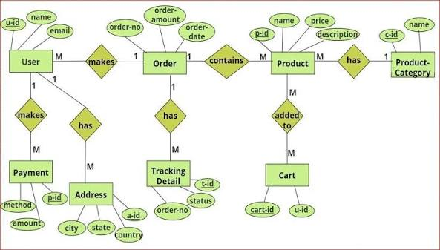
Figure 3.1. ERD Diagram

Project Flow Diagram
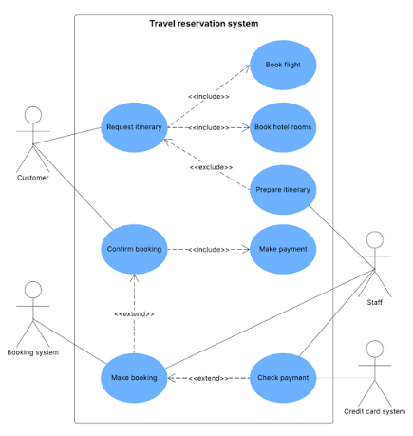
Figure 3.2. Flow Diagram 1

Use Cases
Figure 3.3. Use case Diagram 1
Figure 3.4. Use Case 2

Activity Diagram

User Interface Design

CHAPTER 4

PROJECT PLAN

Process Model (Agile)

User Stories

Sprints Planning

Sprints Sizing

Timeline with Milestones

CHAPTER 5

TEST PLAN

Test Cases

Automated Testing Tools

CHAPTER 6

IMPLEMENTATION DETAILS

Tools and Technology

Data Dictionary

Version Control

Web APIs / Web Services

Website Development

Mobile Application Development

Deployment

CHAPTER 7

CONCLUSION AND FUTURE WORK

REFERENCES

APPENDIX A - SCREENSHOTS

APPENDIX B - ABBREVIATION
sampleee

