PROJECT APPROVAL FORM
The project titled "University Management System" is submitted in partial fulfillment of the requirements of the Bachelor's Final Year Project.
The proposed work has been reviewed by the project advisor and the departmental examination committee in accordance with the university FYP guidelines.
Approval is recorded for the project title, the supervising advisor, and the examining committee prior to the start of the subsequent report chapters.

ABSTRACT
The proposed University Management System automates academic and administrative operations of an educational institution [1]. The report describes the problem context, requirements, design, and planned implementation [2].

TABLE OF CONTENTS
PROJECT APPROVAL FORM i
ABSTRACT ii
LIST OF FIGURES v
LIST OF TABLES vi
ACKNOWLEDGEMENT vii
CHAPTER 1 1
INTRODUCTION 1
1.1 Overview 1
1.2 Purpose 1
1.3 Stakeholders 2
1.4 Benefits 2
1.5 Background Study 2
CHAPTER 2 4
REQUIREMENTS 4
2.1 Functional Requirements 4
2.2 Non-Functional Requirements 5
CHAPTER 3 6
ANALYSIS AND DESIGN 6
3.1 System Architecture 6
3.2 Entity Relationship Diagram 6
3.3 Project Flow Diagram 6
3.4 Use Cases 6
3.5 Activity Diagram 7
3.6 User Interface Design 7
CHAPTER 4 8
PROJECT PLAN 8
4.1 Process Model 8
4.2 User Stories 8
4.3 Sprint Planning 8
4.4 Sprint Sizing 8
4.5 Timeline with Milestones 9
CHAPTER 5 10
TEST PLAN 10
5.1 Test Cases 10
5.2 Automated Testing Tools 10
CHAPTER 6 11
IMPLEMENTATION DETAILS 11
6.1 Tools and Technology 11
6.2 Data Dictionary 11
6.3 Version Control 11
6.4 Web APIs 11
6.5 Website Development 12
6.6 Mobile Application Development 12
6.7 Deployment 12
6.8 Website Hosting 12
6.9 Mobile Application Deployment 12
CHAPTER 7 13
CONCLUSION AND FUTURE WORK 13
REFERENCES 14

LIST OF FIGURES
Figure 1.1. Login Screen 1
Figure 1.2. Signup Screen 2
Figure 2.1. Signup Screen 5

LIST OF TABLES
Table 1.1. System Module Status 3
Table 2.1. System Module Status 4

ACKNOWLEDGEMENT
The author thanks the project advisor and the department faculty for guidance during the study. Institutional support for laboratory access and review meetings is also acknowledged. Any remaining errors remain the responsibility of the author.

CHAPTER 1

INTRODUCTION
Educational institutions continue to replace manual record-keeping with centralized information systems [1]. The proposed system provides a single platform for students, faculty members, and administrators [2].

Overview
The proposed application integrates student, faculty, and course-management functions in one web platform [1].
The following illustration is shown in Figure 1.1.
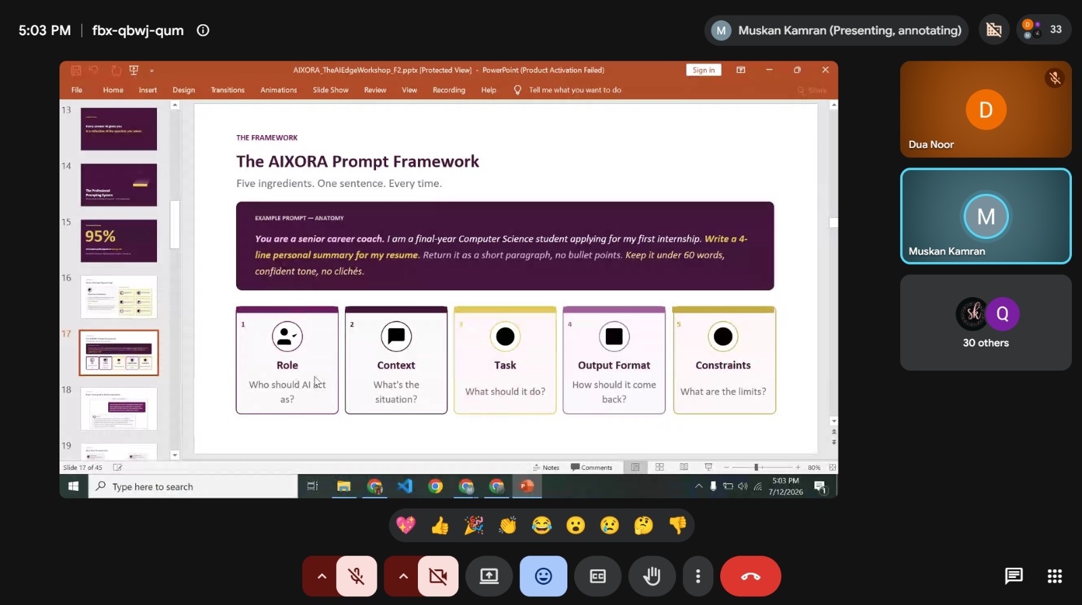
Figure 1.1. Login Screen

Purpose
The purpose of the system is to reduce paperwork and improve access to accurate institutional records [2].

Stakeholders
This section describes the relevant aspect of the proposed system in accordance with the documented requirements [1]. The discussion remains limited to the project scope and the selected implementation approach [2]. Supporting details are provided in the subsequent paragraphs of this section.
The following illustration is shown in Figure 1.2.
Figure 1.2. Signup Screen

Benefits
This section describes the relevant aspect of the proposed system in accordance with the documented requirements [1]. The discussion remains limited to the project scope and the selected implementation approach [2]. Supporting details are provided in the subsequent paragraphs of this section.

Background Study
Existing university information systems were reviewed to identify gaps in cost, customization, and usability [1].

The details are summarized in Table 1.1.
ID | Module Name | Status
1 | User Authentication | Completed
2 | Student Management | In Progress
3 | Report Generation | Pending
Table 1.1. System Module Status

CHAPTER 2

REQUIREMENTS
This chapter records the functional and non-functional requirements of the proposed system [2].

Functional Requirements
This section describes the relevant aspect of the proposed system in accordance with the documented requirements [1]. The discussion remains limited to the project scope and the selected implementation approach [2]. Supporting details are provided in the subsequent paragraphs of this section.

The details are summarized in Table 2.1.
ID | Module Name | Status
1 | User Authentication | Completed
2 | Student Management | In Progress
3 | Report Generation | Pending
Table 2.1. System Module Status
The following illustration is shown in Figure 2.1.
Figure 2.1. Signup Screen

Non-Functional Requirements
This section describes the relevant aspect of the proposed system in accordance with the documented requirements [1]. The discussion remains limited to the project scope and the selected implementation approach [2]. Supporting details are provided in the subsequent paragraphs of this section.

CHAPTER 3

ANALYSIS AND DESIGN
This chapter presents the analysis and design of the proposed system [1]. The discussion follows the university chapter outline and remains consistent with earlier findings [2]. Each required section is introduced below.

System Architecture
This section describes the relevant aspect of the proposed system in accordance with the documented requirements [1]. The discussion remains limited to the project scope and the selected implementation approach [2]. Supporting details are provided in the subsequent paragraphs of this section.

Entity Relationship Diagram
This section describes the relevant aspect of the proposed system in accordance with the documented requirements [1]. The discussion remains limited to the project scope and the selected implementation approach [2]. Supporting details are provided in the subsequent paragraphs of this section.

Project Flow Diagram
This section describes the relevant aspect of the proposed system in accordance with the documented requirements [1]. The discussion remains limited to the project scope and the selected implementation approach [2]. Supporting details are provided in the subsequent paragraphs of this section.

Use Cases
This section describes the relevant aspect of the proposed system in accordance with the documented requirements [1]. The discussion remains limited to the project scope and the selected implementation approach [2]. Supporting details are provided in the subsequent paragraphs of this section.

Activity Diagram
This section describes the relevant aspect of the proposed system in accordance with the documented requirements [1]. The discussion remains limited to the project scope and the selected implementation approach [2]. Supporting details are provided in the subsequent paragraphs of this section.

User Interface Design
This section describes the relevant aspect of the proposed system in accordance with the documented requirements [1]. The discussion remains limited to the project scope and the selected implementation approach [2]. Supporting details are provided in the subsequent paragraphs of this section.

CHAPTER 4

PROJECT PLAN
This chapter presents the project plan of the proposed system [1]. The discussion follows the university chapter outline and remains consistent with earlier findings [2]. Each required section is introduced below.

Process Model
This section describes the relevant aspect of the proposed system in accordance with the documented requirements [1]. The discussion remains limited to the project scope and the selected implementation approach [2]. Supporting details are provided in the subsequent paragraphs of this section.

User Stories
This section describes the relevant aspect of the proposed system in accordance with the documented requirements [1]. The discussion remains limited to the project scope and the selected implementation approach [2]. Supporting details are provided in the subsequent paragraphs of this section.

Sprint Planning
This section describes the relevant aspect of the proposed system in accordance with the documented requirements [1]. The discussion remains limited to the project scope and the selected implementation approach [2]. Supporting details are provided in the subsequent paragraphs of this section.

Sprint Sizing
This section describes the relevant aspect of the proposed system in accordance with the documented requirements [1]. The discussion remains limited to the project scope and the selected implementation approach [2]. Supporting details are provided in the subsequent paragraphs of this section.

Timeline with Milestones
This section describes the relevant aspect of the proposed system in accordance with the documented requirements [1]. The discussion remains limited to the project scope and the selected implementation approach [2]. Supporting details are provided in the subsequent paragraphs of this section.

CHAPTER 5

TEST PLAN
This chapter presents the test plan of the proposed system [1]. The discussion follows the university chapter outline and remains consistent with earlier findings [2]. Each required section is introduced below.

Test Cases
This section describes the relevant aspect of the proposed system in accordance with the documented requirements [1]. The discussion remains limited to the project scope and the selected implementation approach [2]. Supporting details are provided in the subsequent paragraphs of this section.

Automated Testing Tools
This section describes the relevant aspect of the proposed system in accordance with the documented requirements [1]. The discussion remains limited to the project scope and the selected implementation approach [2]. Supporting details are provided in the subsequent paragraphs of this section.

CHAPTER 6

IMPLEMENTATION DETAILS
This chapter presents the implementation details of the proposed system [1]. The discussion follows the university chapter outline and remains consistent with earlier findings [2]. Each required section is introduced below.

Tools and Technology
This section describes the relevant aspect of the proposed system in accordance with the documented requirements [1]. The discussion remains limited to the project scope and the selected implementation approach [2]. Supporting details are provided in the subsequent paragraphs of this section.

Data Dictionary
This section describes the relevant aspect of the proposed system in accordance with the documented requirements [1]. The discussion remains limited to the project scope and the selected implementation approach [2]. Supporting details are provided in the subsequent paragraphs of this section.

Version Control
This section describes the relevant aspect of the proposed system in accordance with the documented requirements [1]. The discussion remains limited to the project scope and the selected implementation approach [2]. Supporting details are provided in the subsequent paragraphs of this section.

Web APIs
This section describes the relevant aspect of the proposed system in accordance with the documented requirements [1]. The discussion remains limited to the project scope and the selected implementation approach [2]. Supporting details are provided in the subsequent paragraphs of this section.

Website Development
This section describes the relevant aspect of the proposed system in accordance with the documented requirements [1]. The discussion remains limited to the project scope and the selected implementation approach [2]. Supporting details are provided in the subsequent paragraphs of this section.

Mobile Application Development
This section describes the relevant aspect of the proposed system in accordance with the documented requirements [1]. The discussion remains limited to the project scope and the selected implementation approach [2]. Supporting details are provided in the subsequent paragraphs of this section.

Deployment
This section describes the relevant aspect of the proposed system in accordance with the documented requirements [1]. The discussion remains limited to the project scope and the selected implementation approach [2]. Supporting details are provided in the subsequent paragraphs of this section.

Website Hosting
This section describes the relevant aspect of the proposed system in accordance with the documented requirements [1]. The discussion remains limited to the project scope and the selected implementation approach [2]. Supporting details are provided in the subsequent paragraphs of this section.

Mobile Application Deployment
This section describes the relevant aspect of the proposed system in accordance with the documented requirements [1]. The discussion remains limited to the project scope and the selected implementation approach [2]. Supporting details are provided in the subsequent paragraphs of this section.

CHAPTER 7

CONCLUSION AND FUTURE WORK
This chapter presents the conclusion and future work of the proposed system [1]. The discussion follows the university chapter outline and remains consistent with earlier findings [2]. Each required section is introduced below.

REFERENCES
[1] Sommerville, I. Software Engineering. Pearson Education.
[2] Pressman, R. S. Software Engineering: A Practitioner's Approach. McGraw-Hill.

