**Aim 1**

**Aim:-** Study and practice of Internal & External DOS Commands.

**Theory:-** DOS Commands are instructions to perform tasks on files and directories very useful to Windows users. DOS commands are case insensitive. File is the area where we store group of information or data, and collection of group of files is called a directory.

**A.Internal commands:** The internal commands are those commands that are automatically loaded in the memory. Some commonly used DOS internal commands are

1 Cls

2. Dir

3. Date

4. Time

5. Ver

6. Copycon

7. Type

8. Ren

9. Del

10. MD

11. CD

12. RD

13. Copy

**1) Cls :-** The purpose of this command is to clear the display screen and redisplay the Dos prompt at the top  left corner of the screen.

**Syntax:-** C : / > Cls

**2) Dir:-** It displays the list of directories and files on the screen.

**Syntax:-** C : / > dir.

     a. C : / > dir/p – It displays the list of directories or files page wise

     b. C: / > dir/w- It displays the list of directories or files width wise

     c. C : / > dir/d: –It display list of directories or files in drive D

     d. C : / > dir filename **.**extension – It displays the information of specified file.

     e. C : / > dir file name with wild cards.

**Wild cards: -**It is the set of special characters wild are used with some commonly used DOS commands there are two types of wild cards.

1. Asterisk (*˜)

2. Question mark (?)

1. Asterisk:-  (*) The wild word will match all characters.

1. C : / > dir *.* - will display list of all files and directories.

2. C : / > dir R*.* - will display all files stored with first character R.

**2. Question mark: -** This wild card represents a single character that a group or files have in common.

1) C : / > dir  ac .* ˜- will display all files having any first character and remaining name has given in command.

2) C : / > dir ??? R **.** doc-will display all files having extension doc and having any first three letters and fourth letter is R.

**3) Date: -** It displays the current system date. User can also change the current date with new date by using this command.

**Syntax: -** C : /> date

Current date is: sat 3-25-2015

Enter of new date (mm-dd-yy):-

**4. Time : -** It displays the current systems time user can also change existing time with new time by using this command.

**Syntax : -** C : / > time

Current time is 12 : 39 - 48 : 36 p

Enter new time : -

**5. VER :** It displays the version of DOS being used currently.

**Syntax : -** C : / > Ver

MS – Dos version 6 : 20

Copy card .

**6. copycon :** - The purpose of this command is to create  a file.

**Syntax : -** C : / > copy con filename **.** extension

Saves the contents of file by pressing  ctrl +z key combination at the last time of the file. File name should not be greater than 11 characters out of which 8 characters are for the name and 3 characters are for the extension.

Extension is optional :

**Eg :** C : / > copy con ram

I am a good boy

1. File is copied.

C : / >

**7. TYPE:-** Allows the user to see the contents of a file.

**Syntax :-** C :/ >Type path

Eg: C:/ > Type D:/> ramu

**8. REN : -** The purpose of this command is to rename the old file name with new file name.

**Syntax : -** C : / > ren oldfilename newfilename

C : / > ren ramu somu

**9. DEL:-** The purpose of this command is to delete file. The user can also delete multiple files by busing this command and long with while cards.

**Syntax : -** C : / > Del file name **.**extension

                  C : / > Del ramu

                  C : Del x **.** prg.

**10. MD:-** The purpose of this command is to create a new directly or sub directly i.e sub ordinate to the currently logged directly.

**Syntax : -** C : /> MD directory

C : /> MD sub directory

**Ex :** C : / > MD college

Now user wants to create a sub directory first year in college directory then

C : / > cd college

C : / > college > Md first year

**11. CD :** - The purpose of this command is to change from one director to another directory or sub – directory.

**Syntax : -** C : / > CD directory name

**Ex :** C: / > cd college

C : / > college > CD first year

C : / > college > first year >

If the user wants to move to the parents directory then use CD command as

C : / > college > first year > cd ….

C : / > college >

**12 . RD: -** The purpose of this command is to  remove a directory or sub directory. If the user wants to remove a directory or sub – directory then first delete all the files in the sub – directory and then remove sub directory and remove  empty main directory.

**13. COPY:** The purpose of this command is to copy one or more specified files to another disk with same file name or with different file name.

**Syntax : -** C : / > copy source path target path

C : / > copy A :/> ˜ *. * ˜ C : /> chinni

**B. External commands: -**  This commands are not permanent part of the memory. To execute or run this commands an external file is required.

**Example :** [.] Dot  exe, bat.

Some commonly used DOS external commands are .

**1. CHKDSK:-** The command CHSDK returns the configuration status of the selected disk. It returns the information about the volume, serial number, total disk space, space in directories, space in each allocation unit, total memory and free memory.

**Syntax : -** C : / > CHKDSK drive name

**Eg:-** C : / > CHKDSK   e :

If drive name is not mentioned by default current drive is considered.

**2. Diskcopy : -** Disk copy command is used to make duplicate copy of the disk like Xerox copy. It first formats the target disk and then copies the files by collection. From the source disk and copied to the target disk.

**Syntax :** - C : / > disk copy < source path > < destination path >

**Ex:** - c : / > diskcopy A : B :

**NOTE:** - This command is used after diskcopy command to ensure that disk is copied successfully.

**3. Format : -** Format is used to erase information off of a computer diskette or fixed drive.

**Syntax : -** C : / > format drive name

**Ex :** C : / > format  A:

**4. Label :** This command is used to see volume label and to change volume label.

**Syntax :** C : / > label drive name

**Ex :** C : / > label  A:

**5.Scandisk : -** This utility is used to repair and check various  disk errors. It also defects various physical disk errors and surface errors.

Syntax : - C : / > scandisk < drive names >

 C : / > Scandisk  A :

**6. Move :** The purpose of move is move to files from one place to another place.

**Syntax:** C : / > Move < source path > < target  path >

**7. Print :**This command allowed users to print a text file to a line printer.

**Syntax**: C : / > Print  < files name >

C : / > print ramu

**8. Tree :** This command displays the list of directories and files on specified path using graphical display. It displays directories of files like a tree.

**Syntax:-** C : / > tree > path

C : / > tree  A:

**9. Deltree:** This command is used to delete files a directories same as by the del and RD commands. This command is more useful than del and RD commands because it completely removes specified directories ie.,  disk will all it files and sub – directories at a time.

**Syntax:-** C : /  > deltree (path)

C : / > deltree  A:/>ramu

**Aim 2**

**Aim:-**Study and practice of MS windows- Folder related operations,

My-Computer,window explorer, Control Panel.

**Desktop:-** The small picture on the desktop or any other window are called Icon. Icon are the gateway to program, application, files and folders started on our computer. We can open any program or files by double clicking on an icon. Icon need not only be on desktop. İcon will be seen in all the applicaion and window.

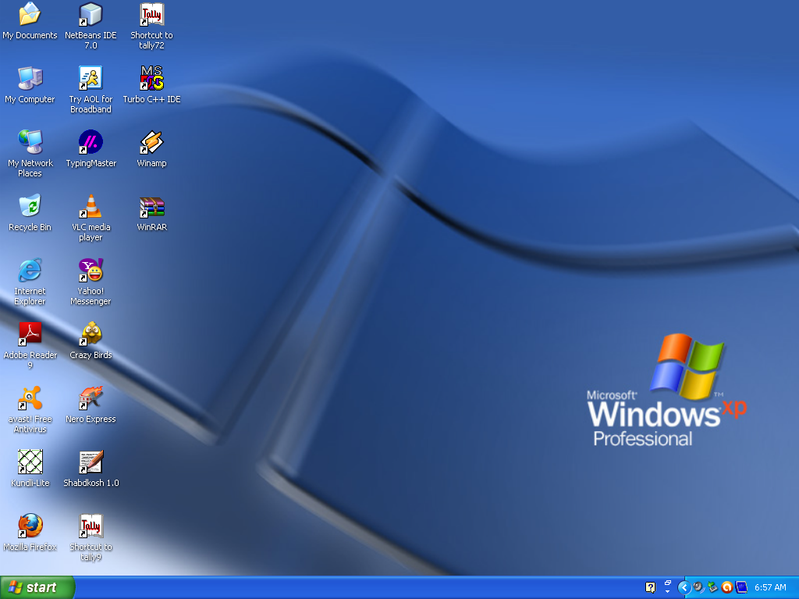

**Start Menu:-**Window Explorer is a file manager application that is included with releases by the Microsoft window operating system. It provides a Graphical User Interface (GUI) for accessing the file system. It is also the component of the operating system that present many user interface items on the monitor such as the taskbar and desktop. Start menu provides all shortcut link of the desktop icons such as My computer, My desktop, My music, My picture, Contro; panel, search,run and many more which is recently used by user.

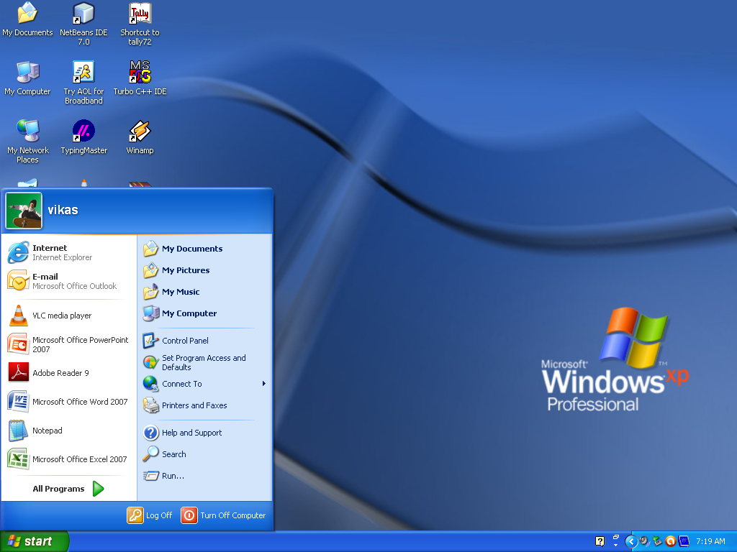

**Folder option:-**This option is obtained in window in menu bar in that tools option. The

Folder option could be seen there. This specifies how folders are displayed. There is provision to view hidden files also. We could easily see the extension of any kind of file.

**My Computer:-**My computer window displays all the contents of your computer disk

drives on two panels. We can open this wndow by double clicking the my computer icon on desktop or select my computer from start menu option.

The right panel of this window displays the content of your floppy disk, hard disk, CD-ROM drive and network drive attached to the system. Infact, now-a-days we can attached removable drives like the pen drive.

The left panel give us four important links:-

1). My Network Place

2). My Document

3). Shared Documents

4). Control Panel

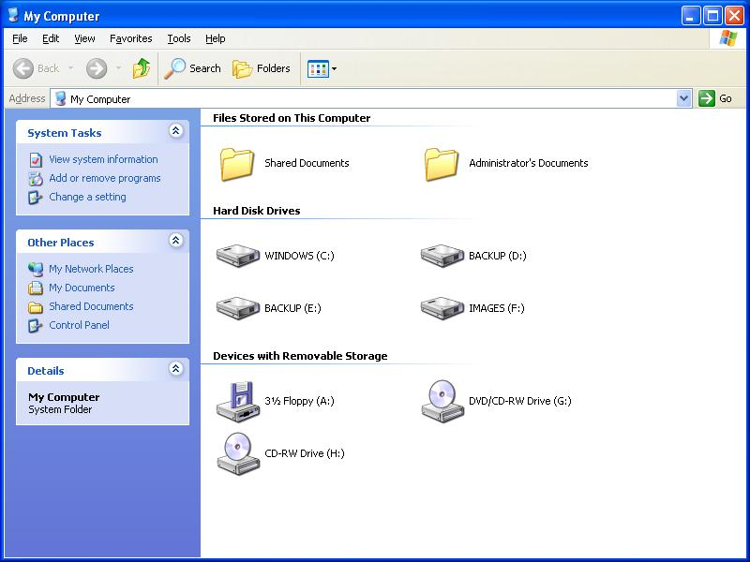

The documents, data and files which use save by default they are saved in my document folder which can be easily access. “My Document” is created by windows itself in the c: drive. Using these above links we can search for and open files and folders on our computer.

**Menu Bar:-**Commonly there are six contents in Menu Bar of My Computer:-

1). **File:-**The first menuof My Computer is ‘File’. It allows to delete, rename files. It can

create shortcuts to a particular folder and to view the properties of a drive. It allows to close a file.

2). **Edit:-** It allows the user to cut,copy,paste,move a folder or a file. Undo allows to back

a done process. It also allows select all contents in the file.

3). **View:-**It is used to arrange the icons or file. It contains tool bar, status bar, explorer

bar, thumbnails, arrange icon, choose details, go to several drives and to refresh.

4). **Favorites:-**To create a special criteria of some special files and the most used files. İt contains Add to favorites, organize favorites links.

5). **Tools:-** It contains the settings, configuration which is used in folders an it has many

other file folder options.

6). **Help:-** it is used to understand some difficult process. İt contains knowledge about the

Operating system and of folders. It provide help to use to know the process.

**Adjust system settings with your computer:-**

If you wish to manage your computer or view other settings and information about your computer instead of double-clicking the My Computer icon to open it, right-click on the My Computer icon and click Properties. Performing these steps will open your System Properties.

**My Document:-**My document is a folder within the windows operating system that provides us with a convenient place to store documents, graphics or other files we want to access quickly. When we save a file in a program such as Microsoft- word, Microsoft excel, WordPad or paint, the file is automatically saved in My Document, unless we choose a different folder.

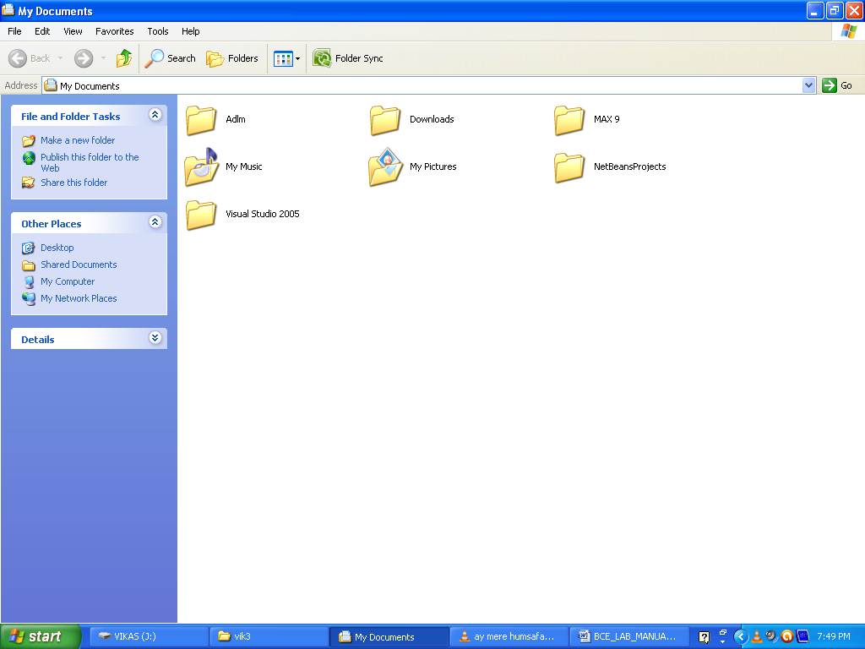

**Control panel:-**The control panel is a feature of the window operating system that

allows the user to modify system setting and control. It includes several applications or control panel that can be used to view and change hardware or software settings. Some example of hardwarecontrol panel are display, keyboard and mouse settings. Software control panel includes date and time, power option, fonts and administraor tools.

**File**:-A file is a collection of data stored in one unit, identified by a file name. It can be a

Document, picture, audio or video stream, data library, application or other collection of data. Files can be opened, saved, deleted and moved to different folders. They can also be transferred across network connections or downloaded from the internet. A file type can be determined by viewing the file icon or by reading the file extension. İf the file type is associated with a specific application, double clicking the file file will typically open the file within the program.

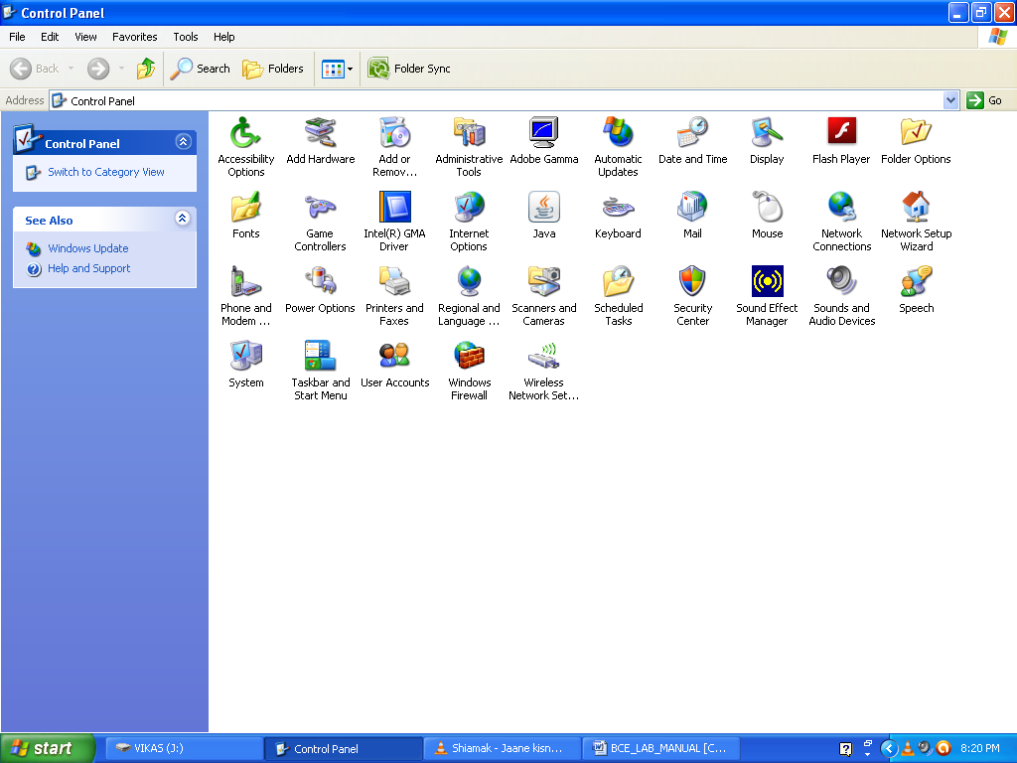

**Drives:-**Computer drives are an integral part of any computer system, be it a PC or a Mac. They perform a variety of different functions ranging from storage to CD and DVD input, through input and output of different types of data, they give us the flexibility to customize and control the funtionality of our computer systems.

Computer drives caome in many sizes and shapes. They allow the user to input specific types of information to be stored in the computers memory. Many drives are input only, meaning they can be used only for reading the information. Other drives such as CD and DVD writers can output information to physical media.