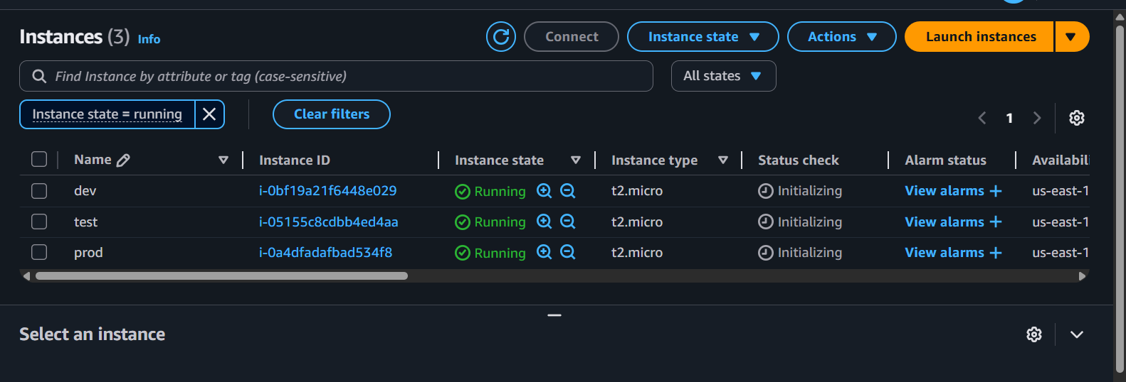

Lets delete the middle one and check out there instance_id:

Terraform plan:  
test to destroy…..

Terraform apply -auto-approve.

