B Capital Portfolio Brand & OnDemand Integration Compendium

135 portfolio companies · evidence-tiered brand profiles · OnDemand application guidance
OnDemand research — read-only web extraction • 2026-10-08

1. Executive summary & methodology
Draft — evidence-tiered. Every field is labelled Verified (official guideline / press kit / media kit / ToS), Observed (captured from the live site CSS/HTML/SVG on 2026-10-08), Third-party (aggregator or unconfirmed host) or Missing. Nothing was inferred into a Verified slot.
Metric | Result | Note
Companies on b.capital/portfolio (actual) | 135 | Target 212 not reached; public page lists 135 (131 Active, 4 Exited). No padding.
Full official guideline coverage | 4/135 = 3.0% | JetZero, Perimeter 81, Perplexity, Starburst Data
Verified hex + verified fonts | 6/135 = 4.4% | Hypersonix, JetZero, Pendo, Perimeter 81, Perplexity, Starburst Data
Any official brand doc / kit asset | 18/135 | Includes partial kits
Primary colour (any tier) | 118/135 | Verified 13 · Observed 104
Fonts (any tier) | 121/135 | Verified 6 · Observed 114
Evidence screenshots | 135/135 | image.thum.io captures; 4 blank/blocked
LinkedIn URL | 98/135 | From official sites; LinkedIn API HTTP 429/403 → HQ/employees Missing
Method
- Portfolio parsed from the orig_data JSON on b.capital/portfolio and cross-checked with /wp-json/wp/v2/companies (both 135). vcbacked.co 404, seedtable 403, seedlist 404.
- Live-CSS extraction for all 135 homepages: CSS variables, colour frequency, body bg/text, font-family/@font-face, logo images, and /brand /press /press-kit /media-kit /newsroom probes.
- Seven parallel sector subagents (Tech A, Tech B, Healthcare A, Healthcare B, Fintech, Energy & Resilience, Consumer/Commerce + prior leads) searched official guidelines/press kits and extracted rules.
- Homepage evidence screenshots and B Capital logo tiles for every company.
- Live OnDemand public docs fetched (40 operations, 2026-10-08T09:39:33Z).
- Analysis: k-means (k=6) in CIELAB, hue wheel, typography frequency/classification, sector × palette heatmap, WCAG contrast.
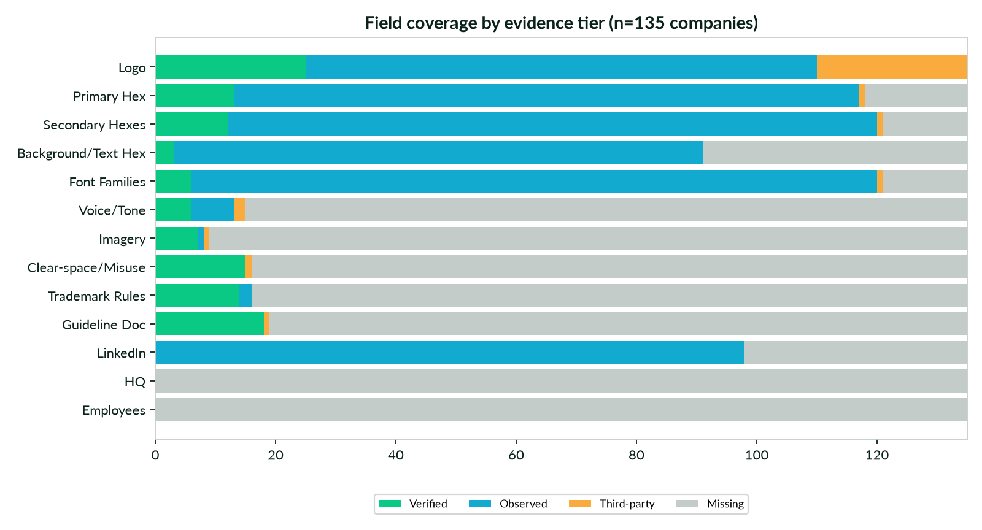
Field coverage by evidence tier
Analyst computation
Inputs read (Step A)
File / source | Status | Used for
on-demand-api_v1.pdf (lz5k / e0ru, identical bytes) | Downloaded, read (15 pp) | KB 2026-07-11: apikey auth, U1–U4 call map, SSE events, error codes, mitigation patterns. Uses agentIds + /file/raw — both outside the live public schema.
CAPABILITY_MATRIX_v1.md (zxnk / tuoq, identical) | Downloaded, read | OnDemand APIs × ODA suite (2026-07-17); cites Endpoints/Reasoning Modes/stream_logs ops no longer in the live index.
Gateway_Integration_Partner_Requirements v1 / v2 .pdf | Downloaded, read (6 pp each) | Partner embed model: front-end access, CORS/CSP whitelisting, credentials/SSO, staging, placement, PoC.
falkoneye-ondemand-integration-architecture_v1.md | Downloaded, read | Auth, rate limits (RAG 100/min, media 5/min free plan), error envelope, execution-log polling only.
integration-spec-ai-legal-claude_v1.json | Downloaded, read | Skill-pack mapping: skills are invoked as query text; no public skill-registration endpoint.
OnDemand-Product-Data-Sheet_v1.pdf | Downloaded, read (12 pp) | Platform positioning: 300+ agents, 3,000+ tools, any LLM, SOC2 Type 2; Flow Builder, Media API, reasoning modes.
B_Capital_Research_Report_v1.docx | Downloaded, read | AIREV report 2026-06-23 — firm overview, $9B+ AUM, BCG partnership.
B_Capital_Research_Leadership_Brief_v1.docx | Downloaded, read | OnDemand brief 2026-06-26 — funds, leadership, nine locations.
B_Capital_Strategic_Research_Brief_v1.pdf | Downloaded, read (8 pp) | AIREV brief — thesis, footprint, notable portfolio.
b.capital / about / portfolio | Fetched live 2026-10-08 | Tagline, GROWTH values, sector language; portfolio = 135 companies (embedded JSON + WP REST API).
BCG-WWOM-Materials-June2026-v3PRINT.pdf | Downloaded, read (17 pp) | “FOCUS: TECH, HEALTHCARE, ENERGY · STAGE: VENTURE + GROWTH”; fund strategy, team, BCG alumni. Data as of 2026-03-31.
Presight_Brand_Guide_v11_18_Jun_2026_btzo.pdf | Downloaded, read (36 pp) | Used only as a format model: identity → logo + safe space → colours → typography → imagery → photography.
2. B Capital — firm & brand profile

B Capital wordmark
b.capital logo-white.svg — Observed
Element | Value | Evidence
Tagline | We empower entrepreneurs to think bigger. Scale faster. Grow global. | Verified
Values | GROWTH — Generosity · Resilience · Open-mindedness · Will · Teamwork · Humility | Verified (b.capital/about)
Sector language | Technology, Healthcare, Energy & Resilience and beyond; filters: Technology & AI · Healthcare · Energy · Opportunistic | Verified
Typography | Reckless Neue (serif base; 350/400) + Yellix (sans accent; 300–600), self-hosted woff2 | Observed (style.css, root.css)
Palette | #0AC985 green (brand) · #12ABCF blue (accent) · #FAAB3D gold · #0A211A black bean (text) · #FFFFFF · #ED544A · greys #F5F5F5 #C4CCC9 #677976 #E3E8E8 | Observed (root.css)
Published guideline | None found | Missing
Firm facts | Founded 2015 (Saverin, Ganguly, Morgan); $9B+ AUM; BCG strategic partnership | Session research files + BCG WWOM deck
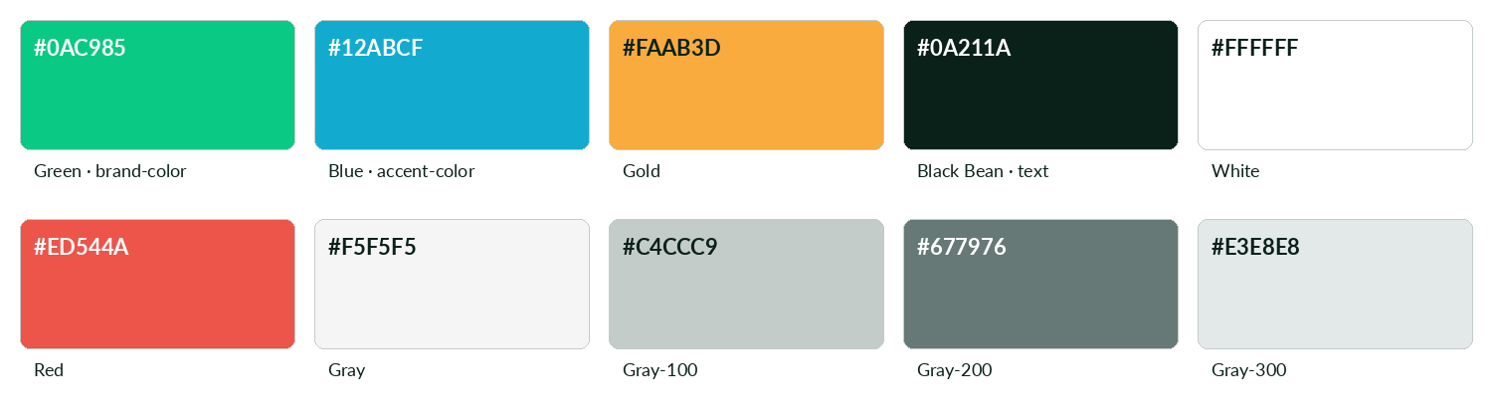
B Capital palette tokens (root.css)
https://b.capital/wp-content/themes/bcapital-theme/markup-template/markup/css/root.css
This document uses the B Capital palette. Reckless Neue and Yellix are not installed in the build container, so Lora (headings) and Lato (body) stand in for them.
3. Portfolio overview by sector and region
135 companies: Technology & AI 66, Healthcare 38, Opportunistic 20, Energy 11; North America 93, Asia 38, Europe 2, Middle East 2.
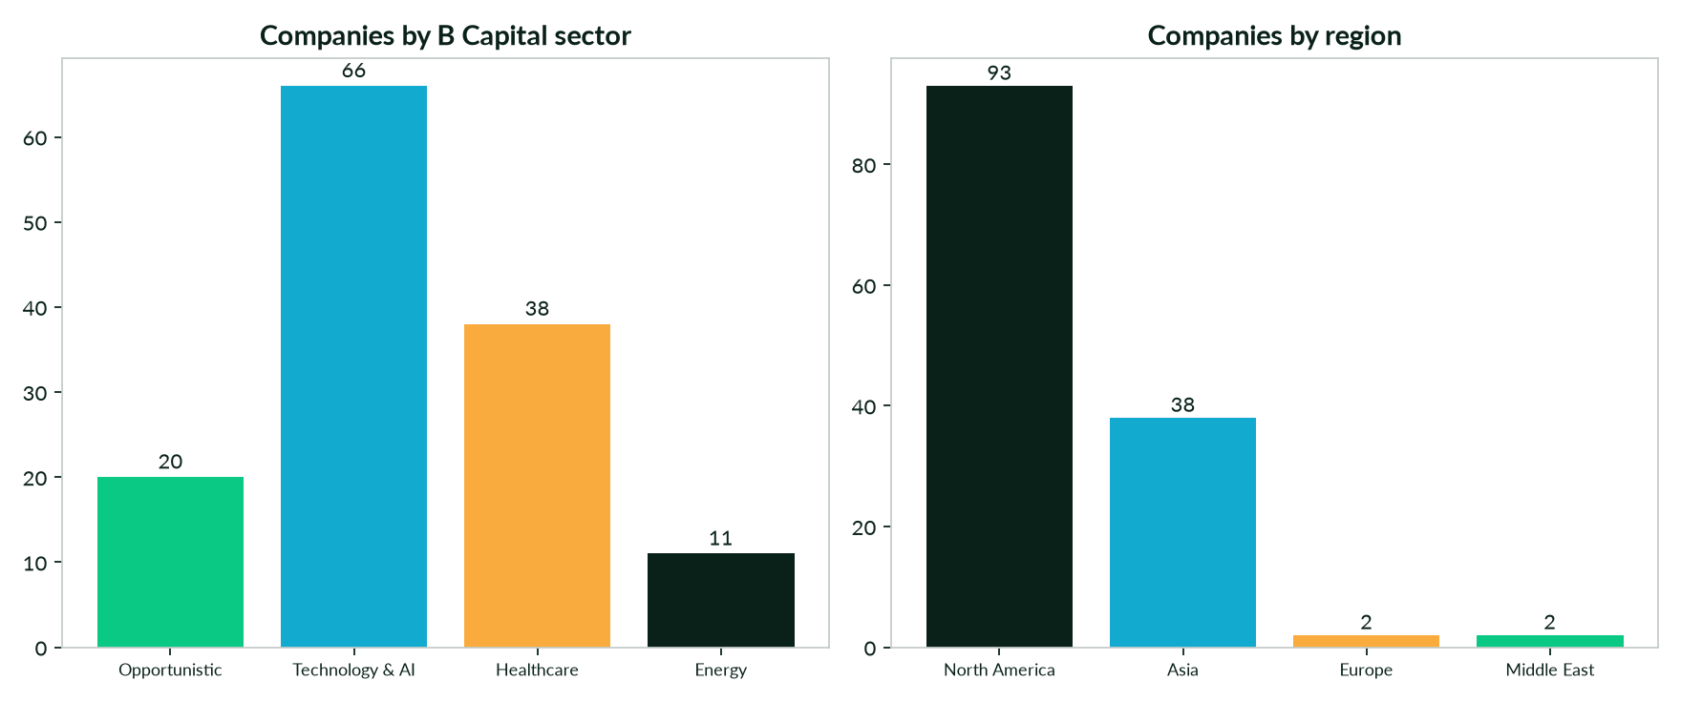
Companies by sector and region
b.capital/portfolio
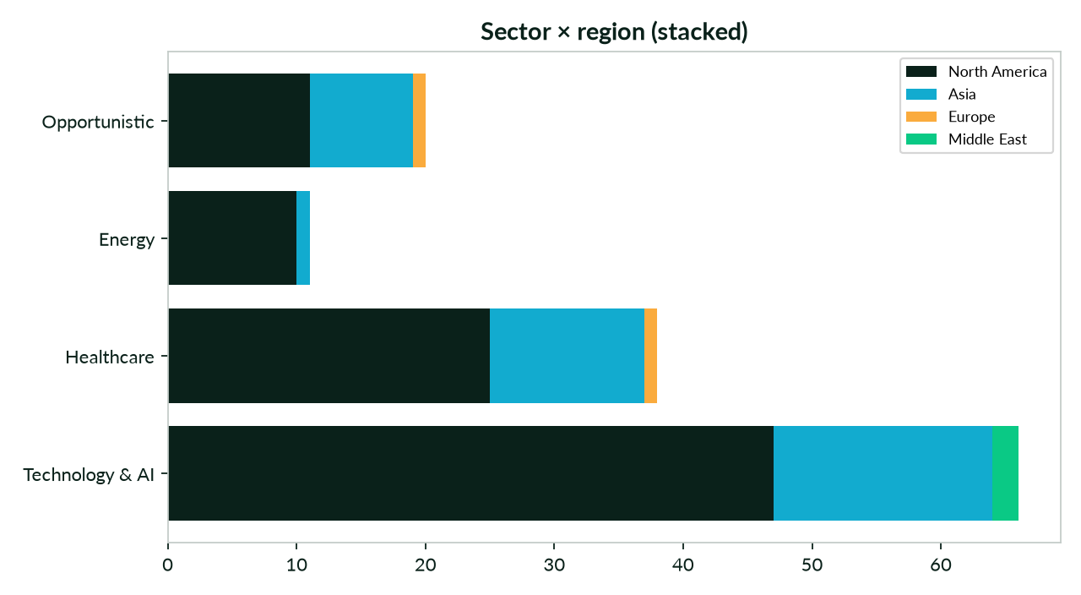
Sector × region
b.capital/portfolio
Research batch | Companies | Official asset/doc | Full guideline
Technology/AI | 55 | 11 | 3
Healthcare/Biotech | 39 | 1 | 0
Fintech | 16 | 3 | 0
Energy & Resilience | 13 | 3 | 1
Consumer/Commerce | 12 | 0 | 0
Flutterwave, Metric Insights and NetSPI were provided as leads but are not on b.capital/portfolio (2026-10-08); recorded in Appendix B and excluded from counts.
4. Company profiles
One profile per company, ordered by sector then name. The card shows the B Capital logo tile, palette swatches with the evidence tier under each swatch, and the homepage evidence screenshot.
6sense
Technology & AI · North America · Active · completeness 8% · tier Third-party — AI-powered revenue platform that helps B2B companies predict buyers and convert pipeline into revenue.
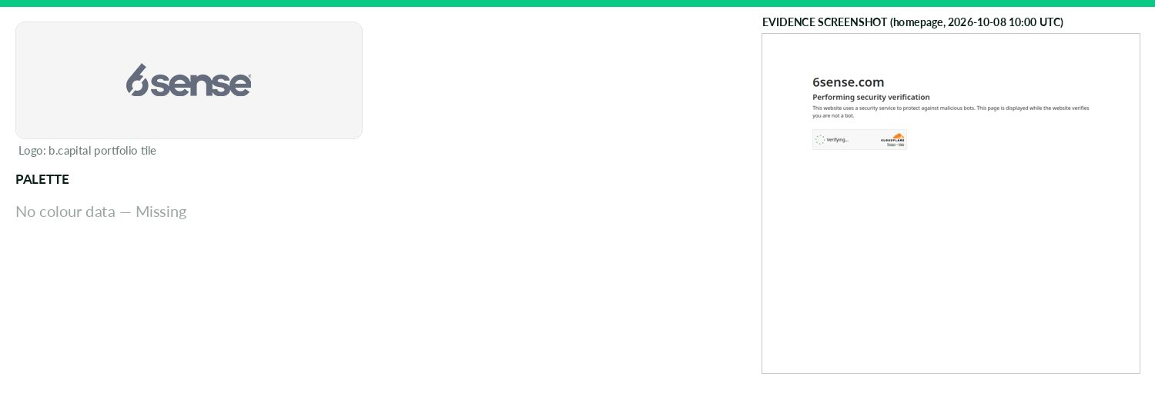
Captured 2026-10-08
Field | Value | Tier | Source
Website | https://6sense.com | Verified | b.capital portfolio
LinkedIn | — | Missing | API 429/403
Primary / secondary | — | Missing | —
Background / text | — | Missing | —
Typography | — | Missing | —
Voice & tone | — | Missing | —
Imagery | — | Missing | —
Clear-space / misuse | — | Missing | —
Trademark | — | Missing | —
Guideline / press kit | — | Missing
HQ / employees | — | Missing | LinkedIn API rate-limited
Draft note | No official guideline; live-site values. Cloudflare 'Just a moment' challenge on homepage, /press, /brand. | Caveat
Apptronik
Technology & AI · North America · Active · completeness 62% · tier Observed — AI-powered humanoid robotics platform that helps enterprises deploy general-purpose robots across real-world applications.
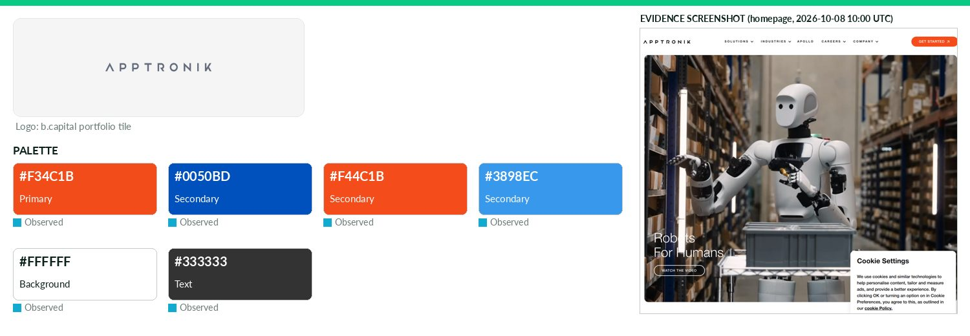
Captured 2026-10-08
Field | Value | Tier | Source
Website | https://apptronik.com | Verified | b.capital portfolio
LinkedIn | https://www.linkedin.com/company/apptronik-inc | Observed | official site link
Primary / secondary | #F34C1B / #0050BD / #F44C1B / #3898EC | Observed | https://apptronik.com/ — most frequent saturated CSS colour
Background / text | #FFFFFF / #333333 | Observed | live CSS body rule
Typography | — | Missing | https://apptronik.com (@font-face)
Voice & tone | argodesign case study: brand values/principles/core attributes defined (not published); Apollo design aims 'approachable, intelligent, and r | Third-party | https://argodesign.com/work/apptronik
Imagery | Agency case study only: friendly, relatable humanoid face; LEDs/expressions convey status (product design, not | Third-party | https://argodesign.com/work/apptronik
Clear-space / misuse | — | Missing | —
Trademark | — | Missing | —
Guideline / press kit | — | Missing
HQ / employees | — | Missing | LinkedIn API rate-limited
OnDemand UI tokens | primary #F34C1B / on #000000 / accent #0050BD / surface #FFFFFF / text #333333 | Derived | contrast 5.86:1 · 12.63:1
Draft note | No official guideline; live-site values. /company/press-releases exists (200) but nav shows Webflow template placeholder copy. No brand/press-kit page | Caveat
Archimetis
Technology & AI · North America · Active · completeness 38% · tier Observed — Next-generation semiconductor memory company developing vertically layered thyristor technology to address AI memory bandwidth, power and supply-chain bottlenec
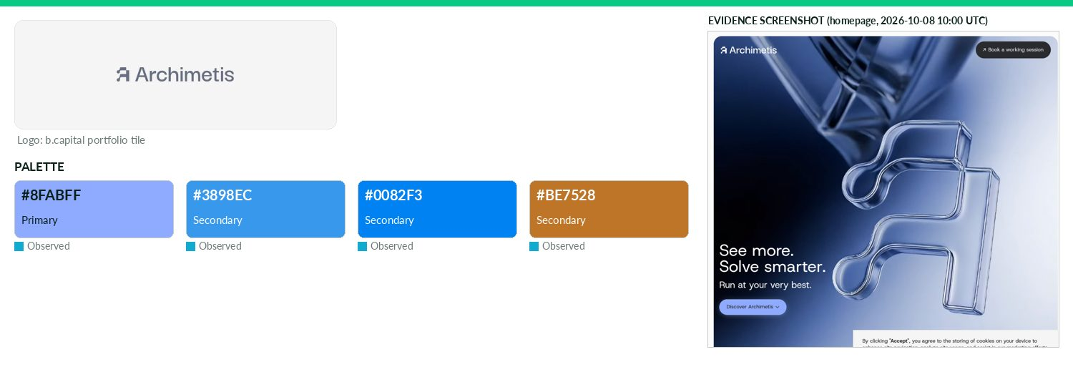
Captured 2026-10-08
Field | Value | Tier | Source
Website | https://www.archimetis.ai | Verified | b.capital portfolio
LinkedIn | https://www.linkedin.com/company/archimetis | Observed | official site link
Primary / secondary | #8FABFF / #3898EC / #0082F3 / #BE7528 | Observed | https://www.archimetis.ai (CSS var --swatch--brand-500)
Background / text | — | Missing | —
Typography | Host Grotesk; General Sans | Observed | https://www.archimetis.ai (@font-face)
Voice & tone | — | Missing | —
Imagery | — | Missing | —
Clear-space / misuse | — | Missing | —
Trademark | — | Missing | —
Guideline / press kit | — | Missing
HQ / employees | — | Missing | LinkedIn API rate-limited
OnDemand UI tokens | primary #8FABFF / on #000000 / accent #3898EC / surface #FFFFFF / text #111111 | Derived | contrast 9.44:1 · 18.88:1
Draft note | No official guideline; live-site values. WARNING: live site describes an 'Operational Reasoning System' for refineries/process industries, not semicond | Caveat
Axiom
Technology & AI · North America · Active · completeness 46% · tier Observed — AI reasoning engine integrating formal reasoning, theorem proving, and novel conjecturing to produce verifiable proofs and discover novel mathematics
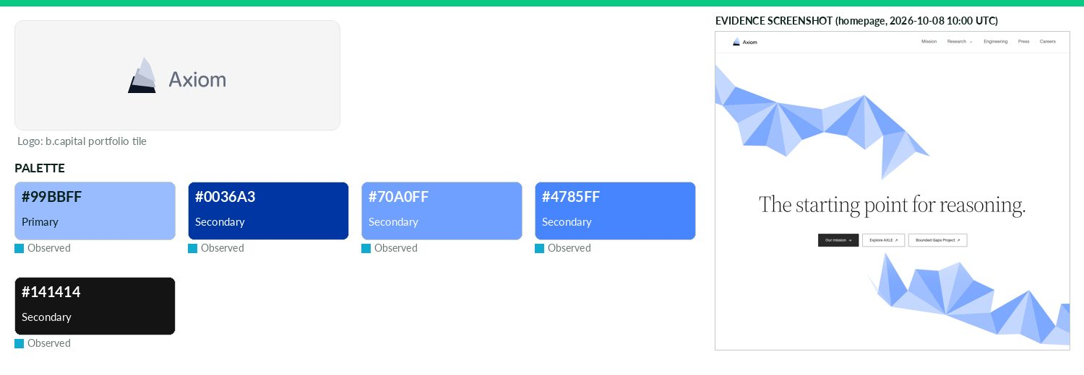
Captured 2026-10-08
Field | Value | Tier | Source
Website | https://axiommath.ai | Verified | b.capital portfolio
LinkedIn | https://www.linkedin.com/company/axiommath | Observed | official site link
Primary / secondary | #99BBFF / #0036A3 / #70A0FF / #4785FF / #141414 | Observed | https://axiommath.ai (CSS var --axiom-color-brand; also fill
Background / text | — | Missing | —
Typography | bodyFont; mathFont | Observed | https://axiommath.ai/ — CSS font-family/@font-face
Voice & tone | Mission-driven, erudite: 'Axiom is building the verified discovery engine'; references Galois, Ramanujan. | Observed | https://axiommath.ai/mission/
Imagery | — | Missing | —
Clear-space / misuse | — | Missing | —
Trademark | — | Missing | —
Guideline / press kit | — | Missing
HQ / employees | — | Missing | LinkedIn API rate-limited
OnDemand UI tokens | primary #99BBFF / on #000000 / accent #0036A3 / surface #FFFFFF / text #111111 | Derived | contrast 10.91:1 · 18.88:1
Draft note | No official guideline; live-site values. /press (200) is a list of media coverage only; no press kit, logo download, or brand guide. | Caveat
Baichuan
Technology & AI · Asia · Active · completeness 38% · tier Observed — Foundational AI platform developing large-scale language models and industry applications.
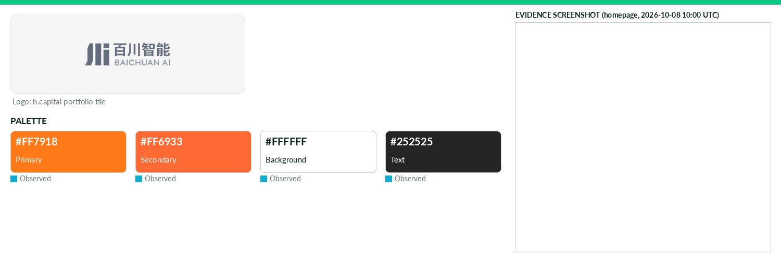
Captured 2026-10-08
Field | Value | Tier | Source
Website | https://www.baichuan-ai.com | Verified | b.capital portfolio
LinkedIn | — | Missing | API 429/403
Primary / secondary | #FF7918 / #FF6933 | Observed | https://www.baichuan-ai.com/ — most frequent saturated CSS c
Background / text | #FFFFFF / #252525 | Observed | live CSS body rule
Typography | PingFang SC; PingFangSC-Regular; SFCompactDisplay; PingFangSC-Medium | Observed | https://www.baichuan-ai.com/ — CSS font-family/@font-face
Voice & tone | — | Missing | —
Imagery | — | Missing | —
Clear-space / misuse | — | Missing | —
Trademark | — | Missing | —
Guideline / press kit | — | Missing
HQ / employees | — | Missing | LinkedIn API rate-limited
OnDemand UI tokens | primary #FF7918 / on #000000 / accent #FF6933 / surface #FFFFFF / text #252525 | Derived | contrast 8.0:1 · 15.33:1
Draft note | No official guideline; live-site values. Homepage is JS-rendered SPA (title '百川大模型-百川智能'); no extractable logo/CSS vars/fonts; no brand/press pages fou | Caveat
Branch International
Technology & AI · North America · Active · completeness 38% · tier Observed — Mobile-first fintech platform expanding fair, affordable access to financial services in emerging markets.
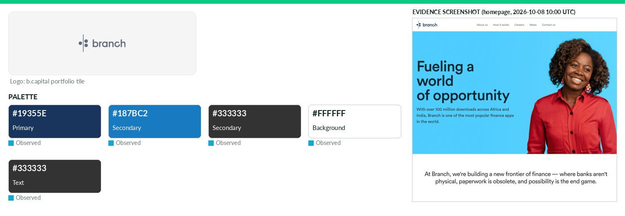
Captured 2026-10-08
Field | Value | Tier | Source
Website | https://branch.co | Verified | b.capital portfolio
LinkedIn | — | Missing | API 429/403
Primary / secondary | #19355E / #187BC2 / #333333 | Observed | https://branch.co/ (CSS, 2nd most frequent hex; logo file na
Background / text | #FFFFFF / #333333 | Observed | live CSS body rule
Typography | Circular | Observed | https://branch.co/ @font-face
Voice & tone | — | Missing | —
Imagery | — | Missing | —
Clear-space / misuse | — | Missing | —
Trademark | — | Missing | —
Guideline / press kit | — | Missing
HQ / employees | — | Missing | LinkedIn API rate-limited
OnDemand UI tokens | primary #19355E / on #FFFFFF / accent #187BC2 / surface #FFFFFF / text #333333 | Derived | contrast 12.26:1 · 12.63:1
Draft note | No official guideline; live-site values. No brand/press page found; /press,/newsroom,/media,/brand return Cloudflare 403. Homepage + /about-us reachabl | Caveat
Brik
Technology & AI · Asia · Active · completeness 31% · tier Observed — B2B construction materials technology platform modernizing Indonesia's building and industrial materials supply chain.
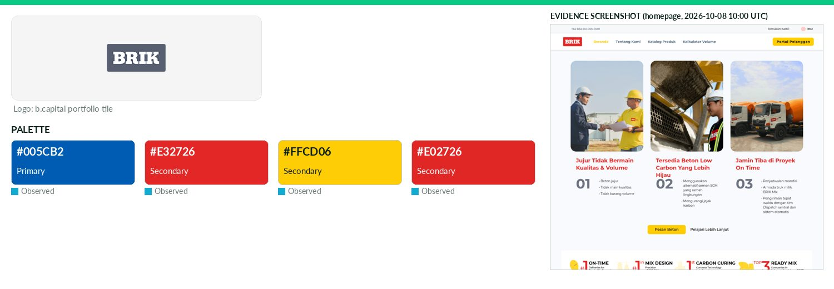
Captured 2026-10-08
Field | Value | Tier | Source
Website | https://brik.id | Verified | b.capital portfolio
LinkedIn | — | Missing | API 429/403
Primary / secondary | #005CB2 / #E32726 / #FFCD06 / #E02726 | Observed | https://brik.id/ — CSS variable --dp-primary-color
Background / text | — | Missing | —
Typography | Inter; Inter Display | Observed | https://brik.id (@font-face)
Voice & tone | — | Missing | —
Imagery | — | Missing | —
Clear-space / misuse | — | Missing | —
Trademark | — | Missing | —
Guideline / press kit | — | Missing
HQ / employees | — | Missing | LinkedIn API rate-limited
OnDemand UI tokens | primary #005CB2 / on #FFFFFF / accent #E32726 / surface #FFFFFF / text #111111 | Derived | contrast 6.62:1 · 18.88:1
Draft note | No official guideline; live-site values. Only CSS vars are date-picker library defaults (--dp-*), not brand. No press/brand pages. | Caveat
Certn
Technology & AI · North America · Active · completeness 46% · tier Observed — Tech-first one-stop-shop for background checks with AI-powered identity verification.
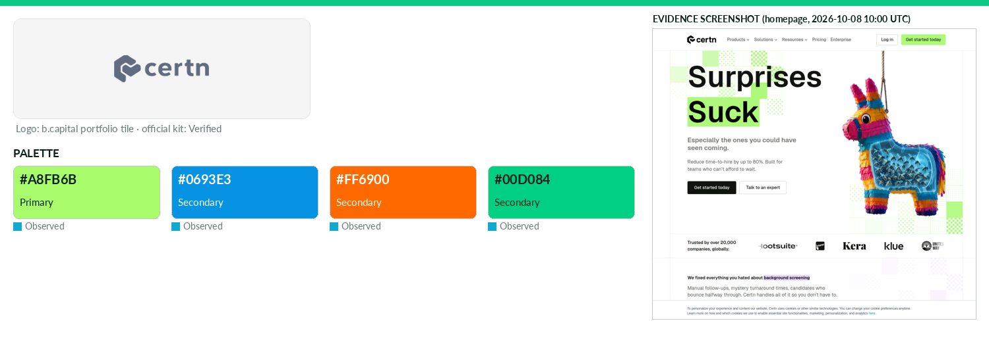
Captured 2026-10-08
Field | Value | Tier | Source
Website | http://certn.co | Verified | b.capital portfolio
LinkedIn | https://www.linkedin.com/company/certn | Observed | official site link
Primary / secondary | #A8FB6B / #0693E3 / #FF6900 / #00D084 | Observed | https://certn.co/ — CSS variable --primary-light
Background / text | — | Missing | —
Typography | Geist | Observed | https://certn.co (theme font file geist-variable-latin-basic
Voice & tone | — | Missing | —
Imagery | — | Missing | —
Clear-space / misuse | — | Missing | —
Trademark | — | Missing | —
Guideline / press kit | https://certn.co/wp-content/uploads/2025/05/2025-Certn-Media-Kit-Compressed-2.pdf | Verified
HQ / employees | — | Missing | LinkedIn API rate-limited
OnDemand UI tokens | primary #A8FB6B / on #000000 / accent #0693E3 / surface #FFFFFF / text #111111 | Derived | contrast 16.68:1 · 18.88:1
Draft note | Partial official material. /press 'Brand Assets': Download Logo (ZIP: colour/white logo + icon PNGs) and Download Media Kit (6-page PDF). | Caveat
ChipAgents
Technology & AI · North America · Active · completeness 46% · tier Observed — Alpha Design AI is revolutionizing the chip design and verification process with agentic AI tools tailored for the semiconductor industry.
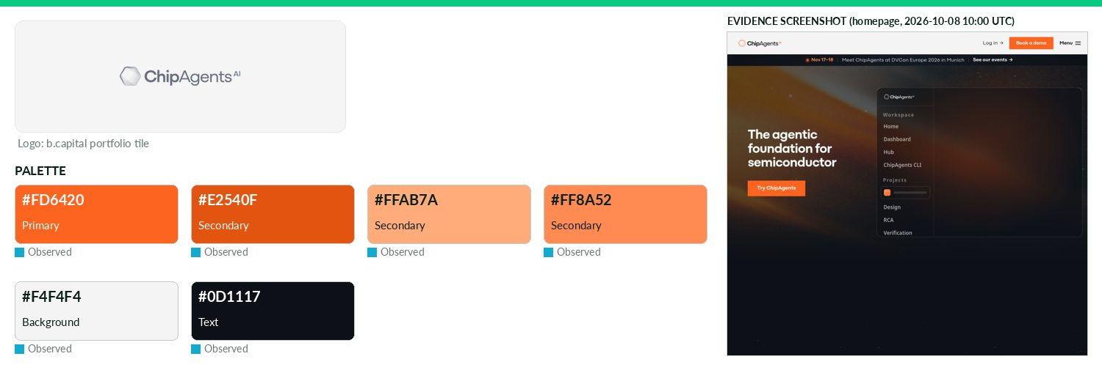
Captured 2026-10-08
Field | Value | Tier | Source
Website | https://chipagents.ai | Verified | b.capital portfolio
LinkedIn | https://www.linkedin.com/company/chipagents-ai | Observed | official site link
Primary / secondary | #FD6420 / #E2540F / #FFAB7A / #FF8A52 | Observed | https://chipagents.ai/ — most frequent saturated CSS colour
Background / text | #F4F4F4 / #0D1117 | Observed | live CSS body rule
Typography | Mozaic Geo; Figtree; JetBrains Mono | Observed | https://chipagents.ai (@font-face)
Voice & tone | — | Missing | —
Imagery | — | Missing | —
Clear-space / misuse | — | Missing | —
Trademark | — | Missing | —
Guideline / press kit | — | Missing
HQ / employees | — | Missing | LinkedIn API rate-limited
OnDemand UI tokens | primary #FD6420 / on #000000 / accent #E2540F / surface #F4F4F4 / text #0D1117 | Derived | contrast 7.02:1 · 17.21:1
Draft note | No official guideline; live-site values. /newsroom exists (announcements, media alerts); no press kit or brand guide found. | Caveat
Cloudwise
Technology & AI · Asia · Active · completeness 46% · tier Observed — Platform providing application performance management and full-stack IT infrastructure monitoring.
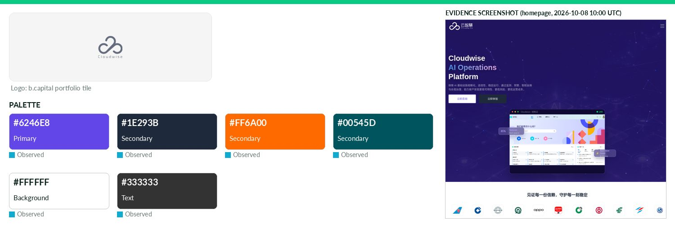
Captured 2026-10-08
Field | Value | Tier | Source
Website | http://cloudwise.com | Verified | b.capital portfolio
LinkedIn | — | Missing | API 429/403
Primary / secondary | #6246E8 / #1E293B / #FF6A00 / #00545D | Observed | https://cloudwise.com/cn/ — most frequent saturated CSS colo
Background / text | #FFFFFF / #333333 | Observed | live CSS body rule
Typography | MicrosoftYaHei; å¾®è½¯é é»; FangSong | Observed | https://cloudwise.com/cn/ — CSS font-family/@font-face
Voice & tone | Tagline 'Reliability for AI Infrastructure' / 'AI for AI Infrastructure' (brand intro page = company profile, not guidelines). | Observed | https://cloudwise.com/cn/about/brand.html
Imagery | — | Missing | —
Clear-space / misuse | — | Missing | —
Trademark | — | Missing | —
Guideline / press kit | — | Missing
HQ / employees | — | Missing | LinkedIn API rate-limited
OnDemand UI tokens | primary #6246E8 / on #FFFFFF / accent #1E293B / surface #FFFFFF / text #333333 | Derived | contrast 5.9:1 · 12.63:1
Draft note | No official guideline; live-site values. http:// timed out; https://cloudwise.com -> /cn/ (Chinese). /cn/about/brand.html is a 品牌介绍 company profile pag | Caveat
Code Metal
Technology & AI · North America · Active · completeness 46% · tier Observed — Code Metal is an AI-driven software company specializing in automated code translation, verification, and edge deployment solutions.
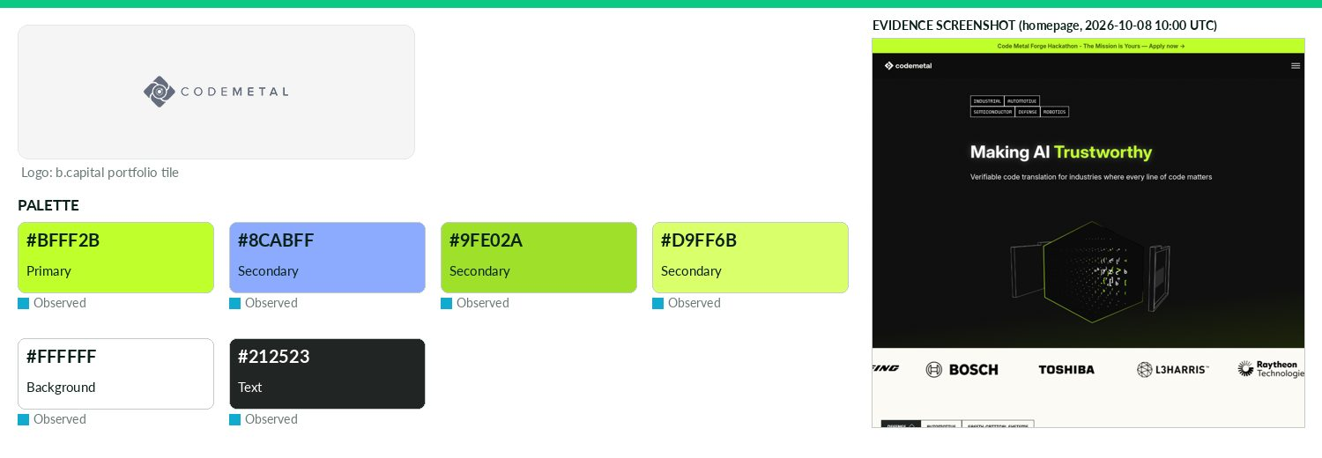
Captured 2026-10-08
Field | Value | Tier | Source
Website | https://www.codemetal.ai | Verified | b.capital portfolio
LinkedIn | — | Missing | API 429/403
Primary / secondary | #BFFF2B / #8CABFF / #9FE02A / #D9FF6B | Observed | https://www.codemetal.ai (CSS var --color-brand-lime)
Background / text | #FFFFFF / #212523 | Observed | live CSS body rule
Typography | Inter; TT Paplane; PT Mono | Observed | https://www.codemetal.ai (@font-face/next font)
Voice & tone | 'Code that works, and proves it.' Values: Trust (proof, not promises), Passion, Humility; serious mission-critical tone. | Observed | https://www.codemetal.ai/about
Imagery | — | Missing | —
Clear-space / misuse | — | Missing | —
Trademark | — | Missing | —
Guideline / press kit | — | Missing
HQ / employees | — | Missing | LinkedIn API rate-limited
OnDemand UI tokens | primary #BFFF2B / on #000000 / accent #8CABFF / surface #FFFFFF / text #212523 | Derived | contrast 17.55:1 · 15.51:1
Draft note | No official guideline; live-site values. /about and /news (newsroom) exist; no press kit, brand page or logo download. Logo SVG fill #fbfaf4 (light ver | Caveat
Collinear AI
Technology & AI · North America · Active · completeness 62% · tier Verified — Collinear AI is revolutionizing AI deployment for enterprises by providing solutions that ensure safety and reliability.
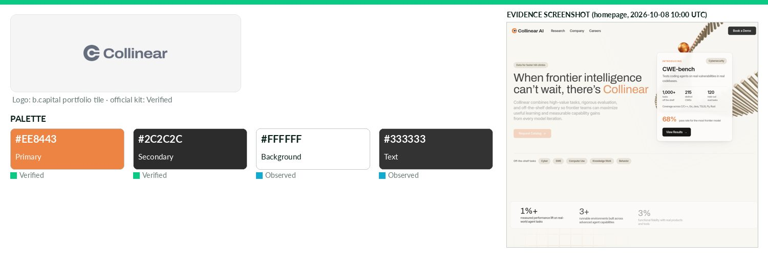
Captured 2026-10-08
Field | Value | Tier | Source
Website | https://www.collinear.ai | Verified | b.capital portfolio
LinkedIn | https://www.linkedin.com/company/collinearai | Observed | official site link
Primary / secondary | #EE8443 / #2C2C2C | Verified | collinear-press-kit.zip logos/collinear-full-color.svg
Background / text | #FFFFFF / #333333 | Observed | live CSS body rule
Typography | Inter; Archivo | Observed | https://collinear.ai/ — CSS font-family/@font-face
Voice & tone | — | Missing | —
Imagery | — | Missing | —
Clear-space / misuse | Logos in full-color, black, white for light/dark backgrounds; 'Use a version with adequate contrast against its backgrou | Verified | collinear-press-kit.zip asset-notes.txt
Trademark | — | Missing | —
Guideline / press kit | https://collinear.ai/media-kit | Verified
HQ / employees | — | Missing | LinkedIn API rate-limited
OnDemand UI tokens | primary #EE8443 / on #000000 / accent #2C2C2C / surface #FFFFFF / text #333333 | Derived | contrast 8.02:1 · 12.63:1
CompanyCam
Technology & AI · North America · Active · completeness 54% · tier Observed — FSM / Vertical software for roofing (photo sharing).
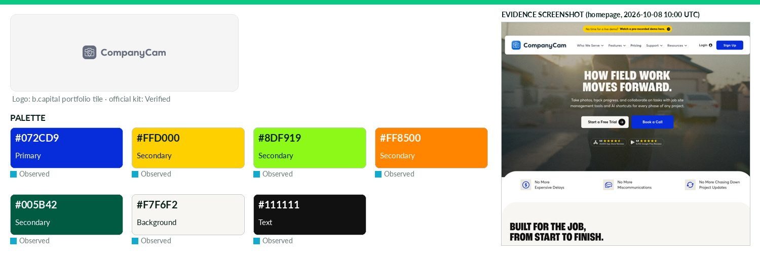
Captured 2026-10-08
Field | Value | Tier | Source
Website | https://companycam.com | Verified | b.capital portfolio
LinkedIn | https://linkedin.com/company/companycam | Observed | official site link
Primary / secondary | #072CD9 / #FFD000 / #8DF919 / #FF8500 / #005B42 | Observed | https://companycam.com CSS var --secondary-blue-new-pool (pr
Background / text | #F7F6F2 / #111111 | Observed | live CSS body rule
Typography | Averta; IBM Plex Serif | Observed | companycam.com @font-face; Averta also in Bynder guideline p
Voice & tone | — | Missing | —
Imagery | — | Missing | —
Clear-space / misuse | — | Missing | —
Trademark | — | Missing | —
Guideline / press kit | https://dam.companycam.com/guidelines/guide/2b8ea8b8-3ae8-4f65-b76f-aa01af9bcd12 | Verified
HQ / employees | — | Missing | LinkedIn API rate-limited
OnDemand UI tokens | primary #072CD9 / on #FFFFFF / accent #FFD000 / surface #F7F6F2 / text #111111 | Derived | contrast 8.86:1 · 17.46:1
Draft note | Partial official material. companycam.com/brand redirects to Bynder brand-guidelines portal (JS-rendered; content not retrievable). /pres | Caveat
Curbwaste
Technology & AI · North America · Active · completeness 38% · tier Observed — Vertical software platform modernizing operations for waste management companies from dispatch to billing.
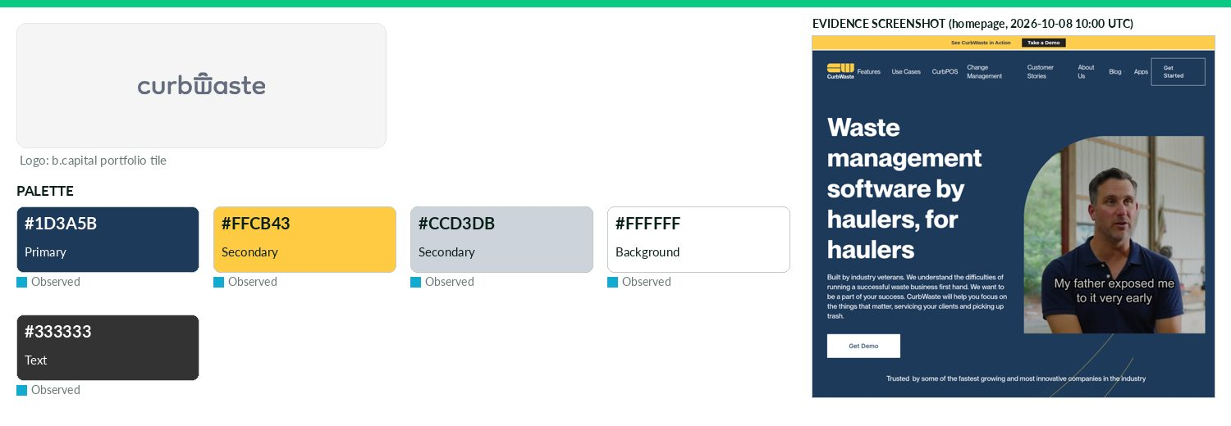
Captured 2026-10-08
Field | Value | Tier | Source
Website | https://curbwaste.com | Verified | b.capital portfolio
LinkedIn | — | Missing | API 429/403
Primary / secondary | #1D3A5B / #FFCB43 / #CCD3DB | Observed | https://www.curbwaste.com (CSS var --brand-blue)
Background / text | #FFFFFF / #333333 | Observed | live CSS body rule
Typography | PP Neue Montreal; Inter | Observed | https://www.curbwaste.com (@font-face)
Voice & tone | — | Missing | —
Imagery | — | Missing | —
Clear-space / misuse | — | Missing | —
Trademark | — | Missing | —
Guideline / press kit | — | Missing
HQ / employees | — | Missing | LinkedIn API rate-limited
OnDemand UI tokens | primary #1D3A5B / on #FFFFFF / accent #FFCB43 / surface #FFFFFF / text #333333 | Derived | contrast 11.61:1 · 12.63:1
Draft note | No official guideline; live-site values. No press/brand pages found. | Caveat
Deferred
Technology & AI · North America · Active · completeness 38% · tier Observed — Exchange platform enabling real estate investors to defer capital gains taxes through 1031 transactions.
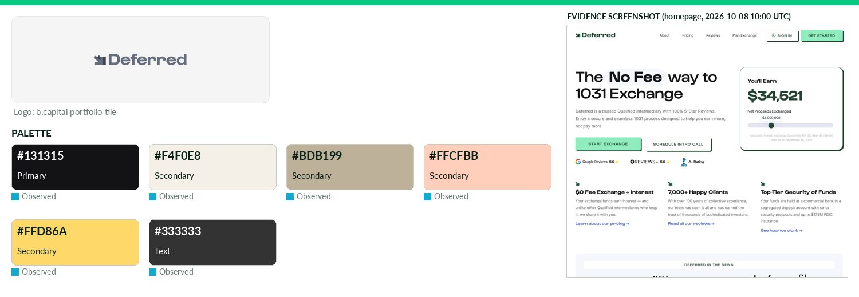
Captured 2026-10-08
Field | Value | Tier | Source
Website | https://www.deferred.com | Verified | b.capital portfolio
LinkedIn | — | Missing | API 429/403
Primary / secondary | #131315 / #F4F0E8 / #BDB199 / #FFCFBB / #FFD86A | Observed | https://www.deferred.com/ CSS var --brand-black
Background / text | — / #333333 | Observed | live CSS body rule
Typography | Gustavo; Inter | Observed | https://www.deferred.com/ @font-face
Voice & tone | — | Missing | —
Imagery | — | Missing | —
Clear-space / misuse | — | Missing | —
Trademark | — | Missing | —
Guideline / press kit | — | Missing
HQ / employees | — | Missing | LinkedIn API rate-limited
OnDemand UI tokens | primary #131315 / on #FFFFFF / accent #F4F0E8 / surface #FFFFFF / text #333333 | Derived | contrast 18.56:1 · 12.63:1
Draft note | No official guideline; live-site values. No press/brand/media-kit pages (404). | Caveat
Dream Labs
Technology & AI · North America · Active · completeness 38% · tier Observed — Dream Labs is founded by the team behind DreamZero (a joint video-and-action model for robotics) and DreamDojo (a world model used as simulation to help robots
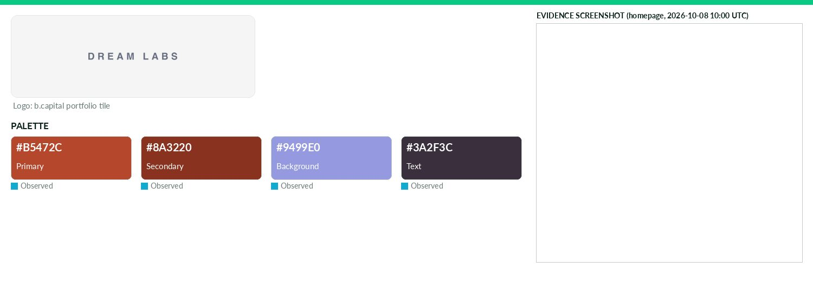
Captured 2026-10-08
Field | Value | Tier | Source
Website | https://dreamlabs.ai | Verified | b.capital portfolio
LinkedIn | — | Missing | API 429/403
Primary / secondary | #B5472C / #8A3220 | Observed | https://dreamlabs.ai (CSS var --accent)
Background / text | #9499E0 / #3A2F3C | Observed | live CSS body rule
Typography | Space Grotesk | Observed | https://dreamlabs.ai (@font-face)
Voice & tone | — | Missing | —
Imagery | — | Missing | —
Clear-space / misuse | — | Missing | —
Trademark | — | Missing | —
Guideline / press kit | — | Missing
HQ / employees | — | Missing | LinkedIn API rate-limited
OnDemand UI tokens | primary #B5472C / on #FFFFFF / accent #8A3220 / surface #9499E0 / text #3A2F3C | Derived | contrast 5.38:1 · 4.78:1
Draft note | No official guideline; live-site values. Logo imgs found were partner logos (NVIDIA, DeepMind...). No press/brand pages. | Caveat
Eureka Robotics
Technology & AI · Asia · Active · completeness 46% · tier Observed — Robotics platform building high-accuracy, high-agility systems for advanced automation.
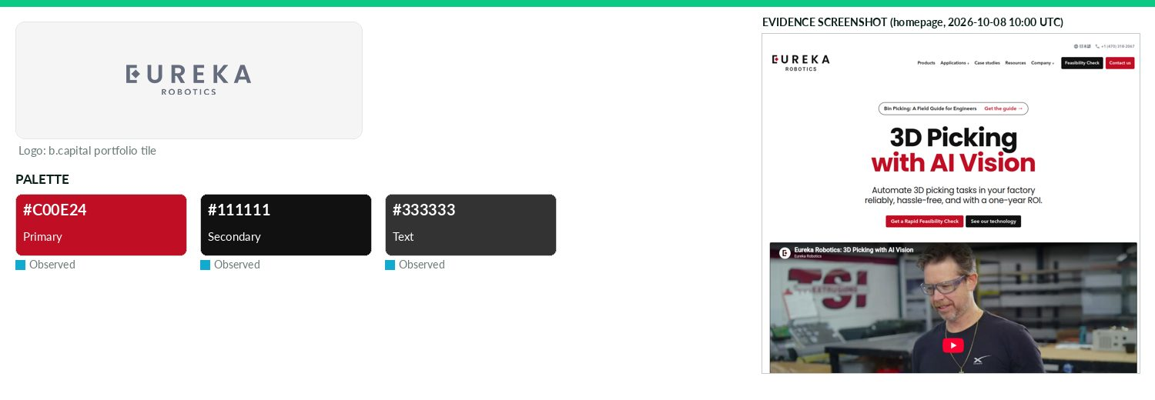
Captured 2026-10-08
Field | Value | Tier | Source
Website | https://eurekarobotics.com | Verified | b.capital portfolio
LinkedIn | https://www.linkedin.com/company/eureka-robotics | Observed | official site link
Primary / secondary | #C00E24 / #111111 | Observed | Eureka_site_logo.svg fill
Background / text | — / #333333 | Observed | live CSS body rule
Typography | Inter; Poppins; Avenir Next | Observed | https://eurekarobotics.com (@font-face)
Voice & tone | — | Missing | —
Imagery | — | Missing | —
Clear-space / misuse | — | Missing | —
Trademark | — | Missing | —
Guideline / press kit | — | Missing
HQ / employees | — | Missing | LinkedIn API rate-limited
OnDemand UI tokens | primary #C00E24 / on #FFFFFF / accent #111111 / surface #FFFFFF / text #333333 | Derived | contrast 6.31:1 · 12.63:1
Draft note | No official guideline; live-site values. /media = media coverage list; no press kit/brand guide. | Caveat
EvenUp
Technology & AI · North America · Active · completeness 54% · tier Observed — AI-powered legal tech platform streamlining personal injury claims for better, faster case outcomes.
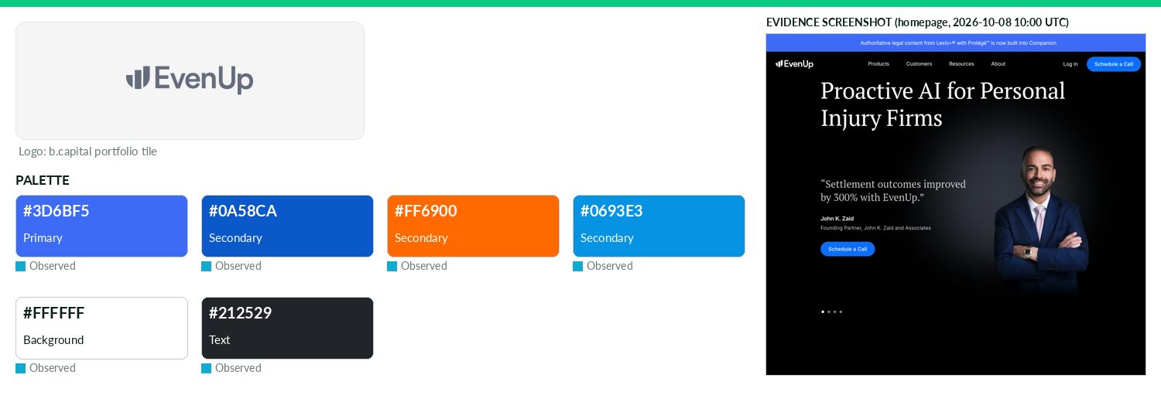
Captured 2026-10-08
Field | Value | Tier | Source
Website | https://www.evenuplaw.com | Verified | b.capital portfolio
LinkedIn | https://www.linkedin.com/company/evenup | Observed | official site link
Primary / secondary | #3D6BF5 / #0A58CA / #FF6900 / #0693E3 | Observed | https://www.evenuplaw.com (CSS --wp--preset--color--accent-b
Background / text | #FFFFFF / #212529 | Observed | live CSS body rule
Typography | Inter; PT Serif | Observed | https://www.evenuplaw.com (@font-face)
Voice & tone | — | Missing | —
Imagery | — | Missing | —
Clear-space / misuse | — | Missing | —
Trademark | Product names carry ™ on site (e.g. 'Express Demands™', 'PLAAS™'); no stated trademark policy found. | Observed | https://www.evenuplaw.com/
Guideline / press kit | — | Missing
HQ / employees | — | Missing | LinkedIn API rate-limited
OnDemand UI tokens | primary #3D6BF5 / on #000000 / accent #0A58CA / surface #FFFFFF / text #212529 | Derived | contrast 4.62:1 · 15.43:1
Draft note | No official guideline; live-site values. /newsroom exists (media coverage + releases); no press kit or brand guide. | Caveat
Extend
Technology & AI · North America · Active · completeness 46% · tier Observed — Virtual card platform helping businesses control, track and manage company spending in one place.
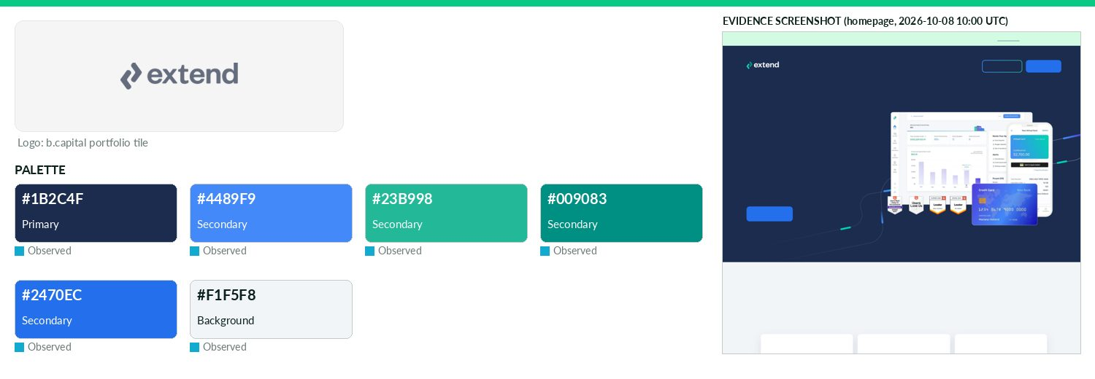
Captured 2026-10-08
Field | Value | Tier | Source
Website | https://paywithextend.com | Verified | b.capital portfolio
LinkedIn | https://www.linkedin.com/company/extend-enterprises-inc | Observed | official site link
Primary / secondary | #1B2C4F / #4489F9 / #23B998 / #009083 / #2470EC | Observed | https://www.paywithextend.com/ CSS var --primary-1
Background / text | #F1F5F8 / — | Observed | live CSS body rule
Typography | Founders; Rubik | Observed | https://www.paywithextend.com/ CSS
Voice & tone | — | Missing | —
Imagery | — | Missing | —
Clear-space / misuse | — | Missing | —
Trademark | — | Missing | —
Guideline / press kit | — | Missing
HQ / employees | — | Missing | LinkedIn API rate-limited
OnDemand UI tokens | primary #1B2C4F / on #FFFFFF / accent #4489F9 / surface #F1F5F8 / text #111111 | Derived | contrast 13.82:1 · 17.23:1
Draft note | No official guideline; live-site values. No press/newsroom/brand pages (404). Header logo is inline/unclear; img logos found were partner logos. | Caveat
FlowGPT
Technology & AI · North America · Active · completeness 31% · tier Observed — Open-source AI app creator community enabling users to discover and integrate prompts into applications.
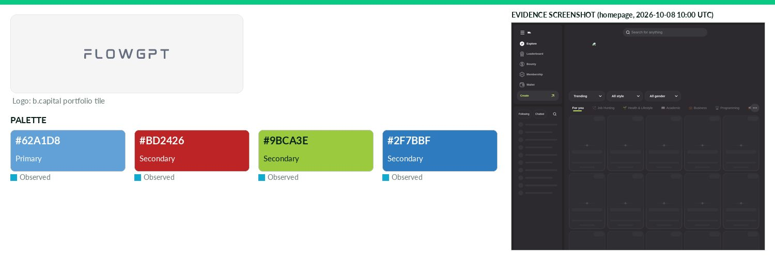
Captured 2026-10-08
Field | Value | Tier | Source
Website | https://flowgpt.com | Verified | b.capital portfolio
LinkedIn | — | Missing | API 429/403
Primary / secondary | #62A1D8 / #BD2426 / #9BCA3E / #2F7BBF | Observed | https://flowgpt.com/ — most frequent saturated CSS colour (4
Background / text | — | Missing | —
Typography | — | Missing | https://flowgpt.com/ — CSS font-family/@font-face
Voice & tone | — | Missing | —
Imagery | — | Missing | —
Clear-space / misuse | — | Missing | —
Trademark | — | Missing | —
Guideline / press kit | — | Missing
HQ / employees | — | Missing | LinkedIn API rate-limited
OnDemand UI tokens | primary #62A1D8 / on #000000 / accent #BD2426 / surface #FFFFFF / text #111111 | Derived | contrast 7.61:1 · 18.88:1
Draft note | No official guideline; live-site values. Homepage returned 403 (bot protection). | Caveat
Forest
Technology & AI · North America · Active · completeness 31% · tier Observed — Forest is a US-based enterprise technology company currently in its pre-seed stage and undergoing final investment consideration.
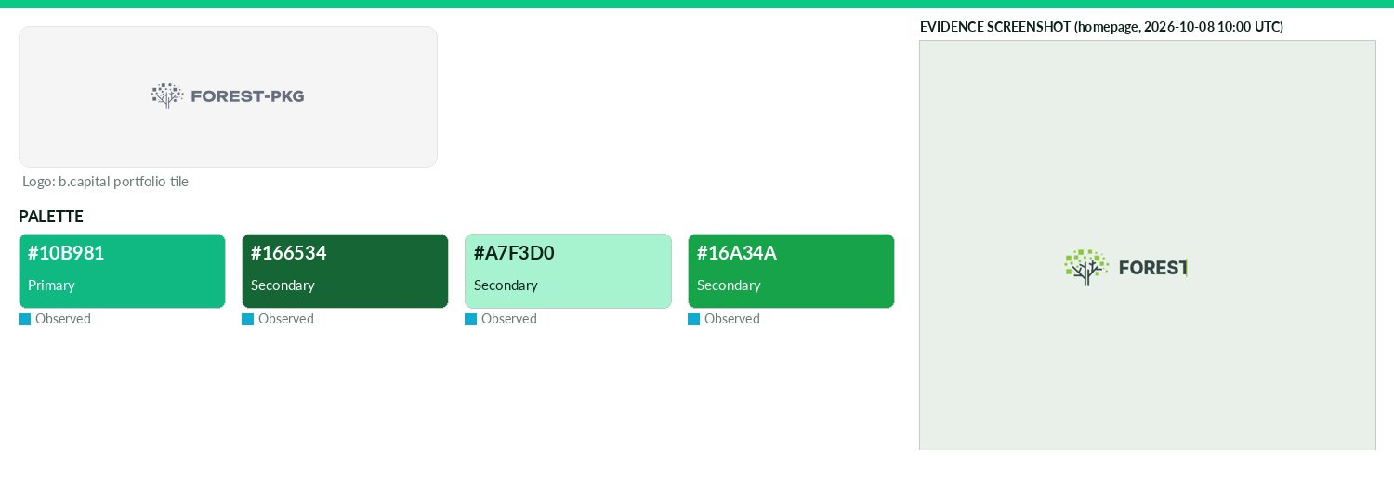
Captured 2026-10-08
Field | Value | Tier | Source
Website | https://www.forest-pkg.com | Verified | b.capital portfolio
LinkedIn | — | Missing | API 429/403
Primary / secondary | #10B981 / #166534 / #A7F3D0 / #16A34A | Observed | https://www.forest-pkg.com (CSS var --forest-accent)
Background / text | — | Missing | —
Typography | Inter | Observed | https://www.forest-pkg.com (@font-face)
Voice & tone | — | Missing | —
Imagery | — | Missing | —
Clear-space / misuse | — | Missing | —
Trademark | — | Missing | —
Guideline / press kit | — | Missing
HQ / employees | — | Missing | LinkedIn API rate-limited
OnDemand UI tokens | primary #10B981 / on #000000 / accent #166534 / surface #FFFFFF / text #111111 | Derived | contrast 8.28:1 · 18.88:1
Draft note | No official guideline; live-site values. No press/brand pages. | Caveat
Fountain
Technology & AI · North America · Active · completeness 62% · tier Verified — Recruitment automation platform enabling companies to attract, assess and hire hourly talent at scale.
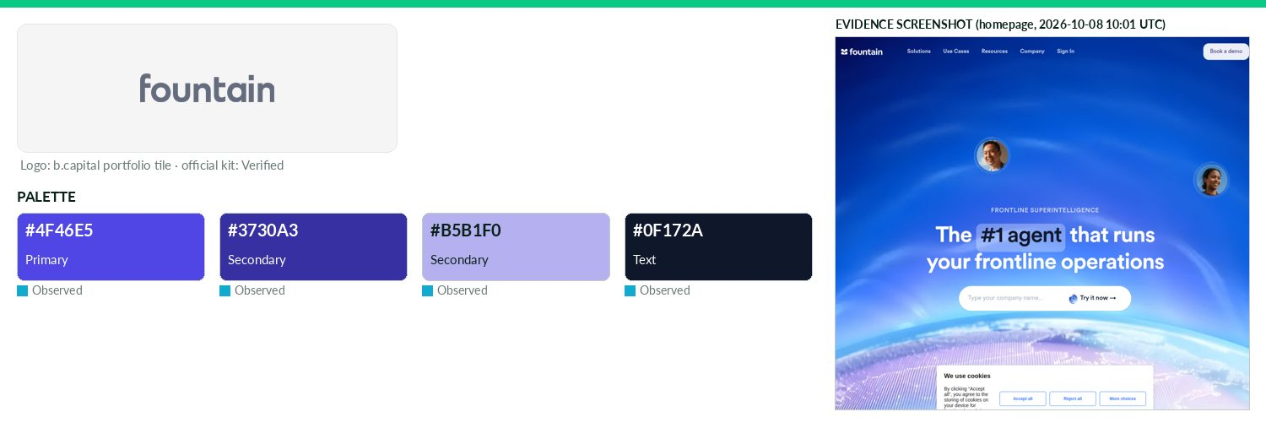
Captured 2026-10-08
Field | Value | Tier | Source
Website | https://get.fountain.com | Verified | b.capital portfolio
LinkedIn | https://linkedin.com/company/fountaininc | Observed | official site link
Primary / secondary | #4F46E5 / #3730A3 / #B5B1F0 | Observed | https://www.fountain.com (CSS vars --accent / --jnr42-brand)
Background / text | — / #0F172A | Observed | live CSS body rule
Typography | Circular XX | Observed | https://www.fountain.com (@font-face 'Circularxx')
Voice & tone | — | Missing | —
Imagery | — | Missing | —
Clear-space / misuse | 'The Fountain logo is available in two colors. Blue is designed for lighter backgrounds, while white works best on dark | Verified | https://www.fountain.com/newsroom
Trademark | — | Missing | —
Guideline / press kit | https://www.fountain.com/newsroom | Verified
HQ / employees | — | Missing | LinkedIn API rate-limited
OnDemand UI tokens | primary #4F46E5 / on #FFFFFF / accent #3730A3 / surface #FFFFFF / text #0F172A | Derived | contrast 6.29:1 · 17.85:1
Gable
Technology & AI · North America · Active · completeness 46% · tier Observed — Data collaboration platform helping engineering teams define and enforce data contracts across systems.
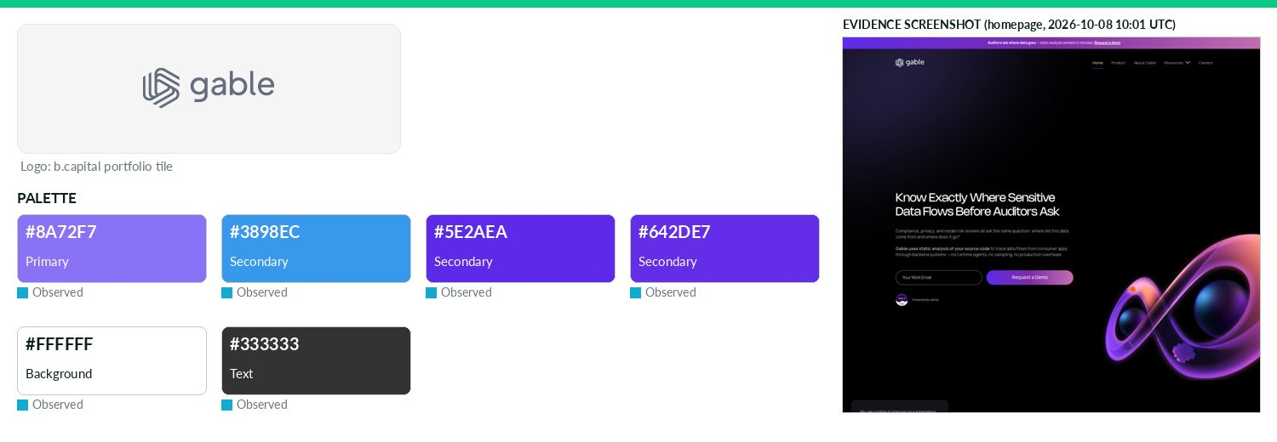
Captured 2026-10-08
Field | Value | Tier | Source
Website | https://www.gable.ai | Verified | b.capital portfolio
LinkedIn | https://www.linkedin.com/company/gable-ai | Observed | official site link
Primary / secondary | #8A72F7 / #3898EC / #5E2AEA / #642DE7 | Observed | https://www.gable.ai (CSS var --old-color--primary--50; 'old
Background / text | #FFFFFF / #333333 | Observed | live CSS body rule
Typography | Aeonik; Nohemi | Observed | https://www.gable.ai (@font-face)
Voice & tone | — | Missing | —
Imagery | — | Missing | —
Clear-space / misuse | — | Missing | —
Trademark | — | Missing | —
Guideline / press kit | — | Missing
HQ / employees | — | Missing | LinkedIn API rate-limited
OnDemand UI tokens | primary #8A72F7 / on #000000 / accent #3898EC / surface #FFFFFF / text #333333 | Derived | contrast 5.83:1 · 12.63:1
Draft note | No official guideline; live-site values. No press/brand pages. | Caveat
Goodfire
Technology & AI · North America · Active · completeness 54% · tier Observed — AI infrastructure platform providing interpretability and control for large generative models.
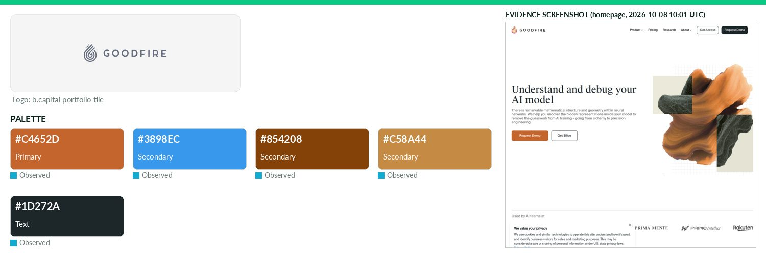
Captured 2026-10-08
Field | Value | Tier | Source
Website | https://www.goodfire.ai | Verified | b.capital portfolio
LinkedIn | https://www.linkedin.com/company/goodfire-ai | Observed | official site link
Primary / secondary | #C4652D / #3898EC / #854208 / #C58A44 | Observed | https://www.goodfire.com/ — most frequent saturated CSS colo
Background / text | — / #1D272A | Observed | live CSS body rule
Typography | Suisse Intl; Suisse Works; IBM Plex Mono | Observed | https://www.goodfire.com (@font-face)
Voice & tone | Research-lab, mission tone: 'AI interpretability research lab'... 'so humanity can trust superintelligence'; public benefit corporation. | Observed | https://www.goodfire.com/company
Imagery | — | Missing | —
Clear-space / misuse | — | Missing | —
Trademark | — | Missing | —
Guideline / press kit | — | Missing
HQ / employees | — | Missing | LinkedIn API rate-limited
OnDemand UI tokens | primary #C4652D / on #000000 / accent #3898EC / surface #FFFFFF / text #1D272A | Derived | contrast 5.25:1 · 15.26:1
Draft note | No official guideline; live-site values. goodfire.ai redirects to goodfire.com. /company exists; no press kit, brand page or logo download. | Caveat
Goose
Technology & AI · North America · Active · completeness 62% · tier Verified — Vertical software platform modernizing operations for pet care businesses.
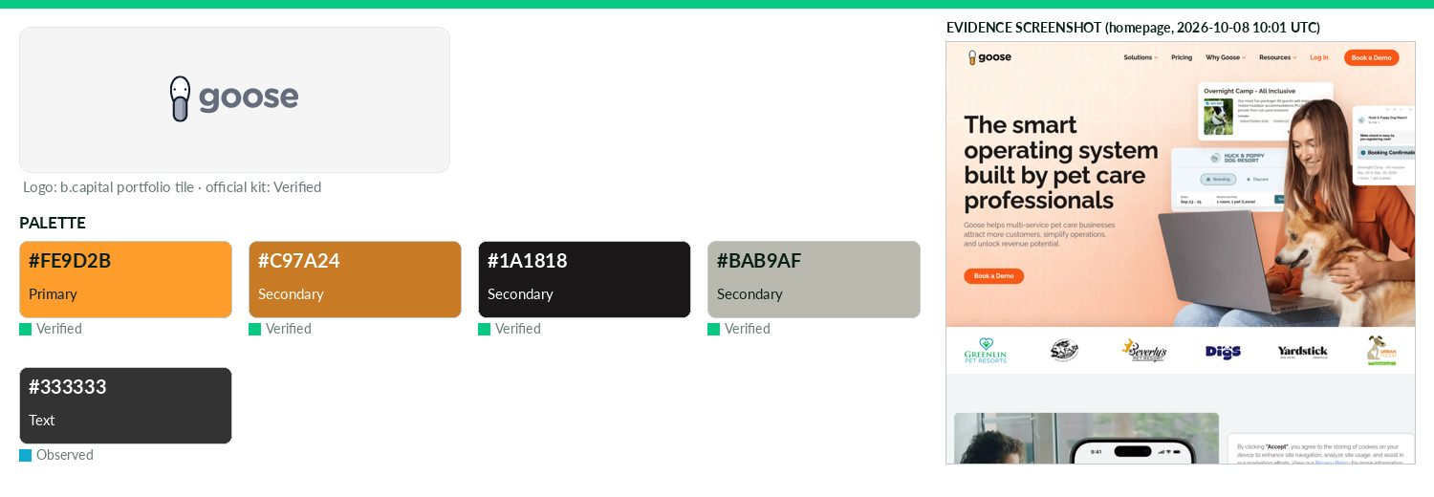
Captured 2026-10-08
Field | Value | Tier | Source
Website | http://www.goose.pet | Verified | b.capital portfolio
LinkedIn | https://www.linkedin.com/company/goose-pet | Observed | official site link
Primary / secondary | #FE9D2B / #C97A24 / #1A1818 / #BAB9AF | Verified | Goose Press Kit.zip Logos/Full_Color_*_RGB.svg (also #f89b2e
Background / text | — / #333333 | Observed | live CSS body rule
Typography | Playfair Display | Observed | https://www.goose.pet (Google Fonts link)
Voice & tone | Playful pet puns: 'We're bound to ruffle some feathers', 'software that makes your tail wag'. | Observed | https://www.goose.pet/press
Imagery | Press kit supplies official photography: dogs, founders, front desk/check-in scenes, product shots. | Verified | https://www.goose.pet/press
Clear-space / misuse | — | Missing | —
Trademark | — | Missing | —
Guideline / press kit | https://www.goose.pet/press | Missing
HQ / employees | — | Missing | LinkedIn API rate-limited
OnDemand UI tokens | primary #FE9D2B / on #000000 / accent #C97A24 / surface #FFFFFF / text #333333 | Derived | contrast 10.07:1 · 12.63:1
Draft note | No official guideline; live-site values. /press-kit redirects to 192MB press kit ZIP (logos SVG, photos). Hexes read from kit logo SVGs (not stated as | Caveat
Grace Investment Machine
Technology & AI · Asia · Active · completeness 54% · tier Observed — GIM (Grace Investment Machine) is building an asset management platform for AGI-era investment machines and full-AI fund managers.
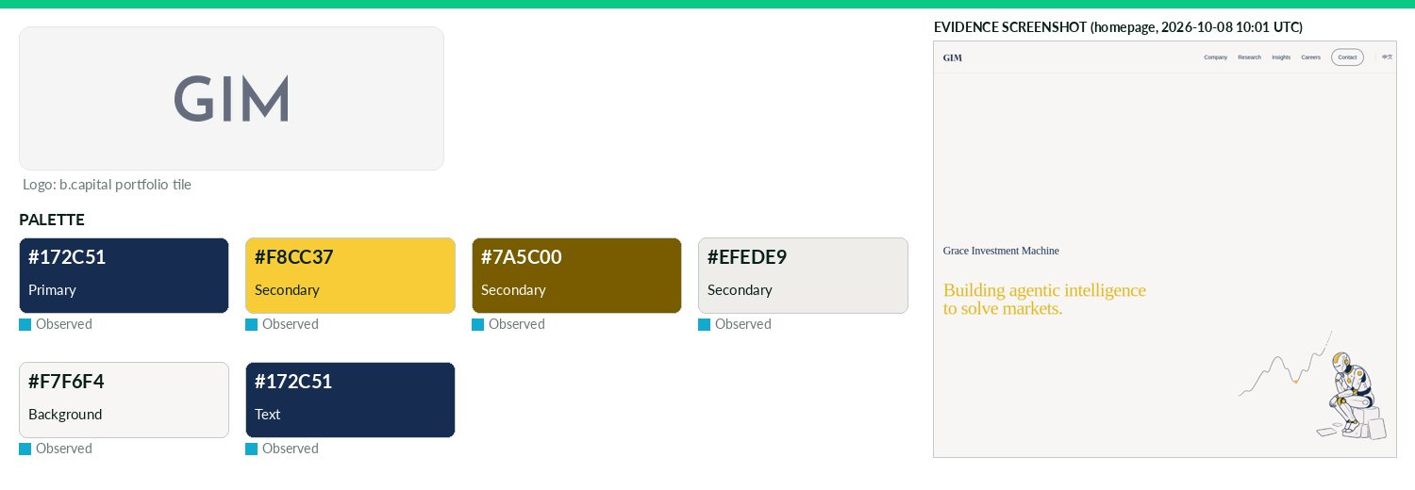
Captured 2026-10-08
Field | Value | Tier | Source
Website | https://graceim.ai | Verified | b.capital portfolio
LinkedIn | https://www.linkedin.com/company/109893320 | Observed | official site link
Primary / secondary | #172C51 / #F8CC37 / #7A5C00 / #EFEDE9 | Observed | https://graceim.ai/ CSS most frequent hex
Background / text | #F7F6F4 / #172C51 | Observed | live CSS body rule
Typography | Financier Display GIM; Josefin Sans GIM; Noto Serif SC | Observed | https://graceim.ai/ @font-face
Voice & tone | — | Missing | —
Imagery | — | Missing | —
Clear-space / misuse | — | Missing | —
Trademark | Brand 'Grace Investment Machine (GIM)', legal name GIM INTELLIGENCE PTE. LTD.; approved brand assets on reques | Verified | https://graceim.ai/media-kit/
Guideline / press kit | https://graceim.ai/media-kit/ | Missing
HQ / employees | — | Missing | LinkedIn API rate-limited
OnDemand UI tokens | primary #172C51 / on #FFFFFF / accent #F8CC37 / surface #F7F6F4 / text #172C51 | Derived | contrast 13.86:1 · 12.83:1
Draft note | No official guideline; live-site values. Media kit page is text only (company details, boilerplate); no downloadable logos/colours. | Caveat
Gushwork
Technology & AI · Asia · Active · completeness 46% · tier Observed — AI marketing agent platform generating inbound leads from generative search engines for small and medium business.
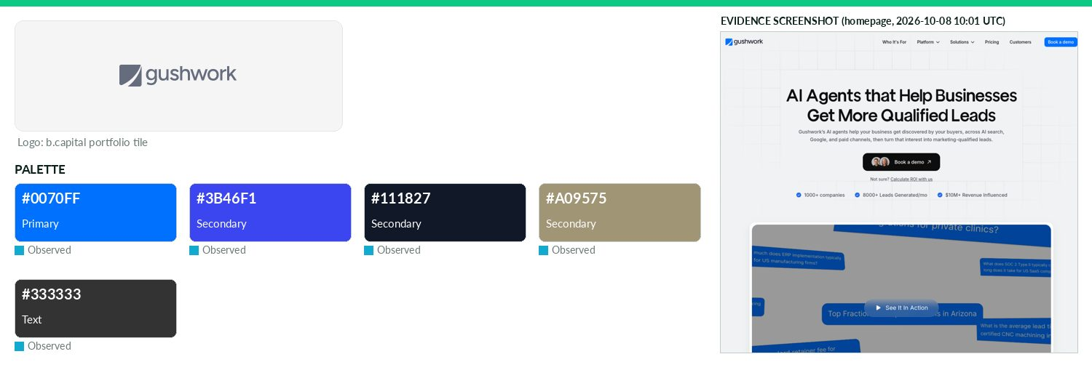
Captured 2026-10-08
Field | Value | Tier | Source
Website | https://www.gushwork.ai | Verified | b.capital portfolio
LinkedIn | https://www.linkedin.com/company/gushwork | Observed | official site link
Primary / secondary | #0070FF / #3B46F1 / #111827 / #A09575 | Observed | gushwork.ai CSS var --_new-style-guide---colors--primary--50
Background / text | — / #333333 | Observed | live CSS body rule
Typography | Vert Grotesk Display; Inter; Open Sans | Observed | https://www.gushwork.ai/ — CSS font-family/@font-face
Voice & tone | — | Missing | —
Imagery | — | Missing | —
Clear-space / misuse | — | Missing | —
Trademark | — | Missing | —
Guideline / press kit | — | Missing
HQ / employees | — | Missing | LinkedIn API rate-limited
OnDemand UI tokens | primary #0070FF / on #000000 / accent #3B46F1 / surface #FFFFFF / text #333333 | Derived | contrast 4.76:1 · 12.63:1
Draft note | No official guideline; live-site values. /brand-memory is a product feature page, not a brand guide. No press kit. | Caveat
HavocAI
Technology & AI · North America · Active · completeness 46% · tier Observed — Delivers integrated hardware, software and logistics that enable collaborative, autonomous maritime operations.
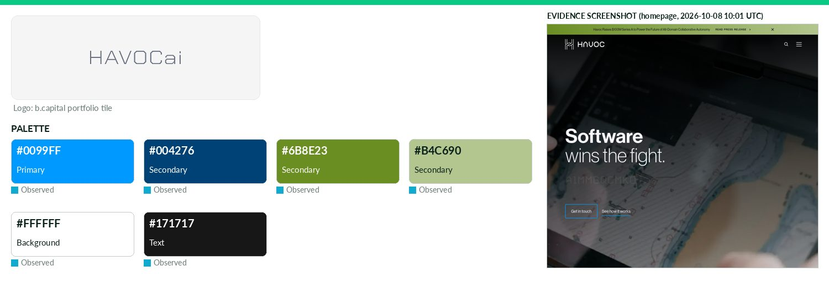
Captured 2026-10-08
Field | Value | Tier | Source
Website | https://www.havocai.com | Verified | b.capital portfolio
LinkedIn | https://www.linkedin.com/company/havocai | Observed | official site link
Primary / secondary | #0099FF / #004276 / #6B8E23 / #B4C690 | Observed | https://www.havocai.com/ — most frequent saturated CSS colou
Background / text | #FFFFFF / #171717 | Observed | live CSS body rule
Typography | Geist; Geist Mono; Inter; IBM Plex Sans | Observed | https://www.havocai.com (@font-face)
Voice & tone | — | Missing | —
Imagery | — | Missing | —
Clear-space / misuse | — | Missing | —
Trademark | — | Missing | —
Guideline / press kit | — | Missing
HQ / employees | — | Missing | LinkedIn API rate-limited
OnDemand UI tokens | primary #0099FF / on #000000 / accent #004276 / surface #FFFFFF / text #171717 | Derived | contrast 7.0:1 · 17.93:1
Draft note | No official guideline; live-site values. Site returns 200 soft-404 for any path (incl. /brand, /press-kit, nonexistent URL) - no real brand/press pages | Caveat
HeyLibby
Technology & AI · North America · Active · completeness 38% · tier Observed — AI receptionist platform automating customer engagement and other tasks across chat, phone and email.
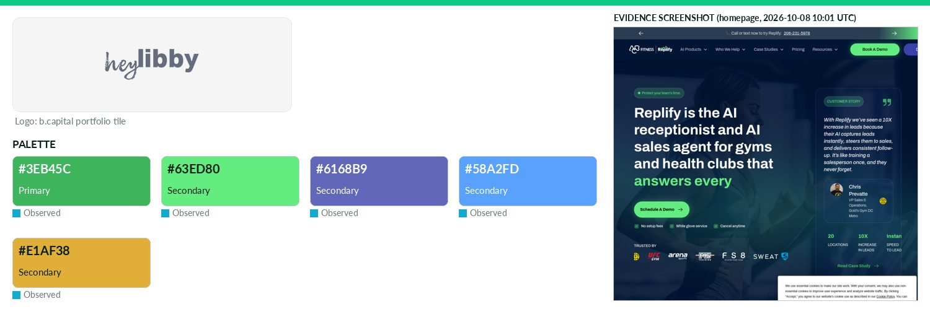
Captured 2026-10-08
Field | Value | Tier | Source
Website | https://www.heylibby.ai | Verified | b.capital portfolio
LinkedIn | https://www.linkedin.com/company/replify-ai | Observed | official site link
Primary / secondary | #3EB45C / #63ED80 / #6168B9 / #58A2FD / #E1AF38 | Observed | https://www.replify.ai CSS var --_primitives---colors--accen
Background / text | — | Missing | —
Typography | Dm Sans; Archivo | Observed | https://www.replify.ai @font-face
Voice & tone | — | Missing | —
Imagery | — | Missing | —
Clear-space / misuse | — | Missing | —
Trademark | — | Missing | —
Guideline / press kit | — | Missing
HQ / employees | — | Missing | LinkedIn API rate-limited
OnDemand UI tokens | primary #3EB45C / on #000000 / accent #63ED80 / surface #FFFFFF / text #111111 | Derived | contrast 7.89:1 · 18.88:1
Draft note | No official guideline; live-site values. heylibby.ai redirects to replify.ai (rebranded Replify, formerly heyLibby). No press/brand pages. | Caveat
Hypersonix
Technology & AI · North America · Active · completeness 62% · tier Verified — Agentic AI platform automating pricing, promotions and inventory decisions to drive profitable growth for commerce brands.
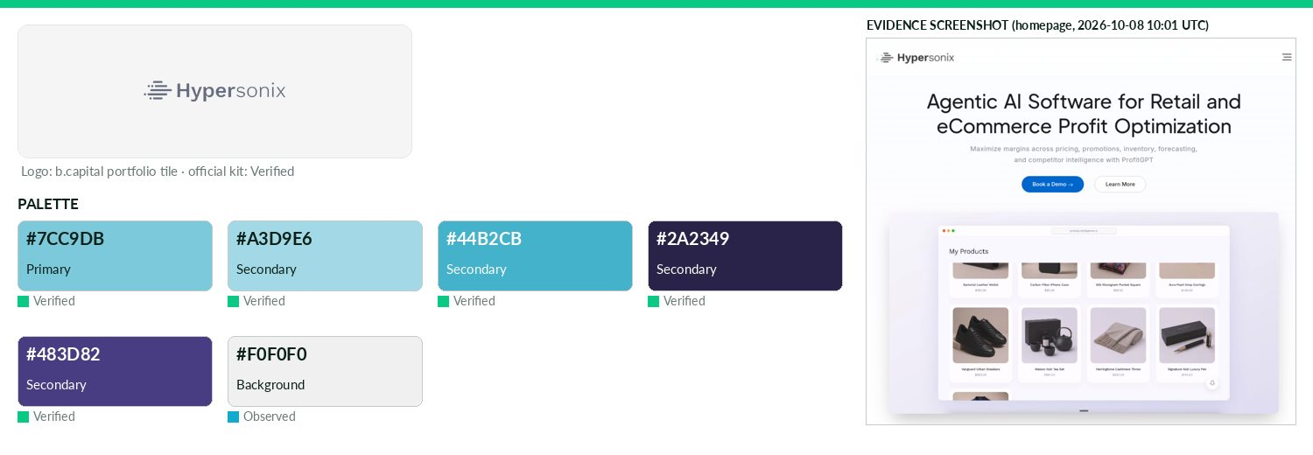
Captured 2026-10-08
Field | Value | Tier | Source
Website | https://hypersonix.ai | Verified | b.capital portfolio
LinkedIn | https://www.linkedin.com/company/hypersonix-ai | Observed | official site link
Primary / secondary | #7CC9DB / #A3D9E6 / #44B2CB / #2A2349 / #483D82 | Verified | Media kit PDF 'Primary' HEX 7CC9DB (also A3D9E6, 44B2CB)
Background / text | #F0F0F0 / — | Observed | live CSS body rule
Typography | Work Sans | Verified | Media kit PDF: 'Our brand font, Work Sans'
Voice & tone | — | Missing | —
Imagery | — | Missing | —
Clear-space / misuse | Logo must have negative space of minimum 20px on all sides. | Verified | Media kit PDF
Trademark | — | Missing | —
Guideline / press kit | https://hypersonix.ai/hubfs/Hypersonix_February_2024/documents/Hx-Media-Kit.zip?hsLang=en (Brand Guidelines an | Verified
HQ / employees | — | Missing | LinkedIn API rate-limited
OnDemand UI tokens | primary #7CC9DB / on #000000 / accent #A3D9E6 / surface #F0F0F0 / text #111111 | Derived | contrast 11.23:1 · 16.57:1
Icertis
Technology & AI · North America · Active · completeness 46% · tier Observed — AI-powered platform transforming contract lifecycle management for global enterprises.
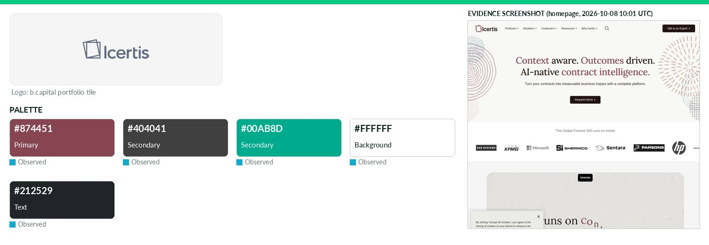
Captured 2026-10-08
Field | Value | Tier | Source
Website | https://www.icertis.com | Verified | b.capital portfolio
LinkedIn | https://www.linkedin.com/company/icertis | Observed | official site link
Primary / secondary | #874451 / #404041 / #00AB8D | Observed | https://www.icertis.com/ CSS var --bs-primary
Background / text | #FFFFFF / #212529 | Observed | live CSS body rule
Typography | lora; inter-18pt; inter-24pt; inter-28pt | Observed | https://www.icertis.com/ @font-face
Voice & tone | — | Missing | —
Imagery | — | Missing | —
Clear-space / misuse | — | Missing | —
Trademark | — | Missing | —
Guideline / press kit | — | Missing
HQ / employees | — | Missing | LinkedIn API rate-limited
OnDemand UI tokens | primary #874451 / on #FFFFFF / accent #404041 / surface #FFFFFF / text #212529 | Derived | contrast 7.06:1 · 15.43:1
Draft note | No official guideline; live-site values. Only /company/news/ newsroom found; /brand, /press, media-kit 404. No brand guideline. | Caveat
InfraHub
Technology & AI · North America · Active · completeness 46% · tier Observed — AI-powered road infrastructure platform automating assessments and enabling data-driven asset management
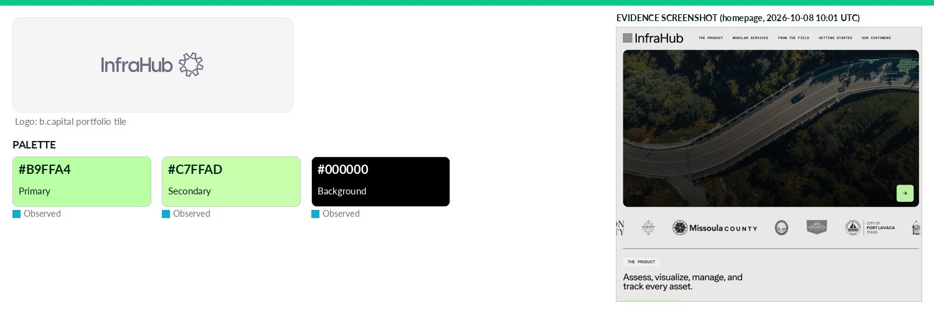
Captured 2026-10-08
Field | Value | Tier | Source
Website | https://www.infrahub.ai | Verified | b.capital portfolio
LinkedIn | https://www.linkedin.com/company/infrahub-ai | Observed | official site link
Primary / secondary | #B9FFA4 / #C7FFAD | Observed | https://www.infrahub.com/ CSS var --color-interactive-accent
Background / text | #000000 / — | Observed | live CSS body rule
Typography | Ease Standard; Azeret Mono | Observed | https://www.infrahub.com/ @font-face
Voice & tone | — | Missing | —
Imagery | — | Missing | —
Clear-space / misuse | — | Missing | —
Trademark | — | Missing | —
Guideline / press kit | — | Missing
HQ / employees | — | Missing | LinkedIn API rate-limited
OnDemand UI tokens | primary #B9FFA4 / on #000000 / accent #C7FFAD / surface #000000 / text #111111 | Derived | contrast 17.9:1 · 1.11:1
Draft note | No official guideline; live-site values. infrahub.ai redirects to infrahub.com. No press/brand pages. | Caveat
Inspace
Technology & AI · Asia · Active · completeness 46% · tier Observed — Property visualization technology platform enabling immersive digital real estate experiences.
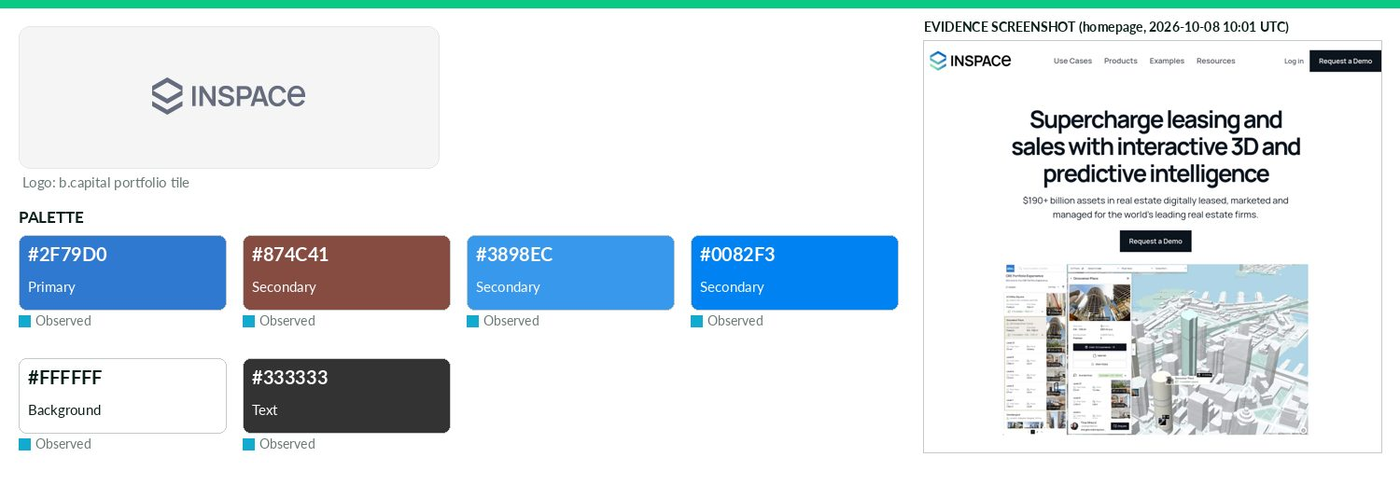
Captured 2026-10-08
Field | Value | Tier | Source
Website | http://inspacestack.com | Verified | b.capital portfolio
LinkedIn | https://au.linkedin.com/company/inspacexr | Observed | official site link
Primary / secondary | #2F79D0 / #874C41 / #3898EC / #0082F3 | Observed | https://www.inspace.ai/ — most frequent saturated CSS colour
Background / text | #FFFFFF / #333333 | Observed | live CSS body rule
Typography | Manrope | Observed | https://www.inspace.ai/ — CSS font-family/@font-face
Voice & tone | — | Missing | —
Imagery | — | Missing | —
Clear-space / misuse | — | Missing | —
Trademark | — | Missing | —
Guideline / press kit | — | Missing
HQ / employees | — | Missing | LinkedIn API rate-limited
OnDemand UI tokens | primary #2F79D0 / on #000000 / accent #874C41 / surface #FFFFFF / text #333333 | Derived | contrast 4.77:1 · 12.63:1
Draft note | No official guideline; live-site values. inspacestack.com redirects to inspace.ai. No press/brand pages. | Caveat
Iru
Technology & AI · North America · Active · completeness 38% · tier Observed — Apple-focused device management and security platform automating compliance and endpoint protection.
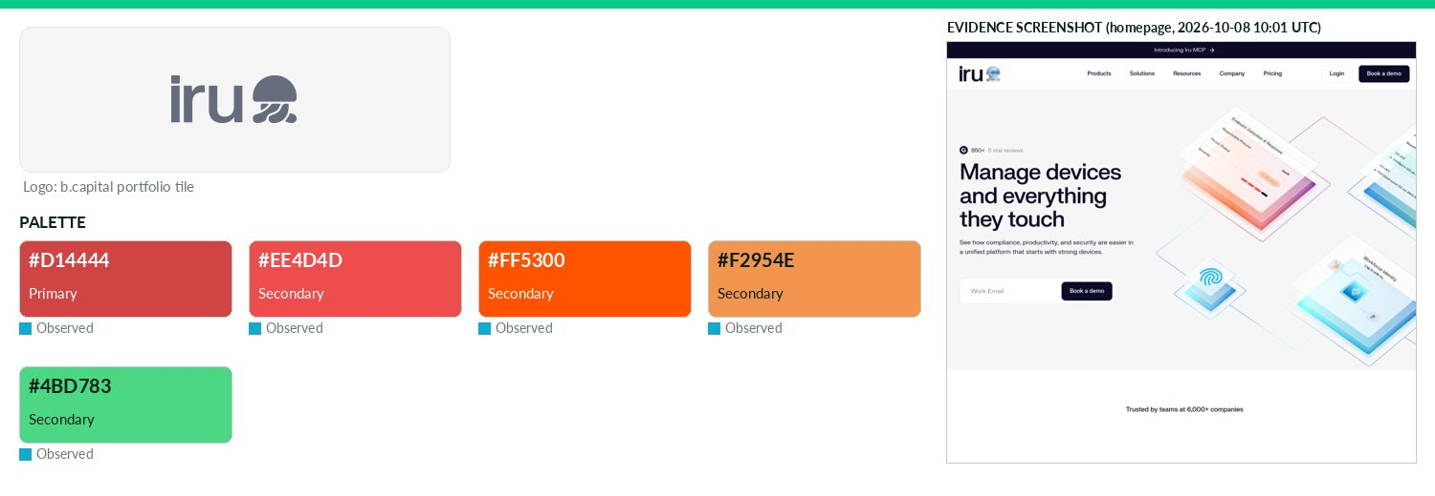
Captured 2026-10-08
Field | Value | Tier | Source
Website | https://www.iru.com | Verified | b.capital portfolio
LinkedIn | https://www.linkedin.com/company/officiallyiru | Observed | official site link
Primary / secondary | #D14444 / #EE4D4D / #FF5300 / #F2954E / #4BD783 | Observed | https://www.iru.com/ CSS var --color-brand-red
Background / text | — | Missing | —
Typography | FK Grotesk Neue | Observed | https://www.iru.com/ @font-face
Voice & tone | — | Missing | —
Imagery | — | Missing | —
Clear-space / misuse | — | Missing | —
Trademark | — | Missing | —
Guideline / press kit | — | Missing
HQ / employees | — | Missing | LinkedIn API rate-limited
OnDemand UI tokens | primary #D14444 / on #000000 / accent #EE4D4D / surface #FFFFFF / text #111111 | Derived | contrast 4.62:1 · 18.88:1
Draft note | No official guideline; live-site values. Formerly Kandji. /newsroom redirects to 'Kandji now Iru' announcement; /brand,/press,/media-kit 404. | Caveat
Khatabook
Technology & AI · Asia · Active · completeness 15% · tier Observed — Fintech startup that provides a digital ledger for small businesses to manage all business transactions.
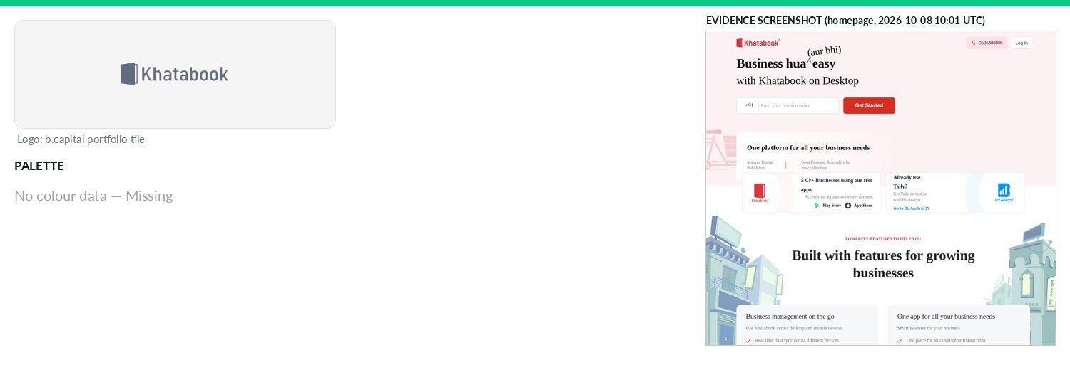
Captured 2026-10-08
Field | Value | Tier | Source
Website | http://khatabook.com | Verified | b.capital portfolio
LinkedIn | — | Missing | API 429/403
Primary / secondary | — | Missing | —
Background / text | — | Missing | —
Typography | Proxima Nova; Inter; Source Sans Pro; Noto Sans | Observed | https://khatabook.com/about/ @font-face + homepage Google Fo
Voice & tone | — | Missing | —
Imagery | — | Missing | —
Clear-space / misuse | — | Missing | —
Trademark | — | Missing | —
Guideline / press kit | — | Missing
HQ / employees | — | Missing | LinkedIn API rate-limited
Draft note | No official guideline; live-site values. No brand/press/media pages (404); /newsroom redirects to home. Homepage is a JS shell; CSS vars are Bootstrap | Caveat
Knox
Technology & AI · North America · Active · completeness 38% · tier Observed — FedRAMP-authorized managed cloud platform accelerating federal security compliance for software vendors.
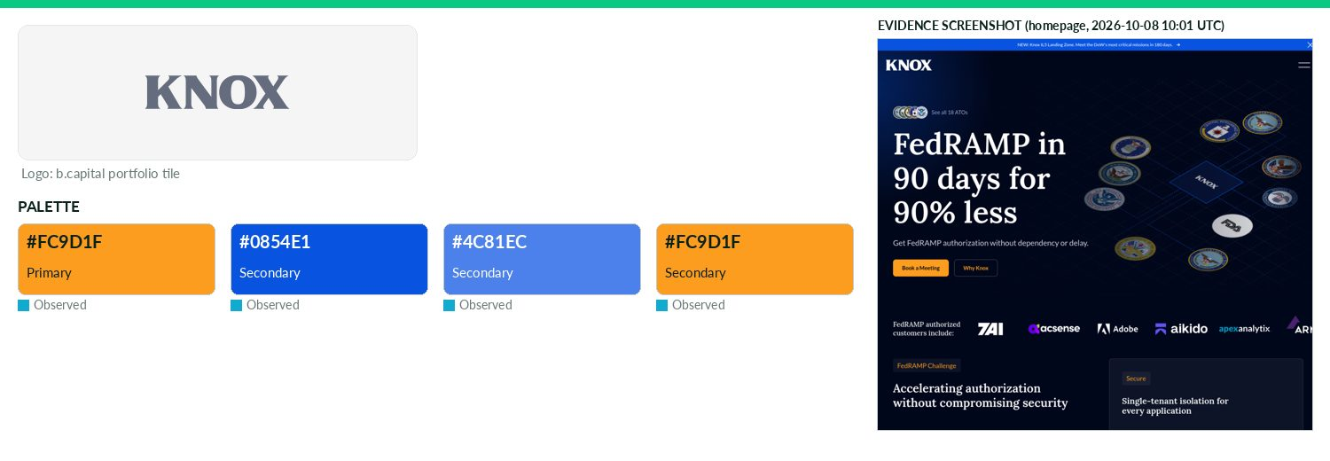
Captured 2026-10-08
Field | Value | Tier | Source
Website | https://www.knoxsystems.com | Verified | b.capital portfolio
LinkedIn | https://www.linkedin.com/company/knox-systems-inc | Observed | official site link
Primary / secondary | #FC9D1F / #0854E1 / #4C81EC / #FC9D1F | Observed | https://knoxsystems.com/ CSS var --swatch--brand
Background / text | — | Missing | —
Typography | Lora; Gantari; Lato; Jetbrainsmono Variablefont Wght | Observed | https://knoxsystems.com/ @font-face
Voice & tone | — | Missing | —
Imagery | — | Missing | —
Clear-space / misuse | — | Missing | —
Trademark | — | Missing | —
Guideline / press kit | — | Missing
HQ / employees | — | Missing | LinkedIn API rate-limited
OnDemand UI tokens | primary #FC9D1F / on #000000 / accent #0854E1 / surface #FFFFFF / text #111111 | Derived | contrast 9.98:1 · 18.88:1
Draft note | No official guideline; live-site values. No press/brand pages found. | Caveat
Labelbox
Technology & AI · North America · Active · completeness 46% · tier Observed — AI-powered data training platform that creates and manages labeled data for machine learning applications.
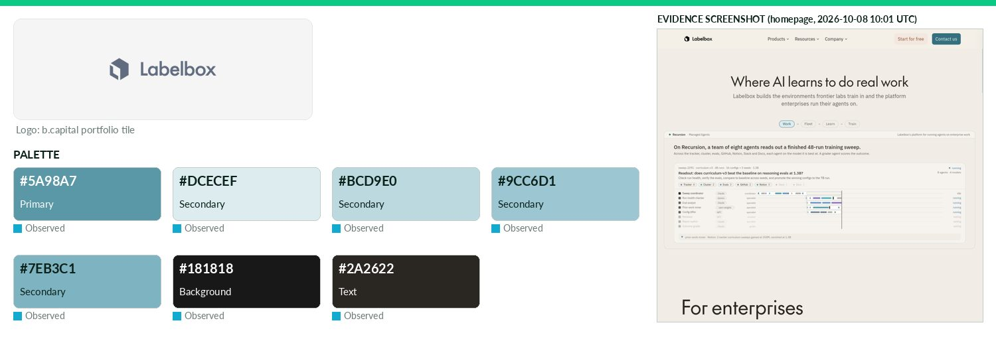
Captured 2026-10-08
Field | Value | Tier | Source
Website | https://labelbox.com | Verified | b.capital portfolio
LinkedIn | https://www.linkedin.com/company/labelbox | Observed | official site link
Primary / secondary | #5A98A7 / #DCECEF / #BCD9E0 / #9CC6D1 / #7EB3C1 | Observed | https://labelbox.com/ CSS var --lb-color-primary-500
Background / text | #181818 / #2A2622 | Observed | live CSS body rule
Typography | IBM Plex Sans; The Future mono; IBM Plex Mono; The Future | Observed | https://labelbox.com/ — CSS font-family/@font-face
Voice & tone | — | Missing | —
Imagery | — | Missing | —
Clear-space / misuse | — | Missing | —
Trademark | — | Missing | —
Guideline / press kit | — | Missing
HQ / employees | — | Missing | LinkedIn API rate-limited
OnDemand UI tokens | primary #5A98A7 / on #000000 / accent #DCECEF / surface #181818 / text #2A2622 | Derived | contrast 6.48:1 · 1.18:1
Draft note | No official guideline; live-site values. /press,/brand,/media-kit,/newsroom 404. | Caveat
LinKMORE
Technology & AI · Asia · Active · completeness 8% · tier Third-party — SaaS platform streamlining supply chain management for the apparel industry.
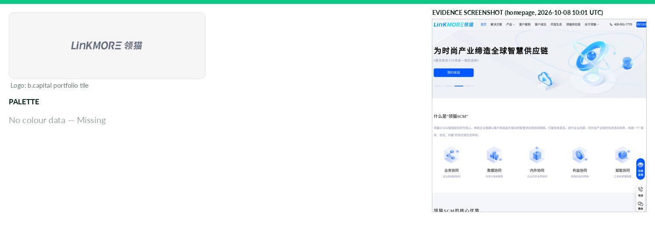
Captured 2026-10-08
Field | Value | Tier | Source
Website | http://cnunify.com | Verified | b.capital portfolio
LinkedIn | — | Missing | API 429/403
Primary / secondary | — | Missing | —
Background / text | — | Missing | —
Typography | — | Missing | —
Voice & tone | — | Missing | —
Imagery | — | Missing | —
Clear-space / misuse | — | Missing | —
Trademark | — | Missing | —
Guideline / press kit | — | Missing
HQ / employees | — | Missing | LinkedIn API rate-limited
Draft note | No official guideline; live-site values. Site unreachable. | Caveat
Miotech
Technology & AI · Asia · Active · completeness 38% · tier Observed — AI-powered platform providing sustainability and ESG data and analytics solutions.
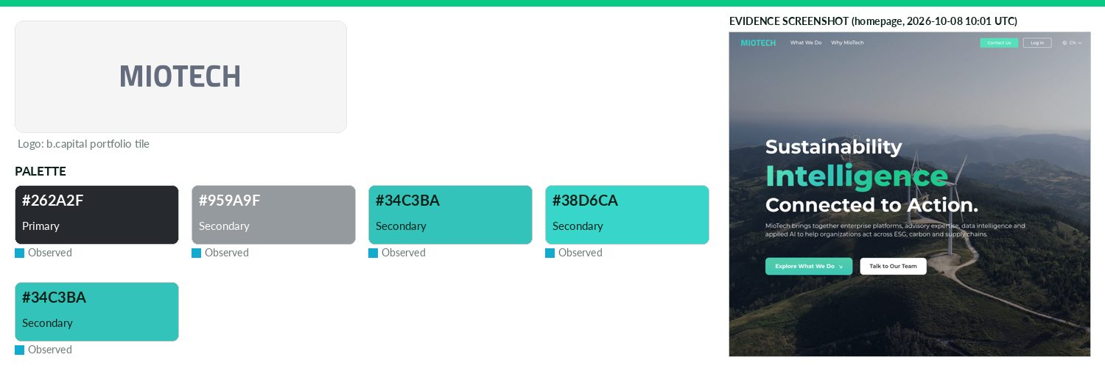
Captured 2026-10-08
Field | Value | Tier | Source
Website | https://www.miotech.com | Verified | b.capital portfolio
LinkedIn | https://www.linkedin.com/company/miotech | Observed | official site link
Primary / secondary | #262A2F / #959A9F / #34C3BA / #38D6CA / #34C3BA | Observed | https://www.miotech.com/zh-CN CSS var --primary
Background / text | — | Missing | —
Typography | Geist; Montserrat; MF FangHei | Observed | https://www.miotech.com/zh-CN @font-face
Voice & tone | — | Missing | —
Imagery | — | Missing | —
Clear-space / misuse | — | Missing | —
Trademark | — | Missing | —
Guideline / press kit | — | Missing
HQ / employees | — | Missing | LinkedIn API rate-limited
OnDemand UI tokens | primary #262A2F / on #FFFFFF / accent #959A9F / surface #FFFFFF / text #111111 | Derived | contrast 14.44:1 · 18.88:1
Draft note | No official guideline; live-site values. No press/brand pages found. | Caveat
Mswipe
Technology & AI · Asia · Active · completeness 46% · tier Observed — Point-of-sale platform enabling merchants to accept payments across multiple methods and channels.
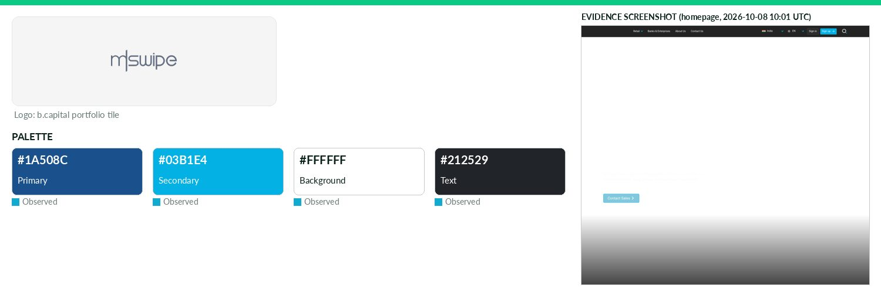
Captured 2026-10-08
Field | Value | Tier | Source
Website | http://mswipe.com | Verified | b.capital portfolio
LinkedIn | https://www.linkedin.com/company/mswipe-technologies | Observed | official site link
Primary / secondary | #1A508C / #03B1E4 | Observed | https://www.mswipe.com/ CSS var --primary-color
Background / text | #FFFFFF / #212529 | Observed | live CSS body rule
Typography | Roboto; Liberation Sans | Observed | https://www.mswipe.com:443/ — CSS font-family/@font-face
Voice & tone | — | Missing | —
Imagery | — | Missing | —
Clear-space / misuse | — | Missing | —
Trademark | — | Missing | —
Guideline / press kit | — | Missing
HQ / employees | — | Missing | LinkedIn API rate-limited
OnDemand UI tokens | primary #1A508C / on #FFFFFF / accent #03B1E4 / surface #FFFFFF / text #212529 | Derived | contrast 8.17:1 · 15.43:1
Draft note | No official guideline; live-site values. Press releases only at https://www.mswipe.com/knowledge?type=pressRelease; no brand kit. Fonts in CSS are icon | Caveat
Nektar.AI
Technology & AI · Asia · Active · completeness 46% · tier Observed — AI-powered RevOps platform eliminating manual data entry and surfacing real-time sales insights.
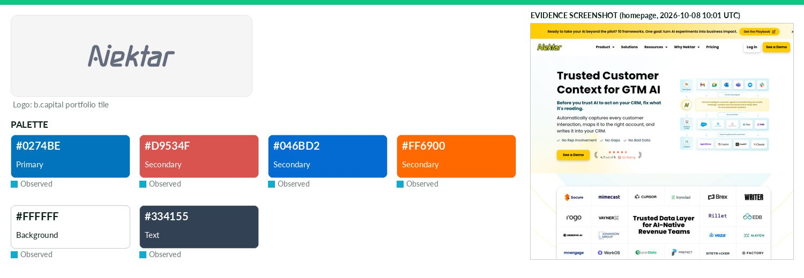
Captured 2026-10-08
Field | Value | Tier | Source
Website | http://nektar.ai | Verified | b.capital portfolio
LinkedIn | https://www.linkedin.com/company/nektar-ai | Observed | official site link
Primary / secondary | #0274BE / #D9534F / #046BD2 / #FF6900 | Observed | https://nektar.ai/ — most frequent saturated CSS colour (9 u
Background / text | #FFFFFF / #334155 | Observed | live CSS body rule
Typography | Fraunces | Observed | https://nektar.ai/ — CSS font-family/@font-face
Voice & tone | — | Missing | —
Imagery | — | Missing | —
Clear-space / misuse | — | Missing | —
Trademark | — | Missing | —
Guideline / press kit | — | Missing
HQ / employees | — | Missing | LinkedIn API rate-limited
OnDemand UI tokens | primary #0274BE / on #FFFFFF / accent #D9534F / surface #FFFFFF / text #334155 | Derived | contrast 4.95:1 · 10.35:1
Draft note | No official guideline; live-site values. No press/brand pages found. | Caveat
Odeko
Technology & AI · North America · Active · completeness 38% · tier Observed — Technology-enabled platform optimizing back-office operations for independent cafes and coffee shops.
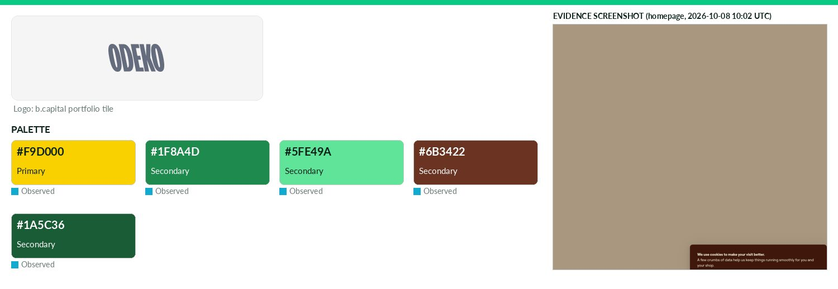
Captured 2026-10-08
Field | Value | Tier | Source
Website | https://www.odeko.com | Verified | b.capital portfolio
LinkedIn | https://www.linkedin.com/company/officialodeko | Observed | official site link
Primary / secondary | #F9D000 / #1F8A4D / #5FE49A / #6B3422 / #1A5C36 | Observed | https://www.odeko.com/ (site CSS)
Background / text | — | Missing | —
Typography | Roobert; Residenz Grotesk | Observed | https://www.odeko.com/ (@font-face/CSS)
Voice & tone | — | Missing | —
Imagery | — | Missing | —
Clear-space / misuse | — | Missing | —
Trademark | — | Missing | —
Guideline / press kit | — | Missing
HQ / employees | — | Missing | LinkedIn API rate-limited
OnDemand UI tokens | primary #F9D000 / on #000000 / accent #1F8A4D / surface #FFFFFF / text #111111 | Derived | contrast 14.05:1 · 18.88:1
Draft note | No official guideline; live-site values. No brand/press/media-kit page found at standard paths (/brand,/press,/press-kit,/media-kit,/media,/newsroom). | Caveat
Oro Labs
Technology & AI · North America · Active · completeness 38% · tier Observed — AI-native procurement orchestration platform streamlining workflows and improving end-to-end process visibility.
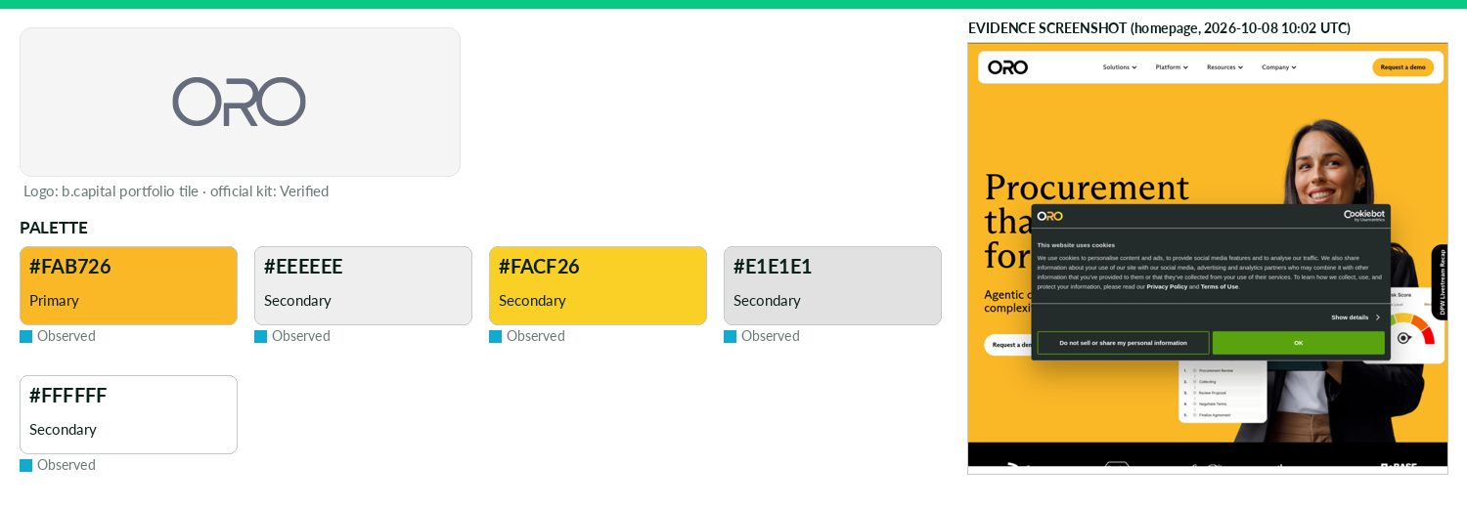
Captured 2026-10-08
Field | Value | Tier | Source
Website | http://orolabs.ai | Verified | b.capital portfolio
LinkedIn | https://www.linkedin.com/company/procurewithoro | Observed | official site link
Primary / secondary | #FAB726 / #EEEEEE / #FACF26 / #E1E1E1 / #FFFFFF | Observed | https://www.orolabs.ai/ CSS var --primary-green
Background / text | — | Missing | —
Typography | Abcarizonasans; Abcarizonamix | Observed | https://www.orolabs.ai/ @font-face
Voice & tone | — | Missing | —
Imagery | — | Missing | —
Clear-space / misuse | — | Missing | —
Trademark | — | Missing | —
Guideline / press kit | https://www.orolabs.ai/resource/media-kit | Missing
HQ / employees | — | Missing | LinkedIn API rate-limited
OnDemand UI tokens | primary #FAB726 / on #000000 / accent #EEEEEE / surface #FFFFFF / text #111111 | Derived | contrast 11.87:1 · 18.88:1
Draft note | No official guideline; live-site values. Media kit = logos + boilerplate PDF only; no colour/type guideline. Colours/fonts Observed from CSS. | Caveat
PaleBlueDot
Technology & AI · North America · Active · completeness 46% · tier Observed — PaleBlueDot Al is a leading Al Cloud Agent platform dedicated to connecting and empowering Al cloud resource suppliers and customers.
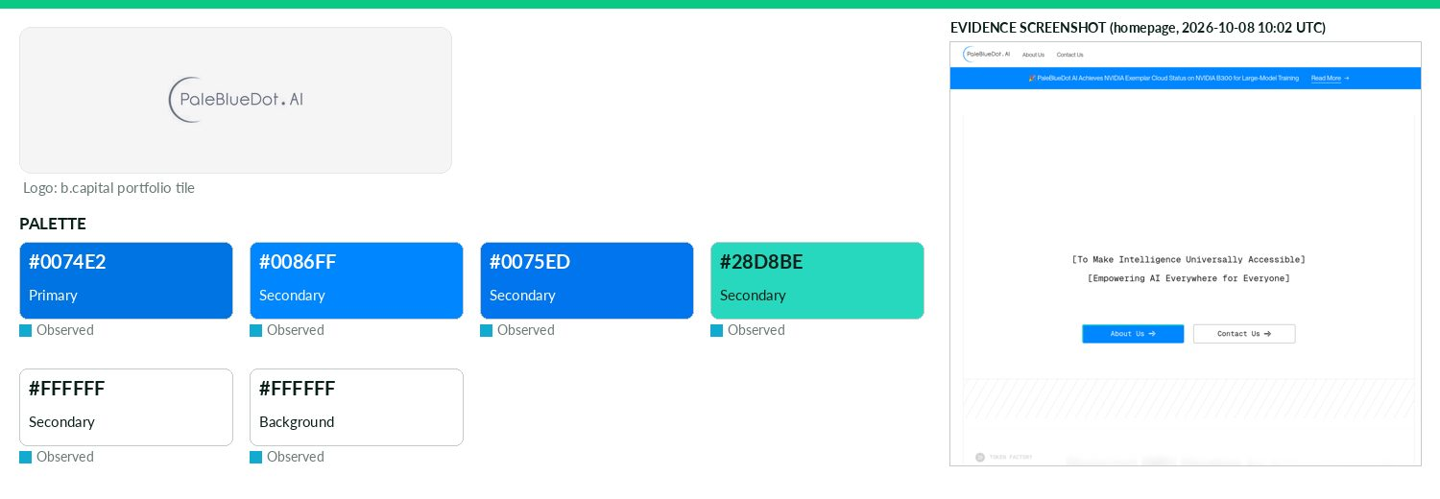
Captured 2026-10-08
Field | Value | Tier | Source
Website | https://www.palebluedot.ai | Verified | b.capital portfolio
LinkedIn | https://www.linkedin.com/company/palebluedot-ai | Observed | official site link
Primary / secondary | #0074E2 / #0086FF / #0075ED / #28D8BE / #FFFFFF | Observed | https://www.palebluedot.ai/ CSS var --color-accent
Background / text | #FFFFFF / — | Observed | live CSS body rule
Typography | PP Neue Montreal; Geist Mono | Observed | https://www.palebluedot.ai/ @font-face
Voice & tone | — | Missing | —
Imagery | — | Missing | —
Clear-space / misuse | — | Missing | —
Trademark | — | Missing | —
Guideline / press kit | — | Missing
HQ / employees | — | Missing | LinkedIn API rate-limited
OnDemand UI tokens | primary #0074E2 / on #000000 / accent #0086FF / surface #FFFFFF / text #111111 | Derived | contrast 4.6:1 · 18.88:1
Draft note | No official guideline; live-site values. SPA serves homepage for every path (incl. nonexistent) - all /brand,/press etc. are soft-404. /newsRoom has ne | Caveat
PAYFAZZ
Technology & AI · Asia · Active · completeness 46% · tier Observed — Digital financial services platform providing payments, savings and lending to underserved businesses in Southeast Asia.
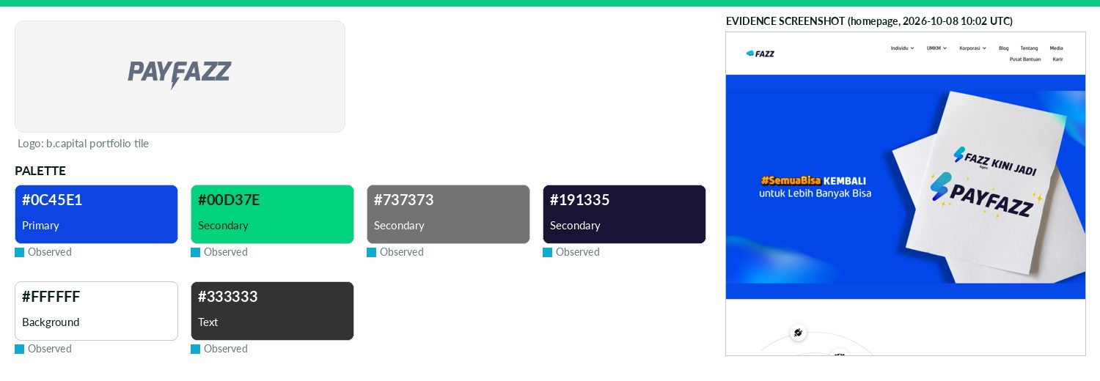
Captured 2026-10-08
Field | Value | Tier | Source
Website | http://payfazz.com | Verified | b.capital portfolio
LinkedIn | http://linkedin.com/company/fazz-financial-group | Observed | official site link
Primary / secondary | #0C45E1 / #00D37E / #737373 / #191335 | Observed | https://fazz.com/ CSS var --e-global-color-primary
Background / text | #FFFFFF / #333333 | Observed | live CSS body rule
Typography | Fazz Neue | Observed | https://fazz.com/ @font-face
Voice & tone | — | Missing | —
Imagery | — | Missing | —
Clear-space / misuse | — | Missing | —
Trademark | — | Missing | —
Guideline / press kit | — | Missing
HQ / employees | — | Missing | LinkedIn API rate-limited
OnDemand UI tokens | primary #0C45E1 / on #FFFFFF / accent #00D37E / surface #FFFFFF / text #333333 | Derived | contrast 7.11:1 · 12.63:1
Draft note | No official guideline; live-site values. payfazz.com unreachable; brand now Fazz (fazz.com). https://fazz.com/media/ is a press-coverage page, no brand | Caveat
Pendo
Technology & AI · North America · Active · completeness 85% · tier Verified — User engagement platform combining usage insights and in-app support to increase adoption.
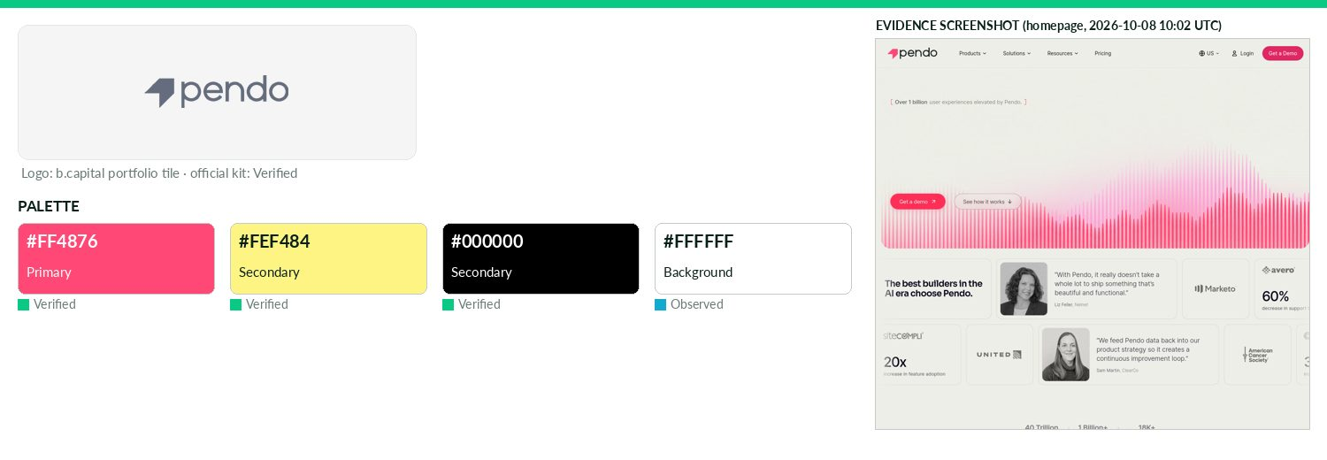
Captured 2026-10-08
Field | Value | Tier | Source
Website | https://www.pendo.io | Verified | b.capital portfolio
LinkedIn | https://www.linkedin.com/company/pendo-io | Observed | official site link
Primary / secondary | #FF4876 / #FEF484 / #000000 | Verified | https://www.pendo.io/brand-guide/color/ 'Pank' RGB 255,72,11
Background / text | #FFFFFF / — | Observed | live CSS body rule
Typography | Sora; Inter | Verified | https://www.pendo.io/brand-guide/typography/ (Sora display,
Voice & tone | Sora described as 'analytical yet approachable'; no dedicated voice section found. | Observed | https://www.pendo.io/brand-guide/typography/
Imagery | Photography tells stories of real people interacting with technology; authentic, inviting, diverse; high-res o | Verified | https://www.pendo.io/brand-guide/photography/
Clear-space / misuse | Clearspace = 1x chevron around lockup (0.5x for chevron alone); chevron only white or pink, never sole logomark on outwa | Verified | https://www.pendo.io/brand-guide/logo/
Trademark | Pendo trademarks, product names, logos are trademarks of Pendo.io, Inc. and may not be used without permission | Verified | https://www.pendo.io/media-kit/ footer
Guideline / press kit | https://www.pendo.io/brand-guide/logo/ | Verified
HQ / employees | — | Missing | LinkedIn API rate-limited
OnDemand UI tokens | primary #FF4876 / on #000000 / accent #FEF484 / surface #FFFFFF / text #111111 | Derived | contrast 6.44:1 · 18.88:1
Percent
Technology & AI · North America · Active · completeness 46% · tier Observed — Investment platform enabling individuals to access alternative assets and diversify portfolios.
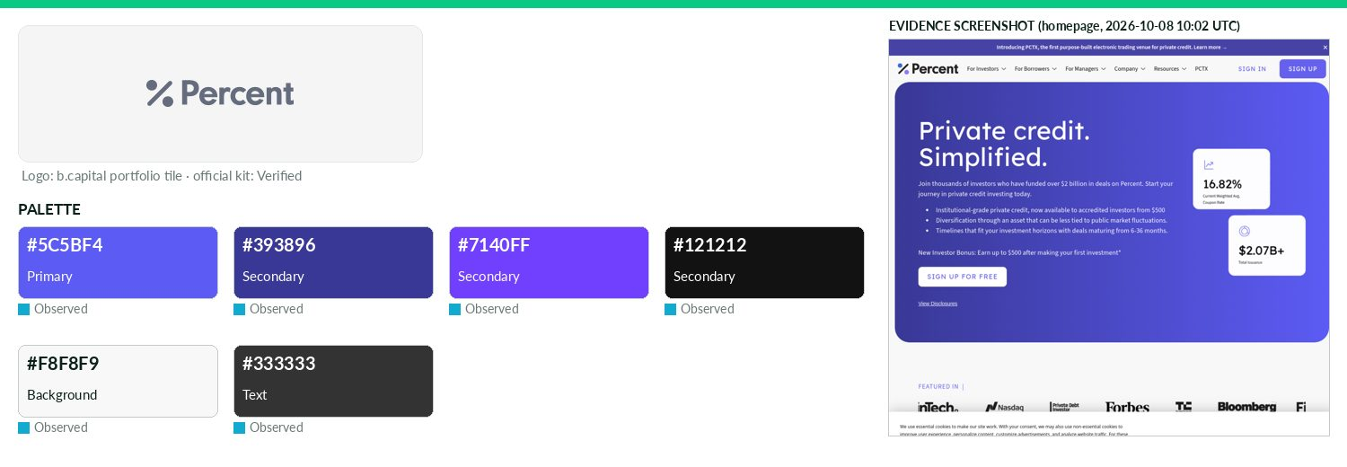
Captured 2026-10-08
Field | Value | Tier | Source
Website | https://percent.com | Verified | b.capital portfolio
LinkedIn | https://www.linkedin.com/company/percent | Observed | official site link
Primary / secondary | #5C5BF4 / #393896 / #7140FF / #121212 | Observed | https://percent.com/ CSS frequent saturated hex
Background / text | #F8F8F9 / #333333 | Observed | live CSS body rule
Typography | Neuzeit Grotesk; Source Sans 3; Hanken Grotesk; Lexend Deca | Observed | https://percent.com/ CSS
Voice & tone | — | Missing | —
Imagery | — | Missing | —
Clear-space / misuse | — | Missing | —
Trademark | — | Missing | —
Guideline / press kit | https://percent.com/media-kit | Missing
HQ / employees | — | Missing | LinkedIn API rate-limited
OnDemand UI tokens | primary #5C5BF4 / on #FFFFFF / accent #393896 / surface #F8F8F9 / text #333333 | Derived | contrast 4.93:1 · 11.9:1
Draft note | No official guideline; live-site values. Media kit links Google Drive folders: Logos, Management Headshots, Percent Leadership. Drive file listing not | Caveat
Perimeter 81
Technology & AI · Middle East · Exited · completeness 69% · tier Verified — Provider of simpler, smarter and more accessible network security to meet the demands of today
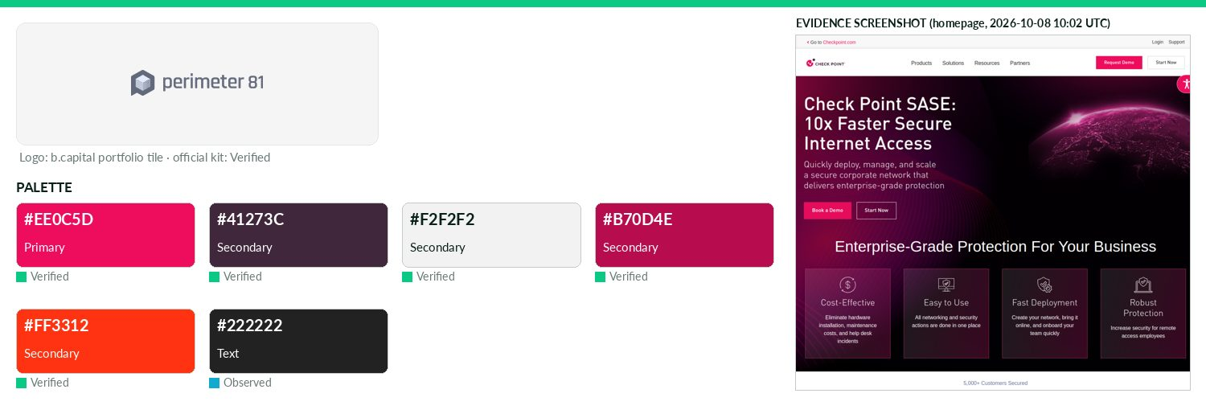
Captured 2026-10-08
Field | Value | Tier | Source
Website | https://perimeter81.com | Verified | b.capital portfolio
LinkedIn | https://www.linkedin.com/company/check-point-software-technologies | Observed | official site link
Primary / secondary | #EE0C5D / #41273C / #F2F2F2 / #B70D4E / #FF3312 | Verified | Check Point Brand Guidelines 2026 p12: Brand Berry, Pantone
Background / text | — / #222222 | Observed | live CSS body rule
Typography | DIN Pro | Verified | CP guidelines: DIN Pro preferred; DIN Pro Light for body
Voice & tone | Brand voice: bold, human, inclusive and authentic (separate Voice & Tone Guide referenced). | Verified | https://www.checkpoint.com/downloads/company/check
Imagery | — | Missing | —
Clear-space / misuse | Keep illustrations/photography/type outside clear space; min logo width 1 inch (stacked version below with approval). | Verified | https://www.checkpoint.com/downloads/company/check
Trademark | — | Missing | —
Guideline / press kit | https://www.checkpoint.com/downloads/company/check-point-brand-guidelines-2026.pdf?v=1.1 | Verified
HQ / employees | — | Missing | LinkedIn API rate-limited
OnDemand UI tokens | primary #EE0C5D / on #000000 / accent #41273C / surface #FFFFFF / text #222222 | Derived | contrast 4.85:1 · 15.91:1
Perplexity
Technology & AI · North America · Active · completeness 69% · tier Verified — AI-powered answer engine that provides accurate, trusted and real-time answers to any question.
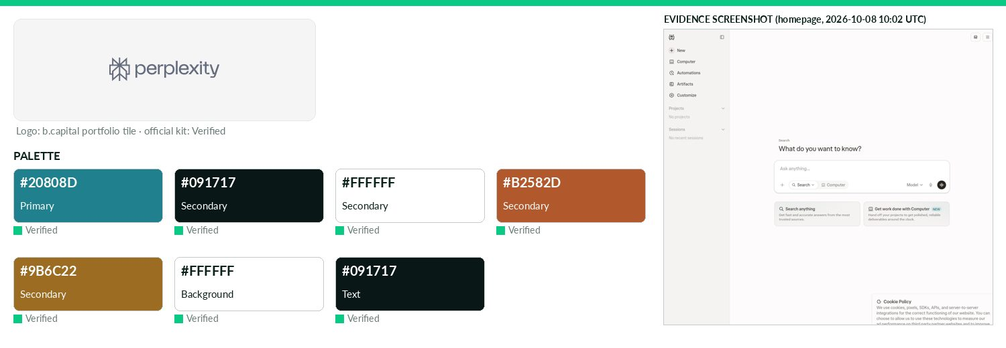
Captured 2026-10-08
Field | Value | Tier | Source
Website | http://www.perplexity.ai | Verified | b.capital portfolio
LinkedIn | — | Missing | API 429/403
Primary / secondary | #20808D / #091717 / #FFFFFF / #B2582D / #9B6C22 | Verified | standards.site swatch 'Perplexity Turquoise' (PMS 2235); als
Background / text | #FFFFFF / #091717 | Verified | —
Typography | Perplexity Sans; Perplexity Serif; Perplexity Mono; FK Grotesk; Noto | Verified | https://live.standards.site/perplexity/ (Grilli Type custom
Voice & tone | 'A guidebook, not a rule book'; brand core = curiosity and knowledge; art direction aims to spark curiosity and awe / aspirational wonder. | Verified | https://live.standards.site/perplexity/
Imagery | Imagery varies widely, often curated AI-generated imagery (do not create your own), plus open-source imagery; | Verified | https://live.standards.site/perplexity/
Clear-space / misuse | No strict spacing; leave ~one symbol's worth of space. Don't rotate the icon, don't fill it, don't make lines too heavy, | Verified | https://live.standards.site/perplexity/
Trademark | — | Missing | —
Guideline / press kit | https://live.standards.site/perplexity/ | Verified
HQ / employees | — | Missing | LinkedIn API rate-limited
OnDemand UI tokens | primary #20808D / on #FFFFFF / accent #091717 / surface #FFFFFF / text #091717 | Derived | contrast 4.63:1 · 18.32:1
Phenom People
Technology & AI · North America · Active · completeness 46% · tier Verified — AI-powered talent experience platform unifying recruiting, development and retention workflows.
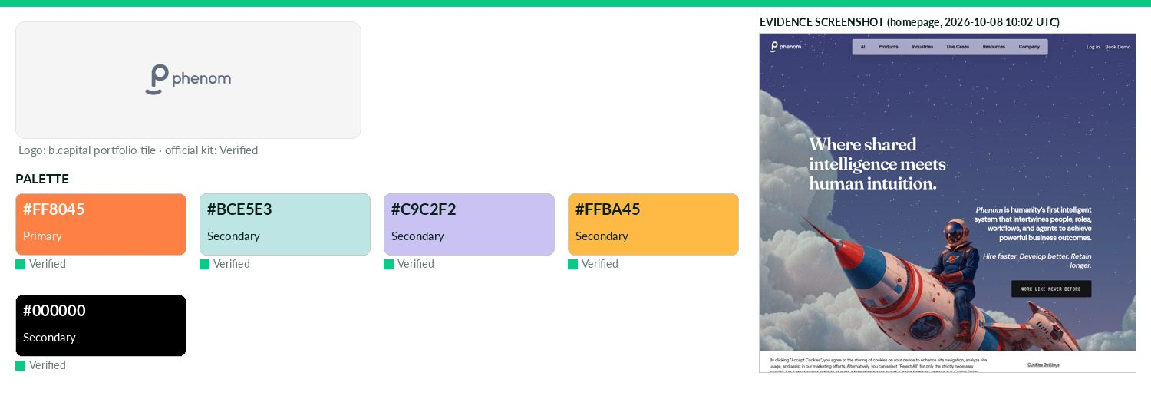
Captured 2026-10-08
Field | Value | Tier | Source
Website | https://www.phenom.com | Verified | b.capital portfolio
LinkedIn | https://www.linkedin.com/company/phenomtxm | Observed | official site link
Primary / secondary | #FF8045 / #BCE5E3 / #C9C2F2 / #FFBA45 / #000000 | Verified | https://www.phenom.com/media-kit Primary Colors: Peach
Background / text | — | Missing | —
Typography | roobert; roobert-semibold; roobert-medium; roobert-display | Observed | https://www.phenom.com/ @font-face
Voice & tone | — | Missing | —
Imagery | — | Missing | —
Clear-space / misuse | — | Missing | —
Trademark | — | Missing | —
Guideline / press kit | https://www.phenom.com/media-kit | Verified
HQ / employees | — | Missing | LinkedIn API rate-limited
OnDemand UI tokens | primary #FF8045 / on #000000 / accent #BCE5E3 / surface #FFFFFF / text #111111 | Derived | contrast 8.43:1 · 18.88:1
Rapyd
Technology & AI · Middle East · Active · completeness 54% · tier Observed — Global payments platform integrating local payment methods into applications.
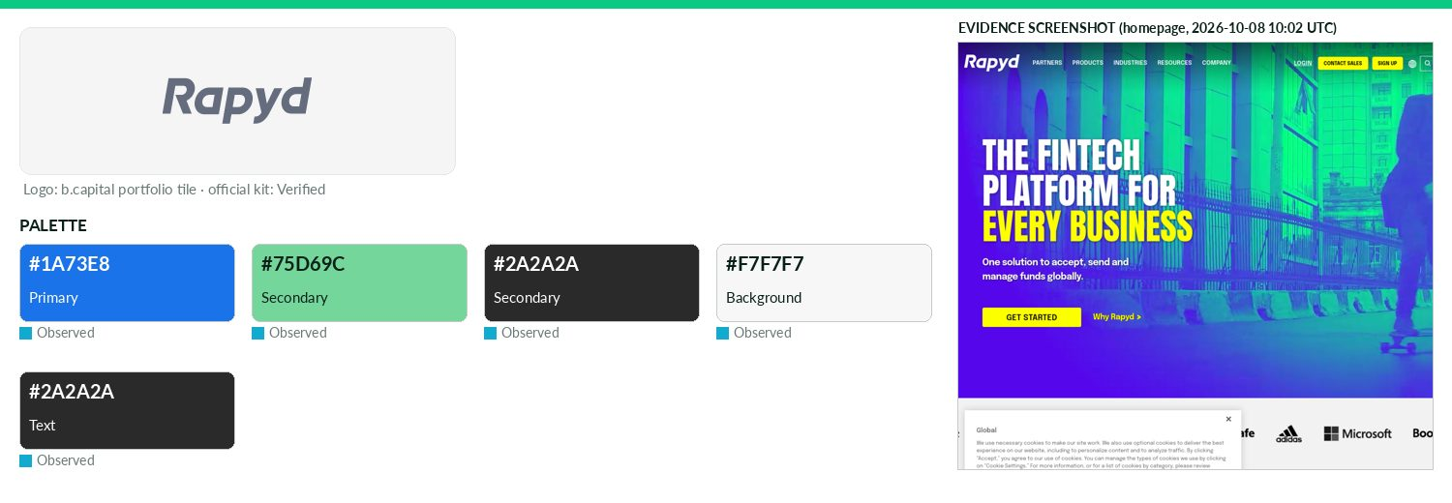
Captured 2026-10-08
Field | Value | Tier | Source
Website | https://www.rapyd.net | Verified | b.capital portfolio
LinkedIn | https://www.linkedin.com/company/rapydpayments | Observed | official site link
Primary / secondary | #1A73E8 / #75D69C / #2A2A2A | Observed | https://www.rapyd.net/ — CSS variable --wpex-accent
Background / text | #F7F7F7 / #2A2A2A | Observed | live CSS body rule
Typography | Epilogue; Rubik | Observed | https://www.rapyd.net/ CSS
Voice & tone | — | Missing | —
Imagery | — | Missing | —
Clear-space / misuse | — | Missing | —
Trademark | — | Missing | —
Guideline / press kit | https://www.rapyd.net/company/brand/ (Brand Portal — password protected) | Verified
HQ / employees | — | Missing | LinkedIn API rate-limited
OnDemand UI tokens | primary #1A73E8 / on #000000 / accent #75D69C / surface #F7F7F7 / text #2A2A2A | Derived | contrast 4.66:1 · 13.4:1
Draft note | Partial official material. Brand Portal exists but 'This content is password protected'. --wpex-brand-color vars are social-icon colours, | Caveat
Reflection
Technology & AI · North America · Active · completeness 38% · tier Observed — Leading Western open-source foundation model provider, an alternative to closed frontier labs, with a commercial strategy centered on enterprise and sovereign c
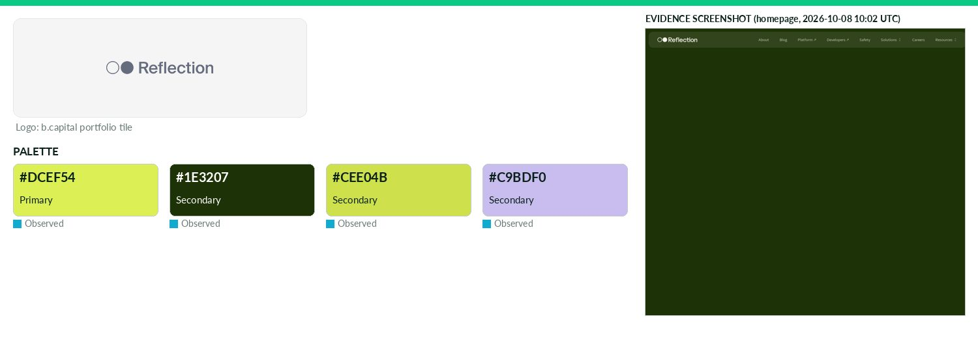
Captured 2026-10-08
Field | Value | Tier | Source
Website | https://reflection.ai | Verified | b.capital portfolio
LinkedIn | https://www.linkedin.com/company/reflectionai | Observed | official site link
Primary / secondary | #DCEF54 / #1E3207 / #CEE04B / #C9BDF0 | Observed | https://reflection.ai/ CSS var --color-accent
Background / text | — | Missing | —
Typography | NaN Serf Sans; NaN Serf B | Observed | https://reflection.ai/ @font-face
Voice & tone | — | Missing | —
Imagery | — | Missing | —
Clear-space / misuse | — | Missing | —
Trademark | — | Missing | —
Guideline / press kit | — | Missing
HQ / employees | — | Missing | LinkedIn API rate-limited
OnDemand UI tokens | primary #DCEF54 / on #000000 / accent #1E3207 / surface #FFFFFF / text #111111 | Derived | contrast 16.52:1 · 18.88:1
Draft note | No official guideline; live-site values. /newsroom exists (news list only); /brand 404. No press kit. | Caveat
Remote
Technology & AI · North America · Active · completeness 38% · tier Observed — Platform for hiring global talent and managing international payroll, benefits and compliance.
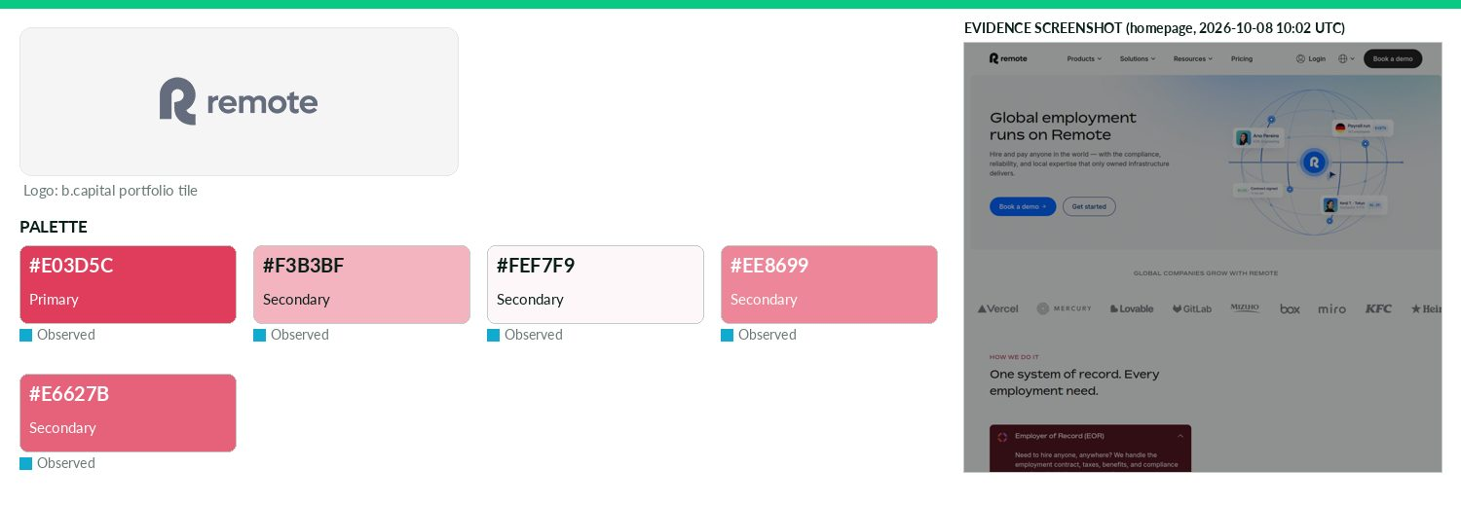
Captured 2026-10-08
Field | Value | Tier | Source
Website | https://remote.com | Verified | b.capital portfolio
LinkedIn | https://www.linkedin.com/company/remote.com | Observed | official site link
Primary / secondary | #E03D5C / #F3B3BF / #FEF7F9 / #EE8699 / #E6627B | Observed | https://remote.com/ CSS var --zora-red-brand-500
Background / text | — | Missing | —
Typography | rotina; Inter; bossa | Observed | https://remote.com/ @font-face
Voice & tone | — | Missing | —
Imagery | — | Missing | —
Clear-space / misuse | — | Missing | —
Trademark | — | Missing | —
Guideline / press kit | — | Missing
HQ / employees | — | Missing | LinkedIn API rate-limited
OnDemand UI tokens | primary #E03D5C / on #000000 / accent #F3B3BF / surface #FFFFFF / text #111111 | Derived | contrast 4.99:1 · 18.88:1
Draft note | No official guideline; live-site values. /press,/brand,/newsroom,/media-kit 404; 'newsroom' links to blog tag company-news. | Caveat
Seltz
Technology & AI · North America · Active · completeness 46% · tier Observed — AI knowledge infrastructure platform providing real-time, factual web data for grounding generative models
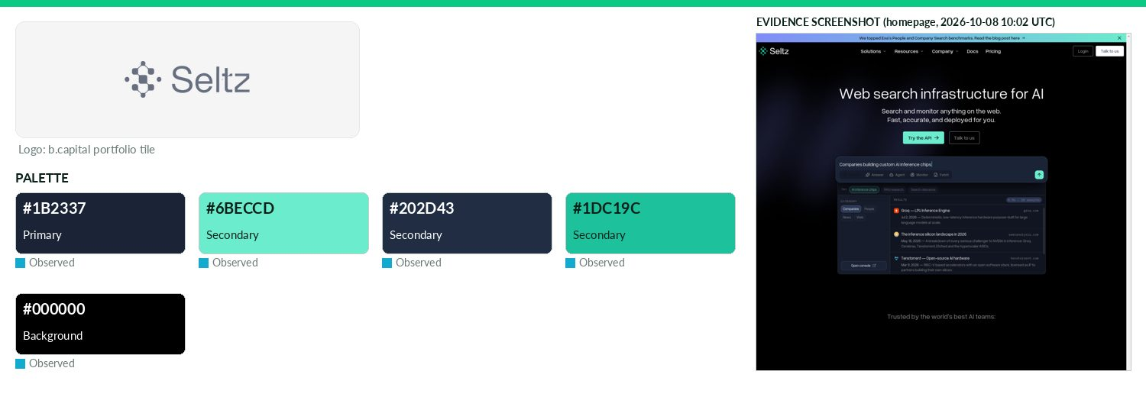
Captured 2026-10-08
Field | Value | Tier | Source
Website | https://www.seltz.ai | Verified | b.capital portfolio
LinkedIn | https://www.linkedin.com/company/seltz | Observed | official site link
Primary / secondary | #1B2337 / #6BECCD / #202D43 / #1DC19C | Observed | https://seltz.ai/ — most frequent saturated CSS colour (65 u
Background / text | #000000 / — | Observed | live CSS body rule
Typography | Fragment Mono; IBM Plex Mono; Overused Grotesk | Observed | https://seltz.ai/ @font-face
Voice & tone | — | Missing | —
Imagery | — | Missing | —
Clear-space / misuse | — | Missing | —
Trademark | — | Missing | —
Guideline / press kit | — | Missing
HQ / employees | — | Missing | LinkedIn API rate-limited
OnDemand UI tokens | primary #1B2337 / on #FFFFFF / accent #6BECCD / surface #000000 / text #111111 | Derived | contrast 15.65:1 · 1.11:1
Draft note | No official guideline; live-site values. 'Press' links to blog; no brand kit. | Caveat
Sharpa
Technology & AI · Asia · Active · completeness 8% · tier Third-party — Sharpa Robotics is an AI robotics company building ultra-high-performance robotic hands.
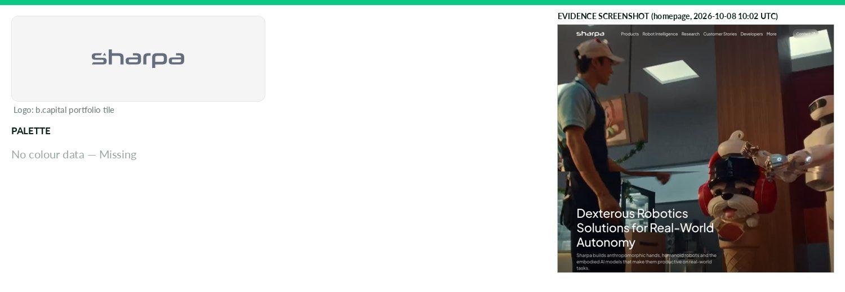
Captured 2026-10-08
Field | Value | Tier | Source
Website | https://www.sharpa.com | Verified | b.capital portfolio
LinkedIn | — | Missing | API 429/403
Primary / secondary | — | Missing | —
Background / text | — | Missing | —
Typography | — | Missing | —
Voice & tone | — | Missing | —
Imagery | — | Missing | —
Clear-space / misuse | — | Missing | —
Trademark | — | Missing | —
Guideline / press kit | — | Missing
HQ / employees | — | Missing | LinkedIn API rate-limited
Draft note | No official guideline; live-site values. Blocked. | Caveat
Sonilo
Technology & AI · North America · Active · completeness 46% · tier Observed — AI music generation platform delivering content-aware soundtracks for social media creators and video content.
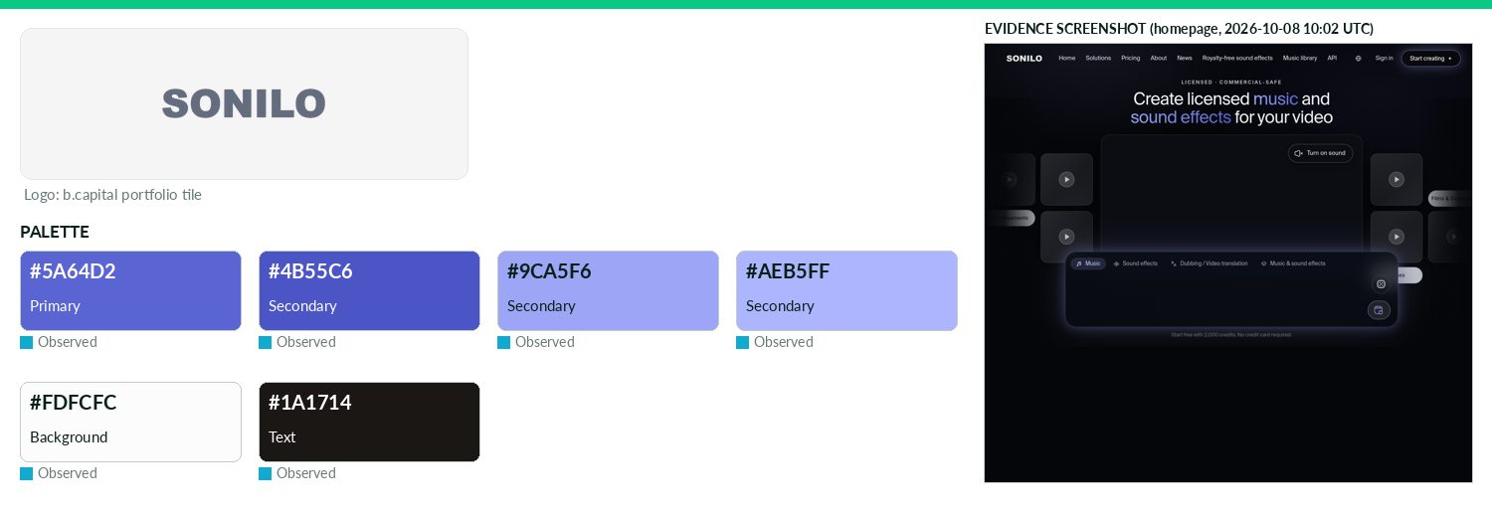
Captured 2026-10-08
Field | Value | Tier | Source
Website | https://sonilo.com | Verified | b.capital portfolio
LinkedIn | https://www.linkedin.com/company/sonilo | Observed | official site link
Primary / secondary | #5A64D2 / #4B55C6 / #9CA5F6 / #AEB5FF | Observed | https://sonilo.com/ (site CSS)
Background / text | #FDFCFC / #1A1714 | Observed | live CSS body rule
Typography | Geist; Inter; Suisse Intl | Observed | https://sonilo.com/ (@font-face/CSS)
Voice & tone | — | Missing | —
Imagery | — | Missing | —
Clear-space / misuse | — | Missing | —
Trademark | — | Missing | —
Guideline / press kit | — | Missing
HQ / employees | — | Missing | LinkedIn API rate-limited
OnDemand UI tokens | primary #5A64D2 / on #FFFFFF / accent #4B55C6 / surface #FDFCFC / text #1A1714 | Derived | contrast 5.01:1 · 17.43:1
Draft note | No official guideline; live-site values. No brand/press/media-kit page found at standard paths (/brand,/press,/press-kit,/media-kit,/media,/newsroom). | Caveat
Starburst Data
Technology & AI · North America · Active · completeness 85% · tier Verified — Data platform for AI and agents enabling governed, trusted access to enterprise data.
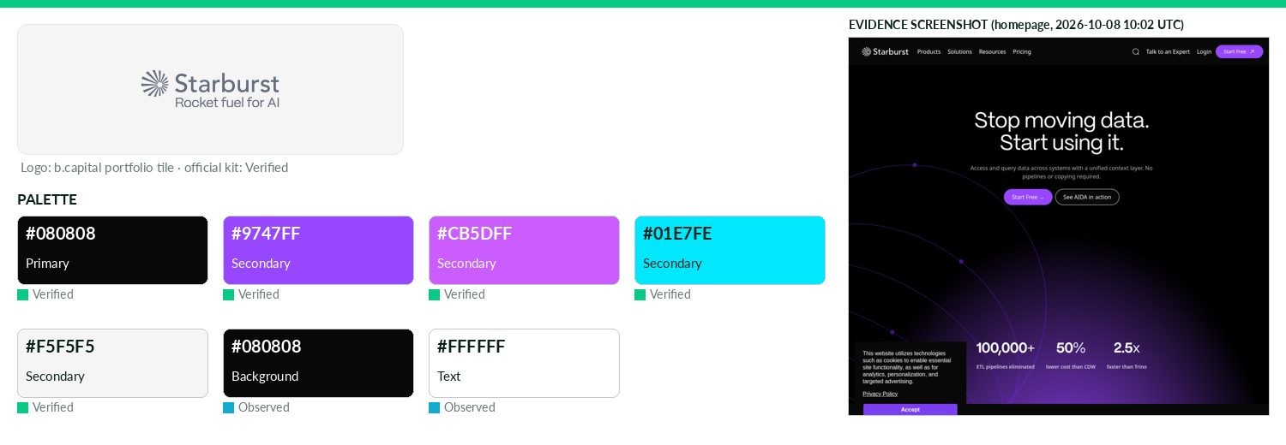
Captured 2026-10-08
Field | Value | Tier | Source
Website | https://www.starburst.io | Verified | b.capital portfolio
LinkedIn | https://www.linkedin.com/company/starburstdata | Observed | official site link
Primary / secondary | #080808 / #9747FF / #CB5DFF / #01E7FE / #F5F5F5 | Verified | Brand Guidelines PDF v1.0 Apr 2024: main colours Cultured #F
Background / text | #080808 / #FFFFFF | Observed | live CSS body rule
Typography | PP Mori; Roboto; Inter | Verified | Brand Guidelines PDF Typefaces: Mori for headlines, Roboto b
Voice & tone | Voice blends playfulness with seriousness, authority with approachability, innovation with classic appeal; elite yet inclusive, responsibly | Verified | https://live-starburst.pantheonsite.io/wp-content/
Imagery | Clean, naturally lit photography, avoid cluttered compositions; emphasis on people collaborating; galaxy-metap | Verified | https://live-starburst.pantheonsite.io/wp-content/
Clear-space / misuse | Logomark min height 24px; clear space = 50% of logomark (wordmark: uppercase 'S' unit). | Verified | https://live-starburst.pantheonsite.io/wp-content/
Trademark | Starburst and Starburst Data are registered trademarks of Starburst Data, Inc. | Verified | https://www.starburst.io/about/newsroom/ footer
Guideline / press kit | https://live-starburst.pantheonsite.io/wp-content/uploads/2026/02/Starburst_Brand_Guidelines.zip | Verified
HQ / employees | — | Missing | LinkedIn API rate-limited
OnDemand UI tokens | primary #080808 / on #FFFFFF / accent #9747FF / surface #080808 / text #FFFFFF | Derived | contrast 20.03:1 · 20.03:1
Tacta
Technology & AI · North America · Active · completeness 46% · tier Observed — Advanced robotics company developing dexterous intelligence systems for human-like robotic tasks.
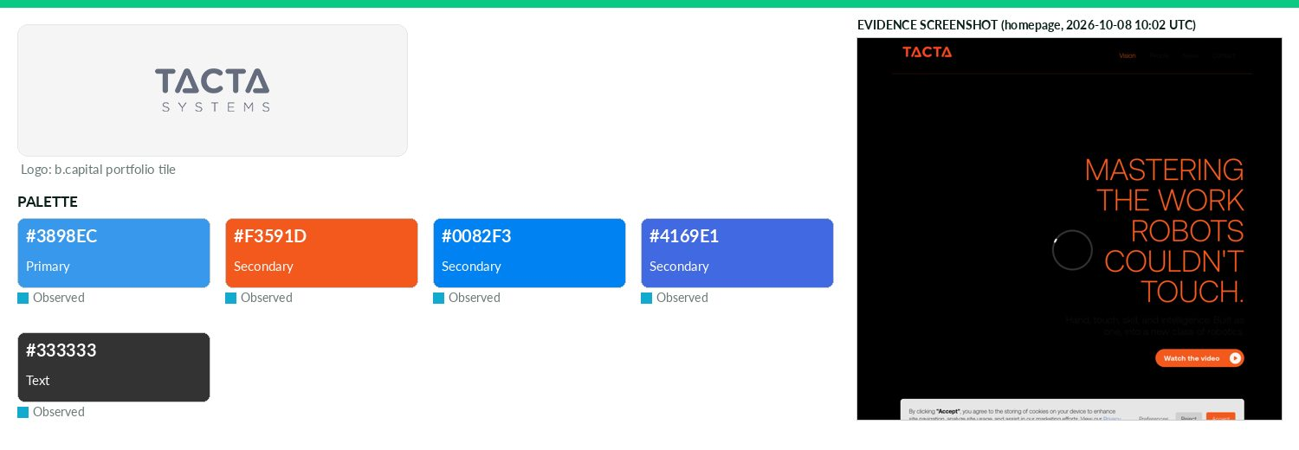
Captured 2026-10-08
Field | Value | Tier | Source
Website | http://www.tactasystems.com | Verified | b.capital portfolio
LinkedIn | https://www.linkedin.com/company/tacta-systems | Observed | official site link
Primary / secondary | #3898EC / #F3591D / #0082F3 / #4169E1 | Observed | https://www.tactasystems.com/ — most frequent saturated CSS
Background / text | — / #333333 | Observed | live CSS body rule
Typography | Aeonik; Aeoniktrial | Observed | https://www.tactasystems.com/ @font-face
Voice & tone | — | Missing | —
Imagery | — | Missing | —
Clear-space / misuse | — | Missing | —
Trademark | — | Missing | —
Guideline / press kit | — | Missing
HQ / employees | — | Missing | LinkedIn API rate-limited
OnDemand UI tokens | primary #3898EC / on #000000 / accent #F3591D / surface #FFFFFF / text #333333 | Derived | contrast 6.87:1 · 12.63:1
Draft note | No official guideline; live-site values. No press/brand pages found. | Caveat
Turbine
Technology & AI · North America · Active · completeness 31% · tier Observed — Lending platform providing liquidity on appreciated LPAs for private capital GPs and LPs.
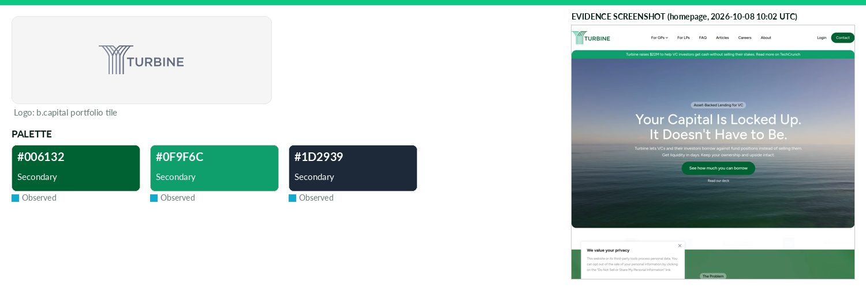
Captured 2026-10-08
Field | Value | Tier | Source
Website | https://www.turbine.co | Verified | b.capital portfolio
LinkedIn | https://www.linkedin.com/company/turbine-finance | Observed | official site link
Primary / secondary | #006132 / #0F9F6C / #1D2939 | Missing | —
Background / text | — | Missing | —
Typography | Figtree | Observed | https://www.turbine.co/ @font-face
Voice & tone | — | Missing | —
Imagery | — | Missing | —
Clear-space / misuse | — | Missing | —
Trademark | — | Missing | —
Guideline / press kit | — | Missing
HQ / employees | — | Missing | LinkedIn API rate-limited
Draft note | No official guideline; live-site values. /press redirects to /articles; no brand kit. /brand 404. | Caveat
Turno
Technology & AI · Asia · Active · completeness 38% · tier Observed — Commercial EV marketplace connecting manufacturers with SMEs and providing financing solutions.
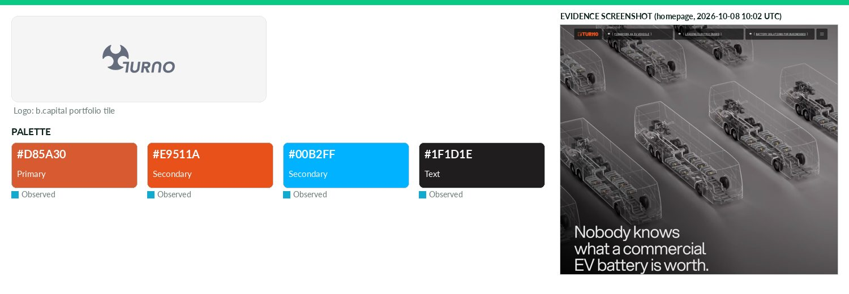
Captured 2026-10-08
Field | Value | Tier | Source
Website | https://www.turno.club | Verified | b.capital portfolio
LinkedIn | — | Missing | API 429/403
Primary / secondary | #D85A30 / #E9511A / #00B2FF | Observed | https://www.turnoev.com/ (site CSS)
Background / text | — / #1F1D1E | Observed | live CSS body rule
Typography | Aspekta; Space Mono | Observed | https://www.turnoev.com/ (@font-face/CSS)
Voice & tone | — | Missing | —
Imagery | — | Missing | —
Clear-space / misuse | — | Missing | —
Trademark | — | Missing | —
Guideline / press kit | — | Missing
HQ / employees | — | Missing | LinkedIn API rate-limited
OnDemand UI tokens | primary #D85A30 / on #000000 / accent #E9511A / surface #FFFFFF / text #1F1D1E | Derived | contrast 5.42:1 · 16.76:1
Draft note | No official guideline; live-site values. No brand/press/media-kit page found at standard paths (/brand,/press,/press-kit,/media-kit,/media,/newsroom). | Caveat
When
Technology & AI · North America · Active · completeness 46% · tier Observed — AI-powered offboarding solution designed to help employees navigate post-employment transitions.
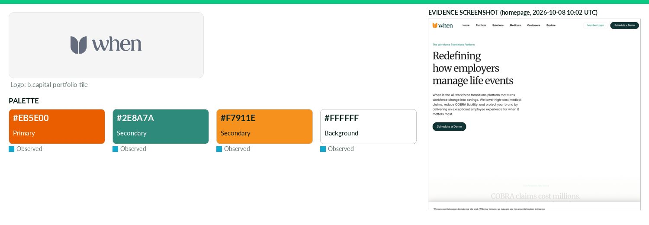
Captured 2026-10-08
Field | Value | Tier | Source
Website | https://www.cobraselect.com | Verified | b.capital portfolio
LinkedIn | https://www.linkedin.com/company/forwhen | Observed | official site link
Primary / secondary | #EB5E00 / #2E8A7A / #F7911E | Observed | https://www.forwhen.com — most frequent saturated CSS colour
Background / text | #FFFFFF / — | Observed | live CSS body rule
Typography | Fragment Mono; Geist; Merriweather | Observed | https://www.forwhen.com @font-face
Voice & tone | — | Missing | —
Imagery | — | Missing | —
Clear-space / misuse | — | Missing | —
Trademark | — | Missing | —
Guideline / press kit | — | Missing
HQ / employees | — | Missing | LinkedIn API rate-limited
OnDemand UI tokens | primary #EB5E00 / on #000000 / accent #2E8A7A / surface #FFFFFF / text #111111 | Derived | contrast 6.13:1 · 18.88:1
Draft note | No official guideline; live-site values. cobraselect.com redirects to forwhen.com; /explore/press-news exists (news only). | Caveat
Wildfire
Technology & AI · North America · Active · completeness 46% · tier Observed — White-label loyalty, rewards and cashback platform that improves online shopping experience for customers.
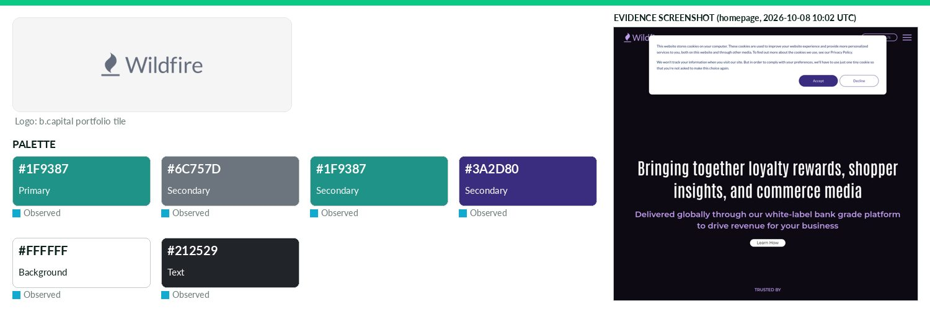
Captured 2026-10-08
Field | Value | Tier | Source
Website | https://www.wildfire-corp.com | Verified | b.capital portfolio
LinkedIn | https://www.linkedin.com/company/wildfire-systems | Observed | official site link
Primary / secondary | #1F9387 / #6C757D / #1F9387 / #3A2D80 | Observed | https://www.wildfire-corp.com/ CSS var --primary (theme over
Background / text | #FFFFFF / #212529 | Observed | live CSS body rule
Typography | Montserrat | Observed | https://www.wildfire-corp.com/ @font-face
Voice & tone | — | Missing | —
Imagery | — | Missing | —
Clear-space / misuse | — | Missing | —
Trademark | — | Missing | —
Guideline / press kit | — | Missing
HQ / employees | — | Missing | LinkedIn API rate-limited
OnDemand UI tokens | primary #1F9387 / on #000000 / accent #6C757D / surface #FFFFFF / text #212529 | Derived | contrast 5.58:1 · 15.43:1
Draft note | No official guideline; live-site values. /news is press coverage list only; no brand kit. | Caveat
Writer
Technology & AI · North America · Active · completeness 69% · tier Verified — Full-stack generative AI platform for building and deploying custom enterprise applications.
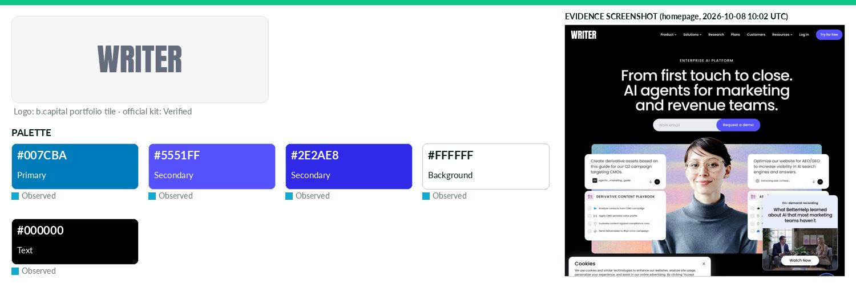
Captured 2026-10-08
Field | Value | Tier | Source
Website | http://www.writer.com | Verified | b.capital portfolio
LinkedIn | https://www.linkedin.com/company/getwriter | Observed | official site link
Primary / secondary | #007CBA / #5551FF / #2E2AE8 | Observed | https://writer.com/ — CSS variable --wp-admin-theme-color
Background / text | #FFFFFF / #000000 | Observed | live CSS body rule
Typography | Poppins; Graphik; CanelaDeck; Formula Condensed | Observed | https://writer.com/ — CSS font-family/@font-face
Voice & tone | — | Missing | —
Imagery | — | Missing | —
Clear-space / misuse | Do not modify Brand Assets (colours, dimensions, obstructing, adding elements); do not imply endorsement or make assets | Verified | https://writer.com/newsroom/
Trademark | Logos, trademarks, service marks are proprietary assets of WRITER, Inc.; use requires compliance with Brand Gu | Verified | https://writer.com/newsroom/
Guideline / press kit | https://writer.com/newsroom/#brand-assets | Verified
HQ / employees | — | Missing | LinkedIn API rate-limited
OnDemand UI tokens | primary #007CBA / on #000000 / accent #5551FF / surface #FFFFFF / text #000000 | Derived | contrast 4.59:1 · 21.0:1
Xingyun
Technology & AI · Asia · Active · completeness 38% · tier Observed — Cross-border commerce platform providing integrated brand, logistics and supply chain financing services.
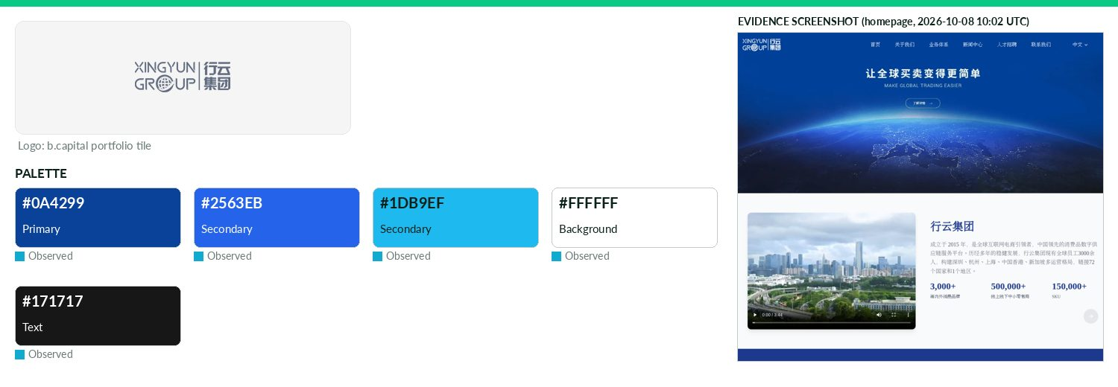
Captured 2026-10-08
Field | Value | Tier | Source
Website | http://xingyungroup.com | Verified | b.capital portfolio
LinkedIn | — | Missing | API 429/403
Primary / secondary | #0A4299 / #2563EB / #1DB9EF | Observed | https://www.xingyungroup.com/ (site CSS)
Background / text | #FFFFFF / #171717 | Observed | live CSS body rule
Typography | PingFang SC | Observed | https://www.xingyungroup.com — CSS font-family/@font-face
Voice & tone | — | Missing | —
Imagery | — | Missing | —
Clear-space / misuse | — | Missing | —
Trademark | — | Missing | —
Guideline / press kit | — | Missing
HQ / employees | — | Missing | LinkedIn API rate-limited
OnDemand UI tokens | primary #0A4299 / on #FFFFFF / accent #2563EB / surface #FFFFFF / text #171717 | Derived | contrast 9.32:1 · 17.93:1
Draft note | No official guideline; live-site values. Chinese site; /brand exists but is the business 'brand services' page (品牌服务), not brand guidelines. No press k | Caveat
Yalo
Technology & AI · North America · Active · completeness 46% · tier Observed — GenAI-powered conversational commerce leveraging chatbots to automate sales, social interaction and support.
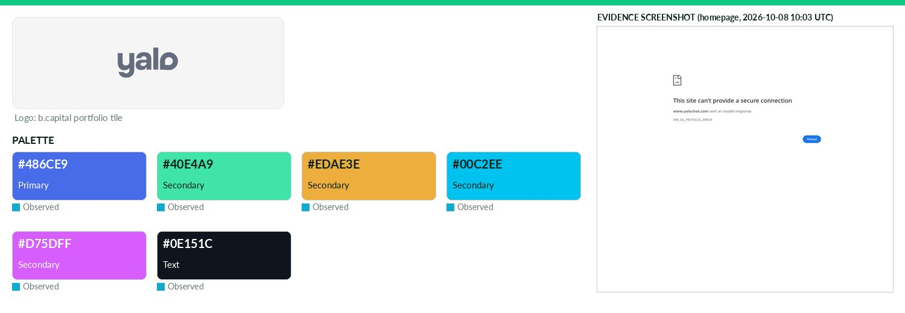
Captured 2026-10-08
Field | Value | Tier | Source
Website | https://www.yalochat.com | Verified | b.capital portfolio
LinkedIn | https://www.linkedin.com/company/yalo | Observed | official site link
Primary / secondary | #486CE9 / #40E4A9 / #EDAE3E / #00C2EE / #D75DFF | Observed | https://www.yalo.ai/ (site CSS)
Background / text | — / #0E151C | Observed | live CSS body rule
Typography | Tomato Grotesk | Observed | https://www.yalo.ai/ (@font-face/CSS)
Voice & tone | — | Missing | —
Imagery | — | Missing | —
Clear-space / misuse | — | Missing | —
Trademark | — | Missing | —
Guideline / press kit | — | Missing
HQ / employees | — | Missing | LinkedIn API rate-limited
OnDemand UI tokens | primary #486CE9 / on #000000 / accent #40E4A9 / surface #FFFFFF / text #0E151C | Derived | contrast 4.6:1 · 18.38:1
Draft note | No official guideline; live-site values. No brand/press/media-kit page found at standard paths (/brand,/press,/press-kit,/media-kit,/media,/newsroom). | Caveat
Zaihui
Technology & AI · Asia · Active · completeness 38% · tier Observed — CRM SaaS and marketing services for restaurants
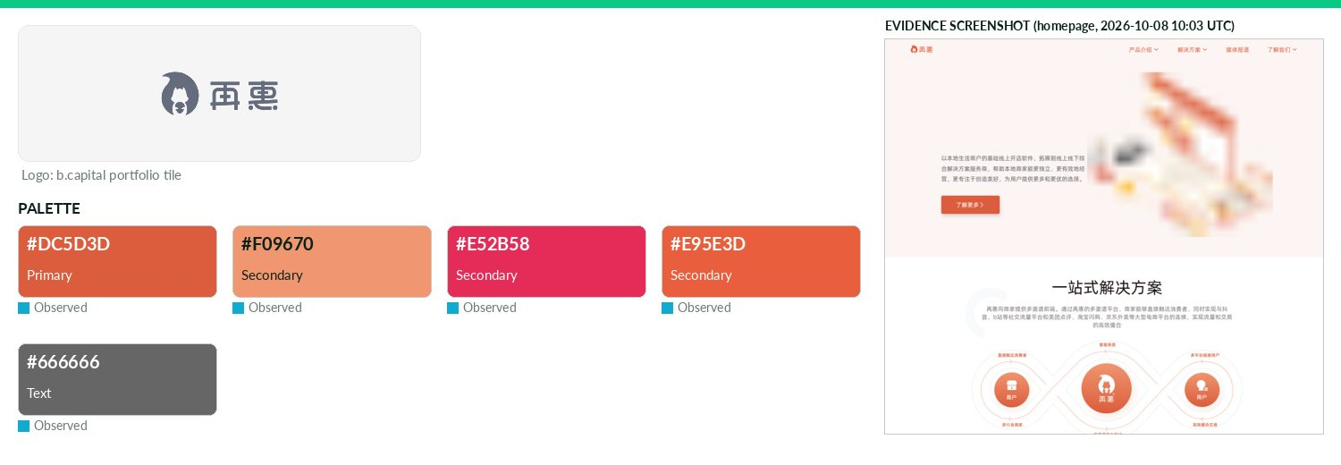
Captured 2026-10-08
Field | Value | Tier | Source
Website | https://www.kezaihui.com | Verified | b.capital portfolio
LinkedIn | — | Missing | API 429/403
Primary / secondary | #DC5D3D / #F09670 / #E52B58 / #E95E3D | Observed | https://www.kezaihui.com/ — most frequent saturated CSS colo
Background / text | — / #666666 | Observed | live CSS body rule
Typography | Alibaba-PuHuiTi; DINPro-Light; DINPro-Regular; DINPro-Medium | Observed | https://www.kezaihui.com/ @font-face
Voice & tone | — | Missing | —
Imagery | — | Missing | —
Clear-space / misuse | — | Missing | —
Trademark | — | Missing | —
Guideline / press kit | — | Missing
HQ / employees | — | Missing | LinkedIn API rate-limited
OnDemand UI tokens | primary #DC5D3D / on #000000 / accent #F09670 / surface #FFFFFF / text #666666 | Derived | contrast 5.68:1 · 5.74:1
Draft note | No official guideline; live-site values. Chinese site; no press/brand pages; fonts from @font-face. | Caveat
ARTBIO
Healthcare · North America · Active · completeness 54% · tier Observed — Biotech company developing radioligand therapies for patients with solid tumors.
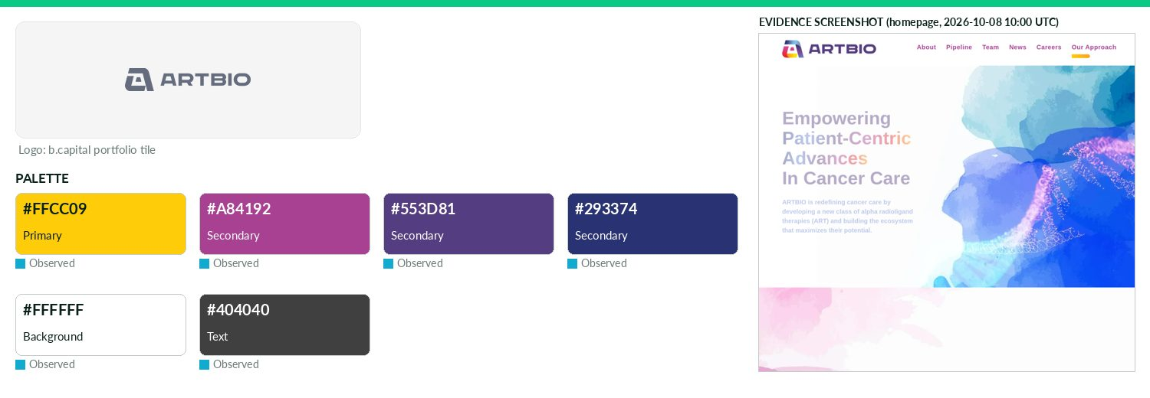
Captured 2026-10-08
Field | Value | Tier | Source
Website | https://artbio.com | Verified | b.capital portfolio
LinkedIn | https://www.linkedin.com/company/artbio-inc | Observed | official site link
Primary / secondary | #FFCC09 / #A84192 / #553D81 / #293374 | Observed | https://artbio.com/ — most frequent saturated CSS colour (21
Background / text | #FFFFFF / #404040 | Observed | live CSS body rule
Typography | Bai Jamjuree; Roboto | Observed | https://artbio.com/ (CSS font-family)
Voice & tone | — | Missing | —
Imagery | — | Missing | —
Clear-space / misuse | — | Missing | —
Trademark | ToS 'Trademarks': marks, service marks and logos referencing ARTBIO are registered/unregistered trademarks of | Verified | https://artbio.com/terms-of-service
Guideline / press kit | — | Missing
HQ / employees | — | Missing | LinkedIn API rate-limited
OnDemand UI tokens | primary #FFCC09 / on #000000 / accent #A84192 / surface #FFFFFF / text #404040 | Derived | contrast 13.89:1 · 10.37:1
Draft note | No official guideline; live-site values. No brand/press/media-kit page (all probes 404/none). News only as homepage anchor #news. Frequent CSS hex ffcc | Caveat
Aurora YaoCheng
Healthcare · Asia · Active · completeness 46% · tier Observed — Digital health platform enabling smarter, faster clinical trials through AI and real-time analytics.
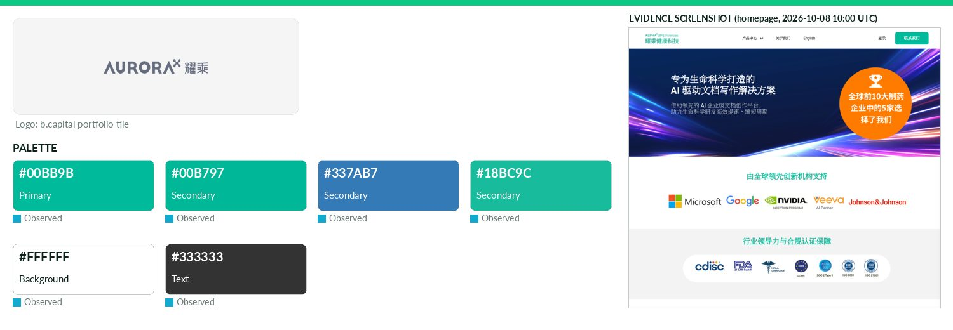
Captured 2026-10-08
Field | Value | Tier | Source
Website | http://yaocheng.cn | Verified | b.capital portfolio
LinkedIn | https://www.linkedin.com/company/alphalife-sciences | Observed | official site link
Primary / secondary | #00BB9B / #00B797 / #337AB7 / #18BC9C | Observed | https://www.yaocheng.cn — most frequent saturated CSS colour
Background / text | #FFFFFF / #333333 | Observed | live CSS body rule
Typography | Roboto | Observed | https://www.yaocheng.cn/ CSS
Voice & tone | — | Missing | —
Imagery | — | Missing | —
Clear-space / misuse | — | Missing | —
Trademark | — | Missing | —
Guideline / press kit | — | Missing
HQ / employees | — | Missing | LinkedIn API rate-limited
OnDemand UI tokens | primary #00BB9B / on #000000 / accent #00B797 / surface #FFFFFF / text #333333 | Derived | contrast 8.58:1 · 12.63:1
Draft note | No official guideline; live-site values. yaocheng.cn redirects to www.yaocheng.cn, branded 'AlphaLife Sciences' (product AuroraPrime); news links to al | Caveat
Cadence
Healthcare · North America · Active · completeness 46% · tier Observed — Operator of a digital healthcare company intended to help physicians improve the treatment of the most prevalent disease.
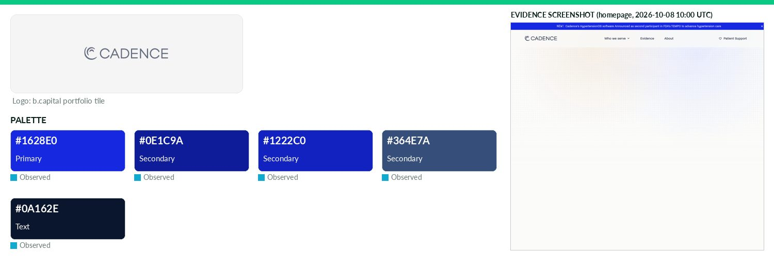
Captured 2026-10-08
Field | Value | Tier | Source
Website | https://cadence.care | Verified | b.capital portfolio
LinkedIn | https://www.linkedin.com/company/cadence-solutions | Observed | official site link
Primary / secondary | #1628E0 / #0E1C9A / #1222C0 / #364E7A | Observed | https://www.cadence.care/ CSS --color-text-brand / --color-s
Background / text | — / #0A162E | Observed | live CSS body rule
Typography | Noi Grotesk; Aeonik Mono; Source Code Pro; Inter | Observed | https://www.cadence.care/ @font-face/CSS
Voice & tone | — | Missing | —
Imagery | — | Missing | —
Clear-space / misuse | — | Missing | —
Trademark | — | Missing | —
Guideline / press kit | — | Missing
HQ / employees | — | Missing | LinkedIn API rate-limited
OnDemand UI tokens | primary #1628E0 / on #FFFFFF / accent #0E1C9A / surface #FFFFFF / text #0A162E | Derived | contrast 8.7:1 · 17.99:1
Draft note | No official guideline; live-site values. Confirmed RPM company: B Capital page (Jun 25 2026) describes Cadence as 'a health technology company building | Caveat
Capital Rx
Healthcare · North America · Active · completeness 54% · tier Observed — A full-service Pharmacy Benefits Manager and Administrator that reduces costs while enhancing transparency and flexibility for members.
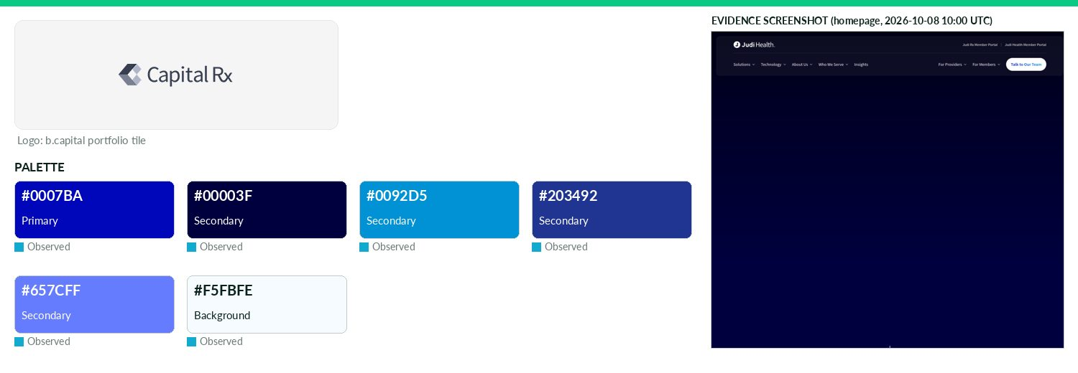
Captured 2026-10-08
Field | Value | Tier | Source
Website | https://www.judi.health | Verified | b.capital portfolio
LinkedIn | https://www.linkedin.com/company/judi-health | Observed | official site link
Primary / secondary | #0007BA / #00003F / #0092D5 / #203492 / #657CFF | Observed | https://www.judi.health/ CSS --brand--blue-electric (most fr
Background / text | #F5FBFE / — | Observed | live CSS body rule
Typography | Rubik; Creato Display; Source Sans Pro | Observed | https://www.judi.health/ @font-face
Voice & tone | — | Missing | —
Imagery | — | Missing | —
Clear-space / misuse | — | Missing | —
Trademark | T&C: all trademarks, logos, service marks displayed are property of Judi Health or third parties; users not pe | Verified | https://www.judi.health/legal/terms-conditions
Guideline / press kit | — | Missing
HQ / employees | — | Missing | LinkedIn API rate-limited
OnDemand UI tokens | primary #0007BA / on #FFFFFF / accent #00003F / surface #F5FBFE / text #111111 | Derived | contrast 12.07:1 · 18.09:1
Draft note | No official guideline; live-site values. Rebranded Capital Rx -> Judi Health (Judi Rx PBM); rebrand PR on judi.health/insights. /press is a 'Press & Me | Caveat
Carrick
Healthcare · North America · Active · completeness 46% · tier Observed — Clinical-stage oncology company developing CDK7 inhibitors for breast cancer and other solid tumors.
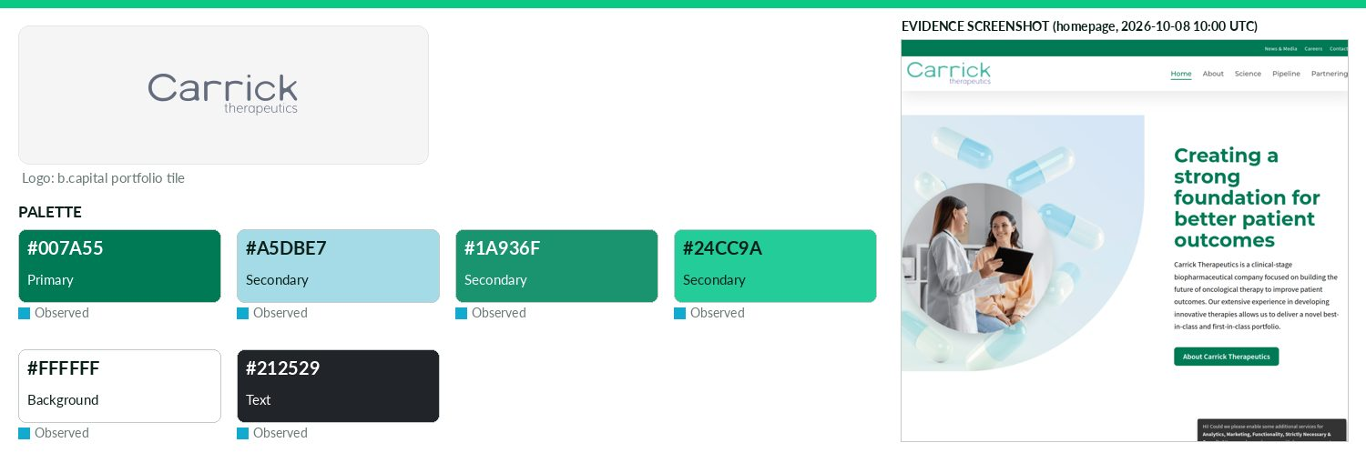
Captured 2026-10-08
Field | Value | Tier | Source
Website | https://www.carricktherapeutics.com | Verified | b.capital portfolio
LinkedIn | https://www.linkedin.com/company/carrick-therapeutics | Observed | official site link
Primary / secondary | #007A55 / #A5DBE7 / #1A936F / #24CC9A | Observed | https://www.carricktherapeutics.com/ — most frequent saturat
Background / text | #FFFFFF / #212529 | Observed | live CSS body rule
Typography | Source Sans Pro; Montserrat | Observed | https://www.carricktherapeutics.com/ @font-face
Voice & tone | — | Missing | —
Imagery | — | Missing | —
Clear-space / misuse | — | Missing | —
Trademark | — | Missing | —
Guideline / press kit | — | Missing
HQ / employees | — | Missing | LinkedIn API rate-limited
OnDemand UI tokens | primary #007A55 / on #FFFFFF / accent #A5DBE7 / surface #FFFFFF / text #212529 | Derived | contrast 5.36:1 · 15.43:1
Draft note | No official guideline; live-site values. News & Media hub (https://www.carricktherapeutics.com/news-media) has press releases, IR calendar, publication | Caveat
Centivo
Healthcare · North America · Active · completeness 54% · tier Observed — Healthcare platform offering employers a lower-cost alternative to traditional health insurance.
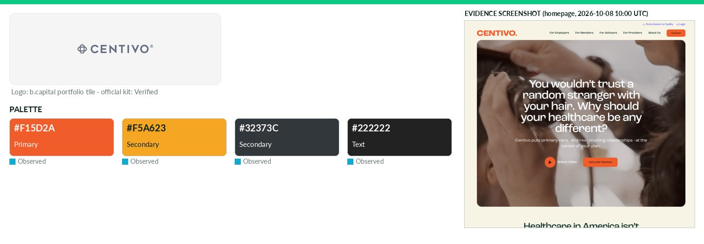
Captured 2026-10-08
Field | Value | Tier | Source
Website | https://centivo.com | Verified | b.capital portfolio
LinkedIn | https://www.linkedin.com/company/centivo | Observed | official site link
Primary / secondary | #F15D2A / #F5A623 / #32373C | Observed | https://centivo.com/wp-content/themes/studio-simpatico/svgs/
Background / text | — / #222222 | Observed | live CSS body rule
Typography | roc-grotesk | Observed | https://centivo.com/ @font-face
Voice & tone | — | Missing | —
Imagery | — | Missing | —
Clear-space / misuse | — | Missing | —
Trademark | T&C: Centivo trademarks/service marks/logos ('Centivo Trademarks') are registered/unregistered marks; do not r | Verified | https://centivo.com/terms-and-conditions/
Guideline / press kit | https://centivo.com/press-kit/ | Missing
HQ / employees | — | Missing | LinkedIn API rate-limited
OnDemand UI tokens | primary #F15D2A / on #000000 / accent #F5A623 / surface #FFFFFF / text #222222 | Derived | contrast 6.34:1 · 15.91:1
Draft note | No official guideline; live-site values. /press-kit page exists ('Centivo media & press kit') but contains NO downloads — only 'email info@centivo.com' | Caveat
Evidation Health
Healthcare · North America · Active · completeness 54% · tier Observed — Health data analytics platform collecting and analyzing behavioral and healthcare data at scale.
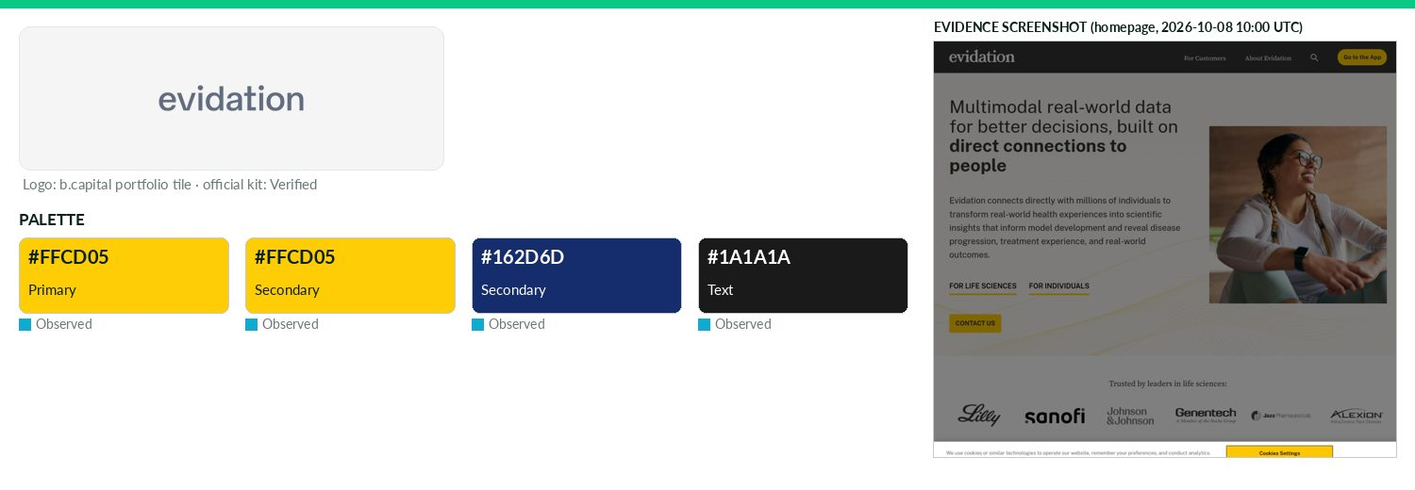
Captured 2026-10-08
Field | Value | Tier | Source
Website | http://evidation.com | Verified | b.capital portfolio
LinkedIn | https://www.linkedin.com/company/evidation | Observed | official site link
Primary / secondary | #FFCD05 / #FFCD05 / #162D6D | Observed | https://evidation.com/ — most frequent saturated CSS colour
Background / text | — / #1A1A1A | Observed | live CSS body rule
Typography | Public Sans; Source Serif Pro/Source Serif 4 | Observed | https://evidation.com/ @font-face
Voice & tone | — | Missing | —
Imagery | — | Missing | —
Clear-space / misuse | — | Missing | —
Trademark | ToS: may not use, display, mirror or frame any Evidation trademark, logo or proprietary info; do not remove/al | Verified | https://evidation.com/terms
Guideline / press kit | https://evidation.com/media-kit | Missing
HQ / employees | — | Missing | LinkedIn API rate-limited
OnDemand UI tokens | primary #FFCD05 / on #000000 / accent #FFCD05 / surface #FFFFFF / text #1A1A1A | Derived | contrast 13.99:1 · 17.4:1
Draft note | No official guideline; live-site values. Media kit page: Logos ZIP (2 PNGs: 'Evidation logo', 'Evidation logo with Eve'), App Images ZIP, Executive Hea | Caveat
Evommune
Healthcare · North America · Active · completeness 46% · tier Observed — Biotech developing novel therapies for chronic inflammatory diseases, including oral mast cell inhibitors.
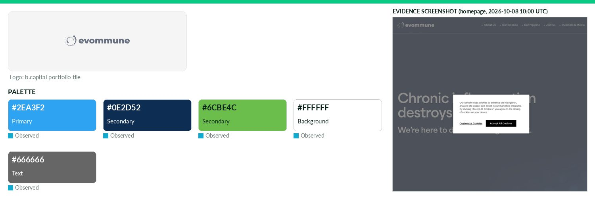
Captured 2026-10-08
Field | Value | Tier | Source
Website | https://evommune.com | Verified | b.capital portfolio
LinkedIn | https://www.linkedin.com/company/evommune | Observed | official site link
Primary / secondary | #2EA3F2 / #0E2D52 / #6CBE4C | Observed | https://www.evommune.com/ — CSS variable --gcid-primary-colo
Background / text | #FFFFFF / #666666 | Observed | live CSS body rule
Typography | area-normal; area-extended | Observed | https://www.evommune.com/ @font-face
Voice & tone | — | Missing | —
Imagery | — | Missing | —
Clear-space / misuse | — | Missing | —
Trademark | — | Missing | —
Guideline / press kit | — | Missing
HQ / employees | — | Missing | LinkedIn API rate-limited
OnDemand UI tokens | primary #2EA3F2 / on #000000 / accent #0E2D52 / surface #FFFFFF / text #666666 | Derived | contrast 7.64:1 · 5.74:1
Draft note | No official guideline; live-site values. Investors & Media at https://ir.evommune.com (press releases); no media kit/brand page. evommune.com apex http | Caveat
Flourish Health
Healthcare · North America · Active · completeness 38% · tier Observed — Flourish Health specializes in providing in-home behavioral health treatment for families, teens, and young adults facing high-acuity mental health conditions.
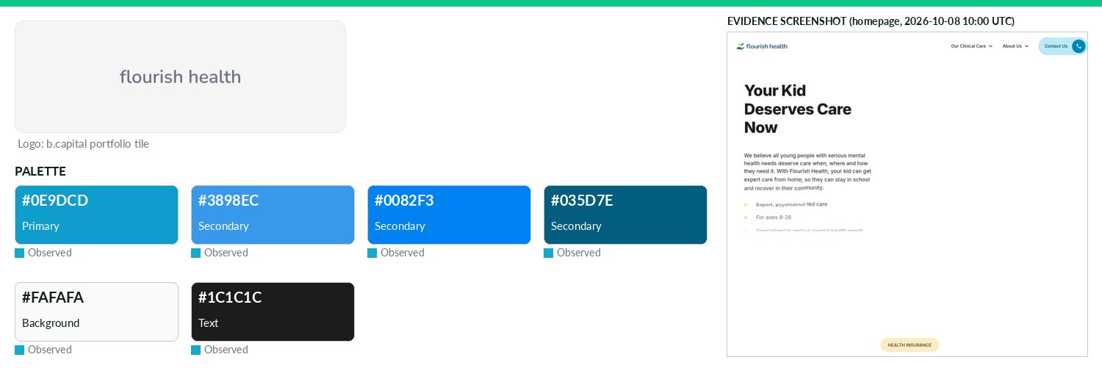
Captured 2026-10-08
Field | Value | Tier | Source
Website | https://flourish.health | Verified | b.capital portfolio
LinkedIn | — | Missing | API 429/403
Primary / secondary | #0E9DCD / #3898EC / #0082F3 / #035D7E | Observed | https://www.flourish.health/ — CSS variable --colors--brand
Background / text | #FAFAFA / #1C1C1C | Observed | live CSS body rule
Typography | Inter | Observed | https://www.flourish.health/ @font-face 'Inter Extra-Bold'
Voice & tone | — | Missing | —
Imagery | — | Missing | —
Clear-space / misuse | — | Missing | —
Trademark | — | Missing | —
Guideline / press kit | — | Missing
HQ / employees | — | Missing | LinkedIn API rate-limited
OnDemand UI tokens | primary #0E9DCD / on #000000 / accent #3898EC / surface #FAFAFA / text #1C1C1C | Derived | contrast 6.72:1 · 16.33:1
Draft note | No official guideline; live-site values. Known gap confirmed: /press,/news,/media,/press-kit,/about all 404; terms-privacy page has no trademark clause | Caveat
Grit
Healthcare · Asia · Active · completeness 15% · tier Observed — Clinical stage cell therapy company specializing in TIL (Tumor Infiltrating Lymphocytes) technology to cure solid tumors.
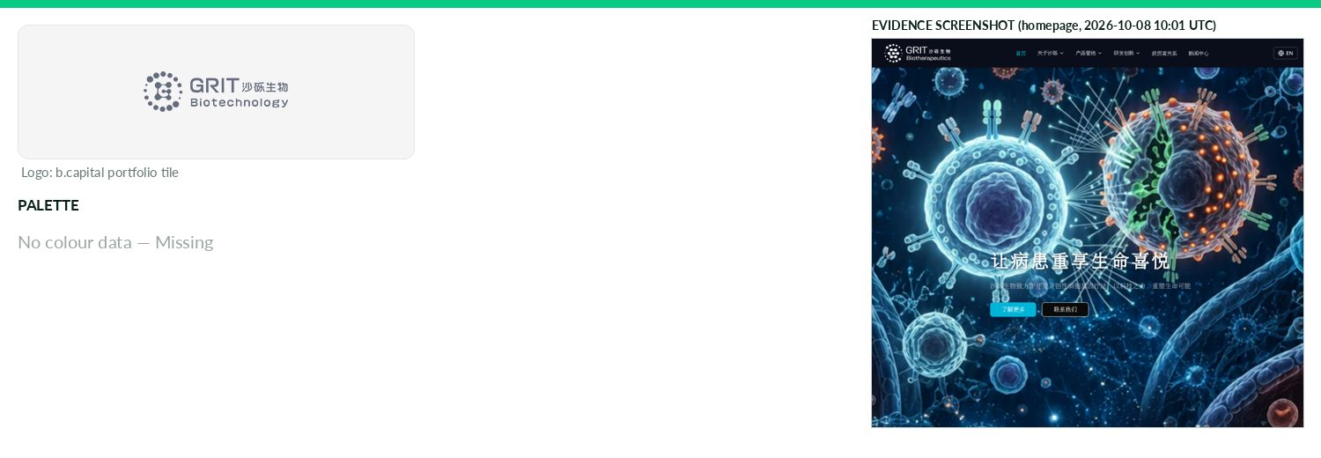
Captured 2026-10-08
Field | Value | Tier | Source
Website | https://www.grit-bio.com | Verified | b.capital portfolio
LinkedIn | — | Missing | API 429/403
Primary / secondary | — | Missing | —
Background / text | — | Missing | —
Typography | font-4c875076bada3b19; font-7219b3fb1d9caa28; font-4f4fe6433ae2a259; font-bb24fe8b0515269d | Observed | https://www.gritbio.com/ — CSS font-family/@font-face
Voice & tone | — | Missing | —
Imagery | — | Missing | —
Clear-space / misuse | — | Missing | —
Trademark | — | Missing | —
Guideline / press kit | — | Missing
HQ / employees | — | Missing | LinkedIn API rate-limited
Draft note | No official guideline; live-site values. JS-rendered SPA (3.4 KB shell; every path returns same shell, so probe 200s are soft). Sitemap points to gritb | Caveat
HifiBio
Healthcare · Asia · Active · completeness 46% · tier Observed — Clinical stage immunotherapy company developing novel antibodies for solid tumors and autoimmune diseases.
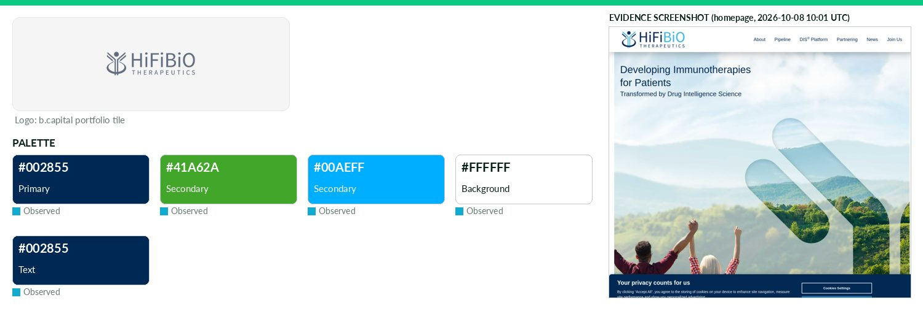
Captured 2026-10-08
Field | Value | Tier | Source
Website | http://hifibio.com | Verified | b.capital portfolio
LinkedIn | https://www.linkedin.com/company/hifibiotherapeutics | Observed | official site link
Primary / secondary | #002855 / #41A62A / #00AEFF | Observed | https://hifibio.com/ CSS most frequent
Background / text | #FFFFFF / #002855 | Observed | live CSS body rule
Typography | wprmenu; icomoon | Observed | https://hifibio.com/ — CSS font-family/@font-face
Voice & tone | — | Missing | —
Imagery | — | Missing | —
Clear-space / misuse | — | Missing | —
Trademark | — | Missing | —
Guideline / press kit | — | Missing
HQ / employees | — | Missing | LinkedIn API rate-limited
OnDemand UI tokens | primary #002855 / on #FFFFFF / accent #41A62A / surface #FFFFFF / text #002855 | Derived | contrast 14.64:1 · 14.64:1
Draft note | No official guideline; live-site values. News page https://hifibio.com/news/; no media kit/brand page. http port 80 timed out, https ok. | Caveat
HotSpot Therapeutics
Healthcare · North America · Active · completeness 8% · tier Third-party — Biopharmaceutical company developing small molecule drugs targeting natural regulatory sites on disease-related proteins.
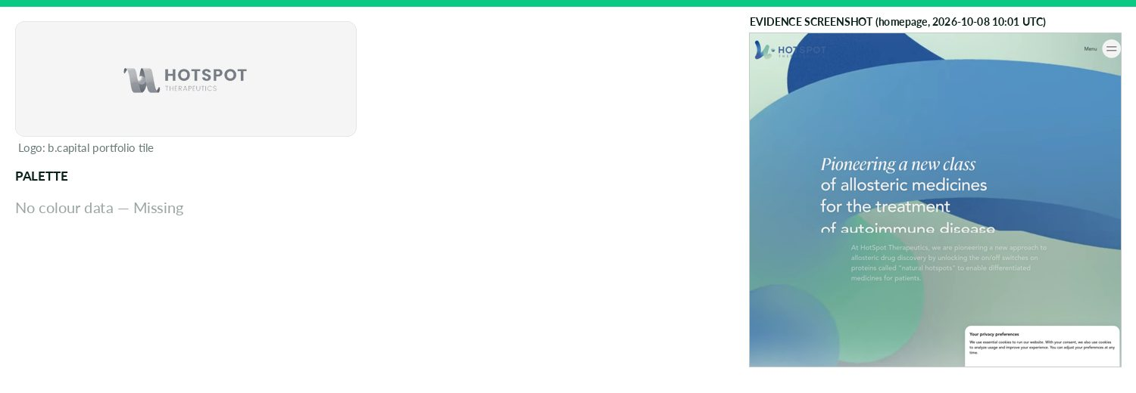
Captured 2026-10-08
Field | Value | Tier | Source
Website | https://www.hotspotthera.com | Verified | b.capital portfolio
LinkedIn | — | Missing | API 429/403
Primary / secondary | — | Missing | —
Background / text | — | Missing | —
Typography | — | Missing | —
Voice & tone | — | Missing | —
Imagery | — | Missing | —
Clear-space / misuse | — | Missing | —
Trademark | — | Missing | —
Guideline / press kit | — | Missing
HQ / employees | — | Missing | LinkedIn API rate-limited
Draft note | No official guideline; live-site values. Cloudflare challenge ('Just a moment...') on all paths incl. /news; nothing retrievable. | Caveat
Innovaccer
Healthcare · North America · Active · completeness 54% · tier Observed — Healthcare data platform unifying clinical, claims and operational data to power care intelligence and analytics.
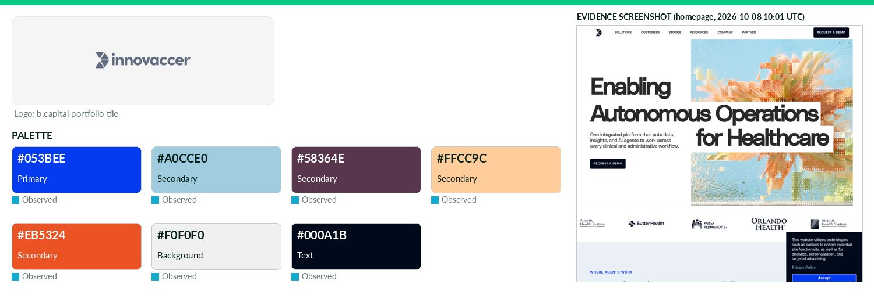
Captured 2026-10-08
Field | Value | Tier | Source
Website | https://innovaccer.com | Verified | b.capital portfolio
LinkedIn | https://www.linkedin.com/company/innovaccer | Observed | official site link
Primary / secondary | #053BEE / #A0CCE0 / #58364E / #FFCC9C / #EB5324 | Observed | https://innovaccer.com/ CSS --primary--cyber-blue
Background / text | #F0F0F0 / #000A1B | Observed | live CSS body rule
Typography | Polysans; Untitled Serif | Observed | https://innovaccer.com/ @font-face
Voice & tone | — | Missing | —
Imagery | — | Missing | —
Clear-space / misuse | — | Missing | —
Trademark | Terms: may not use meta tags/hidden text with Innovaccer name, trademarks, service marks, logos ('Marks'); no | Verified | https://innovaccer.com/terms-of-use
Guideline / press kit | — | Missing
HQ / employees | — | Missing | LinkedIn API rate-limited
OnDemand UI tokens | primary #053BEE / on #FFFFFF / accent #A0CCE0 / surface #F0F0F0 / text #000A1B | Derived | contrast 7.33:1 · 17.4:1
Draft note | No official guideline; live-site values. Newsroom https://innovaccer.com/news: 'media kit access' only via press@innovaccer.com. /brand,/press-kit 404. | Caveat
Insilico Medicine
Healthcare · Asia · Active · completeness 62% · tier Verified — AI-driven drug discovery platform using generative models to design and advance novel therapeutics.
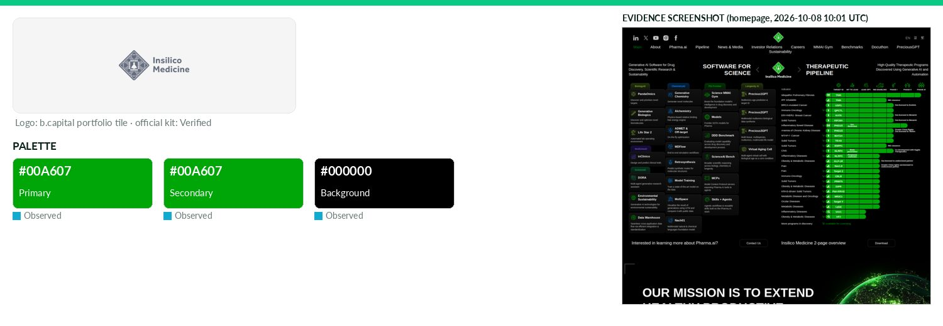
Captured 2026-10-08
Field | Value | Tier | Source
Website | http://insilico.com | Verified | b.capital portfolio
LinkedIn | https://www.linkedin.com/company/in-silico-medicine-inc | Observed | official site link
Primary / secondary | #00A607 / #00A607 | Observed | https://insilico.com/ — CSS variable --uc-button-bgcolor-XxF
Background / text | #000000 / — | Observed | live CSS body rule
Typography | Inter | Observed | https://insilico.com/ CSS
Voice & tone | — | Missing | —
Imagery | — | Missing | —
Clear-space / misuse | Design Kit 'License and Usage Guide': design elements licensed CC BY-NC-SA 4.0 (icons/workflows kit); no clear-space/mis | Verified | https://insilico.com/design-resources
Trademark | — | Missing | —
Guideline / press kit | https://insilico.com/design-resources | Verified
HQ / employees | — | Missing | LinkedIn API rate-limited
OnDemand UI tokens | primary #00A607 / on #000000 / accent #00A607 / surface #000000 / text #111111 | Derived | contrast 6.46:1 · 1.11:1
Isaac Health
Healthcare · North America · Active · completeness 54% · tier Observed — Virtual memory clinic delivering specialized care for dementia and other brain health conditions.
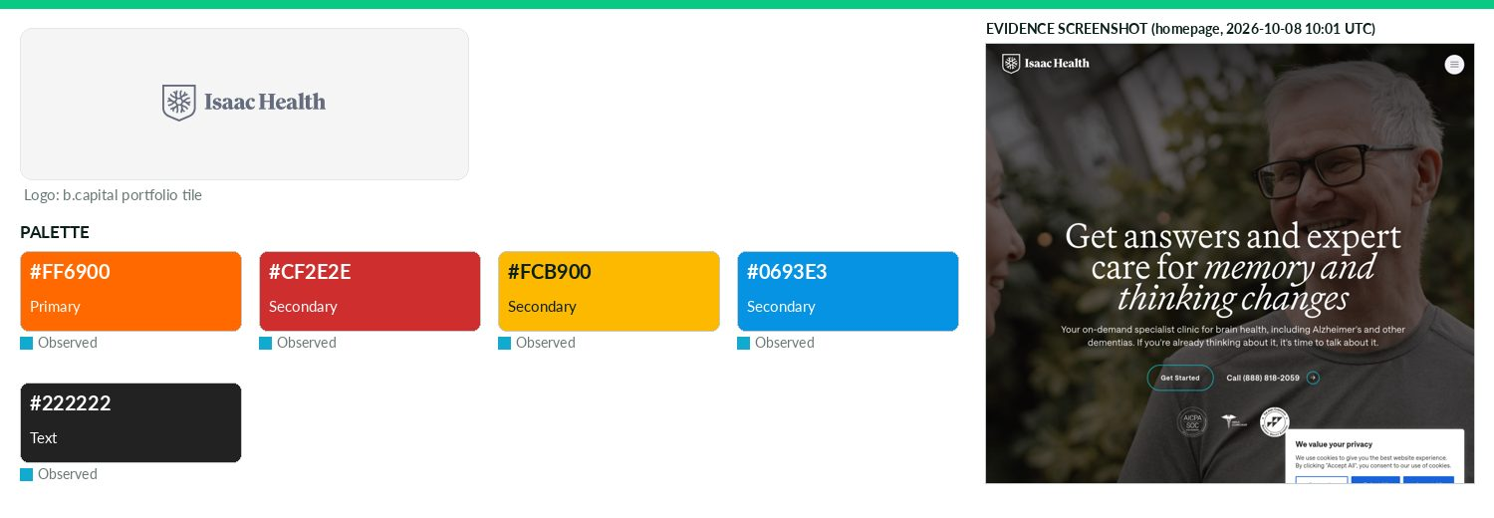
Captured 2026-10-08
Field | Value | Tier | Source
Website | https://www.myisaachealth.com | Verified | b.capital portfolio
LinkedIn | https://www.linkedin.com/company/isaachealth | Observed | official site link
Primary / secondary | #FF6900 / #CF2E2E / #FCB900 / #0693E3 | Observed | https://isaac.health/ — most frequent saturated CSS colour (
Background / text | — / #222222 | Observed | live CSS body rule
Typography | Saans; Martina | Observed | https://isaac.health/ @font-face
Voice & tone | — | Missing | —
Imagery | — | Missing | —
Clear-space / misuse | — | Missing | —
Trademark | Terms: use, reproduction, copying or redistribution of Isaac Health trademarks, service marks and logos strict | Verified | https://isaac.health/terms-of-use/
Guideline / press kit | — | Missing
HQ / employees | — | Missing | LinkedIn API rate-limited
OnDemand UI tokens | primary #FF6900 / on #000000 / accent #CF2E2E / surface #FFFFFF / text #222222 | Derived | contrast 7.27:1 · 15.91:1
Draft note | No official guideline; live-site values. myisaachealth.com -> isaac.health. Newsroom states 'reach out to media@myisaachealth.com for our media kit' (n | Caveat
Labviva
Healthcare · North America · Active · completeness 46% · tier Observed — Digital marketplace streamlining life sciences procurement with AI-driven search and insights.
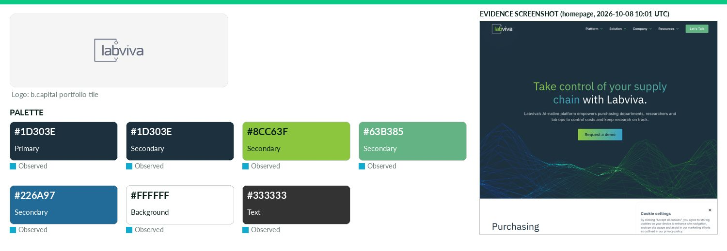
Captured 2026-10-08
Field | Value | Tier | Source
Website | http://labviva.com | Verified | b.capital portfolio
LinkedIn | https://www.linkedin.com/company/labviva | Observed | official site link
Primary / secondary | #1D303E / #1D303E / #8CC63F / #63B385 / #226A97 | Observed | https://labviva.com/ — most frequent saturated CSS colour (4
Background / text | #FFFFFF / #333333 | Observed | live CSS body rule
Typography | Inter; IBM Plex Sans | Observed | https://www.labviva.com/ CSS
Voice & tone | — | Missing | —
Imagery | — | Missing | —
Clear-space / misuse | — | Missing | —
Trademark | — | Missing | —
Guideline / press kit | — | Missing
HQ / employees | — | Missing | LinkedIn API rate-limited
OnDemand UI tokens | primary #1D303E / on #FFFFFF / accent #1D303E / surface #FFFFFF / text #333333 | Derived | contrast 13.6:1 · 12.63:1
Draft note | No official guideline; live-site values. News at https://www.labviva.com/news; /press 404; no media kit. http port 80 timed out, https ok. | Caveat
Lively
Healthcare · North America · Active · completeness 46% · tier Observed — Full-stack HSA and benefits platform offering account management, payments, investments and education.
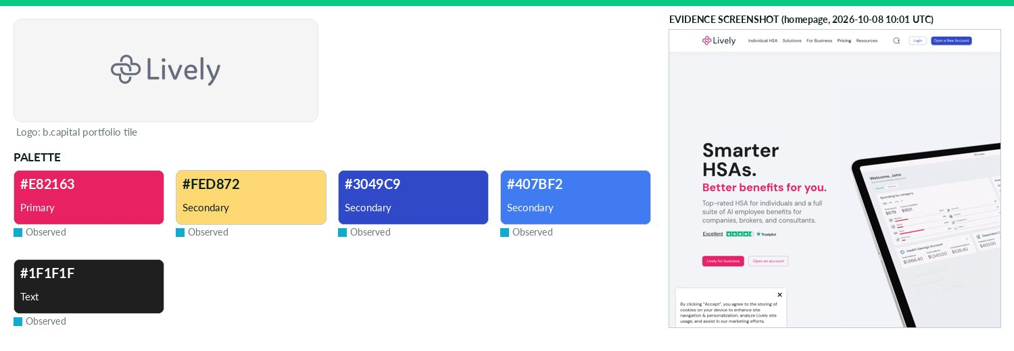
Captured 2026-10-08
Field | Value | Tier | Source
Website | https://livelyme.com | Verified | b.capital portfolio
LinkedIn | https://www.linkedin.com/company/livelyhsa | Observed | official site link
Primary / secondary | #E82163 / #FED872 / #3049C9 / #407BF2 | Observed | https://livelyme.com/ CSS --mui-palette-schemes-pink-primary
Background / text | — / #1F1F1F | Observed | live CSS body rule
Typography | DM Sans | Observed | https://livelyme.com/ next/font DM Sans
Voice & tone | — | Missing | —
Imagery | — | Missing | —
Clear-space / misuse | — | Missing | —
Trademark | — | Missing | —
Guideline / press kit | — | Missing
HQ / employees | — | Missing | LinkedIn API rate-limited
OnDemand UI tokens | primary #E82163 / on #000000 / accent #FED872 / surface #FFFFFF / text #1F1F1F | Derived | contrast 4.83:1 · 16.48:1
Draft note | No official guideline; live-site values. /newsroom redirects to blog category news; /press,/media-kit 404. No trademark clause found in T&C excerpt. | Caveat
Lumara Health
Healthcare · North America · Active · completeness 31% · tier Observed — AI-native healthcare platform automating operational workflows for health plans, brokers and TPAs.
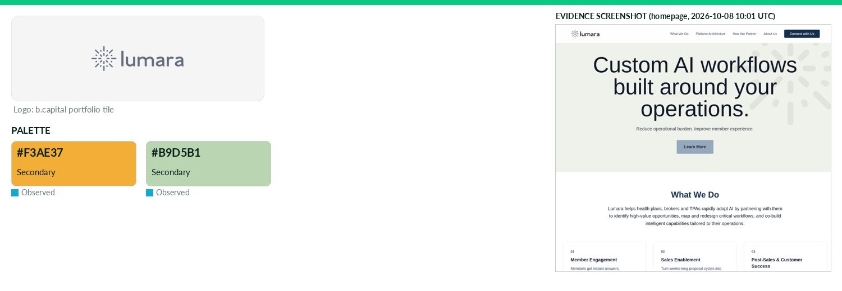
Captured 2026-10-08
Field | Value | Tier | Source
Website | https://www.lumara.health | Verified | b.capital portfolio
LinkedIn | https://www.linkedin.com/company/lumara-ai | Observed | official site link
Primary / secondary | #F3AE37 / #B9D5B1 | Missing | —
Background / text | — | Missing | —
Typography | Arimo | Observed | https://www.lumara.health/ next/font
Voice & tone | — | Missing | —
Imagery | — | Missing | —
Clear-space / misuse | — | Missing | —
Trademark | — | Missing | —
Guideline / press kit | — | Missing
HQ / employees | — | Missing | LinkedIn API rate-limited
Draft note | No official guideline; live-site values. No press/brand/terms pages (all 404). Logo SVGs live under /logo/svg/ path. | Caveat
MacroLux
Healthcare · Asia · Active · completeness 38% · tier Observed — Medical device company developing advanced endoscopic technologies for interventional diagnosis and minimally invasive treatment.
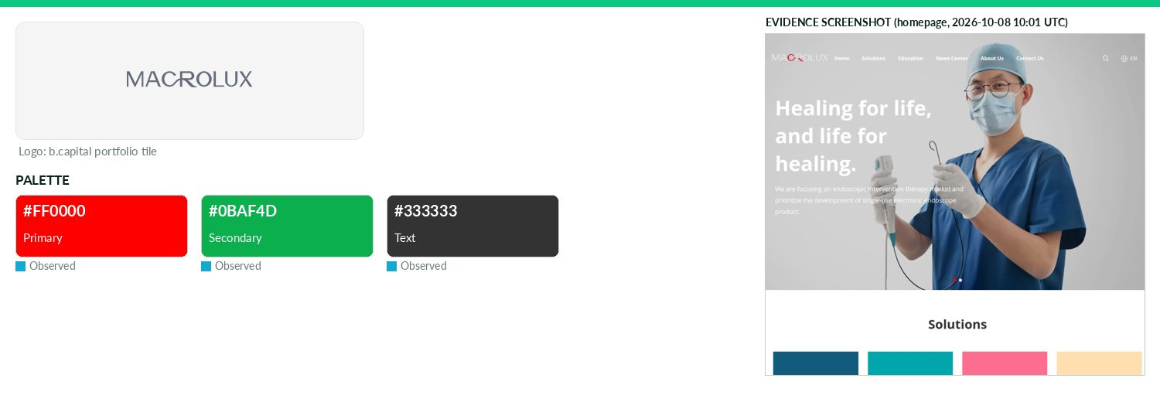
Captured 2026-10-08
Field | Value | Tier | Source
Website | https://www.microlite.cn | Verified | b.capital portfolio
LinkedIn | — | Missing | API 429/403
Primary / secondary | #FF0000 / #0BAF4D | Observed | https://www.microlite.cn/ — most frequent saturated CSS colo
Background / text | — / #333333 | Observed | live CSS body rule
Typography | Poppins; Open Sans | Observed | https://www.microlite.cn/ @font-face
Voice & tone | — | Missing | —
Imagery | — | Missing | —
Clear-space / misuse | — | Missing | —
Trademark | — | Missing | —
Guideline / press kit | — | Missing
HQ / employees | — | Missing | LinkedIn API rate-limited
OnDemand UI tokens | primary #FF0000 / on #000000 / accent #0BAF4D / surface #FFFFFF / text #333333 | Derived | contrast 5.25:1 · 12.63:1
Draft note | No official guideline; live-site values. Site title 'MacroLux Medical Technology Co., Ltd.'; News Center https://www.microlite.cn/info/. No brand/press | Caveat
MediTrust
Healthcare · Asia · Active · completeness 8% · tier Third-party — MediTrust is a leading innovative healthcare payer platform in China which aims to offer drugs benefit management for patients by partnering with insurers, drug
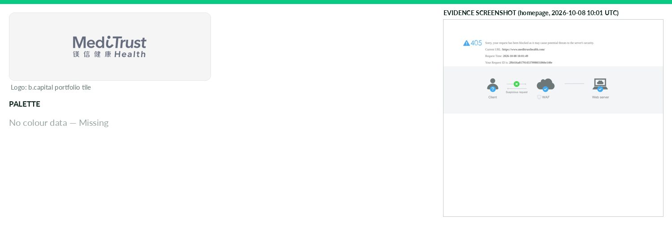
Captured 2026-10-08
Field | Value | Tier | Source
Website | https://www.meditrusthealth.com | Verified | b.capital portfolio
LinkedIn | — | Missing | API 429/403
Primary / secondary | — | Missing | —
Background / text | — | Missing | —
Typography | — | Missing | —
Voice & tone | — | Missing | —
Imagery | — | Missing | —
Clear-space / misuse | — | Missing | —
Trademark | — | Missing | —
Guideline / press kit | — | Missing
HQ / employees | — | Missing | LinkedIn API rate-limited
Draft note | No official guideline; live-site values. Server returns HTTP 405 to scripted GET on / and /en (likely WAF); http port 80 fails. | Caveat
Nalu
Healthcare · North America · Exited · completeness 15% · tier Observed — Developing minimally invasive neurostimulators to treat chronic spinal and peripheral nerve pain.
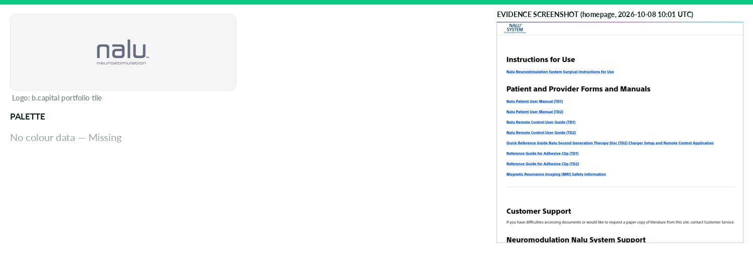
Captured 2026-10-08
Field | Value | Tier | Source
Website | https://nalumed.com | Verified | b.capital portfolio
LinkedIn | — | Missing | API 429/403
Primary / secondary | — | Missing | https://www.nalumed.com/us/en/IFUs.html — CSS variable --pri
Background / text | — | Missing | —
Typography | — | Missing | https://www.nalumed.com/us/en/IFUs.html — CSS font-family/@f
Voice & tone | — | Missing | —
Imagery | — | Missing | —
Clear-space / misuse | — | Missing | —
Trademark | Footer: '©2026 Boston Scientific Corporation or its affiliates. All rights reserved. All trademarks are the pr | Observed | https://www.nalumed.com/us/en/IFUs.html
Guideline / press kit | — | Missing
HQ / employees | — | Missing | LinkedIn API rate-limited
Draft note | No official guideline; live-site values. nalumed.com redirects to Boston Scientific-hosted IFU page (footer ©2026 Boston Scientific); no brand/press pa | Caveat
Nest Genomics
Healthcare · North America · Active · completeness 46% · tier Observed — Healthcare insights platform integrating genetic data and analytics to assess and manage health risks.
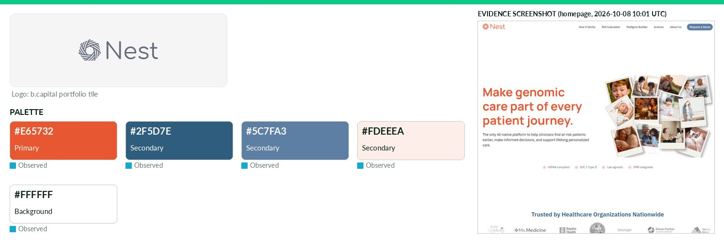
Captured 2026-10-08
Field | Value | Tier | Source
Website | https://www.nestgenomics.com | Verified | b.capital portfolio
LinkedIn | https://www.linkedin.com/company/nesthealth | Observed | official site link
Primary / secondary | #E65732 / #2F5D7E / #5C7FA3 / #FDEEEA | Observed | https://www.nestgenomics.com/
Background / text | #FFFFFF / — | Observed | live CSS body rule
Typography | Manrope; IBM Plex Sans | Observed | https://www.nestgenomics.com/ — CSS font-family/@font-face
Voice & tone | — | Missing | —
Imagery | — | Missing | —
Clear-space / misuse | — | Missing | —
Trademark | — | Missing | —
Guideline / press kit | — | Missing
HQ / employees | — | Missing | LinkedIn API rate-limited
OnDemand UI tokens | primary #E65732 / on #000000 / accent #2F5D7E / surface #FFFFFF / text #111111 | Derived | contrast 5.77:1 · 18.88:1
Draft note | No official guideline; live-site values. CSS vars --color-brand:#e65732, --color-primary:#161616. No brand/press pages found. | Caveat
Neushen Therapeutics
Healthcare · Asia · Active · completeness 46% · tier Observed — Developer of innovative and effective therapies solutions for psychiatric and neurological disorders.
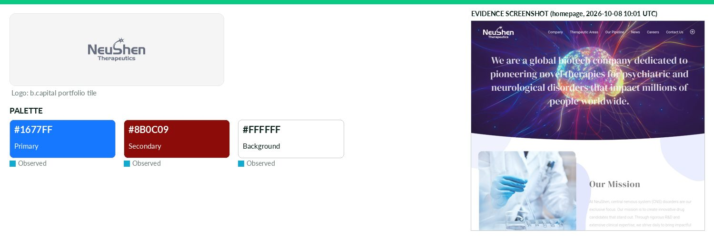
Captured 2026-10-08
Field | Value | Tier | Source
Website | https://www.neushen.com | Verified | b.capital portfolio
LinkedIn | https://www.linkedin.com/company/neushen-therapeutics | Observed | official site link
Primary / secondary | #1677FF / #8B0C09 | Observed | https://www.neushen.com/ — CSS variable --base-theme-color
Background / text | #FFFFFF / — | Observed | live CSS body rule
Typography | Roboto; DM Serif Display; DIN-M | Observed | https://www.neushen.com/
Voice & tone | — | Missing | —
Imagery | — | Missing | —
Clear-space / misuse | — | Missing | —
Trademark | — | Missing | —
Guideline / press kit | — | Missing
HQ / employees | — | Missing | LinkedIn API rate-limited
OnDemand UI tokens | primary #1677FF / on #000000 / accent #8B0C09 / surface #FFFFFF / text #111111 | Derived | contrast 5.12:1 · 18.88:1
Draft note | No official guideline; live-site values. No brand/press kit; /news.html exists (press releases). Top hex mostly framework defaults; #8b0c09 most freque | Caveat
Numerion Labs
Healthcare · North America · Active · completeness 46% · tier Observed — Technology-enabled pharmaceutical company leveraging the power of AI to revolutionize small molecule drug discovery.
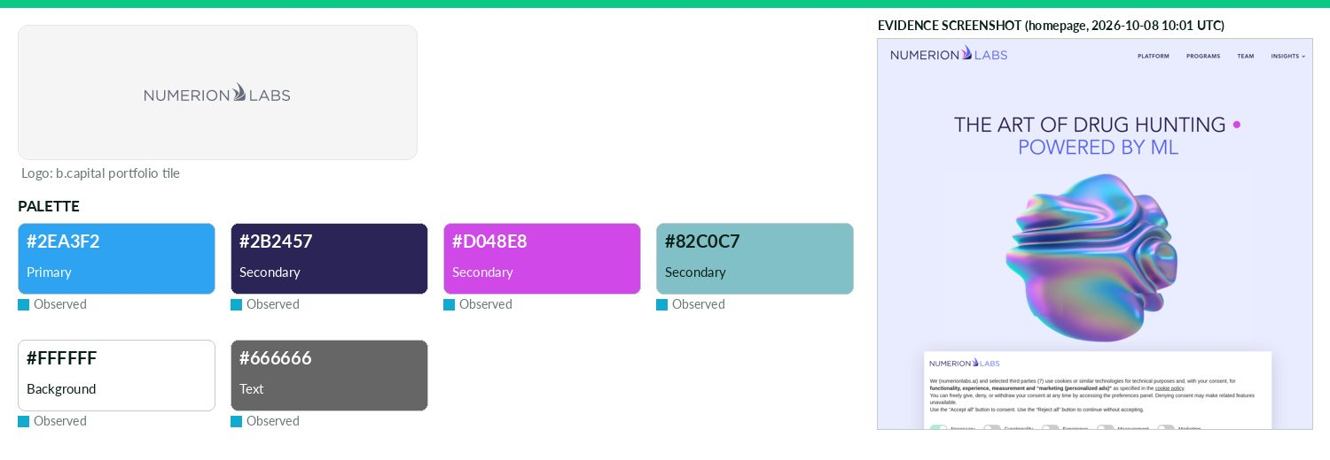
Captured 2026-10-08
Field | Value | Tier | Source
Website | https://www.atomwise.com | Verified | b.capital portfolio
LinkedIn | https://www.linkedin.com/company/numerion-labs | Observed | official site link
Primary / secondary | #2EA3F2 / #2B2457 / #D048E8 / #82C0C7 | Observed | https://numerionlabs.ai/ — most frequent saturated CSS colou
Background / text | #FFFFFF / #666666 | Observed | live CSS body rule
Typography | Open Sans | Observed | https://numerionlabs.ai/
Voice & tone | — | Missing | —
Imagery | — | Missing | —
Clear-space / misuse | — | Missing | —
Trademark | — | Missing | —
Guideline / press kit | — | Missing
HQ / employees | — | Missing | LinkedIn API rate-limited
OnDemand UI tokens | primary #2EA3F2 / on #000000 / accent #2B2457 / surface #FFFFFF / text #666666 | Derived | contrast 7.64:1 · 5.74:1
Draft note | No official guideline; live-site values. atomwise.com redirects to numerionlabs.ai (rebrand). numerion.com SSL error; numerionlabs.com NXDOMAIN. /news | Caveat
Nuvig
Healthcare · North America · Active · completeness 8% · tier Observed — Clinical-stage biotech developing immunomodulatory therapies for autoimmune and chronic inflammatory diseases.
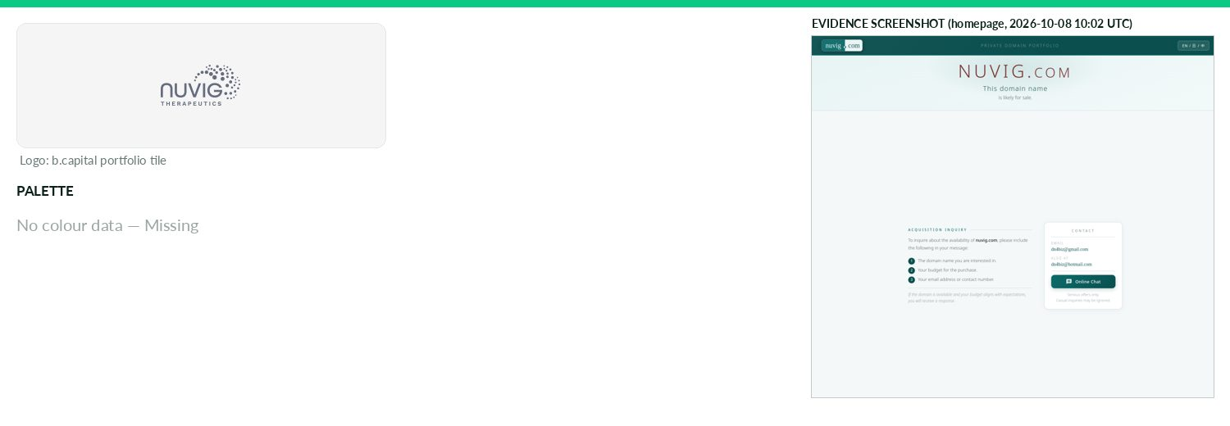
Captured 2026-10-08
Field | Value | Tier | Source
Website | https://www.nuvig.com | Verified | b.capital portfolio
LinkedIn | — | Missing | API 429/403
Primary / secondary | — | Missing | https://www.nuvig.com/ — CSS variable --accent
Background / text | — | Missing | —
Typography | — | Missing | —
Voice & tone | — | Missing | —
Imagery | — | Missing | —
Clear-space / misuse | — | Missing | —
Trademark | — | Missing | —
Guideline / press kit | — | Missing
HQ / employees | — | Missing | LinkedIn API rate-limited
Draft note | No official guideline; live-site values. nuvig.com is a parked 'Premium Domain for Sale' page — not the company site; all probe paths soft-200 on the p | Caveat
PicnicHealth
Healthcare · North America · Active · completeness 38% · tier Observed — Health data platform simplifying medical record access and enabling AI-powered real-world research.
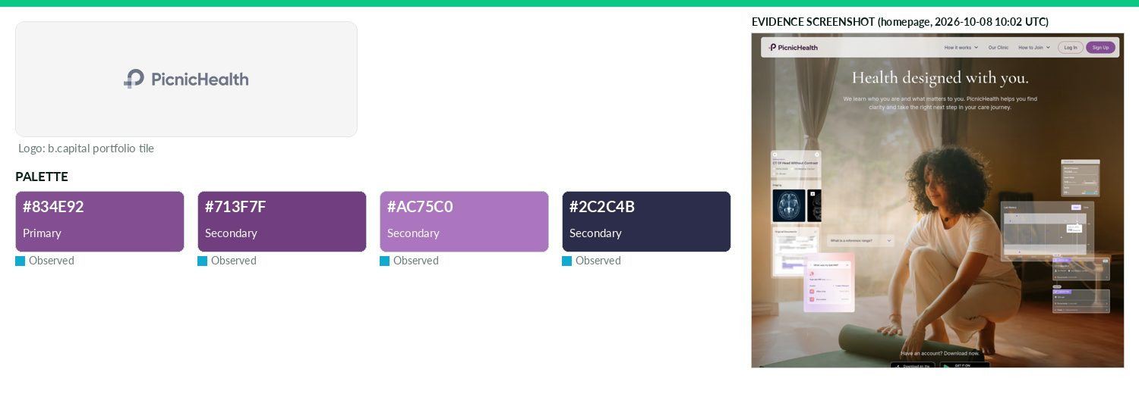
Captured 2026-10-08
Field | Value | Tier | Source
Website | https://picnichealth.com | Verified | b.capital portfolio
LinkedIn | https://www.linkedin.com/company/picnichealth | Observed | official site link
Primary / secondary | #834E92 / #713F7F / #AC75C0 / #2C2C4B | Observed | https://picnichealth.com/
Background / text | — | Missing | —
Typography | DM Sans; Cormorant Garamond; Inter; Gilroy; Halyard Display | Observed | https://picnichealth.com/
Voice & tone | — | Missing | —
Imagery | — | Missing | —
Clear-space / misuse | — | Missing | —
Trademark | — | Missing | —
Guideline / press kit | — | Missing
HQ / employees | — | Missing | LinkedIn API rate-limited
OnDemand UI tokens | primary #834E92 / on #FFFFFF / accent #713F7F / surface #FFFFFF / text #111111 | Derived | contrast 6.05:1 · 18.88:1
Draft note | No official guideline; live-site values. /press and /news return 404; no media kit found. Webflow CSS vars button-primary #834e92. | Caveat
Positive Development
Healthcare · North America · Active · completeness 38% · tier Observed — Autism care provider delivering personalized developmental therapy for neurodivergent children and families.
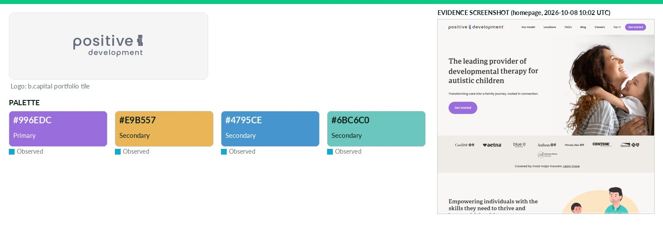
Captured 2026-10-08
Field | Value | Tier | Source
Website | http://positivedevelopment.com | Verified | b.capital portfolio
LinkedIn | https://www.linkedin.com/company/positive-development-inc | Observed | official site link
Primary / secondary | #996EDC / #E9B557 / #4795CE / #6BC6C0 | Observed | https://www.positivedevelopment.com/
Background / text | — | Missing | —
Typography | Poppins; Literata; portada | Observed | https://www.positivedevelopment.com/
Voice & tone | — | Missing | —
Imagery | — | Missing | —
Clear-space / misuse | — | Missing | —
Trademark | — | Missing | —
Guideline / press kit | — | Missing
HQ / employees | — | Missing | LinkedIn API rate-limited
OnDemand UI tokens | primary #996EDC / on #000000 / accent #E9B557 / surface #FFFFFF / text #111111 | Derived | contrast 5.62:1 · 18.88:1
Draft note | No official guideline; live-site values. /press exists (press coverage list) but no logo/brand kit downloads. CSS vars --base-color-brand--purple/yello | Caveat
ProfoundBio
Healthcare · Asia · Exited · completeness 8% · tier Observed — Clinical-stage biotechnology company developing novel antibody-based therapeutics for cancer.
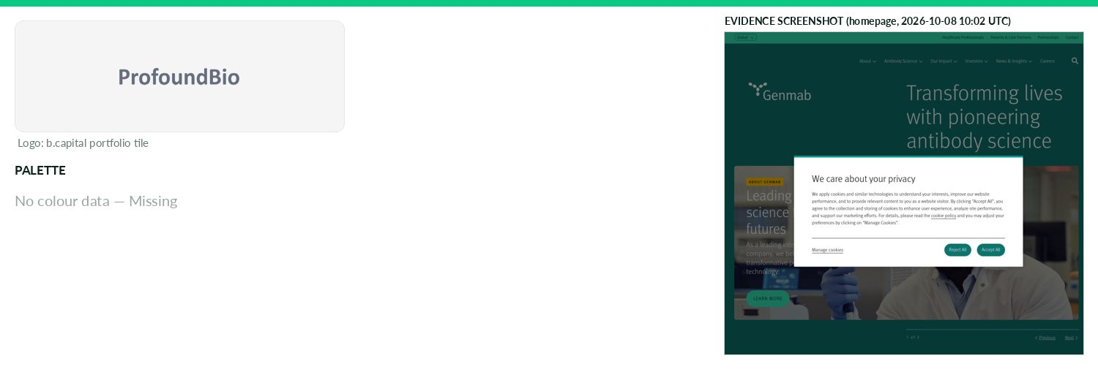
Captured 2026-10-08
Field | Value | Tier | Source
Website | http://www.profoundbio.com | Verified | b.capital portfolio
LinkedIn | — | Missing | API 429/403
Primary / secondary | — | Missing | https://www.genmab.com/ — CSS variable --dxp-g-brand
Background / text | — | Missing | —
Typography | — | Missing | https://www.genmab.com/ — CSS font-family/@font-face
Voice & tone | — | Missing | —
Imagery | — | Missing | —
Clear-space / misuse | — | Missing | —
Trademark | — | Missing | —
Guideline / press kit | — | Missing
HQ / employees | — | Missing | LinkedIn API rate-limited
Draft note | No official guideline; live-site values. profoundbio.com redirects to genmab.com (ProfoundBio acquired by Genmab). Genmab /news-insights/media-library | Caveat
Rona Therapeutics
Healthcare · Asia · Active · completeness 38% · tier Observed — Nucleic acid therapeutics company developing differentiated siRNA medicines for metabolic and neurological diseases.
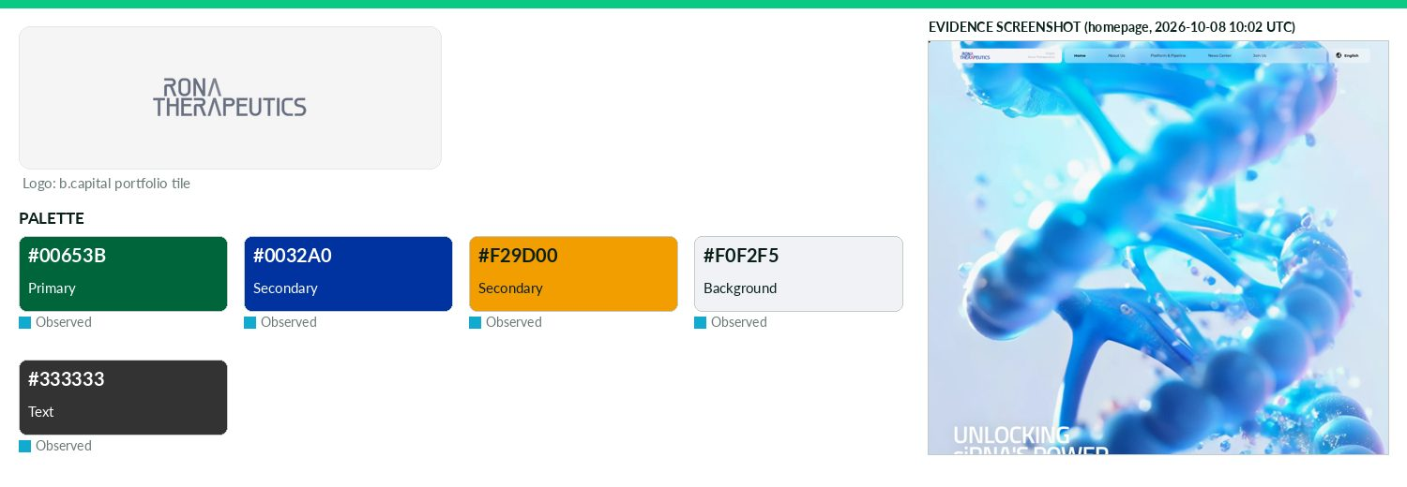
Captured 2026-10-08
Field | Value | Tier | Source
Website | https://www.ronatherapeutics.com | Verified | b.capital portfolio
LinkedIn | — | Missing | API 429/403
Primary / secondary | #00653B / #0032A0 / #F29D00 | Observed | https://www.ronatherapeutics.com/
Background / text | #F0F2F5 / #333333 | Observed | live CSS body rule
Typography | Montserrat; Titillium; Baskerville | Observed | https://www.ronatherapeutics.com/
Voice & tone | — | Missing | —
Imagery | — | Missing | —
Clear-space / misuse | — | Missing | —
Trademark | — | Missing | —
Guideline / press kit | — | Missing
HQ / employees | — | Missing | LinkedIn API rate-limited
OnDemand UI tokens | primary #00653B / on #FFFFFF / accent #0032A0 / surface #F0F2F5 / text #333333 | Derived | contrast 7.18:1 · 11.27:1
Draft note | No official guideline; live-site values. /news exists; no brand/press kit. | Caveat
Sift Healthcare
Healthcare · North America · Active · completeness 46% · tier Observed — Healthcare revenue cycle platform using data and machine learning to optimize revenue.
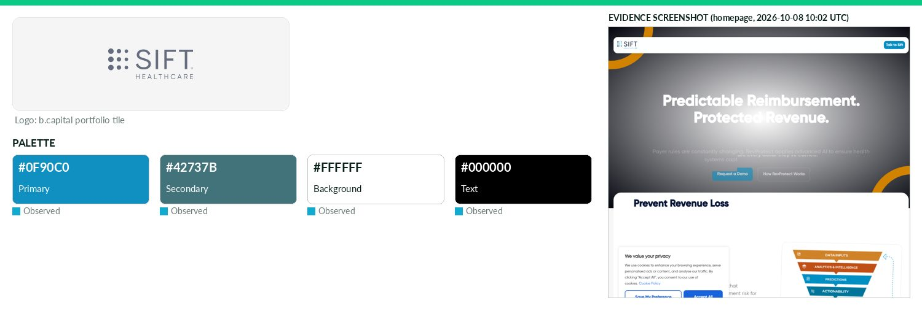
Captured 2026-10-08
Field | Value | Tier | Source
Website | https://www.sifthealthcare.com | Verified | b.capital portfolio
LinkedIn | https://www.linkedin.com/company/sift-healthcare | Observed | official site link
Primary / secondary | #0F90C0 / #42737B | Observed | https://www.sifthealthcare.com/ — CSS variable --e-global-co
Background / text | #FFFFFF / #000000 | Observed | live CSS body rule
Typography | Gilroy; Manrope | Observed | https://www.sifthealthcare.com/
Voice & tone | — | Missing | —
Imagery | — | Missing | —
Clear-space / misuse | — | Missing | —
Trademark | — | Missing | —
Guideline / press kit | — | Missing
HQ / employees | — | Missing | LinkedIn API rate-limited
OnDemand UI tokens | primary #0F90C0 / on #000000 / accent #42737B / surface #FFFFFF / text #000000 | Derived | contrast 5.77:1 · 21.0:1
Draft note | No official guideline; live-site values. /news exists with press-release PDFs (not brand docs). No brand/media kit. | Caveat
SilverCloud Health
Healthcare · Europe · Active · completeness 38% · tier Observed — On-demand digital mental health platform providing evidence based wellbeing and behavioral health solutions.
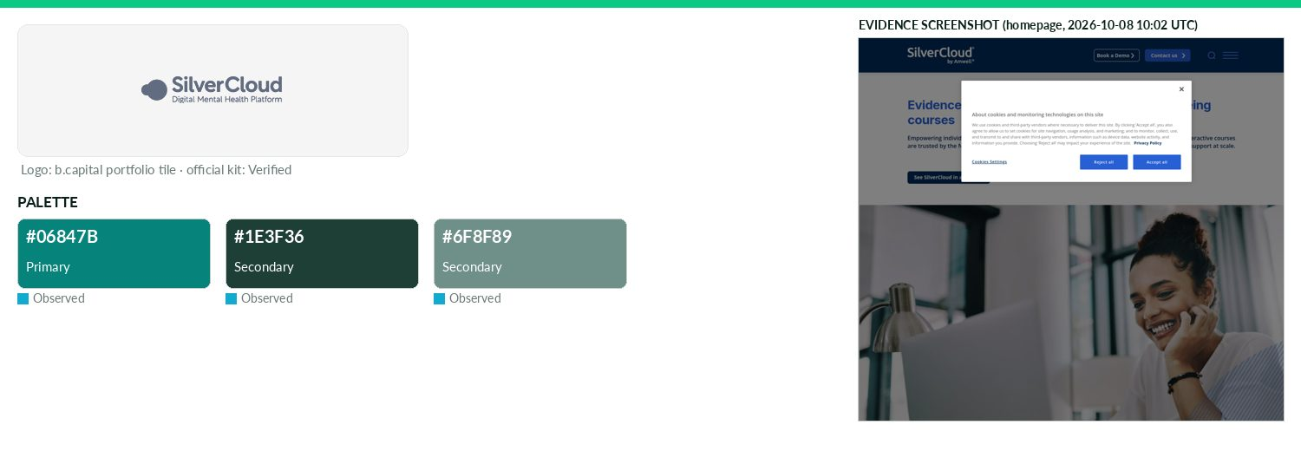
Captured 2026-10-08
Field | Value | Tier | Source
Website | http://silvercloudhealth.com | Verified | b.capital portfolio
LinkedIn | https://www.linkedin.com/company/amwellcorp | Observed | official site link
Primary / secondary | #06847B / #1E3F36 / #6F8F89 | Observed | https://silvercloud.amwell.com/
Background / text | — | Missing | —
Typography | Questrial; Barlow Condensed; Inter; Open Sans | Observed | https://silvercloud.amwell.com/
Voice & tone | — | Missing | —
Imagery | — | Missing | —
Clear-space / misuse | — | Missing | —
Trademark | — | Missing | —
Guideline / press kit | https://business.amwell.com/docs/amwell-media-logos.zip | Missing
HQ / employees | — | Missing | LinkedIn API rate-limited
OnDemand UI tokens | primary #06847B / on #000000 / accent #1E3F36 / surface #FFFFFF / text #111111 | Derived | contrast 4.59:1 · 18.88:1
Draft note | No official guideline; live-site values. silvercloudhealth.com redirects to silvercloud.amwell.com ('SilverCloud by Amwell'). Parent Amwell newsroom of | Caveat
Solve Therapeutics
Healthcare · North America · Active · completeness 46% · tier Observed — Biotech company focused on antibody-drug conjugates (ADCs).
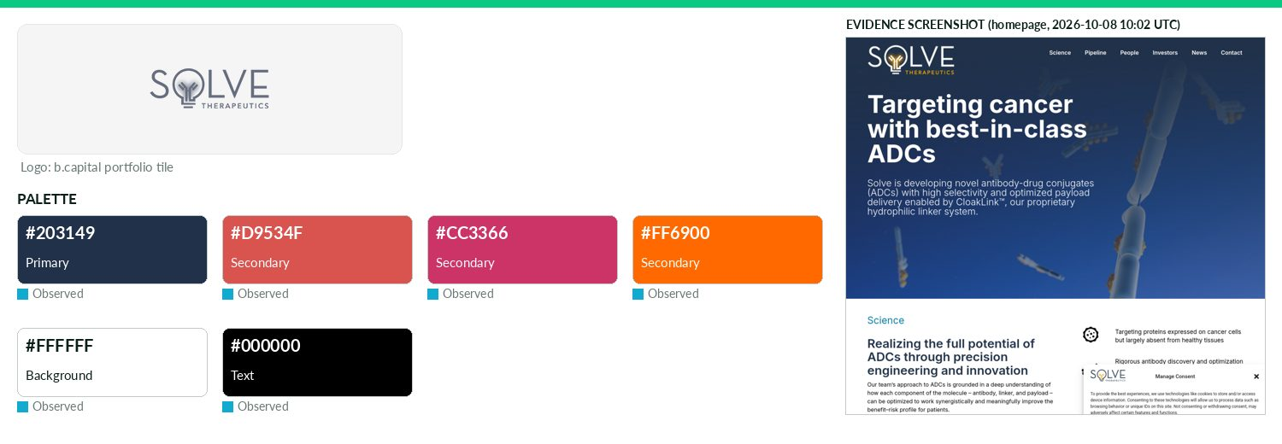
Captured 2026-10-08
Field | Value | Tier | Source
Website | https://solvetx.com | Verified | b.capital portfolio
LinkedIn | https://www.linkedin.com/company/matrix-capital-management-llc | Observed | official site link
Primary / secondary | #203149 / #D9534F / #CC3366 / #FF6900 | Observed | https://solvetx.com/ — CSS variable --e-global-color-primary
Background / text | #FFFFFF / #000000 | Observed | live CSS body rule
Typography | Inter | Observed | https://solvetx.com/
Voice & tone | — | Missing | —
Imagery | — | Missing | —
Clear-space / misuse | — | Missing | —
Trademark | — | Missing | —
Guideline / press kit | — | Missing
HQ / employees | — | Missing | LinkedIn API rate-limited
OnDemand UI tokens | primary #203149 / on #FFFFFF / accent #D9534F / surface #FFFFFF / text #000000 | Derived | contrast 13.15:1 · 21.0:1
Draft note | No official guideline; live-site values. Tried hard: /, /news, /contact 200; /about, brand, press-kit, media-kit all 404/soft. Elementor globals: typog | Caveat
Spectrumedics
Healthcare · Asia · Active · completeness 8% · tier Observed — Cardiovascular medical device company developing shockwave-based therapies for minimally invasive treatment of vascular disease.
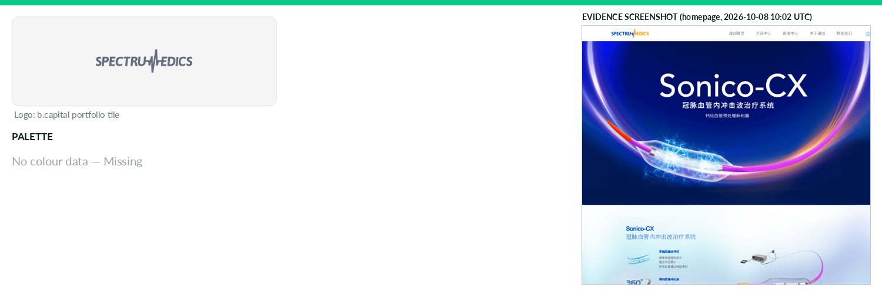
Captured 2026-10-08
Field | Value | Tier | Source
Website | https://spectrumedics.com | Verified | b.capital portfolio
LinkedIn | — | Missing | API 429/403
Primary / secondary | — | Missing | https://spectrumedics.com/ — most frequent saturated CSS col
Background / text | — | Missing | —
Typography | — | Missing | https://spectrumedics.com/ — CSS font-family/@font-face
Voice & tone | — | Missing | —
Imagery | — | Missing | —
Clear-space / misuse | — | Missing | —
Trademark | — | Missing | —
Guideline / press kit | — | Missing
HQ / employees | — | Missing | LinkedIn API rate-limited
Draft note | No official guideline; live-site values. spectrumedics.com serves an unrelated Chinese-language gambling-style page (title '开云(中国)Kaiyun...'); domain a | Caveat
Sugarfit
Healthcare · Asia · Active · completeness 46% · tier Observed — Digital health platform delivering personalized diabetes and weight management programs in India.
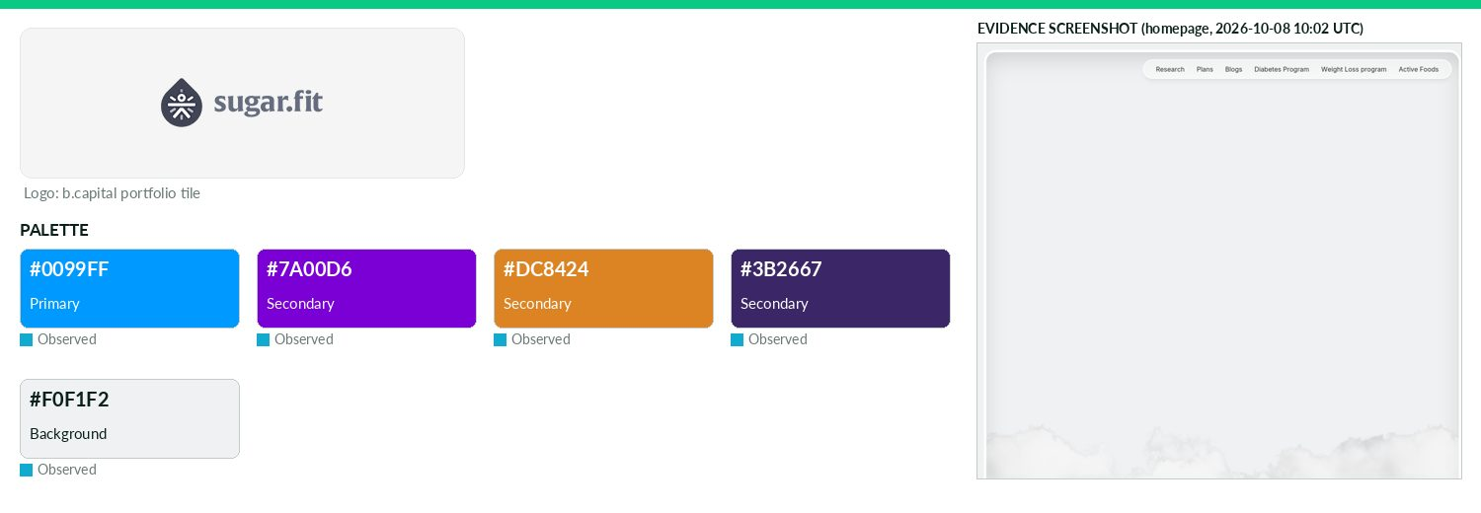
Captured 2026-10-08
Field | Value | Tier | Source
Website | https://www.sugarfit.com | Verified | b.capital portfolio
LinkedIn | https://www.linkedin.com/company/sugarfit | Observed | official site link
Primary / secondary | #0099FF / #7A00D6 / #DC8424 / #3B2667 | Observed | https://home.sugarfit.com/ — most frequent saturated CSS col
Background / text | #F0F1F2 / — | Observed | live CSS body rule
Typography | Inter; Inter Display; Nunito Sans; Plus Jakarta Sans | Observed | https://home.sugarfit.com/
Voice & tone | — | Missing | —
Imagery | — | Missing | —
Clear-space / misuse | — | Missing | —
Trademark | — | Missing | —
Guideline / press kit | — | Missing
HQ / employees | — | Missing | LinkedIn API rate-limited
OnDemand UI tokens | primary #0099FF / on #000000 / accent #7A00D6 / surface #F0F1F2 / text #111111 | Derived | contrast 7.0:1 · 16.7:1
Draft note | No official guideline; live-site values. Redirects to home.sugarfit.com (Framer). /press redirects to home or 404; no media kit. Colours mostly neutral | Caveat
Synapticure
Healthcare · North America · Active · completeness 38% · tier Observed — Nationwide virtual neurology clinic providing integrated specialty care and access to novel therapies.
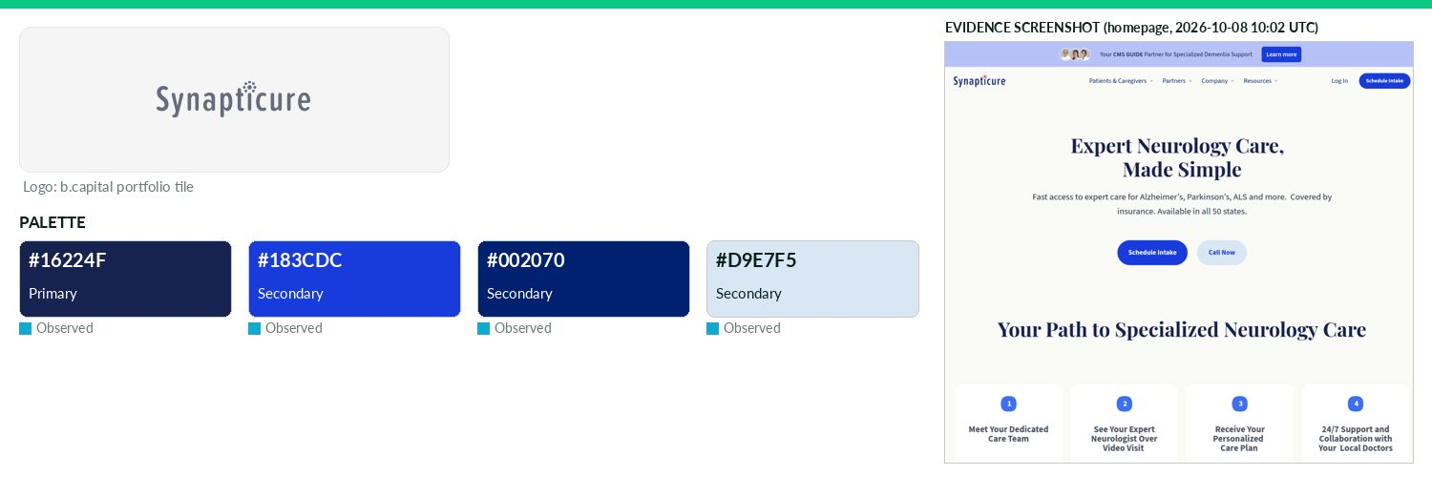
Captured 2026-10-08
Field | Value | Tier | Source
Website | https://www.synapticure.com | Verified | b.capital portfolio
LinkedIn | https://www.linkedin.com/company/71207928 | Observed | official site link
Primary / secondary | #16224F / #183CDC / #002070 / #D9E7F5 | Observed | https://www.synapticure.com/
Background / text | — | Missing | —
Typography | Playfair Display; Source Sans 3; Work Sans | Observed | https://www.synapticure.com/
Voice & tone | — | Missing | —
Imagery | — | Missing | —
Clear-space / misuse | — | Missing | —
Trademark | — | Missing | —
Guideline / press kit | — | Missing
HQ / employees | — | Missing | LinkedIn API rate-limited
OnDemand UI tokens | primary #16224F / on #FFFFFF / accent #183CDC / surface #FFFFFF / text #111111 | Derived | contrast 15.26:1 · 18.88:1
Draft note | No official guideline; live-site values. /press = Newsroom page (press releases + contact); no logo/brand kit. CSS var --synapticure-2025_color---brand | Caveat
TinyHealth
Healthcare · North America · Active · completeness 46% · tier Observed — Developer of microbiome test kits designed to improve the health outcomes of future generations through evidence-based insights.
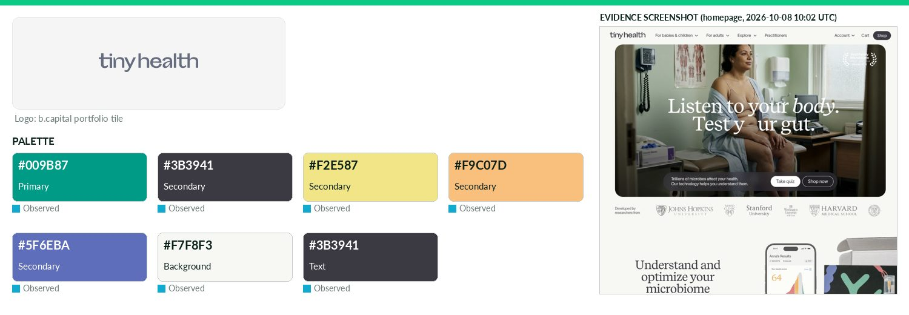
Captured 2026-10-08
Field | Value | Tier | Source
Website | https://www.tinyhealth.com | Verified | b.capital portfolio
LinkedIn | https://www.linkedin.com/company/tinyhealth | Observed | official site link
Primary / secondary | #009B87 / #3B3941 / #F2E587 / #F9C07D / #5F6EBA | Observed | https://www.tinyhealth.com/
Background / text | #F7F8F3 / #3B3941 | Observed | live CSS body rule
Typography | TWK Lausanne; Recife | Observed | https://www.tinyhealth.com/
Voice & tone | — | Missing | —
Imagery | — | Missing | —
Clear-space / misuse | — | Missing | —
Trademark | — | Missing | —
Guideline / press kit | — | Missing
HQ / employees | — | Missing | LinkedIn API rate-limited
OnDemand UI tokens | primary #009B87 / on #000000 / accent #3B3941 / surface #F7F8F3 / text #3B3941 | Derived | contrast 6.04:1 · 10.65:1
Draft note | No official guideline; live-site values. /press lists media coverage; contact hello@tinyhealth.com; no logo/brand kit. bg/text inferred from most frequ | Caveat
Vivacta
Healthcare · Asia · Active · completeness 8% · tier Third-party — Point-of-care diagnostics company developing piezofilm-based biomarker testing from small blood samples
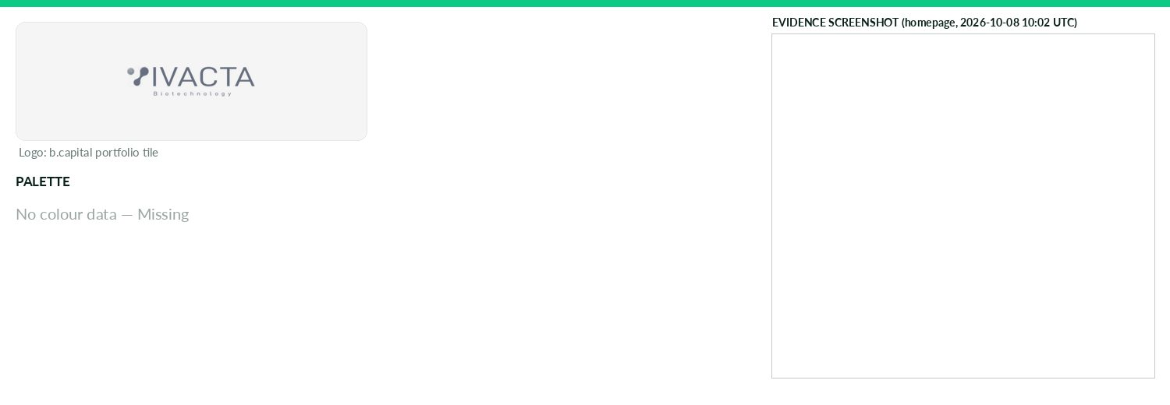
Captured 2026-10-08
Field | Value | Tier | Source
Website | http://vivacta-bio.com | Verified | b.capital portfolio
LinkedIn | — | Missing | API 429/403
Primary / secondary | — | Missing | —
Background / text | — | Missing | —
Typography | — | Missing | —
Voice & tone | — | Missing | —
Imagery | — | Missing | —
Clear-space / misuse | — | Missing | —
Trademark | — | Missing | —
Guideline / press kit | — | Missing
HQ / employees | — | Missing | LinkedIn API rate-limited
Draft note | No official guideline; live-site values. vivacta-bio.com returns a near-empty Chinese page titled '微滔生物-首页' (Weitao Bio), JS-rendered; could not confir | Caveat
Volastra
Healthcare · North America · Active · completeness 46% · tier Observed — Clinical-stage oncology company developing KIF18A inhibitors targeting chromosomal instability in ovarian cancer.
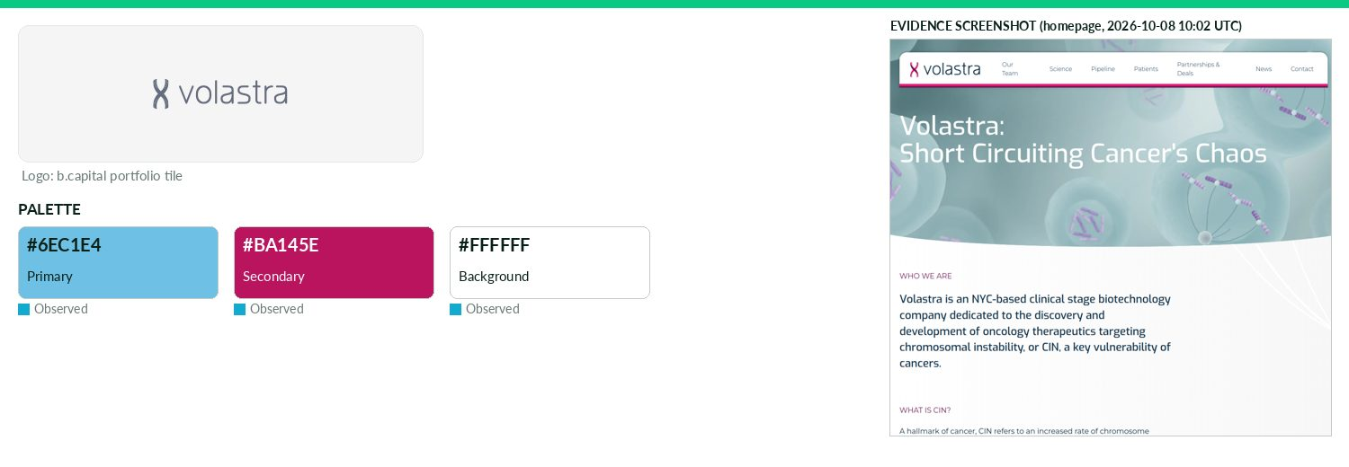
Captured 2026-10-08
Field | Value | Tier | Source
Website | https://www.volastratx.com | Verified | b.capital portfolio
LinkedIn | https://www.linkedin.com/company/volastra-therapeutics | Observed | official site link
Primary / secondary | #6EC1E4 / #BA145E | Observed | https://www.volastratx.com/ — CSS variable --e-global-color-
Background / text | #FFFFFF / — | Observed | live CSS body rule
Typography | Exo; Montserrat | Observed | https://www.volastratx.com/
Voice & tone | — | Missing | —
Imagery | — | Missing | —
Clear-space / misuse | — | Missing | —
Trademark | — | Missing | —
Guideline / press kit | — | Missing
HQ / employees | — | Missing | LinkedIn API rate-limited
OnDemand UI tokens | primary #6EC1E4 / on #000000 / accent #BA145E / surface #FFFFFF / text #111111 | Derived | contrast 10.41:1 · 18.88:1
Draft note | No official guideline; live-site values. /press-releases and /news exist; no media kit. Elementor global colour vars are defaults (#6EC1E4 etc.) so not | Caveat
Fervo Energy
Energy · North America · Active · completeness 54% · tier Observed — Geothermal energy developer advancing drilling and subsurface analytics to provide reliable clean power
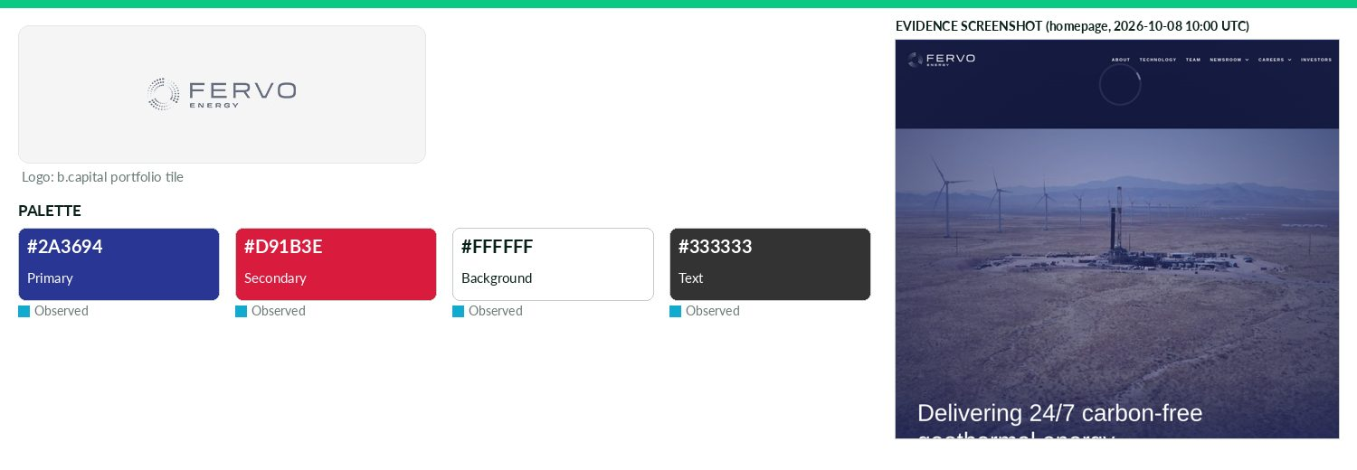
Captured 2026-10-08
Field | Value | Tier | Source
Website | https://fervoenergy.com | Verified | b.capital portfolio
LinkedIn | https://www.linkedin.com/company/fervo-energy | Observed | official site link
Primary / secondary | #2A3694 / #D91B3E | Observed | https://fervoenergy.com/ CSS (most frequent saturated)
Background / text | #FFFFFF / #333333 | Observed | live CSS body rule
Typography | normalidad-extended; normalidad-text; normalidad-wide | Observed | https://fervoenergy.com/ @font-face / Typekit rpx5fpv
Voice & tone | Technical, milestone-driven ('next-generation geothermal', '24/7 carbon-free energy'). | Observed | https://fervoenergy.com/newsroom-2-2-2-2-2/
Imagery | — | Missing | —
Clear-space / misuse | — | Missing | —
Trademark | — | Missing | —
Guideline / press kit | — | Missing
HQ / employees | — | Missing | LinkedIn API rate-limited
OnDemand UI tokens | primary #2A3694 / on #FFFFFF / accent #D91B3E / surface #FFFFFF / text #333333 | Derived | contrast 10.23:1 · 12.63:1
Draft note | No official guideline; live-site values. No brand/press kit found (/brand,/press,/press-kit,/media-kit 404). Newsroom https://fervoenergy.com/newsroom- | Caveat
JetZero
Energy · North America · Active · completeness 85% · tier Verified — Clean-sheet aircraft manufacturer developing blended-wing-body aircraft for more fuel-efficient aviation.
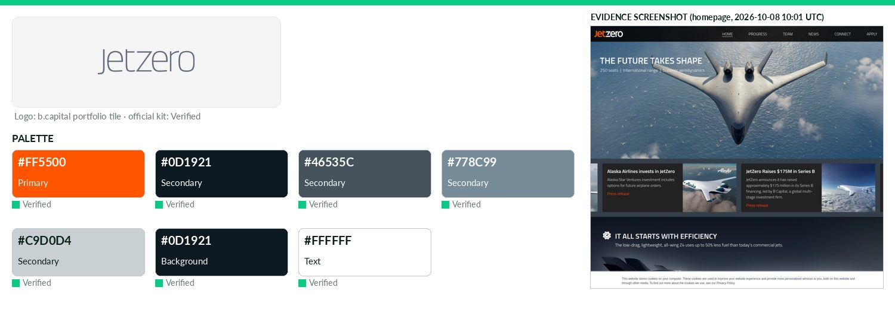
Captured 2026-10-08
Field | Value | Tier | Source
Website | https://www.jetzero.aero | Verified | b.capital portfolio
LinkedIn | https://www.linkedin.com/company/jetzero | Observed | official site link
Primary / secondary | #FF5500 / #0D1921 / #46535C / #778C99 / #C9D0D4 | Verified | https://www.jetzero.aero/hubfs/Media-center/Brand%20Assets/J
Background / text | #0D1921 / #FFFFFF | Verified | —
Typography | Titillium; Martian Mono | Verified | https://www.jetzero.aero/hubfs/Media-center/Brand%20Assets/J
Voice & tone | Confident, engineering-forward, never hype; technical/concrete claims; sentence case; left-aligned; no emoji; tagline 'Reshape aviation.' | Verified | https://www.jetzero.aero/hubfs/Media-center/Brand%
Imagery | Guide defers photography direction to full Brandbook 2026 (request brand@jetzero.aero). Media center images: e | Verified | https://www.jetzero.aero/hubfs/Media-center/Brand%
Clear-space / misuse | Clearspace = 1 cap-height of 'j' all sides; min 24px screen / 12mm print; don't stretch, rotate, recolor (Fire/white/Nig | Verified | https://www.jetzero.aero/hubfs/Media-center/Brand%
Trademark | Images/video editorial use only; JetZero retains copyright; commercial use needs written permission (press@jet | Verified | https://www.jetzero.aero/media-center
Guideline / press kit | https://www.jetzero.aero/hubfs/Media-center/Brand%20Assets/JetZero_Brand_Kit_072026.zip (JetZero-Brand-Guide.p | Verified
HQ / employees | — | Missing | LinkedIn API rate-limited
OnDemand UI tokens | primary #FF5500 / on #000000 / accent #0D1921 / surface #0D1921 / text #FFFFFF | Derived | contrast 6.55:1 · 17.82:1
Karman Industries
Energy · North America · Active · completeness 46% · tier Observed — Developer of an industrial thermal energy electrifying platform intended to reduce onsite scope emissions.
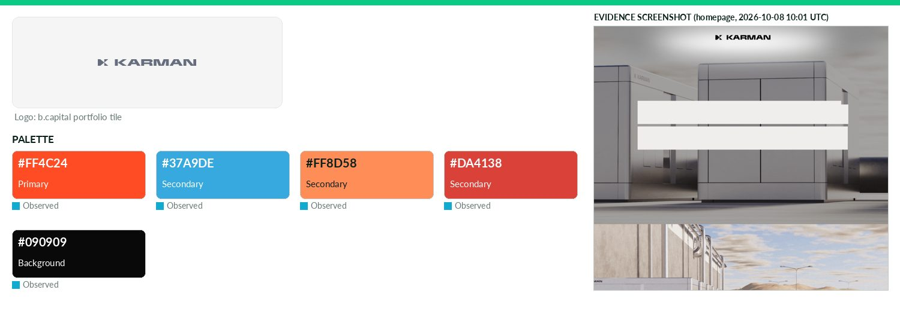
Captured 2026-10-08
Field | Value | Tier | Source
Website | https://www.karmanindustries.com | Verified | b.capital portfolio
LinkedIn | https://www.linkedin.com/company/karman-industries | Observed | official site link
Primary / secondary | #FF4C24 / #37A9DE / #FF8D58 / #DA4138 | Observed | https://www.karmanindustries.com/ CSS --color-primary
Background / text | #090909 / — | Observed | live CSS body rule
Typography | Hind Madurai; Orbitron | Observed | https://www.karmanindustries.com/ — CSS font-family/@font-fa
Voice & tone | — | Missing | —
Imagery | — | Missing | —
Clear-space / misuse | — | Missing | —
Trademark | — | Missing | —
Guideline / press kit | — | Missing
HQ / employees | — | Missing | LinkedIn API rate-limited
OnDemand UI tokens | primary #FF4C24 / on #000000 / accent #37A9DE / surface #090909 / text #111111 | Derived | contrast 6.31:1 · 1.05:1
Draft note | No official guideline; live-site values. /newsroom (200) has no kit; other probes 404. | Caveat
Lambda
Energy · North America · Active · completeness 77% · tier Verified — Cloud platform providing GPU-optimized infrastructure for large-scale AI training and inference.
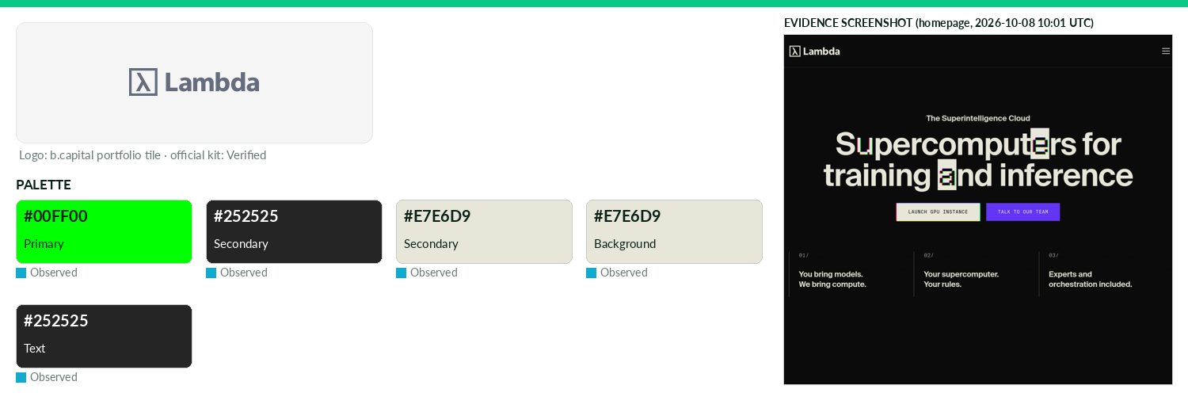
Captured 2026-10-08
Field | Value | Tier | Source
Website | https://lambda.ai | Verified | b.capital portfolio
LinkedIn | https://www.linkedin.com/company/lambda-cloud | Observed | official site link
Primary / secondary | #00FF00 / #252525 / #E7E6D9 | Observed | https://lambda.ai/ — most frequent saturated CSS colour (9 u
Background / text | #E7E6D9 / #252525 | Observed | live CSS body rule
Typography | Suisse Intl; Suisse Intl Mono | Observed | https://lambda.ai/ @font-face
Voice & tone | Official boilerplate provided: 'make compute as ubiquitous as electricity...'; playful technical asides in guideline copy. | Verified | https://lambda.ai/brand-guidelines (Boilerplate)
Imagery | — | Missing | —
Clear-space / misuse | Clear space = gap between λ mark (X) and wordmark; minimum sizes; no transparency, recolor, effects, stretching, symbol | Verified | https://lambda.ai/brand-guidelines
Trademark | Lambda Brand Use Policy (updated Oct 24 2025): marks registered/pending; no use without written authorization; | Verified | https://lambda.ai/lambda-brand-use-policy
Guideline / press kit | https://lambda.ai/brand-guidelines | Verified
HQ / employees | — | Missing | LinkedIn API rate-limited
OnDemand UI tokens | primary #00FF00 / on #000000 / accent #252525 / surface #E7E6D9 / text #252525 | Derived | contrast 15.3:1 · 12.2:1
LevelTen
Energy · North America · Active · completeness 46% · tier Observed — Marketplace connecting power buyers to renewable projects for efficient, transparent energy procurement.
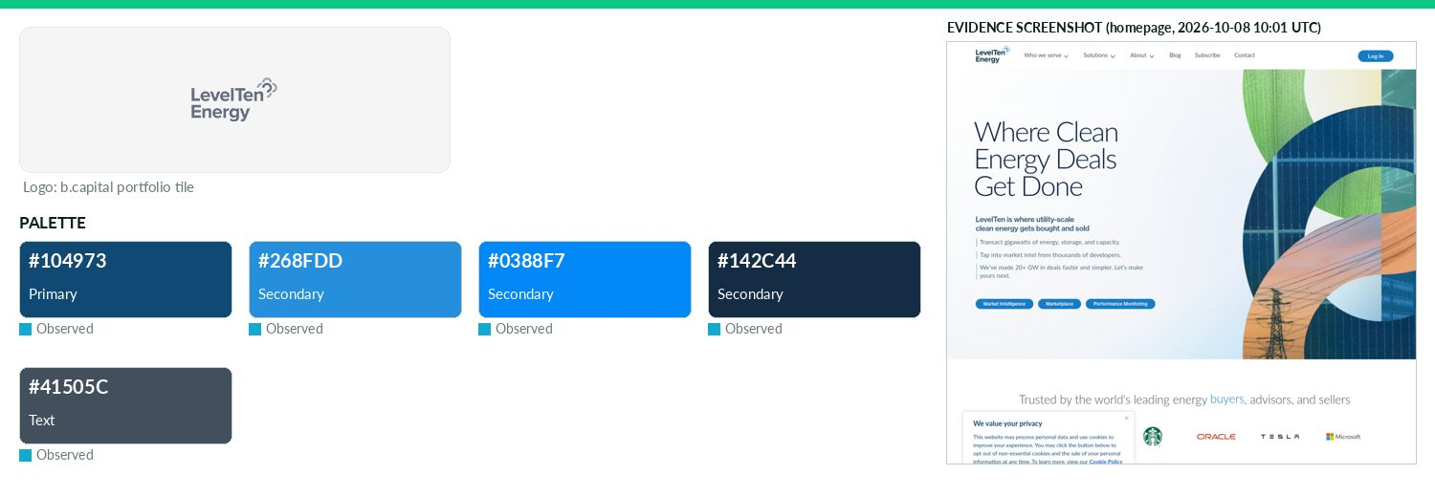
Captured 2026-10-08
Field | Value | Tier | Source
Website | https://www.leveltenenergy.com | Verified | b.capital portfolio
LinkedIn | https://www.linkedin.com/company/levelten-energy | Observed | official site link
Primary / secondary | #104973 / #268FDD / #0388F7 / #142C44 | Observed | https://www.leveltenenergy.com/ CSS
Background / text | — / #41505C | Observed | live CSS body rule
Typography | Lato; Neue Haas Grotesk Text; Zalando Sans | Observed | https://www.leveltenenergy.com/ CSS
Voice & tone | — | Missing | —
Imagery | — | Missing | —
Clear-space / misuse | — | Missing | —
Trademark | — | Missing | —
Guideline / press kit | — | Missing
HQ / employees | — | Missing | LinkedIn API rate-limited
OnDemand UI tokens | primary #104973 / on #FFFFFF / accent #268FDD / surface #FFFFFF / text #41505C | Derived | contrast 9.45:1 · 8.31:1
Draft note | No official guideline; live-site values. Known gap confirmed: /brand,/press,/press-kit,/media-kit 404; sitemap (529 URLs) has no brand/press-kit page; | Caveat
Lunar Energy
Energy · North America · Active · completeness 46% · tier Observed — Clean energy technology company electrifying homes and enabling resilient virtual power plants.
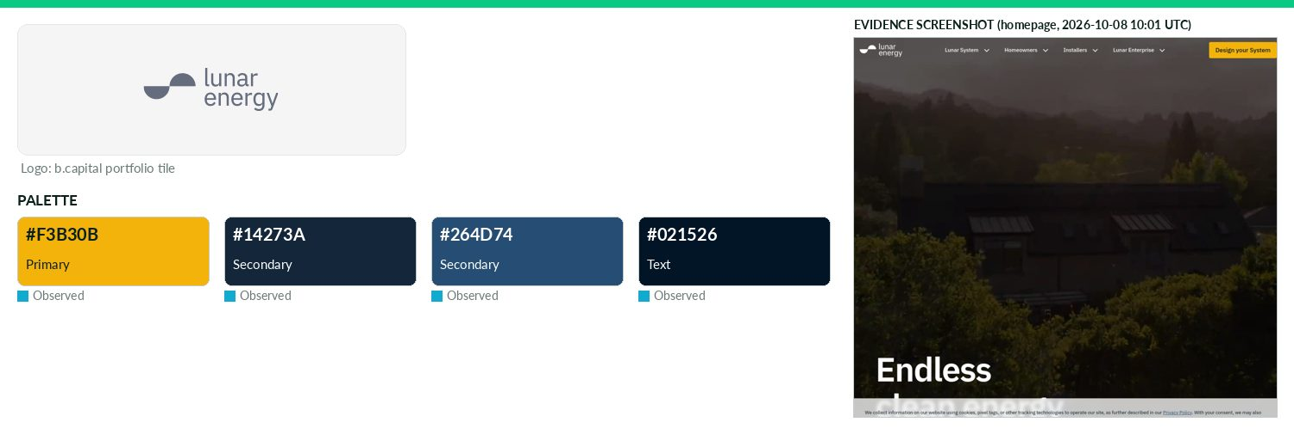
Captured 2026-10-08
Field | Value | Tier | Source
Website | https://www.lunarenergy.com | Verified | b.capital portfolio
LinkedIn | https://www.linkedin.com/company/lunarenergyinc | Observed | official site link
Primary / secondary | #F3B30B / #14273A / #264D74 | Observed | https://www.lunarenergy.com/ CSS
Background / text | — / #021526 | Observed | live CSS body rule
Typography | TT Interphases Pro; IBM Plex Sans | Observed | https://www.lunarenergy.com/ @font-face ('Tt Interphases Pro
Voice & tone | — | Missing | —
Imagery | — | Missing | —
Clear-space / misuse | — | Missing | —
Trademark | — | Missing | —
Guideline / press kit | — | Missing
HQ / employees | — | Missing | LinkedIn API rate-limited
OnDemand UI tokens | primary #F3B30B / on #000000 / accent #14273A / surface #FFFFFF / text #021526 | Derived | contrast 11.26:1 · 18.46:1
Draft note | No official guideline; live-site values. /press (200) is a coverage list + press@lunarenergy.com only; no downloadable kit/logos. gridshare.com redirec | Caveat
Omnidian
Energy · North America · Active · completeness 46% · tier Observed — AI-powered platform providing performance monitoring and maintenance for residential and commercial solar assets.
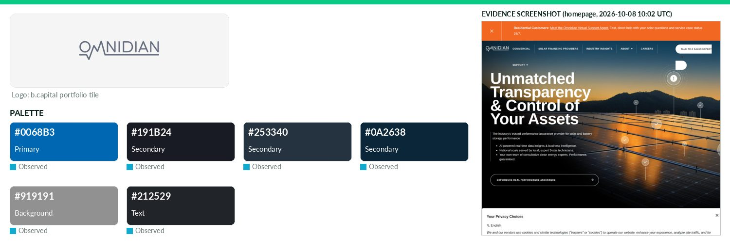
Captured 2026-10-08
Field | Value | Tier | Source
Website | https://www.omnidian.com | Verified | b.capital portfolio
LinkedIn | https://www.linkedin.com/company/omnidian-inc | Observed | official site link
Primary / secondary | #0068B3 / #191B24 / #253340 / #0A2638 | Observed | https://www.omnidian.com/ CSS
Background / text | #919191 / #212529 | Observed | live CSS body rule
Typography | Neue Haas Grotesk Display | Observed | https://www.omnidian.com/ inline CSS
Voice & tone | — | Missing | —
Imagery | — | Missing | —
Clear-space / misuse | — | Missing | —
Trademark | — | Missing | —
Guideline / press kit | — | Missing
HQ / employees | — | Missing | LinkedIn API rate-limited
OnDemand UI tokens | primary #0068B3 / on #FFFFFF / accent #191B24 / surface #919191 / text #212529 | Derived | contrast 5.78:1 · 4.89:1
Draft note | No official guideline; live-site values. /media-inquiries exists (contact page only, no kit). | Caveat
Overstory
Energy · North America · Active · completeness 38% · tier Observed — AI platform enhancing grid resiliency by preventing wildfires and reducing power outages.
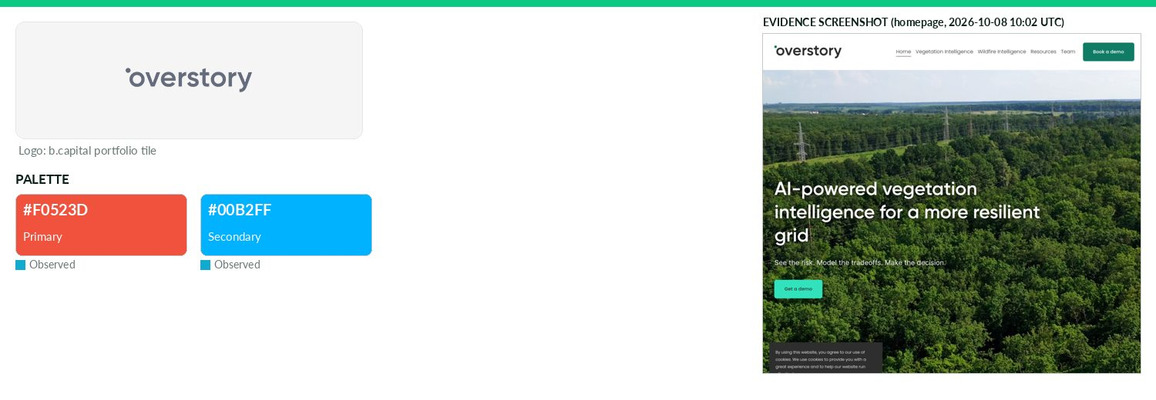
Captured 2026-10-08
Field | Value | Tier | Source
Website | https://www.overstory.com | Verified | b.capital portfolio
LinkedIn | https://www.linkedin.com/company/overstoryai | Observed | official site link
Primary / secondary | #F0523D / #00B2FF | Observed | https://www.overstory.com/ — most frequent saturated CSS col
Background / text | — | Missing | —
Typography | Poppins | Observed | https://www.overstory.com/ inline CSS
Voice & tone | — | Missing | —
Imagery | — | Missing | —
Clear-space / misuse | — | Missing | —
Trademark | — | Missing | —
Guideline / press kit | — | Missing
HQ / employees | — | Missing | LinkedIn API rate-limited
OnDemand UI tokens | primary #F0523D / on #000000 / accent #00B2FF / surface #FFFFFF / text #111111 | Derived | contrast 5.98:1 · 18.88:1
Draft note | No official guideline; live-site values. Squarespace site; /news only; no press/brand kit. No reliable brand hex in CSS. | Caveat
Poolside
Energy · North America · Active · completeness 62% · tier Verified — Frontier AI lab developing foundation models and agents for autonomous software creation.
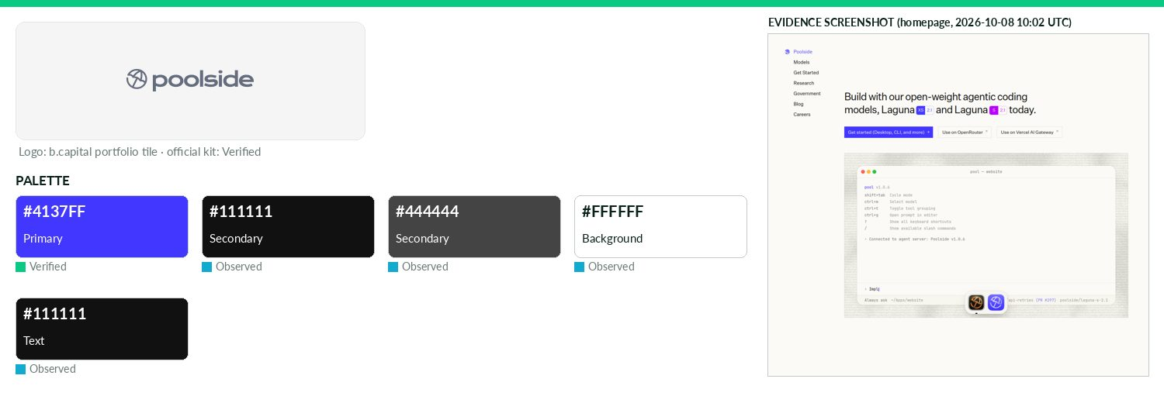
Captured 2026-10-08
Field | Value | Tier | Source
Website | https://www.poolside.ai | Verified | b.capital portfolio
LinkedIn | — | Missing | API 429/403
Primary / secondary | #4137FF / #111111 / #444444 | Verified | Fill colour in press-kit logo SVGs (e.g. Logos/svg/Logo (Sol
Background / text | #FFFFFF / #111111 | Observed | live CSS body rule
Typography | Untitled Sans; Untitled Serif; PP Neuebit; JetBrains Mono | Observed | https://poolside.ai/ @font-face
Voice & tone | Name is 'Poolside' (not 'Poolside AI'/'poolside.ai'); call Laguna 'models' not 'LLMs'; exact product names; 'inside your security boundary'; | Verified | Brand Operating Guide pp2-3 (image PDF, read via O
Imagery | — | Missing | —
Clear-space / misuse | Gradient full logo primary, logomark for icons; solid when gradient can't reproduce; monochrome allowed. No clear-space | Verified | Brand Operating Guide pp4-7 (OCR)
Trademark | — | Missing | —
Guideline / press kit | https://poolside.ai/brand/Poolside-press-kit.zip (Poolside - Brand Operating Guide.pdf, 2 Apr 2025) | Verified
HQ / employees | — | Missing | LinkedIn API rate-limited
OnDemand UI tokens | primary #4137FF / on #FFFFFF / accent #111111 / surface #FFFFFF / text #111111 | Derived | contrast 6.53:1 · 18.88:1
Solar Square
Energy · Asia · Active · completeness 38% · tier Observed — Developer of a solar power system intended to drive mass adoption of rooftops that convert sunlight into usable electricity.
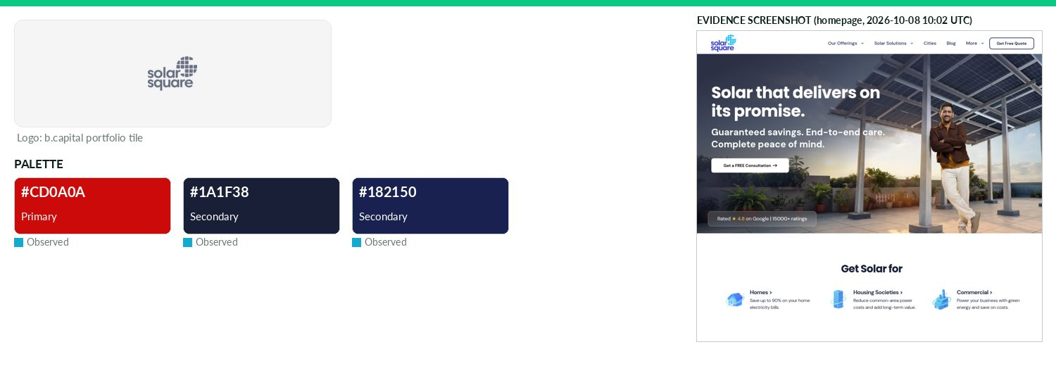
Captured 2026-10-08
Field | Value | Tier | Source
Website | https://www.solarsquare.in | Verified | b.capital portfolio
LinkedIn | https://www.linkedin.com/company/solarsquare-energy-private-limited | Observed | official site link
Primary / secondary | #CD0A0A / #1A1F38 / #182150 | Observed | https://www.solarsquare.in/ — most frequent saturated CSS co
Background / text | — | Missing | —
Typography | Poppins; DM Sans | Observed | website-assets.solarsquare.in theme CSS font-family
Voice & tone | — | Missing | —
Imagery | — | Missing | —
Clear-space / misuse | — | Missing | —
Trademark | — | Missing | —
Guideline / press kit | — | Missing
HQ / employees | — | Missing | LinkedIn API rate-limited
OnDemand UI tokens | primary #CD0A0A / on #FFFFFF / accent #1A1F38 / surface #FFFFFF / text #111111 | Derived | contrast 5.76:1 · 18.88:1
Draft note | No official guideline; live-site values. Known gap confirmed: /media,/press,/in-the-news,/brand 404; sitemap (7 entries) no press/brand. | Caveat
Star Catcher
Energy · North America · Active · completeness 69% · tier Verified — Developing satellite technology to harness and transmit energy from space to Earth.
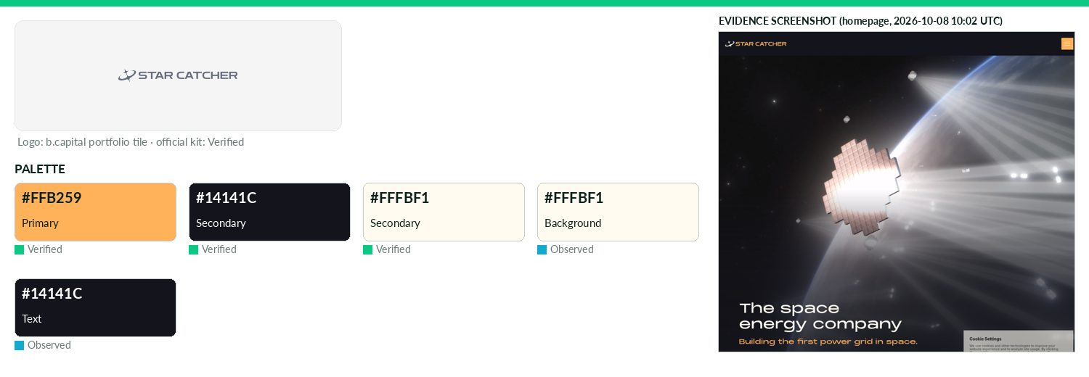
Captured 2026-10-08
Field | Value | Tier | Source
Website | https://www.star-catcher.com | Verified | b.capital portfolio
LinkedIn | https://www.linkedin.com/company/starcatcherind | Observed | official site link
Primary / secondary | #FFB259 / #14141C / #FFFBF1 | Verified | Logo Pack SVG 'Sol-Yellow' variant (https://frameruserconten
Background / text | #FFFBF1 / #14141C | Observed | live CSS body rule
Typography | PP Monument Extended; Inter; Figtree; Aileron; Fragment Mono | Observed | https://www.star-catcher.com/ Framer @font-face
Voice & tone | — | Missing | —
Imagery | Media kit offers power-beaming photos (Blue/Infrared), Power Node renders, beam videos/GIFs. | Observed | https://www.star-catcher.com/media
Clear-space / misuse | Assets may not be altered beyond routine cropping/resizing/formatting; visible credit 'Image courtesy of Star Catcher' r | Verified | https://www.star-catcher.com/media-assets-terms-of
Trademark | No commercial exploitation of name/trademark/logo; no implied endorsement; permission revocable. | Verified | https://www.star-catcher.com/media-assets-terms-of
Guideline / press kit | https://www.star-catcher.com/media | Missing
HQ / employees | — | Missing | LinkedIn API rate-limited
OnDemand UI tokens | primary #FFB259 / on #000000 / accent #14141C / surface #FFFBF1 / text #14141C | Derived | contrast 11.76:1 · 17.72:1
Draft note | No official guideline; live-site values. Previously a gap: media page has logo pack ZIP (dark/light/all-white/black, print CMYK + digital RGB) and asse | Caveat
1AU
Opportunistic · North America · Active · completeness 38% · tier Observed — Directed energy platform for space and terrestrial use cases.
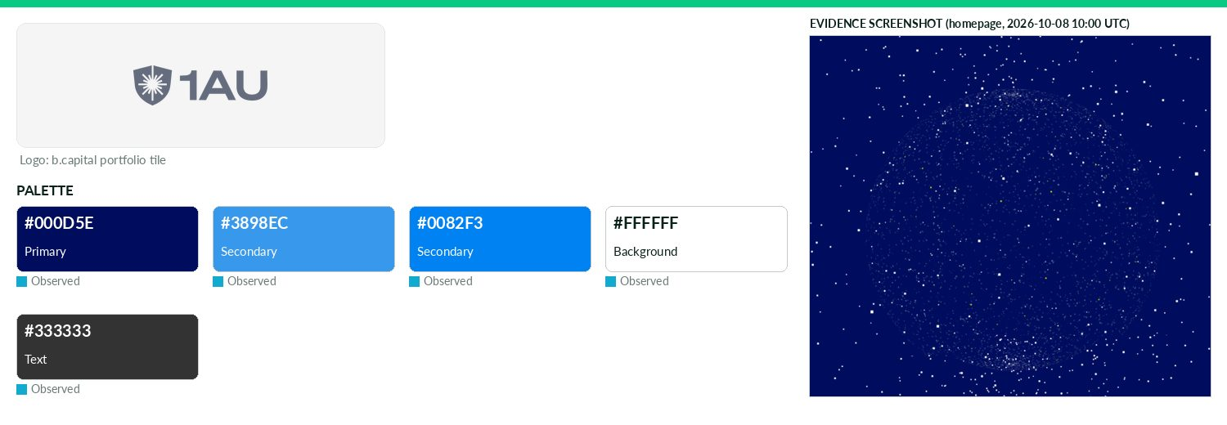
Captured 2026-10-08
Field | Value | Tier | Source
Website | https://www.1autechnologies.com | Verified | b.capital portfolio
LinkedIn | — | Missing | API 429/403
Primary / secondary | #000D5E / #3898EC / #0082F3 | Observed | https://www.1autechnologies.com/ CSS (low-count)
Background / text | #FFFFFF / #333333 | Observed | live CSS body rule
Typography | Aeonik; Founders Grotesk; Söhne | Observed | https://www.1autechnologies.com/ @font-face
Voice & tone | — | Missing | —
Imagery | — | Missing | —
Clear-space / misuse | — | Missing | —
Trademark | — | Missing | —
Guideline / press kit | — | Missing
HQ / employees | — | Missing | LinkedIn API rate-limited
OnDemand UI tokens | primary #000D5E / on #FFFFFF / accent #3898EC / surface #FFFFFF / text #333333 | Derived | contrast 17.22:1 · 12.63:1
Draft note | No official guideline; live-site values. Single-page Webflow site; all probes 404; no news/press. | Caveat
Accacia
Opportunistic · Asia · Active · completeness 46% · tier Observed — AI-enabled carbon accounting platform designed to help real-estate and infrastructure companies meet their net-zero goals.
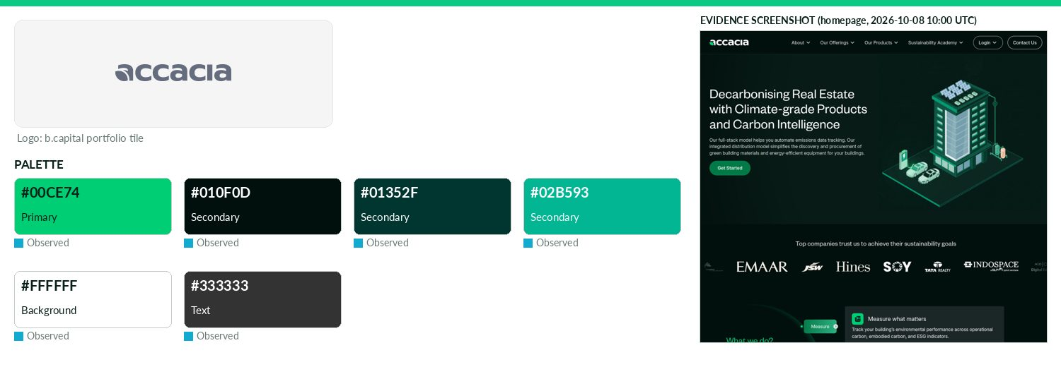
Captured 2026-10-08
Field | Value | Tier | Source
Website | https://accacia.ai | Verified | b.capital portfolio
LinkedIn | https://www.linkedin.com/company/accacia | Observed | official site link
Primary / secondary | #00CE74 / #010F0D / #01352F / #02B593 | Observed | https://www.accacia.com/ CSS/HTML frequency
Background / text | #FFFFFF / #333333 | Observed | live CSS body rule
Typography | Founders Grotesk; Inter | Observed | https://www.accacia.com/ @font-face
Voice & tone | — | Missing | —
Imagery | — | Missing | —
Clear-space / misuse | — | Missing | —
Trademark | — | Missing | —
Guideline / press kit | — | Missing
HQ / employees | — | Missing | LinkedIn API rate-limited
OnDemand UI tokens | primary #00CE74 / on #000000 / accent #010F0D / surface #FFFFFF / text #333333 | Derived | contrast 10.08:1 · 12.63:1
Draft note | No official guideline; live-site values. accacia.ai redirects to accacia.com; all probe paths soft-404 to homepage. | Caveat
AIMotive
Opportunistic · Europe · Exited · completeness 46% · tier Observed — Platform helping automotive partners build advanced driver-assistance systems (ADAS) faster, safer and more efficiently.
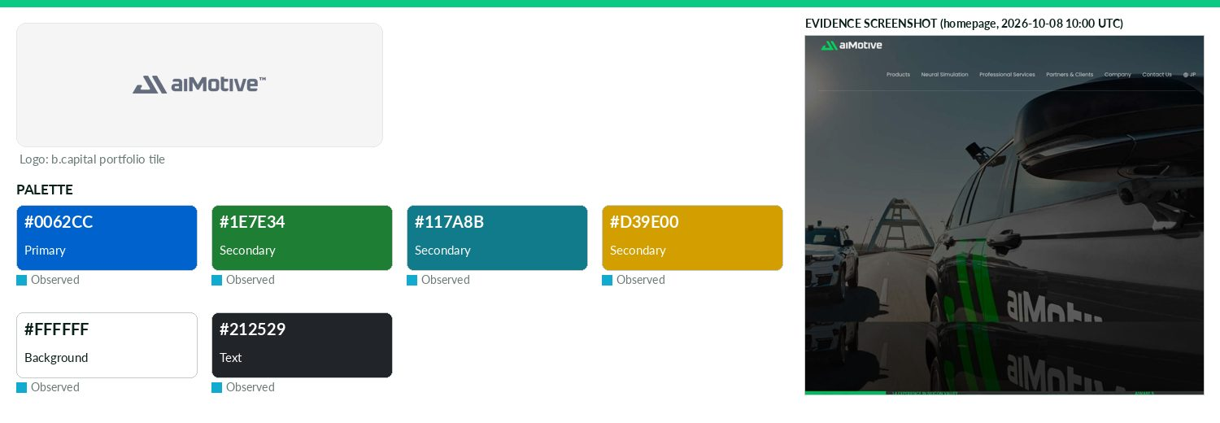
Captured 2026-10-08
Field | Value | Tier | Source
Website | http://aimotive.com | Verified | b.capital portfolio
LinkedIn | https://www.linkedin.com/company/aimotive | Observed | official site link
Primary / secondary | #0062CC / #1E7E34 / #117A8B / #D39E00 | Observed | https://aimotive.com/ — most frequent saturated CSS colour (
Background / text | #FFFFFF / #212529 | Observed | live CSS body rule
Typography | Hind; Poppins | Observed | https://aimotive.com (Google Fonts link)
Voice & tone | — | Missing | —
Imagery | — | Missing | —
Clear-space / misuse | — | Missing | —
Trademark | — | Missing | —
Guideline / press kit | — | Missing
HQ / employees | — | Missing | LinkedIn API rate-limited
OnDemand UI tokens | primary #0062CC / on #FFFFFF / accent #1E7E34 / surface #FFFFFF / text #212529 | Derived | contrast 5.8:1 · 15.43:1
Draft note | No official guideline; live-site values. http:// failed; https://aimotive.com OK. /press,/brand,/press-kit,/media-kit,/media,/newsroom,/news all 404. N | Caveat
Bhanzu
Opportunistic · Asia · Active · completeness 46% · tier Observed — Learning platform making math engaging through experiential, student-centered education.
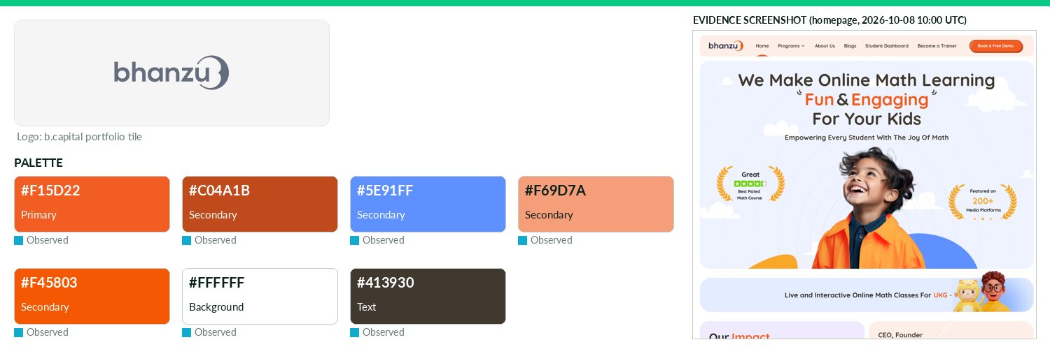
Captured 2026-10-08
Field | Value | Tier | Source
Website | https://bhanzu.com | Verified | b.capital portfolio
LinkedIn | https://www.linkedin.com/company/exploring-infinities | Observed | official site link
Primary / secondary | #F15D22 / #C04A1B / #5E91FF / #F69D7A / #F45803 | Observed | https://bhanzu.com/ (site CSS)
Background / text | #FFFFFF / #413930 | Observed | live CSS body rule
Typography | Quicksand | Observed | https://bhanzu.com/ (@font-face/CSS)
Voice & tone | — | Missing | —
Imagery | — | Missing | —
Clear-space / misuse | — | Missing | —
Trademark | — | Missing | —
Guideline / press kit | — | Missing
HQ / employees | — | Missing | LinkedIn API rate-limited
OnDemand UI tokens | primary #F15D22 / on #000000 / accent #C04A1B / surface #FFFFFF / text #413930 | Derived | contrast 6.33:1 · 11.33:1
Draft note | No official guideline; live-site values. No brand/press/media-kit page found at standard paths (/brand,/press,/press-kit,/media-kit,/media,/newsroom). | Caveat
BuildOps
Opportunistic · North America · Active · completeness 38% · tier Observed — A data-driven, all-in-one platform that helps commercial contractors streamline operations and grow their businesses.
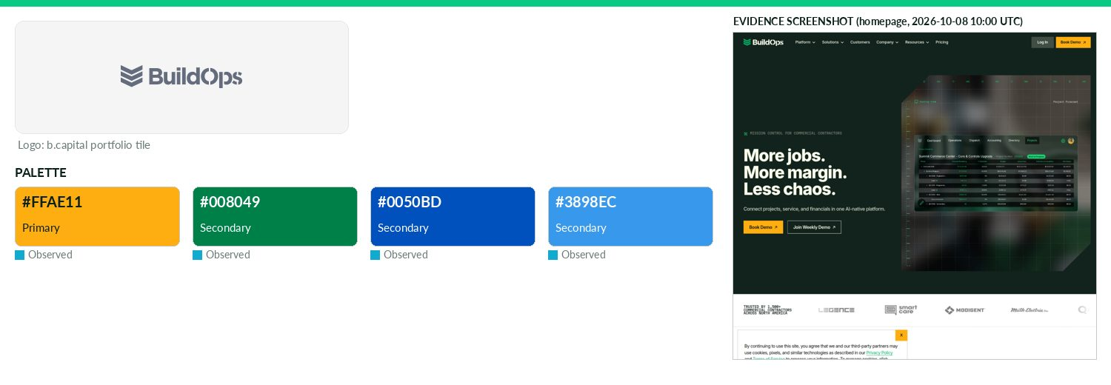
Captured 2026-10-08
Field | Value | Tier | Source
Website | https://buildops.com | Verified | b.capital portfolio
LinkedIn | https://www.linkedin.com/company/buildops | Observed | official site link
Primary / secondary | #FFAE11 / #008049 / #0050BD / #3898EC | Observed | https://buildops.com/ — most frequent saturated CSS colour (
Background / text | — | Missing | —
Typography | Inter; Martian Mono | Observed | https://buildops.com (@font-face)
Voice & tone | — | Missing | —
Imagery | — | Missing | —
Clear-space / misuse | — | Missing | —
Trademark | — | Missing | —
Guideline / press kit | — | Missing
HQ / employees | — | Missing | LinkedIn API rate-limited
OnDemand UI tokens | primary #FFAE11 / on #000000 / accent #008049 / surface #FFFFFF / text #111111 | Derived | contrast 11.31:1 · 18.88:1
Draft note | No official guideline; live-site values. /press is a press room (news list); no press kit, logo download or guideline found. Header logo not identified | Caveat
Carro
Opportunistic · Asia · Active · completeness 8% · tier Third-party — Full-stack automotive platform using AI to simplify car buying, selling and ownership.
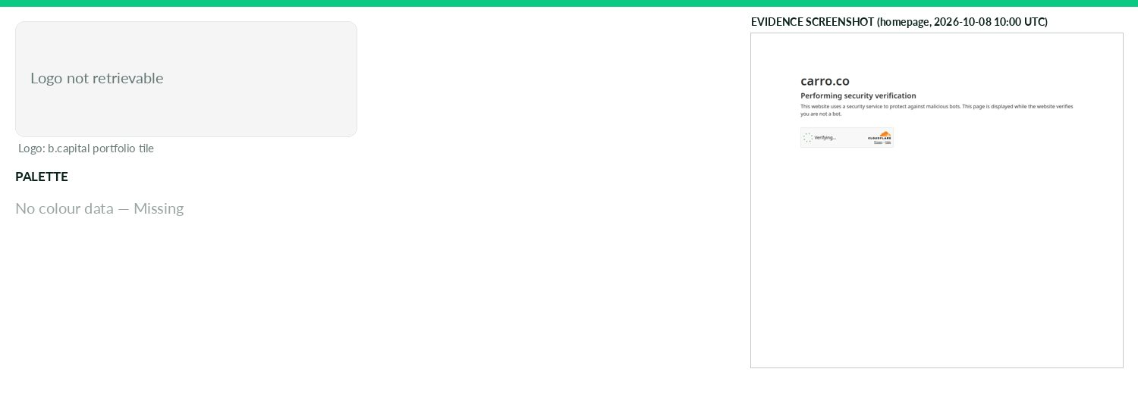
Captured 2026-10-08
Field | Value | Tier | Source
Website | http://carro.sg | Verified | b.capital portfolio
LinkedIn | — | Missing | API 429/403
Primary / secondary | — | Missing | —
Background / text | — | Missing | —
Typography | — | Missing | —
Voice & tone | — | Missing | —
Imagery | — | Missing | —
Clear-space / misuse | — | Missing | —
Trademark | — | Missing | —
Guideline / press kit | — | Missing
HQ / employees | — | Missing | LinkedIn API rate-limited
Draft note | No official guideline; live-site values. carro.sg (http) connection refused; https://carro.sg redirects to carro.co/sg/en which returns Cloudflare 'Jus | Caveat
CoinDCX
Opportunistic · Asia · Active · completeness 8% · tier Third-party — Crypto investing and trading platform expanding access to digital assets in India.
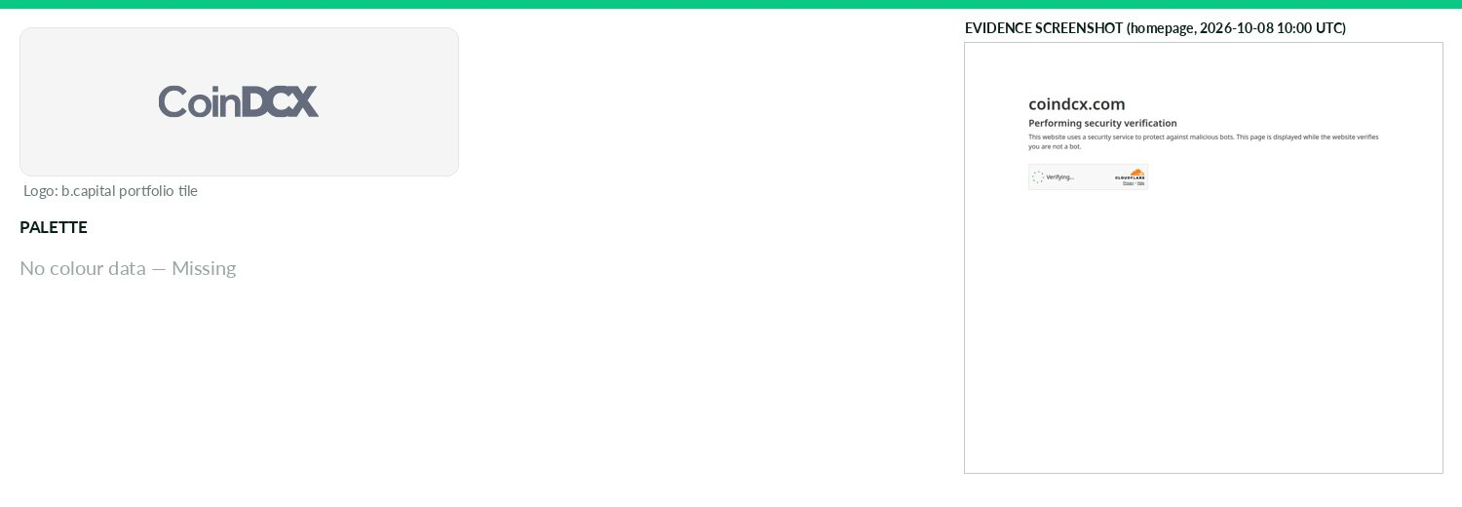
Captured 2026-10-08
Field | Value | Tier | Source
Website | http://coindcx.com | Verified | b.capital portfolio
LinkedIn | — | Missing | API 429/403
Primary / secondary | — | Missing | —
Background / text | — | Missing | —
Typography | — | Missing | —
Voice & tone | — | Missing | —
Imagery | — | Missing | —
Clear-space / misuse | — | Missing | —
Trademark | — | Missing | —
Guideline / press kit | — | Missing
HQ / employees | — | Missing | LinkedIn API rate-limited
Draft note | No official guideline; live-site values. Entire site behind Cloudflare challenge ('Just a moment...'); no data retrievable without a browser. | Caveat
DailyHunt
Opportunistic · Asia · Active · completeness 38% · tier Observed — Personalized content platform offering local news, search, and recommendations across Indian languages.
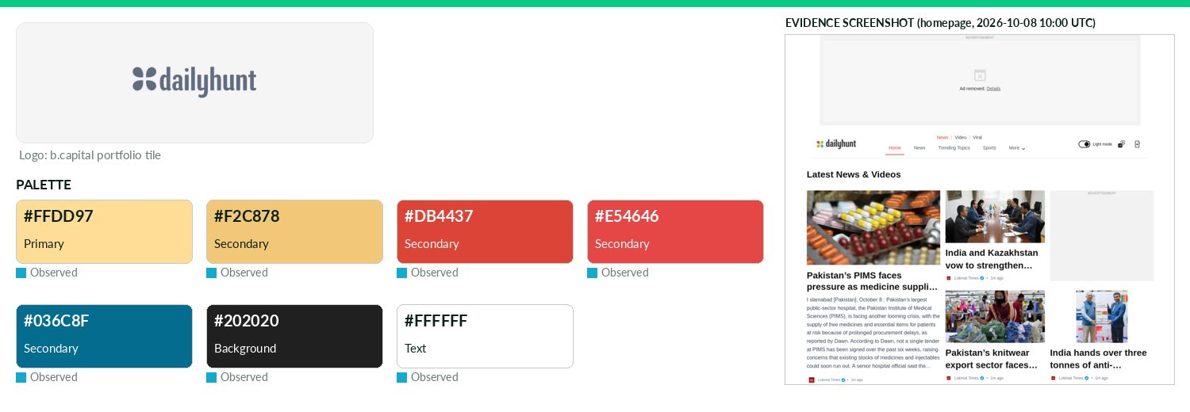
Captured 2026-10-08
Field | Value | Tier | Source
Website | http://dailyhunt.in | Verified | b.capital portfolio
LinkedIn | — | Missing | API 429/403
Primary / secondary | #FFDD97 / #F2C878 / #DB4437 / #E54646 / #036C8F | Observed | https://m.dailyhunt.in/ (site CSS; low confidence)
Background / text | #202020 / #FFFFFF | Observed | live CSS body rule
Typography | en_regular; en_bold | Observed | https://m.dailyhunt.in/ (@font-face/CSS)
Voice & tone | — | Missing | —
Imagery | — | Missing | —
Clear-space / misuse | — | Missing | —
Trademark | — | Missing | —
Guideline / press kit | — | Missing
HQ / employees | — | Missing | LinkedIn API rate-limited
OnDemand UI tokens | primary #FFDD97 / on #000000 / accent #F2C878 / surface #202020 / text #FFFFFF | Derived | contrast 16.04:1 · 16.29:1
Draft note | No official guideline; live-site values. No brand/press/media-kit page found at standard paths (/brand,/press,/press-kit,/media-kit,/media,/newsroom). | Caveat
EeroQ
Opportunistic · North America · Active · completeness 46% · tier Observed — Quantum computing company building scalable systems using electrons-on-helium (eHe) architecture.
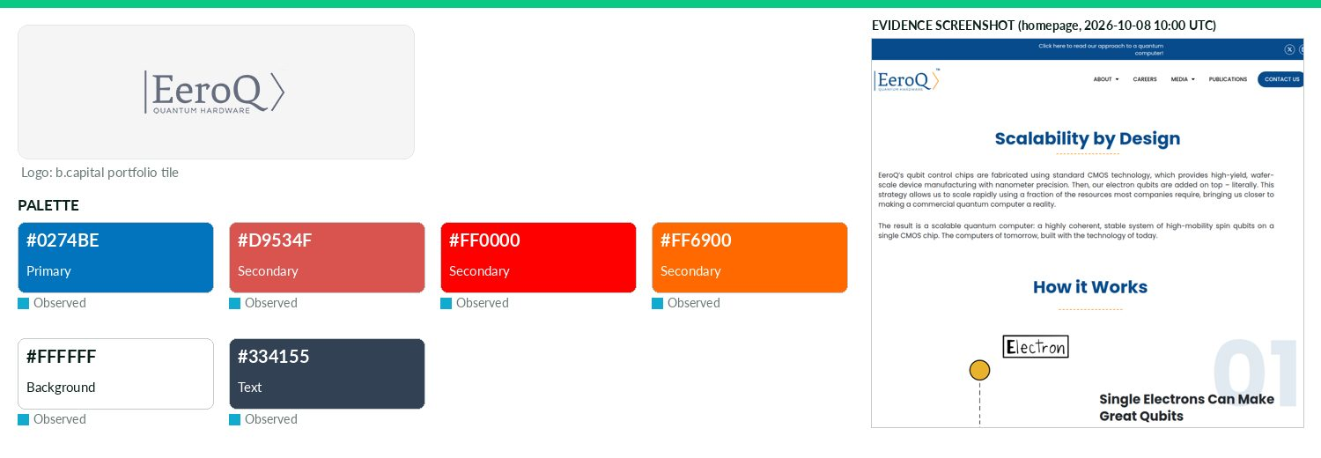
Captured 2026-10-08
Field | Value | Tier | Source
Website | https://eeroq.com | Verified | b.capital portfolio
LinkedIn | https://www.linkedin.com/company/qchardware | Observed | official site link
Primary / secondary | #0274BE / #D9534F / #FF0000 / #FF6900 | Observed | https://www.eeroq.com/ — most frequent saturated CSS colour
Background / text | #FFFFFF / #334155 | Observed | live CSS body rule
Typography | Montserrat | Observed | https://www.eeroq.com/ — CSS font-family/@font-face
Voice & tone | — | Missing | —
Imagery | — | Missing | —
Clear-space / misuse | — | Missing | —
Trademark | — | Missing | —
Guideline / press kit | — | Missing
HQ / employees | — | Missing | LinkedIn API rate-limited
OnDemand UI tokens | primary #0274BE / on #FFFFFF / accent #D9534F / surface #FFFFFF / text #334155 | Derived | contrast 4.95:1 · 10.35:1
Draft note | No official guideline; live-site values. /all-press-releases/ exists (press release list); 'Media' nav item points to homepage. No press kit, logo down | Caveat
FalconX
Opportunistic · North America · Active · completeness 46% · tier Observed — Crypto brokerage platform providing institutional-grade trading and digital asset management tools.
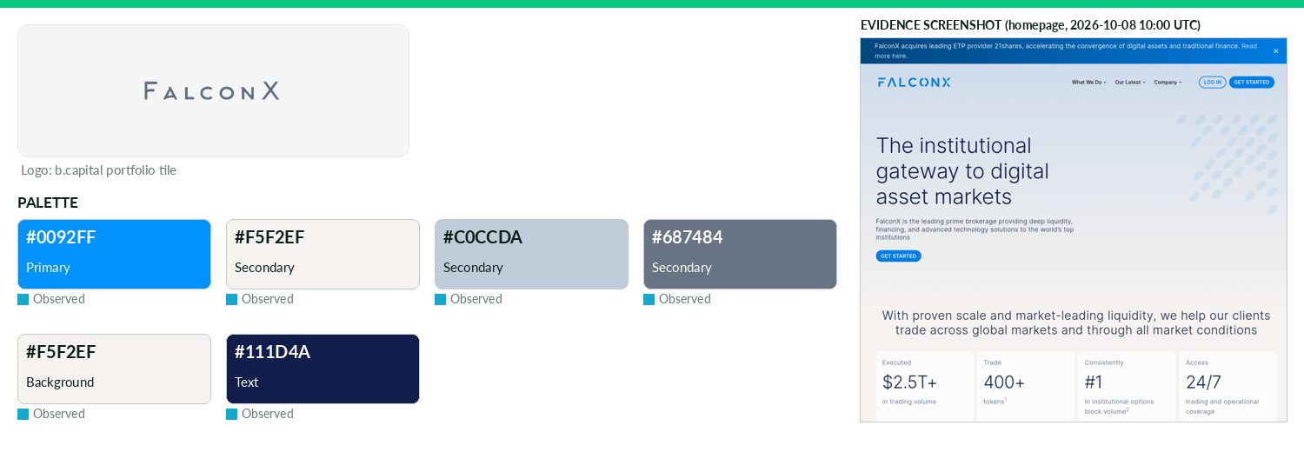
Captured 2026-10-08
Field | Value | Tier | Source
Website | https://falconx.io | Verified | b.capital portfolio
LinkedIn | https://www.linkedin.com/company/thefalconx | Observed | official site link
Primary / secondary | #0092FF / #F5F2EF / #C0CCDA / #687484 | Observed | https://www.falconx.io/ CSS (most frequent saturated hex)
Background / text | #F5F2EF / #111D4A | Observed | live CSS body rule
Typography | Gt Planar; Geist; Inter | Observed | https://www.falconx.io/ @font-face
Voice & tone | — | Missing | —
Imagery | — | Missing | —
Clear-space / misuse | — | Missing | —
Trademark | — | Missing | —
Guideline / press kit | — | Missing
HQ / employees | — | Missing | LinkedIn API rate-limited
OnDemand UI tokens | primary #0092FF / on #000000 / accent #F5F2EF / surface #F5F2EF / text #111D4A | Derived | contrast 6.56:1 · 14.5:1
Draft note | No official guideline; live-site values. Newsroom https://www.falconx.io/newsroom exists (press releases; media@falconx.io) but no logo/brand kit. /pre | Caveat
Figment
Opportunistic · North America · Active · completeness 54% · tier Verified — Blockchain infrastructure platform powering institutional staking and decentralized network participation.
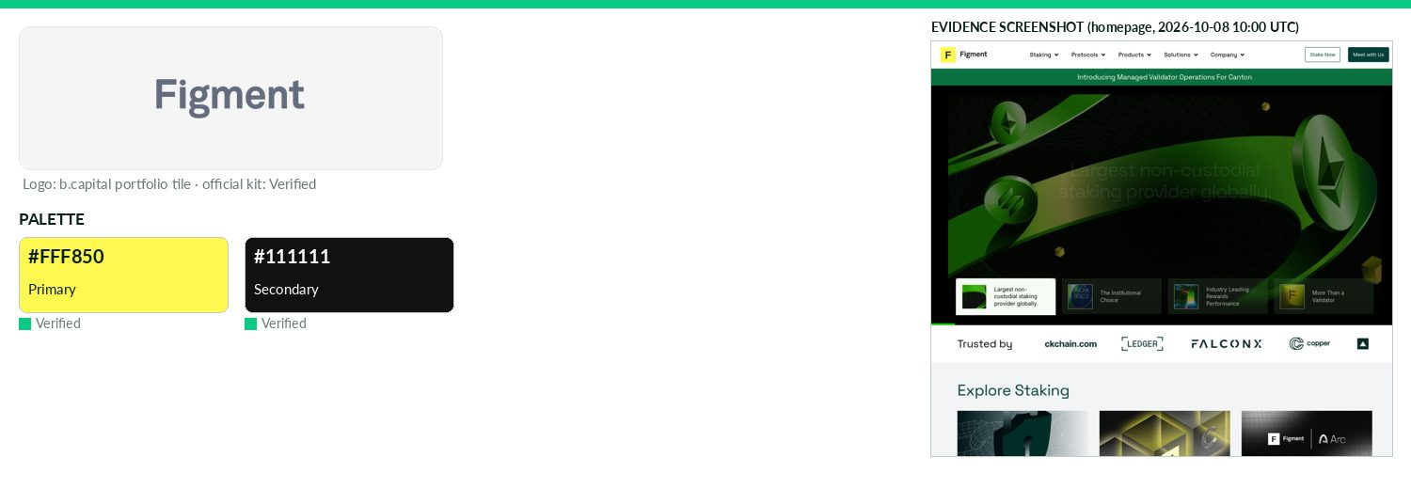
Captured 2026-10-08
Field | Value | Tier | Source
Website | https://figment.io | Verified | b.capital portfolio
LinkedIn | https://www.linkedin.com/company/figment.io | Observed | official site link
Primary / secondary | #FFF850 / #111111 | Verified | Official press-kit logo SVG fill (figment-logo-colour-white.
Background / text | — | Missing | —
Typography | Space Grotesk; Tiempo Headline; Inter | Observed | https://www.figment.io/ CSS
Voice & tone | — | Missing | —
Imagery | — | Missing | —
Clear-space / misuse | 4 logo versions (colour-black/colour-white on backgrounds complementing Yellow; black on light/photos; white on dark/pho | Verified | https://www.figment.io/wp-content/uploads/2025/12/
Trademark | — | Missing | —
Guideline / press kit | https://www.figment.io/wp-content/uploads/2025/12/Figment-Colour-SVG.zip (contains 'Logo Usage Guidelines.pdf' | Verified
HQ / employees | — | Missing | LinkedIn API rate-limited
OnDemand UI tokens | primary #FFF850 / on #000000 / accent #111111 / surface #FFFFFF / text #111111 | Derived | contrast 18.79:1 · 18.88:1
Floor NFTs
Opportunistic · North America · Active · completeness 31% · tier Observed — NFT app for discovering, tracking and minting NFTs across chains in one interface.
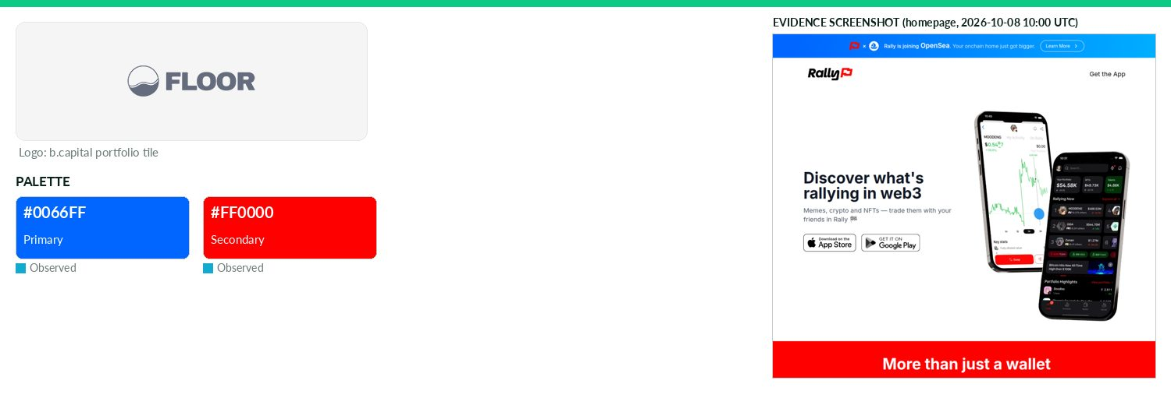
Captured 2026-10-08
Field | Value | Tier | Source
Website | https://www.floornfts.io | Verified | b.capital portfolio
LinkedIn | — | Missing | API 429/403
Primary / secondary | #0066FF / #FF0000 | Observed | https://rally.xyz/ — most frequent saturated CSS colour (3 u
Background / text | — | Missing | —
Typography | Inter; Darker Grotesque | Observed | https://rally.xyz/ CSS
Voice & tone | — | Missing | —
Imagery | — | Missing | —
Clear-space / misuse | — | Missing | —
Trademark | — | Missing | —
Guideline / press kit | — | Missing
HQ / employees | — | Missing | LinkedIn API rate-limited
OnDemand UI tokens | primary #0066FF / on #FFFFFF / accent #FF0000 / surface #FFFFFF / text #111111 | Derived | contrast 4.83:1 · 18.88:1
Draft note | No official guideline; live-site values. floornfts.io (all paths) redirects to https://rally.xyz/ ('Your wallet, made social') — apparent rebrand to Ra | Caveat
GrayMatter Robotics
Opportunistic · North America · Active · completeness 46% · tier Observed — Robotics platform building intelligent assistants to automate repetitive and ergonomically challenging tasks.
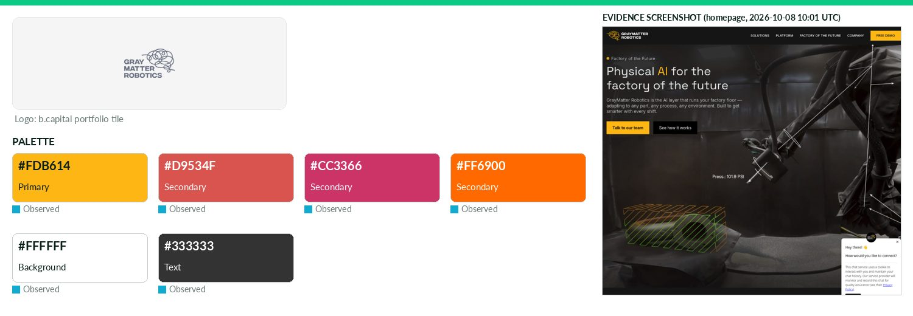
Captured 2026-10-08
Field | Value | Tier | Source
Website | http://graymatter-robotics.com | Verified | b.capital portfolio
LinkedIn | https://www.linkedin.com/company/graymatter-robotics | Observed | official site link
Primary / secondary | #FDB614 / #D9534F / #CC3366 / #FF6900 | Observed | GMR_logo_white text_orange logo_horizontal.svg fill
Background / text | #FFFFFF / #333333 | Observed | live CSS body rule
Typography | NB International; Roboto Slab; Inter | Observed | https://factory.graymatter-robotics.com/ — CSS font-family/@
Voice & tone | — | Missing | —
Imagery | — | Missing | —
Clear-space / misuse | — | Missing | —
Trademark | — | Missing | —
Guideline / press kit | — | Missing
HQ / employees | — | Missing | LinkedIn API rate-limited
OnDemand UI tokens | primary #FDB614 / on #000000 / accent #D9534F / surface #FFFFFF / text #333333 | Derived | contrast 11.88:1 · 12.63:1
Draft note | No official guideline; live-site values. http:// timed out; https redirects to factory.graymatter-robotics.com. /press exists (minimal). No press kit/g | Caveat
Kopi Kenangan
Opportunistic · Asia · Active · completeness 46% · tier Observed — Tech-enabled grab-and-go coffee chain.
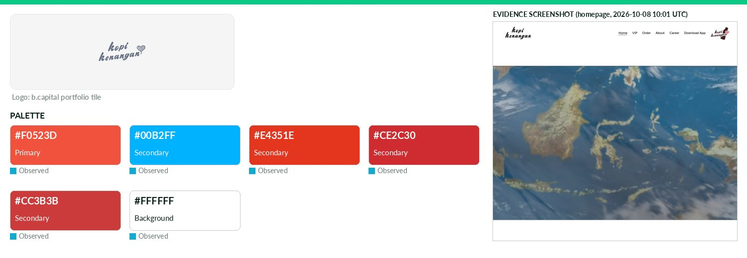
Captured 2026-10-08
Field | Value | Tier | Source
Website | http://kopikenangan.com | Verified | b.capital portfolio
LinkedIn | https://www.linkedin.com/company/kopi-kenangan | Observed | official site link
Primary / secondary | #F0523D / #00B2FF / #E4351E / #CE2C30 / #CC3B3B | Observed | https://kopikenangan.com/ (site CSS)
Background / text | #FFFFFF / — | Observed | live CSS body rule
Typography | Figtree; roc-grotesk; anziano | Observed | https://kopikenangan.com/ (@font-face/CSS)
Voice & tone | — | Missing | —
Imagery | — | Missing | —
Clear-space / misuse | — | Missing | —
Trademark | — | Missing | —
Guideline / press kit | — | Missing
HQ / employees | — | Missing | LinkedIn API rate-limited
OnDemand UI tokens | primary #F0523D / on #000000 / accent #00B2FF / surface #FFFFFF / text #111111 | Derived | contrast 5.98:1 · 18.88:1
Draft note | No official guideline; live-site values. No brand/press/media-kit page found at standard paths (/brand,/press,/press-kit,/media-kit,/media,/newsroom). | Caveat
Meesho
Opportunistic · Asia · Active · completeness 62% · tier Third-party — Mobile-first marketplace connecting small businesses and individual sellers with value-conscious shoppers in Tier 2+ cities.
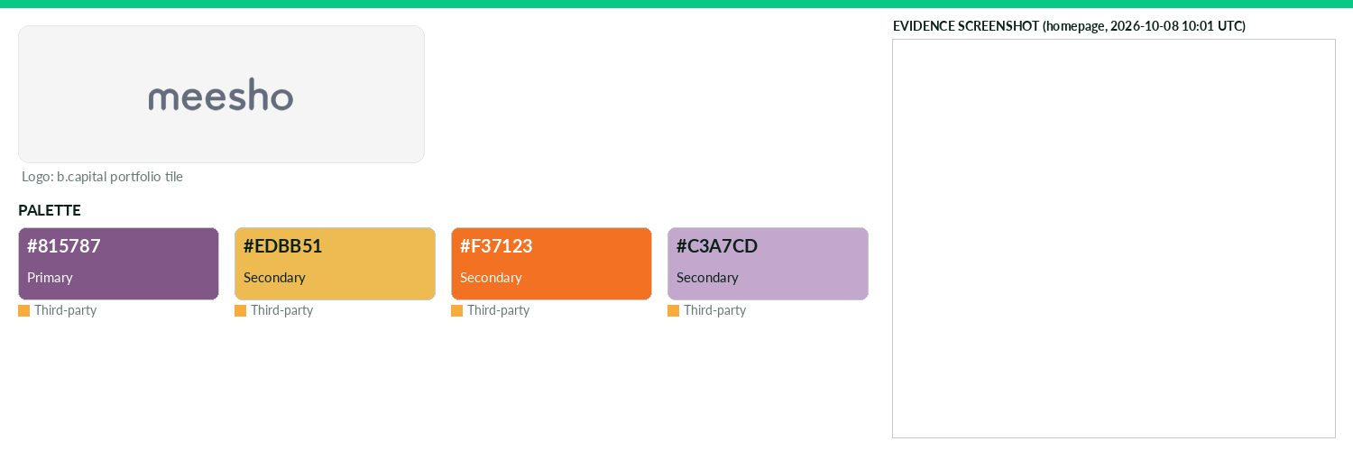
Captured 2026-10-08
Field | Value | Tier | Source
Website | https://www.meesho.com | Verified | b.capital portfolio
LinkedIn | — | Missing | API 429/403
Primary / secondary | #815787 / #EDBB51 / #F37123 / #C3A7CD | Third-party | heyzine-hosted 'Brand manual meesho' PDF p22 (Muted Purple,
Background / text | — | Missing | —
Typography | Futura; Playfair Display | Third-party | heyzine PDF p25-29
Voice & tone | Voice: Inclusive, Empowering, Energetic. Tone words: energetic, welcoming, enthusiastic, passionate, trendy, fun, empowering, vibrant, chic. | Third-party | heyzine PDF p9-11
Imagery | Applications use purple tones; 40-60 grid ratio for layouts. No photography rules stated. | Verified | heyzine PDF p32-34
Clear-space / misuse | Clear space 40-60% of logo height (freeform logo). Don't: use std logo <1 inch, dark backgrounds, drop shadow, distort/s | Third-party | heyzine PDF p16-19, p30-31
Trademark | — | Missing | —
Guideline / press kit | https://cdnc.heyzine.com/files/uploaded/v2/c9d5ed8e55d95c3b819609f176ed45487ca281ad.pdf | Third-party
HQ / employees | — | Missing | LinkedIn API rate-limited
OnDemand UI tokens | primary #815787 / on #FFFFFF / accent #EDBB51 / surface #FFFFFF / text #111111 | Derived | contrast 5.76:1 · 18.88:1
Draft note | No official guideline; live-site values. PDF (36pp, Illustrator, created 2024-05) titled 'Brand manual meesho' hosted on heyzine.com CDN, NOT meesho.co | Caveat
Ninja Van
Opportunistic · Asia · Active · completeness 38% · tier Observed — Technology-enabled logistics company powering last-mile delivery for ecommerce across Southeast Asia.
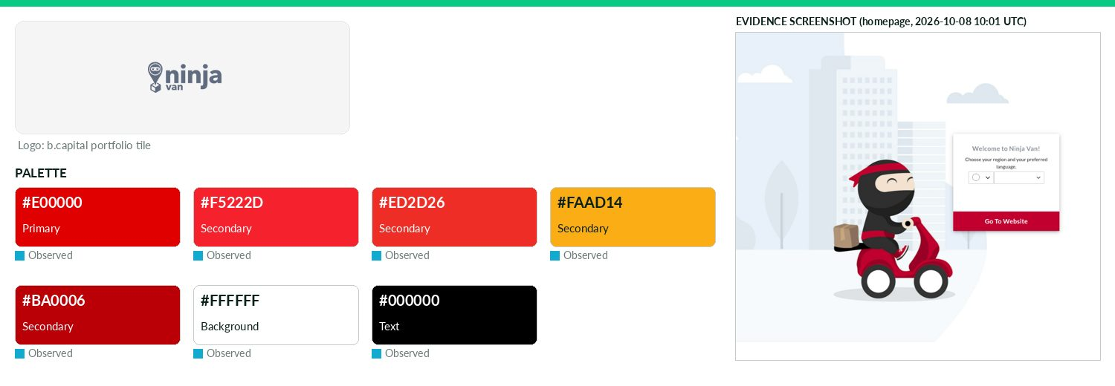
Captured 2026-10-08
Field | Value | Tier | Source
Website | http://ninjavan.co | Verified | b.capital portfolio
LinkedIn | — | Missing | API 429/403
Primary / secondary | #E00000 / #F5222D / #ED2D26 / #FAAD14 / #BA0006 | Observed | https://www.ninjavan.co/ (site CSS)
Background / text | #FFFFFF / #000000 | Observed | live CSS body rule
Typography | Lato | Observed | https://www.ninjavan.co/ (@font-face/CSS)
Voice & tone | — | Missing | —
Imagery | — | Missing | —
Clear-space / misuse | — | Missing | —
Trademark | — | Missing | —
Guideline / press kit | — | Missing
HQ / employees | — | Missing | LinkedIn API rate-limited
OnDemand UI tokens | primary #E00000 / on #FFFFFF / accent #F5222D / surface #FFFFFF / text #000000 | Derived | contrast 5.04:1 · 21.0:1
Draft note | No official guideline; live-site values. No brand/press/media-kit page found at standard paths (/brand,/press,/press-kit,/media-kit,/media,/newsroom). | Caveat
Precision Neuro
Opportunistic · North America · Active · completeness 31% · tier Observed — Neurotechnology company developing minimally invasive brain-computer interfaces to restore communication and independence.
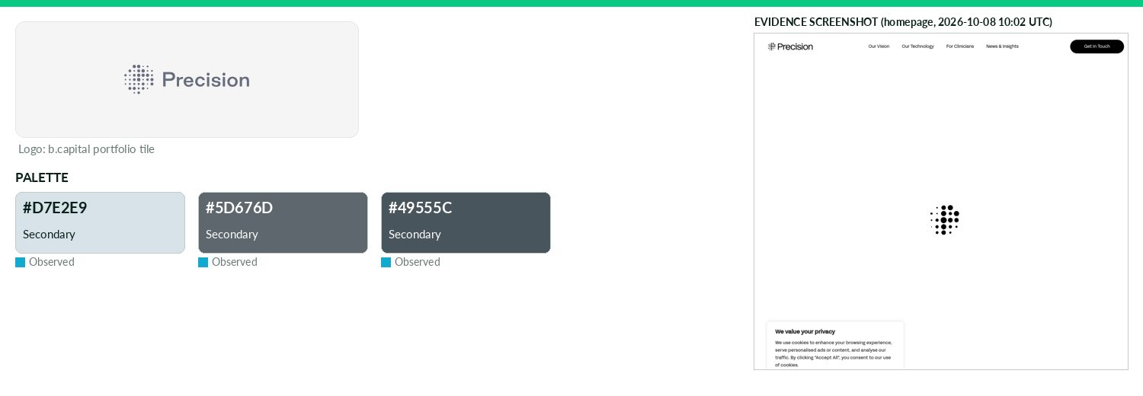
Captured 2026-10-08
Field | Value | Tier | Source
Website | http://precisionneuro.io | Verified | b.capital portfolio
LinkedIn | https://www.linkedin.com/company/precision-neuroscience-corporation | Observed | official site link
Primary / secondary | #D7E2E9 / #5D676D / #49555C | Missing | —
Background / text | — | Missing | —
Typography | fff-acid-grotesk; immortel-colera; abc-monument-grotesk-mono | Observed | https://www.precisionneuro.io/
Voice & tone | — | Missing | —
Imagery | — | Missing | —
Clear-space / misuse | — | Missing | —
Trademark | — | Missing | —
Guideline / press kit | — | Missing
HQ / employees | — | Missing | LinkedIn API rate-limited
Draft note | No official guideline; live-site values. Site brands as 'Precision' (Precision Neuroscience). CSS vars --color-brand-primary #d7e2e9 (pale), secondary | Caveat
Shipday
Opportunistic · North America · Active · completeness 38% · tier Observed — All-in-one local delivery software, enabling restaurants to better manage orders and increase margins.
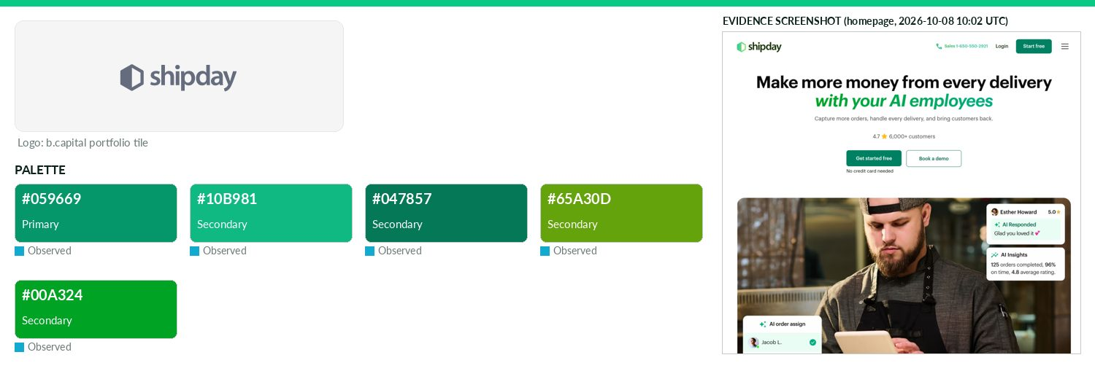
Captured 2026-10-08
Field | Value | Tier | Source
Website | http://www.shipday.com | Verified | b.capital portfolio
LinkedIn | https://www.linkedin.com/company/shipdayinc | Observed | official site link
Primary / secondary | #059669 / #10B981 / #047857 / #65A30D / #00A324 | Observed | https://www.shipday.com/ (site CSS)
Background / text | — | Missing | —
Typography | Graphik | Observed | https://www.shipday.com/ (@font-face/CSS)
Voice & tone | — | Missing | —
Imagery | — | Missing | —
Clear-space / misuse | — | Missing | —
Trademark | — | Missing | —
Guideline / press kit | — | Missing
HQ / employees | — | Missing | LinkedIn API rate-limited
OnDemand UI tokens | primary #059669 / on #000000 / accent #10B981 / surface #FFFFFF / text #111111 | Derived | contrast 5.57:1 · 18.88:1
Draft note | No official guideline; live-site values. No brand/press/media-kit page found at standard paths (/brand,/press,/press-kit,/media-kit,/media,/newsroom). | Caveat
TRM Labs
Opportunistic · North America · Active · completeness 77% · tier Verified — Blockchain intelligence platform helping institutions detect and investigate crypto-related fraud and financial crime.
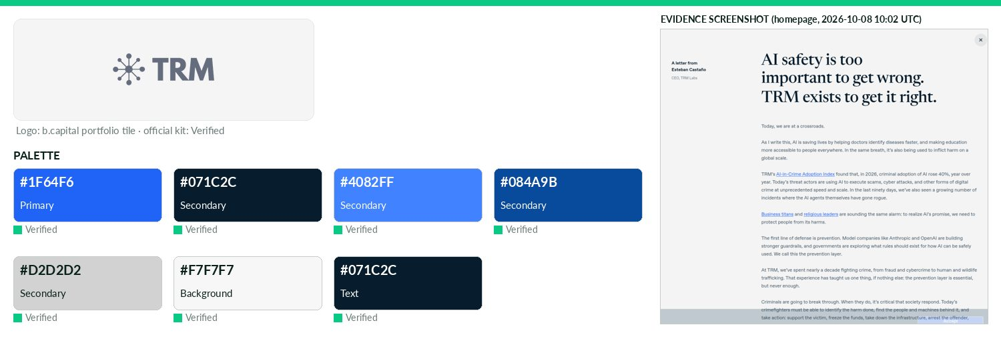
Captured 2026-10-08
Field | Value | Tier | Source
Website | https://www.trmlabs.com | Verified | b.capital portfolio
LinkedIn | https://www.linkedin.com/company/trmlabs | Observed | official site link
Primary / secondary | #1F64F6 / #071C2C / #4082FF / #084A9B / #D2D2D2 | Verified | https://cdn.prod.website-files.com/6082dc5b670562507b3587b4/
Background / text | #F7F7F7 / #071C2C | Verified | —
Typography | Avenir Next; Lyon Display | Observed | Fonts embedded in https://cdn.prod.website-files.com/6082dc5
Voice & tone | — | Missing | —
Imagery | Logo over photos only on simple, clean areas; never over faces/figures/complex graphics; white logo on dark ar | Verified | https://cdn.prod.website-files.com/6082dc5b6705625
Clear-space / misuse | Min clear space 2x around logo. Logo only TRM Black or white, never Bright Blue. Don't distort, recolour, respace, add e | Verified | https://cdn.prod.website-files.com/6082dc5b6705625
Trademark | All design elements are TRM Labs exclusive property; no duplication without written authorization (typefaces l | Verified | https://cdn.prod.website-files.com/6082dc5b6705625
Guideline / press kit | https://cdn.prod.website-files.com/6082dc5b670562507b3587b4/686c0b3424676a6f4bd081a0_TRM_BrandGuidelines_Press | Verified
HQ / employees | — | Missing | LinkedIn API rate-limited
OnDemand UI tokens | primary #1F64F6 / on #FFFFFF / accent #071C2C / surface #F7F7F7 / text #071C2C | Derived | contrast 4.99:1 · 16.18:1
Unblocked Brands
Opportunistic · North America · Active · completeness 38% · tier Observed — Loyalty and engagement platform using blockchain to connect enterprises with their customers.
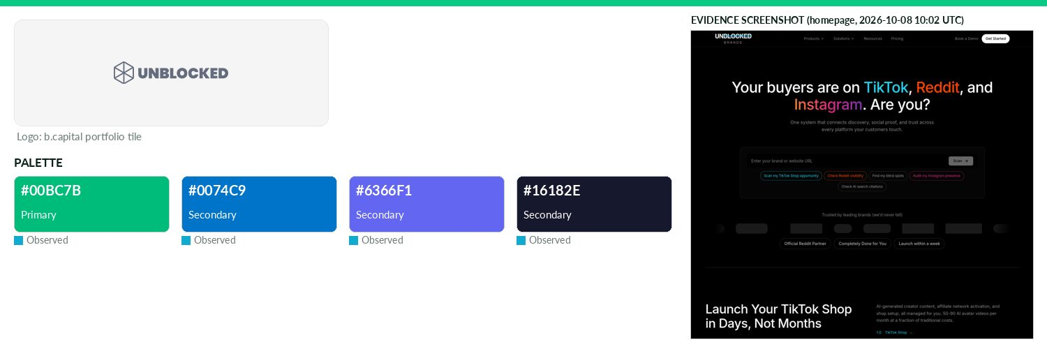
Captured 2026-10-08
Field | Value | Tier | Source
Website | https://unblockedbrands.com | Verified | b.capital portfolio
LinkedIn | https://linkedin.com/company/unblocked-brands | Observed | official site link
Primary / secondary | #00BC7B / #0074C9 / #6366F1 / #16182E | Observed | https://www.unblockedbrands.com/ CSS var --slide-primary
Background / text | — | Missing | —
Typography | Plus Jakarta Sans; Inter; DM Sans; Instrument Serif | Observed | https://www.unblockedbrands.com/ @font-face
Voice & tone | — | Missing | —
Imagery | — | Missing | —
Clear-space / misuse | — | Missing | —
Trademark | — | Missing | —
Guideline / press kit | — | Missing
HQ / employees | — | Missing | LinkedIn API rate-limited
OnDemand UI tokens | primary #00BC7B / on #000000 / accent #0074C9 / surface #FFFFFF / text #111111 | Derived | contrast 8.48:1 · 18.88:1
Draft note | No official guideline; live-site values. Site now positions as TikTok/Instagram/Reddit/AI search marketing agency. No press/brand pages. | Caveat
5. Cross-portfolio pattern analysis
Primary colours for 118 companies were converted sRGB→CIELAB and clustered with k-means (k=6, 20 inits, seed 7).
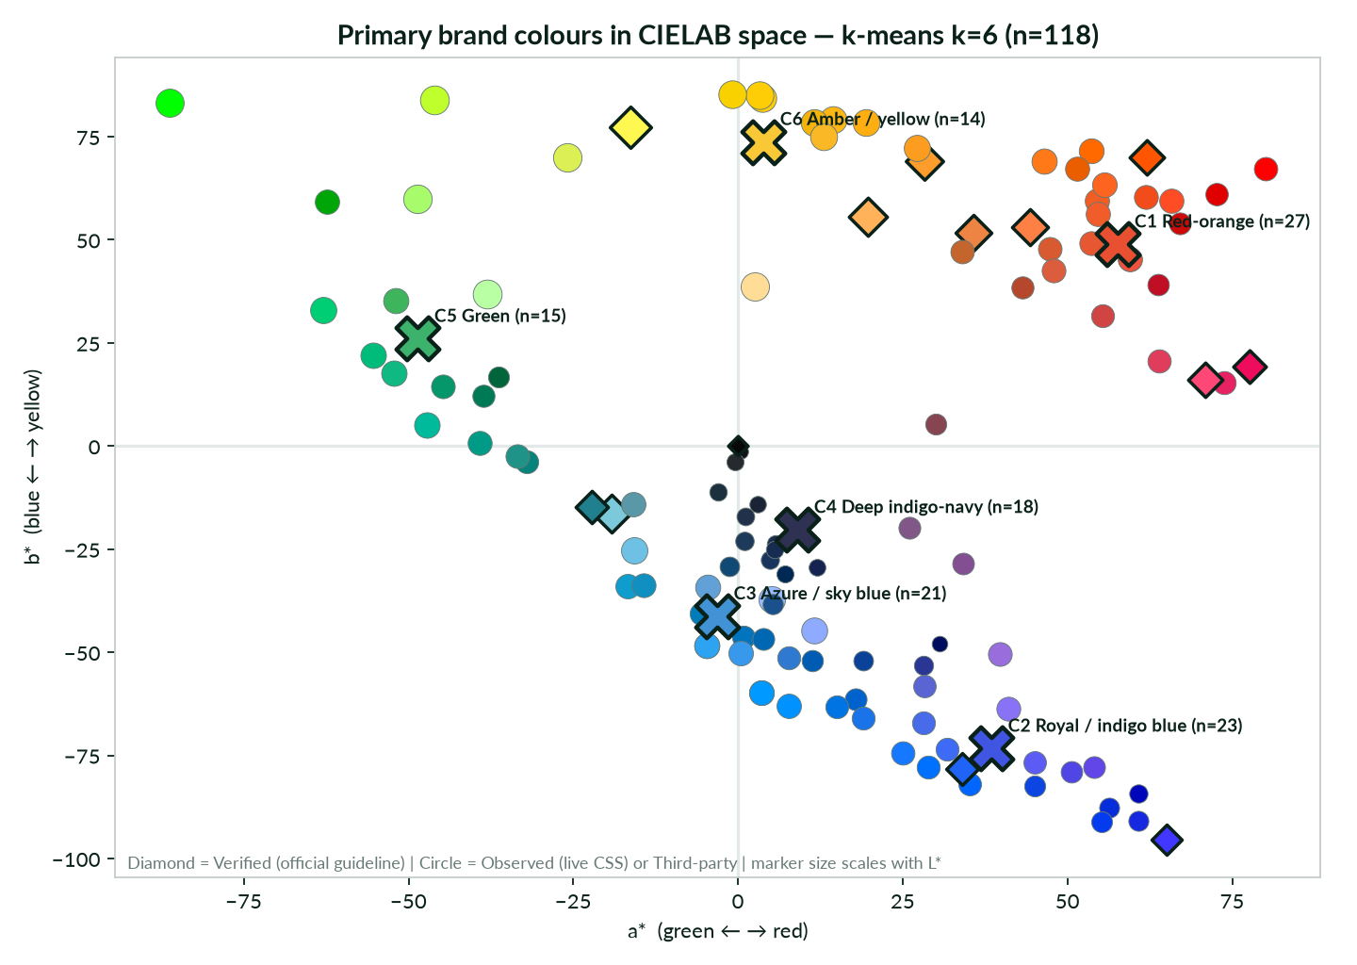
Primary colours in CIELAB a*/b* with centroids
Analyst computation
Cluster | Centroid | Family | n | Members
C1 | #E95032 | Red-orange | 27 | Apptronik, Baichuan, Bhanzu, Centivo, ChipAgents, Collinear AI, Dream Labs, Eureka Robotics, Goodfire, Iru … (+17)
C2 | #4055E1 | Royal / indigo blue | 23 | AIMotive, Cadence, Capital Rx, Cloudwise, CompanyCam, EvenUp, Fervo Energy, Floor NFTs, Fountain, Gable … (+13)
C3 | #4293D6 | Azure / sky blue | 21 | Archimetis, Axiom, Brik, EeroQ, Evommune, FalconX, Flourish Health, FlowGPT, HavocAI, Hypersonix … (+11)
C4 | #2F3152 | Deep indigo-navy | 18 | 1AU, Branch International, Curbwaste, Deferred, Extend, Grace Investment Machine, HifiBio, Icertis, Labviva, LevelTen … (+8)
C5 | #3CB26C | Green | 15 | Accacia, Aurora YaoCheng, Carrick, Certn, Forest, HeyLibby, InfraHub, Insilico Medicine, Lambda, Rona Therapeutics … (+5)
C6 | #F8C836 | Amber / yellow | 14 | ARTBIO, BuildOps, Code Metal, DailyHunt, Evidation Health, Figment, Goose, GrayMatter Robotics, Knox, Lunar Energy … (+4)
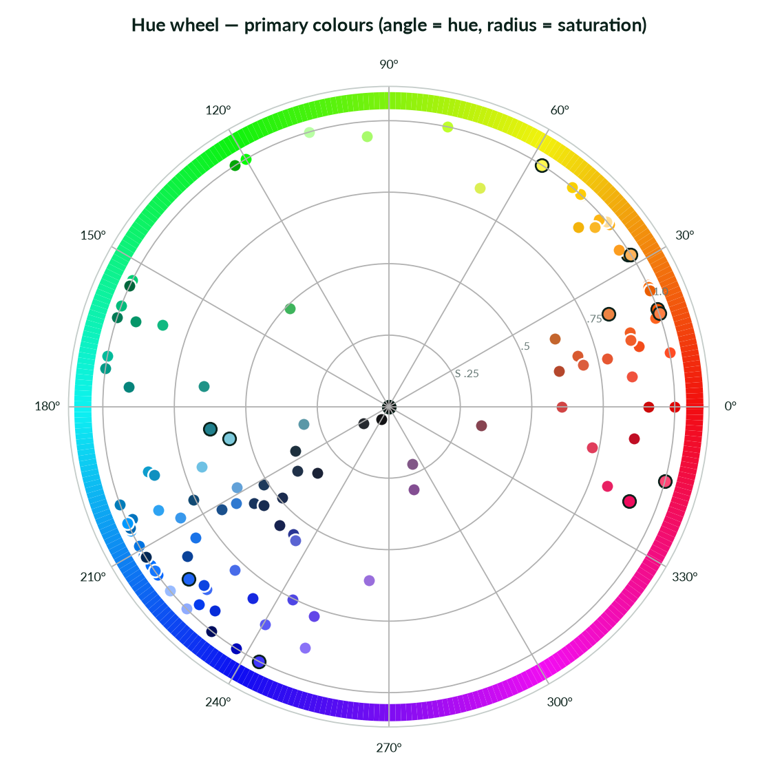
Hue wheel (angle = hue, radius = saturation; dark outline = Verified)
Analyst computation
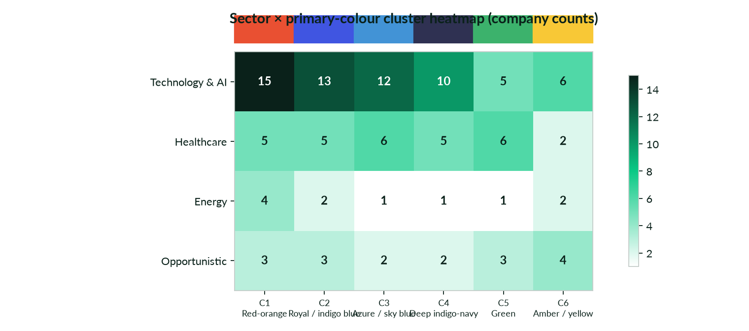
Sector × primary-colour cluster heatmap
Analyst computation
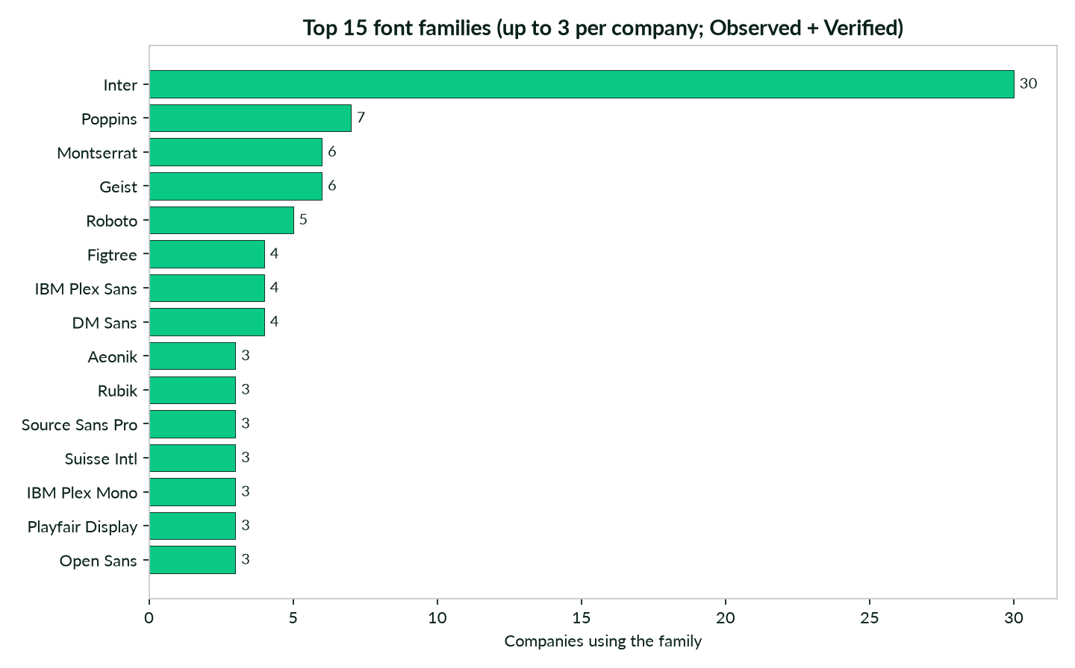
Font-family frequency
Live CSS + guidelines
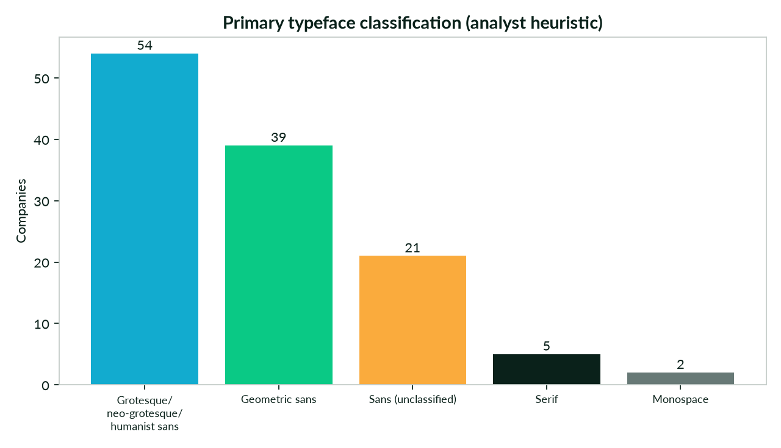
Typeface classification (heuristic)
Analyst classification
Blues dominate (clusters 2–4: 62 companies), then red-orange (27), green (15) and amber (14). Inter is the most common family (30 companies); serifs/monospace appear mainly as editorial accents.
6. OnDemand application guidance
Only documented endpoints (live docs fetched 2026-10-08T09:39:33Z). Auth is the apikey header. REST API Key Management, Reasoning Modes, Endpoints listing, Chat Batches and Stream Workflow Logs are not in the live index (reference slugs return HTTP 400) and are not used.
Service | Operation | Method | Path (https://api.on-demand.io) | Required body
Media API | Fetch Media | GET | /media/v1/public/file | —
Media API | Create Media URL | POST | /media/v1/public/file | url, plugins, responseMode
Services API | Convert audio to text | POST | /services/v1/public/service/execute/speech_to_text | audioUrl
Services API | Convert text to audio | POST | /services/v1/public/service/execute/text_to_speech | model, input, voice
Services API | Translate text to another language | POST | /services/v1/public/service/execute/language_translation | input, languageCode
Agents Flow Builder API | Get execution by ID | GET | /automation/api/execution/{executionID} | —
Agents Flow Builder API | Get execution logs | GET | /automation/api/execution/{executionID}/logs | —
Agents Flow Builder API | Get execution node outputs | GET | /automation/api/execution/{executionID}/node/outputs | —
Agents Flow Builder API | Create a new workflow | POST | /automation/api/workflow/ | name, trigger, nodes, delivery
Agents Flow Builder API | Activate workflow | POST | /automation/api/workflow/{id}/activate | —
Agents Flow Builder API | Execute workflow | POST | /automation/api/workflow/{id}/execute | —
Chat API | Create Chat Session | POST | /chat/v1/sessions | externalUserId
Chat API | Get Chat Messages | GET | /chat/v1/sessions/{sessionId}/messages | —
Chat API | Submit Query | POST | /chat/v1/sessions/{sessionId}/query | query, endpointId, responseMode
6.1 Agents — system-prompt voice block + session/query
- POST /chat/v1/sessions with {"externalUserId": "bcap-portfolio--", "pluginIds": []} → data.id (accept 200/201).
- POST /chat/v1/sessions/{sessionId}/query with {"query", "endpointId", "responseMode":"sync"|"stream", "modelConfigs": {"fulfillmentPrompt": "", "temperature": 0.4}} → data.answer, data.status.
- BRAND VOICE BLOCK: "You write for {Company}. Voice: {voice_tone or plain, factual, confident}. Naming: {trademark rules}. Never invent claims, metrics or logos. If a fact is not in context, say so." — fill only with Verified/Observed values and keep the tier label.
6.2 Chat UI theming — CSS token map and contrast
Tokens: --brand-primary, --brand-on-primary (black/white by contrast), --brand-accent, --surface, --text, --font-sans. 118 of 118 brands reach ≥4.5:1 on primary/on-primary. Full token table is in the XLSX (OnDemand_Token_Map).
Company | Tier | primary | on-primary | accent | font | P/onP | text/surf.
1AU | Observed | #000D5E | #FFFFFF | #3898EC | Aeonik | 17.22 | 12.63
Accacia | Observed | #00CE74 | #000000 | #010F0D | Founders Grotesk | 10.08 | 12.63
AIMotive | Observed | #0062CC | #FFFFFF | #1E7E34 | Hind | 5.8 | 15.43
Apptronik | Observed | #F34C1B | #000000 | #0050BD | system-ui | 5.86 | 12.63
Archimetis | Observed | #8FABFF | #000000 | #3898EC | Host Grotesk | 9.44 | 18.88
ARTBIO | Observed | #FFCC09 | #000000 | #A84192 | Bai Jamjuree | 13.89 | 10.37
Aurora YaoCheng | Observed | #00BB9B | #000000 | #00B797 | Roboto | 8.58 | 12.63
Axiom | Observed | #99BBFF | #000000 | #0036A3 | bodyFont | 10.91 | 18.88
Baichuan | Observed | #FF7918 | #000000 | #FF6933 | PingFang SC | 8.0 | 15.33
Bhanzu | Observed | #F15D22 | #000000 | #C04A1B | Quicksand | 6.33 | 11.33
Branch International | Observed | #19355E | #FFFFFF | #187BC2 | Circular | 12.26 | 12.63
Brik | Observed | #005CB2 | #FFFFFF | #E32726 | Inter | 6.62 | 18.88
BuildOps | Observed | #FFAE11 | #000000 | #008049 | Inter | 11.31 | 18.88
Cadence | Observed | #1628E0 | #FFFFFF | #0E1C9A | Noi Grotesk | 8.7 | 17.99
Capital Rx | Observed | #0007BA | #FFFFFF | #00003F | Rubik | 12.07 | 18.09
Carrick | Observed | #007A55 | #FFFFFF | #A5DBE7 | Source Sans Pro | 5.36 | 15.43
Centivo | Observed | #F15D2A | #000000 | #F5A623 | roc-grotesk | 6.34 | 15.91
Certn | Observed | #A8FB6B | #000000 | #0693E3 | Geist | 16.68 | 18.88
ChipAgents | Observed | #FD6420 | #000000 | #E2540F | Mozaic Geo | 7.02 | 17.21
Cloudwise | Observed | #6246E8 | #FFFFFF | #1E293B | Microsoft YaHei | 5.9 | 12.63
Code Metal | Observed | #BFFF2B | #000000 | #8CABFF | Inter | 17.55 | 15.51
Collinear AI | Verified | #EE8443 | #000000 | #2C2C2C | Inter | 8.02 | 12.63
CompanyCam | Observed | #072CD9 | #FFFFFF | #FFD000 | Averta | 8.86 | 17.46
Curbwaste | Observed | #1D3A5B | #FFFFFF | #FFCB43 | PP Neue Montreal | 11.61 | 12.63
DailyHunt | Observed | #FFDD97 | #000000 | #F2C878 | en_regular | 16.04 | 16.29
Deferred | Observed | #131315 | #FFFFFF | #F4F0E8 | Gustavo | 18.56 | 12.63
Dream Labs | Observed | #B5472C | #FFFFFF | #8A3220 | Space Grotesk | 5.38 | 4.78
EeroQ | Observed | #0274BE | #FFFFFF | #D9534F | Montserrat | 4.95 | 10.35
Eureka Robotics | Observed | #C00E24 | #FFFFFF | #111111 | Inter | 6.31 | 12.63
EvenUp | Observed | #3D6BF5 | #000000 | #0A58CA | Inter | 4.62 | 15.43
Evidation Health | Observed | #FFCD05 | #000000 | #FFCD05 | Public Sans | 13.99 | 17.4
Evommune | Observed | #2EA3F2 | #000000 | #0E2D52 | area-normal | 7.64 | 5.74
Extend | Observed | #1B2C4F | #FFFFFF | #4489F9 | Founders | 13.82 | 17.23
FalconX | Observed | #0092FF | #000000 | #F5F2EF | Gt Planar | 6.56 | 14.5
Fervo Energy | Observed | #2A3694 | #FFFFFF | #D91B3E | normalidad-extended | 10.23 | 12.63
Figment | Verified | #FFF850 | #000000 | #111111 | Space Grotesk | 18.79 | 18.88
Floor NFTs | Observed | #0066FF | #FFFFFF | #FF0000 | Inter | 4.83 | 18.88
Flourish Health | Observed | #0E9DCD | #000000 | #3898EC | Inter | 6.72 | 16.33
FlowGPT | Observed | #62A1D8 | #000000 | #BD2426 | system-ui | 7.61 | 18.88
Forest | Observed | #10B981 | #000000 | #166534 | Inter | 8.28 | 18.88
Fountain | Observed | #4F46E5 | #FFFFFF | #3730A3 | Circular XX | 6.29 | 17.85
Gable | Observed | #8A72F7 | #000000 | #3898EC | Aeonik | 5.83 | 12.63
Goodfire | Observed | #C4652D | #000000 | #3898EC | Suisse Intl | 5.25 | 15.26
Goose | Verified | #FE9D2B | #000000 | #C97A24 | Playfair Display | 10.07 | 12.63
Grace Investment Machine | Observed | #172C51 | #FFFFFF | #F8CC37 | Financier Display GI | 13.86 | 12.83
GrayMatter Robotics | Observed | #FDB614 | #000000 | #D9534F | NB International | 11.88 | 12.63
Gushwork | Observed | #0070FF | #000000 | #3B46F1 | Vert Grotesk Display | 4.76 | 12.63
HavocAI | Observed | #0099FF | #000000 | #004276 | Geist | 7.0 | 17.93
HeyLibby | Observed | #3EB45C | #000000 | #63ED80 | Dm Sans | 7.89 | 18.88
HifiBio | Observed | #002855 | #FFFFFF | #41A62A | wprmenu | 14.64 | 14.64
Hypersonix | Verified | #7CC9DB | #000000 | #A3D9E6 | Work Sans | 11.23 | 16.57
Icertis | Observed | #874451 | #FFFFFF | #404041 | lora | 7.06 | 15.43
InfraHub | Observed | #B9FFA4 | #000000 | #C7FFAD | Ease Standard | 17.9 | 1.11
Innovaccer | Observed | #053BEE | #FFFFFF | #A0CCE0 | Polysans | 7.33 | 17.4
Insilico Medicine | Observed | #00A607 | #000000 | #00A607 | Inter | 6.46 | 1.11
Inspace | Observed | #2F79D0 | #000000 | #874C41 | Manrope | 4.77 | 12.63
Iru | Observed | #D14444 | #000000 | #EE4D4D | FK Grotesk Neue | 4.62 | 18.88
Isaac Health | Observed | #FF6900 | #000000 | #CF2E2E | Saans | 7.27 | 15.91
JetZero | Verified | #FF5500 | #000000 | #0D1921 | Titillium | 6.55 | 17.82
Karman Industries | Observed | #FF4C24 | #000000 | #37A9DE | Hind Madurai | 6.31 | 1.05
Knox | Observed | #FC9D1F | #000000 | #0854E1 | Lora | 9.98 | 18.88
Kopi Kenangan | Observed | #F0523D | #000000 | #00B2FF | Figtree | 5.98 | 18.88
Labelbox | Observed | #5A98A7 | #000000 | #DCECEF | IBM Plex Sans | 6.48 | 1.18
Labviva | Observed | #1D303E | #FFFFFF | #1D303E | Inter | 13.6 | 12.63
Lambda | Observed | #00FF00 | #000000 | #252525 | Suisse Intl | 15.3 | 12.2
LevelTen | Observed | #104973 | #FFFFFF | #268FDD | Lato | 9.45 | 8.31
Lively | Observed | #E82163 | #000000 | #FED872 | DM Sans | 4.83 | 16.48
Lunar Energy | Observed | #F3B30B | #000000 | #14273A | TT Interphases Pro | 11.26 | 18.46
MacroLux | Observed | #FF0000 | #000000 | #0BAF4D | Poppins | 5.25 | 12.63
Meesho | Third-party | #815787 | #FFFFFF | #EDBB51 | Futura | 5.76 | 18.88
Miotech | Observed | #262A2F | #FFFFFF | #959A9F | Geist | 14.44 | 18.88
Mswipe | Observed | #1A508C | #FFFFFF | #03B1E4 | Roboto | 8.17 | 15.43
Nektar.AI | Observed | #0274BE | #FFFFFF | #D9534F | Fraunces | 4.95 | 10.35
Nest Genomics | Observed | #E65732 | #000000 | #2F5D7E | Manrope | 5.77 | 18.88
Neushen Therapeutics | Observed | #1677FF | #000000 | #8B0C09 | Roboto | 5.12 | 18.88
Ninja Van | Observed | #E00000 | #FFFFFF | #F5222D | Lato | 5.04 | 21.0
Numerion Labs | Observed | #2EA3F2 | #000000 | #2B2457 | Open Sans | 7.64 | 5.74
Odeko | Observed | #F9D000 | #000000 | #1F8A4D | Roobert | 14.05 | 18.88
Omnidian | Observed | #0068B3 | #FFFFFF | #191B24 | Neue Haas Grotesk Di | 5.78 | 4.89
Oro Labs | Observed | #FAB726 | #000000 | #EEEEEE | Abcarizonasans | 11.87 | 18.88
Overstory | Observed | #F0523D | #000000 | #00B2FF | Poppins | 5.98 | 18.88
PaleBlueDot | Observed | #0074E2 | #000000 | #0086FF | PP Neue Montreal | 4.6 | 18.88
PAYFAZZ | Observed | #0C45E1 | #FFFFFF | #00D37E | Fazz Neue | 7.11 | 12.63
Pendo | Verified | #FF4876 | #000000 | #FEF484 | Sora | 6.44 | 18.88
Percent | Observed | #5C5BF4 | #FFFFFF | #393896 | Neuzeit Grotesk | 4.93 | 11.9
Perimeter 81 | Verified | #EE0C5D | #000000 | #41273C | DIN Pro | 4.85 | 15.91
Perplexity | Verified | #20808D | #FFFFFF | #091717 | Perplexity Sans | 4.63 | 18.32
Phenom People | Verified | #FF8045 | #000000 | #BCE5E3 | roobert | 8.43 | 18.88
PicnicHealth | Observed | #834E92 | #FFFFFF | #713F7F | DM Sans | 6.05 | 18.88
Poolside | Verified | #4137FF | #FFFFFF | #111111 | Untitled Sans | 6.53 | 18.88
Positive Development | Observed | #996EDC | #000000 | #E9B557 | Poppins | 5.62 | 18.88
Rapyd | Observed | #1A73E8 | #000000 | #75D69C | Epilogue | 4.66 | 13.4
Reflection | Observed | #DCEF54 | #000000 | #1E3207 | NaN Serf Sans | 16.52 | 18.88
Remote | Observed | #E03D5C | #000000 | #F3B3BF | rotina | 4.99 | 18.88
Rona Therapeutics | Observed | #00653B | #FFFFFF | #0032A0 | Montserrat | 7.18 | 11.27
Seltz | Observed | #1B2337 | #FFFFFF | #6BECCD | Fragment Mono | 15.65 | 1.11
Shipday | Observed | #059669 | #000000 | #10B981 | Graphik | 5.57 | 18.88
Sift Healthcare | Observed | #0F90C0 | #000000 | #42737B | Gilroy | 5.77 | 21.0
SilverCloud Health | Observed | #06847B | #000000 | #1E3F36 | Questrial | 4.59 | 18.88
Solar Square | Observed | #CD0A0A | #FFFFFF | #1A1F38 | Poppins | 5.76 | 18.88
Solve Therapeutics | Observed | #203149 | #FFFFFF | #D9534F | Inter | 13.15 | 21.0
Sonilo | Observed | #5A64D2 | #FFFFFF | #4B55C6 | Geist | 5.01 | 17.43
Star Catcher | Verified | #FFB259 | #000000 | #14141C | PP Monument Extended | 11.76 | 17.72
Starburst Data | Verified | #080808 | #FFFFFF | #9747FF | PP Mori | 20.03 | 20.03
Sugarfit | Observed | #0099FF | #000000 | #7A00D6 | Inter | 7.0 | 16.7
Synapticure | Observed | #16224F | #FFFFFF | #183CDC | Playfair Display | 15.26 | 18.88
Tacta | Observed | #3898EC | #000000 | #F3591D | Aeonik | 6.87 | 12.63
TinyHealth | Observed | #009B87 | #000000 | #3B3941 | TWK Lausanne | 6.04 | 10.65
TRM Labs | Verified | #1F64F6 | #FFFFFF | #071C2C | Avenir Next | 4.99 | 16.18
Turno | Observed | #D85A30 | #000000 | #E9511A | Aspekta | 5.42 | 16.76
Unblocked Brands | Observed | #00BC7B | #000000 | #0074C9 | Plus Jakarta Sans | 8.48 | 18.88
Volastra | Observed | #6EC1E4 | #000000 | #BA145E | Exo | 10.41 | 18.88
When | Observed | #EB5E00 | #000000 | #2E8A7A | Fragment Mono | 6.13 | 18.88
Wildfire | Observed | #1F9387 | #000000 | #6C757D | Montserrat | 5.58 | 15.43
Writer | Observed | #007CBA | #000000 | #5551FF | Poppins | 4.59 | 21.0
Xingyun | Observed | #0A4299 | #FFFFFF | #2563EB | PingFang SC | 9.32 | 17.93
Yalo | Observed | #486CE9 | #000000 | #40E4A9 | Tomato Grotesk | 4.6 | 18.38
Zaihui | Observed | #DC5D3D | #000000 | #F09670 | Alibaba-PuHuiTi | 5.68 | 5.74
6.3 Generated content — Media, Services, Flow Builder
- Media: POST /media/v1/public/file {"url","plugins","responseMode":"sync"|"webhook", optional name, sessionId, externalUserId} — register brand assets by URL (no multipart in the public contract).
- TTS: POST /services/v1/public/service/execute/text_to_speech {"model":"tts-1"|"tts-1-hd","input","voice":"alloy|echo|fable|onyx|nova|shimmer"} → data.audioUrl.
- Translate: POST /services/v1/public/service/execute/language_translation {"input","languageCode"} → data.translatedText.
- Flow Builder: POST /automation/api/workflow/ {"name","trigger","nodes","delivery"} → POST /workflow/{id}/activate → POST /workflow/{id}/execute → {"executionID"} → poll GET /execution/{executionID} and /logs (replaces stream_logs) → GET /execution/{executionID}/node/outputs.
6.4 Skill best practices
- One skill per brand (SKILL.md + tokens.json + logo URLs + evidence URLs/timestamps).
- Carry the evidence tier into the skill; Observed values are not approved brand rules.
- Skills are invoked as query text — no public skill-registration endpoint; deliver context via modelConfigs.fulfillmentPrompt and Media API.
- Quarterly refresh via a Flow Builder workflow re-running CSS extraction; alert on change.
- Contrast gate: never set body text below 4.5:1; fall back to #0A211A on white.
7. Gaps and next steps
Only 4 of 135 (3.0%) publish a complete official guideline; 6 (4.4%) have verified hex + fonts. HQ and employee band are Missing for all 135.
Company | Block / error
6sense | home HTTP 403 (Cloudflare); /press 403; /brand 403; home 403: Just a moment...
Branch International | branch.co/press,/newsroom,/media,/brand: HTTP 403 Cloudflare
Carro | http://carro.sg: connection error; https://carro.co/sg/en: 403 Cloudflare challenge (all probed paths); home ERR: HTTPCo
CoinDCX | coindcx.com (all paths incl. /press,/media-kit,/brand-assets,/blog): HTTP 403 Cloudflare challenge; http://coindcx.com:
Evommune | https://evommune.com redirects to http://www.evommune.com which timed out; https://www.evommune.com ok
FlowGPT | home HTTP 403; home 403:
Grit | SPA shell - no server-rendered content; css ERR https://www.gritbio.com/assets/index-B6o3jSkD.css
HotSpot Therapeutics | 403 Cloudflare challenge on https://www.hotspotthera.com/ and /news; home 403: Just a moment...
LinKMORE | http://cnunify.com connect timeout; https://www.cnunify.com SSL cert verify failed; home ERR: HTTPConnectionPool(host='c
MediTrust | 405 on https://www.meditrusthealth.com/; http://www.meditrusthealth.com connect error; home 405:
Meesho | https://www.meesho.com: HTTP 403 (all probed paths); home 403:  Access Denied  Access Denied  You don't have perm
Perplexity | www.perplexity.ai homepage HTTP 403; home ERR: HTTPConnectionPool(host='www.perplexity.ai', port=80): Max retries exceed
Sharpa | https://www.sharpa.com HTTP 429 (rate-limited); home 429:
Yalo | https://www.yalochat.com: SSL TLSV1_ALERT_INTERNAL_ERROR
- Request kits by email where offered (Innovaccer, Isaac Health, Centivo, GIM, Lambda form, JetZero Brandbook).
- Authenticated LinkedIn enrichment for HQ/employees.
- Live browser for JS-only and Cloudflare-protected sites (Baichuan, Grit, CompanyCam portal, Rapyd portal, 6sense, HotSpot, Branch, CoinDCX, Carro, FlowGPT).
- Confirm identity for changed domains (Nuvig, Spectrumedics, Vivacta, ProfoundBio→Genmab, Nalu→Boston Scientific, SilverCloud→Amwell, Floor NFTs→Rally, Perimeter 81→Check Point, HeyLibby→Replify, Capital Rx→Judi Health).
- Ask B Capital for the ~77 companies behind the 212 figure — not on the public page.
Companies with gaps
Company | Missing (count) | Missing fields
6sense | 12 | Primary Hex, Secondary Hexes, Background/Text Hex, Font Families, Voice/Tone, Imagery, Clear-space/Misuse, Trademark Rules, Guideline Doc, LinkedIn, HQ, Employees
Carro | 12 | Primary Hex, Secondary Hexes, Background/Text Hex, Font Families, Voice/Tone, Imagery, Clear-space/Misuse, Trademark Rules, Guideline Doc, LinkedIn, HQ, Employees
CoinDCX | 12 | Primary Hex, Secondary Hexes, Background/Text Hex, Font Families, Voice/Tone, Imagery, Clear-space/Misuse, Trademark Rules, Guideline Doc, LinkedIn, HQ, Employees
HotSpot Therapeutics | 12 | Primary Hex, Secondary Hexes, Background/Text Hex, Font Families, Voice/Tone, Imagery, Clear-space/Misuse, Trademark Rules, Guideline Doc, LinkedIn, HQ, Employees
LinKMORE | 12 | Primary Hex, Secondary Hexes, Background/Text Hex, Font Families, Voice/Tone, Imagery, Clear-space/Misuse, Trademark Rules, Guideline Doc, LinkedIn, HQ, Employees
MediTrust | 12 | Primary Hex, Secondary Hexes, Background/Text Hex, Font Families, Voice/Tone, Imagery, Clear-space/Misuse, Trademark Rules, Guideline Doc, LinkedIn, HQ, Employees
Nuvig | 12 | Primary Hex, Secondary Hexes, Background/Text Hex, Font Families, Voice/Tone, Imagery, Clear-space/Misuse, Trademark Rules, Guideline Doc, LinkedIn, HQ, Employees
ProfoundBio | 12 | Primary Hex, Secondary Hexes, Background/Text Hex, Font Families, Voice/Tone, Imagery, Clear-space/Misuse, Trademark Rules, Guideline Doc, LinkedIn, HQ, Employees
Sharpa | 12 | Primary Hex, Secondary Hexes, Background/Text Hex, Font Families, Voice/Tone, Imagery, Clear-space/Misuse, Trademark Rules, Guideline Doc, LinkedIn, HQ, Employees
Spectrumedics | 12 | Primary Hex, Secondary Hexes, Background/Text Hex, Font Families, Voice/Tone, Imagery, Clear-space/Misuse, Trademark Rules, Guideline Doc, LinkedIn, HQ, Employees
Vivacta | 12 | Primary Hex, Secondary Hexes, Background/Text Hex, Font Families, Voice/Tone, Imagery, Clear-space/Misuse, Trademark Rules, Guideline Doc, LinkedIn, HQ, Employees
Grit | 11 | Primary Hex, Secondary Hexes, Background/Text Hex, Voice/Tone, Imagery, Clear-space/Misuse, Trademark Rules, Guideline Doc, LinkedIn, HQ, Employees
Khatabook | 11 | Primary Hex, Secondary Hexes, Background/Text Hex, Voice/Tone, Imagery, Clear-space/Misuse, Trademark Rules, Guideline Doc, LinkedIn, HQ, Employees
Nalu | 11 | Primary Hex, Secondary Hexes, Background/Text Hex, Font Families, Voice/Tone, Imagery, Clear-space/Misuse, Guideline Doc, LinkedIn, HQ, Employees
FlowGPT | 10 | Background/Text Hex, Font Families, Voice/Tone, Imagery, Clear-space/Misuse, Trademark Rules, Guideline Doc, LinkedIn, HQ, Employees
Brik | 9 | Background/Text Hex, Voice/Tone, Imagery, Clear-space/Misuse, Trademark Rules, Guideline Doc, LinkedIn, HQ, Employees
Floor NFTs | 9 | Background/Text Hex, Voice/Tone, Imagery, Clear-space/Misuse, Trademark Rules, Guideline Doc, LinkedIn, HQ, Employees
Forest | 9 | Background/Text Hex, Voice/Tone, Imagery, Clear-space/Misuse, Trademark Rules, Guideline Doc, LinkedIn, HQ, Employees
Lumara Health | 9 | Primary Hex, Background/Text Hex, Voice/Tone, Imagery, Clear-space/Misuse, Trademark Rules, Guideline Doc, HQ, Employees
Precision Neuro | 9 | Primary Hex, Background/Text Hex, Voice/Tone, Imagery, Clear-space/Misuse, Trademark Rules, Guideline Doc, HQ, Employees
Turbine | 9 | Primary Hex, Background/Text Hex, Voice/Tone, Imagery, Clear-space/Misuse, Trademark Rules, Guideline Doc, HQ, Employees
1AU | 8 | Voice/Tone, Imagery, Clear-space/Misuse, Trademark Rules, Guideline Doc, LinkedIn, HQ, Employees
Archimetis | 8 | Background/Text Hex, Voice/Tone, Imagery, Clear-space/Misuse, Trademark Rules, Guideline Doc, HQ, Employees
Baichuan | 8 | Voice/Tone, Imagery, Clear-space/Misuse, Trademark Rules, Guideline Doc, LinkedIn, HQ, Employees
Branch International | 8 | Voice/Tone, Imagery, Clear-space/Misuse, Trademark Rules, Guideline Doc, LinkedIn, HQ, Employees
BuildOps | 8 | Background/Text Hex, Voice/Tone, Imagery, Clear-space/Misuse, Trademark Rules, Guideline Doc, HQ, Employees
Curbwaste | 8 | Voice/Tone, Imagery, Clear-space/Misuse, Trademark Rules, Guideline Doc, LinkedIn, HQ, Employees
DailyHunt | 8 | Voice/Tone, Imagery, Clear-space/Misuse, Trademark Rules, Guideline Doc, LinkedIn, HQ, Employees
Deferred | 8 | Voice/Tone, Imagery, Clear-space/Misuse, Trademark Rules, Guideline Doc, LinkedIn, HQ, Employees
Dream Labs | 8 | Voice/Tone, Imagery, Clear-space/Misuse, Trademark Rules, Guideline Doc, LinkedIn, HQ, Employees
Flourish Health | 8 | Voice/Tone, Imagery, Clear-space/Misuse, Trademark Rules, Guideline Doc, LinkedIn, HQ, Employees
HeyLibby | 8 | Background/Text Hex, Voice/Tone, Imagery, Clear-space/Misuse, Trademark Rules, Guideline Doc, HQ, Employees
Iru | 8 | Background/Text Hex, Voice/Tone, Imagery, Clear-space/Misuse, Trademark Rules, Guideline Doc, HQ, Employees
Knox | 8 | Background/Text Hex, Voice/Tone, Imagery, Clear-space/Misuse, Trademark Rules, Guideline Doc, HQ, Employees
MacroLux | 8 | Voice/Tone, Imagery, Clear-space/Misuse, Trademark Rules, Guideline Doc, LinkedIn, HQ, Employees
Miotech | 8 | Background/Text Hex, Voice/Tone, Imagery, Clear-space/Misuse, Trademark Rules, Guideline Doc, HQ, Employees
Ninja Van | 8 | Voice/Tone, Imagery, Clear-space/Misuse, Trademark Rules, Guideline Doc, LinkedIn, HQ, Employees
Odeko | 8 | Background/Text Hex, Voice/Tone, Imagery, Clear-space/Misuse, Trademark Rules, Guideline Doc, HQ, Employees
Oro Labs | 8 | Background/Text Hex, Voice/Tone, Imagery, Clear-space/Misuse, Trademark Rules, Guideline Doc, HQ, Employees
Overstory | 8 | Background/Text Hex, Voice/Tone, Imagery, Clear-space/Misuse, Trademark Rules, Guideline Doc, HQ, Employees
PicnicHealth | 8 | Background/Text Hex, Voice/Tone, Imagery, Clear-space/Misuse, Trademark Rules, Guideline Doc, HQ, Employees
Positive Development | 8 | Background/Text Hex, Voice/Tone, Imagery, Clear-space/Misuse, Trademark Rules, Guideline Doc, HQ, Employees
Reflection | 8 | Background/Text Hex, Voice/Tone, Imagery, Clear-space/Misuse, Trademark Rules, Guideline Doc, HQ, Employees
Remote | 8 | Background/Text Hex, Voice/Tone, Imagery, Clear-space/Misuse, Trademark Rules, Guideline Doc, HQ, Employees
Rona Therapeutics | 8 | Voice/Tone, Imagery, Clear-space/Misuse, Trademark Rules, Guideline Doc, LinkedIn, HQ, Employees
Shipday | 8 | Background/Text Hex, Voice/Tone, Imagery, Clear-space/Misuse, Trademark Rules, Guideline Doc, HQ, Employees
SilverCloud Health | 8 | Background/Text Hex, Voice/Tone, Imagery, Clear-space/Misuse, Trademark Rules, Guideline Doc, HQ, Employees
Solar Square | 8 | Background/Text Hex, Voice/Tone, Imagery, Clear-space/Misuse, Trademark Rules, Guideline Doc, HQ, Employees
Synapticure | 8 | Background/Text Hex, Voice/Tone, Imagery, Clear-space/Misuse, Trademark Rules, Guideline Doc, HQ, Employees
Turno | 8 | Voice/Tone, Imagery, Clear-space/Misuse, Trademark Rules, Guideline Doc, LinkedIn, HQ, Employees
Unblocked Brands | 8 | Background/Text Hex, Voice/Tone, Imagery, Clear-space/Misuse, Trademark Rules, Guideline Doc, HQ, Employees
Xingyun | 8 | Voice/Tone, Imagery, Clear-space/Misuse, Trademark Rules, Guideline Doc, LinkedIn, HQ, Employees
Zaihui | 8 | Voice/Tone, Imagery, Clear-space/Misuse, Trademark Rules, Guideline Doc, LinkedIn, HQ, Employees
Accacia | 7 | Voice/Tone, Imagery, Clear-space/Misuse, Trademark Rules, Guideline Doc, HQ, Employees
AIMotive | 7 | Voice/Tone, Imagery, Clear-space/Misuse, Trademark Rules, Guideline Doc, HQ, Employees
Aurora YaoCheng | 7 | Voice/Tone, Imagery, Clear-space/Misuse, Trademark Rules, Guideline Doc, HQ, Employees
Axiom | 7 | Background/Text Hex, Imagery, Clear-space/Misuse, Trademark Rules, Guideline Doc, HQ, Employees
Bhanzu | 7 | Voice/Tone, Imagery, Clear-space/Misuse, Trademark Rules, Guideline Doc, HQ, Employees
Cadence | 7 | Voice/Tone, Imagery, Clear-space/Misuse, Trademark Rules, Guideline Doc, HQ, Employees
Carrick | 7 | Voice/Tone, Imagery, Clear-space/Misuse, Trademark Rules, Guideline Doc, HQ, Employees
Certn | 7 | Background/Text Hex, Voice/Tone, Imagery, Clear-space/Misuse, Trademark Rules, HQ, Employees
ChipAgents | 7 | Voice/Tone, Imagery, Clear-space/Misuse, Trademark Rules, Guideline Doc, HQ, Employees
Cloudwise | 7 | Imagery, Clear-space/Misuse, Trademark Rules, Guideline Doc, LinkedIn, HQ, Employees
Code Metal | 7 | Imagery, Clear-space/Misuse, Trademark Rules, Guideline Doc, LinkedIn, HQ, Employees
EeroQ | 7 | Voice/Tone, Imagery, Clear-space/Misuse, Trademark Rules, Guideline Doc, HQ, Employees
Eureka Robotics | 7 | Voice/Tone, Imagery, Clear-space/Misuse, Trademark Rules, Guideline Doc, HQ, Employees
Evommune | 7 | Voice/Tone, Imagery, Clear-space/Misuse, Trademark Rules, Guideline Doc, HQ, Employees
Extend | 7 | Voice/Tone, Imagery, Clear-space/Misuse, Trademark Rules, Guideline Doc, HQ, Employees
FalconX | 7 | Voice/Tone, Imagery, Clear-space/Misuse, Trademark Rules, Guideline Doc, HQ, Employees
Gable | 7 | Voice/Tone, Imagery, Clear-space/Misuse, Trademark Rules, Guideline Doc, HQ, Employees
GrayMatter Robotics | 7 | Voice/Tone, Imagery, Clear-space/Misuse, Trademark Rules, Guideline Doc, HQ, Employees
Gushwork | 7 | Voice/Tone, Imagery, Clear-space/Misuse, Trademark Rules, Guideline Doc, HQ, Employees
HavocAI | 7 | Voice/Tone, Imagery, Clear-space/Misuse, Trademark Rules, Guideline Doc, HQ, Employees
HifiBio | 7 | Voice/Tone, Imagery, Clear-space/Misuse, Trademark Rules, Guideline Doc, HQ, Employees
Icertis | 7 | Voice/Tone, Imagery, Clear-space/Misuse, Trademark Rules, Guideline Doc, HQ, Employees
InfraHub | 7 | Voice/Tone, Imagery, Clear-space/Misuse, Trademark Rules, Guideline Doc, HQ, Employees
Inspace | 7 | Voice/Tone, Imagery, Clear-space/Misuse, Trademark Rules, Guideline Doc, HQ, Employees
Karman Industries | 7 | Voice/Tone, Imagery, Clear-space/Misuse, Trademark Rules, Guideline Doc, HQ, Employees
Kopi Kenangan | 7 | Voice/Tone, Imagery, Clear-space/Misuse, Trademark Rules, Guideline Doc, HQ, Employees
Labelbox | 7 | Voice/Tone, Imagery, Clear-space/Misuse, Trademark Rules, Guideline Doc, HQ, Employees
Labviva | 7 | Voice/Tone, Imagery, Clear-space/Misuse, Trademark Rules, Guideline Doc, HQ, Employees
LevelTen | 7 | Voice/Tone, Imagery, Clear-space/Misuse, Trademark Rules, Guideline Doc, HQ, Employees
Lively | 7 | Voice/Tone, Imagery, Clear-space/Misuse, Trademark Rules, Guideline Doc, HQ, Employees
Lunar Energy | 7 | Voice/Tone, Imagery, Clear-space/Misuse, Trademark Rules, Guideline Doc, HQ, Employees
Mswipe | 7 | Voice/Tone, Imagery, Clear-space/Misuse, Trademark Rules, Guideline Doc, HQ, Employees
Nektar.AI | 7 | Voice/Tone, Imagery, Clear-space/Misuse, Trademark Rules, Guideline Doc, HQ, Employees
Nest Genomics | 7 | Voice/Tone, Imagery, Clear-space/Misuse, Trademark Rules, Guideline Doc, HQ, Employees
Neushen Therapeutics | 7 | Voice/Tone, Imagery, Clear-space/Misuse, Trademark Rules, Guideline Doc, HQ, Employees
Numerion Labs | 7 | Voice/Tone, Imagery, Clear-space/Misuse, Trademark Rules, Guideline Doc, HQ, Employees
Omnidian | 7 | Voice/Tone, Imagery, Clear-space/Misuse, Trademark Rules, Guideline Doc, HQ, Employees
PaleBlueDot | 7 | Voice/Tone, Imagery, Clear-space/Misuse, Trademark Rules, Guideline Doc, HQ, Employees
PAYFAZZ | 7 | Voice/Tone, Imagery, Clear-space/Misuse, Trademark Rules, Guideline Doc, HQ, Employees
Percent | 7 | Voice/Tone, Imagery, Clear-space/Misuse, Trademark Rules, Guideline Doc, HQ, Employees
Phenom People | 7 | Background/Text Hex, Voice/Tone, Imagery, Clear-space/Misuse, Trademark Rules, HQ, Employees
Seltz | 7 | Voice/Tone, Imagery, Clear-space/Misuse, Trademark Rules, Guideline Doc, HQ, Employees
Sift Healthcare | 7 | Voice/Tone, Imagery, Clear-space/Misuse, Trademark Rules, Guideline Doc, HQ, Employees
Solve Therapeutics | 7 | Voice/Tone, Imagery, Clear-space/Misuse, Trademark Rules, Guideline Doc, HQ, Employees
Sonilo | 7 | Voice/Tone, Imagery, Clear-space/Misuse, Trademark Rules, Guideline Doc, HQ, Employees
Sugarfit | 7 | Voice/Tone, Imagery, Clear-space/Misuse, Trademark Rules, Guideline Doc, HQ, Employees
Tacta | 7 | Voice/Tone, Imagery, Clear-space/Misuse, Trademark Rules, Guideline Doc, HQ, Employees
TinyHealth | 7 | Voice/Tone, Imagery, Clear-space/Misuse, Trademark Rules, Guideline Doc, HQ, Employees
Volastra | 7 | Voice/Tone, Imagery, Clear-space/Misuse, Trademark Rules, Guideline Doc, HQ, Employees
When | 7 | Voice/Tone, Imagery, Clear-space/Misuse, Trademark Rules, Guideline Doc, HQ, Employees
Wildfire | 7 | Voice/Tone, Imagery, Clear-space/Misuse, Trademark Rules, Guideline Doc, HQ, Employees
Yalo | 7 | Voice/Tone, Imagery, Clear-space/Misuse, Trademark Rules, Guideline Doc, HQ, Employees
Apptronik | 6 | Font Families, Clear-space/Misuse, Trademark Rules, Guideline Doc, HQ, Employees
ARTBIO | 6 | Voice/Tone, Imagery, Clear-space/Misuse, Guideline Doc, HQ, Employees
Capital Rx | 6 | Voice/Tone, Imagery, Clear-space/Misuse, Guideline Doc, HQ, Employees
Centivo | 6 | Voice/Tone, Imagery, Clear-space/Misuse, Guideline Doc, HQ, Employees
CompanyCam | 6 | Voice/Tone, Imagery, Clear-space/Misuse, Trademark Rules, HQ, Employees
EvenUp | 6 | Voice/Tone, Imagery, Clear-space/Misuse, Guideline Doc, HQ, Employees
Evidation Health | 6 | Voice/Tone, Imagery, Clear-space/Misuse, Guideline Doc, HQ, Employees
Fervo Energy | 6 | Imagery, Clear-space/Misuse, Trademark Rules, Guideline Doc, HQ, Employees
Figment | 6 | Background/Text Hex, Voice/Tone, Imagery, Trademark Rules, HQ, Employees
Goodfire | 6 | Imagery, Clear-space/Misuse, Trademark Rules, Guideline Doc, HQ, Employees
Grace Investment Machine | 6 | Voice/Tone, Imagery, Clear-space/Misuse, Guideline Doc, HQ, Employees
Innovaccer | 6 | Voice/Tone, Imagery, Clear-space/Misuse, Guideline Doc, HQ, Employees
Isaac Health | 6 | Voice/Tone, Imagery, Clear-space/Misuse, Guideline Doc, HQ, Employees
Rapyd | 6 | Voice/Tone, Imagery, Clear-space/Misuse, Trademark Rules, HQ, Employees
Collinear AI | 5 | Voice/Tone, Imagery, Trademark Rules, HQ, Employees
Fountain | 5 | Voice/Tone, Imagery, Trademark Rules, HQ, Employees
Goose | 5 | Clear-space/Misuse, Trademark Rules, Guideline Doc, HQ, Employees
Hypersonix | 5 | Voice/Tone, Imagery, Trademark Rules, HQ, Employees
Insilico Medicine | 5 | Voice/Tone, Imagery, Trademark Rules, HQ, Employees
Meesho | 5 | Background/Text Hex, Trademark Rules, LinkedIn, HQ, Employees
Poolside | 5 | Imagery, Trademark Rules, LinkedIn, HQ, Employees
Perimeter 81 | 4 | Imagery, Trademark Rules, HQ, Employees
Perplexity | 4 | Trademark Rules, LinkedIn, HQ, Employees
Star Catcher | 4 | Voice/Tone, Guideline Doc, HQ, Employees
Writer | 4 | Voice/Tone, Imagery, HQ, Employees
Lambda | 3 | Imagery, HQ, Employees
TRM Labs | 3 | Voice/Tone, HQ, Employees
JetZero | 2 | HQ, Employees
Pendo | 2 | HQ, Employees
Starburst Data | 2 | HQ, Employees
8. Source appendix
Source | URL | Accessed (UTC)
B Capital portfolio | https://b.capital/portfolio/ | 2026-10-08
B Capital WP REST | https://b.capital/wp-json/wp/v2/companies | 2026-10-08
B Capital CSS | https://b.capital/wp-content/themes/bcapital-theme/markup-template/markup/css/root.css | 2026-10-08T10:29:16Z
OnDemand docs | https://api.on-demand.io/config/v1/public/docs/categories | 2026-10-08T09:39:33Z
BCG WWOM deck | https://b.capital/wp-content/uploads/2026/05/BCG-WWOM-Materials-June2026-v3PRINT.pdf | 2026-10-08
Certn | https://certn.co/wp-content/uploads/2025/05/2025-Certn-Media-Kit-Compressed-2.pdf | 2026-10-08T10:14:31.544886Z
Collinear AI | https://collinear.ai/media-kit | 2026-10-08T10:14:35.133244Z
CompanyCam | https://dam.companycam.com/guidelines/guide/2b8ea8b8-3ae8-4f65-b76f-aa01af9bcd12 | 2026-10-08T10:14:36.014304Z
Fountain | https://www.fountain.com/newsroom | 2026-10-08T10:14:43.565644Z
Goose | https://www.goose.pet/press | 2026-10-08T10:14:45.947824Z
Grace Investment Machine | https://graceim.ai/media-kit/ | 2026-10-08T10:18:49Z
Hypersonix | https://hypersonix.ai/hubfs/Hypersonix_February_2024/documents/Hx-Media-Kit.zip?hsLang=en | 2026-10-08T10:14:33.712502Z
Oro Labs | https://www.orolabs.ai/resource/media-kit | 2026-10-08T10:15:09.440974Z
Pendo | https://www.pendo.io/brand-guide/logo/ | 2026-10-08T10:14:36.305814Z
Percent | https://percent.com/media-kit | 2026-10-08T10:18:49Z
Perimeter 81 | https://www.checkpoint.com/downloads/company/check-point-brand-guidelines-2026.pdf?v=1.1 | 2026-10-08T10:14:54.799200Z
Perplexity | https://live.standards.site/perplexity/ | 2026-10-08T10:15:07.884650Z
Phenom People | https://www.phenom.com/media-kit | 2026-10-08T10:14:38.040730Z
Rapyd | https://www.rapyd.net/company/brand/ | 2026-10-08T10:18:49Z
Starburst Data | https://live-starburst.pantheonsite.io/wp-content/uploads/2026/02/Starburst_Brand_Guidelines.zip | 2026-10-08T10:14:49.377481Z
Writer | https://writer.com/newsroom/#brand-assets | 2026-10-08T10:15:18.501832Z
Centivo | https://centivo.com/press-kit/ | 2026-10-08T10:17:50Z
Evidation Health | https://evidation.com/media-kit | 2026-10-08T10:17:50Z
Insilico Medicine | https://insilico.com/design-resources | 2026-10-08T10:17:50Z
SilverCloud Health | https://business.amwell.com/docs/amwell-media-logos.zip | 2026-10-08T10:15:58.308397Z
JetZero | https://www.jetzero.aero/hubfs/Media-center/Brand%20Assets/JetZero_Brand_Kit_072026.zip | 2026-10-08T10:20:05.258840Z
Lambda | https://lambda.ai/brand-guidelines | 2026-10-08T10:20:05.261981Z
Poolside | https://poolside.ai/brand/Poolside-press-kit.zip | 2026-10-08T10:20:06.114283Z
Star Catcher | https://www.star-catcher.com/media | 2026-10-08T10:20:06.666514Z
Figment | https://www.figment.io/wp-content/uploads/2025/12/Figment-Colour-SVG.zip | 2026-10-08T10:18:49Z
Meesho | https://cdnc.heyzine.com/files/uploaded/v2/c9d5ed8e55d95c3b819609f176ed45487ca281ad.pdf | 2026-10-08T10:21:05Z
TRM Labs | https://cdn.prod.website-files.com/6082dc5b670562507b3587b4/686c0b3424676a6f4bd081a0_TRM_BrandGuidelines_PressCenter.pdf | 2026-10-08T10:18:49Z
Appendix B — prior leads not on the portfolio page
Flutterwave — primary #FF9B00 (Verified); fonts Millik (title), Moderat (primary; Extended secondary), DM Sans (fallback); voice Innovative, audacious, daring, young; 'speaking in ONE VOICE'. Brief not curt, empathetic, thoughtfully witty, warm; informal but respectful; no puns/. Prior lead: not on b.capital/portfolio as of 2026-10-08. Press kit also has SendApp brandbook/logos. ToV doc marked 'Strictly Confidential' but publicly linked.
Metric Insights — primary #075B7E (Verified); fonts Inter, Arial/system sans (fallback); voice . Prior lead: not on b.capital/portfolio as of 2026-10-08. Logo pack download link not found in static HTML (contact design@metricinsights.com).
NetSPI — primary #07142A (Observed); fonts Source Code Pro; voice Trust and optimism; conscious step away from fear, uncertainty and doubt (FUD).. Prior lead: not on b.capital/portfolio as of 2026-10-08. Rebrand blog dated 2024-05-01 (verified wording). Blog page does not mention Synack (merger unverified here). No press/medi

