**Changelog:**

|  |  |  |
| --- | --- | --- |
| ***Date*** | ***Author*** | ***Description*** |
| 2010-02-23 | PH | Separating the customer component documentation as a separate work order document |
| 2010-05-31 | PH | About the functionality of version 0.8 |
| 2010-06-01 | PH | About refreshing the Java cache |
| 2010-06-16 | PH | Updated description according to the state reached for release date 1 |
| 2010-06-22 | PH | Correction; Details of the download |
| 2010-07-12 | PH | Update of status and screens for version 1.1 |
| 2010-08-31 | PH | Update for version 1.2 |
| 2010-09-27 | PH | Partial update to version 1.3 |
| 2010-09-30 | PH | Updated to Release 1.3 |
| 2010-11-08 | PH | Update to 1.4 |
| 2010-12-20 | PH | Upgrading to Release 1.5 |
|  |  |  |

# Motion Database Client (BDR Client)

The client component contains a user interface and mechanisms for communicating with the server, based on standard protocols. It allows you to view BDR content, complete and edit its content, and upload and download files.

## Commissioning requirements

The BDR client is available via the website:

<http://v21.pjwstk.edu.pl/Motion-Client/>

In communication with BDR (both through the online client and directly, via API), it is recommended to use individual logins of the operators, which they have in the PJWSTK domain. In order to register a given user login as authorized to communicate with BDR, please contact: Piotr Habela <habela@pjwstk.edu.pl>

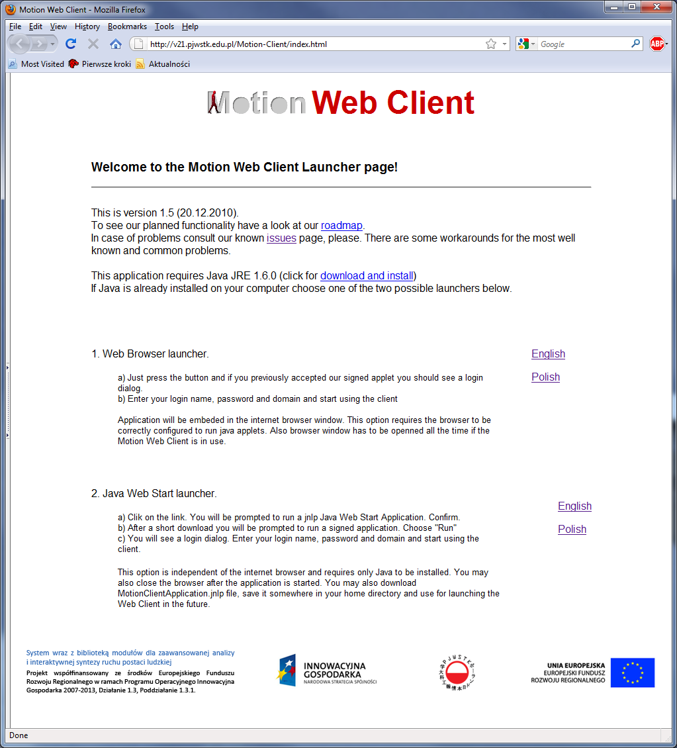

On the home page, we have two options to launch the client:

* as an applet from a browser window – in this mode we can choose the language version of the user interface: Polish or English;
* as a Java Web Start application.

Due to the fact that the client performs privileged operations (single and group uploading of indicated files, authentication in access to the server), it has been digitally signed and the user must agree to run it:

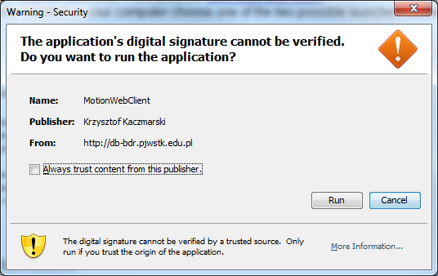

In addition to a web browser, it is necessary to install a Java virtual machine on the client's machine – in the form of the Java Runtime Environment SE 1.6.0 package or later.

In terms of communication capabilities, the machine on which the client is run must be allowed to operate in web client and FTPS mode.

The client start page allows you to run the client application as an applet embedded in a web page, or by using the Java Web Start engine.

Correct authentication is required for the client to work properly. Because the client supports platforms other than Windows, the user name and password must be entered explicitly when the applet starts.

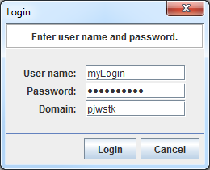

### Download the latest version

At the implementation stage, the client's functionality may be subject to frequent updates. Therefore, make sure that you have an up-to-date version of the applet published on the server, and not an earlier, locally cached version. Flush the cache of Java applications can be done as follows (screen images from Windows 7 are shown; in Windows XP the Java configuration dialog should be looked for in Control Panel -> Other control panel options).

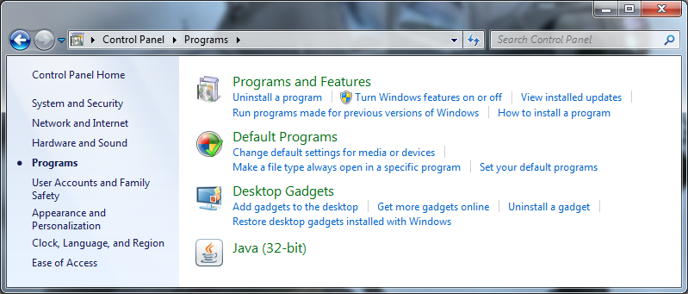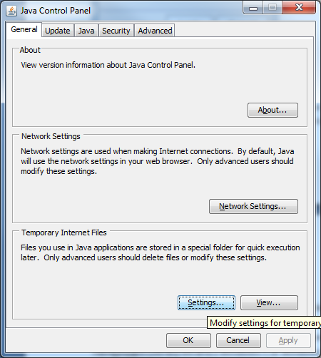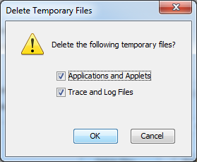

## Browse resources

The interfaces for editing and viewing data assume working on the hierarchy of the [1] Session > Trial > Measurement entity[2]. In addition, the motion data structure consists of the following entities: Measurement Configuration, Session Group (simple because it has only a name), Performer and Performer Configuration. These 4 consecutive entities no longer form a simple hierarchy. The links between them, together with the number of these connections, are illustrated in the diagram below from the technical documentation.



Circles are used to denote entities that can act as "vertices" – i.e. starting points for navigation "inside" the structure. Octagon (Session) – an entity from which we may also start navigation (e.g. by pre-selecting after an attribute). The rest of the entities are marked with a square. The names of the operations that enable navigation are not important from this point of view (they belong rather to the technical documentation).

Note – due to implementation priorities (no use of this part of the schema with the current data collection convention), the Measurement entity support remains available in a rudimentary form for the time being. It is only possible to view the measurements associated with a given observation (trial).

Each uploaded file must be assigned to the parent entity, and this role can currently be performed by only 3 entities: Measurement Configuration, Session and Trial. Therefore, if you want to include more precise information in the database – e.g. that a given file is a video image from the front camera as part of a video measurement, you should upload this file as subject to the appropriate Trial, and in a later step – assign it to the appropriate attribute of this Measurement.

For those entities that are marked with the letter A in the figure above, they can be defined and collected into thematic groups, generic attributes. Once a generic attribute is defined, you can enter its value for each instance of the corresponding entity.

The functionality of defining new attributes and attribute groups is available to users with administrative privileges. The process of defining a new attribute is shown in the following illustrations.

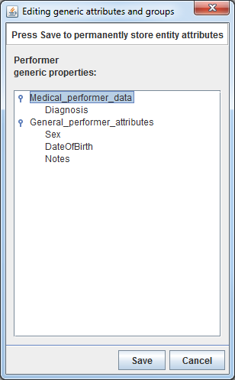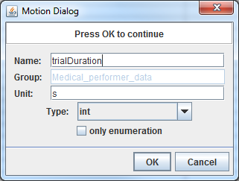

If you select enumeration-bound values for an attribute, a separate field is available to define them.

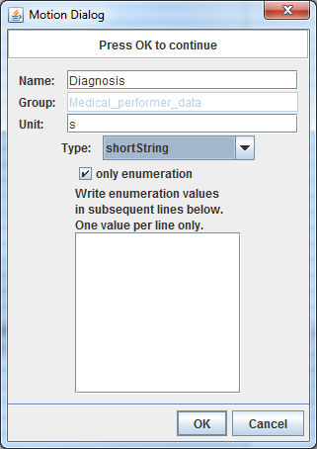

The actual saving of changes in the definitions of attributes and their groups will take place after they are confirmed with the OK button in the "Editing generic attributes and groups" dialog.

This functionality must be protected from wider access to prevent excessive heterogeneity of data input.

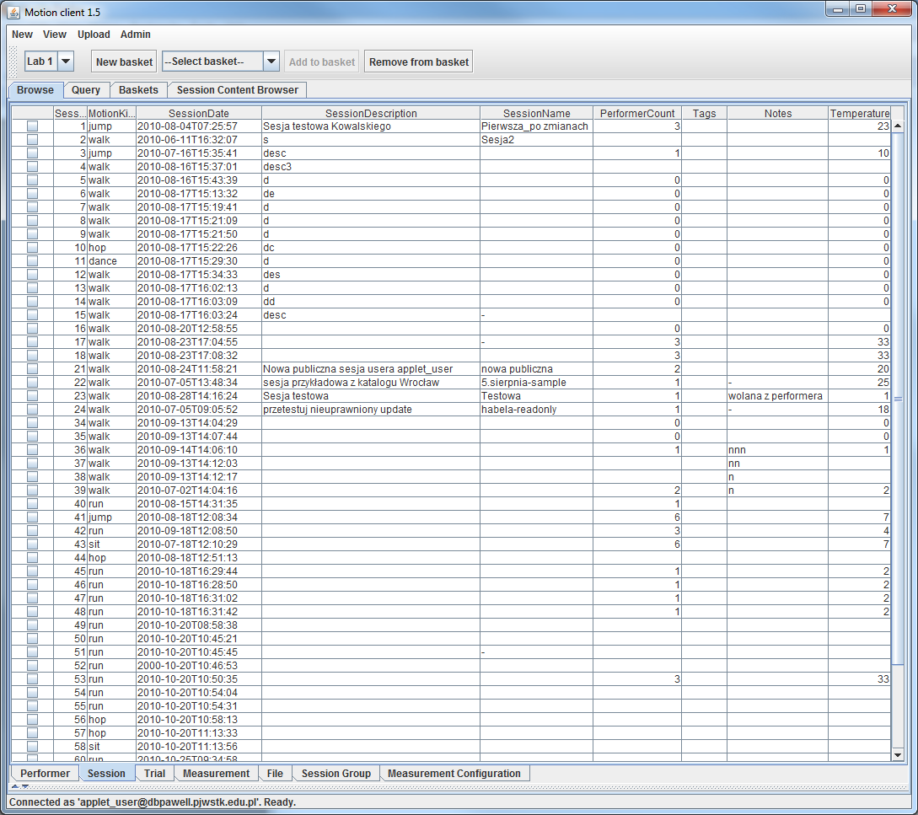

The central element of the user interface is the tabular view. It is designed to show summaries of selected data – if necessary, also in the form of a denormalized entity merge (e.g. Perforer + Session, or Performer + Session + Trial, or Session + Trial, etc.).

Potentially, this can lead to a large number of columns being displayed, hence the interface at the bottom of the window that allows you to adjust the set of displayed properties When you use the applet routinely, it can remain collapsed into a horizontal beam (as shown above). It can be expanded by clicking on the arrow symbols located at the left end of this bar, or by selecting View > View configuration from the top drop-down menu. The view of this view configuration is illustrated in the following image.

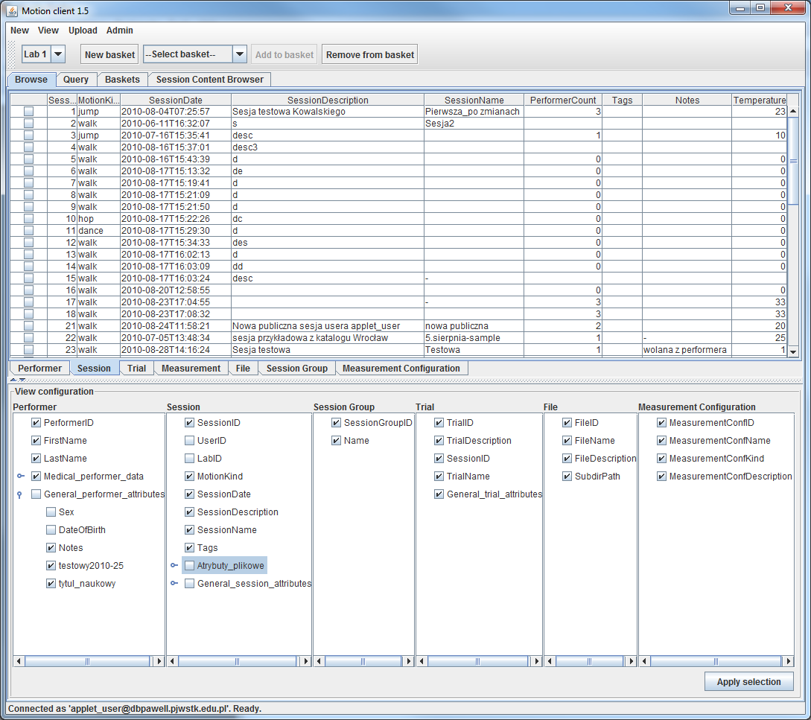

The basic search mechanism is to define filters – for the sake of simplification of expressions – divided into conditions related to the Performer, Session, Trial, etc.

A combo control at the top of the screen allows you to select which lab you want the displayed data to come from. It is a temporary mechanism to help you recover a complete set of Session entities from a given lab. The list of performers, on the other hand, is displayed globally.

Currently, the sample data contains only from Lab1, which corresponds to the name PJWSTK.

With a list of data instances, we can use the context menu (right click) to navigate deeper into the entity hierarchy. For example, we can invoke the "View sessions" command by indicating the desired performer:

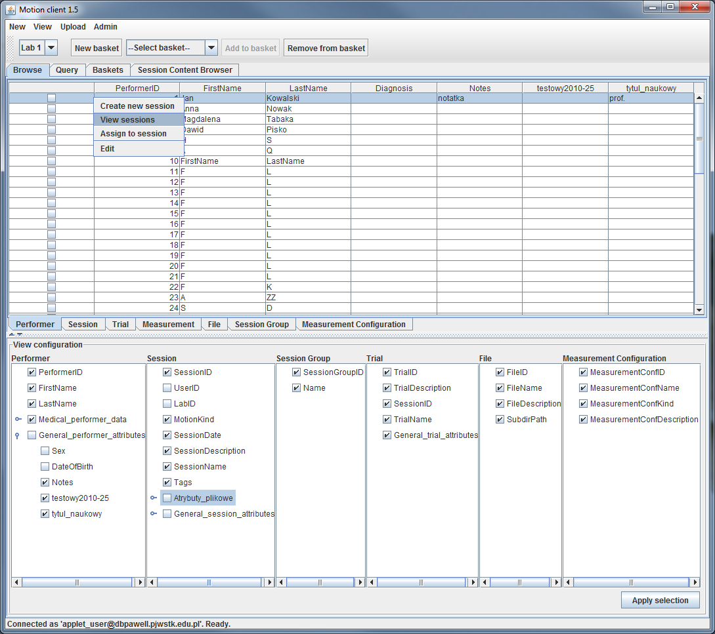

In this way, we can navigate through the entity hierarchy by navigating through the tabs visible at the bottom of the table view. Remember that the Session -> Trial-> Measurement entities form a hierarchy, and files can be embedded at the Measurement Configuration, Session, and Trial levels. The content of the highest level of the *Performer tab*  and the next one, i.e. *Session*, is filled in automatically after logging in. The contents of the tabs related to levels lower than session and performer are initially empty. They can be filled in, as explained above, by selecting a selected instance (e.g. session or performer) and selecting a command from the context menu to display the associated child elements. These tabs will contain the found instances until you select others. However, the information about the parent entity from which the searched instances come is not currently explicitly provided in the status field.

To improve navigation to child elements or to the default many-to-many related elements, you can use a double-click of the mouse instead of the context menu. Currently, this functionality applies to the following transitions:

* Performer > Session
* Session > Observation
* Observation > Measurement
* Session Group > Session
* ...

Then, when you want to view all the *Performer* or *Session* entities again, you can use *the All performers* and *All sessions commands* from the View drop-down menu, respectively.

## Filter-based search

The interface for defining filters is similar in design to the one known from the Gaitabase system, but it provides for several significant improvements.

You can define filters in separate tree lists for each entity. If it happens that the query will be run with active filters for more than one entity (e.g. filtering by Performer and Session properties), then the logical product (AND) of the indicated filter trees will be taken as the resulting condition.

In the current version, such a combination of conditions is not available, because each of the filter views (Performer, Session, Trial) has its own separate Start button, so only the conditions contained in it will be taken into account. Ultimately, it is planned to enable the combined use of filters for different entities, as well as to add filters for the other terms introduced to the schema: Session Group, Performer Configuration, Measurement Configuration and Measurement.

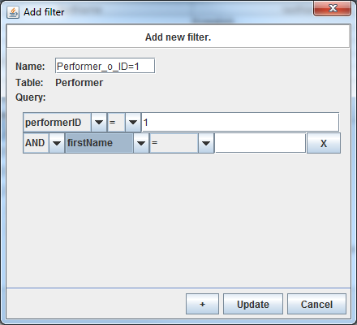

In the window of adding/editing a filter, the user can use the names of attributes (both static and generic) related to a given entity, and formulate conditions based on them, including comparison operators and compared values. When more than one condition is defined within a single filter, it is necessary to specify which logical operators are used to compose these conditions.

On the other hand, in order to maintain the clarity of the interface for defining a single filter, the possibility of "bracketing" inside the filter has not been introduced - i.e. within a single filter it is impossible to formulate a condition:   
 (condition1 OR condition2) AND condition3 .

In order to achieve such an effect, you need to create subsequent filters so that the set of conditions that you want to include in parentheses is located independently in its own filter. For example, for the above-mentioned expression, it would be necessary to create two filters related to each other in the manner shown below (descendant-ancestor relation) or vice versa.

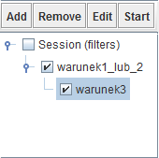

As in Gaitabase, the branches of the filter tree are a metaphor for pipes (or wires), in the sense of visualizing the OR operator as a sibling relationship in the filter tree, and the AND condition as an ancestor-descendant relationship in the filter tree.

## Update Commands

The anticipated process of uploading a single session with motion data to the database can be described as consisting of two phases: data entry and ordering and annotation. The first one contains the following steps:

1. Create a new session and provide the base values for the attributes that describe it
2. Checking the current list of performers entered into the database
3. If necessary, create one or more new performers
4. In dialogue with the details of the session – assigning the performers participating in it to it[3]
5. Creation of one or more trials
6. Uploading a set of files belonging to the current session as a whole
7. Uploading sets of files belonging to individual trials

The functionality mentioned below (grayed out) is not yet available in this release.

The second phase can be postponed. It potentially includes:

1. Creation of subordinate Measurements within individual Trials (with simultaneous indication of the Measurement Configurations describing them)
2. Supplementing the values of attributes describing: Sessions, Trials, Measurements – with a possible indication that, for example, a video file uploaded as subject to a given trial is, more precisely, the value of the "front image" attribute belonging to a given Measurement.

The Performer entity is not strictly subject to any parent element (unlike, for example, the Observer, which requires it to be associated with exactly one session), so its instances can be created without the requirement to declare a context.

After selecting the "New performer" command from the drop-down menu, you can enter attribute values for the newly created instance, including the generic attribute values that will be assigned to it immediately after the instance is created.

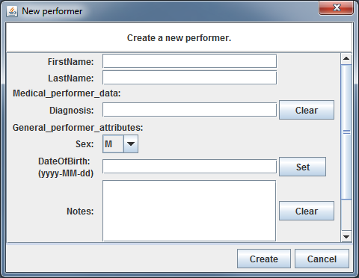

The actual content of the form may vary depending on the generic attributes that are currently defined.

The rest of the data creation commands can be based on the parent element in the entity hierarchy. For example, when creating a new Session, we can use the context menu command after selecting the appropriate performer.

The session creation dialog is structured in the following way:

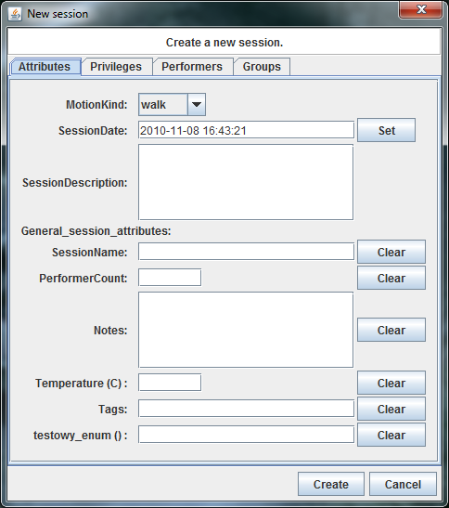

In addition, you can specify whether you want to allow public access (and to what extent) to the session you are creating. This is done by using the options available in the second tab of the dialogue, entitled Privileges.

Pressing the Clear button actually removes the attribute from the database.

The Set button for date or dateTime fields supports entering values with a calendar control.

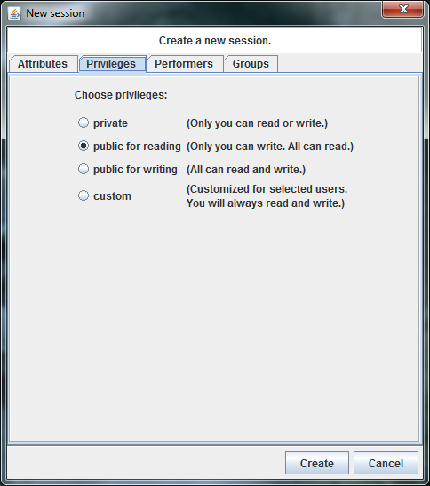

In addition, in the session dialogue, one or more performers who are taking part in the session can be listed:

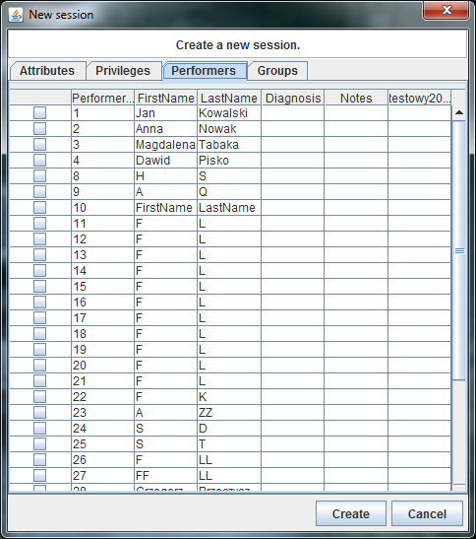

Finally, you can assign the created session to any number of predefined Session Groups:

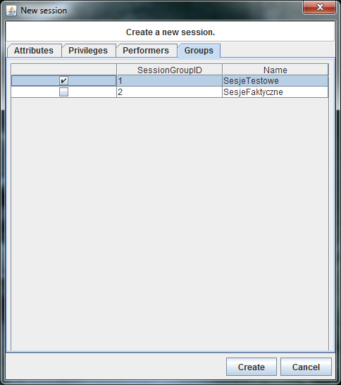

In the next step, we can create one or more Trials that are part of the newly created session:

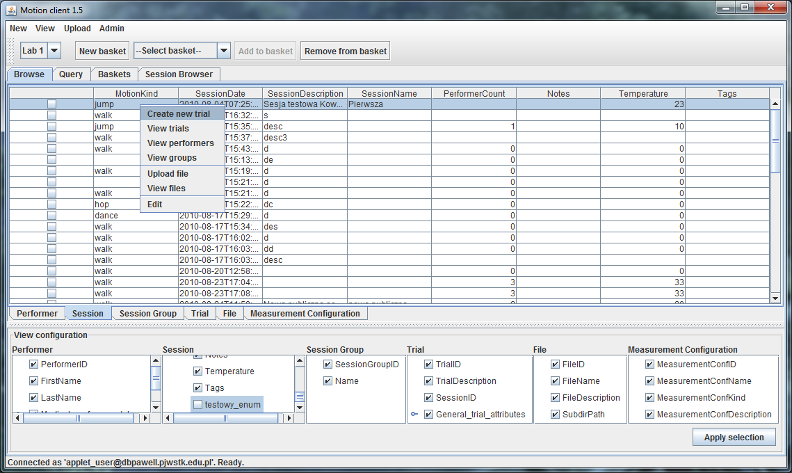

The dialog will contain a few static attribute fields (as shown in the image below) and, depending on the definitions created in the database instance, fields representing generic attribute values.

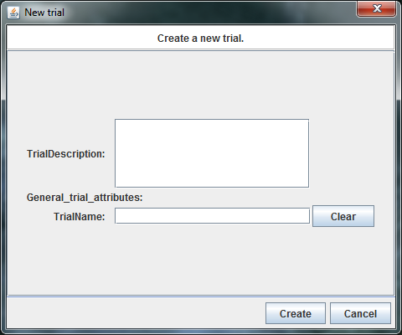

**Through identically constructed dialogs, it is also possible to update resources previously entered into the database by invoking the "Edit" command for it from the context menu.**

A similar dialog allows you to define new types of measurement configurations that will be indicated when creating a measurement instance (Measurement).

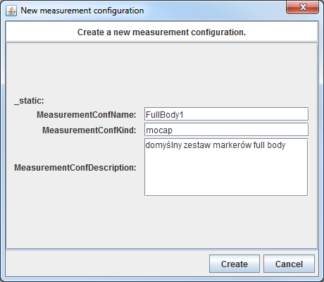

Ultimately, the MeasurementConfKind field will take the form of a combo list – because the set of measurement types is relatively unchangeable and will probably include 4 values: video, mocap, sEMG and GRF.

The dialogs for creating Measurement entity instances are not yet available.

## Uploading files

Like the update commands, the functionality of uploading files is made available through the context menu.

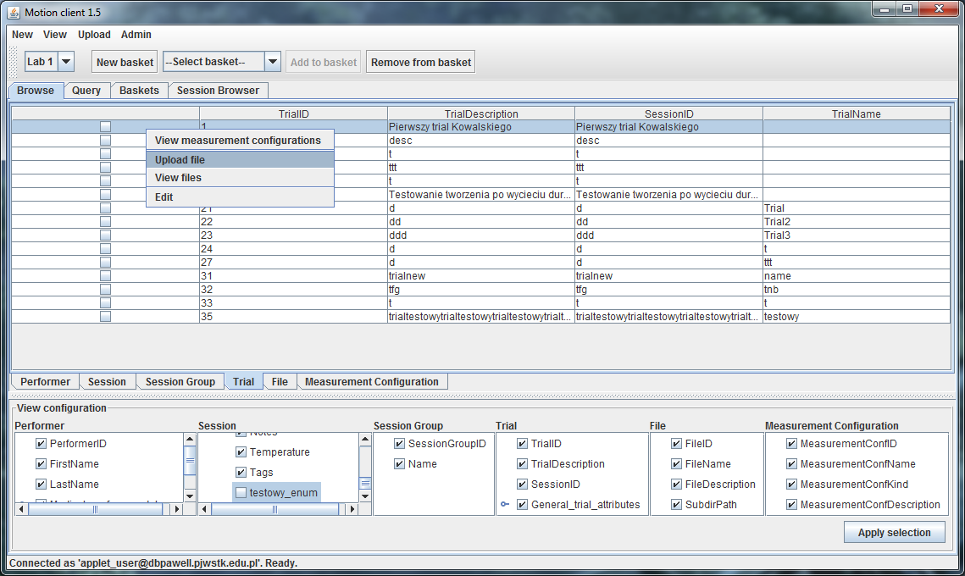

You need to specify the entity instance to which you want the file to be associated, and then you need to specify the location of the file on your local disk.

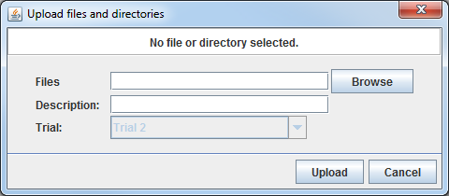

The option to select a directory above allows you to upload multiple files with a single command. This can be done in two ways. Or, instead of pointing to a single file in the view of browsing disk directories, we will highlight the selected files, or we will indicate in this dialog, instead of a file, the subdirectory whose full content is to be uploaded. In the latter case, the system will register the name of the subdirectory for future retrieval and allow you to recreate it.

A dialog box will inform you about the progress of the upload.

Remark! If you enter multiple files with a single command, the progress bar will be updated only twice when you have finished uploading individual files, i.e. when uploading 2 files.

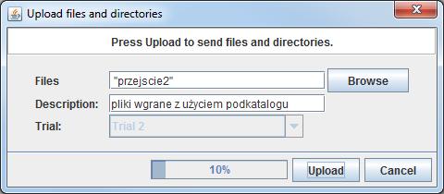

## Downloading files

Downloading files is carried out, in the same way as uploading them, through the options in the context menu for the indicated instance.

Selecting *View files* will display a tabular list of files in the *File tab*.

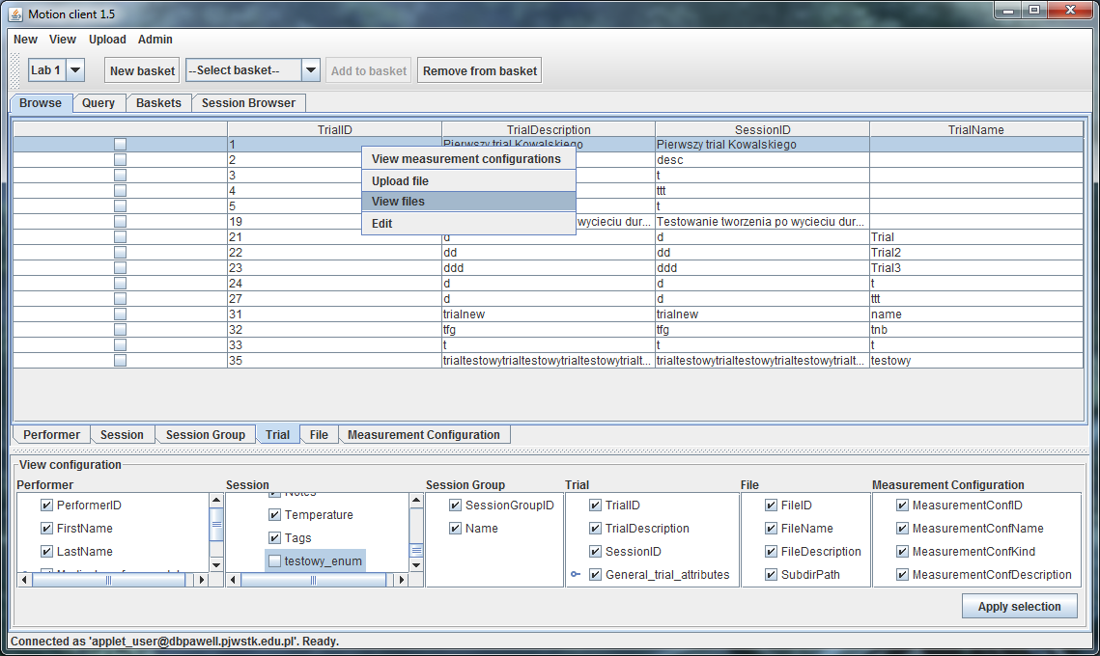

On the list displayed in this way, it is possible to execute, by means of a command from the context menu, orders to download files from the database: *Download selected.* Remark! After introducing the possibility of batch downloading, the interface requires checking the checkbox of downloaded files (even if you download only one).

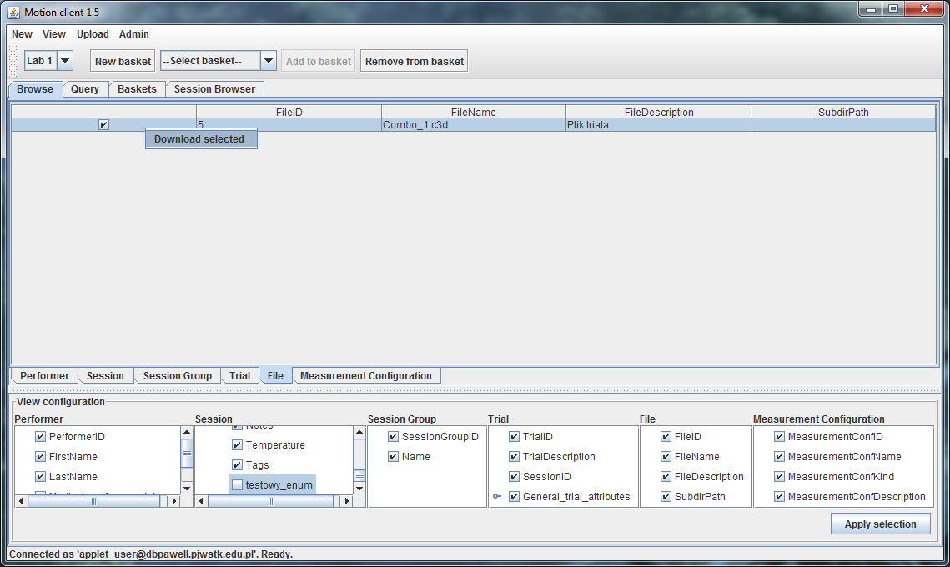

This functionality allows you to specify the target location of the downloaded file:

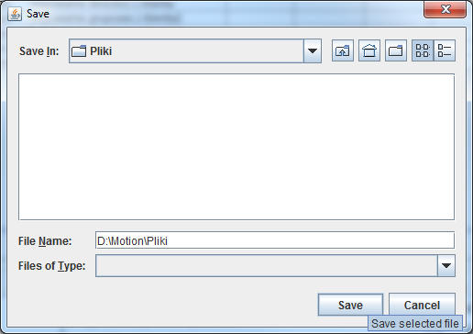

and then approve the download decision. The "Recreate original directory" option is used to recreate the name of the subdirectory, which could optionally be saved along with the file name.

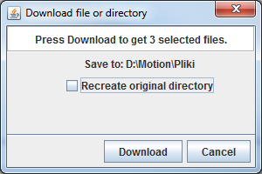

The next dialog view will inform you of the progress of the download.

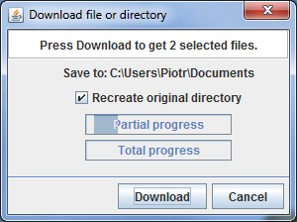

## Default Session Content Entry Wizard

For the default (currently considered standard for our lab) session structure and naming, you can use the Quick Session Creation Wizard. It is used to upload a set of files for a single session and all its observations (trials) along with the simultaneous automatic creation of appropriate instances of the Session and Trial entities.

A set of files and how they are named must meet the following conditions:

* Session name in the form YYYY-MM-DD-PXX-SXX, where the prefix YYYY-MM-DD is the numerical date of recording the session (four-digit year, one-digit month numbers and days preceded by zero), PXX is the letter P (from – "Project") and the next two characters are the number of such a project (single-digit numbers are preceded by a zero); numbering started with 01. A similar numbering convention applies to the SXX element, where the letter S is followed by successive numbers of the session registered as part of a given project; numbering starting with 01. The combination of session number and project number uniquely identifies the session in the database. This means that the date that starts the name has only an informative function.
* The name of the observations in the form nazwa_sesji-TXX, where TXX is the letter T and a two-digit (preceded by zero for the first 9) number of observations within a given session, starting with 01.
* The session name recovered from the names of the uploaded files must not coincide with the name of any session already stored in the database.
* The YYYY-MM-DD prefix must represent a valid date (it will be converted to a *date* attribute).
* The uploaded fileset must contain exactly one session data file as a whole, named *nazwa_sesji*.zip and between 1 and 20 sets of Observation files (see below).
* The set of observation files must consist of exactly 5 files, with the following names:
  + nazwa_obserwacji.c3d
  + *nazwa_obserwacji*.*identyfikator_kamery1.*avi
  + *nazwa_obserwacji*.*identyfikator_kamery2.*avi
  + *nazwa_obserwacji*.*identyfikator_kamery3.*avi
  + *nazwa_obserwacji*.*identyfikator_kamery4.*avi

After preparing appropriately named files, we can call the wizard from the drop-down menu via the New > Session wizard option.

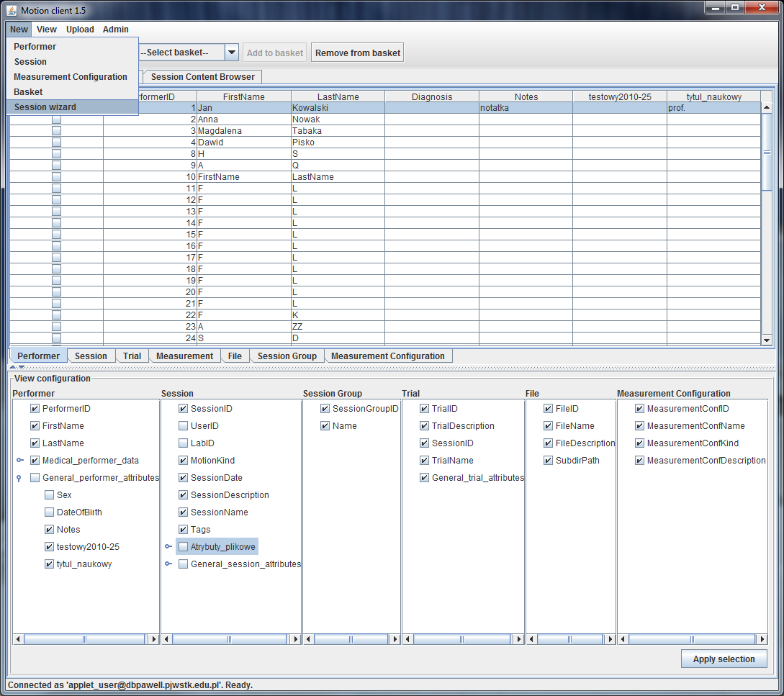

In the first step of the wizard's work, you need to indicate a subdirectory containing (only) the full set of files to be uploaded.

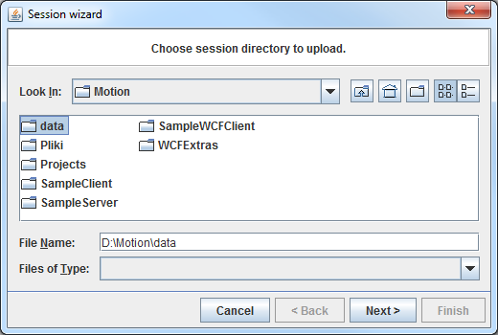

If the set of files passes the validation, a window with the designed session structure will appear, allowing the operator to verify whether the structure and naming of the session have been correctly recognized based on the indicated set of files. At this stage, the dialog does not allow you to fill in this data – it only allows you to check the automatically recovered attribute values.

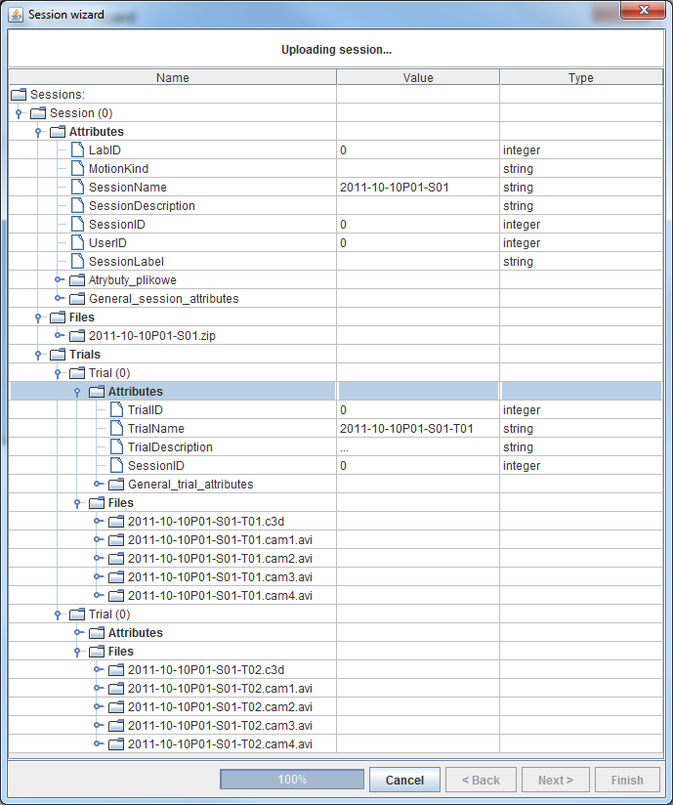

The illustration above already shows the state of the dialog after confirming the structure with the "Finish" button. A progress bar illustrates the progress of uploading files. Once the files are collected on the server side, a session will be created, a corresponding number of observations will be created, and the appropriate files will be assigned to them.

If, on the other hand, after pointing to a set of files, it turns out that the session name resulting from their naming is taken, we will get a message similar to the one shown below.

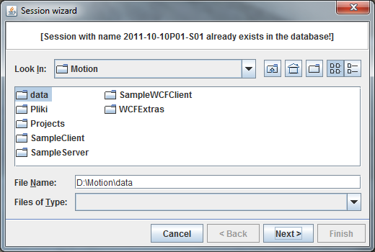

Other critical errors signaled by the file list validator will be communicated in a similar way.

In the case of successful uploading of files and setting up a session, it will be possible to edit the newly created instances, and in particular – to fill in the Session attributes.

## Creating and using shopping carts

The user can create any number of *shopping carts* , which are an individual mechanism for marking and grouping the resources of interest. The term refers to a shopping cart in an online store. The resources collected in the basket do not have to be uniform in relation to any of the criteria – they are selected by the user manually, not through a query. The named shopping cart, as well as its contents, belong to the functionality of the so-called User's Private Area and are stored on the server, which makes it possible to access them when logging in again – even from another machine.

Before using the shopping carts functionality for the first time, the user must define at least one shopping cart and give it a name:

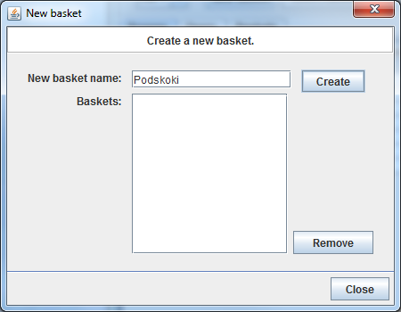

The dialog box also allows you to delete shopping carts.

Then, when in the main window of the application we select the resources we are interested in in the table view (checkbox) and select the basket in the combo list at the top of the window, the "Add to basket" command (button at the top of the screen) becomes available.

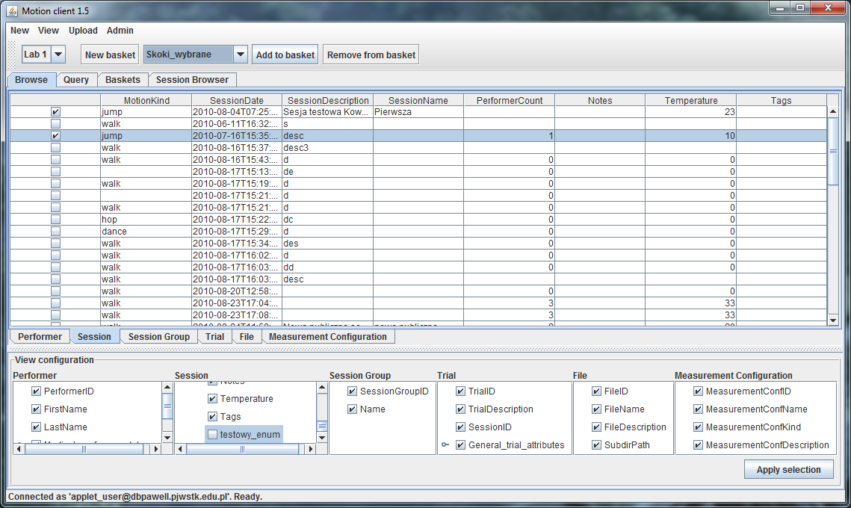

The user can then explore their baskets and the resources they contain using the tree view in the "Baskets" tab.

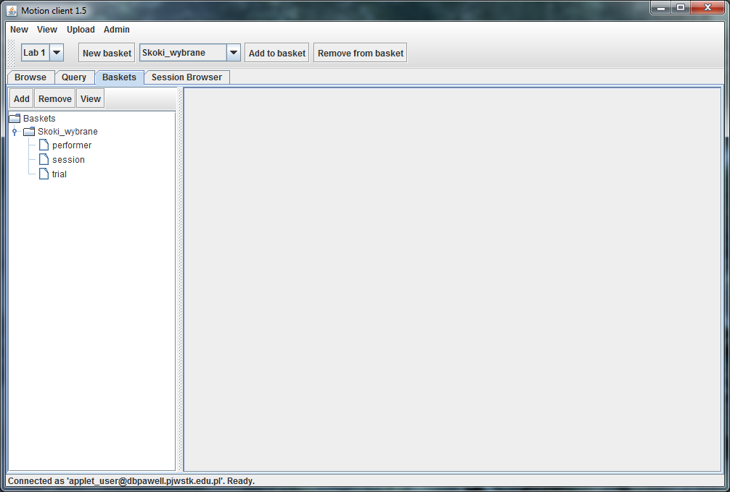

The resources in each basket are divided by their type. To display resources in a tabular view, select the appropriate tree node and select the "View" command above:

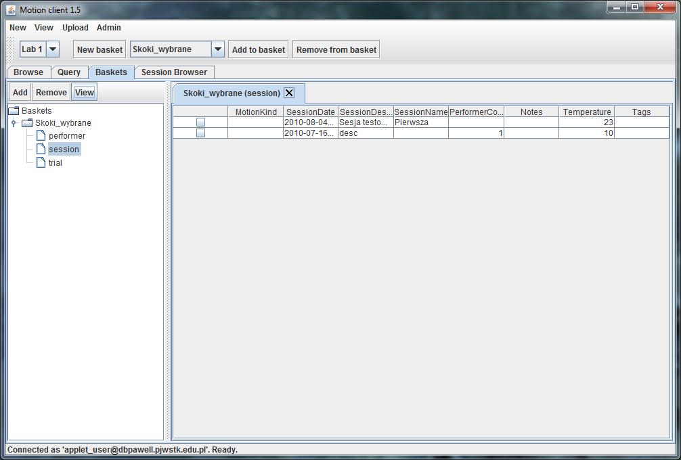

In this view, you can also remove resources from the basket – to do this, select the checkbox in the appropriate row and select the "Remove from basket" command at the top of the screen.

Remark! The "Remove" command available in the tree view of the baskets will delete the entire highlighted cart. In the current version, it is not possible to explore the data collected in the basket (e.g. by issuing a command to display all sessions of a given performer) known from the basic tabular view in the Browse tab. A similar limitation applies to query result views in the "Query" tab.

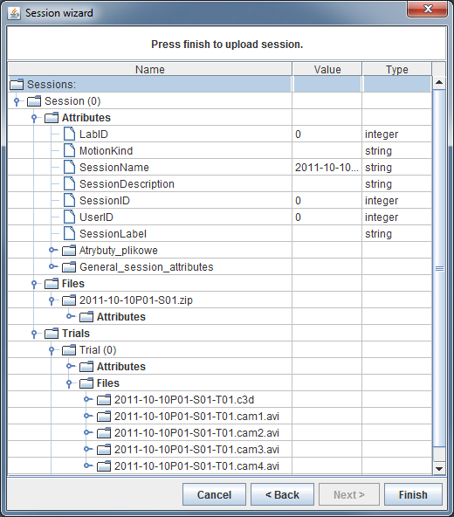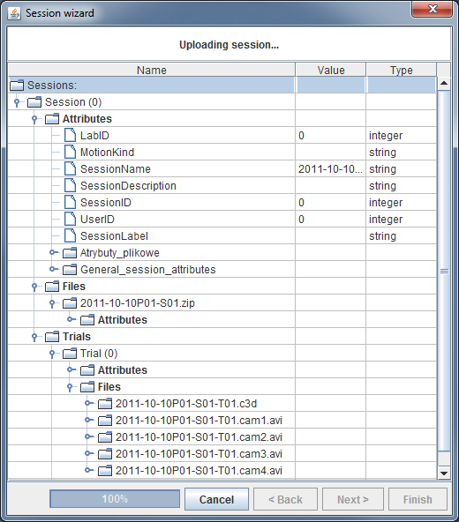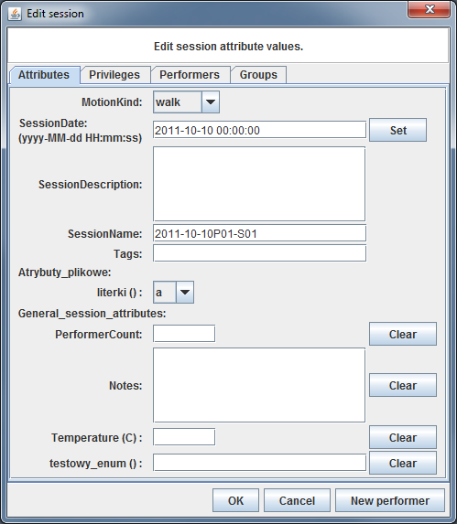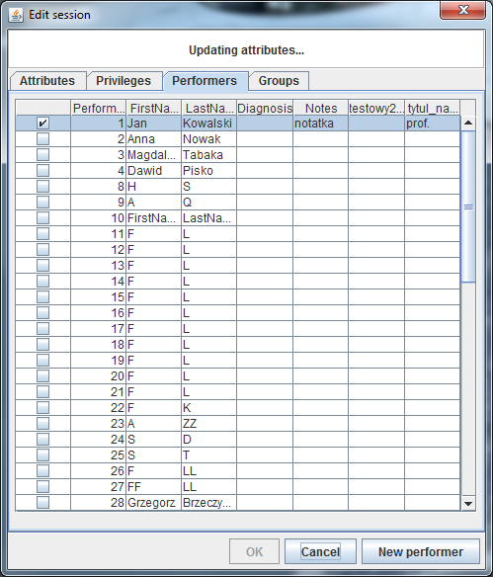

1. We use English-language names here – such as those used in service interfaces. Hence the slight linguistic awkwardness in the description below.
2. Measurement tab support – in preparation
3. If you still don't have a performer you want to assign to the session, you can also use the "New performer" button inside the session edit dialog.