Instructions for Deploying the Motion Database Client (BDR Client)

**Changelog:**

|  |  |  |
| --- | --- | --- |
| ***Date*** | ***Author*** | ***Description*** |
| 2011-05-06 | KK | Creating the first version of the document |

# Prerequisites

1. A client can be deployed on a server that meets the following requirements:
   1. It must be running the Motion Database Server component
   2. it must run an FTPS server with the ability to connect a client named *testUser* with the password *testUser*, which will be used to upload temporary files to the server
   3. there must be an authorization mechanism in the NTLM scheme that is currently used by the client
2. The person performing the deployment must have access to the SVN repository containing the two projects that make up the client component: *DatabaseConnection* and *Motion_1.*
3. The person carrying out the implementation must have Eclipse version 3.5 at least with the FatJar plugin installed (downloadable using the Eclipse plugin manager from: <http://kurucz-grafika.de/fatjar>) and ant (included in Eclipse as standard).
4. To sign a jar file, you need a *keystore* file with the key used for encryption, stored in the root directory of the Motion_1 project. This file is not available in the svn repository for security reasons.

# Preparatory

In the following, we assume that the deployment takes place on a production server v21.pjwstk.edu.pl the test server is dbpawell.pjwstk.edu.pl. Currently, the connection to the production server can be established directly, while the connection to the test server can only be established via VPN. This document does not describe how to set up a VPN and assumes that the person performing the deployment has the VPN gateway open. Please note that currently the svn repository with the source code is outside the PJWSTK domain, which may require you to disconnect the VPN before downloading projects from the repository.

1. Download the latest version of the code from the svn repository. In a typical case, it is done through appropriate Eclipsa procedures. After this step, the user should see two projects: DatabaseConnection and Motion_1:

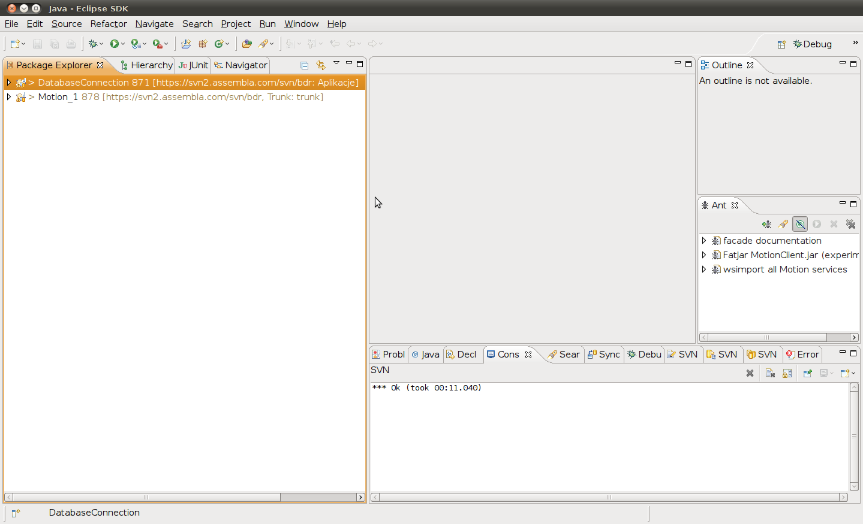

1. Connecting the Web Service client to the deployment (production) server
   1. We open the DatabaseConnection project.

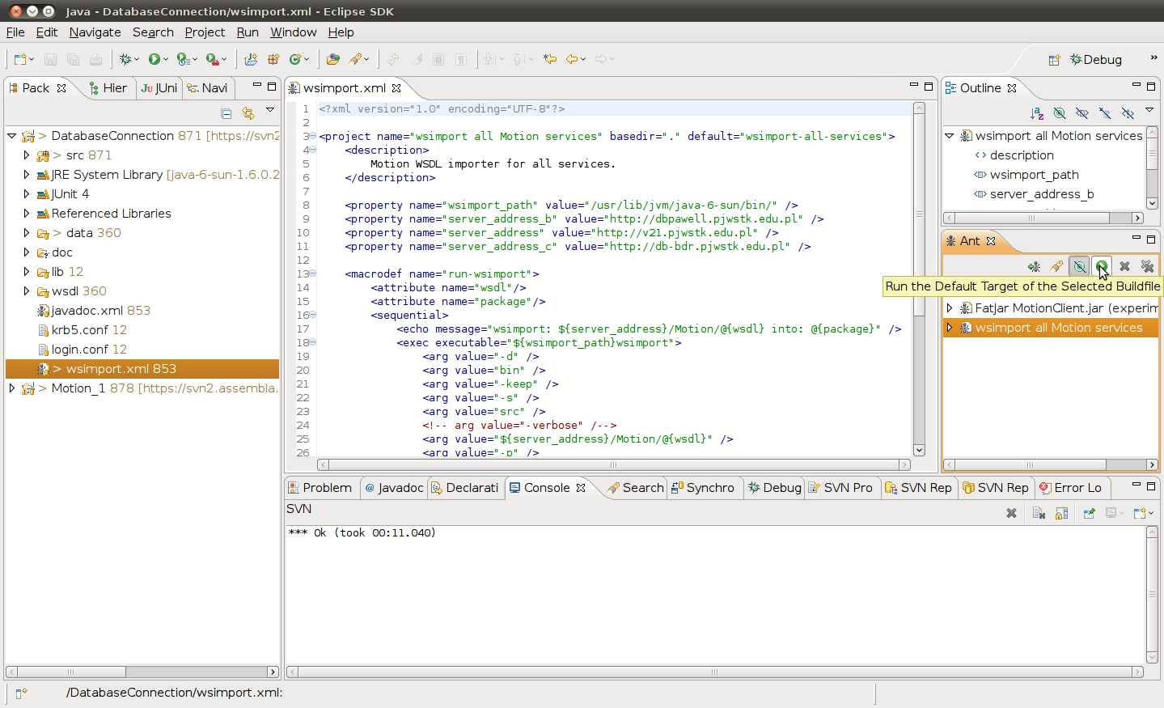

* 1. Specify the address of the deployment server in the wsimport.xml file: on lines 9, 10 or 11, set the server_address ownership to point to the target server. The remaining values (*server_address_b* and *server_address_c*) have only a supporting role for the user and are not taken into account during the WS stump import procedure. In the figure, the server address is set to the production server.
  2. We set the path to the wsimport tool in the *wsimport_path property*. In a typical configuration, it is included in the JVM distribution. On the screen above, it is located in */usr/lib/jvm/java-6-sun/bin.*
  3. After saving the changes to the wsimport.xml file, you need to run the import procedure as an ant script. To do this, drag the wsimport.xml file from the project view to the Ant view and press the Run button on it.Once the procedure is complete, the message "Build successful" should appear on the console

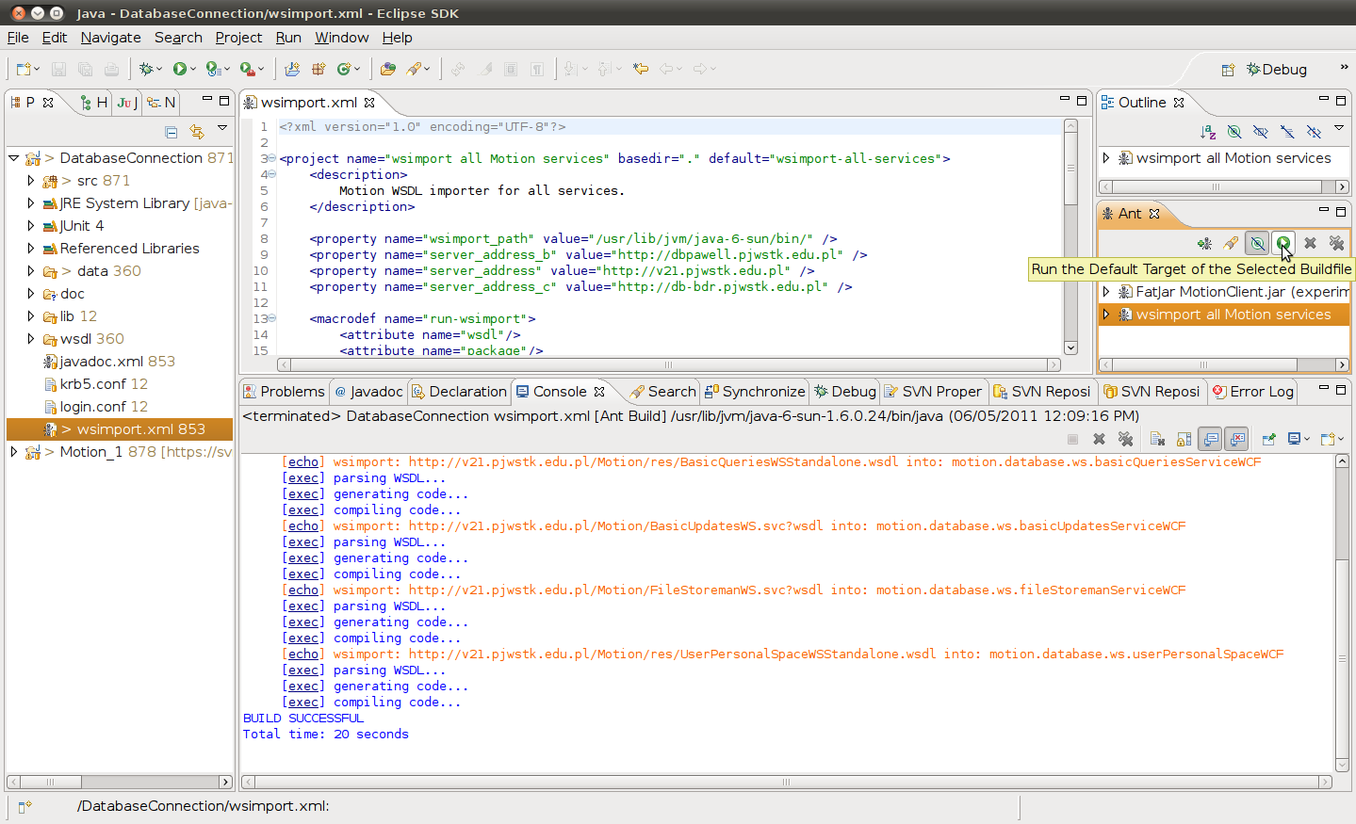

1. Determine the version of a given release.
   1. In the DatabaseConnection project, we find the files src/motion/messages.properties and src/motion/messages-latin1.properties, and in them the properties:

MotionApplet.AppletName=Motion client 1.6  
MotionApplet.AppletName_PL=Motion 1.6

* 1. Enter the appropriate values (1.6 for example) of the version and save the changes.
  2. The messages-latin1.properties file (encoded in latin 1) can also be created automatically from the messages.properties file (encoded in utf-8) by running the command:   
     native2ascii -encoding UTF8 messages.properties messages-latin1.properties  
     The native2ascii program is part of the JDK distribution.

1. Connect the applet to the appropriate server.
   1. Let's move on to the Motion_1 project.
   2. Open the file src/motion/applet/dialogs/LoginDialog.java and in lines 110 – 114 set the initial content of the dialog box for user authentication. In the case of a production server, it is only desirable to fill in the field with the domain to "PJWSK" by default. The rest of the fields should be blank.
   3. We set the address of the target server FTPS user and passwords in lines 150-151 of the same file. All you have to do is comment and uncomment the relevant lines.
   4. We save changes
2. Preparation of the content of the website, i.e. HTML files presented to the user.
   1. In the Motion_1 project, in the html directory there are files that make up the web pages presented by the server to the user. Prepare the contents of the index.html (issue number) and roadmap.html (with the schedule of further releases and current changes) accordingly.
   2. In addition, you can modify the issues.html file.
3. Once you have completed the above steps, your application is ready to be deployed.

# Moving the application to the server

1. Preparing the distribution in the form of a jar file.
   1. Let's move on to the Motion_1 project.
   2. We run the ant deploy.xml script. As before, wsimport.xml.
   3. After a few seconds, you should see the message "Build successful"
   4. The ready-to-deploy application is located in the deploy directory in the Motion_1 project. You need to upload the entire contents of this directory to the appropriate directory on the server.
2. Uploading the client application to the production server.
   1. We open a connection to the v21.pjwstk.edu.pl server
   2. The files in the deploy directory should be located in the C:\Inetpub\wwwroot\Motion-Client directory on the server.
   3. For security reasons, the previous contents of the deploy directory can be moved to a subdirectory with the same name as the previous version of the application (e.g. 1.52)
3. Checking the installation.
   1. From the moment the files are placed, the client application is available to the public. You can check the correctness of the installation by going to the website:http://v21.pjwstk.edu.pl/Motion-Client/index.html  
      The previous version can be run from the subdirectory address – e.g http://v21.pjwstk.edu.pl/Motion-Client/1.52/index.html
   2. On the home page, you should see the current date and version number of the client.

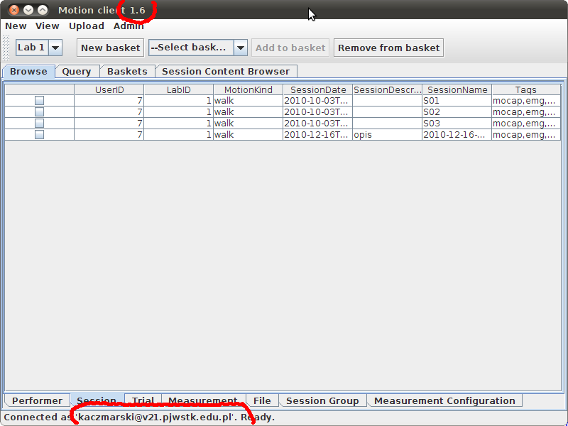

* 1. When the client starts, you should be able to see the current version number in the title of the window.
  2. At the same time, the server to which the client is connected should be visible in the status at the bottom of the client application window. It should always be the same server from which the applet was launched.
  3. Occasionally, you may find that your client computer stores a previous version of the client applet locally. In this case, you need to clear the cache of the local Java virtual machine via the Java Control Panel:
     1. Select the General tab
     2. Press the Settings button in the "Temporary Internet Files" panel
     3. Press the "Delete Files" button and confirm the deletion of local applications and applets.

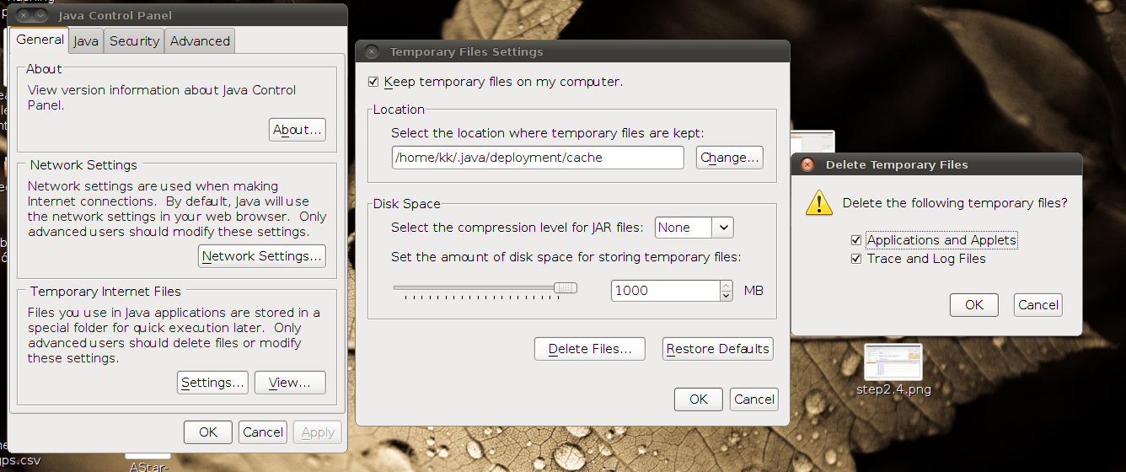

# Concluding Remarks

After deployment, the client's application can be committed to the repository in its current form in order to remember a specific production version. However, you should immediately switch the application to the test server and recommit it so that the version available to developers in the repository during test runs is not dangerous to the data on the production server.

The version that the developers are working on should always be configured to connect to the test server!