QUESTION:
Given an array of positive integers. All numbers occur even number of times except one number which occurs odd number of times. Find the number in O(n) time & constant
space

EX:NO 1.1 (A) | FIND The Odd Number Count
DATE: | FIND The Odd Number Count

Aim:TO write a c programm to find FIND The Odd Number Count
DATA STRUCTURES :ARRAY

PSEUDOCODE:
//Input:arrray
//output:integer

Begin
Declare all variable
Get n
for i <- 0 to i <n
Get n
for i <- 0 to i <n
hash[a[i]%10]+=1
for i <- 0 to i <n
if(hash[i]>max)
max=hash[i]
displax max
END

SOURCE CODE

#include<stdio.h>
main()
{
int temp;
int i,j,n,a[10],hash[111];
printf("Enter the n\n");
scanf("%d",&n);
printf("Enter the n element one by one\n");
for(i=0;i<n;i++)
{
scanf("%d",&a[i]);
hash[i]=0;
}
for(i=0;i<n;i++)
{
hash[a[i]%10]+=1;
}
int max=hash[0];
for(i=0;i<n;i++)
{
if (hash[i]>max)
max=hash[i];
}
if(max%2!=0)
printf("\n%d",max);
else
printf("\nYou Enter the input is not contains any odd count\n");
}

OUTPUT:

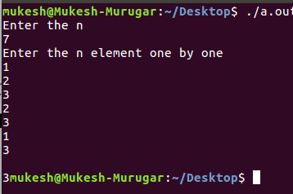

RESULT:
HENCE ABOVE PROGRAMM EXECUTE SUCCESSFULLY

Question:
Rupam and Ankit are both fond of collecting stones. They both follow this hobby diligently and go out finding stones together. So, one fine day they decided to play a small game.They decided to weigh each of the stones and note them down in a notepad, and then at the end of the day both of them will compare their notes. They will check how many stones of a particular weight are there. Then they will compare the weight of the stone occurring maximum number of times (you can consider stones of similar weight to be similar). In case that all different stones occur exactly same number of times, the stone with maximum weight will be considered for comparison. The person with higher
weighing stone wins; else there will be a tie. You need to determine the result.

EX:NO 1.1 (B) | To Find and display max stone weight
DATE: | To Find and display max stone weight

AIM:TO write the c programm To Find and display max stone weight
DATA STRUCTRES: ARRAY

PSEUDOCODE:
//Input:Array
//Output:String
Begin
Declare all the variable
Get n
for i <- 0 to i <n
get a[i]
get b[i]
set hash[i]=0
set hash1[i]=0
for i <- 0 to i <n
hash[a[i]%10]+=1
hash1[b[i]%10]+=1
max1=has[0]
max2=[hash1[0]
for i <- 0 to i <n
find max1*i,max2*i
if max1>max2
display rupan
else if max1<max2
dispaly ankit
else
display Tie

SOURCE CODE:

#include<stdio.h>
main()
{
int max1,max2,n,i;
int a[10],b[10],hash[100],hash1[100];
printf("Enter the n\n");
scanf("%d",&n);
printf("Enter rupan stone weight");
for(i=1;i<=n;i++)
scanf("%d",&a[i]);
printf("Enter ankit stone weight");
for(i=1;i<=n;i++)
scanf("%d",&b[i]);

for(i=1;i<=n;i++)
{
hash[i]=0;
hash1[i]=0;
}
for(i=1;i<=n;i++)
{
hash[a[i]%10]+=1;
}
for(i=1;i<=n;i++)
{
hash1[b[i]%10]+=1;
}
max1=hash[1];
for(i=1;i<=n;i++)
{
if(hash[i]>max1)
max1=hash[i]*i;
}
max2=hash1[1];
for(i=1;i<=n;i++)
{
if(hash1[i]>max2)
max2=hash1[i]*i;
}
if(max1>max2)
printf("Rupan");
else if(max1<max2)
printf("Ankit");
else
printf("Tie");
}

OUTPUT:

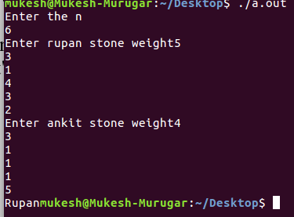

RESULT:
HENCE ABOVE PROGRAMM EXECUTE SUCCESSFULLY

Question:
Eragon is a dragon that is visiting the town of Osaka. There are 'n' towers of various
heights in the city, and tower 'i' has height of height i . Because the taller towers tower
over the shorter ones, Eragon can only blow out the tallest towers. For example assume
there are four towers of heights 3, 5, 4 and 5. Then Eragon can blow out 2 towers as there
are two towers of maximum height 5. Given the height height i for each individual tower,
find and print the number of towers that Eragon can successfully blow out.
INPUT:
The first line contains a single integer, n, denoting the number of towers in the city.
The second line contains n space-separated integers, where each integer i describes the
height of tower i .

EX:NO 1.2 (A) | Print the number of towers Eragon blows out on a new line.
DATE: | Print the number of towers Eragon blows out on a new line.

AIM:TO Write a program to Print the number of towers Eragon blows out on a new line.
DATA STRUCTRES: ARRAY

PSEUDOCODE:
//Input:Array
//Output:Integer
Begin
Declare all the variable
Get n
for i<-0 to i<n
get a[i]
set hash[a[i]%10]+=1
for i<-0 to i<n
if(hash[i]>max)
max=hash[i]
Display max

SOURCE CODE:

#include<stdio.h>
main()
{
int temp;
int i,j,n,a[10],hash[111];
printf("Enter the n\n");
scanf("%d",&n);
printf("Enter the n element one by one\n");
for(i=0;i<n;i++)
{
scanf("%d",&a[i]);
hash[i]=0;
}
for(i=0;i<n;i++)
{
hash[a[i]%10]+=1;
}
int max=hash[0];
for(i=0;i<n;i++)
{
if (hash[i]>max)
max=hash[i];
}
printf("%d",max);
}

OUTPUT:

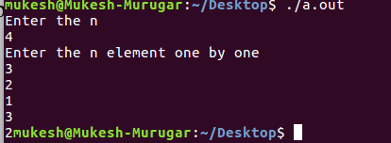

RESULT:
HENCE ABOVE PROGRAMM EXECUTE SUCCESSFULL
Question:
Given an array of n numbers. Give an algorithm for finding the first element in the array
which is repeated? Can we use sorting technique for solving this problem? Can we use
hashing technique? Justify the solution by writing the algorithm for each.

EX:NO 1.2 (B) | STACK IMPLEMENTATION USING CORRESPONDING E AND *
DATE: | STACK IMPLEMENTATION USING CORRESPONDING E AND *

AIM:TO write the c programm to to implement the stach basic operation by e and *
DATA STRUCTRES: Array

PSEUDOCODE:
//Input:Array
//output:integer
Begin
Declare required variable
Get n
for i <- 0 to i<-n
Get a[i]
set c=a[0]
for i <- 0 to i<-n
if(a[i]==c)
m++
Display m
END

SOURCE CODE:

#include<stdio.h>
main()
{
int temp;
int i,j,n,m=0;
printf("Enter the n\n");
scanf("%d",&n);
int a[n];
for(i=0;i<n;i++)
{
scanf("%d",&a[i]);
}
int c=a[0];
for(i=0;i<n;i++)
{
if(a[i]==c)
m++;
}
printf("%d Occurrs %d times",a[0],m);
}

OUTPUT:

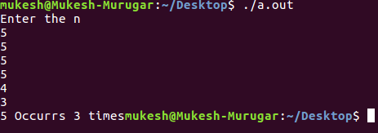

RESULT:
HENCE ABOVE PROGRAMM EXECUTE SUCCESSFULLY

