Final Project Report

Web Based Digital Certificate Authority System (WCAMAN)



Project Supervisor
DR. Arif Husen

Submitted By

F250281831

Moazam Samah Khan BC200408672

Software Projects & Research Section,
Department of Computer Sciences,
Virtual University of Pakistan


CERTIFICATE

This is to certify that Moazam Samah Khan (BC200408672) have worked on and completed their Software Project at Software & Research Projects Section, Department of Computer Sciences, Virtual University of Pakistan in partial fulfillment of the requirement for the degree of BS in Computer Sciences under my guidance and supervision.

In our opinion, it is satisfactory and up to the mark and therefore fulfills the requirements of BS in Computer Sciences.

Supervisor / Internal Examiner

DR. Arif Husen
Supervisor,
Software Projects & Research Section,
Department of Computer Sciences
Virtual University of Pakistan

___________________
(Signature)

External Examiner/Subject Specialist
Usman Waheed

___________________
(Signature)

Accepted By:

_____________
(For office use)

EXORDIUM

In the name of Allah, the Compassionate, the Merciful.

Praise be to Allah, Lord of Creation,
The Compassionate, the Merciful,
King of Judgment-day!

You alone we worship, and to You alone we pray for help,
Guide us to the straight path

The path of those who You have favored,

Not of those who have incurred Your wrath,
Nor of those who have gone astray.

DEDICATION

I dedicate this project to my beloved parents, whose endless love, prayers, and encouragement have been my guiding light throughout my academic journey. Their sacrifices and unwavering support have been the foundation of my success.
I also dedicate this work to my teachers and mentors, especially my project supervisor, Dr. Arif Husen, whose guidance, motivation, and valuable feedback inspired me to work with commitment and dedication.
Finally, I dedicate this report to my friends and classmates who have always encouraged me and shared knowledge and support during the course of this project.

ACKNOWLEDGEMENT

All praise to Almighty Allah, the Most Gracious and the Most Merciful, who bestowed upon us the courage, patience, and ability to complete this project successfully.
We would like to express our deepest gratitude to our parents for their unconditional love, prayers, and encouragement, which motivated us throughout our academic journey.
Our sincere thanks go to our respected supervisor, Dr. Arif Husen, for his invaluable guidance, continuous support, and constructive feedback during every stage of this project. His expertise and encouragement have been instrumental in shaping our work.
We are also thankful to our teachers at Virtual University of Pakistan for providing us with the knowledge and skills that made this project possible.
Lastly, we are grateful to our friends and classmates for their cooperation, motivation, and teamwork, which helped us overcome challenges and complete this project on time.

PREFACE

This report has been prepared as part of our Final Year Project at the Virtual University of Pakistan. The project, “Web-Based Digital Certificate Authority Management System”, was undertaken to fulfill the requirements of the CS619 course.
The purpose of this project is to design and develop a secure, scalable, and user-friendly platform for managing digital certificates. The system integrates with step-ca to handle certificate generation, issuance, renewal, and revocation, while also providing role-based access control for administrators, certificate managers, and regular users. This work not only allowed us to apply the theoretical knowledge we have acquired during our studies but also provided us with valuable hands-on experience in working with modern web technologies, database design, and security protocols.
This report presents a detailed account of the project, including the problem statement, objectives, methodology, implementation details, and results. It also highlights the challenges faced during the development and the strategies adopted to overcome them.
We sincerely hope that this report will serve as a useful reference for students, researchers, and professionals interested in the fields of Public Key Infrastructure (PKI), certificate management, and secure web application development.

TABLE OF CONTENTS

CHAPTER NO. 1
gathering & Analyzing info 10

1.1 Introduction

1.2 purpose

1.3 scope

1.4 definitions, acronyms and abbreviations

1.5 Project requirements

1.5.1 Functional Requirements

1.5.2 Non-Functional Requirements

1.6 use cases and usage scenarios

1.6.1 Use Case Diagrams

1.6.2 Usage Scenarios

1.7 Development Methodology

1.7.1 Chosen Methodology

1.7.2 Reasons for Chosen Methodology
1.7.2 Work Plan (Gantt Chart)
1.7.2 Project Schedule (Submission Calendar)

CHAPTER NO. 2
designing the project 19

2.1 Introduction

2.2 purpose

2.3 scope

2.4 definitions, acronyms and abbreviations

2.5 Architectural Representation (Architecture Diagram)

2.6 Dynamic Model: Sequence Diagrams

2.7 Object Model/Logical Model: Class Diagram

2.8 Database Model (Database Diagram)

2.9 Graphical User Interfaces

Chapter no.3
DEvelopment 28
3.1 Development plan (Architecture Diagram)

3.2 Development Tools & Technologies

3.3 Implementation Details

3.4 Deployment Environment

CHAPTER 1
Gathering & Analyzing Info

1.1 Introduction
In the modern digital world, security is a top priority for organizations and individuals. Digital certificates play a crucial role in ensuring secure communication, authentication, and data integrity. However, manual management of certificates is often prone to errors, misconfigurations, and risks of expiry or misuse.
This project, “Web-Based Digital Certificate Authority Management System”, provides a centralized solution for managing certificates. The system integrates with step-ca, a lightweight and secure Certificate Authority, to issue, renew, and revoke certificates. The solution also includes role-based access control to ensure that only authorized personnel can manage critical certificate operations.

1.2 Purpose
The purpose of this project is to:
- Provide a secure and user-friendly web portal for managing digital certificates.
- Automate certificate lifecycle operations including request, issuance, renewal, and revocation.
- Enable role-based dashboards for Admin, CA Manager, and Regular Users.
- Support secure authentication and authorization mechanisms like OAuth2 and JWT.
- Maintain audit logs of all certificate-related activities for compliance.

1.3 Scope
The project is designed to serve organizations, academic institutions, or enterprises that require centralized certificate management.
- Admin will manage system settings, users, and all certificates.
- CA Manager will handle certificate lifecycle (issue, renew, revoke, deploy).
- Regular User will request and track their own certificates.
- The system will support X.509 certificates, ACME protocol integration, and secure storage for private keys.
- It will provide alerts, logs, and monitoring for certificate validity and revocation.

1.4 Definitions, Acronyms, and Abbreviations
- CA: Certificate Authority
- CSR: Certificate Signing Request
- PKI: Public Key Infrastructure
- TLS: Transport Layer Security
- HSM: Hardware Security Module
- RBAC: Role-Based Access Control
- JWT: JSON Web Token
- OAuth2: Open Authorization Protocol

1.5 Project Requirements

1.5.1 Functional Requirements
- User roles: Admin, CA Manager, Regular User.
- Certificate request, issue, renewal, and revocation.
- Role-based dashboards.
- Audit logging and notifications.
- REST API for integration.
- Search and filter in UI.

1.5.2 Non-Functional Requirements
- TLS 1.3 for secure communication.
- Secure storage of keys (HSM/Vault).
- Mobile-responsive UI.
- 99.9% system uptime.
- Compliance with X.509, RFC 5280, GDPR, ISO 27001.

1.6 Use Cases and Usage Scenarios

1.6.1 Use Case Diagram
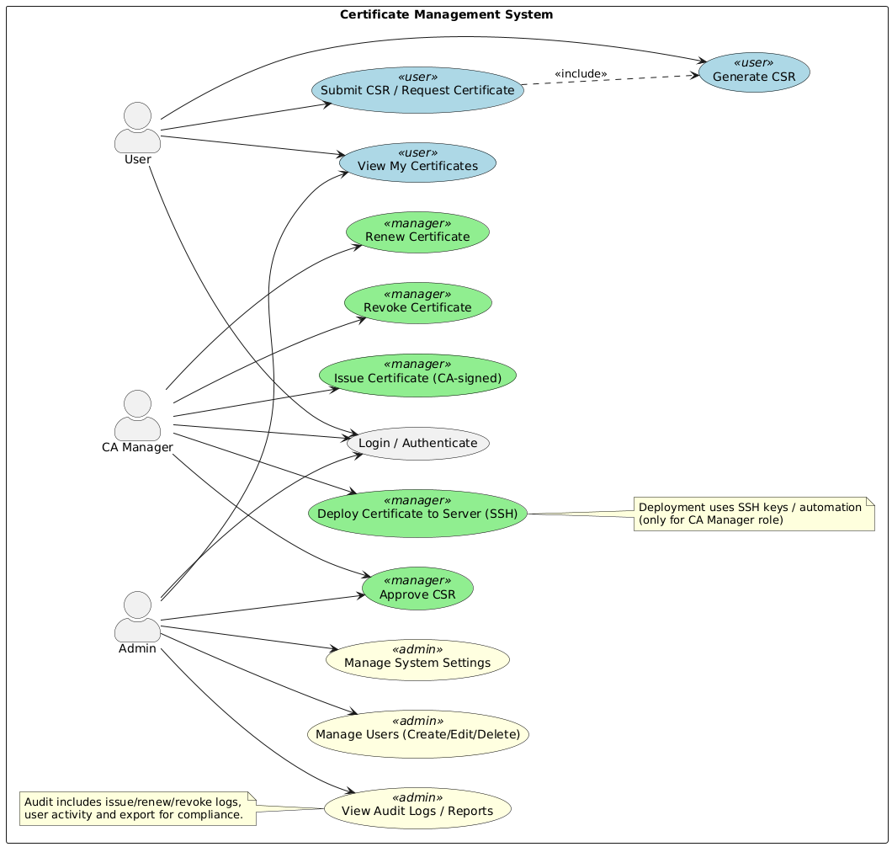

1.6.2 Usage Scenarios

Scenario 1: User Requests a Certificate
- Actor: User
- Precondition: User is logged in.
- Flow:
  - User navigates to “Request Certificate” page.
  - Fills in subject details and submits CSR.
  - System stores request and forwards it to CA Manager for approval.
- Postcondition: CSR is pending approval.

Scenario 2: User Views Certificates
- Actor: User
- Precondition: User has requested or issued certificates.
- Flow:
  - User logs in and opens “My Certificates” dashboard.
  - System fetches all certificates (active, expired, revoked).
  - User views certificate details and downloads certificate if required.
- Postcondition: User sees updated certificate status.

Scenario 3: CA Manager Approves CSR
- Actor: CA Manager
- Precondition: Pending CSR exists in system.
- Flow:
  - CA Manager logs in to dashboard.
  - Opens “Pending Requests”.
  - Reviews CSR details.
  - Approves request.
- Postcondition: Certificate is issued and available to User.

Scenario 4: CA Manager Issues Certificate
- Actor: CA Manager
- Precondition: Valid CSR exists.
- Flow:
  - CA Manager selects “Issue Certificate” option.
  - Step-CA generates certificate and private key.
  - System stores certificate in database.
  - User is notified.
- Postcondition: Certificate status = Issued.

Scenario 5: CA Manager Renews Certificate
- Actor: CA Manager
- Precondition: Certificate is near expiry.
- Flow:
  - CA Manager navigates to “Certificates Expiring Soon”.
  - Selects certificate and clicks “Renew”.
  - Step-CA generates a renewed certificate.
  - Old certificate is replaced.
- Postcondition: Renewed certificate is active.

Scenario 6: CA Manager Revokes Certificate
- Actor: CA Manager
- Precondition: Certificate is valid but compromised/invalid.
- Flow:
  - CA Manager searches for certificate by subject/serial.
  - Clicks “Revoke” and selects revocation reason.
  - System marks certificate as revoked.
  - Revocation is logged in Audit Logs.
- Postcondition: Certificate status = Revoked.

Scenario 7: CA Manager Deploys Certificate via SSH
- Actor: CA Manager
- Precondition: Server access details configured.
- Flow:
  - CA Manager selects a valid certificate.
  - Clicks “Deploy to Server”.
  - Provides server IP and SSH credentials.
  - System deploys certificate to server.
- Postcondition: Server uses new certificate.

Scenario 8: Admin Manages Users
- Actor: Admin
- Precondition: Admin is authenticated.
- Flow:
  - Admin goes to “User Management”.
  - Creates, edits, or deletes users.
  - Assigns roles (User / CA Manager).
- Postcondition: User records updated.

Scenario 9: Admin Manages System Settings
- Actor: Admin
- Precondition: Admin logged in.
- Flow:
  - Admin navigates to “System Settings”.
  - Updates CA URL, provisioner details, password policy.
  - Saves changes.
- Postcondition: New settings applied system-wide.

Scenario 10: Admin Views Audit Logs
- Actor: Admin
- Precondition: Certificate actions exist in system.
- Flow:
  - Admin opens “Audit Logs” section.
  - Filters logs by date, action, or user.
  - Exports logs for compliance.
- Postcondition: Admin has audit trail for system monitoring.

1.7 Development Methodology

1.7.1 Chosen Methodology
For the development of the Digital Certificate Authority Management System, we have adopted the VU Software Process Model, a custom framework tailored for final year projects at Virtual University. This model is a hybrid of the Waterfall and Spiral models, combining the structured, sequential nature of Waterfall with the iterative, risk-handling strengths of the Spiral model.
The model follows a phase-by-phase approach with clear milestones, while also allowing feedback loops and refinements at critical stages.
- The process begins with Requirement Gathering & Analysis, where both functional and non-functional requirements are identified.
- This is followed by the Design Phase, including architecture planning, database schema design, and UI layout.
- Next is the Implementation Phase, where modules are coded according to specifications.
- After development, the Testing Phase ensures quality assurance through unit, integration, and system testing.
- The system is then moved to Deployment Phase, where it is hosted and demonstrated.
- Finally, the Maintenance Phase addresses post-deployment issues and improvements.

1.7.2 Reasons for Chosen Methodology
- Hybrid Strengths: VU Model combines the discipline of Waterfall with the flexibility of Spiral, ensuring structured progress while allowing refinements.
- Risk Management: The iterative aspects allow early identification and resolution of risks (e.g., certificate issuance/revocation security).
- Alignment with FYP Needs: Designed specifically for Virtual University projects, it ensures academic deliverables are met.
- Quality Assurance: Continuous feedback and testing at each stage improve overall system reliability.
- Industry Relevance: Mimics real-world practices with documentation, version control, and iterative improvements.

1.7.3 Work Plan (Gantt Chart)
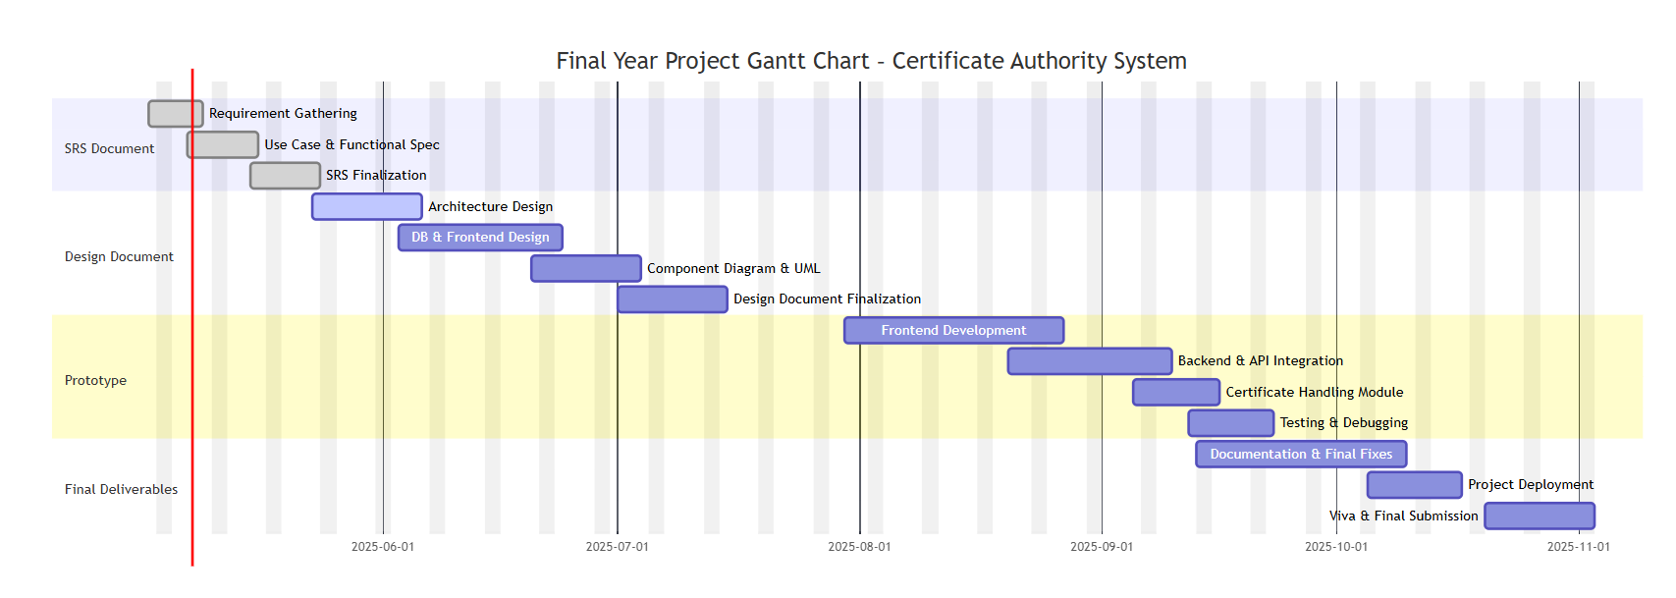

1.7.4 Project Schedule (Submission Calendar)
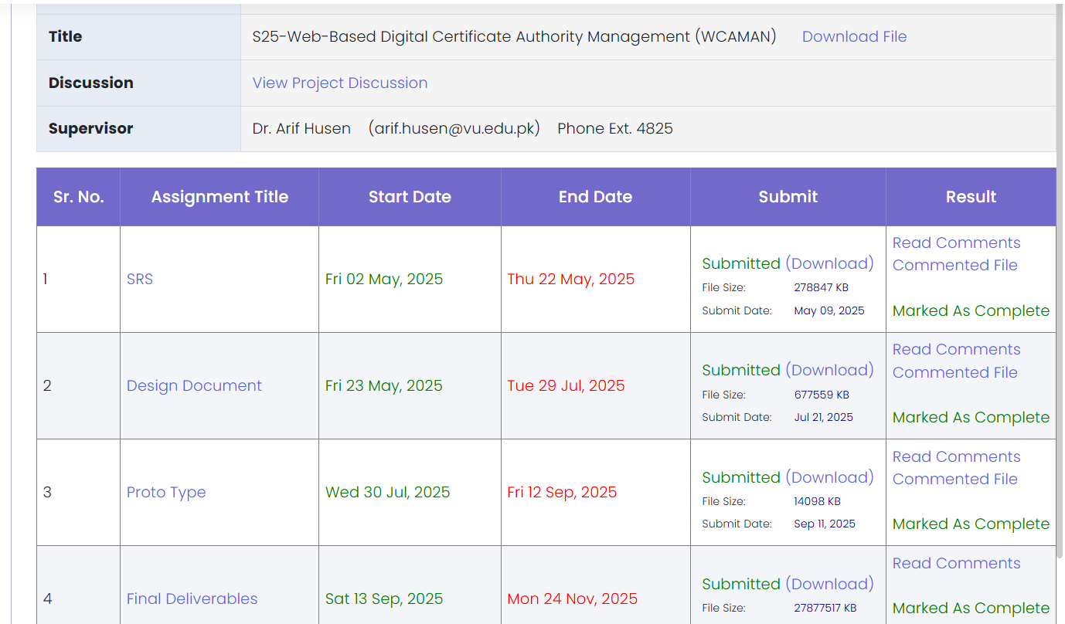

CHAPTER 2
Designing the Project

2.1 Introduction
The design phase focuses on translating the gathered requirements into a well-structured system model. This involves developing the system’s architecture, dynamic interactions, object models, database schema, and graphical user interfaces. The design ensures that all system components integrate smoothly and meet both functional and non-functional requirements identified earlier.

2.2 Purpose
The purpose of this design phase is to provide:
- A blueprint for implementation.
- Clear representation of system architecture and interactions.
- Models for database, class structure, and GUI design.
- Documentation of system components for developers and stakeholders.

2.3 Scope
The scope of this design is to cover the following aspects:
- Architectural Representation: High-level system architecture showing frontend, backend, step-ca integration, and database.
- Dynamic Model: Sequence diagrams illustrating interactions for login, certificate request, issuance, revocation, renewal, and audit logs.
- Object Model: Class diagram defining relationships between system entities (User, Certificate, CSR, AuditLog).
- Database Model: Entity-Relationship diagram (ERD) representing schema.
- Graphical User Interfaces: Prototype UI designs for Admin, CA Manager, and User dashboards.

2.4 Definitions, Acronyms and Abbreviations
- CSR – Certificate Signing Request
- CA – Certificate Authority
- RBAC – Role-Based Access Control
- UI – User Interface
- DB – Database
- PKI – Public Key Infrastructure
- JWT – JSON Web Token
- CRUD – Create, Read, Update, Delete

2.5 Architectural Representation (Architecture Diagram)
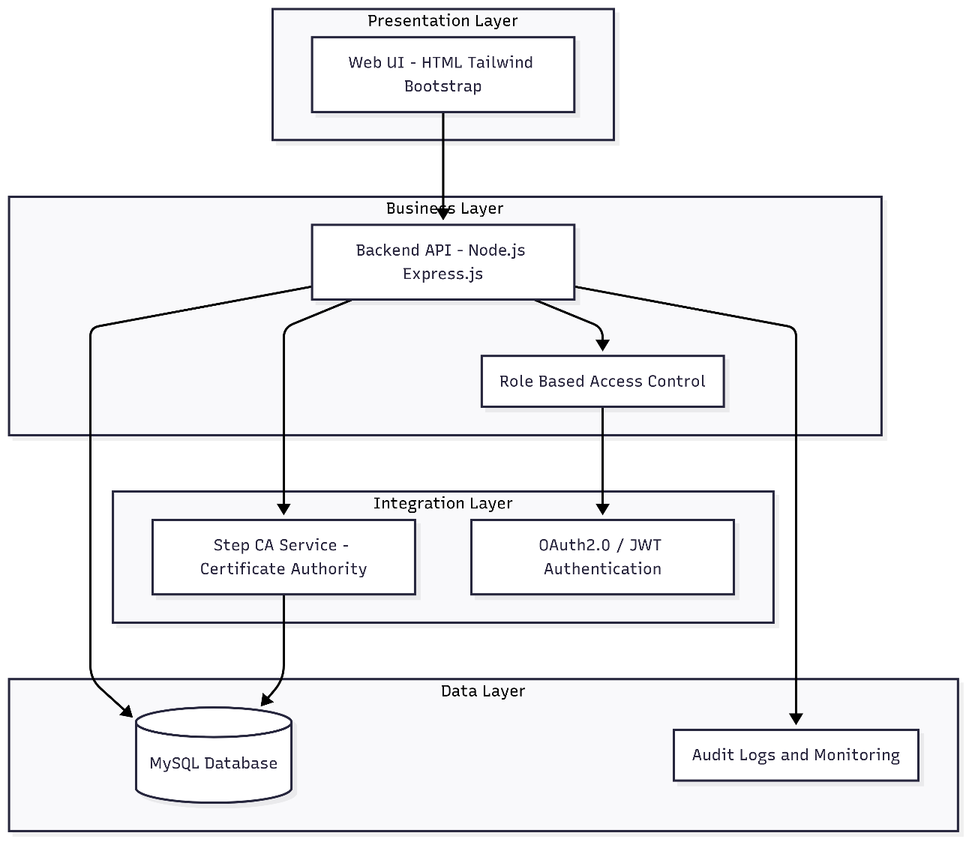

2.6 Dynamic Model: Sequence Diagrams
- User Login
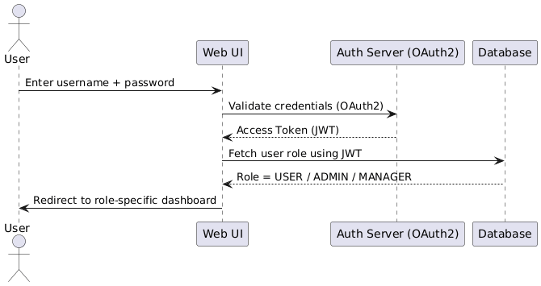
- Certificate Request
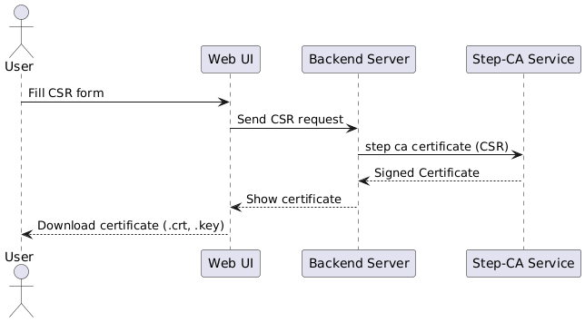
- Certificate Issuance (Manager)
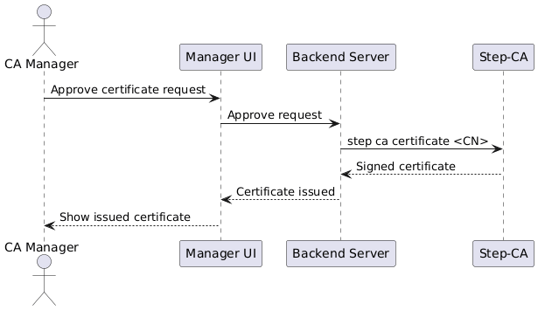
- Certificate Renewal (Manager)
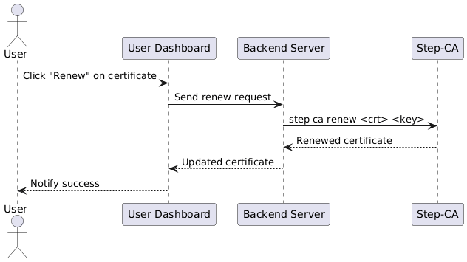
- Certificate Revocation (Manager)
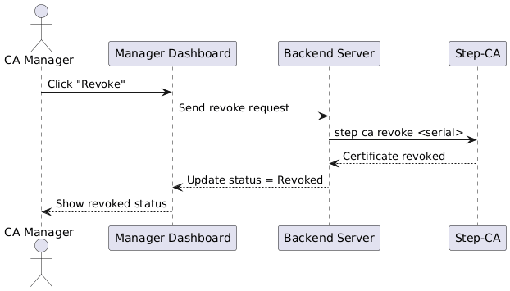
- Audit Log Viewing (Admin)
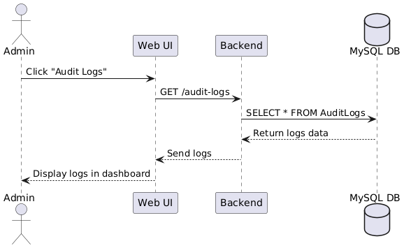
- Monitoring and alert
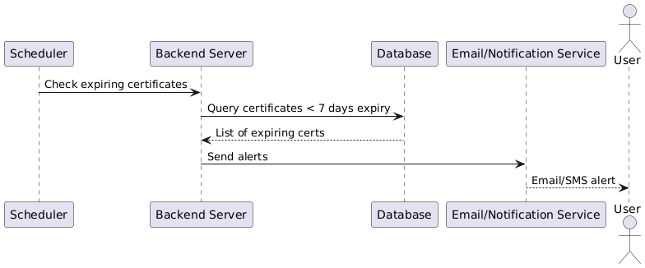

2.7 Object Model / Logical Model: Class Diagram

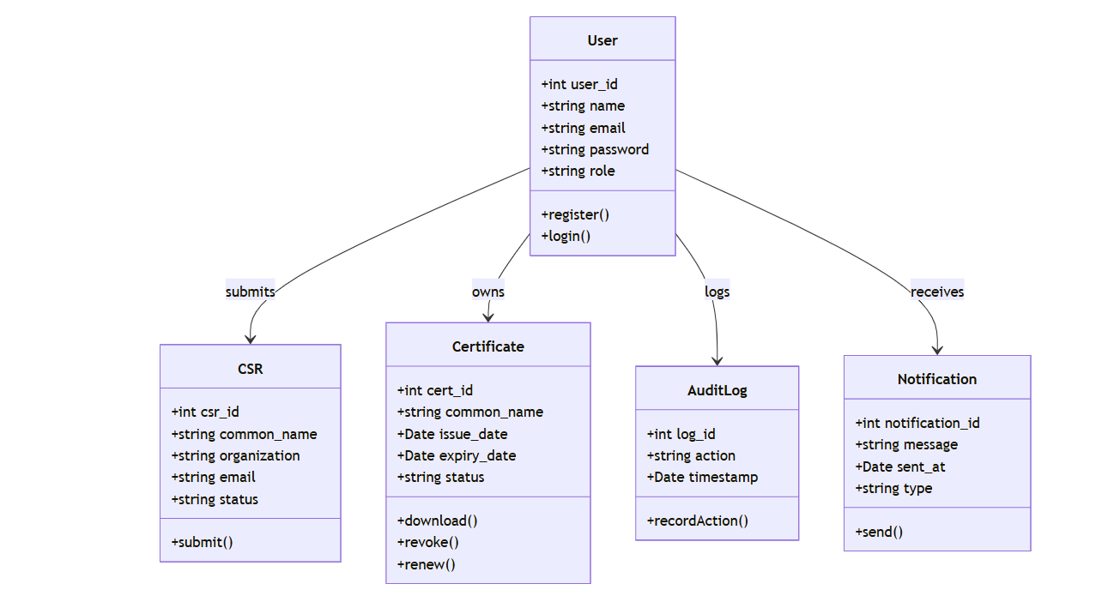2.8 Database Model (Database Diagram)

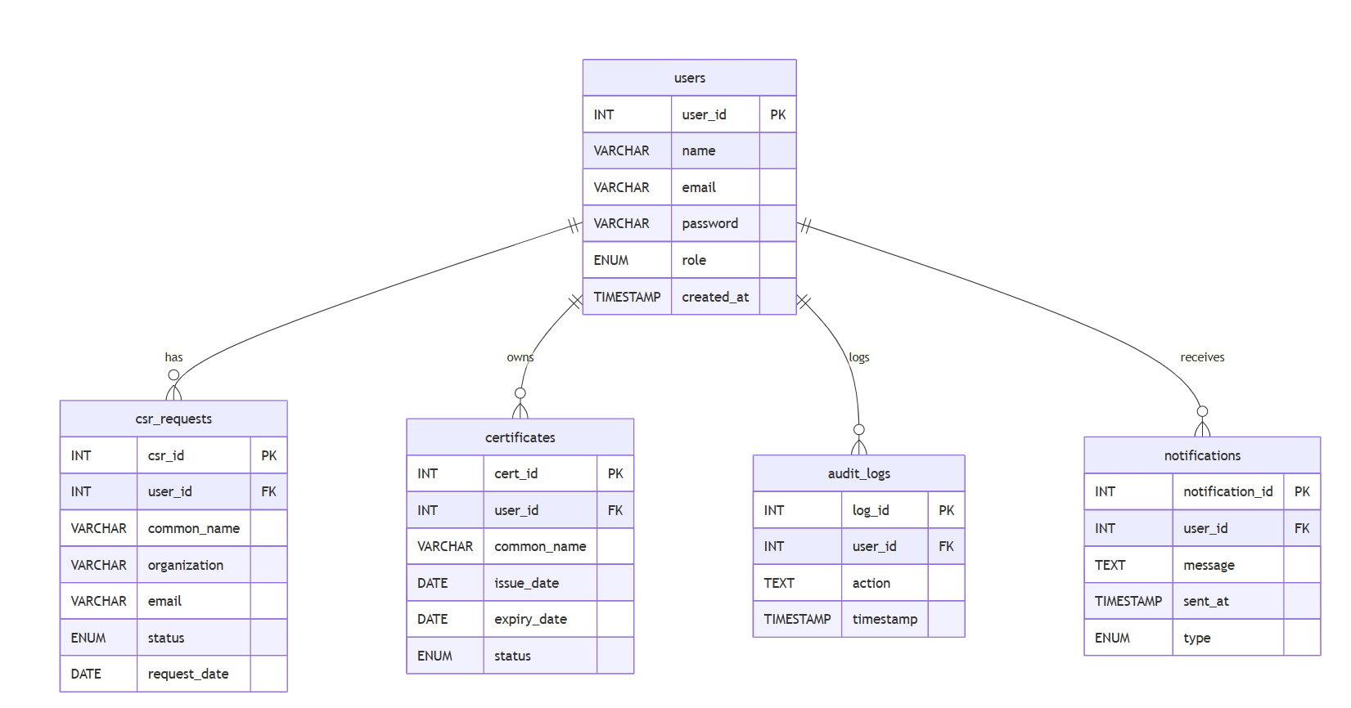

2.9 Graphical User Interfaces
Prototype designs for the system:
- Login Page
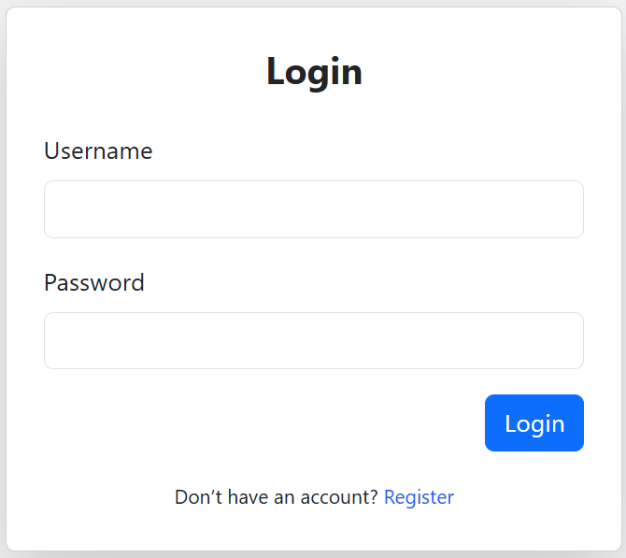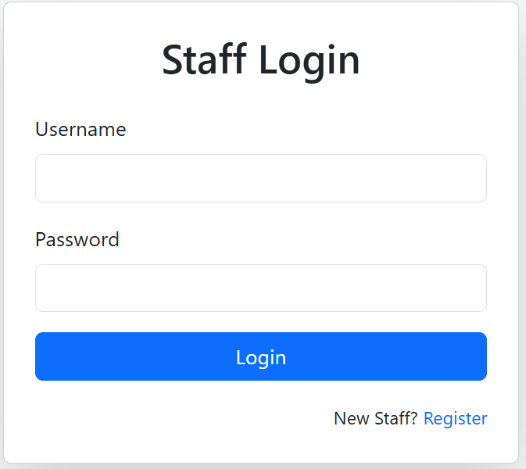
- Admin Dashboard
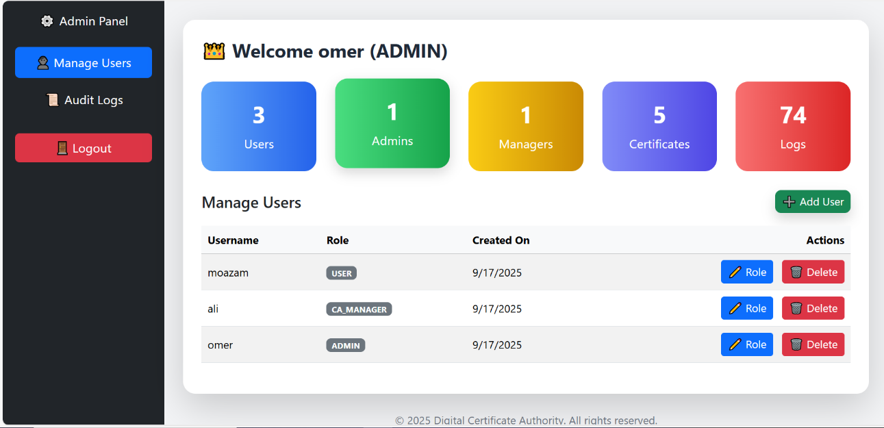
- CA Manager Dashboard
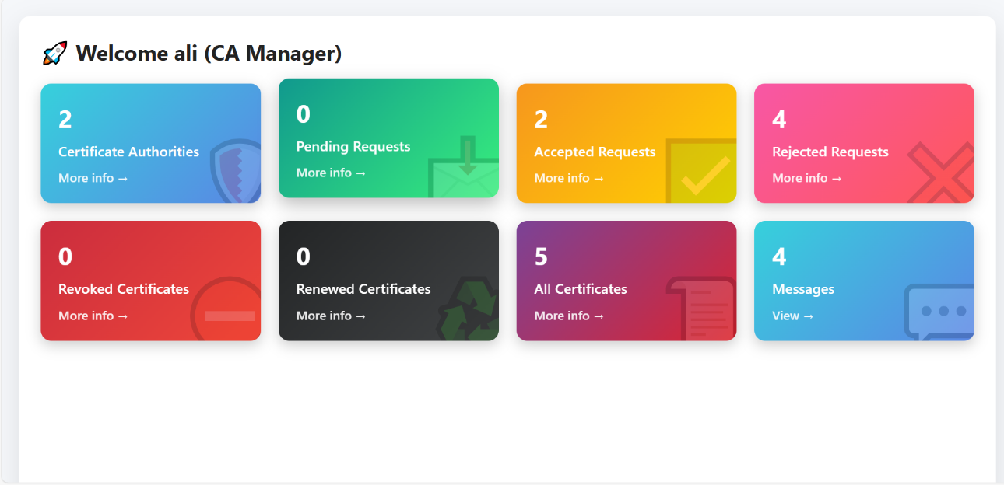
- User Dashboard
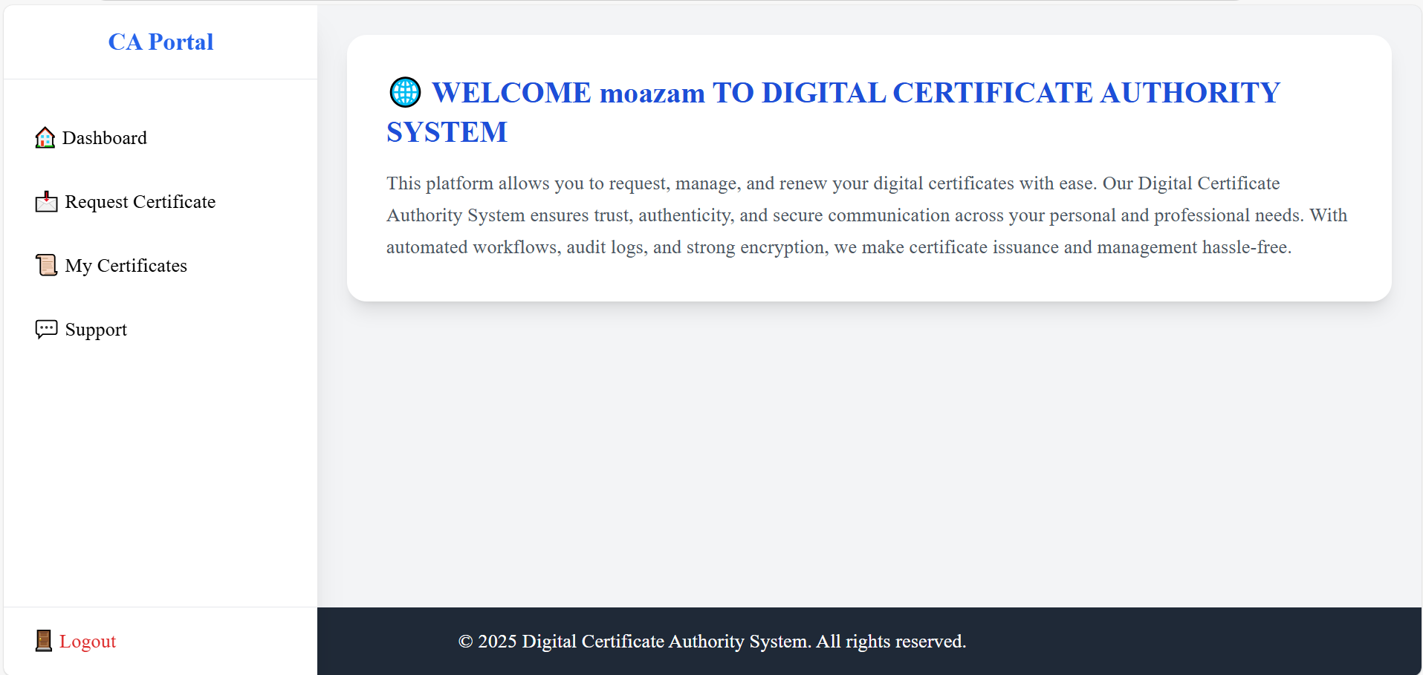

CHAPTER 3
Development

3.1 Development Plan (Architecture Diagram)



3.2 Development Tools & Technologies
- Programming Language: Node.js (JavaScript / Express)
- Frontend: HTML, CSS, Bootstrap, Tailwind
- Database: MySQL
- Certificate Authority: step-ca (Smallstep)
- Version Control: GitHub
- IDE/Editor: VS Code
- Other Tools: Docker, Postman, Browser for testing

3.3 Implementation Details
- Authentication & Role Management (JWT/OAuth2)
- Certificate Module: CSR generation, issue, renew, revoke
- Audit Logging Module: Logs stored in DB
- User Module: Request certificate + view status
- Admin Module: Manage users, system settings, view logs
- CA Manager Module: Approve requests, issue/renew/revok

3.4 Deployment Environment
- Operating System: Linux (Ubuntu/Debian) for step-ca
- Backend: Runs on Node.js server
- Database: MySQL hosted locally / on server
- Frontend: Runs in browser
- Containerization: Docker for step-ca service

REFERENCES

[1] Smallstep, “Step-CA Documentation,” 2023. [Online]. Available: https://smallstep.com/docs/
[2] OpenSSL Project, “OpenSSL: Cryptography and SSL/TLS Toolkit,” 2023. [Online]. Available: https://www.openssl.org/
[3] D. Cooper, S. Santesson, S. Farrell, S. Boeyen, R. Housley, and W. Polk, Internet X.509 Public Key Infrastructure Certificate and Certificate Revocation List (CRL) Profile (RFC 5280), IETF, 2008.
[4] Oracle, “MySQL Documentation,” 2023. [Online]. Available: https://dev.mysql.com/doc/
[5] Node.js Foundation, “Node.js Documentation,” 2023. [Online]. Available: https://nodejs.org/en/docs/
[6] Express.js Contributors, “Express.js Guide,” 2023. [Online]. Available: https://expressjs.com/
[7] OAuth, “OAuth 2.0 and OpenID Connect Standards,” 2023. [Online]. Available: https://oauth.net/2/
[8] Bootstrap Team, “Bootstrap Documentation,” 2023. [Online]. Available: https://getbootstrap.com/
[9] Tailwind Labs, “Tailwind CSS Documentation,” 2023. [Online]. Available: https://tailwindcss.com/
[10] Virtual University of Pakistan, Final Year Project Guidelines (VU Process Model), 2025.

APPENDIX

Appendix A – Source Code Samples

A.1 Certificate Revocation (Node.js)
router.post("/certificates/revoke/:id", (req, res) => {
const certFile = req.params.id;
const certPath = path.join(CERTS_DIR, certFile);
const serial = inspectCert(certPath).serial_number;

const cmd = `${STEP_BIN} ca revoke ${serial} \
--provisioner "admin@wacman.com" \
--password-file "${PROV_PASS}" \
--ca-url "${CA_URL}" \
--root "${ROOT_CA}"`;

execSync(cmd, { stdio: "inherit" });
res.redirect("/dashboard?msg=cert_revoked");
});

A.2 Certificate Renewal (Node.js)
router.post("/certificates/renew/:id", (req, res) => {
const certFile = req.params.id;
const certPath = path.join(CERTS_DIR, certFile);
const keyPath = certPath.replace(".crt", ".key");
const newCertPath = certPath.replace(".crt", "-renewed.crt");

const cmd = `${STEP_BIN} ca renew "${certPath}" "${keyPath}" \
--out "${newCertPath}" \
--ca-url "${CA_URL}" \
--root "${ROOT_CA}" \
--provisioner "admin@wacman.com" \
--password-file "${PROV_PASS}"`;

execSync(cmd, { stdio: "inherit" });
res.redirect("/dashboard?msg=cert_renewed");
});

Appendix B – Database Schema (MySQL)
CREATE TABLE Users (
id INT AUTO_INCREMENT PRIMARY KEY,
name VARCHAR(100),
email VARCHAR(100) UNIQUE,
password_hash VARCHAR(255),
role ENUM('Admin','Manager','User'),
status VARCHAR(20)
);

CREATE TABLE Certificates (
id INT AUTO_INCREMENT PRIMARY KEY,
user_id INT,
serial_number VARCHAR(255),
subject VARCHAR(255),
status ENUM('issued','revoked','renewed','expired'),
issued_date DATETIME,
expiry_date DATETIME,
revoked_date DATETIME,
FOREIGN KEY (user_id) REFERENCES Users(id)
);

CREATE TABLE CSRs (
id INT AUTO_INCREMENT PRIMARY KEY,
user_id INT,
csr_data TEXT,
status ENUM('pending','approved','rejected'),
request_date DATETIME,
FOREIGN KEY (user_id) REFERENCES Users(id)
);

CREATE TABLE AuditLogs (
id INT AUTO_INCREMENT PRIMARY KEY,
user_id INT,
action VARCHAR(100),
timestamp DATETIME,
ip_address VARCHAR(50),
FOREIGN KEY (user_id) REFERENCES Users(id)
);

Appendix C – Configuration Files

Sample ca.json (Step-CA)
{
"address": ":8443",
"dnsNames": ["127.0.0.1", "192.168.100.17", "wacman.com"],
"authority": {
"provisioners": [{
"name": "admin@wacman.com",
"type": "JWK",
"key": {}
}],
"enableRenewal": true
}
}

Appendix D – User Manual
- Login: Enter credentials. Role decides dashboard view.
- Request Certificate (User): Fill subject/common name, click submit.
- Issue Certificate (Manager): Approve CSR, issue certificate.
- Renew Certificate (Manager): Select expiring cert → Renew.
- Revoke Certificate (Manager): Select cert → Revoke.
- Admin: Manage users, system settings, view audit logs.

Appendix E – Test Cases
Test Case ID | Action | Input | Expected Output | Status
TC-01 | User Login | Valid credentials | Redirect to dashboard | Pass
TC-02 | Request Certificate | CSR details | Request stored, pending approval | Pass
TC-03 | Issue Certificate | Valid CSR | Certificate issued (.crt, .key) | Pass
TC-04 | Revoke Certificate | Valid serial | Status updated to revoked | Pass
TC-05 | Renew Certificate | Expiring cert | New certificate generated | Pass

