Area | Logic / Design Weight | Hardware Pain
Bare-metal firmware | Low | High
Driver-level firmware | Low–Medium | Very High
RTOS-based embedded | High | Medium
Embedded Linux | Very High | Low–Medium
Backend systems | Very High | None

• RTOS scheduling
• task / queue / semaphore
• ISR ↔ task 경계
• state machine 설계

Real-Time Temperature Monitoring System (STM32 + FreeRTOS)
- Designed a real-time embedded application using STM32F4 and FreeRTOS
- Implemented multitasking with sensor read, data processing, and UART logging
- Interfaced I2C temperature sensor and optimized task scheduling
- Debugged timing issues using logic analyzer
Tech: C, STM32, FreeRTOS, I2C, UART

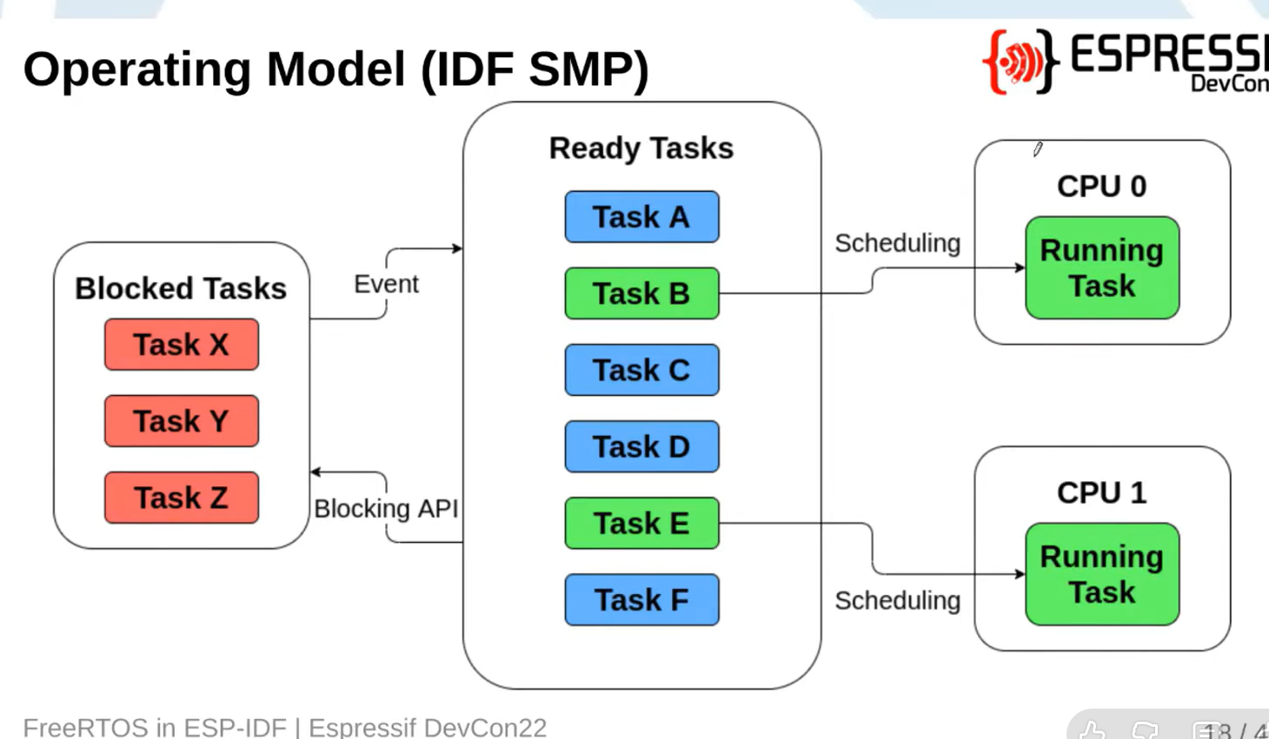
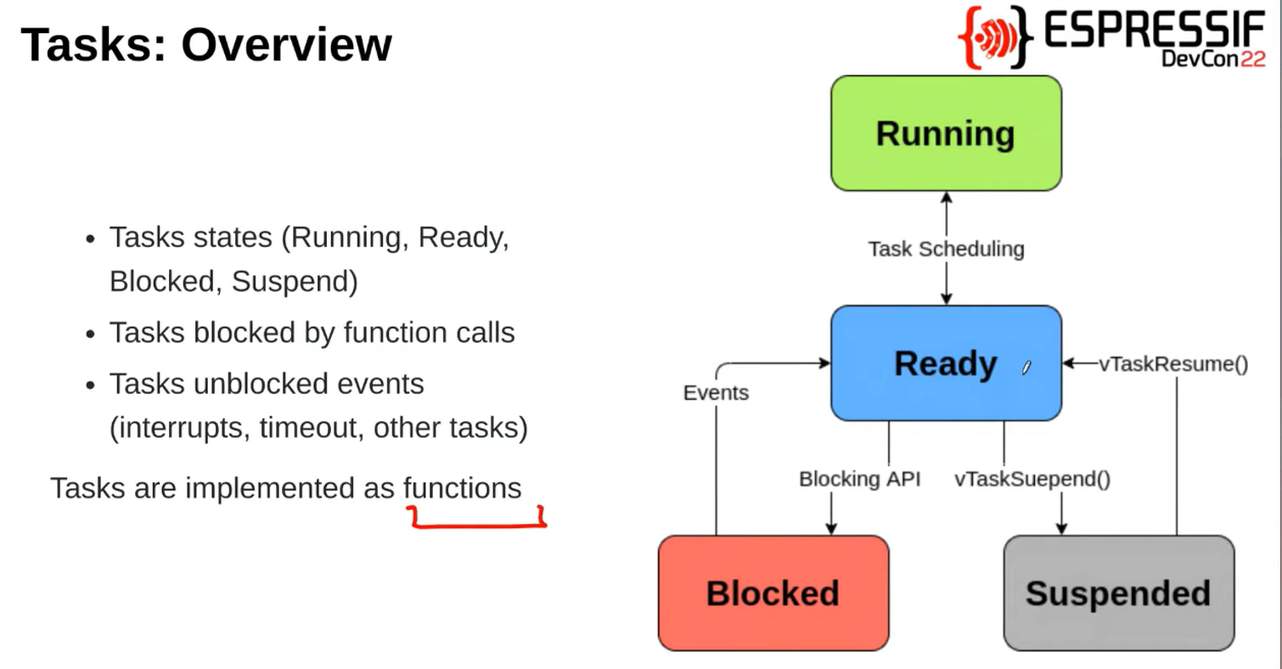
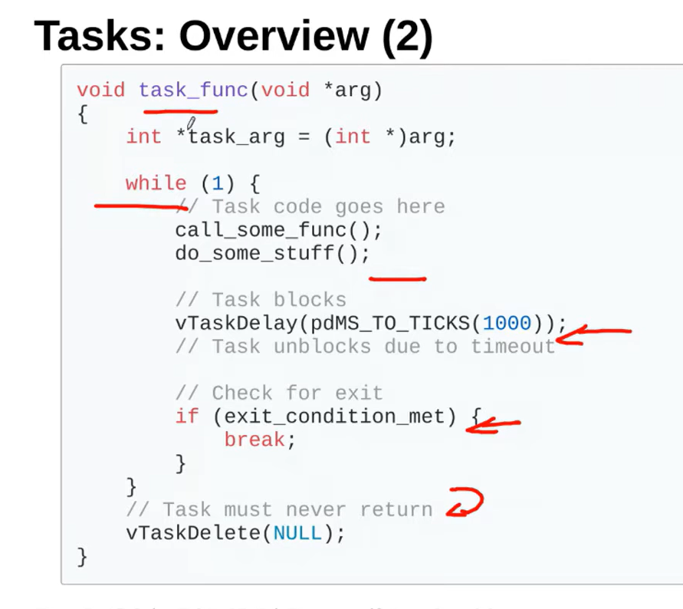
xTaskCreatePinnedToCore() : Create a new task and add it to the list of tasks that are ready to run.

What not to do
❌ One giant tasks.c
❌ LED driver + animations + logic in one file
❌ Calling WS2812 write functions from multiple tasks
WS2812 must be owned by exactly one task.
Only ONE task writes to the strip
Bad:
sensor_task -> ws2812_set_pixel()
logic_task -> ws2812_set_pixel()
Good:
logic_task -> send command
led_task -> ws2812_show()
Use:
- queue
- task notification
- shared struct + mutex

-thread in software=task, thread in hw=cpu core

symmetric multi-processing
different states
scheduling (which core and which task)
tick interrupt
critical section: can be executed by only one thread

