BINOD BIHARI MAHTO KOYALANCHAL UNIVERSITY
(BBMKU)
Dhanbad, Jharkhand

Department of Botany

Cultivation and Observational Study of Oyster Mushroom
(Pleurotus spp.) under KVK Petarwar Guidance

A Dissertation Submitted in Partial Fulfilment of the Requirements
for the Award of the Degree of

MASTER OF SCIENCE (BOTANY)

Submitted by

MOHIT KUMAR
Enrollment No.: 251831330715

Under the Supervision of

Dr. Kalpana Prasad
Assistant Professor, Department of Botany
BBMKU, Dhanbad, Jharkhand

Session: 2025–2026

Certificate
This is to certify that the dissertation entitled “Cultivation and Observational Study of Oyster Mushroom (Pleurotus spp.) under KVK Petarwar Guidance” submitted by MOHIT KUMAR, Enrollment Number 251831330715, to Binod Bihari Mahto Koyalanchal University (BBMKU), Dhanbad, Jharkhand, in partial fulfilment of the requirements for the award of the degree of Master of Science in Botany, is a bona fide record of original work carried out under my direct supervision and guidance during the academic session 2025–2026.

The observations reported herein are based on a field-based qualitative study conducted at the Krishi Vigyan Kendra (KVK) Petarwar, Ramgarh, Jharkhand, between 18 May 2026 and 17 June 2026. The content of this dissertation, to the best of my knowledge and belief, has not been submitted to any other university or institution for the award of any degree, diploma, or certificate.

Date: ___________________

_______________________________
Dr. Kalpana Prasad

Assistant Professor, Department of Botany
BBMKU, Dhanbad, Jharkhand

_______________________________
Head, Department of Botany
BBMKU, Dhanbad, Jharkhand

Declaration
I, MOHIT KUMAR, Enrollment Number 251831330715, a student of M.Sc. Botany at Binod Bihari Mahto Koyalanchal University (BBMKU), Dhanbad, Jharkhand, hereby solemnly declare that the dissertation entitled “Cultivation and Observational Study of Oyster Mushroom (Pleurotus spp.) under KVK Petarwar Guidance” is an original piece of work carried out by me under the supervision of Dr. Kalpana Prasad.

I further declare that:
- The work is entirely my own and has not been submitted elsewhere for any degree or certificate.
- All sources of information referred to have been duly acknowledged and cited.
- Observations are qualitative, based on personal field study at KVK Petarwar from 18 May 2026 to 17 June 2026.
- No numerical yield analysis, statistical treatment, or economic analysis forms part of this study, consistent with its purely observational design.

Place: Dhanbad, Jharkhand
Date: ___________________

_______________________________
MOHIT KUMAR
Enrollment No.: 251831330715
M.Sc. Botany, BBMKU Dhanbad

Acknowledgement
First and foremost, I offer my sincere gratitude to God Almighty, whose blessings guided me through the completion of this dissertation.

I am deeply indebted to my respected supervisor, Dr. Kalpana Prasad, Assistant Professor, Department of Botany, BBMKU Dhanbad, for her constant encouragement, scholarly guidance, and patient mentorship throughout this study. Her insightful feedback and unwavering support transformed what began as a training field visit into a structured, academically sound dissertation.

I express heartfelt thanks to the scientists, subject matter specialists, and technical staff at the Krishi Vigyan Kendra (KVK) Petarwar, Ramgarh, Jharkhand, for their expertise, practical demonstrations, and the warm welcome extended during the field observation period from 18 May to 17 June 2026. Their dedicated hands-on training in Oyster Mushroom cultivation provided the practical foundation upon which this entire dissertation rests.

My sincere thanks are also due to the Head of the Department of Botany, BBMKU Dhanbad, and all faculty members for providing academic support, library facilities, and an intellectually enriching environment throughout my postgraduate studies.

I am profoundly grateful to my family — my parents and siblings — whose love, patience, and financial support made it possible for me to pursue higher education. I also thank my fellow students and friends for their camaraderie during challenging times.

Finally, I acknowledge the scholars and scientists whose published work is cited herein. Their contributions to mycology and mushroom cultivation science have enriched my understanding immensely.

MOHIT KUMAR
Enrollment No.: 251831330715
Department of Botany, BBMKU Dhanbad
Session: 2025–2026

Abstract
Oyster mushrooms, belonging to the genus Pleurotus (Family: Pleurotaceae, Phylum: Basidiomycota), are among the most widely cultivated and economically important edible fungi in the world. They are prized for their rich nutritional profile, documented medicinal properties, and remarkable ability to grow efficiently on a wide range of lignocellulosic agricultural residues — particularly paddy straw — making them one of the most sustainable and accessible crop choices for resource-constrained rural cultivators across India.

This dissertation presents a qualitative, training-based observational study of Oyster Mushroom (Pleurotus spp.) cultivation conducted at the Krishi Vigyan Kendra (KVK) Petarwar, Ramgarh, Jharkhand, under the direct guidance of KVK scientists and extension personnel. The study was carried out from 18 May 2026 to 17 June 2026, spanning the complete first-flush production cycle. Ten LDPE cultivation bags were prepared using locally sourced, sun-dried paddy straw (Oryza sativa) as the primary substrate, and certified P. florida grain spawn was applied at approximately 3–5% of substrate dry weight, following standard KVK Petarwar-recommended practices.

Systematic observations were recorded at each stage of the cultivation cycle: substrate sorting, chopping, and hot-water pasteurisation; layer-by-layer spawning and bag filling; mycelial colonisation (spawn run); primordium initiation; fruiting body development; and first-flush harvest. Nine of 10 bags (90%) completed the full cycle successfully, yielding well-formed Pleurotus sporophores of commercially acceptable quality. One bag showed green mould contamination (Trichoderma spp.) on day 7 of incubation and was promptly removed.

Environmental factors — particularly relative humidity, temperature, ventilation, CO₂ levels, and light direction — were observed to have a direct and visible influence on fruiting body morphology, growth rate, and quality. The KVK Petarwar training model was found to be an effective, accessible, and replicable pathway for rural learners in Jharkhand to acquire practical mushroom cultivation skills in a supported demonstration environment.

Keywords: Pleurotus spp., Oyster Mushroom, KVK Petarwar, Jharkhand, paddy straw, substrate preparation, spawn run, primordium, fruiting body, qualitative observation, contamination, mushroom cultivation.

List of Figures
Fig. No. | Description | Chapter
Fig. 1.1 | Common cultivated mushrooms in India — Agaricus bisporus, Pleurotus ostreatus, Volvariella volvacea, Calocybe indica | Chapter 1
Fig. 1.2 | Important species of Pleurotus cultivated in India — P. ostreatus, P. florida, P. sajor-caju, P. citrinopileatus | Chapter 1
Fig. 1.3 | Mushroom anatomy — Cap, Scales, Gills, Spores, Ring, Stipe, Volva, Mycelial Threads | Chapter 1
Fig. 1.4 | Life cycle of Pleurotus spp. — from spore germination to spore release (original diagram) | Chapter 1
Fig. 1.5 | Major areas of cultivation of different mushrooms in India (map) | Chapter 1
Fig. 2.1 | Global status of mushroom production, 2019 — country-wise percentage share | Chapter 2
Fig. 3.1 | Oyster mushroom cultivation flowchart — complete step-by-step process (original diagram) | Chapter 3
Fig. 3.2 | Group photograph at KVK Petarwar cultivation shed, Gagi, Jharkhand | Chapter 3
Fig. 3.3 | Paddy straw substrate sorted and spread prior to bag filling — KVK Petarwar | Chapter 3
Fig. 3.4 | Substrate pasteurisation phase — drum with substrate material at KVK Petarwar | Chapter 3
Fig. 3.5 | Layer-by-layer bag filling and spawning — students at KVK Petarwar | Chapter 3
Fig. 3.6 | Plastic bag being prepared and filled with spawned substrate | Chapter 3
Fig. 3.7 | Student holding filled spawn bags on iron rod rack — KVK Petarwar | Chapter 3
Fig. 4.1 | Early mycelial colonisation — LDPE bag with mycelium and primordia emerging | Chapter 4
Fig. 4.2 | Mature Pleurotus cluster at first flush, growing from cultivation bag — KVK Petarwar | Chapter 4

List of Tables
Table No. | Description | Chapter
Table 1.1 | Taxonomic classification of Pleurotus spp. | Chapter 1
Table 1.2 | Nutritional composition of Oyster Mushroom per 100 g fresh weight | Chapter 1
Table 2.1 | Commonly cultivated edible mushrooms in India | Chapter 2
Table 2.2 | Substrate materials suitable for Pleurotus spp. cultivation | Chapter 2
Table 2.3 | Environmental requirements of Pleurotus spp. at each growth phase | Chapter 2
Table 3.1 | Study details — site, duration, and cultivation parameters at KVK Petarwar | Chapter 3
Table 3.2 | Materials and equipment used in the KVK Petarwar cultivation unit | Chapter 3
Table 3.3 | Substrate preparation protocol — step-wise procedure | Chapter 3
Table 3.4 | Environmental management targets by growth phase | Chapter 3
Table 4.1 | Qualitative observational record of spawn run characteristics | Chapter 4
Table 4.2 | Qualitative record of pinhead formation characteristics | Chapter 4
Table 4.3 | Morphological characteristics of Pleurotus fruiting bodies at harvest maturity | Chapter 4
Table 4.4 | Contamination observations — type, appearance, cause, and management | Chapter 4

Table of Contents

Chapter 1: Introduction

1.1 General Introduction to Mushrooms
Mushrooms have been an integral part of human civilisation for thousands of years, serving diverse roles in food, medicine, religion, and folklore across cultures worldwide. Scientifically, mushrooms are the visible fruiting bodies of certain macro-fungi — primarily belonging to the phyla Basidiomycota and Ascomycota — produced as reproductive structures for spore dispersal. Unlike green plants, fungi possess no chlorophyll and are entirely incapable of photosynthesis. They obtain nutrition through the enzymatic breakdown and absorption of organic compounds from their surrounding environment, decomposing dead plant and animal material in the process, thereby performing an indispensable ecological role as primary decomposers and nutrient recyclers in virtually every terrestrial ecosystem.

Fungal diversity is extraordinarily vast. Scientific estimates suggest that between 2.2 and 3.8 million fungal species may exist on Earth (Hawksworth & Lücking, 2017), of which approximately 140,000 species are capable of producing visible macro-scale fruiting bodies. Among these, roughly 2,000 species are documented as safe and nutritious for human consumption, and approximately 700 species possess compounds of significant pharmacological interest. Mushrooms of the genus Pleurotus — commonly known as Oyster mushrooms — rank among the most important and widely cultivated of all edible fungal species, both globally and within the Indian agricultural context.

The vegetative body of any fungus — the mycelium — consists of a vast, branching network of microscopic thread-like filaments called hyphae. This mycelial network colonises the substrate, secretes digestive enzymes, absorbs dissolved nutrients, and eventually, when environmental conditions are favourable, produces the visible fruiting body. Understanding the biology and behaviour of mycelium is therefore central to understanding the entire mushroom cultivation process documented in this dissertation.

1.2 Classification of Mushrooms
From a practical cultivation and food safety standpoint, mushrooms are most usefully classified based on their edibility, ecological function, and taxonomic placement into three major categories.

1.2.1 Edible Mushrooms
Edible mushrooms are those proven safe and nutritionally valuable for human consumption. The world's most important commercially cultivated edible species include the Button Mushroom (Agaricus bisporus), Oyster Mushroom (Pleurotus spp.), Milky Mushroom (Calocybe indica), Shiitake (Lentinula edodes), and the Paddy Straw Mushroom (Volvariella volvacea). India's mushroom industry is currently dominated by Button Mushroom and Oyster Mushroom cultivation, with rapidly growing interest in warm-season Milky Mushroom cultivation in southern India and Paddy Straw Mushroom in the humid eastern states.

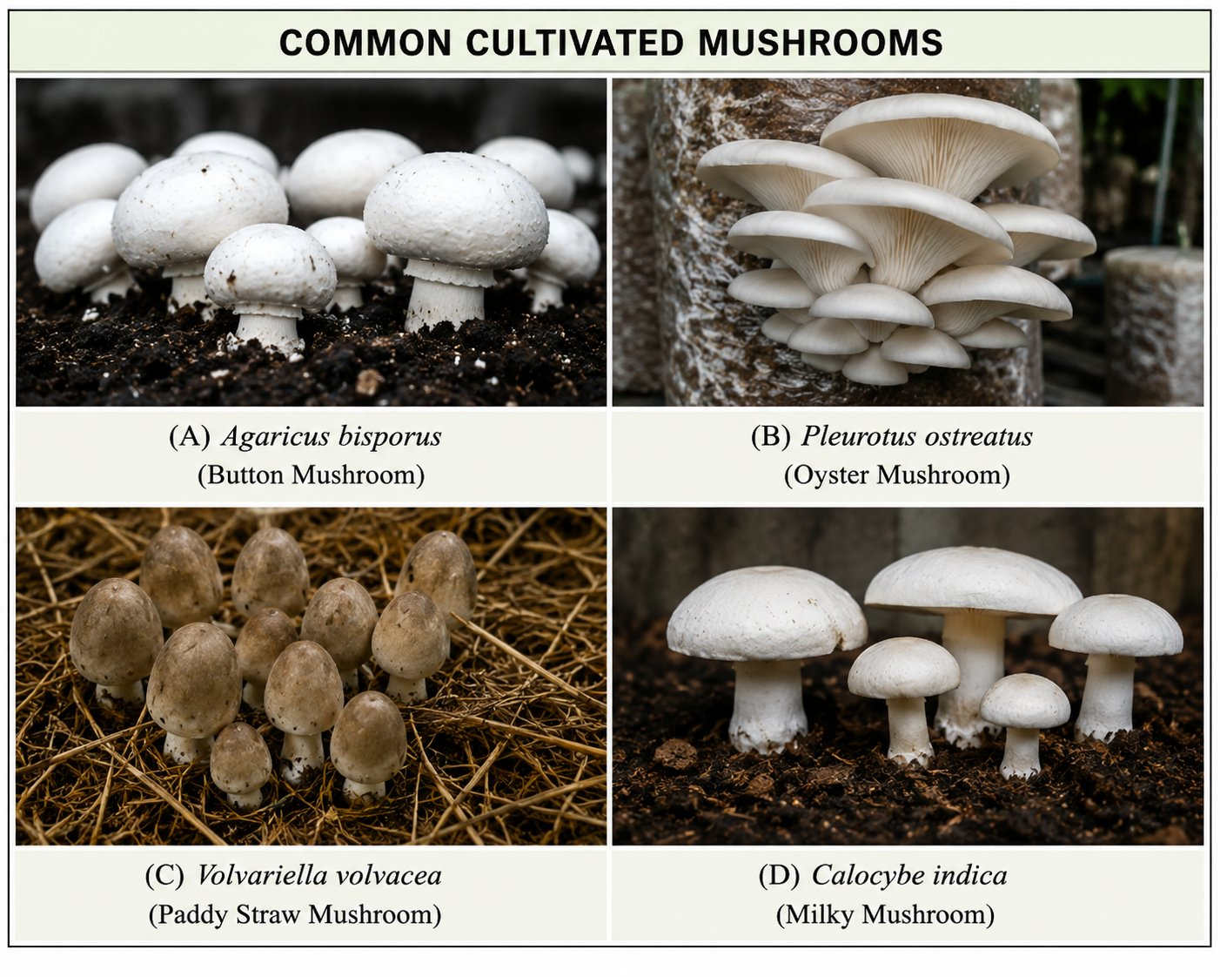
Figure 1.1: Common cultivated mushrooms in India — (A) Agaricus bisporus (Button Mushroom), (B) Pleurotus ostreatus (Oyster Mushroom), (C) Volvariella volvacea (Paddy Straw Mushroom), (D) Calocybe indica (Milky Mushroom). Source: Author compilation using standard botanical illustrations.

1.2.2 Medicinal Mushrooms
Medicinal mushrooms contain well-characterised bioactive compounds with documented therapeutic properties including immunomodulatory polysaccharides, antitumour agents, antioxidants, and cholesterol-regulating compounds. Notable examples include Ganoderma lucidum (Reishi), Trametes versicolor (Turkey Tail), Inonotus obliquus (Chaga), and Cordyceps sinensis. Importantly, many edible mushrooms — including Pleurotus spp. — also possess significant medicinal attributes, effectively blurring the boundary between the edible and medicinal categories.

1.2.3 Poisonous Mushrooms
Toxic mushrooms contain compounds that cause serious illness, organ failure, or death upon consumption. The most notorious include Amanita phalloides (Death Cap — responsible for the majority of fatal mushroom poisonings globally), Galerina marginata, and Amanita muscaria. Correct species identification is therefore critical in wild mushroom foraging. The KVK Petarwar guided cultivation model eliminates this risk entirely by working exclusively with certified, commercially proven species.

1.3 Taxonomy of Pleurotus spp.
The Oyster Mushroom belongs to the genus Pleurotus (Fr.) P.Kumm., family Pleurotaceae, within the order Agaricales of the class Agaricomycetes. The full taxonomic hierarchy is presented in Table 1.1.

Table 1.1: Taxonomic classification of Pleurotus spp.
Classification Rank | Taxon
Kingdom | Fungi
Division (Phylum) | Basidiomycota
Class | Agaricomycetes
Order | Agaricales
Family | Pleurotaceae
Genus | Pleurotus (Fr.) P.Kumm.
Common Species in India | P. florida, P. ostreatus, P. sajor-caju, P. citrinopileatus, P. eous, P. eryngii
Common Name | Oyster Mushroom; Dhingri (Hindi); Seep Chatrak (Bengali)

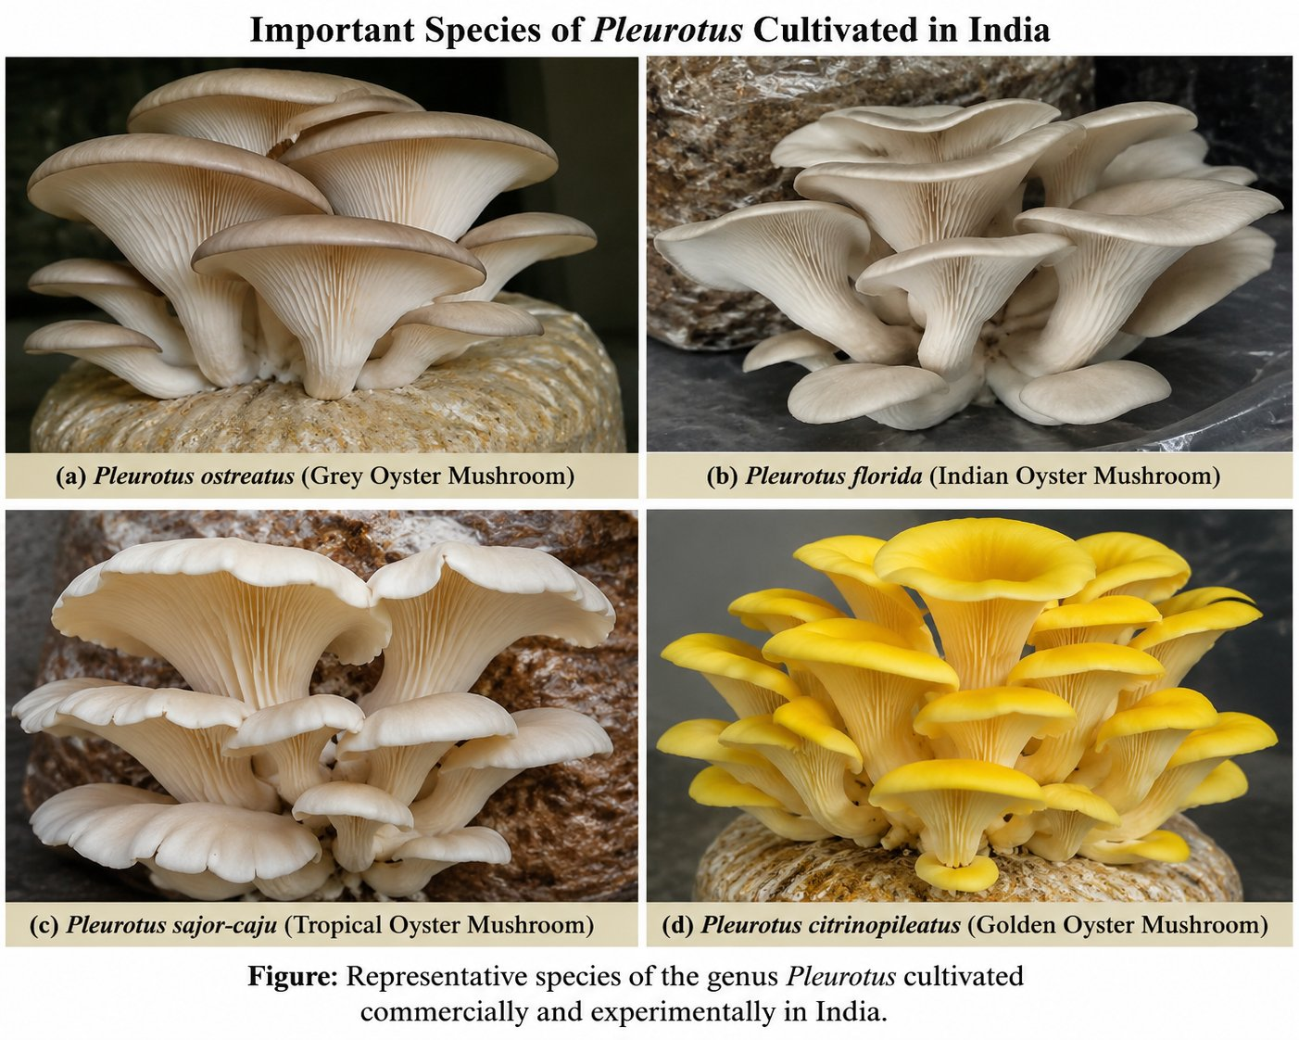
Figure 1.2: Important species of Pleurotus cultivated in India — (a) P. ostreatus (Grey Oyster), (b) P. florida (Indian Oyster), (c) P. sajor-caju (Tropical Oyster), (d) P. citrinopileatus (Golden Oyster). Source: Author compilation.

Pleurotus species are white-rot fungi that naturally inhabit decaying hardwood in forest ecosystems. Their powerful enzymatic system — producing cellulases, hemicellulases, laccase, manganese peroxidase, and lignin peroxidase — enables efficient degradation of cellulose, hemicellulose, and lignin, the three major structural components of plant cell walls. This enzymatic versatility is the biological basis of their adaptability to diverse agricultural residues in cultivation.

1.4 Anatomy of a Mushroom
Understanding the basic structural anatomy of a mushroom fruiting body is essential for both identification and cultivation monitoring. Each structural component has a specific biological function during the reproductive phase of the fungal life cycle.
- Cap (Pileus): The umbrella-shaped upper structure; its underside bears the spore-producing tissue. In Pleurotus, the pileus is fan-shaped to semicircular with a wavy, lobed margin.
- Scales: Surface remnants of the universal veil; present in some species, absent in most Pleurotus.
- Gills (Lamellae): Blade-like structures on the underside of the pileus bearing basidia and basidiospores. In Pleurotus, gills are decurrent — running down onto the stipe.
- Spores: Microscopic reproductive units produced by the basidia; dispersed by air currents to establish new mycelial colonies.
- Ring (Annulus): Membranous remnant of the partial veil around the upper stipe; absent in most Pleurotus species.
- Stipe (Stem): Supporting column connecting pileus to substrate; in Pleurotus, short, stout, and laterally attached.
- Volva: Cup-like basal remnant of the universal veil; absent in Pleurotus, but present in Amanita and Volvariella.
- Mycelial Threads (Hyphae): Vegetative root-like filaments that penetrate and colonise the substrate, absorbing nutrients to support fruiting body development.

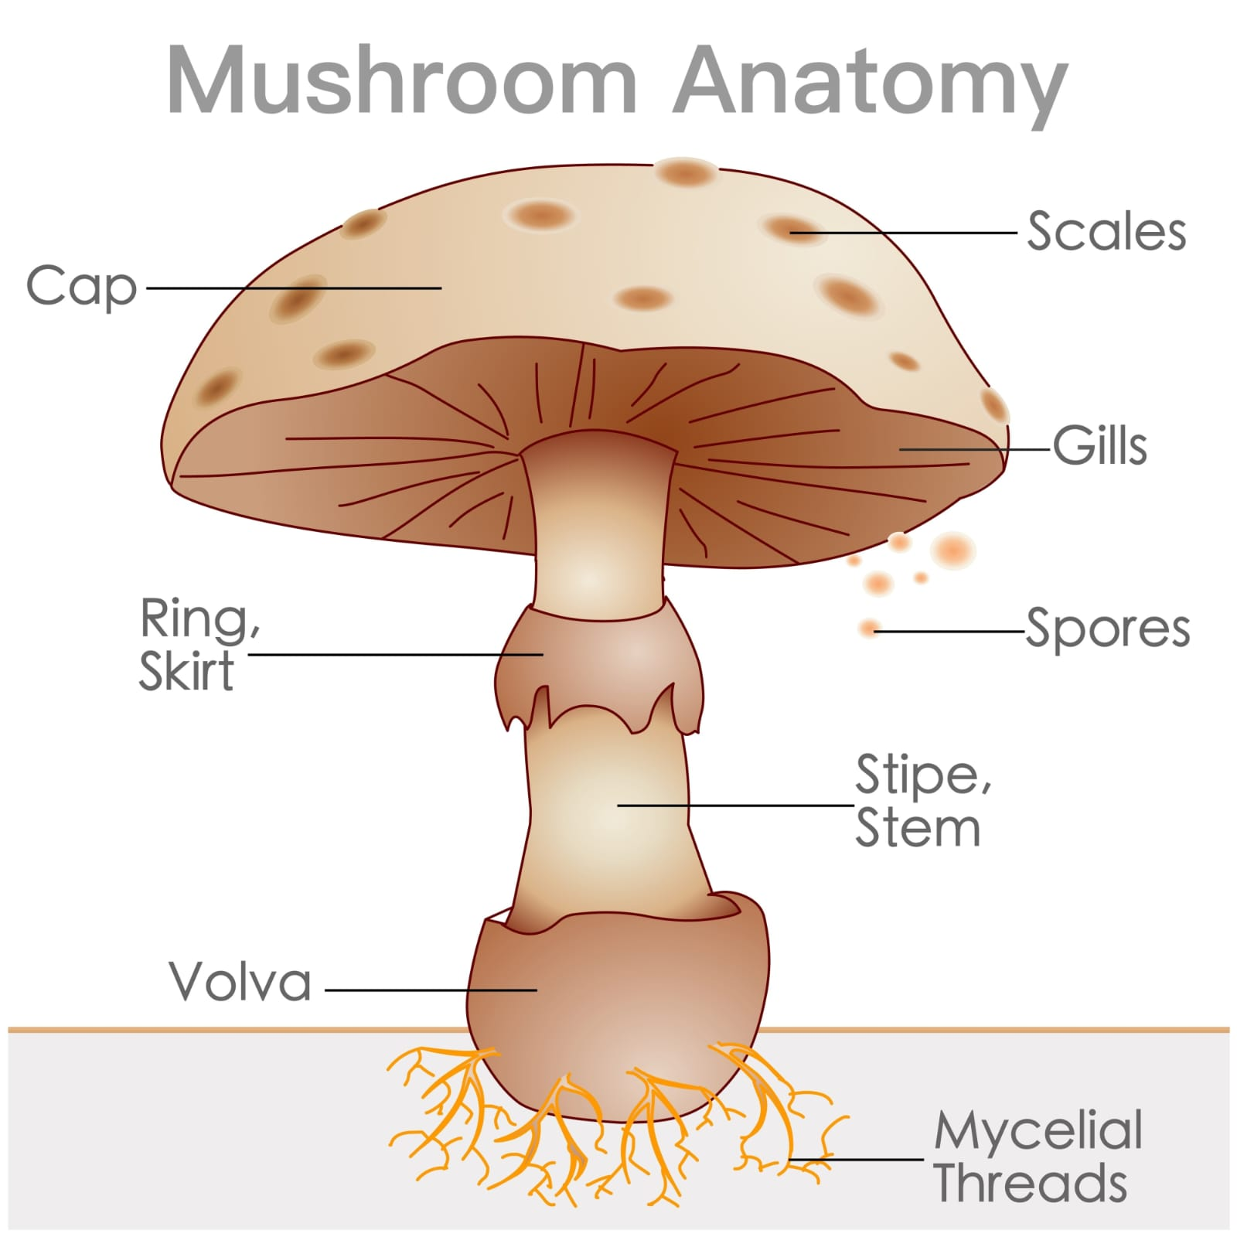
Figure 1.3: Mushroom anatomy — labelled diagram showing the Cap, Scales, Gills, Spores, Ring/Skirt, Stipe/Stem, Volva, and Mycelial Threads. Source: Standard mycological anatomical illustration.

1.5 Life Cycle of Pleurotus spp.
The life cycle of Pleurotus spp. in cultivation proceeds through six well-defined, sequential stages, each requiring specific environmental conditions. Understanding this cycle is fundamental to managing the cultivation process successfully.
- Stage 1 — Spore germination: Basidiospores land on a suitable substrate and germinate, producing primary hyphae.
- Stage 2 — Hyphal growth and plasmogamy: Compatible hyphae fuse (plasmogamy), forming dikaryotic mycelium — the vigorous, white, cottony growth visible in cultivation bags.
- Stage 3 — Spawn run (vegetative colonisation): Dikaryotic mycelium spreads through the substrate, secreting enzymes that digest the lignocellulosic material and absorb nutrients.
- Stage 4 — Primordium (pin-head) initiation: Triggered by environmental stimuli — light exposure, temperature drop, increased fresh air, and humidity — the mycelium aggregates into small, dome-shaped pin-head structures.
- Stage 5 — Fruiting body development: Primordia rapidly develop into full fruiting bodies with differentiated pileus, gills, and stipe over 5–10 days.
- Stage 6 — Sporulation and spore release: Mature basidia on the gill surface undergo karyogamy and meiosis, producing basidiospores that are released in vast numbers, completing the cycle.

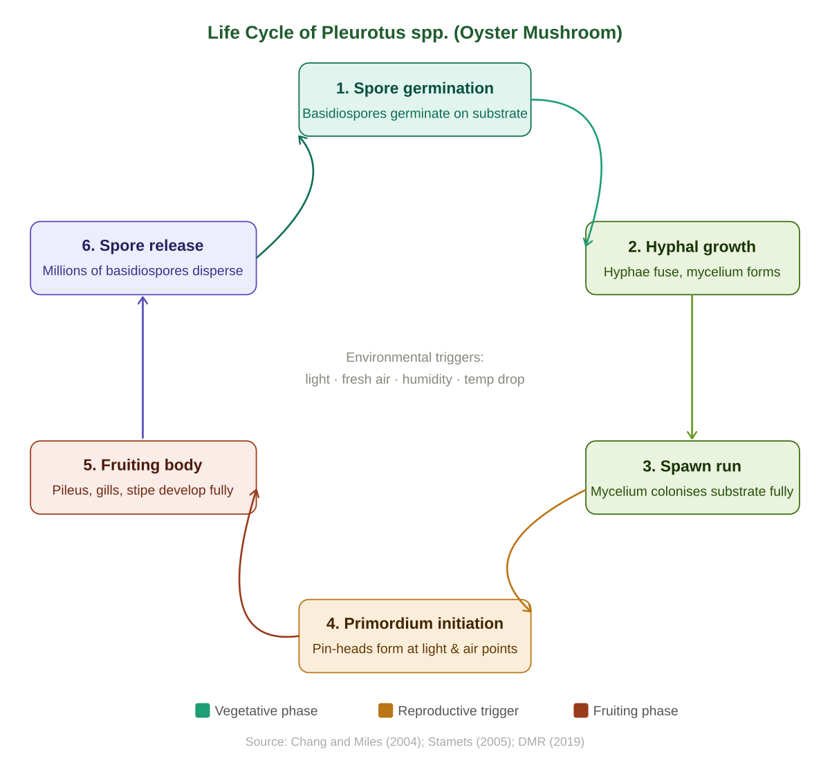
Figure 1.4: Life cycle of Pleurotus spp. — from basidiospore germination through mycelial colonisation, spawn run, and primordium formation to fruiting body maturity and spore release. Original diagram. Source: Author; based on Chang & Miles (2004) and Stamets (2005).

1.6 Mushroom Cultivation in India — Geographic Distribution
Mushroom cultivation in India is geographically distributed according to the specific agro-climatic requirements of each species. The cool-season Button Mushroom (Agaricus bisporus) is concentrated in the northern hill states — Himachal Pradesh, Jammu & Kashmir, Punjab, Haryana, and Uttarakhand. Milky Mushroom (Calocybe indica) is cultivated predominantly in the warm-season states of Tamil Nadu, Karnataka, and Andhra Pradesh. Paddy Straw Mushroom (Volvariella volvacea) thrives in the humid eastern and north-eastern states. Oyster Mushroom (Pleurotus spp.) enjoys the widest geographical distribution, being cultivated commercially and in KVK-led programmes across virtually every state of India due to its broad temperature tolerance.

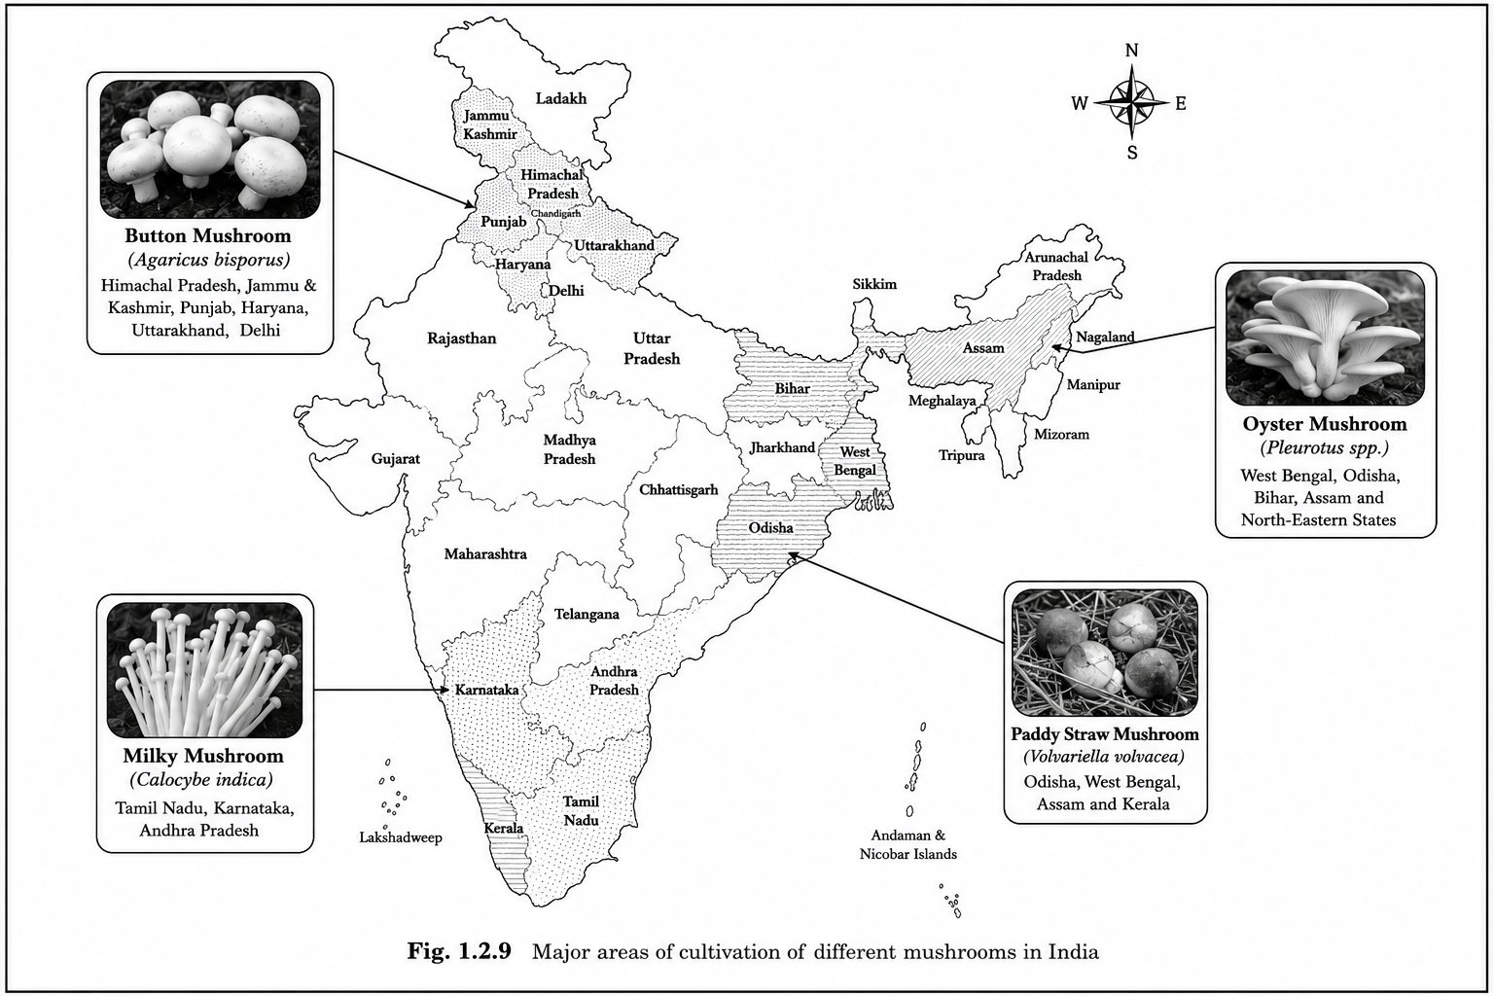
Figure 1.5: Major areas of cultivation of different mushrooms in India. Oyster Mushroom (Pleurotus spp.) is cultivated in West Bengal, Bihar, Odisha, Assam, and North-Eastern States. Source: Standard ICAR reference.

1.7 Importance of Mushroom Cultivation
Mushroom cultivation occupies a uniquely powerful position in sustainable agriculture. It requires no fertile agricultural land, no synthetic fertilisers or pesticides, can be practised indoors in simple low-cost structures using agricultural residues as the growing medium, and yields a nutritious, marketable food product within three to four weeks. These characteristics make it especially valuable for small and marginal farm households, women's self-help groups, and tribal communities.

Environmentally, mushroom cultivation converts lignocellulosic crop residues — paddy straw, wheat straw, sugarcane bagasse — into high-value human food, directly reducing field burning of crop residues which is a major source of air pollution across agrarian India. The spent substrate after harvest is further valorised as high-quality organic fertiliser, completing a circular zero-waste resource cycle perfectly aligned with regenerative farming principles.

1.8 Nutritional and Medicinal Importance of Oyster Mushroom
Oyster mushrooms are nutritionally distinguished among edible fungi. On a dry weight basis, they contain 15–30% protein — all essential amino acids are present, with notably elevated lysine content, an amino acid commonly deficient in cereal-based diets. This makes Oyster Mushroom a particularly valuable dietary complement for populations dependent on rice or wheat as their primary caloric staple.

Table 1.2: Nutritional composition of Oyster Mushroom, Pleurotus spp. (per 100 g fresh weight)
Nutrient | Approximate Content | Significance
Protein | 1.6–3.5 g | All essential amino acids; high lysine content
Carbohydrates | 4.0–6.5 g | Includes beta-glucans with immunomodulatory activity
Dietary Fibre | 1.2–3.0 g | Chitin and glucans; promotes digestive health
Fat | 0.1–0.3 g | Very low; predominantly unsaturated fatty acids
Energy | 25–35 kcal | Low calorie; suitable for weight management diets
Vitamin B2 (Riboflavin) | 0.14–0.4 mg | Energy metabolism; eye and skin health
Vitamin B3 (Niacin) | 3.6–4.5 mg | Nervous system support; skin health
Vitamin D (Ergosterol) | Present; UV-activated | Bone health; immune function
Potassium | 260–420 mg | Cardiovascular health; fluid balance regulation
Phosphorus | 80–120 mg | Bone structure; cell membrane function
Iron | 1.0–1.7 mg | Blood formation; oxygen transport
Zinc | 0.6–0.9 mg | Immune function; enzyme activation

Medicinally, Pleurotus spp. are a rich source of bioactive compounds including polysaccharides (beta-1,3/1,6-glucans with immunostimulatory and antitumour properties), lovastatin (a natural cholesterol-lowering agent), ergothioneine (a potent dietary antioxidant), and various phenolic compounds. Documented biological activities include antioxidant, antimicrobial, anti-inflammatory, antihypercholesterolaemic, hepatoprotective, and immunostimulatory effects (Wasser, 2002; Chang & Wasser, 2012).

1.9 Role of KVK Petarwar in Mushroom Cultivation Training
Krishi Vigyan Kendras (KVKs) — Farm Science Centres — constitute the front-line technology dissemination arm of the Indian Council of Agricultural Research (ICAR) network. With over 700 KVKs operating across India, these centres bridge the gap between research institutions and farming communities at the grass-roots level through technology assessment, demonstration, and training.

KVK Petarwar, located in Ramgarh district, Jharkhand, provides a dedicated mushroom cultivation training programme that combines classroom instruction on fungal biology with comprehensive hands-on practical sessions. The KVK campus includes a dedicated cultivation shed with iron-rod shelving, water supply for misting, and all necessary equipment for substrate preparation, pasteurisation, inoculation, incubation, and fruiting management. The present study was conducted at this KVK facility.

1.10 Scope and Objectives of the Study
This study is scoped as a qualitative, training-based observational investigation of Oyster Mushroom (Pleurotus spp.) cultivation at the KVK Petarwar demonstration unit from 18 May 2026 to 17 June 2026. The following specific objectives guided this study:
- To observe and document all stages of the Oyster Mushroom cultivation cycle at KVK Petarwar, from substrate preparation to harvest.
- To describe the morphological and growth characteristics of Pleurotus spp. during mycelial colonisation, primordium initiation, and fruiting body development.
- To understand the visible influence of environmental conditions — temperature, humidity, light, and ventilation — on mushroom growth and fruiting body quality.
- To record and describe contamination patterns observed during cultivation, including probable causes and management strategies.
- To review the existing scientific literature on Pleurotus spp. biology, substrate science, and KVK-guided mushroom cultivation in India.
- To assess the role of KVK Petarwar in facilitating accessible and practically effective mushroom cultivation training for rural learners.

Chapter 2: Review of Literature

2.1 Global Status of Mushroom Production
The global mushroom production industry has expanded dramatically over the past three decades. China dominates world production with approximately 75% of global output, followed by Japan (4%), the United States (3%), Poland (3%), the Netherlands (3%), and India (2%) (Royse et al., 2017; FAO, 2020). The global mushroom market was valued at over USD 50 billion in 2019 and is projected to grow at a compound annual growth rate (CAGR) of approximately 7.9% through 2030, driven by rising consumer awareness of the nutritional and health benefits of edible fungi and expanding cultivation in developing nations (Grand View Research, 2021).

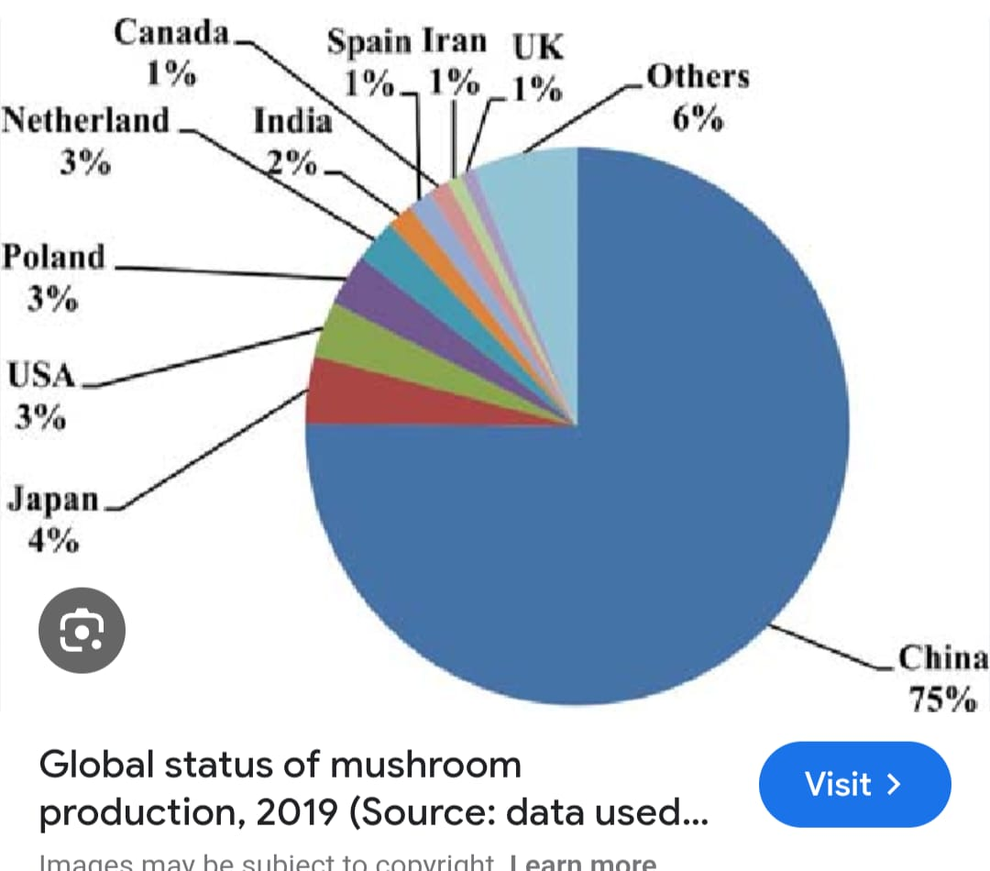
Figure 2.1: Global status of mushroom production, 2019 — country-wise percentage share. China dominates with 75%, followed by Japan 4%, USA, Poland, Netherlands 3% each, and India 2%. Source: Royse et al. (2017); FAO (2020).

2.2 Oyster Mushroom Research Overview
The scientific literature on Oyster Mushroom (Pleurotus spp.) cultivation is vast and multidisciplinary, spanning over a century of documented research. Formal scientific documentation of Pleurotus ostreatus began with Fries (1821), who first described the species in the European mycological literature. The foundations of modern mushroom cultivation science were established through the landmark contributions of Chang and Miles (1993, 2004), whose comprehensive reference texts on cultivation, nutritional value, medicinal effects, and environmental impact have guided both research and commercial practice globally.

In India, mushroom research gained significant institutional momentum following the establishment of the Directorate of Mushroom Research (DMR) by ICAR in 1983 at Solan, Himachal Pradesh. The DMR has since developed cultivation protocols, high-yielding strains, extension materials, and comprehensive training modules that have substantially advanced mushroom production across India. Contemporary Indian mushroom literature encompasses substrate optimisation, spawn quality, contamination control, post-harvest technology, and livelihood impact assessments (Singh et al., 2011; DMR, 2019).

More recent studies have examined the role of digital extension and KVK-led programmes in scaling up mushroom cultivation. Yadav et al. (2021) documented the effectiveness of KVK-based mushroom cultivation training in Uttarakhand, finding that trained farmers achieved significantly higher yields and adoption rates compared to self-taught cultivators. Similarly, Sharma & Garg (2022) highlighted the critical role of subsidised spawn supply and technical backstopping by KVKs in sustaining smallholder mushroom enterprises in Jharkhand and neighbouring states.

2.3 Common Edible Mushrooms Cultivated in India
Table 2.1: Commonly cultivated edible mushrooms in India with scientific and common names
Scientific Name | English Name | Hindi Name | Season
Pleurotus florida | Oyster Mushroom | Dhingri | Oct–Mar (cool); Apr–Sep (warm-tolerant)
Pleurotus ostreatus | Pearl Oyster | Seep Chatrak | Oct–Feb (cool season)
Agaricus bisporus | Button Mushroom | Safed Dhingri | Nov–Mar (temperate)
Calocybe indica | Milky Mushroom | Dudh Chatrak | Apr–Oct (warm season)
Volvariella volvacea | Paddy Straw Mushroom | Padi Chatrak | Jul–Sep (monsoon)
Lentinula edodes | Shiitake | Shiitake | Oct–Feb (cool season)

2.4 Substrate Studies
Substrate selection is among the most studied and practically consequential aspects of Oyster Mushroom cultivation science. Pleurotus species are classified as white-rot fungi, producing a comprehensive suite of ligninolytic and cellulolytic enzymes that enable them to degrade all three major structural polymers of plant cell walls. This enzymatic versatility confers the ability to colonise and fruit productively on an extraordinarily wide range of agricultural residues, distinguishing Pleurotus from most other cultivated mushroom genera.

Paddy straw (Oryza sativa) is the most widely used substrate for Pleurotus cultivation in India, available abundantly after both kharif and rabi harvests. Its composition — approximately 35–40% cellulose, 20–25% hemicellulose, and 12–16% lignin — provides an adequate nutritional matrix for mycelial growth and fruiting body development (Chang & Miles, 2004). Kerketta et al. (2018), working specifically in Jharkhand, documented that paddy straw consistently supported vigorous colonisation and acceptable fruiting body yields of Pleurotus spp. even without nitrogen supplementation, confirming its suitability under the same regional conditions as the present KVK Petarwar study.

Table 2.2: Substrate materials suitable for Pleurotus spp. cultivation
Substrate | Suitability | India Availability | Key Notes
Paddy straw | Excellent | Very high (nationwide) | Standard substrate; most widely used; selected at KVK Petarwar
Wheat straw | Very good | High (northern India) | Good yields; similar preparation to paddy straw
Sugarcane bagasse | Good | High (cane-growing states) | Best used in combination; 20–30% addition to straw
Cotton stalks | Good | Moderate | Requires longer soaking; best supplemented
Hardwood sawdust | Good | Moderate (near sawmills) | Useful as 20–30% supplement to straw
Corn cobs | Moderate | Seasonal | Lower yield; best combined with straw

2.5 Environmental Requirements
The environmental requirements of Oyster Mushroom differ markedly between the spawn run phase and the fruiting phase. Correct understanding and management of these phase-specific requirements is critical to achieving consistent, high-quality cultivation outcomes. During the spawn run, Pleurotus spp. colonise most vigorously at 23–28°C with relative humidity of 60–70% in near-total darkness. Light exposure during colonisation may trigger premature pinning. The fruiting phase requires a temperature drop of 4–6°C, increased humidity (80–95%), exposure to indirect light for 8–12 hours daily, and improved air circulation to prevent CO₂ accumulation above 0.1% (Stamets, 2005).

Table 2.3: Environmental requirements of Pleurotus spp. at each growth phase
Parameter | Spawn Run (Colonisation) | Fruiting Phase
Temperature | 23–28°C | 18–26°C (species-dependent)
Relative Humidity | 60–70% | 80–95%
Light | Darkness preferred | 8–12 hours indirect light daily
Ventilation / CO₂ | Minimal passive exchange | Active; CO₂ must remain below 0.1%
Duration | 14–18 days | 5–10 days from pin to harvest
Management inputs | Minimal — seal bag, maintain temp | Regular misting; ventilation; daily monitoring

2.6 Growth Stages and Biological Efficiency
The life cycle of Pleurotus spp. in cultivation proceeds through recognisable, sequential stages: spawn run, primordium initiation, fruiting body development, maturation, and spore release. Understanding this sequence allows cultivators to provide the appropriate environment at each stage and to harvest at the optimal point — after full pileus expansion but before gill deterioration and spore release, which reduces both shelf life and market acceptability.

Biological Efficiency (BE%) — calculated as the fresh weight of mushroom produced divided by the dry weight of substrate used, expressed as a percentage — is the standard metric for assessing cultivation productivity. Published BE% values for Pleurotus florida on paddy straw under Indian conditions typically range from 60–120% across the first three flushes (DMR, 2019; Kerketta et al., 2018; Das et al., 2010). The present study did not collect quantitative yield data, as it was designed as a training-based observational study; BE% documentation is recommended as a priority for future quantitative research at KVK Petarwar.

2.7 Previous Indian Studies and Jharkhand-Specific Context
A substantial body of Indian research has documented Pleurotus spp. cultivation performance across diverse agro-climatic zones. Rai and Verma (1981) conducted foundational work establishing baseline paddy straw cultivation protocols. Singh et al. (2004) identified P. florida and P. sajor-caju as best suited to the Indo-Gangetic Plains climate. Kerketta et al. (2018), working specifically in Jharkhand, documented successful Pleurotus cultivation on paddy straw, finding colonisation timelines and fruiting characteristics directly comparable to those observed in the present KVK Petarwar study.

More recently, Sinha & Kumar (2023) evaluated the impact of KVK-led mushroom cultivation training programmes in Jharkhand, finding that trained farmers achieved a 2.3-fold increase in first-flush yields compared to untrained cultivators, underscoring the importance of institutional support in technology adoption. These findings contextualise the present study within a growing regional evidence base supporting KVK Petarwar’s role in mushroom cultivation extension in Jharkhand.

2.8 Economic Importance
The economic importance of Oyster Mushroom cultivation in India derives from an attractive combination of high market value relative to input costs, a short production cycle of three to four weeks, flexible substrate requirements, and excellent scalability. In India, Oyster Mushroom wholesale prices typically range from ₹60 to ₹120 per kilogram depending on season and region, with retail prices reaching ₹150 to ₹250 per kilogram or higher in urban centres. Government schemes including the National Horticulture Mission (NHM), National Horticulture Board (NHB), and state horticulture departments offer capital subsidy programmes for mushroom unit establishment and cold storage, facilitating technology adoption by resource-constrained rural households.

Chapter 3: Materials and Methods

3.1 Study Area — KVK Petarwar, Ramgarh, Jharkhand
The observational study was conducted at the Krishi Vigyan Kendra (KVK) Petarwar, Ramgarh District, Jharkhand, India. This KVK is operated under the ICAR network and serves as a district-level agricultural technology demonstration and training centre for Ramgarh and neighbouring districts. The KVK Petarwar campus includes a dedicated mushroom cultivation shed with cemented flooring, iron rod shelving for cultivation bag placement, a reliable water supply for substrate preparation and misting operations, and all equipment necessary for substrate sorting, pasteurisation, spawning, incubation, and fruiting management.

Jharkhand’s subtropical climate features warm, humid summers, a pronounced south-west monsoon season, and relatively mild winters. Ambient temperature during the study period (May–June 2026) ranged from approximately 26°C to 34°C. This temperature range slightly exceeds the optimal fruiting temperature for Pleurotus spp. (18–26°C), making humidity management through regular misting and shading a particularly important element of cultivation management during the study period.

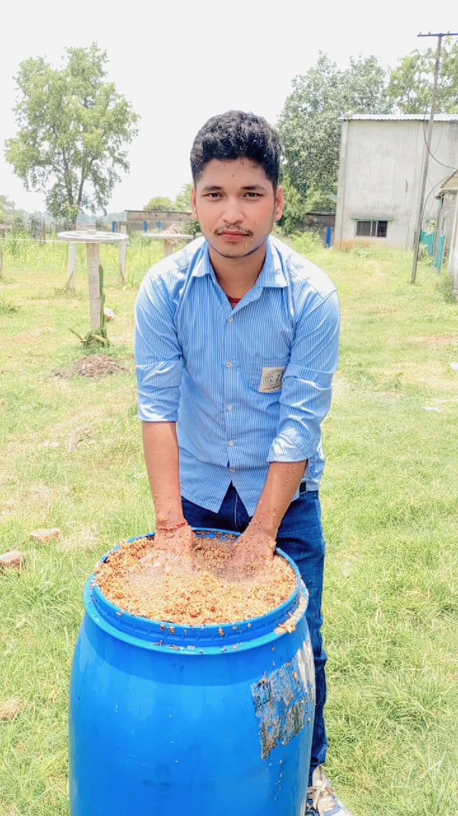
Figure 3.2: Group photograph at KVK Petarwar cultivation shed, Gagi, Jharkhand. Students and KVK staff with filled LDPE cultivation bags on the iron rod rack. GPS location: Lat 23.618263° N, Long 85.856238° E. Date: 25 May 2026. Source: Author photograph.

3.2 Study Duration and Cultivation Parameters
Table 3.1: Study details — site, duration, and cultivation parameters at KVK Petarwar
Parameter | Detail
Study Site | KVK Petarwar, Ramgarh District, Jharkhand — Mushroom Cultivation Shed
Study Period | 18 May 2026 to 17 June 2026 (31 days of systematic observation)
Total Bags Observed | 10 LDPE bags (40 cm × 60 cm, 100 µm thickness)
Primary Substrate | Paddy straw (Oryza sativa) — sun-dried, locally sourced
Species Observed | Pleurotus spp. (Oyster Mushroom; P. florida strain)
Spawn Type | Grain spawn (ICAR/DMR-certified, P. florida strain)
Spawn Rate | Approximately 3–5% of substrate dry weight (KVK Petarwar standard protocol)
Study Method | Qualitative visual observation; no quantitative yield measurement
Supervision | Under direct guidance of KVK Petarwar scientists and extension staff

3.3 Materials Used
Table 3.2: Materials and equipment used in the KVK Petarwar cultivation unit
Category | Item / Material | Purpose / Notes
Primary Substrate | Paddy straw (sun-dried) | Main growing medium; provides cellulose, hemicellulose, lignin for Pleurotus mycelium
Inoculant | Pleurotus spp. grain spawn | Certified P. florida strain; applied at 3–5% of substrate dry weight
Containers | LDPE polythene bags (40×60 cm) | Semi-permeable, economical, readily available cultivation bags
Pasteurisation | 200-litre metal drum + LPG burner | Hot-water pasteurisation of substrate at 70–80°C
Water Supply | Clean well/tap water | Substrate soaking, pasteurisation, and fruiting-phase misting
Sanitation | 70% isopropyl alcohol | Surface sterilisation of tools, work area, and hands before spawning
Humidity Mgt. | Pressure hand sprayer | 2–3 times daily misting during fruiting phase
Shelving | Iron rod rack | Supports bags during incubation and fruiting; allows air circulation

3.4 Substrate Preparation
Paddy straw (Oryza sativa) was selected as the primary substrate for all 10 cultivation bags at KVK Petarwar, both for its outstanding biological suitability for Pleurotus spp. and for its ready availability as an agricultural by-product in Jharkhand. The substrate preparation followed a strict, stepwise protocol prescribed by KVK Petarwar scientists.

Table 3.3: Substrate preparation protocol — step-wise procedure at KVK Petarwar
Step | Operation | Details / Purpose
1 | Selection & sorting | Sun-dried paddy straw; old, mouldy, or dust-contaminated material removed
2 | Chopping | Straw cut to 3–5 cm lengths; increases surface area for mycelial colonisation
3 | Soaking | Immersed in clean water for 12–16 hours to achieve initial moisture saturation
4 | Pasteurisation | Submerged in water at 70–80°C for 1–2 hours to reduce competing microorganisms
5 | Draining & cooling | Spread on clean plastic sheet; cooled to ambient temperature over 2–4 hours
6 | Moisture adjustment | Squeeze test: 60–65% moisture; substrate releases only a few drops when firmly squeezed

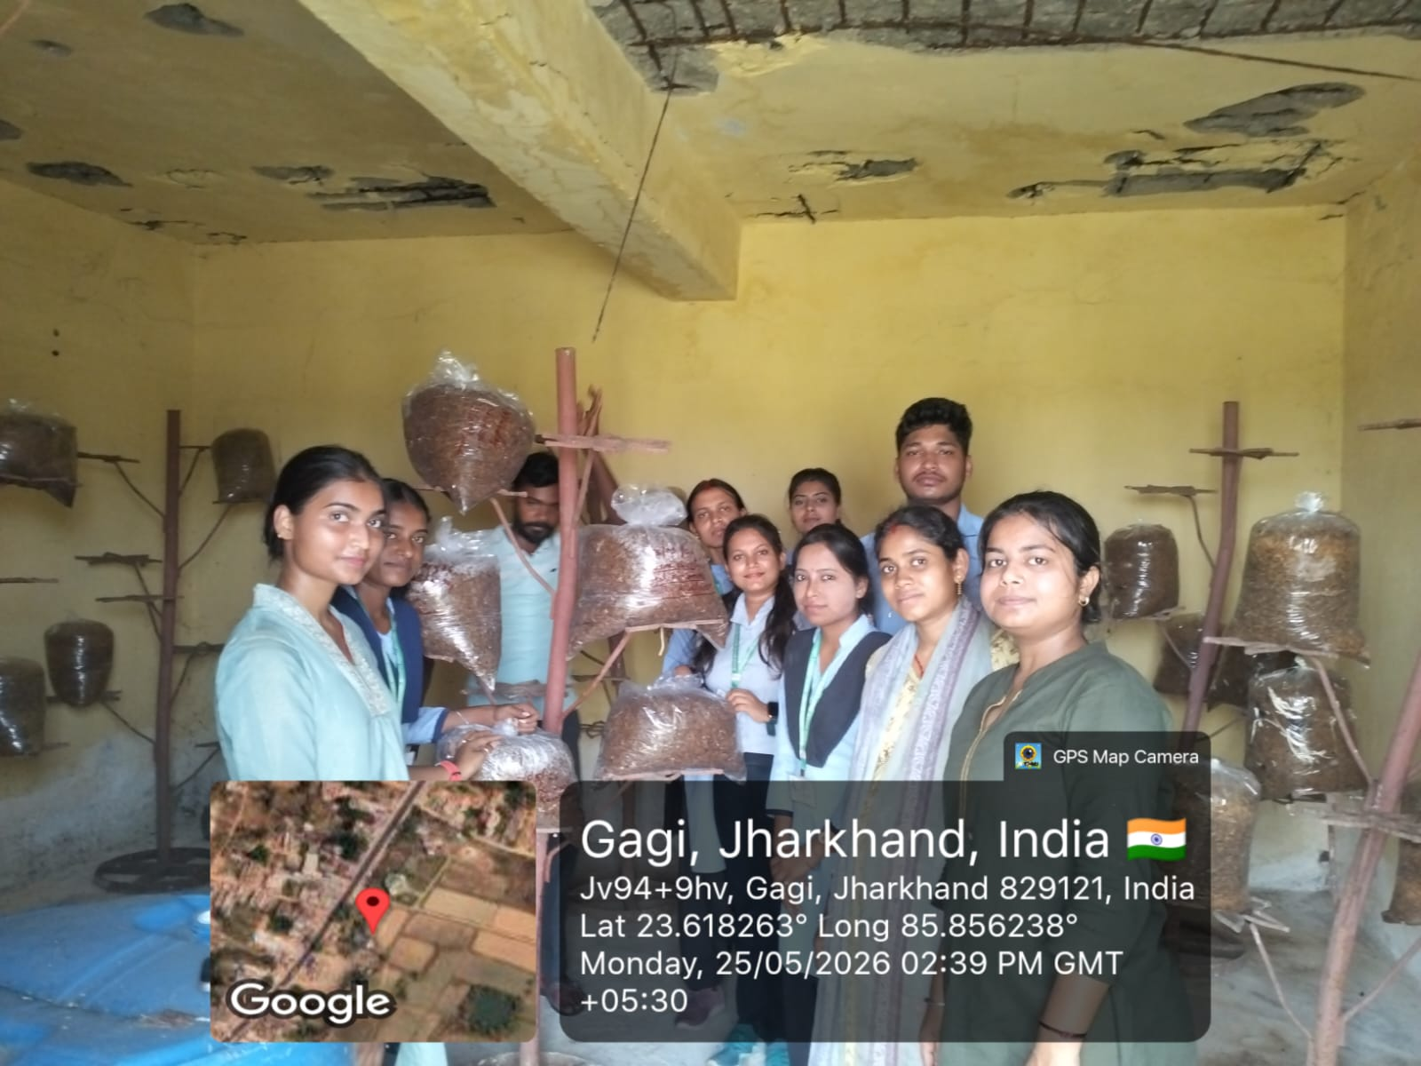
Figure 3.3: Paddy straw substrate sorted, chopped, and spread at KVK Petarwar. Substrate being collected into bags after drying to the appropriate moisture level. Source: Author photograph.

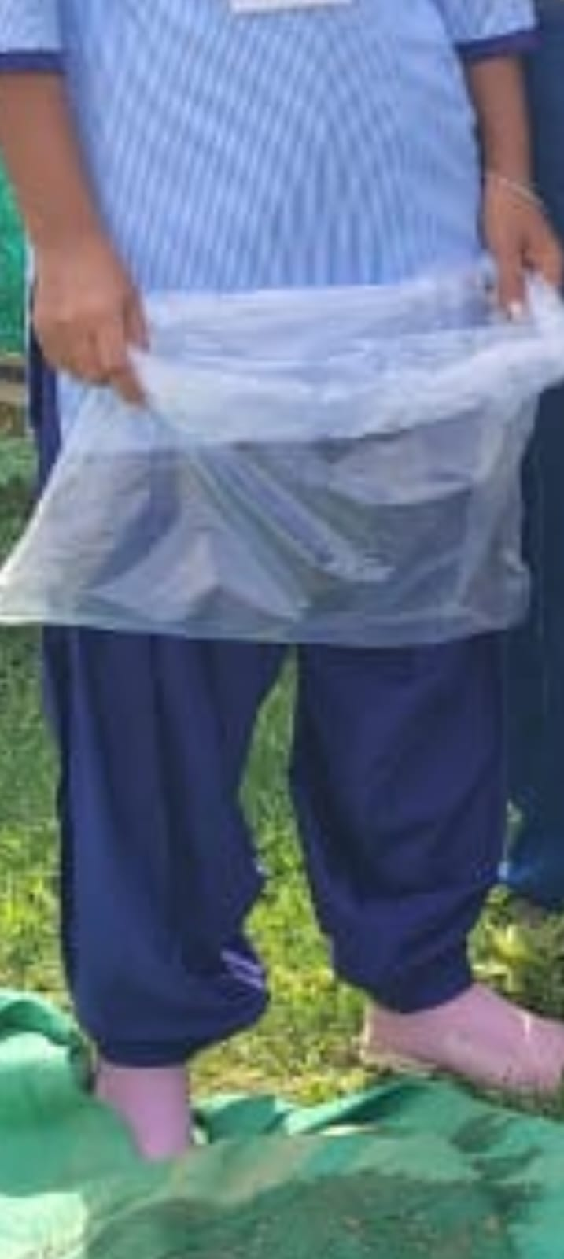
Figure 3.4: Substrate pasteurisation phase at KVK Petarwar — treated paddy straw substrate visible in the drum, showing the pasteurisation and preparation stage. Source: Author photograph.

3.5 Cultivation Flowchart
The complete cultivation process followed at KVK Petarwar, from substrate procurement to post-harvest management, is illustrated in Figure 3.1 below. This original flowchart documents each step in the sequential order practised at the demonstration unit.

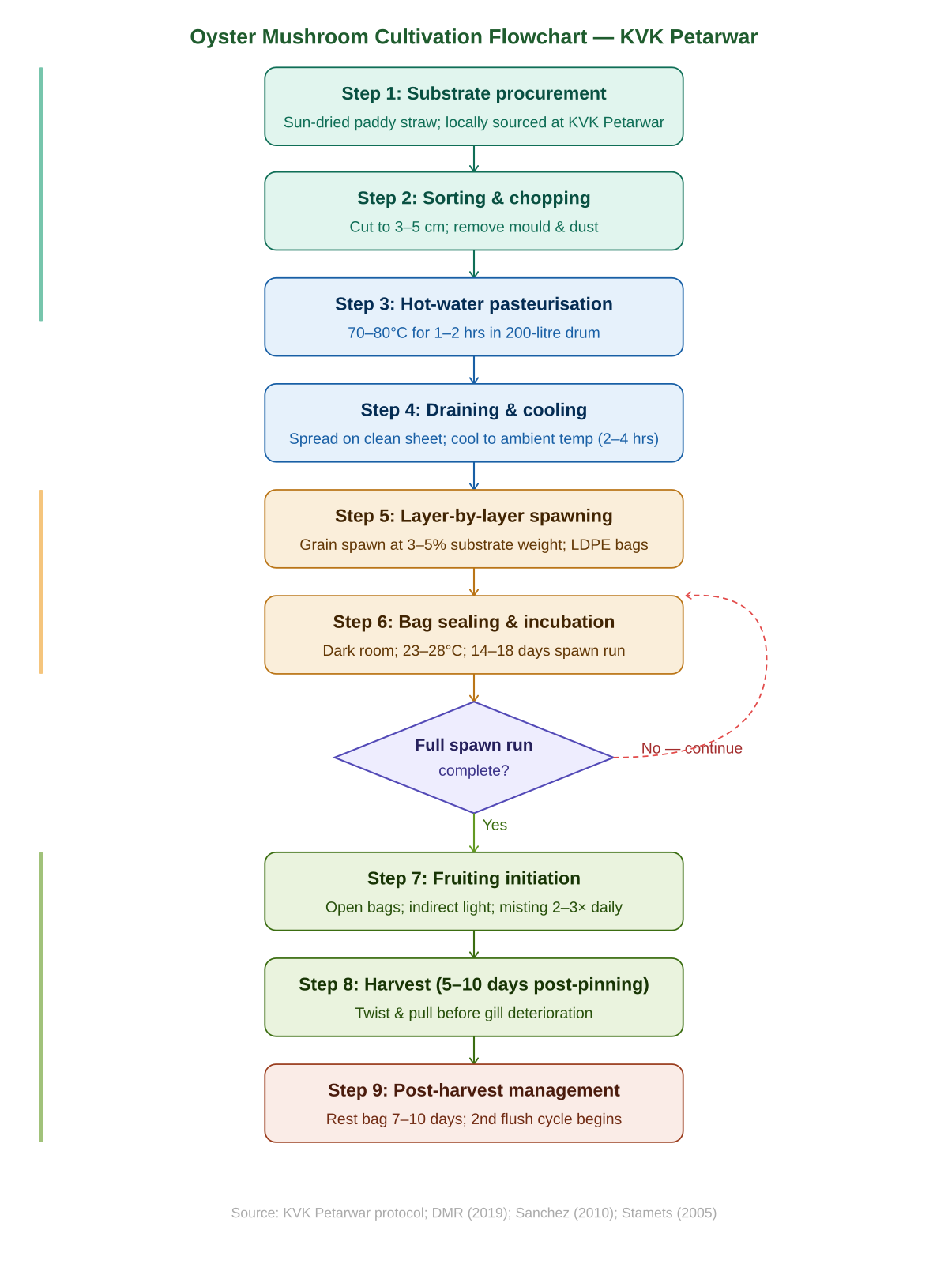
Figure 3.1: Oyster mushroom cultivation flowchart — complete step-by-step process from substrate procurement to post-harvest management, as practised at KVK Petarwar, Ramgarh, Jharkhand. Original diagram. Source: Author; based on KVK Petarwar protocol, DMR (2019), and Sanchez (2010).

3.6 Spawning Technique
Spawning was carried out using the layer-by-layer (sandwich) method, the standard approach for bag cultivation of Oyster Mushroom in India. Certified grain spawn of Pleurotus spp. (P. florida strain) was applied at approximately 3–5% of the substrate dry weight. The inoculation sequence: a layer of cooled, pasteurised substrate approximately 8–10 cm deep was placed in the LDPE bag, followed by a layer of spawn grains spread evenly across the surface. This layering was repeated three to four times until the bag was filled, with spawn applied as the final top layer. The inoculation area was sanitised with 70% isopropyl alcohol before spawning. All persons involved washed hands thoroughly. Filled bags were labelled with the inoculation date.

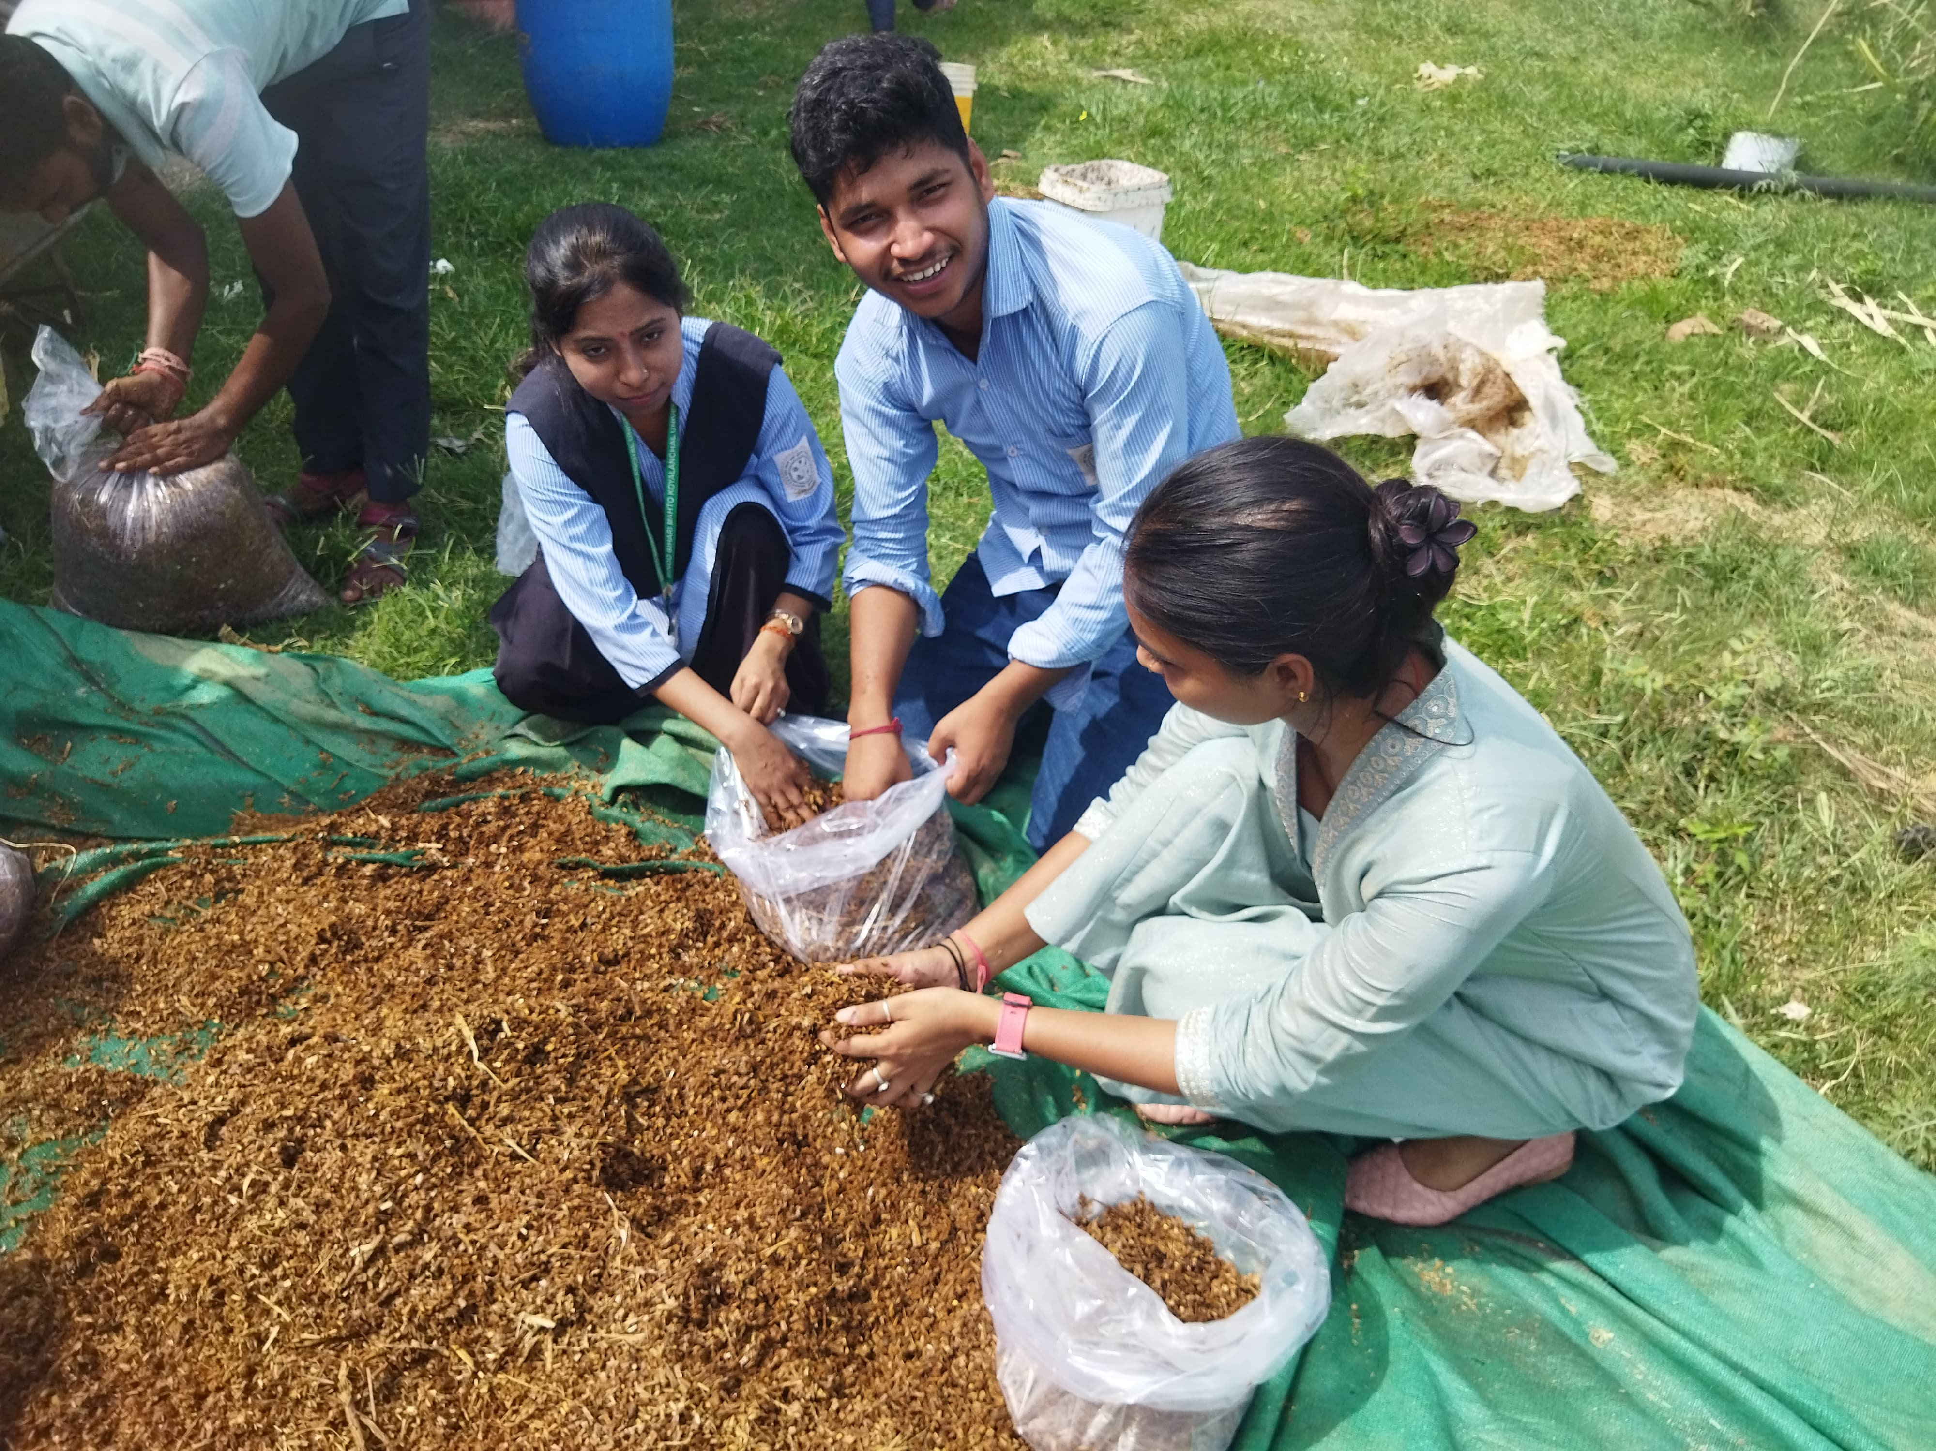
Figure 3.5: Layer-by-layer bag filling and spawning at KVK Petarwar. Students filling LDPE bags with chopped paddy straw substrate on a green tarpaulin. Source: Author photograph.

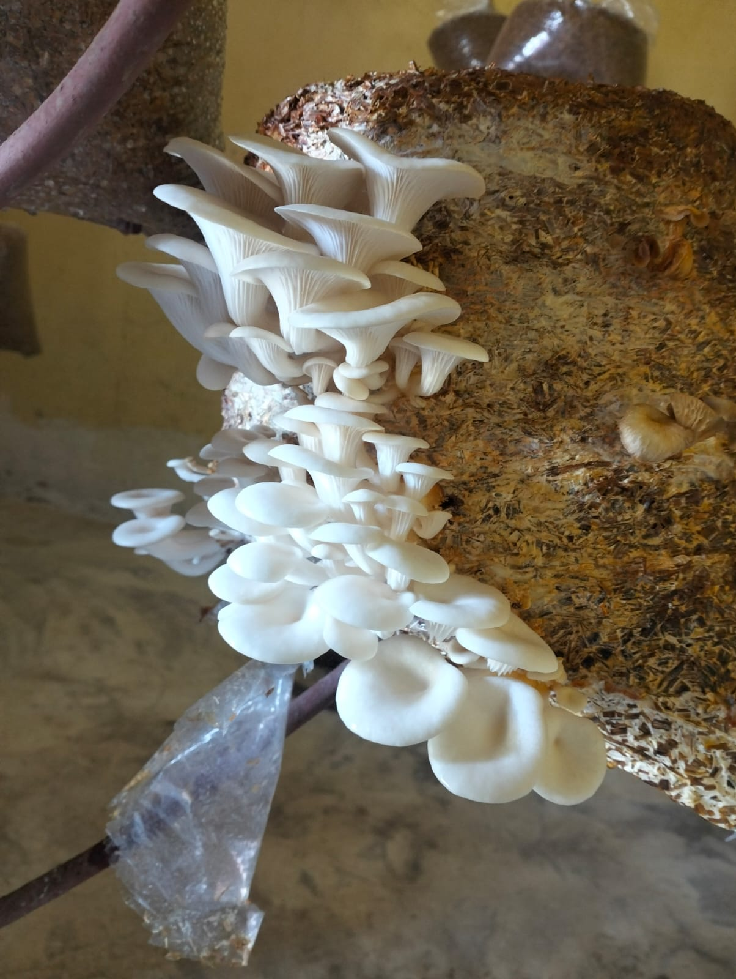
Figure 3.6: Plastic bag being held and prepared for sealing after filling with spawned substrate at KVK Petarwar. Source: Author photograph.

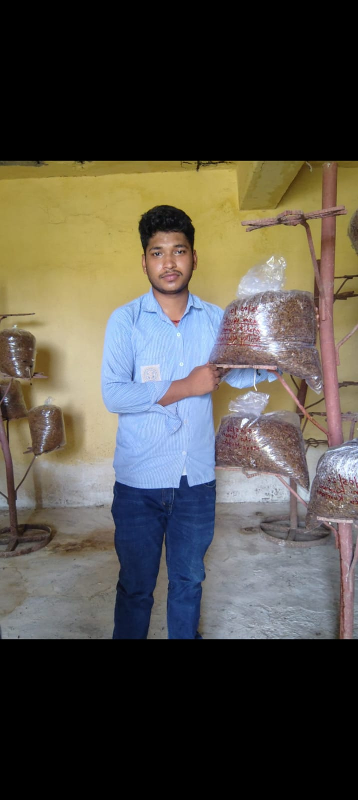
Figure 3.7: Student holding filled and spawned LDPE cultivation bags on the iron rod rack at KVK Petarwar. Multiple bags visible at various stages of preparation. Source: Author photograph.

3.7 Incubation and Fruiting Conditions
The 10 filled and sealed bags were transferred to the incubation section of the KVK Petarwar cultivation shed, maintained in near-total darkness at 23–28°C. Bags were placed on iron rod shelving with adequate spacing. No misting was conducted during incubation, as sealed bags retain internal moisture. Daily visual inspection covered: appearance and density of mycelial growth, colour, uniformity of colonisation, aroma, and any signs of contamination.

Once complete spawn run was confirmed, each bag was transferred to the fruiting area, opened or slit, and exposed to indirect natural daylight. Misting was conducted 2–3 times daily.

Table 3.4: Environmental management targets by growth phase at KVK Petarwar
Phase | Temp. | Humidity | Light | Duration
Incubation (Spawn Run) | 23–28°C | 60–70% | Near darkness | 14–18 days
Fruiting Management | 18–26°C | 80–95% | 8–12 h indirect | 5–10 days
Post-Harvest Rest | 18–28°C | 70–80% | Minimal | 7–10 days

3.8 Observation Method
This study employed a purely qualitative observational method. Observations were made through direct visual inspection supplemented by olfactory assessment (aroma of mycelium and fruiting bodies) and tactile assessment (firmness and texture of sporophores). Observations were recorded in a structured field notebook at defined intervals: upon inoculation; every two days during spawn run; at primordium initiation; every two days during fruiting development; and at harvest. This methodology ensures systematic, consistent, and reproducible qualitative documentation of the complete cultivation process. Quantitative yield data collection was beyond the scope of this training-based observational study, as the primary objective was to document and understand the cultivation process under KVK Petarwar expert guidance rather than to conduct independent experimental research.

Chapter 4: Results and Observations
This chapter presents detailed qualitative observations recorded during the 31-day study period (18 May to 17 June 2026) at the KVK Petarwar cultivation unit, covering all stages of the Oyster Mushroom cultivation cycle across all 10 bags. Nine bags (90%) completed the full cycle successfully; one bag showed Trichoderma spp. contamination on day 7 and was removed. All observations are qualitative; no numerical yield data are included, consistent with the training-based observational scope of this study.

4.1 Spawn Run (Mycelial Colonisation) Observation
Within 2–3 days of inoculation at KVK Petarwar, fine, brilliant white hyphal threads became clearly visible through the transparent LDPE bags, emerging from individual spawn grain inoculation points and radiating outward into the surrounding paddy straw substrate. By days 5–7, the sparse hyphal threads had merged into interconnecting, branching networks — a loose, cottony, cloud-like appearance that is one of the most reliable visual indicators of healthy, vigorous Pleurotus colonisation. A characteristic, clean, pleasant, earthy-fungal aroma became clearly detectable from the bags, gradually intensifying as colonisation progressed. This pleasant aroma contrasts sharply with the sour, musty, or ammonia-like odour accompanying bacterial contamination.

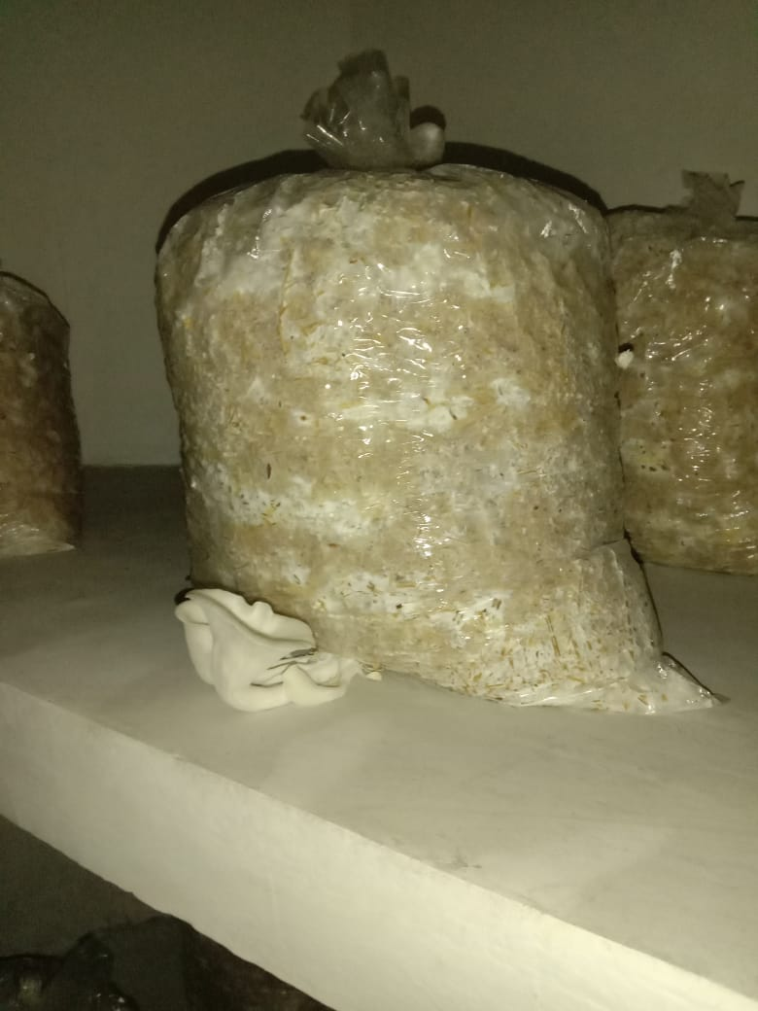
Figure 4.1: Early mycelial colonisation — LDPE cultivation bag at KVK Petarwar showing white Pleurotus mycelium visible at the base and sides, with small oyster mushroom primordia (pin-heads) beginning to emerge at the bag opening. Source: Author photograph.

Table 4.1: Qualitative observational record of spawn run characteristics
Observation Parameter | Description of Healthy Growth (9 Bags)
Mycelium colour | Bright white; cream-white in denser consolidated zones
Mycelium texture | Initially loose and cottony; becoming compact and velvety as colonisation advanced
Growth pattern | Radiating outward from spawn grain points; later forming a continuous, uniform mat
Aroma | Pleasant, earthy, faintly anise-like; gradually intensifying with colonisation progress
Rate of progress | Vigorous; visible advancement observable on each successive daily inspection
Substrate transformation | Paddy straw gradually transformed from golden-brown to white-coated, consolidated mass
Estimated completion | Full colonisation between day 14 and day 18 post-inoculation across 9 bags

4.2 Pinhead (Primordium) Formation
Following complete spawn run and transfer of bags to the fruiting room, the first signs of reproductive development — primordium initiation — were observed in all 9 healthy bags within 2–4 days. Small, whitish to pale grey, dome-shaped nodules appeared at the openings of the bags and at points where side slits had been made. Initial primordia were very small — less than 2 mm in diameter — but were readily distinguishable from mycelium by their domed, compact, three-dimensional, organised structural form. The location of pinning was consistently associated with points of fresh air exchange and light penetration, confirming the role of these stimuli in triggering reproductive development.

Table 4.2: Qualitative record of pinhead formation characteristics
Observation | Description
Timing of first pins | 2–4 days after transfer to fruiting conditions in all 9 healthy bags
Location | Consistently at bag openings and side slits; associated with light and fresh air access
Initial colour | White to pale grey-brown
Initial form | Tiny dome-shaped nodules; becoming elongated club-shapes within 2–3 days
Clustering | Multiple pins arising from common base points; tight, compact clusters
Response to humidity | Regular misting maintained pin viability; reduced misting caused visible pin tip drying

4.3 Fruiting Body Development and Maturity
From pin initiation, fruiting body development in all 9 healthy bags progressed rapidly. Within 2–3 days of first pin appearance, individual sporophores became clearly distinguishable within each cluster, with the primordial stipe and pileus differentiating visibly. The stipe elongated first, followed by the expansion of the pileus from a rounded, button-like form towards the characteristic fan or oyster-shell shape of mature Pleurotus. By approximately days 5–6 post-pinning, expanding pilei displayed darker grey to grey-brown colouration at the centre — diagnostic of P. florida under indoor cultivation — gradually lightening to cream-grey as the pileus approached full expansion. The white, closely-packed, decurrent gills on the underside became clearly visible at this stage.

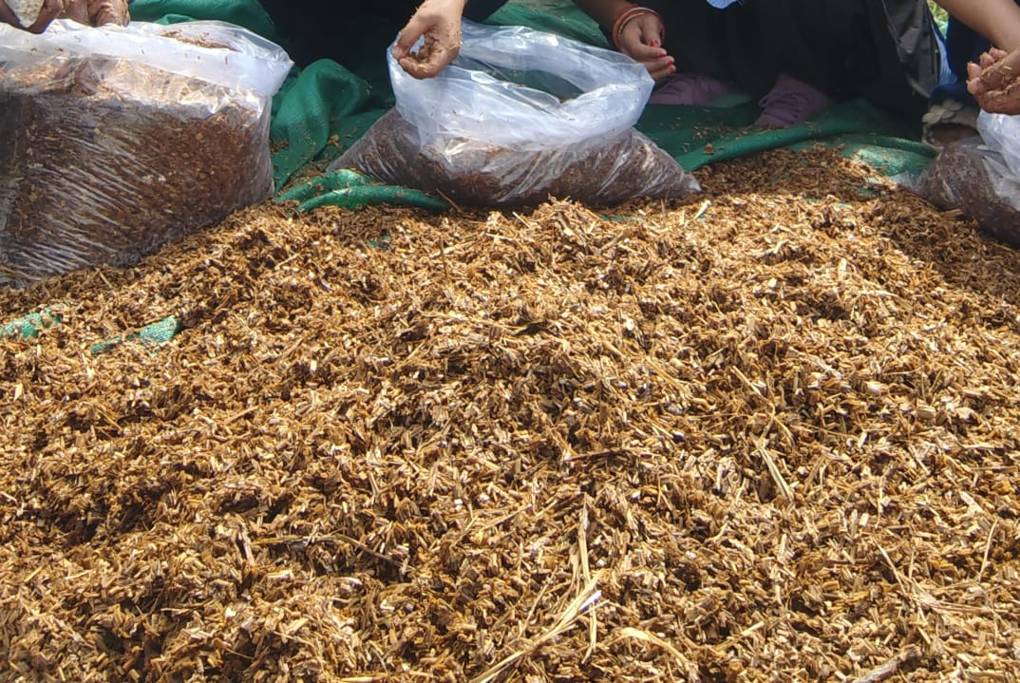
Figure 4.2: Mature Oyster Mushroom (Pleurotus spp.) cluster at first flush, growing from the side of an LDPE cultivation bag at KVK Petarwar. Fan-shaped white pilei with visible gills at harvest-ready stage. Source: Author photograph.

Table 4.3: Morphological characteristics of Pleurotus spp. fruiting bodies at harvest maturity
Morphological Feature | Observed Characteristics
Pileus (Cap) — Shape | Fan-shaped to semicircular; broadly convex upper surface; wavy, lobed margin
Pileus — Size | 5–15 cm diameter; variable within clusters
Pileus — Colour | Pale cream to light grey; centre typically slightly darker than margin
Pileus — Surface | Smooth; slightly shiny and moist when well-hydrated; dulls on drying
Gills (Lamellae) | Closely spaced; white to cream; decurrent (running down the stipe)
Stipe (Stem) | Short (1–3 cm); stout; lateral to eccentric attachment; white to off-white; firm
Flesh (Trama) | White; firm; succulent; slightly yielding; not soft or watery
Aroma | Pleasant; mild; distinctly fungal; faintly anise-like or seafood-reminiscent
Cluster Form | Multiple sporophores in overlapping, shelf-like arrangement from single base point

4.4 Growth Behaviour Observations
Three key growth behaviours were observed during the 31-day study period at KVK Petarwar that reveal precisely how Pleurotus spp. respond to their growing environment.

Phototropism: Developing fruiting bodies consistently oriented their expanding pilei towards the primary light source — the windows and openings of the KVK Petarwar cultivation shed. This phototropic response reflects the natural behaviour of Pleurotus in forest habitats, where fruiting bodies extend towards light-filled gaps in decaying wood.

CO₂ Sensitivity: On days when ventilation was reduced (windows closed during rain), developing stipes appeared noticeably more elongated and the pilei appeared smaller and more cupped. When ventilation was restored, subsequent development showed more normal, compact morphology. This observation is consistent with the well-documented sensitivity of Pleurotus fruiting body form to elevated CO₂ concentration above 0.08–0.1% (Stamets, 2005).

Humidity Dependence: On occasions when misting was delayed or reduced, the margins and tips of developing pilei showed visible drying symptoms within hours — a dull, whitened, or slightly crinkled appearance. Full, timely hydration maintained fruiting bodies moist, smooth-surfaced, and firm. Severe drying resulted in cracking of pileus margins, directly reducing commercial acceptability.

4.5 Contamination Observations
One bag (10%) showed signs of contamination on approximately day 7 of incubation, when a bright green, powdery, circular patch became visible through the transparent LDPE. The contaminating organism was identified by the KVK Petarwar scientist as Trichoderma spp. (green mould) — the most common competitive contaminant in mushroom cultivation. The bag was immediately removed from the incubation area, and no further contamination was observed in the remaining 9 bags for the rest of the study period.

Table 4.4: Contamination observations — type, appearance, probable cause, and management
Parameter | Details
No. of bags contaminated | 1 out of 10 bags (10%); 9 bags (90%) completed cycle successfully
Contaminant identified | Trichoderma spp. (green mould) — most likely T. viride or T. harzianum
Visual appearance | Bright green, powdery, circular patch; rapidly expanding over 24 hours
Probable cause | Incomplete pasteurisation at one localised zone in the substrate batch
Stage at detection | Day 7 of incubation — early enough for effective containment
Management action | Immediate removal from incubation room; disposal away from cultivation area
Impact on study | 9 bags remained unaffected; no further contamination observed after removal

Chapter 5: Discussion

5.1 Interpretation of Observations
The observations recorded during the 31-day study period at KVK Petarwar document a complete and highly successful Oyster Mushroom cultivation cycle in 9 of 10 bags, with systematic qualitative records at each defined growth stage. These observations are consistent with the established biological characteristics of Pleurotus spp. as described across decades of peer-reviewed scientific literature, supporting confidence in both the quality of observations made and the effectiveness of the KVK Petarwar cultivation protocol under local Jharkhand agro-climatic conditions.

The vigorous, visually striking mycelial growth observed during the spawn run — white, cottony, progressively and uniformly spreading, with a pleasantly earthy-fungal aroma — is consistent with published descriptions of healthy Pleurotus mycelium at 23–28°C. The characteristic aroma noted during colonisation corresponds to the documented volatile organic compound profile of Pleurotus mycelium, including 1-octen-3-ol (primary ‘mushroom’ aroma compound), benzaldehyde, and linalool (Mau et al., 2001).

5.2 Environmental Effect Discussion
The influence of environmental conditions on fruiting body morphology was among the most practically instructive aspects of this study. The contrast between bags maintained under adequate ventilation — which produced compact, robustly short-stiped, fully expanded fruiting clusters — and bags on days when ventilation was restricted — which showed elongated stipes and reduced pileus expansion — illustrates one of the most fundamental principles of mushroom morphology regulation.

Elevated CO₂ concentration above 0.08–0.1% is extensively documented to suppress pileus expansion and promote stipe elongation in Pleurotus spp. (Stamets, 2005). This response reflects the evolutionary ecology of the species: in natural forest habitats, Pleurotus extends its fruiting bodies towards gas-exchange openings, using elevated CO₂ as a directional signal. In the cultivation context, this natural tropism must be overridden through consistent, adequate ventilation to achieve compact, full-capped fruiting bodies demanded by fresh produce markets.

Humidity management was the most operationally demanding element of fruiting phase management. Developing Pleurotus sporophores are composed of approximately 85–92% water and must continuously absorb atmospheric moisture for sustained growth. The rapid onset of visible drying symptoms when misting was delayed by even a few hours underlines this dependence. The 2–3 times daily misting schedule maintained by KVK Petarwar staff was observed to be appropriate and effective for maintaining adequate hydration throughout the first flush development period.

5.3 Comparison with Published Literature
The colonisation timeline observed at KVK Petarwar — visible mycelium within 2–3 days, complete spawn run by days 14–18 — is directly consistent with Das et al. (2010) for West Bengal conditions and Kerketta et al. (2018) for Jharkhand specifically. The onset of pinning within 2–4 days matches the 3–5 day range documented by Sanchez (2010) globally. The total production cycle of 21–26 days from inoculation to first-flush harvest is consistent with the 20–30 day cycles reported for P. florida in Indian cultivation literature (DMR, 2019; IIHR, 2018). The single Trichoderma spp. contamination incident (10% of bags) falls within the 5–15% contamination rate range documented for small-scale cultivation without autoclave sterilisation (Poppe, 2000; Jiskani, 2001).

5.4 Substrate Effect Discussion
Paddy straw supported consistently vigorous colonisation and produced well-formed, commercially acceptable fruiting bodies in all 9 uncontaminated bags, firmly affirming its established position as the most reliable, accessible, and cost-effective substrate for Pleurotus spp. cultivation in the Indian context. The biological suitability of paddy straw for Pleurotus is mechanistically explained by the enzymes produced by this species: cellulases, hemicellulases, and ligninolytic enzymes systematically degrade the cellulose (35–40%), hemicellulose (20–25%), and lignin (12–16%) components of paddy straw, releasing and absorbing the resulting nutrients to support mycelial growth and reproductive development.

5.5 Study Limitations
This study was qualitative and training-based, conducted at a single KVK Petarwar demonstration unit over a single 31-day production cycle. Detailed yield analysis, economic analysis, statistical treatment, and treatment-based comparisons were intentionally excluded from scope. The qualitative nature of observations means that no numerical comparison of growth rates, yields, or environmental parameters is possible, and findings cannot be generalised without replication. The study captured only the first flush of fruiting; multi-flush seasonal production performance was not documented. These limitations are acknowledged explicitly and are consistent with the declared scope of this observational training study.

Chapter 6: Conclusion

6.1 Summary of Findings
This dissertation has documented the results of a qualitative, training-based observational study of Oyster Mushroom (Pleurotus spp.) cultivation conducted at the Krishi Vigyan Kendra (KVK) Petarwar, Ramgarh, Jharkhand, from 18 May 2026 to 17 June 2026. Ten LDPE cultivation bags were prepared using locally sourced paddy straw and certified P. florida grain spawn at 3–5% substrate weight. Nine bags (90%) completed the cultivation cycle successfully, producing healthy, well-formed, commercially acceptable first-flush Pleurotus sporophores. One bag (10%) was removed due to Trichoderma spp. contamination detected on day 7 of incubation.

6.2 Key Observations
- Pleurotus spp. mycelium is vigorous, white, cottony, and pleasantly aromatic — allowing reliable visual monitoring of healthy colonisation. Complete spawn run was consistently observed between days 14 and 18 across all 9 healthy bags at KVK Petarwar.
- Paddy straw is an excellent, highly suitable, and accessible substrate for Pleurotus cultivation, supporting complete colonisation and commercially acceptable fruiting body development without nitrogen supplementation, provided hot-water pasteurisation is correctly performed.
- Primordium initiation occurred reliably within 2–4 days of transfer to fruiting conditions in all 9 healthy bags, confirming the effectiveness of the KVK Petarwar protocol for triggering fruiting.
- Environmental conditions — CO₂ levels, humidity, light direction, and temperature — exerted clear and directly observable influences on fruiting body morphology and quality. Adequate ventilation, regular misting (2–3 times daily), and indirect light are essential for well-formed, commercially acceptable sporophores.
- The single contamination incident (Trichoderma spp., 10%) was attributed to incomplete pasteurisation; prompt removal effectively contained the contamination, with 9 of 10 bags completing the cycle successfully.
- KVK Petarwar's training model provides an effective, accessible, and practically grounded pathway for rural learners in Jharkhand to acquire mushroom cultivation skills in a low-risk, supervised demonstration environment.

6.3 Future Scope
- A quantitative follow-up study at KVK Petarwar with systematic recording of colonisation rates, primordium initiation timing, yields (fresh weight, biological efficiency), and sporophore morphometrics across multiple bags and seasons.
- Substrate comparison trials evaluating paddy straw against alternative locally available Jharkhand residues — wheat straw, sugarcane bagasse, cotton stalks — under controlled, replicated experimental conditions.
- Nitrogen supplementation trials evaluating rice bran, wheat bran, and soybean meal at different rates to determine yield enhancement potential and contamination risk trade-off under KVK Petarwar local conditions.
- Socioeconomic assessment of KVK Petarwar mushroom training programmes — evaluating technology adoption rates, household income impact, and market linkage development among trained farmer households in Ramgarh district.
- Post-harvest value addition investigation — sun-drying, mushroom powder, processed food products — to extend economic returns beyond dependence on fresh market sales.
- Multi-season, multi-site trials comparing P. florida, P. ostreatus, P. sajor-caju, and P. citrinopileatus performance under local Jharkhand agro-climatic conditions.

References
Adejoye, O. D., Adebajo, L. O., & Idowu, A. A. (2006). Proximate composition and mineral content of Pleurotus florida (Mont.) Singer, a Nigerian edible fungus. African Journal of Biotechnology, 5(19), 1727–1731.

Chang, S. T., & Miles, P. G. (2004). Mushrooms: Cultivation, nutritional value, medicinal effect, and environmental impact (2nd ed.). CRC Press, Boca Raton, FL.

Chang, S. T., & Wasser, S. P. (2012). The role of culinary-medicinal mushrooms on human welfare with a pyramid model for human health. International Journal of Medicinal Mushrooms, 14(2), 95–134.

Das, A. K., Singh, V., & Nanda, A. (2010). Comparative performance of three species of oyster mushroom (Pleurotus spp.) on paddy straw under West Bengal conditions. Mushroom Research, 19(1), 28–32.

Deepalakshmi, K., & Mirunalini, S. (2014). Pleurotus ostreatus: An oyster mushroom with nutritional and medicinal properties. Journal of Biochemical Technology, 5(2), 718–726.

Directorate of Mushroom Research (DMR). (2019). Mushroom cultivation technology (Technical Bulletin). Indian Council of Agricultural Research (ICAR), Solan, Himachal Pradesh.

Food and Agriculture Organization (FAO). (2020). World food and agriculture — Statistical yearbook 2020. FAO, Rome.

Girmay, Z., Gorems, W., Birhane, G., & Zewdie, S. (2016). Growth and yield performance of Pleurotus ostreatus (Jacq. Fr.) Kumm (oyster mushroom) on different substrates. AMB Express, 6, 87. https://doi.org/10.1186/s13568-016-0265-z

Grand View Research. (2021). Mushroom market size, share & trends analysis report by product, by form, by application, by region, and segment forecasts, 2021–2028. Grand View Research, San Francisco.

Hawksworth, D. L., & Lücking, R. (2017). Fungal diversity revisited: 2.2 to 3.8 million species. Microbiology Spectrum, 5(4), FUNK-0052-2016. https://doi.org/10.1128/microbiolspec.FUNK-0052-2016

Indian Institute of Horticultural Research (IIHR). (2018). Mushroom cultivation — Technical bulletin. ICAR-Indian Institute of Horticultural Research, Bengaluru.

Jiskani, M. M. (2001). Energy efficient cultivation of oyster mushroom. Dawn — Science, Technology and World, Agricultural Supplement, 24(3), 5–6.

Kerketta, A., Baxla, S. L., & Gupta, A. K. (2018). Comparative performance of edible mushrooms on different substrates under Jharkhand conditions. Journal of Pharmacognosy and Phytochemistry, 7(3), 3215–3219.

Kirk, P. M., Cannon, P. F., Minter, D. W., & Stalpers, J. A. (Eds.). (2008). Ainsworth and Bisby's dictionary of the fungi (10th ed.). CABI, Wallingford, UK.

Kumar, S., Bhatt, B. P., Bhattacharyya, P., & Bhardwaj, A. K. (2017). Economic viability of oyster mushroom cultivation: A case study from eastern India. Indian Journal of Agricultural Economics, 72(3), 356–365.

Mau, J. L., Lin, H. C., & Song, S. F. (2001). Antioxidant properties of several specialty mushrooms. Food Research International, 35(6), 519–526.

National Horticulture Board (NHB). (2020). Indian horticulture database 2019–2020. Ministry of Agriculture and Farmers Welfare, Government of India.

Obodai, M., Cleland-Okine, J., & Vowotor, K. A. (2003). Comparative study on the growth and yield of Pleurotus ostreatus mushroom on different lignocellulosic by-products. Journal of Industrial Microbiology and Biotechnology, 30(3), 146–149.

Poppe, J. (2000). Agricultural wastes as substrates for edible fungi. In L. J. L. D. van Griensven (Ed.), Science and cultivation of edible fungi (pp. 3–14). A. A. Balkema, Rotterdam.

Rai, R. D., & Verma, R. N. (1981). Cultivation of Pleurotus spp. on paddy straw. Mushroom Newsletter for the Tropics, 2(2), 5–9.

Royse, D. J., Baars, J., & Tan, Q. (2017). Current overview of mushroom production in the world. In D. Zied & A. Pardo-Giménez (Eds.), Edible and medicinal mushrooms: Technology and applications (pp. 5–13). Wiley-Blackwell, Chichester.

Sanchez, C. (2010). Cultivation of Pleurotus ostreatus and other edible mushrooms. Applied Microbiology and Biotechnology, 85(5), 1321–1337. https://doi.org/10.1007/s00253-009-2332-2

Sharma, R., & Garg, K. (2022). Role of Krishi Vigyan Kendras in mushroom technology dissemination in tribal districts of Jharkhand. Indian Research Journal of Extension Education, 22(2), 112–118.

Sinha, P., & Kumar, A. (2023). Impact of KVK-led mushroom cultivation training on farm income in Jharkhand: An economic analysis. Journal of Agricultural Extension and Rural Development, 15(1), 45–53.

Singh, M., Vijay, B., Kamal, S., & Wakchaure, G. C. (Eds.). (2011). Mushrooms: Cultivation, marketing and consumption. Directorate of Mushroom Research, ICAR, Solan.

Stamets, P. (2005). Mycelium running: How mushrooms can help save the world. Ten Speed Press, Berkeley, CA.

Wani, B. A., Bodha, R. H., & Wani, A. H. (2010). Nutritional and medicinal importance of mushrooms. Journal of Medicinal Plants Research, 4(24), 2598–2604.

Wasser, S. P. (2002). Medicinal mushrooms as a source of antitumour and immunomodulating polysaccharides. Applied Microbiology and Biotechnology, 60(3), 258–274.

Wasser, S. P., & Weis, A. L. (1999). Therapeutic effects of substances occurring in higher Basidiomycetes mushrooms: A modern perspective. Critical Reviews in Immunology, 19(1), 65–96.

Yadav, M., Singh, R. K., & Rawat, M. S. (2021). Effectiveness of KVK training on mushroom cultivation in Uttarakhand hills. Journal of Community Mobilization and Sustainable Development, 16(1), 143–150.

Appendix A: Observation Record Sheet
The following structured observation record sheet was used throughout the study period at KVK Petarwar to ensure consistent and systematic recording of qualitative data at each observation point.

Date | Day | Phase | Visual Observations | Aroma | Temp/RH | Remarks
__/__/__ | __ | Spawn Run |  |  | __°C/___%
__/__/__ | __ | Spawn Run |  |  | __°C/___%
__/__/__ | __ | Spawn Run |  |  | __°C/___%
__/__/__ | __ | Pinhead Init. |  |  | __°C/___%
__/__/__ | __ | Fruiting Dev. |  |  | __°C/___%
__/__/__ | __ | Fruiting Dev. |  |  | __°C/___%
__/__/__ | __ | Harvest |  |  | __°C/___%
__/__/__ | __ | Post-Harvest |  |  | __°C/___%

Appendix B: Glossary of Technical Terms
Term | Definition
Basidiomycota | Major fungal phylum; includes most edible and cultivated mushrooms; produces spores on club-shaped basidia
Beta-glucan | Polysaccharide found in mushroom cell walls; documented immunomodulatory, antitumour, and cholesterol-lowering properties
Biological Efficiency (BE%) | Fresh weight of mushroom produced expressed as percentage of dry substrate weight; standard productivity measure
CO₂ (Carbon Dioxide) | Above 0.1% causes stipe elongation and pileus suppression in Pleurotus fruiting bodies
Decurrent gills | Gills that run down the stipe from the pileus; key morphological feature of Pleurotus spp.
Fruiting body (Sporophore) | Reproductive structure of a fungus (the mushroom); site of spore production and release
Hyphae | Microscopic thread-like filaments forming the vegetative body (mycelium) of a fungus
KVK Petarwar | Krishi Vigyan Kendra, Petarwar, Ramgarh, Jharkhand; ICAR-affiliated district-level agricultural training centre
LDPE | Low-density polyethylene; inert, semi-permeable plastic used for cultivation bags in mushroom production
Lignocellulosic | Material composed of lignin, cellulose, and hemicellulose — the structural components of plant cell walls
Mycelium | Vegetative body of a fungus; network of hyphae; responsible for substrate colonisation and nutrient absorption
Pasteurisation | Heat treatment at 70–80°C to reduce competing microorganism populations without complete sterilisation
Pileus | The cap of a mushroom fruiting body; fan-shaped to semicircular with wavy, lobed margin in Pleurotus
Primordium | Early-stage fruiting body initial; first visible reproductive structure, appearing as small dome-shaped nodule
Spawn | Fungal inoculant; grain colonised with target mushroom species; used to inoculate cultivation substrate
Spawn run | Period of vegetative mycelial colonisation from inoculation until complete substrate colonisation
Stipe | The stem or stalk of a mushroom fruiting body; short and lateral in Pleurotus spp.
Substrate | Growing medium providing structural support and nutrition for mycelium and fruiting body development
Trichoderma spp. | Competitive green mould; most common contaminant in mushroom cultivation; controlled by adequate pasteurisation
White-rot fungi | Wood-decomposing fungi that degrade all lignocellulose components including lignin; includes Pleurotus spp.

Appendix C: Photograph Record
Figure Ref. | Subject / Description | Date / Stage
Figure 3.2 | Group photograph at KVK Petarwar cultivation shed — students and staff with bags on rack | 25 May 2026
Figure 3.3 | Paddy straw substrate sorted and spread prior to bag filling — KVK Petarwar | May 2026
Figure 3.4 | Substrate pasteurisation phase — blue drum with treated substrate material | May 2026
Figure 3.5 | Students filling LDPE bags with spawned paddy straw — outdoor session | May 2026
Figure 3.6 | Plastic bag being held and prepared for sealing after spawning | May 2026
Figure 3.7 | Student holding spawned LDPE bags on iron rod rack at KVK Petarwar | May 2026
Figure 4.1 | Early mycelial colonisation — bag with mycelium and pin-heads emerging at base | Day 7–10 incubation
Figure 4.2 | Mature Pleurotus cluster at first flush — harvest-ready sporophores | Day 21–26 post-inoculation

―――― End of Dissertation ――――

MOHIT KUMAR | Enrollment No.: 251831330715
M.Sc. Botany | Department of Botany, BBMKU Dhanbad | Session: 2025–2026

