FAERS 2024 Semaglutide Capstone
Blind Replication 2: step-by-step process record
Prepared for Maxwell Nyarko · Run date 1 October 2026 · R 4.4.1

Summary
This document records how the FAERS 2024 semaglutide analysis was rebuilt a second time from the raw FDA quarterly files, one step at a time, in an R session you could watch in the Terminal panel. The run paused at every checkpoint the replication spec defines, so each row count and the model reference levels could be reviewed before the next step began.
Result. Final analytic sample: 2,427 US reports in which semaglutide was the primary suspect drug. Every checkpoint count and every estimate is identical to the first blind replication (Blind Replication 1), and the analytic dataset is byte-for-byte identical. The pipeline therefore gives the same answer when built twice from the spec.
Item | Value
Final analytic sample | n = 2,427
Older vs younger: GI and metabolic (adjusted OR) | 0.71 (0.58–0.86)
Older vs younger: Cardiovascular (adjusted OR) | 1.15 (0.76–1.74)
Older vs younger: Psychiatric (adjusted OR) | 0.47 (0.30–0.75)
Age × sex interaction (LRT) | χ² = 0.78, df = 3, p = 0.85
Model fit (McFadden pseudo-R²) | 0.032
Table 1. Headline results. Reference outcome = Others; reference age group = 18–64.

Inputs and ground rules
Materials. Only the three items connected to the session were used: the replication spec (FAERS_Semaglutide_Replication_Spec.pdf, 30 September 2026), the Aims and Methods extract (for reference; the spec wins where they differ) and the FAERS_DATA_2024 folder.
Blind conditions. The original R Markdown code, results, Figure 1 counts and the original GitHub repository were not seen, as the spec requires. Information from earlier chats was not used. At the very start of the session, before these ground rules were set, folder and file names under Documents were listed to locate the project; no files were opened. After the rules were set, nothing outside the connected items and the output folders was accessed.
Where outputs live. Local folder: CAPSTONE AUTOMATION/BLIND_REPLICATION_2. GitHub (private): github.com/mkNyarko/capstone-blind-replication2. The first run is kept separately in BLIND_REPLICATION_1 and github.com/mkNyarko/capstone-blind-replication1.

Computational environment
Setting | Value
R | 4.4.1 (2024-06-14)
Platform | x86_64-apple-darwin20, macOS 15.7.9
Locale (collation) | en_US.UTF-8
Time zone | America/New_York
Key packages | data.table 1.17.0, dplyr 1.1.4, nnet 7.3-19, broom 1.0.11, pscl 1.5.9, gtsummary 2.4.0, ggplot2 4.0.0
Package match with spec | All 21 packages listed in the spec matched exactly
Seeds | None needed (multinom starts from zero weights; slice_* use with_ties = FALSE)
Table 2. Environment. Full sessionInfo() is in output/logs/sessionInfo.txt.

How the step-by-step run worked
Live session. A single R session (watch_steps.R) was started in a Terminal tab named “R replication 2”. Each step was written as a numbered R file and placed in a queue/ folder. The session picked it up, ran it with every line of code and its comments echoed, printed the output, and then filed the step under R/. Data stayed in memory between steps, so each step continued from the last.
Pauses. The run stopped after each of the seven cohort checkpoints and after the reference-level checkpoint, and waited for a “go” before continuing. The analysis half was run in three further steps with a pause after each.
One restart. The session was restarted once, after the setup step, because Rscript strips comments from echoed code. Adding keep.source = TRUE made the terminal show the code exactly as written. No data had been processed at that point.
Replay. The 15 step files run end to end, with the same echoed output, using:
LC_ALL=en_US.UTF-8 Rscript run_all.R

Step log
Step | What ran | Key output
00 | Setup: packages, paths, checkpoint tracker | Package versions confirmed
01 | 2024Q1 walkthrough: import DRUG/DEMO/REAC/OUTC; semaglutide rows; case list; US filter; three left joins; make.unique; collapse to one row per case (most severe outcome); write CSV | 7,307 drug rows → 5,943 cases → 4,935 US cases
02 | Same logic as a function, checked against Q1; Q2–Q4 (Q4: first semaglutide drug row per case) | Q2 2,101 · Q3 7,344 · Q4 2,901 US cases
03 | Read quarters back (CSV round-trip), stack | Checkpoint 1: 17,281
04 | Deduplicate: latest quarter per caseid; keep 19 spec columns | Checkpoint 2: 15,971
05 | Age group (capital labels, relabelled); age filter 18–120; placeholder text → NA | Checkpoint 3: 8,067
06 | Primary suspect filter; save cleaned file | Checkpoint 4: 5,302
07 | Read cleaned file back; no OUTC record → NR; drop NR | Checkpoint 5: 2,604
08 | Drop congenital anomaly (CA) | Checkpoint 6: 2,601
09 | Drop missing/UNK sex; relabel Male/Female | Checkpoint 7: 2,427
10 | Event categories, weight/dose categories, drug_standardized; reference levels | dose_cat ref <0.5 mg; wt_cat ref <80 kg
11 | Table 1; ROR/PRR (6 pairs) | Table 1 (.html/.docx/.csv); ror_prr.csv
12 | Main multinomial model; pseudo-R²; age × sex likelihood ratio test | Converged (code 0); LRT p = 0.85
13 | Sensitivity models S1–S4; Figures 2–4 | Sensitivity tables; 3 PNG figures
14 | Aim 3 support: key-PT age RORs; product mix by age | faers_key_pt_age_rors.csv; product mix
Table 3. The 15 steps, as filed in R/.

Cohort checkpoints
Before the first Figure 1 box, each quarter was already restricted to semaglutide reports, US reporter_country, and one row per case. Counts after each spec step:
# | Figure 1 box | n | Removed | What was removed
1 | Raw data (4 quarters combined) | 17,281 | — | Stacked per-quarter files (Q1 4,935; Q2 2,101; Q3 7,344; Q4 2,901)
2 | After deduplication | 15,971 | 1,310 | Cases in more than one quarter: 1,172 in two, 60 in three, 6 in four
3 | After cleaning age variable | 8,067 | 7,904 | Missing age 7,867; under 18: 34; over 120: 3
4 | Primary Suspect (PS) | 5,302 | 2,765 | Concomitant 2,131; secondary suspect 631; interacting 3
5 | After outcome cleaning | 2,604 | 2,698 | No OUTC record (non-serious): 2,698
6 | After excluding congenital anomaly | 2,601 | 3 | Congenital anomaly: 3
7 | Final analytic sample | 2,427 | 174 | Missing sex 171; UNK 3
Table 4. Checkpoint counts, for comparison with Figure 1.
Age rule in practice. Age was used as reported, with age_cod ignored, as the spec instructs. About 15 reports carried decade, month, week or day codes; a value such as 6 decades is read as age 6 and dropped. The largest raw age, 25,256, is almost certainly in days.
Checkpoint 5 note. After the CSV round-trip, all 2,698 missing outcome codes came back as empty strings, not NA. Both were recoded to NR and dropped at step 5. If the original code recoded only NA, its box 5 would read 5,302 and these reports would instead drop at box 6; the final sample would be unchanged.

Model reference levels
Factor | Reference | How set
event_category (outcome) | Others | Set explicitly
age_group | Younger Adults (18–64) | Set explicitly
sex | Male | Set explicitly
quarter | 2024Q1 | Set explicitly
dose_cat | <0.5 mg | as.factor(), en_US.UTF-8 collation
wt_cat | <80 kg | as.factor(), en_US.UTF-8 collation
Table 5. Sort order chosen by R: dose_cat <0.5 mg, ≥1 mg, 0.5–0.99 mg, Missing; wt_cat <80 kg, ≥100 kg, 80–99 kg, Missing. Sensitivity 4 (relabelled dose): High dose.

Results

Descriptive table (Table 1)
Characteristic | Overall (n = 2,427) | Younger 18–64 (n = 1,460) | Older ≥65 (n = 967)
Sex
Male | 762 (31%) | 402 (28%) | 360 (37%)
Female | 1,665 (69%) | 1,058 (72%) | 607 (63%)
Weight category
<80 kg | 243 (10%) | 172 (12%) | 71 (7.3%)
≥100 kg | 330 (14%) | 251 (17%) | 79 (8.2%)
80–99 kg | 317 (13%) | 239 (16%) | 78 (8.1%)
Missing | 1,537 (63%) | 798 (55%) | 739 (76%)
Dose category
<0.5 mg | 289 (12%) | 175 (12%) | 114 (12%)
≥1 mg | 534 (22%) | 303 (21%) | 231 (24%)
0.5–0.99 mg | 310 (13%) | 152 (10%) | 158 (16%)
Missing | 1,294 (53%) | 830 (57%) | 464 (48%)
Drug (standardized)
Combination Product | 27 (1.1%) | 24 (1.6%) | 3 (0.3%)
Ozempic | 1,656 (68%) | 849 (58%) | 807 (83%)
Rybelsus | 106 (4.4%) | 53 (3.6%) | 53 (5.5%)
Semaglutide (Unspecified) | 187 (7.7%) | 136 (9.3%) | 51 (5.3%)
Wegovy | 451 (19%) | 398 (27%) | 53 (5.5%)
Quarter of report
2024Q1 | 598 (25%) | 383 (26%) | 215 (22%)
2024Q2 | 439 (18%) | 239 (16%) | 200 (21%)
2024Q3 | 631 (26%) | 385 (26%) | 246 (25%)
2024Q4 | 759 (31%) | 453 (31%) | 306 (32%)
Adverse event category
Others | 1,499 (62%) | 850 (58%) | 649 (67%)
Gastro-Intestinal and Metabolic | 706 (29%) | 465 (32%) | 241 (25%)
Cardiovascular | 102 (4.2%) | 51 (3.5%) | 51 (5.3%)
Psychiatric-related | 120 (4.9%) | 94 (6.4%) | 26 (2.7%)
Outcome category
Death | 66 (2.7%) | 43 (2.9%) | 23 (2.4%)
Life-threatening | 118 (4.9%) | 96 (6.6%) | 22 (2.3%)
Hospitalization | 944 (39%) | 558 (38%) | 386 (40%)
Disability | 102 (4.2%) | 70 (4.8%) | 32 (3.3%)
Required intervention | 65 (2.7%) | 51 (3.5%) | 14 (1.4%)
Other serious outcome | 1,132 (47%) | 642 (44%) | 490 (51%)
Table 6. Characteristics by age group (the capstone's Table 1), n (%), column percentages.

Disproportionality (ROR and PRR)
Comparison | Event | a / c | ROR (95% CI) | PRR | CI excludes 1
Age (Older vs Younger) | Gastro-Intestinal and Metabolic | 241 / 465 | 0.71 (0.59–0.85) | 0.78 | Yes
Age (Older vs Younger) | Cardiovascular | 51 / 51 | 1.54 (1.03–2.29) | 1.51 | Yes
Age (Older vs Younger) | Psychiatric-related | 26 / 94 | 0.40 (0.26–0.62) | 0.42 | Yes
Sex (Female vs Male) | Gastro-Intestinal and Metabolic | 477 / 229 | 0.93 (0.77–1.13) | 0.95 | No
Sex (Female vs Male) | Cardiovascular | 61 / 41 | 0.67 (0.45–1.00) | 0.68 | No
Sex (Female vs Male) | Psychiatric-related | 84 / 36 | 1.07 (0.72–1.60) | 1.07 | No
Table 7. Each event vs all other categories (including Others), within semaglutide reports. Wald 95% CI, no continuity correction.
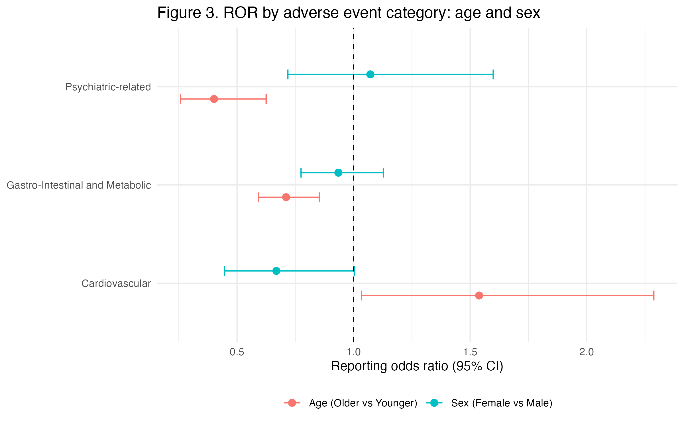
Figure 3. ROR by event category, age and sex comparisons. Figure 2 (age rows only) is in output/figures.

Multinomial logistic regression
Event category | Adjusted OR (95% CI) | p
Gastro-Intestinal and Metabolic | 0.71 (0.58–0.86) | 0.0005
Cardiovascular | 1.15 (0.76–1.74) | 0.514
Psychiatric-related | 0.47 (0.30–0.75) | 0.002
Table 8. Older (≥65) vs younger (18–64), adjusted for sex, quarter, dose and weight category. Reference outcome = Others.
Fit and interaction. The model converged in about 40 iterations. McFadden pseudo-R² = 0.032; G² = 143.8; log-likelihood -2206.3 vs -2278.2 for the null model. Adding age_group:sex did not improve fit (χ² = 0.78, df = 3, p = 0.85).
Other terms. Missing weight was strongly associated with fewer psychiatric terms (OR 0.27); weight 80–99 kg with more GI terms (OR 1.65); 2024Q2 with fewer GI terms (OR 0.69); 2024Q4 with fewer psychiatric terms (OR 0.58). Female vs male for cardiovascular terms was 0.66 (p = 0.055).

Sensitivity analyses
Model | n | Gastro-Intestinal and Metabolic | Cardiovascular | Psychiatric-related
Main | 2,427 | 0.71 (0.58–0.86) | 1.15 (0.76–1.74) | 0.47 (0.30–0.75)
S1: exclude missing dose | 1,133 | 0.66 (0.50–0.87) | 1.30 (0.74–2.30) | 0.66 (0.30–1.46)
S2: exclude missing weight | 890 | 1.26 (0.90–1.78) | 0.83 (0.32–2.16) | 0.35 (0.17–0.74)
S3: exclude both | 314 | 1.04 (0.60–1.81) | 0.94 (0.26–3.43) | 0.14 (0.02–1.15)
Table 9. Age-group ORs (older vs younger) across models. S4 (relabelled dose, same cut-points) left the age ORs unchanged.
The GI finding holds when missing dose is excluded but not when missing weight is excluded. The psychiatric finding holds when missing weight is excluded but not when missing dose is excluded. With both excluded (n = 314) the intervals are too wide to interpret.

Aim 3: comparison with label and trial evidence
FAERS gives reporting ratios within semaglutide reports; trials give incidence against placebo, so only the direction and presence of a signal are compared. The literature review (current DailyMed labels, SUSTAIN-6, PIONEER 6, STEP 1–4, SELECT, age-subgroup analyses, FDA Sentinel) was carried out on 1 October 2026 during run 1; its FAERS inputs were recomputed in step 14 and are identical, so the classifications are unchanged.
Row | FAERS age finding | Label / trial evidence | Class
GI and metabolic | ↓ older (ROR 0.71; OR 0.71) | Labelled; ↑ vs placebo; trials show no age gradient | Concordant
Cardiovascular | ↑ crude (ROR 1.54); null adjusted (OR 1.15) | HR increase, hypotension, syncope labelled; MACE ↓ and consistent by age | Concordant
Psychiatric-related | ↓ older (ROR 0.40; OR 0.47) | Not in current labels (Wegovy warning removed 02/2026); FDA 91-trial meta-analysis and Sentinel: no increase | Novel (by rule)
Others | Reference | — | Indeterminate
Pancreatitis | 0.78 (0.52–1.16) | Labelled (5.2); rare in trials | Concordant
Gallbladder | 0.41 (0.19–0.90) | Labelled; ↑ vs placebo | Concordant
Hypoglycaemia | 0.82 (0.30–2.23) | Labelled; no age gradient in trials | Concordant
Ileus / obstruction / gastric emptying | 0.40 (0.26–0.63) | Labelled (postmarketing) | Concordant
Nausea / vomiting / diarrhoea / constipation | 0.84 (0.64–1.10) | Labelled; ≥65 similar to overall | Concordant
Suicidal ideation / behaviour | 0.13 (0.04–0.44) | As psychiatric row | Novel (by rule)
Heart rate increased / tachycardia | 0.91 (0.22–3.80) | Labelled | Concordant
Dehydration | 1.11 (0.56–2.23) | AKI via volume depletion labelled | Concordant
Diabetic ketoacidosis | 0.75 (0.19–3.02) | Not labelled | Indeterminate
Table 10. Evidence classification. PT-level rows show age ROR (95% CI). Full table and sources: aim3/AIM3_evidence_comparison.md.
Follow-up. No row is divergent. The psychiatric rows are “novel” only under the spec’s rule: the finding is less reporting in older adults, not an excess risk. Indication is a likely confounder (Wegovy is 27% of younger reports vs 5.5% of older), so stratifying by product is the suggested follow-up.

Agreement with Blind Replication 1
Every checkpoint count, the analytic dataset (byte-identical), ROR/PRR, multinomial ORs, model fit, interaction test, sensitivity models and key-PT RORs are identical between the two runs. Only some label text in two output tables differs (for example “Age (Older vs Younger)”).

Judgement calls
Issue | What was done
Empty strings after CSV round-trip | Missing outc_cod ("" or NA) treated as no OUTC record → NR, per the spec. Empty sex → NA via factor levels.
Order of placeholder clean-up | Applied after the age filter and before the PS filter; either order gives the same rows.
Sensitivity model fitting | do.call() used so broom::tidy(conf.int = TRUE) can re-evaluate the model call; estimates unchanged.
Deprecated plot function | geom_errorbar(orientation = "y") in place of geom_errorbarh() (ggplot2 4.0.0); plots unchanged.
Table 11. Decisions where the spec left room.

Open items
Figure 1 comparison. Compare Table 4 with the withheld Figure 1 counts, starting with box 5 (see the Checkpoint 5 note under Cohort checkpoints).
Suggested analysis. Repeat the age comparison within product (Wegovy vs Ozempic/Rybelsus) to separate age from indication.

