AI Spam Classifier

**Introduction**

In today's digital age, the proliferation of electronic communication has led to an increasing amount of unwanted, irrelevant, or harmful messages commonly known as spam. Spam can be a significant nuisance, clogging email inboxes, social media feeds, and other online platforms. To combat this issue effectively, Artificial Intelligence (AI) has played a pivotal role in developing spam classifiers.

**Understanding Spam**

Spam refers to any unsolicited and often irrelevant or inappropriate messages sent over digital channels. These messages can take various forms, including email spam, SMS spam, social media spam, and comment spam on websites. Spam can be commercial in nature, promoting products or services, or malicious, intending to deceive, steal personal information, or spread malware.

**The Need for AI Spam Classifiers**

The volume of spam messages can be overwhelming, making it nearly impossible for users to manually filter through their communications effectively. Traditional rule-based methods, while still in use, are limited in their ability to adapt to evolving spam tactics. This is where AI spam classifiers come into play.

**How AI Spam Classifiers Work**

AI spam classifiers leverage machine learning techniques to automatically identify and categorize messages as either spam or not spam. These systems analyze various features of messages, such as text content, sender information, and metadata, to make informed decisions. Common techniques include Natural Language Processing (NLP), supervised learning, and neural networks.

**Types of AI Spam Classifiers**

a. Rule-Based Classifiers

These classifiers use predefined rules to flag messages as spam or not. While effective to some extent, they struggle to adapt to new and evolving spam tactics.

b. Machine Learning Classifiers

Machine learning classifiers use historical data to train models to recognize spam patterns. These models can continuously improve their accuracy over time.

c. Deep Learning Classifier

Deep learning models, like Convolutional Neural Networks (CNNs) and Recurrent Neural Networks (RNNs), excel in processing large amounts of text data and are highly effective in spam detection.

**Challenges in AI Spam Classification**

AI spam classifiers face several challenges, including:

 Evolving Tactics: Spammers continually change their methods to evade detection.

 False Positives: Overzealous spam filters may flag legitimate messages as         spam.

 Multilingual Content: Handling messages in different languages.

 Contextual Understanding: Determining context, sarcasm, or nuanced content.

 Privacy Concerns: Balancing spam detection with user privacy.

**Benefits of Using AI Spam Classifiers**

Efficiency: Automates the spam filtering process, saving users time.

Accuracy: Continuously learns and adapts to new spam techniques.

Customization: Users can fine-tune classifiers to match their preferences.

Reduced Security Risks: Protects users from malicious content.

**Applications of AI Spam Classifiers**

AI spam classifiers are used in various applications, including:

Email: Filtering spam from email inboxes.

Social Media: Removing spammy comments and accounts.

Messaging Apps: Preventing unwanted messages.

Websites: Filtering out comment and forum spam.

E-commerce: Identifying and blocking fake product reviews.

**Future Trends in AI Spam Classification**

As technology continues to advance, AI spam classifiers will likely:

Leverage Explainable AI: Providing transparency in decisions.

Enhance Multilingual Support: Better handling of diverse languages.

Integration with IoT: Protecting smart devices from spam.

Privacy-Preserving AI: Balancing spam detection with user privacy.

`**AI INNOVATION**

Machine learning advances: Improved machine learning algorithms, like deep learning and recurrent neural networks, have enhanced the accuracy of spam classifiers by allowing them to learn complex patterns in text data.

Beheavioural Analysis: Some spam classifiers now consider the behaviour of users , such as how they interact with emails or messages, to identify spammy patterns and adapt to new spam tactics.

Ensemble model: Combining multiple machine learning models has become common to boost accuracy and reduce falser positive in spam classification.

Deep learning for audio and image spam: The use of deep learning for image and audio spam detection has become more prevalent as spammers diversify their methods.

Language models: Advanced language model like GPT-3 can assist in contextual understanding and identifying spam with more natural language processing.

**TECH STACK**

**Front-End**

Implementing UI/UX using HTML, CSS, and JavaScript to create an intuitive and user-friendly interface.

The frontend development is responsible for creating the visual interface through which guests interact with the chatbot. It focuses on delivering a user experience (UX) that is intuitive, visually appealing, and responsive to user actions.

HTML (HyperText Markup Language): HTML forms the structural foundation of the chatbot's interface. It defines the layout and arrangement of elements, allowing for proper organization and presentation of information.

```

<!DOCTYPE html>

<html>

<head>

<title>SMS Spam Classifier</title>

<link rel="stylesheet" type="text/css" href="style.css">

</head>

<body>

<h1>SMS Spam Classifier</h1>

<textarea id="smsInput" placeholder="Enter your SMS message here..." rows="10" cols="50"></textarea>

<button id="classifyButton">Classify</button>

<p id="result"></p>

<script src="script.js"></script>

</body>

</html>

```

CSS (Cascading Style Sheets): CSS is used to style and design the HTML elements. It determines the visual aspects such as colors, fonts, spacing, and layout, ensuring a cohesive and aesthetically pleasing user interface.

```

body {

font-family: Arial, sans-serif;

text-align: center;

}

h1 {

font-size: 24px;

margin-top: 20px;

}

textarea {

padding-left: 30%;

width: 80%;

padding: 10px;

margin: 20px auto;

}

button {

padding: 10px 20px;

background-color: #007BFF;

color: #fff;

border: none;

cursor: pointer;

}

button:hover {

background-color: #0056b3;

}

#result {

margin: 20px;

font-size: 18px;

}

```

**BACK END**

Flask:Flask is a micro web framework for python that is designed to be lightweight and easy to build web applications and APIS.It’s simplicity and extensibility make it a popular option for many developers.

```

app = Flask(_name_)

@app.route('/')

def index():

return render_template('spam_classifier.html', result="")

@app.route('/classify', methods=['POST'])

def classify():

message = request.form.get('message')

# Implement your AI-based spam classification logic here

# result = classify_spam(message) # Replace with your actual classification function

result = "This is a sample result."

return render_template('spam_classifer.html', result=result)

if _name_ == '_main_':

app.run(debug=True)

```

Python: Python is one of the most popular programming languages for machine learning. You'll need Python installed, and you can use package managers like pip to install the necessary libraries.

```

import numpy as np

import pandas as pd

from sklearn.model_selection import train_test_split

from sklearn.feature_extraction.text import CountVectorizer

from sklearn.linear_model import LogisticRegression

from flask import Flask, render_template, request

import joblib

appfrom sklearn.metrics import accuracy_score, precision_score, recall_score, f1_score

def load_data(file_path):

df = pd.read_csv(spam.csv, header=None)

df = df.dropna()

return df[0], df[1]

def preprocess_text(text):

# Implement your text preprocessing steps here

pass

data_file_path = "spam.csv"

X, y = load_data(data_file_path)

X = X.apply(preprocess_text)

X_train, X_test, y_train, y_test = train_test_split(X, y, test_size=0.2, random_state=42)

vectorizer = CountVectorizer()

X_train_counts = vectorizer.fit_transform(X_train)

X_test_counts = vectorizer.transform(X_test)

clf = LogisticRegression()

clf.fit(X_train_counts, y_train)

y_pred = clf.predict(X_test_counts)

print("Accuracy:", accuracy_score(y_test, y_pred))

print("Precision:", precision_score(y_test, y_pred))

print("Recall:", recall_score(y_test, y_pred))

print("F1 Score:", f1_score(y_test, y_pred))

```

NumPy: NumPy is a fundamental library for numerical and matrix operations. It provides support for arrays and mathematical functions essential for machine learning.

Pandas: Pandas is used for data manipulation and analysis. It's especially helpful for data preprocessing and cleaning.

Scikit-Learn: Scikit-Learn is a powerful library for machine learning. It provides various tools for classification, regression, clustering, and more.

Matplotlib and Seaborn: These libraries are used for data visualization. They are essential for understanding your data and model performance.

TensorFlow or PyTorch: Depending on your preference, you may use TensorFlow or PyTorch as deep learning frameworks. These libraries are essential for building and training neural networks.

Keras: Keras is an abstraction layer that sits on top of TensorFlow and other backends. It simplifies the process of building and training neural networks.

Jupyter Notebook: While not strictly necessary, Jupyter Notebook is a popular tool for creating and sharing documents that contain live code, equations, visualizations, and narrative text. It's often used for developing and documenting machine learning models.

Scipy: Scipy builds on NumPy and provides additional functionality for scientific and technical computing. It includes functions for optimization, integration, interpolation, and more.

XGBoost or LightGBM: These are popular libraries for gradient boosting, which can be particularly useful for structured data and tabular data problems.

NLTK (Natural Language Toolkit) or SpaCy: If your project involves natural language processing (NLP), you'll need one of these libraries to work with text data.

OpenCV: If you're working with computer vision tasks, OpenCV is a valuable package for image and video analysis.

TextBlob: TextBlob is a simple library for processing textual data, including text classification tasks.

Gunicorn (optional): Gunicorn is a production-ready WSGI HTTP server that can be used to serve your Flask application.

Heroku (optional): If you plan to deploy your Flask application to the web, you might want to consider using a cloud platform like Heroku. You'll need to install the Heroku CLI and set up your account.

**NAIVE BAYES**

1.Begin by gathering a labeled dataset. The dataset should include examples of both spam and non-spam messages. Each example should be represented as a feature vector

2.Next, we will need to calculate the probability distributions for each label (spam and non-spam) given the data in your training set.

a. Start by calculating the number of messages for each label.

b. Next, calculate the probabilities of each feature occurring for each label. We can do this by counting the number of times each feature appears for each label and then dividing by the total number of messages for that label.

3.After we have calculated the probability distributions, we can use the Naive Bayes model to make predictions about new, unseen data.

a. To predict whether a new message is spam or not, calculate the probabilities of each feature occurring for the spam label and for the non-spam label.

b. Next, use the Bayes theorem to calculate the probability of the spam label given the features in the new message, and the probability of the non-spam label given the features in the new message.

c. Finally, classify the new message as spam if the probability of the spam label is greater than the probability of the non-spam label, and as non-spam otherwise

Python Code:

```

import numpy as np

import pandas as pd

from sklearn.model_selection import train_test_split

from sklearn.feature_extraction.text import CountVectorizer

from sklearn.linear_model import LogisticRegression

from flask import Flask, render_template, request

import joblib

appfrom sklearn.metrics import accuracy_score, precision_score, recall_score, f1_score

def load_data(file_path):

df = pd.read_csv(spam.csv, header=None)

df = df.dropna()

return df[0], df[1]

def preprocess_text(text):

# Implement your text preprocessing steps here

pass

data_file_path = "spam.csv"

X, y = load_data(data_file_path)

X = X.apply(preprocess_text)

X_train, X_test, y_train, y_test = train_test_split(X, y, test_size=0.2, random_state=42)

vectorizer = CountVectorizer()

X_train_counts = vectorizer.fit_transform(X_train)

X_test_counts = vectorizer.transform(X_test)

clf = LogisticRegression()

clf.fit(X_train_counts, y_train)

y_pred = clf.predict(X_test_counts)

print("Accuracy:", accuracy_score(y_test, y_pred))

print("Precision:", precision_score(y_test, y_pred))

print("Recall:", recall_score(y_test, y_pred))

print("F1 Score:", f1_score(y_test, y_pred))

```

**DATASET EXPLANATION**

Dataset Representation:

In a CSV dataset, data is organized into rows and columns, with each row representing an individual data sample (e.g., SMS messages), and each column representing a feature or attribute of the data.

For a classification task like SMS spam classification, the dataset typically consists of two main columns:

Feature(s): These are columns containing the input data or attributes that the model uses for classification. In the case of SMS spam classification, a common feature is the text of the SMS message.

Label(s): These are columns containing the target labels that the model aims to predict. In SMS spam classification, labels are usually binary, such as "spam" and "ham" (not spam).

**Data Preprocessing:**

Before using the CSV dataset, it often requires preprocessing. Common preprocessing steps include:

Text preprocessing (e.g., lowercasing, removing punctuation, stemming).

Handling missing data (if any).

Encoding categorical features (if present).

Splitting the dataset into training, validation, and testing sets for model training and evaluation.

Feature Engineering:

Depending on the dataset, you might perform feature engineering to extract meaningful information from the raw data. For text data, common techniques include TF-IDF vectorization or word embeddings (e.g., Word2Vec or GloVe) to convert text into numerical features that machine learning models can process.

**TRAINING OF A MODEL**

Naive Bayes is a simple but powerful algorithm for classification tasks. For spam classification, we can follow these general steps to train a Naive Bayes model:

Data Preprocessing: Clean and preprocess your data, which involves tasks such as tokenization, removing stopwords, and stemming.

Feature Extraction: Create a bag-of-words or TF-IDF representation of your text data. This step involves converting text data into numerical feature vectors that can be used as input for the model.

Model Training: Use the preprocessed data to train the Naive Bayes classifier, considering the conditional probabilities of each word or feature given the class (spam or non-spam) using the Bayes theorem.

Model Evaluation: Evaluate the trained model using a test set to assess its performance, considering metrics such as accuracy, precision, recall, and F1-score.

Python Code

```

from sklearn.feature_extraction.text import CountVectorizer

from sklearn.model_selection import train_test_split

from sklearn.naive_bayes import MultinomialNB

from sklearn.metrics import accuracy_score, classification_report

# Assume you have 'X' as the input text data and 'y' as the corresponding labels.

X_train, X_test, y_train, y_test = train_test_split(X, y, test_size=0.2, random_state=42)

# Feature extraction

vectorizer = CountVectorizer()

X_train_counts = vectorizer.fit_transform(X_train)

X_test_counts = vectorizer.transform(X_test)

# Model training

clf = MultinomialNB()

clf.fit(X_train_counts, y_train)

# Model evaluation

y_pred = clf.predict(X_test_counts)

print("Accuracy:", accuracy_score(y_test, y_pred))

print(classification_report(y_test, y_pred))

```

Here's a basic Python implementation using the popular scikit-learn library:

python

```

from sklearn.feature_extraction.text import CountVectorizer

from sklearn.model_selection import train_test_split

from sklearn.naive_bayes import MultinomialNB

from sklearn.metrics import accuracy_score, classification_report

```

# Assume you have 'X' as the input text data and 'y' as the corresponding labels.

```

X_train, X_test, y_train, y_test = train_test_split(X, y, test_size=0.2, random_state=42)

```

# Feature extraction

```

vectorizer = CountVectorizer()

X_train_counts = vectorizer.fit_transform(X_train)

X_test_counts = vectorizer.transform(X_test)

```

# Model training

```

clf = MultinomialNB()

clf.fit(X_train_counts, y_train)

```

# Model evaluation

```

y_pred = clf.predict(X_test_counts)

print("Accuracy:", accuracy_score(y_test, y_pred))

print(classification_report(y_test, y_pred))

```

**PERMANANCE EVALUATION:**

To properly evaluate the model, we would need to provide the training data (X_train and y_train) and the test data (X_test and y_test) that were used for the evaluation. Additionally, we should supply the actual performance metrics generated by the code, such as accuracy, precision, recall, and the F1-score.

Without the specific data and metrics, we can't directly evaluate the model's performance. However, we can check the printed results from the print statements in the code to obtain the accuracy score and the classification report, which includes precision, recall, and F1-score for each class.

Inspecting these metrics will give you a clear understanding of how well the model performs on the given dataset. If the accuracy is high and the precision, recall, and F1-scores are balanced, it indicates that the model is performing well. If the metrics are not satisfactory, you might need to explore other techniques, such as hyperparameter tuning, different feature extraction methods, or more advanced preprocessing techniques, to improve the model's performance."

**DATASET CLASSIFICATION**:

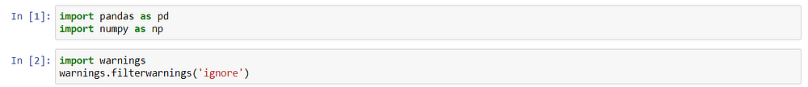

We will start the data cleaning process. So first see if we have any null values or not. If yes then we need to handle it accordingly.

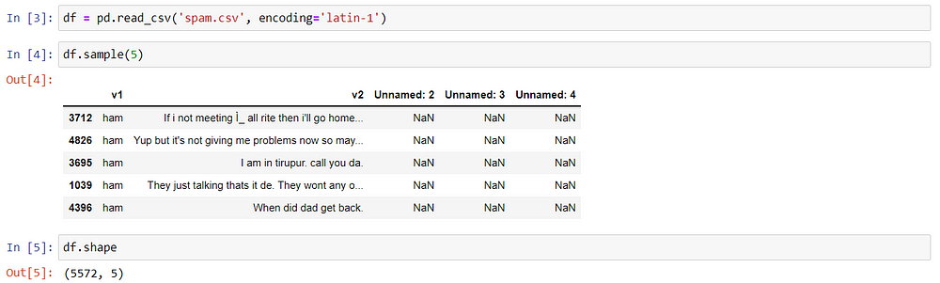

we can see that the last 3 columns have hardly any non-null values so it doesn’t makes any sense to keep them

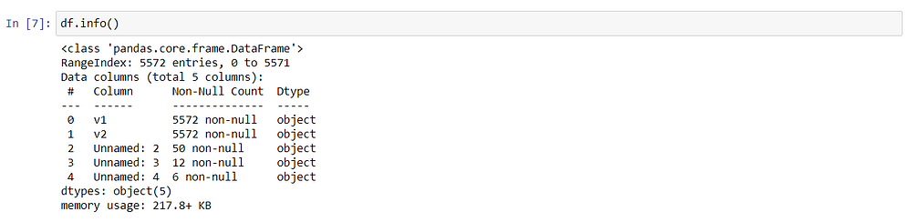

Now name of the remaining columns is not very descriptive so we will rename it according to the value it has and information it possesses. So I decided to change the name of v1 to target and v2 to text

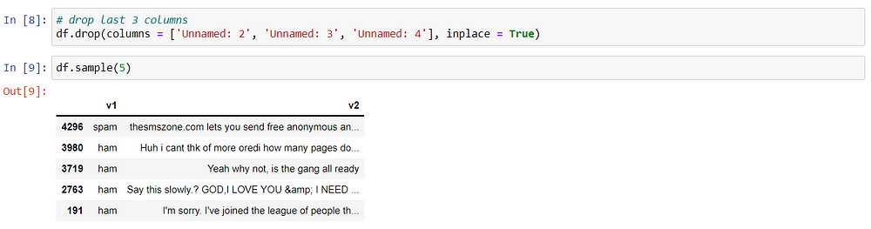

we look at the target column we have two values in it- spam and ham. We have to convert it to 1 and 0 respectively. So we will use LabelEncoder for it

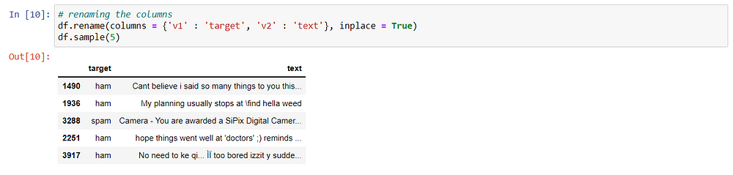

Now comes the last step of data cleaning. we will check the duplicate values and remove them if present.

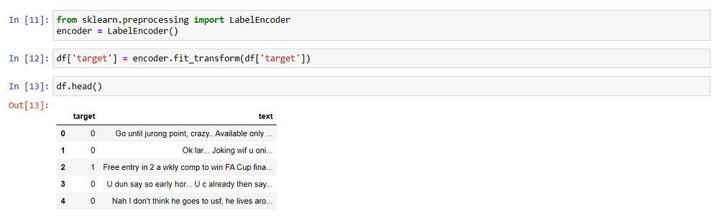

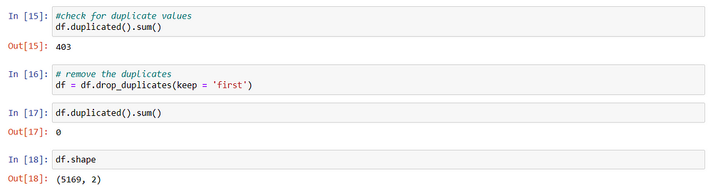

Now we will start with EDA (Exploratory data analysis). Lets check the balance of the dataset.

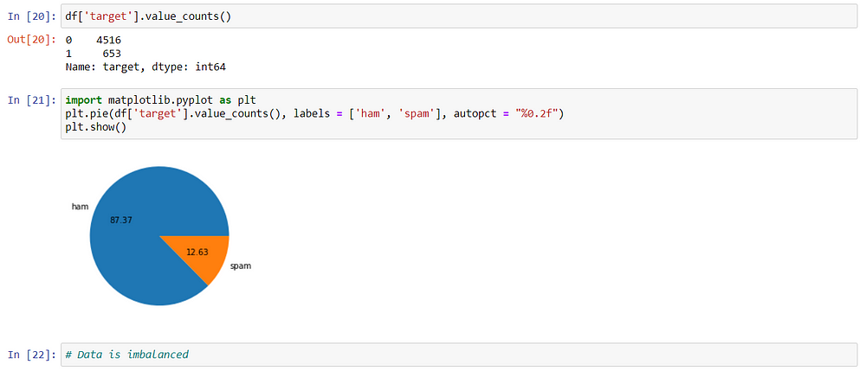

**TRAINING OF A MODEL**

Naive Bayes is a simple but powerful algorithm for classification tasks. For spam classification, we can follow these general steps to train a Naive Bayes model:

Data Preprocessing: Clean and preprocess your data, which involves tasks such as tokenization, removing stopwords, and stemming.

Feature Extraction: Create a bag-of-words or TF-IDF representation of your text data. This step involves converting text data into numerical feature vectors that can be used as input for the model.

Model Training: Use the preprocessed data to train the Naive Bayes classifier, considering the conditional probabilities of each word or feature given the class (spam or non-spam) using the Bayes theorem.

Model Evaluation: Evaluate the trained model using a test set to assess its performance, considering metrics such as accuracy, precision, recall, and F1-score.

**Python Code:**

```

from sklearn.feature_extraction.text import CountVectorizer

from sklearn.model_selection import train_test_split

from sklearn.naive_bayes import MultinomialNB

from sklearn.metrics import accuracy_score, classification_report

```

# Assume you have 'X' as the input text data and 'y' as the corresponding labels.

X_train, X_test, y_train, y_test = train_test_split(X, y, test_size=0.2, random_state=42)

# Feature extraction

```

vectorizer = CountVectorizer()

X_train_counts = vectorizer.fit_transform(X_train)

X_test_counts = vectorizer.transform(X_test)

```

# Model training

```

clf = MultinomialNB()

clf.fit(X_train_counts, y_train)

```

# Model evaluation

```

y_pred = clf.predict(X_test_counts)

print("Accuracy:", accuracy_score(y_test, y_pred))

print(classification_report(y_test, y_pred))

```

PERMANANCE EVALUATION:

To properly evaluate the model, we would need to provide the training data (X_train and y_train) and the test data (X_test and y_test) that were used for the evaluation. Additionally, we should supply the actual performance metrics generated by the code, such as accuracy, precision, recall, and the F1-score.

Without the specific data and metrics, we can't directly evaluate the model's performance. However, we can check the printed results from the print statements in the code to obtain the accuracy score and the classification report, which includes precision, recall, and F1-score for each class.

Inspecting these metrics will give you a clear understanding of how well the model performs on the given dataset. If the accuracy is high and the precision, recall, and F1-scores are balanced, it indicates that the model is performing well. If the metrics are not satisfactory, you might need to explore other techniques, such as hyperparameter tuning, different feature extraction methods, or more advanced preprocessing techniques, to improve the model's performance."

code block

```

`import numpy as np

import pandas as pd

from sklearn.model_selection import train_test_split

from sklearn.feature_extraction.text import CountVectorizer

from sklearn.linear_model import LogisticRegression

from flask import Flask, render_template, request

import joblib

appfrom sklearn.metrics import accuracy_score, precision_score, recall_score, f1_score

def load_data(file_path):

df = pd.read_csv(spam.csv, header=None)

df = df.dropna()

return df[0], df[1]

def preprocess_text(text):

# Implement your text preprocessing steps here

pass

data_file_path = "spam.csv"

X, y = load_data(data_file_path)

X = X.apply(preprocess_text)

X_train, X_test, y_train, y_test = train_test_split(X, y, test_size=0.2, random_state=42)

vectorizer = CountVectorizer()

X_train_counts = vectorizer.fit_transform(X_train)

X_test_counts = vectorizer.transform(X_test)

clf = LogisticRegression()

clf.fit(X_train_counts, y_train)

y_pred = clf.predict(X_test_counts)

print("Accuracy:", accuracy_score(y_test, y_pred))

print("Precision:", precision_score(y_test, y_pred))

print("Recall:", recall_score(y_test, y_pred))

print("F1 Score:", f1_score(y_test, y_pred))`

```

**Conclusion**

AI spam classifiers have become indispensable in our digital lives, offering a robust defense against the ever-evolving threat of spam. With ongoing advancements in AI and machine learning, these classifiers will continue to improve in accuracy and adaptability, ensuring a cleaner and safer online environment for users worldwide.