OFFDAYS
Brand Guidelines
Logo usage, color, typography, and asset index

The Logo
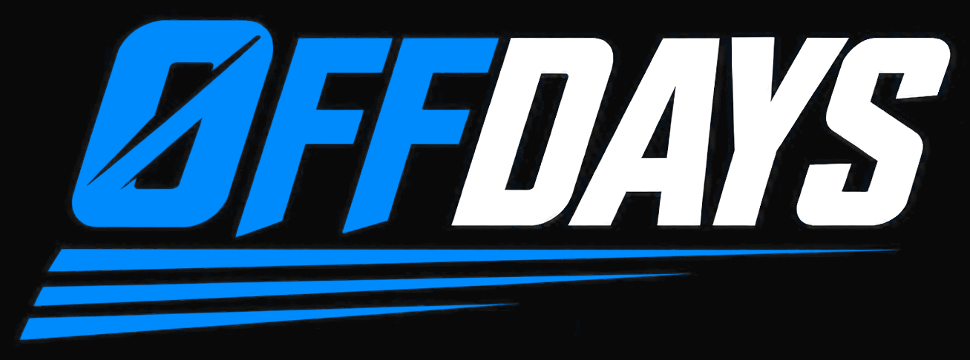
The primary lockup is the wordmark with the Ø mark. Blue carries "OFF", the neutral carries "DAYS", and the speed lines sit beneath. On dark backgrounds "DAYS" is white; on light backgrounds it becomes Ink.

Clear space and minimum size
- Clear space: leave at least the height of the Ø mark on every side. Nothing else goes inside that margin.
- Minimum width: 120 px on screen, 1.25 inches in print. Below that the speed lines break up and the counter inside the Ø fills in.
- Below 120 px, use the Ø mark alone instead of shrinking the lockup.

Rules
- Do not recolor. Blue is Electric Blue; the second color is white or Ink and nothing else.
- Do not stretch, skew, rotate, or straighten the italic.
- Do not add effects — no outer glow, bevel, gradient, or drop shadow beyond what ships in the file.
- Do not place the full-color lockup on a mid-tone or busy photo. Use the white monochrome version.
- Do not rebuild the wordmark in another typeface.

Color
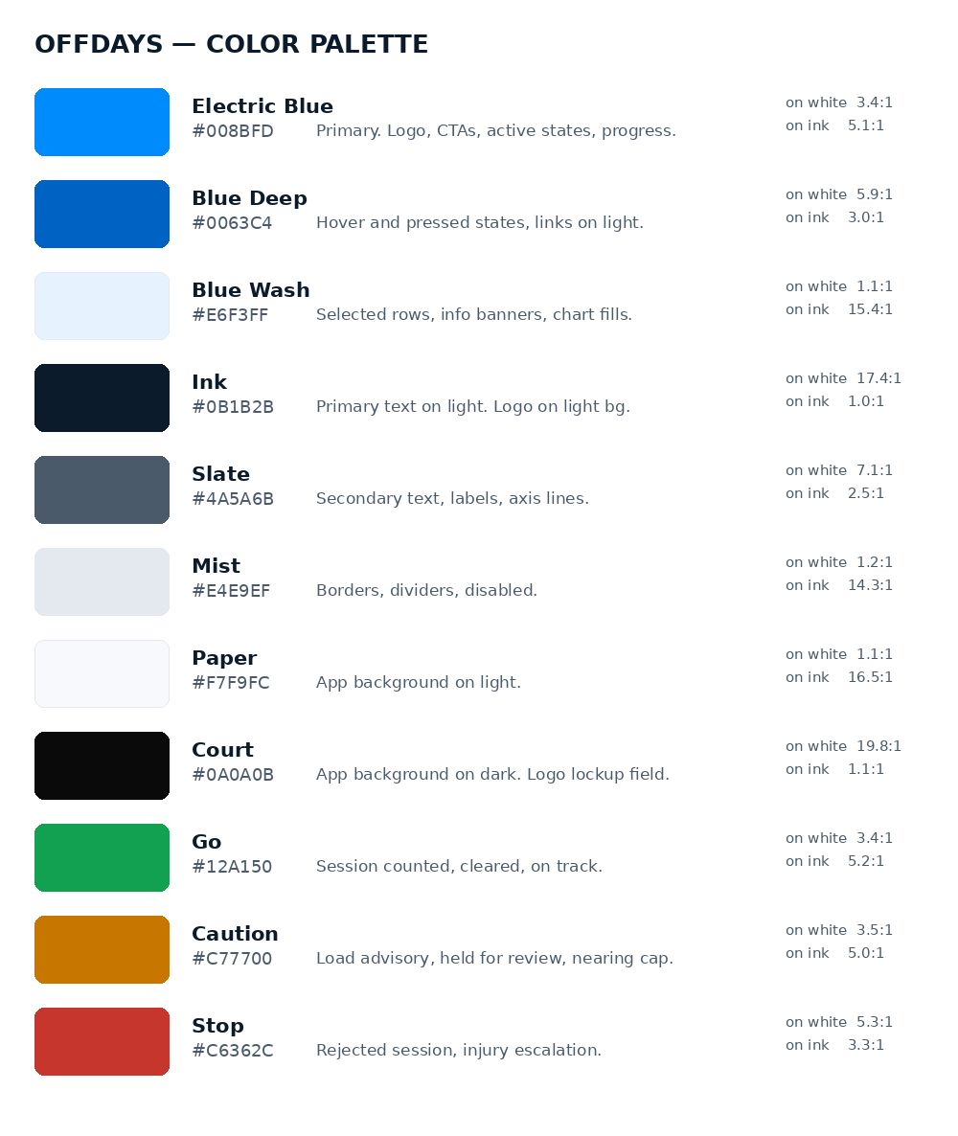

Accessibility note worth acting on
Electric Blue reaches only 3.4:1 against white. That passes WCAG AA for large text and for UI components such as buttons and icons, but it fails for body-size text. Use Blue Deep (#0063C4, 5.9:1) for links and any small blue text on a light background, and reserve Electric Blue for the logo, filled buttons, charts, and accents. On Ink or Court backgrounds Electric Blue reaches 5.1:1 and is safe for text.
This matters more than usual here: the product is read by parents and children, often on a phone outdoors.

Typography
The logo is a custom italic condensed face and is artwork, not a typeface you set text in. For everything else, two free families carry the whole product.
Role | Family | Notes
Headings | Barlow Condensed | Bold and Semibold. Athletic and condensed enough to echo the logo without imitating it. Use for screen titles, KPI numbers, and the digest header.
Body and UI | Inter | Regular, Medium, Semibold. Built for interfaces at small sizes. Enable tabular figures for rep counts, streaks, and any number that updates in place, so digits do not shift as they change.
Code and IDs | JetBrains Mono | Claim codes and athlete identifiers only.

One product-specific rule: streak counts, rep totals, and load figures should always use tabular figures. A streak counter whose digits jump width as it ticks from 9 to 10 looks broken, and this product puts numbers in front of children constantly.

Asset Index
File | Use
logos/offdays-primary-on-dark-transparent.png | Primary lockup, transparent. Dark backgrounds.
logos/offdays-primary-on-black.png | Primary lockup on Court. Presentations, social.
logos/offdays-primary-on-light-transparent.png | Blue and Ink, transparent. Light backgrounds.
logos/offdays-primary-on-white.png | Blue and Ink on white. Documents, print.
logos/offdays-mono-white-transparent.png | One-color white. Photos, dark video, merchandise.
logos/offdays-mono-navy-transparent.png | One-color Ink. Faxable, single-color print, embroidery.
logos/offdays-mono-blue-transparent.png | One-color blue. Restricted palettes.
icons/icon-blue-1024.png / 512 / 256 / 128 | App icon, white mark on blue. Store listings.
icons/icon-navy-512.png / 256 | App icon, blue mark on Ink. Dark-mode contexts.
icons/icon-mark-transparent-512.png / 256 | Bare Ø mark. Watermarks, avatars, loading states.
icons/apple-touch-icon-180.png | iOS home screen.
icons/favicon-32.png, favicon-16.png, favicon.ico | Browser tab.
offdays-color-palette.png | Palette reference with contrast ratios.
tokens.css / tokens.json | Design tokens for the app.

Two Things To Fix Before Launch
1. These are raster assets derived from an AI-generated image. They will not scale past their native size, and the source carried a "Made with AI" watermark that has been cropped out. Before you print anything, put a designer on redrawing the wordmark as vector artwork. An SVG is required for a crisp favicon, embroidery, signage, and anything above about 1300 px wide. Budget a few hundred dollars; it is a couple of hours of work for someone with the right tools.
2. Clear the name before you commit. Offday and OFFDAYS both exist as apparel and lifestyle brands, and the term is used in recovery and wellness contexts. Those sit in different trademark classes than youth-sports software, but run a USPTO search in classes 9 and 42, check the .com specifically, and search the App Store and Google Play. A name conflict in an app store is worse than a domain conflict.

Assets generated from the supplied logo image. Not legal advice; trademark clearance is required before commercial use.

