AI STUDY BUDDY
TEAM ID
SWTID-2026-5631
TEAM LEADER
KANAKA JOTHI.M (C24UG152CSC028)
TEAM MEMBERS
MAHALAKSHMI.S(C24UG152CSC040)
MANASA.K(C24UG152CSC042)
SOUMYA.M(C24UG152CSC072)
Project Overview – AI StudyBuddy
AI StudyBuddy is an AI-powered learning assistance platform designed to help students study, revise, and prepare for examinations more effectively. The system combines Generative AI, Node.js, Express.js, MongoDB, and secure authentication to provide personalized learning resources from student-provided study materials.
The platform allows students to upload or enter study content and automatically generate summaries, flashcards, quizzes, and personalized study plans using the Google Gemini AI API. This reduces the time and effort required for manually preparing revision materials.
The backend follows a RESTful API architecture, with separate modules for authentication, database operations, business logic, and AI processing. MongoDB with Mongoose ODM is used to store user details, study materials, and generated resources. JWT authentication, Role-Based Access Control (RBAC), and bcryptjs password encryption help protect user accounts and restricted resources.
Key Features
- Secure Authentication – JWT-based login and registration.
- Role-Based Access Control – Separate student and administrator privileges.
- Study Material Management – Upload and store learning content.
- AI Summarization – Converts lengthy content into concise revision notes.
- Flashcard Generation – Creates flashcards for active recall.
- AI Quiz Generation – Produces MCQs for self-assessment.
- Personalized Study Plans – Generates study schedules based on examination timelines and preferences.
- MongoDB Database – Stores users, materials, and generated learning resources.
- RESTful APIs – Provides communication between frontend and backend.
- Modular Architecture – Makes the system easier to maintain, scale, and enhance.

Overall Workflow
Student → Login/Register → Upload Study Material → Select AI Feature → Gemini AI Processing → Generate Learning Resource → Store in MongoDB → View & Reuse
Expected Outcome
AI StudyBuddy provides a centralized and intelligent learning environment that reduces manual study preparation, supports personalized learning, and helps students revise more efficiently. Its modular and secure backend architecture also provides a foundation for adding future features such as AI mock interviews, performance analytics, adaptive learning, and advanced recommendation systems.
Software Requirements
- Operating System: Windows 10/11, macOS, or Linux (supports cross-platform operations).
- Node.js (v16 or above): Runtime ecosystem running server logic and routing infrastructure.
- npm (v8 or above): Node package manager to control operational dependencies.
- Express.js: Lightweight routing web framework to construct backend RESTful entry points.
- MongoDB: Document NoSQL engine storing users, posts, categories, comments, and analytics metrics.
- Postman: API verification toolkit to assert schema validation responses across administrative route shields.
- Code Editor: Visual Studio Code or similar IDE environment.
Hardware Requirements
- Processor: Intel Core i5 (8th Gen or above) / AMD Ryzen 5 or equivalent.
- RAM: 8 GB minimum (16 GB recommended for concurrent instances of MongoDB, processing layers, and execution nodes).
- Storage: 1 GB of available disk workspace.

Project Architecture
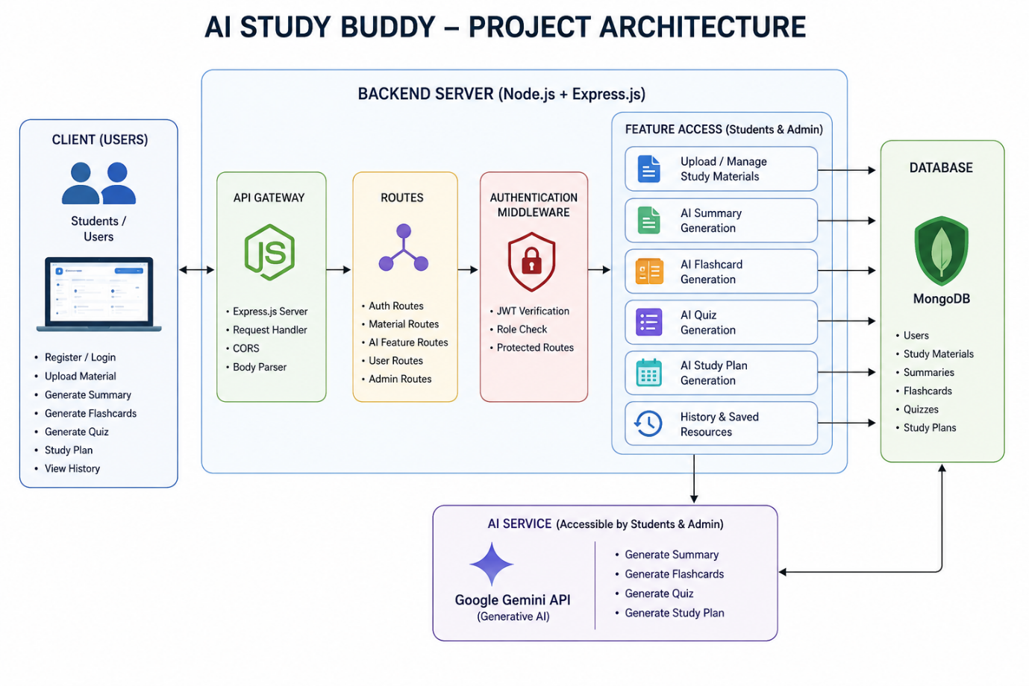
The AI StudyBuddy backend uses a modular RESTful architecture to provide secure and AI-powered learning services. It processes client requests using Express.js, authenticates users with JWT, stores data in MongoDB, and generates learning resources through the Google Gemini AI API.
Components
- Client Application: React.js frontend for login, study material upload, and AI features.
- Express Server: Handles HTTP requests, routing, middleware, and responses.
- Authentication: JWT verifies users and protects private APIs.
- Route Handlers: Manage authentication, study materials, AI, and admin operations.
- AI Service Layer: Connects with Gemini API to generate summaries, quizzes, flashcards, and study plans.
- Database Layer: MongoDB + Mongoose stores users, study materials, and generated resources.

Entity-Relationship (ER) Diagram Description

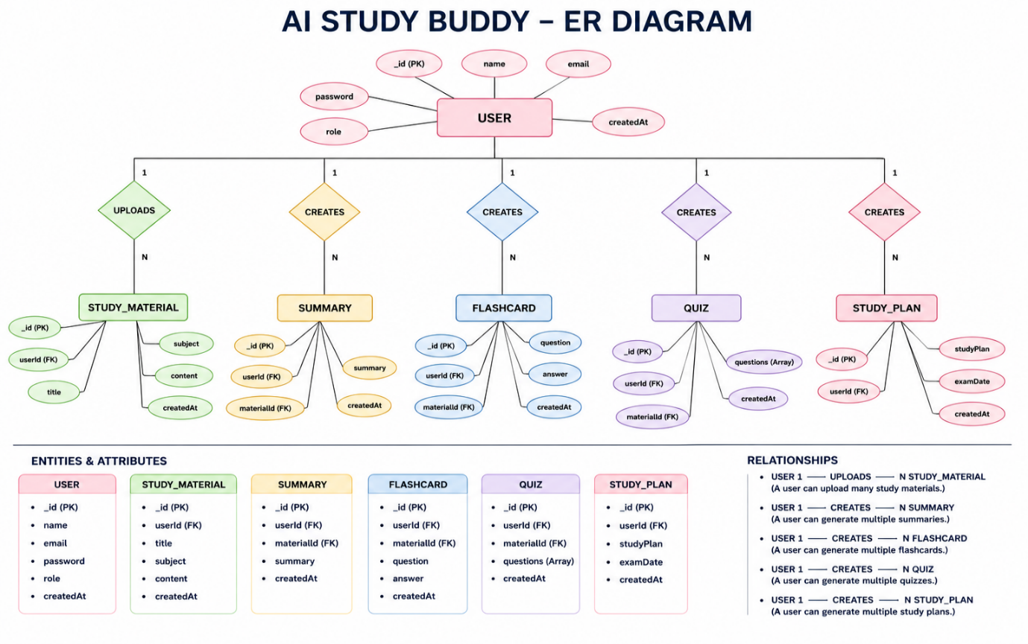
AI StudyBuddy – Database, Features & User Flow
Database Entities
- User: Stores name, email, password, role, and account details.
- Study Material: Stores user-uploaded title, subject, and content.
- Summary: Stores AI-generated summaries linked to study materials.
- Flashcard: Stores AI-generated questions and answers.
- Quiz: Stores AI-generated quiz questions.
- Study Plan: Stores personalized study plans and exam dates.
Key Relationships
- User → Study Material: One-to-Many
- Study Material → Summary: One-to-One
- Study Material → Flashcards: One-to-Many
- Study Material → Quiz: One-to-One
- User → Study Plan: One-to-Many
- User → AI Resources: One-to-Many
Key Features
- Secure JWT authentication and bcrypt password encryption
- Study material management
- AI-generated summaries, flashcards, and quizzes
- Personalized study plans
- Role-Based Access Control (RBAC)
- MongoDB data storage
Roles
Student: Registers, uploads materials, generates AI resources, and manages study content.
Administrator: Manages users, monitors system activity, and maintains the platform.
User Flow
Register/Login → JWT Authentication → Dashboard → Upload Study Material → Select AI Feature → Gemini AI Processing → Generate Resource → Save & View Resource
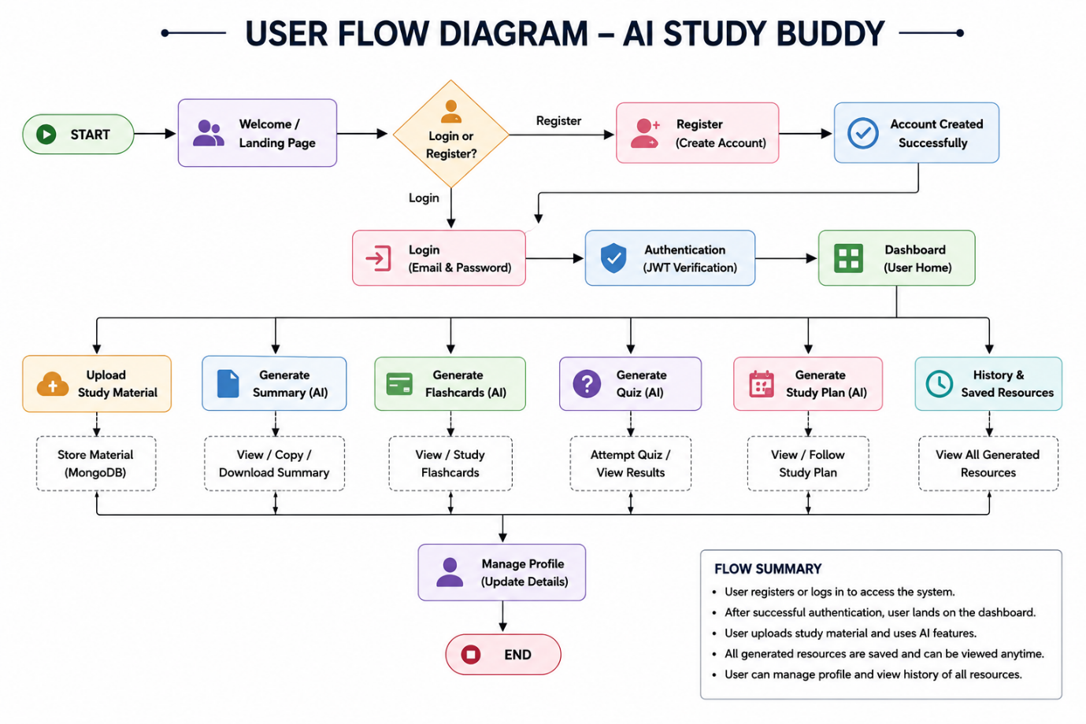

MVC Architecture Pattern

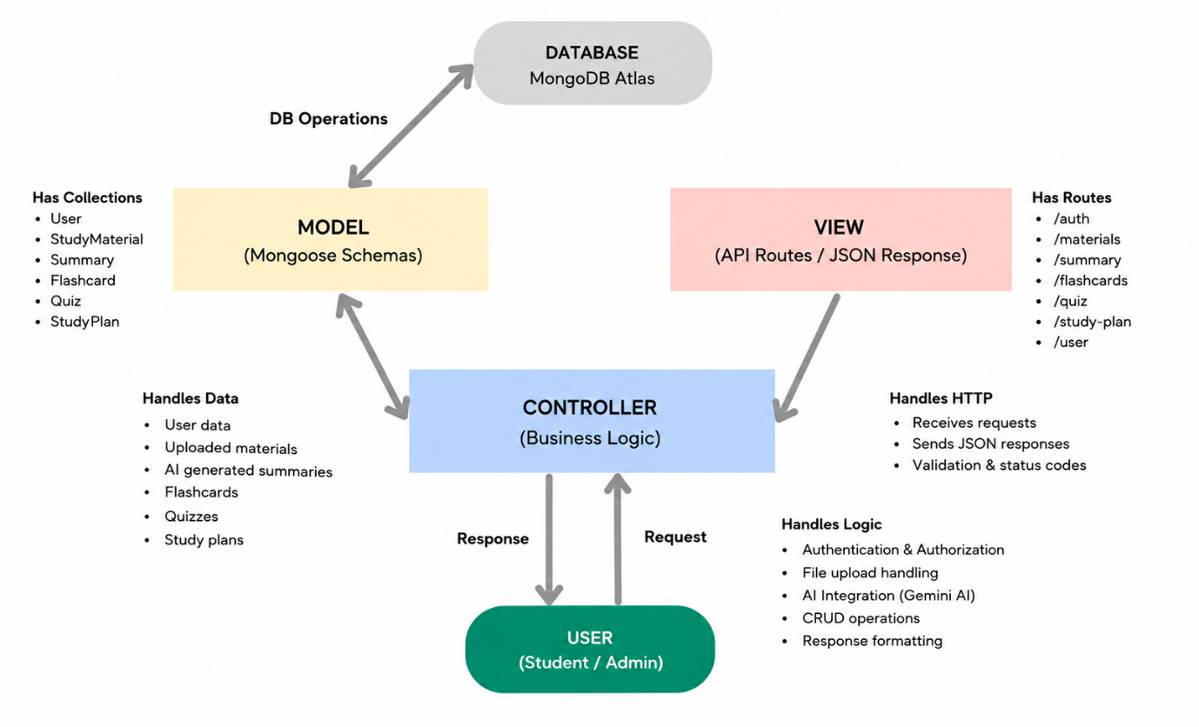
AI StudyBuddy – MVC Architecture
The AI StudyBuddy backend uses the MVC architecture to keep the application modular, maintainable, and scalable.
- Model Layer: Uses MongoDB and Mongoose to manage users, study materials, and AI-generated resources.
- View Layer: Returns JSON API responses to the React frontend through REST APIs.
- Controller Layer: Handles requests, validation, authentication, database operations, and communication with the Google Gemini AI API.
Benefits
- Modular and organized code
- Easy debugging and testing
- Better maintainability
- Supports scalability and future feature integration

Project Setup and Configuration
Creating the Project Folder
- Create a new folder named AI StudyBuddy .
- Open the project folder in Visual Studio Code.
- Initialize the project using Node.js and install the required dependencies.
Project Initialization
Open the project folder in the VS Code terminal and execute:
npm init -y
Install the required dependencies:
npm install express mongoose bcryptjs jsonwebtoken cors dotenv multer @google/genai
Install Nodemon for development:
npm install --save-dev nodemon
Create the Following Files
- index.js
- .env
- package.json
- .gitignore
Create the Following Folder Structure

Environment Configuration
Create a .env file in the project root and configure the required environment variables.
PORT=5000
MONGO_URI=your_mongodb_connection_string
JWT_SECRET=your_jwt_secret
GEMINI_API_KEY=your_gemini_api_key
Backend Development
The AI StudyBuddy backend is developed using Node.js, Express.js, and MongoDB, following a modular architecture. The application separates routing, controllers, middleware, models, and utility modules to improve code maintainability and scalability. The backend exposes secure REST APIs for authentication, study material management, AI-powered content generation, and administrative operations.
Backend Structure


Core System Script Implementations
1. Application Entry Point (index.js)
The index.js file serves as the main entry point of the application. It initializes the Express server, loads environment variables, configures middleware, establishes the MongoDB connection, registers API routes, and starts the server after a successful database connection.

2. Database Connection (src/utils/db.js)
This module establishes a connection between the application and MongoDB using Mongoose. It ensures that the backend communicates with the database before processing any client requests.


3. Authentication Middleware (src/middleware/auth.js)
The authentication middleware verifies JWT access tokens for protected routes. It authenticates users before granting access to secured APIs and includes role-based authorization to restrict administrative operations.

4. AI Integration (src/utils/gemini.js)
This utility integrates the backend with the Google Gemini 2.5 Flash API. It sends prompts to the AI model and returns generated responses for summaries, flashcards, quizzes, and study plans.

5. File Upload Middleware (src/middleware/upload.js)
The upload middleware handles study material uploads and validates incoming files before they are processed by the backend.

Backend Development Demo:
AI_Studybuddy_Backend_Demo.mkv
Database Configuration
The AI StudyBuddy backend uses MongoDB as its primary NoSQL database and Mongoose ODM for data modeling and schema validation. MongoDB stores user information, uploaded study materials, and AI-generated learning resources in a structured manner. Mongoose simplifies database operations by providing schemas, validation rules, and efficient query handling.
Configure MongoDB
Install Mongoose using the following command:
npm install mongoose
Create Database Connection
Before performing any database operations, establish a connection between the backend and MongoDB using Mongoose. The connection module is initialized during server startup to ensure reliable communication with the database.
Mongoose Schema Definitions
1. User Schema (models/User.js)
The User schema stores authentication and profile information for registered users. It includes fields such as name, email, password, and role. Passwords are securely encrypted before being stored in the database.

2. Study Material Schema (models/Material.js)
The Study Material schema stores the learning content uploaded by users. This content acts as the input for AI-powered features such as summaries, quizzes, flashcards, and study plans.

Database Collections
The AI StudyBuddy database consists of the following collections:
- Users – Stores user account and authentication details.
- Study Materials – Stores uploaded learning materials.

API Route Interface Endpoints
The backend exposes RESTful APIs to interact with the database and AI services.
1. Authentication APIs
Handles user registration, login, JWT authentication, and protected route access.
2. Study Material APIs
Allows users to upload, retrieve, update, and manage study materials.
3. AI Feature APIs
Provides endpoints for:
- AI Summary Generation
- AI Flashcard Generation
- AI Quiz Generation
- AI Study Plan Generation
4. Administrative APIs
Provides administrator-only endpoints for managing users and monitoring system activities.
Project Execution
The AI StudyBuddy backend can be executed locally using Node.js. Before running the application, ensure that MongoDB is running and the required environment variables are configured correctly. The backend exposes REST APIs that can be tested using Postman or Thunder Client.
Running the Backend Server
Install all required dependencies:
npm install
Start the development server:
npm start
After successful execution, the server connects to MongoDB and starts listening for incoming API requests.

API Testing
The backend APIs can be tested using Postman.
1. User Registration
Registers a new user by accepting the required details and securely storing the encrypted password in the MongoDB database.
Endpoint:
POST /api/auth/register
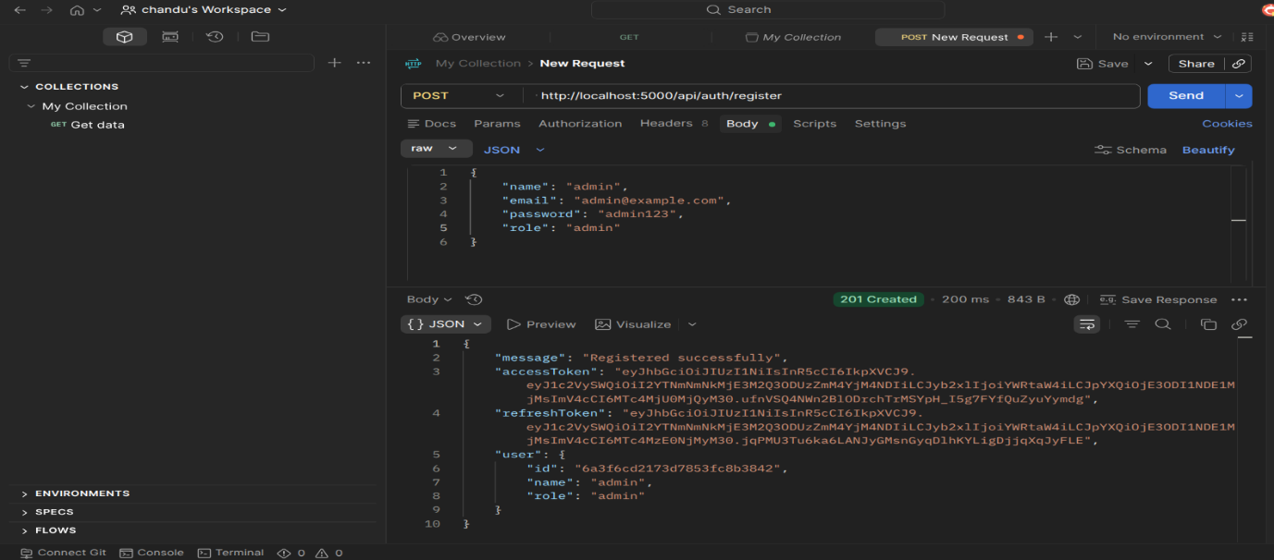
2. User Login
Authenticates the registered user and generates a JWT access token for accessing protected APIs.
Endpoint:
POST /api/auth/login
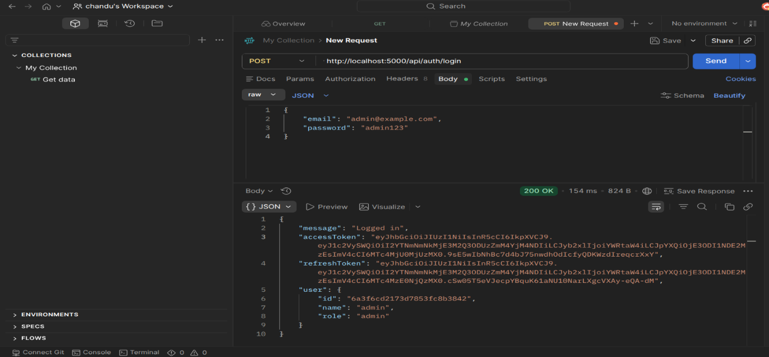
3. Upload Study Material
Allows authenticated users to upload study material that will be used as input for AI-powered content generation.
Endpoint:
POST /api/material/upload
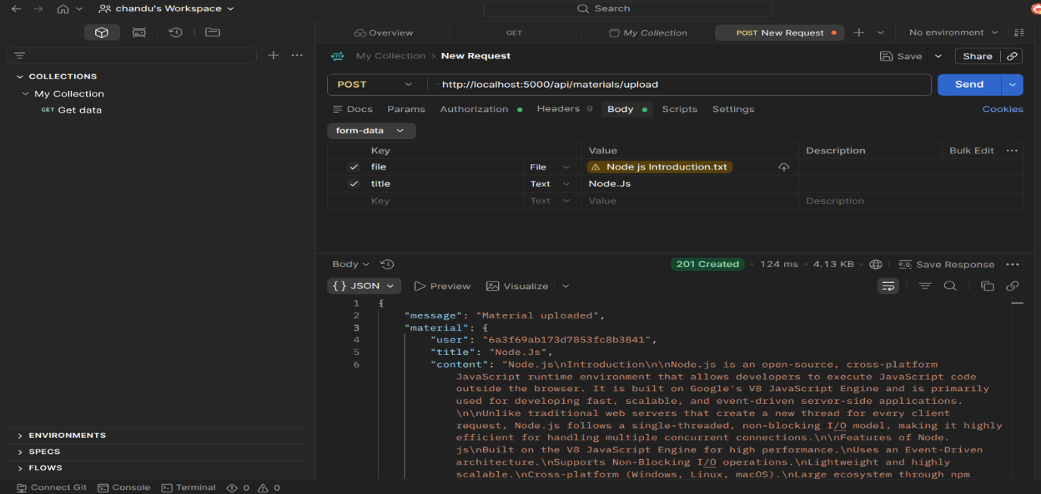
4. Generate AI Summary
Sends the uploaded study material to the Google Gemini API and generates a concise summary.
Endpoint:
POST /api/materials/:id/summarize
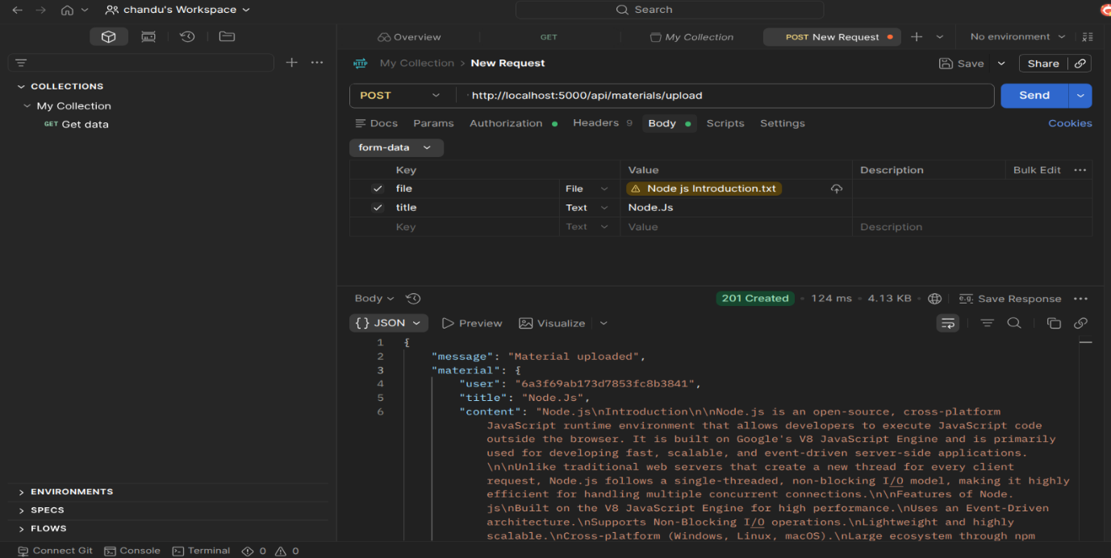
5. Generate AI Flashcards
Creates AI-generated flashcards from the uploaded study material for effective revision.
Endpoint:
POST /api/ai/flashcards
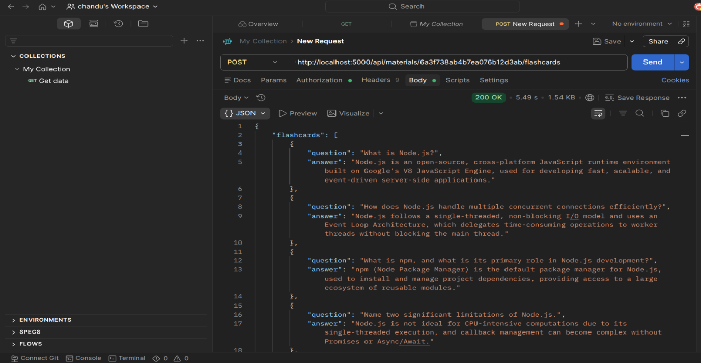
6. Generate AI Quiz
Generates multiple-choice questions from the uploaded study material to help users assess their understanding.
Endpoint:
POST /api/ai/quiz
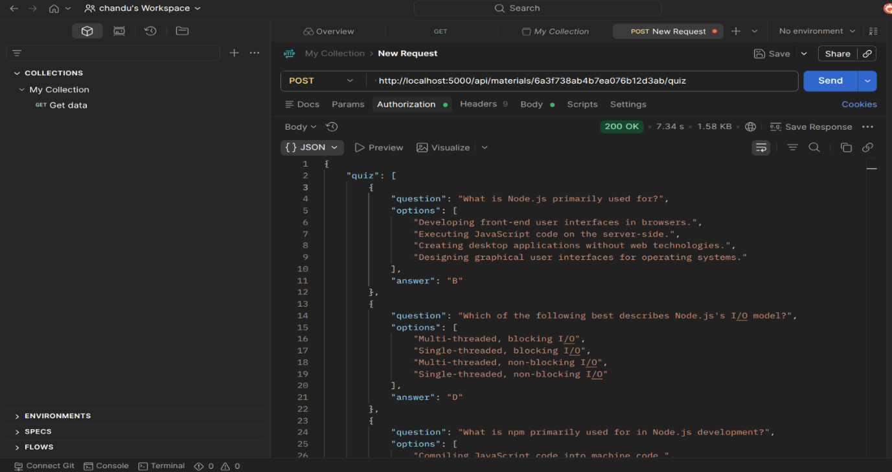
7. Generate AI Study Plan
Creates a personalized study schedule based on the user's learning goals and available study time.
Endpoint:
POST /api/ai/study-plan
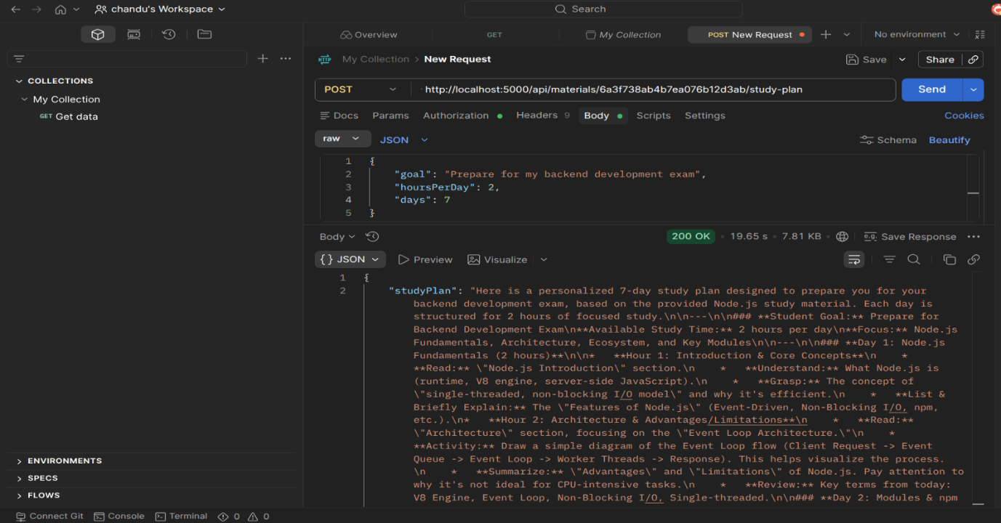

DEMO VIDEO LINK :https://drive.google.com/file/d/1gKDLRQ_CqXIoJnYVNsBVq6-ztoHHmjoF/view?usp=drive_link
Code Drive Link : https://drive.google.com/file/d/15ErFejVsAIaVE-Qi-NFoA0hBTKd7zfib/view?usp=drive_link

