

Statistical Working System
Project
Statistics Division

Imputation and Validation Methodologies for the FAOSTAT Production Domain
29th June 2011

Comments
This document combines products 16 and 17 of the Statistical Working System and was produced by the Data Collection, Workflows and Methodology (DCWM) team. Contributions from Josef Schmidhuber (ESS), Onno Hoffmeister (ESS) and Adam Prakash (ESS) were essential for the preparation of this document
Ref: SWS/DCWM/P16&P17

ABSTRACT

This document is the outcome of the imputation and validation methodologies that have been developed as part of the FAO CapEx Statistical Working System Project. One of the main aims of the project is to design standard and well documented procedures for the processing of data related to the FAOSTAT data domains.

The production domain of FAOSTAT was used as a basis to develop and test imputation and validation methodologies that could assist in standardisation across the different statistical domains in FAO. Imputation and validation were performed on production and area data that had been imputed in the past. Keeping in line with FAO statistical policy, only official values were used as source data in imputation. Two imputation and validation methodologies each were developed - the first methodology uses the information in the time series of a commodity as a basis for imputing its missing data, while the second methodology uses commodity aggregates and/or country aggregates as a basis.

The application of the first imputation and validation methodologies resulted in some 67 percent of all data points that were subjected to imputation being imputed and clearing validation. The use of the second imputation and validation methodologies provided optimal results for 91 percent of data. Validation of imputed data was mainly performed taking into account past trends of a commodity, the deviation of an imputed value from its preceding value and using yield as an indicator. In addition, imputed values were also checked by subject matter experts to ascertain their validity, i.e. a peer review.

The three imputation methods viz., linear interpolation, trend regression and the use of aggregates were then assessed for the precision of their results. For this, random samples of official values were drawn from the FAOSTAT database, and the three imputation methods were applied to the data points in the sample. Comparison of the imputed values with the observed official figures allowed for analyzing the bias and the distribution of the error throughout the samples. The results demonstrated that in all samples, data imputed using the method of aggregates was more accurate (or, closer to the actual values) as compared to the other two methods.

However, further work on refinement and/or expansion of the imputation and validation methodologies is pertinent. This is because of several reasons. For instance, the proposed methodology was unsuccessful in imputing all data points. This may require increasing the scope of imputation methodology to include other methods. But this has yet to be tested. In addition, the imputed data was validated only in terms of their impact on yield. No assessment was undertaken with respect to the inter-relationships that exist between one commodity/element and all other related commodities/elements, and the impact on supply utilization accounts (SUAs) and Food Balance Sheets (FBS).

Table of contents

1. Introduction

2. Newly Designed Imputation and Validation Methodologies
2.1. Imputation Methodology (1)
2.2. Validation Methodology (1)
2.3. Imputation Methodology (2)
2.4. Validation Methodology (2)

3. Assessment of accuracy of imputation results

4. Main Conclusions

5. Next steps in methodology development

Annex 1: Commodity groups in Imputation Methodology (2)
Annex 2.A: Geographic sub-regions aggregates
Annex 2.B: Geographic regions aggregates
Annex 3: Workflow corresponding to Imputation Methodology (2)
Annex 4: Charts depicting assessment of accuracy of imputation results

References

1. Introduction

One of the key deliverables under the Statistical Working System Project (CapEx) is the development and specification of workflows and routines for data processing i.e. editing, imputing, estimating and validating FAOSTAT data sets. In this connection, the underlying objective is to establish data processing procedures that are standardised, automated, well documented and transparent to users of data. As part of the project, it has been agreed that the development of routines for imputation and validation will be first undertaken for the food and agriculture production domain of FAOSTAT and then extended to other statistical data domains.

Developing new methodologies for imputing and validating data in the FAOSTAT data domains are broadly classifiable under the following activity dimensions:
- Surveying the extent of missing/unreliable data and examining the imputation methods currently in use.
- Developing imputation and validation methodologies relevant to the specific characteristics of the domain and based on agreed standards and principles.
- Evaluating the outcomes with a view to standardising the methodologies.

The purpose of this document is to describe the development of new data processing methodologies for imputing and validating data in the food and agriculture production domain of FAOSTAT which was based on the above activities. The development and use of these methodologies and their resulting outcomes that are presented in this document will be subject to peer and management review. It is hoped that the resulting feedback will provide further impetus to the beneficial development of standard procedures for data imputation and validation.

This document is organized into five main sections. Following the introduction, a description of the newly developed imputation and validation methods is provided, including a review of the results generated from their application. In the next section, an assessment of accuracy of results obtained from the imputation methods is provided and results of the assessment are discussed. Section 4 provides concluding remarks on the proposed imputation and validation methodology whilst section 5 outlines the next steps in the methodological processes.

2. Newly Designed Imputation and Validation Methodologies

Two imputation methodologies were developed and tested. These are referred to, in this document, as Imputation Methodology (1) and Imputation Methodology (2). The first approach relied on using statistical/econometric methods such as trend regression and linear interpolation to impute data. In the second approach, growth rates of aggregates (commodity/country) were used to impute missing data. This section of the document provides a detailed description of them, including issues related to data, and their results.

Imputation was undertaken for current values in the production domain that had been imputed using the less-than-ideal carry-forward method. Thus, any imputed value which was a repeat of the value immediately preceding it (for the same time series) was considered for imputation. Such values were identified by existing flags: “T” (repeat of previous year) or “F” (only for cases where the value was equal to the amount recorded in the year before).

The following describes the two methodologies and summarizes the results. Subsequently, the validation methodologies developed to validate imputed data obtained from these two methodologies are described.

2.1. Imputation Methodology (1)

Imputation Methodology (1) was derived on the basis of the following three approaches: linear interpolation, trend regression and calculation based on average yield. The exact approach applied depended on the nature of the underlying time series.
Source Data

This methodology focused on the imputation of data occurring in FAOSTAT in the years from 2000 to 2009 in the time series of Element 51 (production), Element 31 (area) and Element 11 (yield) for 287 commodity groups observed in 242 geographical entities (countries).

Only the following data classifications were used as a basis for imputing missing data
- Data pertaining to official figures reported by countries (i.e. not being marked by any flag)
- Semi-official figures collected from an external source (flagged by a “*” or “X”),
- Values automatically calculated by the processing system based on a predefined identity (flagged by a “C”)
- FAO estimates derived, for example, by assuming a fixed unit value.

On the other hand, the following data types were not considered a suitable basis for imputation:
- Values estimated by an unknown method (flagged by an “E”),
- Values set to zero because they are not applicable in the respective country (flagged by an “M”),
- A series with a zero-value at its starting point

Imputation Approaches Applied

a) Linear Interpolation

A linear trend is assumed to exist between the start- and endpoints of gaps in the time series. Let y₀, y₁, ..., y_{t-l} denote the data points with values obtained from official sources before the gap and y_{t+r}, y_{t+r+1}, ..., y_{m} denote the data points with official values after the gap. The imputed values are calculated as:

(1) 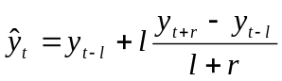.

b) Trend Regression

A polynomial regression is run based on the model

(2) ,

where y_{t} is a valid value observed for year t and u_{t} is the residual in that year. The autoregressive (AR) error term ρu_{t-1} (where is included only if serial correlation is assumed to be significant, identified by a value of the Durbin-Watson statistics between 1.5 and 2.5. ρ is then estimated using the approach of Prais and Winsten (Prais, S. J. and C. B. Winsten, 1954. Trend Estimators and Serial Correlation, Cowles).

For parsimony, the terms β₁t, β₂t², β₃t³ and β₄t⁴ remain in the model only if the respective β-coefficient is found to be non-zero at the 5% level of significance. To arrive at the final model, starting from the complete model (2), step-by-step the least significant coefficient (identified by the highest p-value) has been set to zero until all remaining β coefficients turned out significant.

Once the parameters of model (2) have been estimated, the imputed values are calculated as

(3)

A pre-condition for a regression on model (2) to lead unbiased estimates is stationarity. With few degrees of freedom in many of the time series owing to a small number of observations, stationarity has been assumed whenever the Dickey-Fuller test leads to a t-value with an absolute amount greater than 3 and the estimator of ρ lies between +0.95 and -0.95.

The trend regression approach has not been applied when:
- less than ten continuous observations are available;
- collinearity exists between the dependent and independent variables;
- the residuals of the regression on model (2), without the AR-term, are non-stationary;
- the approximation method, used in the Prais-Winsten approach for the determination of ρ, fails to achieve convergence...

c) Estimation Based on Average Yield

An estimate of the yield in data point 0 is calculated by taking the average of the ratio between agricultural output (y) and agricultural input (x) observed at the three data points with valid observations in both y and x which are nearest to the imputable value in terms of years. Those three data points are identified below by the equations 4, 5 and 6.
(4) 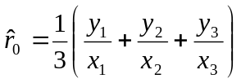

If a valid value for agricultural input exists in the current year, x₀, then the corresponding value of agricultural output is estimated as

(5) 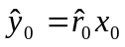

If a valid value for agricultural output exists in the current year, y₀, then the corresponding value of agricultural input is estimated as

(6) 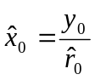.

Selecting the Imputation Approach

The imputation interval, the type of data and the size of the sample on which to conduct imputation will dictate the choice of approach. For example, linear interpolation, as it is based exclusively on information on the start- and end-points of a missing data interval, may prove less accurate for large gaps in the time series. Furthermore, when the series exhibits non-linearity, linear interpolation methods will result in poor approximation.

By contrast, trend regressions, as they are based on the entire information of a time series, can be used to predict longer-term tendencies in the data. Using identity relationships between variables i.e. yield is a preferred approach, but applicable when only a single variable is unobservable.

The selection of the suggested imputation method was based on theoretical reasoning. The decision tree, which has been followed for the selection of the above methods, is presented in Figure 1.

Figure 1: Decision tree for the selection of an imputation approach
Yield can be calculated from other time periods and official data on the counterpart element (element 31 or 51 respectively) exists?
yes | no
Calculation based on yield using official data of the counterpart element | Missing value falls within an interval not exceeding two years (i.e. no more than two successive missing data points)?
 | yes | no
 | Linear interpolation | Are there at least 10 continuous data points (trend regression can be run using at least 10 data points)?
 | Linear interpolation | yes | no
 |  | Prediction of the imputed value on the basis of the regression model | Yield can be calculated from other time periods and the value of the counterpart element (elements 31 <-> 51) has been imputed?
 |  |  | yes | no
 |  |  | Estimation based on yield using the imputed data of the counterpart element | Cell remains empty.

Results

Using the methodology, some 43,467 data points were imputed. Regarding the values finally selected for the imputation, 6,067 (14%) of the imputed values were replaced by linear interpolation estimates, 18,256 (42%) by trend-regression estimates, and 8,996 (21%) by yield-based estimates. All of those yield-based estimates rely on official data (first column in figure 1). For 10,148 (23%) data points, no imputed value could be generated, remained empty.

2. 2. Validation Methodology (1)

The results of imputation on area and production were subjected to validation checks. The validation methodology and the results obtained are described below. However, before proceeding it is important to note that validating data does not depend on the properties of the data, that is, data may be empirically observed or imputed/estimated.

Methodology

The imputed data were validated using two indicators:
- Yield
- Past three year unweighted average.

As for the first step, yields and past three year unweighted average were calculated. Yields were calculated for situations where either data for both elements (production and area) were imputed or data for only element was imputed (and the other was official or semi-official).

Y = P_{i}/A_{i} or P/A_{i} or P_{i}/A

where the subscript i denotes an imputed variable.

As yield is a quotient of production and area, there were some commodity groups for which yields by definition could not be calculated. These mainly included derived products such as vegetable oils, beer and wine. Imputed data for such products were validated using only one indicator i.e. the past three year’s average.

The past three year average for area and production was calculated as,

X = 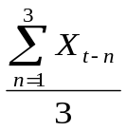

where X is average area or production of a commodity and X_{t} is its imputed value.

The validation methodology used a range function/tolerance level for the two indicators. The imputed data lying within the established tolerance were deemed to have passed validation. The tolerance was calculated with respect to the value (X_{t-1}) immediately preceding the imputed value (X_{t}).

Validation rests on the condition: X_{t-1}-1 (1-Tolerance) < X_{t} < X_{t-1}-1 (1+Tolerance). The range checks with regard to the two indicators are outlined below:

Range checks on yield

Different ranges were attributed to primary and processed products. This is because experience suggests that yields (for primary crops) can vary relatively more than extraction rates (for crop processed products) or carcass weights (for meat). For primary crop products, a validation range of (+/-) 20 percent tolerance was established. For processed crop products and livestock, the range was fixed at (+/-) 5 percent.

Range checks on past three year’s average

A range of (+/-) 25 percent tolerance was established for this indicator. The range was applicable to all commodities i.e. no distinction was made between primary and processed products, and crops and livestock products.

Results
Each imputed value was subjected to range checks using both validation indicators (yield and the three year average). Outcomes can be summarized using the following three situations:
i) data that cleared validation range checks for both indicators.
ii) data that cleared validation range checks for only one indicator.
iii) data that did not clear validation range checks for any of the two indicators.

Clearly, situation i) was the most favourable and imputed data that passed both checks were deemed as clearing validation. In terms of situation (ii), it was considered fair that imputed data which cleared the yield indicator check were fit for use. Finally, imputed data that did not clear any of the two validation checks, situation (iii) were considered unfit for use.

The imputation methodology identified some 33 000 imputable data points. Of these, some 88 percent cleared the validation checks (situations i and ii). In terms of the three situations, approximately 72 percent cleared both validation checks, while 16 percent cleared the validation check for yield but not for past three year’s average.

In sum, of the approximately 43 000 data points considered for imputation and validation using Imputation Methodology 1, some 67 percent (29 000) data points were imputed and cleared validation.

2. 3. Imputation Methodology (2)

The Imputation methodology (2) was developed for two main reasons - first, to take into account the peculiarities of the food and agricultural domain, and secondly, to overcome some of the drawbacks of Imputation Methodology (1). As agricultural production depends, for a large part, on climatic conditions, outcomes may not always be conditional entirely on past trends. For this reason, using reported data from identical crops grown in neighbouring countries, or similar crops grown within the same country could capture changes in weather patterns, thus yielding a sound basis for imputation. In addition, such an approach also offsets the main drawback confronted by the Imputation Methodology (1) i.e. lack of adequate official data in a country, which resulted in large number of values not being imputed. Using aggregates would result in more commodities and countries being considered as source of data, and thus improved possibility of finding adequate official data.
The basis of this imputation methodology was to employ growth rates of relevant commodity and/or geographic aggregates to impute data. Five approaches using various combinations of commodity and geographic aggregates were devised. These were implemented sequentially, until satisfactory results were obtained.

A distinct feature of the methodological design is that validation checks are performed at two stages – the first, at the end of every imputation approach and the second at the end of the entire imputation process, on all imputed data.

Source Data

The imputation methodology (2) focused on the imputation of data in the years from 1990 to 2009. The elements for which data were imputed included Element 31 (i.e. area harvested / slaughtered animals / input) and Element 51 (i.e. output of agricultural and livestock items). As mentioned earlier, all values identified by flags “T” (repeat of previous year) or “F” (only for cases where the value was a repeat of the previous year) were considered for imputation.

As before, only data points pertaining to official figures (not marked by any flag) or semi-official figures collected from an external source (flagged by a “*”) were used for imputation. In addition, all zero-values of a time series were excluded for the imputation.

A total of 22 commodity aggregates were constructed (see Annex 1 for the list); these were based on 221 commodities that are disseminated in FAOSTAT. The geographic aggregates comprised 7 regions and 18 sub-regions, formed using a total of 242 countries (see Annex 2A and Annex 2B for the list of sub-region and region aggregates respectively). A region denotes a much larger geographical area as opposed to sub-region. Thus, for example, Africa is a region while West Africa is a sub-region.

Imputation methods applied

Under this methodology, imputation for a data point was derived by multiplying the growth rate in the appropriate aggregate, with the previous non-zero value of the data point. The choice of the commodity or geographic aggregate depended on the commodity/country to which the imputable value belonged to).

The equation can be written as:

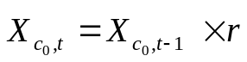
where:

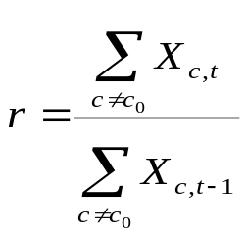

X represents the value to be imputed
c denotes a commodity/country which belongs to the relevant commodity/region/sub-region aggregate
t is the year in which the value is to be imputed
r is the growth rate of the commodity/region/sub-region aggregate

Five different approaches were developed. Each approach, essentially, used a unique combination of commodity and geographic aggregates. These approaches are described below:

- Same country / commodity aggregate: In this approach the value for a commodity was imputed based on the growth rate of the commodity group and the country to which it belongs. Thus, for example, data for wheat is imputed based on the growth rate of the cereal aggregate in the same country.

- Sub-region aggregate / same commodity: In this approach, the data for a commodity is imputed based on the growth rate of the commodity in the relevant sub-region. Thus, for example, data for wheat is imputed based on the growth rate of all wheat production in the relevant sub-region.

- Sub-region aggregate / commodity aggregate: This approach is similar to the previous approach, except that in this case, imputation is based on the growth rate of the commodity aggregate to which the commodity in question belongs (and the country aggregate assigned to the country in question). Thus, continuing with the example of wheat, the data for wheat in a country is imputed based on the growth rate of cereal aggregate in the relevant sub-region.

- Region aggregate / same commodity: This approach is similar to approach ii, except that imputation is based on the growth rate of region to which the commodity in question belongs as opposed to the sub-region. Thus, for example, data for wheat is imputed based on the growth rate of all wheat production in the relevant region.

- Region aggregate / commodity aggregate: This approach is similar to approach iii, except that imputation is based on the growth rate of the commodity aggregate in the region aggregate assigned to the country in question. In this case, the data for wheat in a country is imputed based on the growth rate of all cereal production in the relevant region.

In terms of the process, the methodology proposed the use of these approaches in a sequential manner. Thus, a value was first imputed using approach (i) and then a validation check was performed on the imputed value. If the value could not be imputed (this was possible if no official/semi-official data were available for the concerned aggregate) or if it did not clear the validation check, then the process applied approach (ii), and the validation check was done again. This procedure was repeated until either a value was imputed and cleared validation, or, all approaches were exhausted (see Annex 3 for the workflow chart corresponding to this method, prepared as part of the Statistical Workflows document).

After implementing approach (v), the entire procedure (using five approaches) was run once more. But in this case, the imputed value was derived by back-casting the value observed in the first year after the data to be imputed (using the average growth rate observed in the aggregate). This was done essentially to address the issue of a zero value in the year before the data to be imputed; having a zero in the preceding year meant that the imputation algorithm would return zero value as the result.

The initial validation procedure involved a range function, with the range assumed at (+/-) 40 percent. Thus, if the imputed value in the current year lay within (+/-) 40 percent of the previous year’s value, it was considered to have passed the validation check. If the value was outside this range, then it was over-written by the value obtained from the subsequent approach and was subjected to re-validation.

The choice of the sequence was based both on generally accepted statistical recommendations that propose the use of country data for in-country imputations and on theoretical reasoning. Thus, approach (i) which uses source data from within the country is the first choice. The sequence of the other four approaches was determined on the basis of geographical proximity to the country in question and homogeneity of the product in question. Thus, data from the sub-region/same commodity assumed the next approach followed by the sub-region/commodity aggregate. Finally, data from the subregion was accorded next priority compared to data from the region; similarly, data for the same commodity was the next choice followed by commodity aggregate from the sub-region.

Results

A total of roughly 80 000 data points, in the Element 31 (area) and Element 51 (production), were identified by flags “T” (repeat of previous year) or “F” (only for cases where the value was a repeat of the previous year) and hence were considered for imputation. The imputation methodology (2) resulted in some 89 percent data points for area and 92 percent data points for production being imputed. The remaining data were not imputed either because there were no official data available in the aggregate or because imputed data failed to pass validation checks. Table 1 below presents the main results of the imputation methodology (2) exercise.

Table 1: Results of Imputation Methodology (2) for area and production

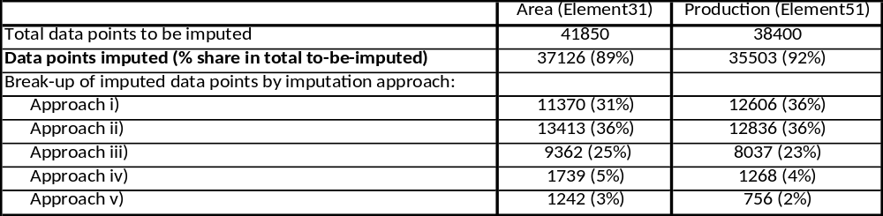

The results also show that most imputed data, for both Elements, were derived from approaches (i), (ii) and (iii). In other words, most data were imputed using information from the commodity aggregate and/or sub-regional aggregate. However, these results are not intended to be used for comparison amongst approaches. The low applicability of approaches (iv) and (v) are a reflection of the relatively lesser data points that are available for imputation after the first three approaches had been applied.

2.4. Validation Methodology (2)

The validation methodology developed for this methodology was similar to the one developed for imputation methodology (1), in that yield was used as the basis for validation.
As the first step, yield was calculated for all time series containing imputed data. The validation of the imputed data was based on the cross-country distribution of yield. The checks involved whether both the following conditions were met:

- the yield in the given country was greater than the mean plus 3 times the standard deviation, and,
- the yield in the given country was more then 40 percent above the next smaller value in the distribution.

Those values that did not meet the two conditions following the first round of outlier testing were considered as outliers. The validation checks resulted in only 328 imputed data points being considered as outliers.

Box 1: Presentation of the imputation methodologies at regional workshops organized by the FAO Statistics Division

In order to foster transparency and elicit feedback from FAO Member countries, the new imputation methodologies were presented in two regional workshops in Bangkok and Budapest which were organized by the FAO Statistics Division in March 2011 and May 2011 respectively. The participants included national experts on production, Supply Utilisation Accounts and trade data.

The feedback received from participants provided the Statistics Division useful inputs on the new imputation methods. Some of the feedback included recommendations to take consideration of factors such as climate, area sown, etc. in imputing production data. In addition, participants recommended that data validation methods should be made rigorous. A notable comment was that, in many national statistical units, missing data are often imputed using the nearest neighbour or data donor approaches. For instance, missing production data for a commodity is imputed using data from a region in the country that has similar yield patterns for the same commodity. This approach is similar to the one proposed in the Imputation Methodology (2) i.e. similar commodities/neighbouring countries.

3. Assessment of Accuracy of Imputation Results

In order to assess the accuracy of results obtained from the three imputation methods viz., linear interpolation, trend regression and commodity/country aggregates, an error assessment exercise was carried out. For this, random samples of official values were drawn from the FAOSTAT database, and the three imputation methods were applied to the data points in the sample. Comparison of the imputed values with the official figures allowed for analyzing the bias and the distribution of the error throughout the samples.

The data on production of primary crops, area harvested for those crops and on meat production from 1990 to 2009, disseminated in FAOSTAT, formed a baseline set of around 180 thousand data points which represented the universe for the random sampling. This baseline was subdivided into three strata. From each stratum, approximately a thousand data points were selected randomly without replacement.

In the application of imputation methods, different scenarios were simulated to portray different locations of (ostensibly) missing data points. Firstly, missing values situated within a data gap were distinguished from those lying beyond the endpoint of a time series. Secondly, the distance to the left and right boundaries of data gaps or, in other cases, to the time series end point was varied within a range from 1 to 5 years. Thereby, ten different scenarios were set up. For each scenario a new random sample of data points as outlined above was drawn. Table 2 shows the exact sample size in each stratum for each scenario. The figures in parenthesis denote the size of the population from which the related sample was drawn. In sum, imputations were simulated for almost 30 000 data points.

Accuracy was measured in terms of the root mean squared error (RMSE), defined as:

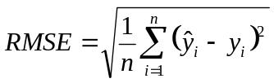. (6)
For measuring accuracy, the data were indexed with regard to their time-series mean, calculated over the time period from 1990 to 2009. This ensured that an error of 1 percent of the time-series mean was given equal weight throughout the entire sample, regardless of the unit of measurement, size of the country or economic importance of the commodity group to which a data point belonged.

Table 2: Sample Sizes Used for the Simulation of Different Scenarios
 |  | Area | Primary
 |  | harvested | crops | Meat
Scenario |  | for crops | production | production
Middle of a data gap, | gap length: 1 year | 936  (78,550) | 948  (94,142) | 963  (9,808)
Middle of a data gap, | gap length: 3 years | 919  (69,123) | 933  (83,616) | 970  (8,669)
Middle of a data gap, | gap length: 5 years | 915  (61,267) | 949  (74,668) | 971  (7,754)
End of a data gap, | gap length: 2 years | 935  (75,228) | 934  (90,888) | 961  (9,425)
End of a data gap, | gap length: 3 years | 920  (72,812) | 927  (88,329) | 979  (9,139)
End of a data gap, | gap length: 5 years | 922  (68,594) | 932  (83,996) | 973  (8,646)
Beyond the series end, | distance to series end: 1 year | 938  (87,185) | 949  (103,739) | 967  (10,780)
Beyond the series end, | distance to series end: 2 years | 924  (83,584) | 929  (100,144) | 957  (10,348)
Beyond the series end, | distance to series end: 3 years | 927  (80,530) | 947  (97,063) | 978  (10,005)
Beyond the series end, | distance to series end: 5 years | 932  (75,993) | 952  (92,339) | 983  (9,459)

Results

The graphs in the figures A1 to A3 in Annex 5 show the proportion of successfully imputed data points and the RMSE achieved with different imputation methods, for different types of data and for different scenarios. The following findings can be inferred from these graphs:

- The trend regression approach is applicable to much fewer cases than the linear interpolation and the aggregation approach. This is the case for all scenarios analyzed. In the case of imputations within time series gaps (interpolation), the coverage rate ranges between 65 and 80 percent (see figures A1 and A2); for imputations carried out beyond the time-series ends (extrapolation) this rate is even lower, amounting to around a half (see figure A3).

- In contrast to the trend regression approach, the coverage rate achievable with aggregate method is consistently high, ranging between 90 to 98 percent, both for data gaps and missing values lying beyond the end points of time series. For data gaps, this approach is thereby only modestly less productive than linear interpolation, for which the coverage rate is by definition 100 percent.

- The trend regression approach is not only the one with the lowest coverage; it shows also in most cases a smaller level of accuracy than the other analyzed methods. Especially close to the end of a time series gap, imputations based on trend regression tend to be affected by high error.

- In contrary, imputations based on aggregates lead to a persistently high accuracy. For all scenarios analyzed the mean squared error achieved with that method is below 40 percentage points. It is especially striking that the values of the indicators do not even increase for extrapolations when the distance to the endpoint of the time series becomes large (see figure A3).

- Data on meat production seem on average better predictable than data on crops production and harvested area.

These results show that, clearly, imputation using the aggregate approach produced relatively more accurate results.

4. Main Conclusions

The following are the main conclusions that can be drawn from the development and implementation of the two imputation and validation methodologies for the production domain.

- Two imputation methodologies were designed and tested on data currently imputed using the carry forward method. The methodology designed first, Imputation Methodology (1), resulted in some 77 percent of carried-forward data points being imputed, leaving, 23 percent which could not be imputed. The 77 percent were then subjected to validation checks. Of these, around 88 percent passed the validation checks. The results show that using Imputation Methodology (1), 69 percent of all data that were considered for imputation were ‘satisfactorily’ imputed.

- The second methodology, Imputation Methodology (2), resulted in the satisfactory imputation of 91 percent of data. In other words, the data that could be imputed using Imputation Methodology (2), and which passed the validation checks, represented 91 percent of all data that were considered for imputation.

- The methodologies designed to validate the imputed values relied on two main methods: range checks on the time series of the imputed variable and range checks performed on a secondary variable i.e. yield.

5. Next steps in methodology development

Although the proposed imputation and validation methodologies resulted in imputation of almost 90 percent of the 80 000 data points considered, more work needs to be done before these methodologies can be standardised across different domains. This section examines some of the critical outstanding issues with regards to imputation and validation methodologies and the potential steps to address these.

Not all data could be imputed using the proposed imputation and validation methodologies. This was because either there were insufficient official data or the imputed value lay outside the range of validation. This clearly underscores the need to develop a methodology which should impute all applicable cases. One possibility could be to use the trend regression approach to impute the remaining data points. However, the use of trend approach could be subjected to some conditionality, such as the availability of a minimum number of official values in the time series.

- There is a possibility that the country/commodity aggregates could have been based on data of one commodity/country alone. This would be the case if there was only one country/commodity with official values in the aggregate. This could potentially result in over-dependency on very few observations. One option could be to have a certain threshold for the number of observations that would be needed to ‘use’ an aggregate.

- Imputation was performed using information from the same element only. Thus, production data was imputed using data from production only, either from the same country (commodity aggregate) or from other countries. No account was taken of other inter-related elements such as a country’s trade in a commodity which can have an important bearing on its production. Thus, some ‘logical’ checks could be built into the imputation algorithm before an imputed value could be accepted. One such check could involve ensuring that the sum of the (imputed) production and import of a commodity is greater than its export (in the absence of commodity stockholding). Taking into consideration data from other related elements pertaining to the same country could also be particularly useful if the standard of using official data from within the country is to be followed.

- Increases in the variance of Dietary Energy Supplies (DES) in the FBS domain could constitute another important cross-validation check.

- The methodology did not account for the mathematical identities or ratios that exist between various commodities, for example, the ratio between heads of livestock and its meat, between eggs in units and in tonnes, etc. One possibility is to use these identities to impute data before the aggregate methods can be used provided one of the related commodities has official data. Thus, if official data on meat, for example, are available, these should be used to impute missing data for livestock. If no official data are available, then the same level of change resulting from imputing one product should be maintained for the other.

- Finally, in the current validation methodology, the tolerance levels were designed on an arbitrary basis. Thus, there is a need to design tolerance levels on more scientific basis and taking into consideration the peculiarities of data being validated. For instance, using the same percentage tolerance level for all values, big and small, may not result in desired outcomes, as bigger values are affected differently by percentage changes as opposed to smaller ones.

Taking account of all these aspects would lead to some modification of the imputation and validation methodologies. As such, development of the new methodology tested thus far could be termed as the first step towards standardising the statistical processing methodology. It is proposed that a next stage be carried out to develop a more robust methodology and one that can be easily standardised. It is hoped that lessons learnt from designing a well functioning statistical processing procedure for the production domain, one of the important and complex data domains in FAOSTAT, will ease the development of standard procedures for other data domains.

ANNEXES

Annex 1: Commodity groups in Imputation Methodology (2)

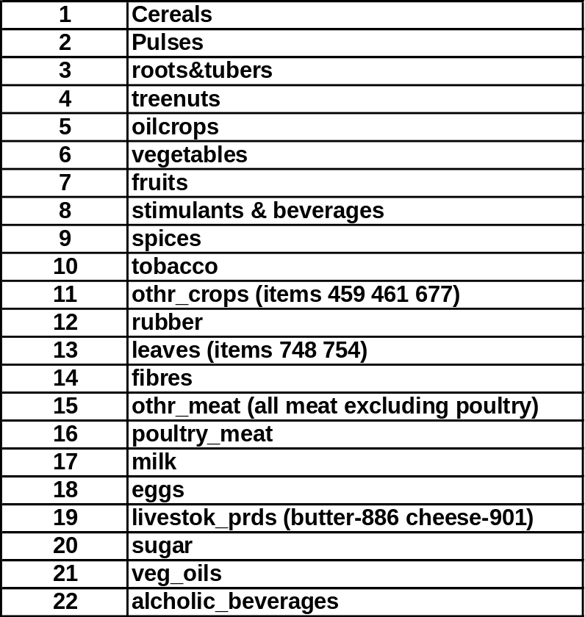

Annex 2.A: Geographic sub-regions aggregates

EASTERN AFRICA
MIDDLE AFRICA
NORTHERN AFRICA & NEAR EAST
SOUTHERN AFRICA
WESTERN AFRICA
NORTHERN AMERICA
CARIBBEAN
SOUTH AMERICA
CENTRAL AMERICA
CENTRAL ASIA
EASTERN ASIA
SOUTHERN ASIA
SOUTH-EASTERN ASIA
EASTERN EUROPE
NORTHERN EUROPE
SOUTHERN EUROPE
WESTERN EUROPE
OCEANIA

Annex 2.B: Geographic regions aggregates

SUB SAHARAN AFRICA
NORTHERN AFRICA & NEAR EAST
NORTHERN AMERICA
LATIN AMERICA & CARIBBEAN
ASIA
NORTHERN AFRICA & NEAR EAST
OCEANIA

Annex 3: Workflow corresponding to Imputation Methodology (2)

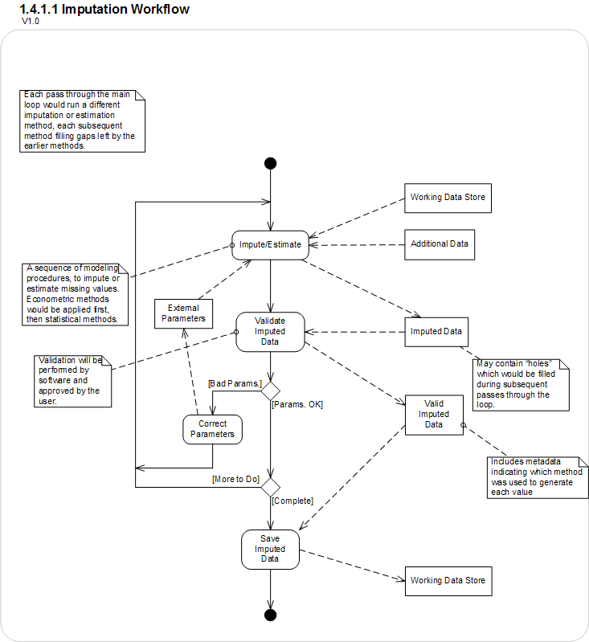

Annex 5: Charts depicting assessment of accuracy of imputation results

Figure A1: Exhaustiveness and accuracy in the middle of a time series gap
 | Coverage rate¹ | Root mean squared error
Area  harvested  for crops | 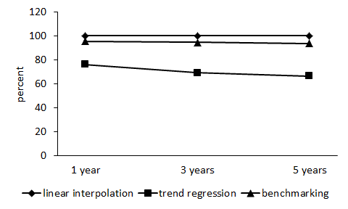 | 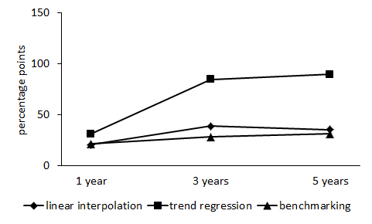
Crops  production | 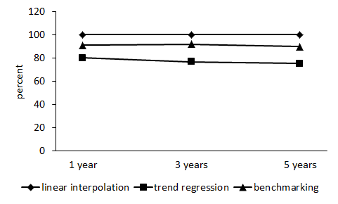 | 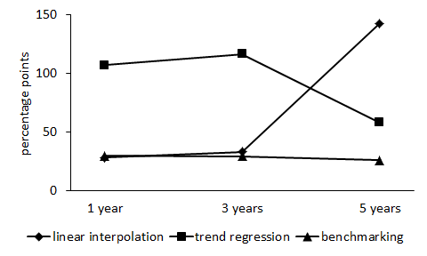
Meat  production | 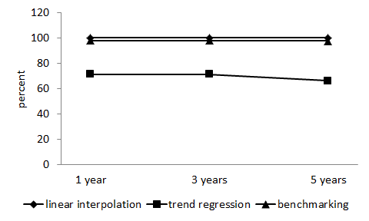 | 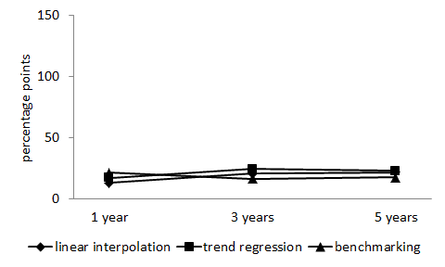
Notes: X-axis measures the length of the series gap. ¹) Proportion of imputed data points.

Figure A2: Exhaustiveness and accuracy at the end of a time series gap
 | Coverage rate¹ | Root mean squared error
Area  harvested  for crops | 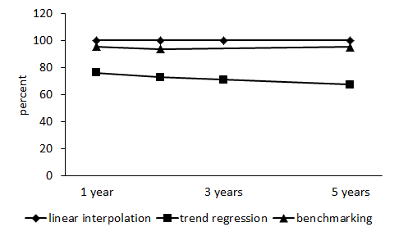 | 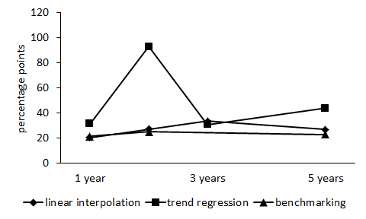
Crops  production | 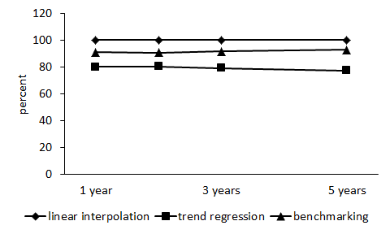 | 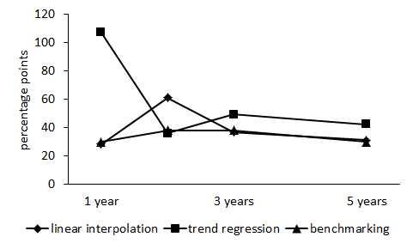
Meat  production | 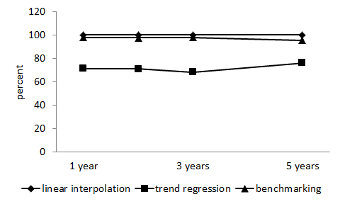 | 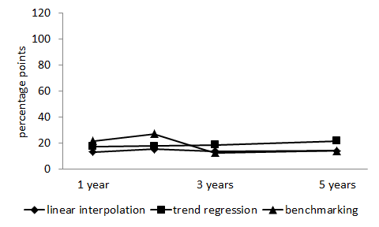
Notes: X-axis measures the length of the series gap. ¹) Proportion of imputed data points.

Figure A3: Exhaustiveness and accuracy beyond the time series endpoint
 | Coverage rate | Root mean squared error
Area  harvested  for crops | 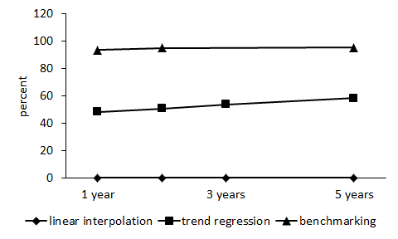 | 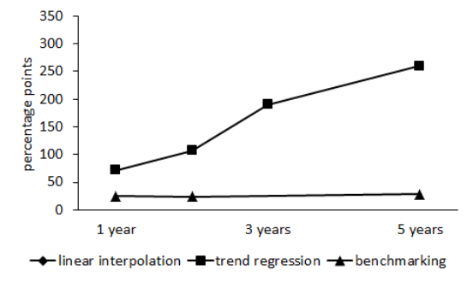
Crops  production | 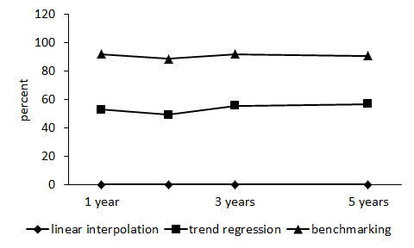 | 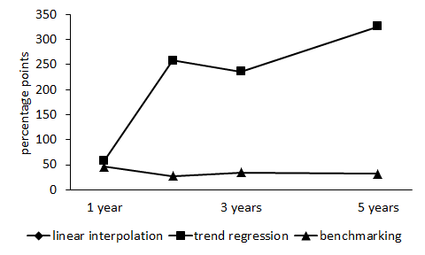
Meat  production | 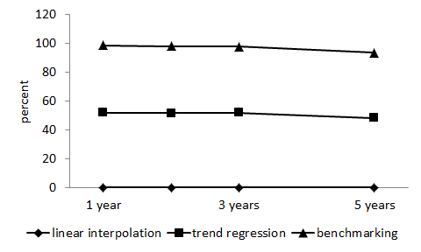 | 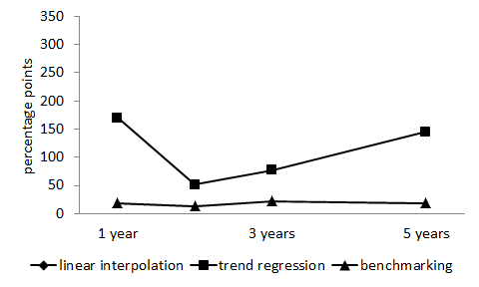
Notes: X-axis measures the distance to the time series end. ¹) Proportion of imputed data points.

References

Durrant, G. (2005) “Imputation Methods for Handling Item-Nonresponse in the Social Sciences: A Methodological Review”, NCRM Methods Review Papers NCRM/002, June 2005.

FAO, 2011, FAOSTAT, http://faostat.fao.org

Holt, T. (2003) “Aggregation of National Data to Regional and Global Estimates” Report prepared for the Committee for the Coordination of Statistical Activities, Geneva, 8-10 September 2003.

Hu, M., Salvucci S. M. and Cohen, M. (1998) “Evaluation of Some Popular Imputation Algorithms.”

ILO Employment Trends Unit (2010) “Trends Econometric Models: A Review of the Methodology”, January 2010.

Rubin, D.B. (1987): Multiple Imputation for Nonresponse in Surveys, New York, Chichester.

Schafer, J.L. and Graham, J.W. (2002) “Missing Data: Our view of the State of the Art”, Psychological Methods 7 (2), 147-177

Schaible, W. (2000) “Methods for Producing Estimates for Selected Key Indicators of the Labour Market”, Employment Paper 2000/6, International Labour Office, Geneva. Available at http://www.ilo.org/public/english/employment/strat/download/ep6.pdf

World Bank (2011), http://data.worldbank.org/about/data-overview/methodologies

A core team comprising seven Statisticians from the Statistics Division was involved at various stages of the methodology development and documentation process. These included Josef Schmidhuber, Mariana Campeanu, Nicholas Sakoff, Adam Prakash, Onno Hoffmeister and Hansdeep Khaira. The methodologies were also presented in two workshops organised by the Statistics Division that involved experts from national statistical offices and ministries of agriculture. The aim was to increase transparency between FAO and Member Nations and to elicit feedback from national experts.
It is important to note that in the production domain these elements are not unique, for instance, element 31 is used to denote area, in case of primary crops (expressed in hectares);producing/slaughtered animals, in case of livestock, (expressed in heads); and an input, in case of processed crop products (expressed in metric tonnes).

