FAO of the UN
Aupus Code Analysis
Information Technology Team,
Statistical Working System

Change history
Revision Version | Revision  Date | Author | Description of changes/status
V0.1 | 19th August 2011 | N.A.Connell | Initial draft version
V0.2 | 15th September 2011 | N.A.Connell | Corrections and enhancements after ESS review.

Contents

Introduction 6
The Data 7
Timeseries 7
Input From Processing 7
Aupus Shares 7
Aupus Ratios 8
The Process 9
Element Processing 11
11: Initial Existence 12
21: Potential Producing Factor 12
31: Actual Producing Factor 13
Element 31 13
Element 41 13
Element 51 14
Production Element Calculation 14
41: Productivity element 15
51: Output 15
58: Production Crop Year 15
61: Inflow 15
62: Inflow Value 15
63: Inflow Unit Value 15
66: Standardized Inflow 15
71: From Initial Existence 16
81: To Initial Existence 16
91: Outflow 16
92: Outflow Value 17
93: Outflow Unit Value 17
95: Re-export 17
96: Standardized Outflow 17
101: Use For Animals 17
111: Use For Same Product 18
121: Losses 18
131: Reemployment Same Sector 18
141: Consumption 19
144: Consumption Per Day 20
151: Reemployment Other Sector 20
161: Final Existence 21
171: Consumption 21
174: Consumption Per Caput 21
181: Statistical Discrepancies 21
261: Calories 21
264: Calories Per Day 22
271: Proteins 22
274: Proteins Per Day 22
281: Fats 22
284: Fats Per Day 22
541: Final Demand 22
546: Total Demand 22
Calculate Balance 24
Trend Calculation 27
Validation 28
Appendix A – Stock Commodity Types 31
Appendix B – Trade Commodity Types 32
Appendix C – Seeding Rate Commodity Types 33
Appendix D – Production Commodity Types 34
Appendix E - Symbols 35
Appendix F – Diagrams 36
Element 31 37
Element 41 38
Production Elements 39
Element 61 40
Element 66 41
Element 111 42
Annexes 43

Introduction
This document describes the processing performed by the C++ program which applies the AUPUS calculations. This document was developed by reading the code and documenting the flows and formulae applied during the program operation.
This document contains both text and diagrams (where logic is complex) explaining the various processes from the code; in each case, if a diagram is available, it complements the text and diagram and associated text should be read together.

The Data

Timeseries
A de-normalized yearly time series, keyed by area, commodity and element.
The established faostat term for commodity is item, however the term item also includes population (See Annex 3).
The matrix extracted from the database depends on the command line parameters supplied and the contents of the constnts.ini file, which defines the year ranges. Usually only the country area code is supplied on the command line, in which case all commodities and elements for the country and year range are extracted and processed. A commodity code may be supplied on the command line; in this case only the commodities in the tree below that commodity, and population are extracted and processed.

Input From Processing
Table: INPUT_FROM_PROC
View: INPUT_FROM_PROCV
A de-normalized time series (yearly) keyed by area, parent commodity and child commodity.
Some of this may be input by clerks (verify?), while a value is calculated during the pre-processing stage of element 31 (See below).

Aupus Shares
Table: AUPUS_ITEM_TREE_SHARES
A normalized set of share values (percentages) and a “process” flag keyed by area, parent commodity, child commodity and year.
These describe the percentage of the parent (input) commodity that is processed to obtain the child (output/processed) commodity. For example:
Parent | Child | Share
16:Wheat flour | 18:Macaroni | 95%
16:Wheat flour | 20:Bread | 3%
16:Wheat flour | 22:Pastry | 2%
Area and year keys may be zero which acts as a wildcard, indicating that the share can be applied across all areas/years respectively. There are currently over 60,000 entries in the shares table.
Note that shares do not have an element code as part of the key; they are only applied to certain elements by the C++ code.

Aupus Ratios
Table: AUPUS_RATIOS
A normalized set of technical conversion factors keyed by area, item(commodity), element and year. Area and year values may by zero, which acts as a wildcard value.
For example, these are the generic values for calculating calories, protein and fats from wheat flour:
AREA | ITEM | ELE | YR | RATIO
0 | 16:Wheat flour | 261:Calories | 0 | 364
0 | 16:Wheat flour | 271:Protein | 0 | 109
0 | 16:Wheat flour | 281:Fats | 0 | 11

This table also contains the balance element indicator defining which element (if any) should contain the supply/utilization balance figure calculated by the aupus code.
There are currently approximately 185,000 entries in this table.

The Process
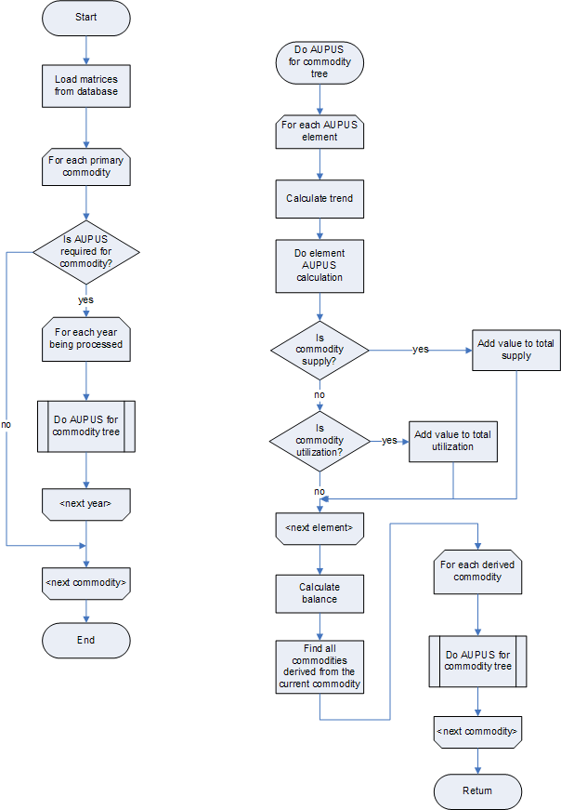
The various matrices for data, ratios, shares and input from processing are extracted from the database.
The code creates a list of area/commodity/year key sets over which it will iterate. E.g.:
0: [ Area 68, Commodity 15, Year 2000 ]
1: [ Area 68, Commodity 15, Year 2001 ]
2: [ Area 68, Commodity 44, Year 2000 ]
3: [ Area 68, Commodity 44, Year 2001 ]
Processed commodities are not included in this list, since they will be handled when the code walks down the commodity tree of their parent commodity.
At certain places in the code, while processing one of these key sets, either the preceding or following year can be added to the set so that that year is processed for the area/commodity immediately after the current year has finished. While there may be some value to reprocessing the previous year, it seems pointless for the following year since it will be processed anyway (if the next year is not present in the matrix then it will not be processed in either case).
The code iterates over the key sets, processing the entire tree below each root commodity. It processes each commodity tree top-to-bottom; at each node it processes any children which have a share relationship (i.e. an entry in the shares database table, for which the area is not a wild card) with the current commodity and which have the “aupus required” flag set for that share. For each 1st level processed commodity it process the entire sub-tree of 2nd and 3rd level processed commodities, before proceeding to the next 1st level processed commodity.
Before processing a processed commodity, the code checks to see if there is a country specific share relationship between the commodities and whether the “aupus required” indicator is set for the share. If either there is not a specific share or aupus is not required the input from processing (IFP) value for the relationship is set to empty (0M) before processing the processed commodity.
For each commodity the code iterates through the set of aupus elements in numerical order of element code [11, 21, 31, 41, 51, 58, 61, 62, 66, 71, 91, 92, 95, 96, 101, 111, 121, 131, 141, 144, 151, 161, 171, 174, 261, 264, 271, 274, 281, 284, 541, 546]. The processing for each element is detailed below. Values for the two sides of the supply/utilization account are gathered as each element is processed (See below for details of the balance calculation itself).
Trend values are calculated before the processing of each element occurs (See trend calculation details below).
After all elements are processed for the commodity (area and year) the balance calculation is applied.

Element Processing
Only cells with replaceable symbol values (See appendix E below) will be overwritten with calculated values; often if a calculated value would replace an entered value, the calculated and entered value are compared and differences reported.
The process works using the concept of a current cell, which is the area, commodity, element and year keyed cell containing a value and symbol which should be processed and possibly replaced in the matrix. Sometimes cells other than the current cell are modified in the matrix during the processing of a given cell. The current cell's potential new value is calculated on an element-by-element basis, the code then decides whether that value should replace the current value for the cell, or not.
The general pattern of processing is that a segment of code will calculate a potential new value for the target commodity/element and pass this value back to calling code, which then inserts any valid values into the matrix, however some code segments insert the value (or other values) into the matrix themselves, sometimes returning nothing to the calling code, sometimes returning the calculated value. This diversity often makes it difficult to see whether a given value is actually placed in the matrix or not.
If a given element code segment does not calculate a value, but a trend value was calculated during this processing pass, the code puts that trended value in the matrix, otherwise it sets the target value to empty (0M). Existing trended values (I.e. From previous passes) are not replaced in this situation.
A cell may be either null (it did not exist at all in the current data), empty (it has a specific non-value: 0M) or zero. The code is often unclear on which of these it tests for; for instance there are a number of methods for testing and creating empty values (i.e. 0M) but these are all named xxxNullCell.
As a general rule calculated cells have their symbol set to calculated [C].
Balance results and trended values have their symbols set to B and T respectively.
Differences to this rule are noted on an element-by-element basis below.
In the text and formulae below:
- Vt₉₉₉ Refers to a value for the current target commodity, element 999
- V_{s999} Refers to a value for some source commodity, element 999
- V_{comp} Refers to the computed value which may become the new value for the target commodity/element
- R_{t999} Refers to the ratio (conversion factor) value for the target commodity, element 999
- S_{st} Refers to the share value between the source and target (processed) commodities
- V_{ifp} Refers to the input from processing value for a source/target commodity pair

11: Initial Existence
This is only applied to stock commodity types (See appendix A).
The content of the source commodity, element 161 [V_{t161}] is copied from the previous year:
V_{comp} = V_{t161}
The symbol (See Appendix E) used depends on the symbol in the previous year's 161 element:
- Unofficial source --> transferred unofficial
- FAO estimate or Trend --> Calculated
- Otherwise --> Transferred official

21: Potential Producing Factor
If seeding rates are applicable to the commodity type, and the cell value has been trended, set to process the previous year in the next pass.
Otherwise, if the target commodity is of type population [1] copy the value for from the target commodity, element 11 [Initial Existence], setting the flag to transferred official.
V_{comp} = V_{t021}

31: Actual Producing Factor
The same processing is done once for elements 31, 41 and 51, triggered by whichever is encountered first (I am not sure why this should ever be anything other than element 31). The second and third elements encountered, simply return the matching working value calculated during the first pass.
E.g. assuming the elements are encountered in order
Pass #1: V_{t031}, V_{t041} and V_{t051} are calculated. V_{comp} = V_{t031}
Pass #2: No calculation. V_{comp} = V_{t041}
Pass #3: No calculation. V_{comp} = V_{t051}

Element 31
[Diagram: Element 31]
Firstly, if the target commodity is a processed product (eg. Wheat flour) a value for element 031 (Input) is calculated from the sum of all source commodity Input From Processing (IFP) values. Before summing the IFP values, if the IFP value from the current source commodity is either missing or calculated (not forgetting that the processing walks the commodity tree, and hence is processing a known commodity input/output pair) the IFP value is calculated as
V_{ifp} = V_{s131} x S_{st} / 100
where:
V_{s131} is the source commodity value for element 131 (reemployment, same sector)
S_{st} is the share between the source and target commodity (AUPUS_SHARES table)
V_{ifp} is a potential value for the target commodity, element 031 [V_{t031}] depending on the current value.
If the current value for V_{t031} is an entered value (not calculated, trended or empty) that current value is used for the production calculations.
Otherwise, if the V_{ifp} value is available, that calculated value is used; finally, if none of those values are available an empty (0M) value is used.

Element 41
[Diagram: Element 41]
If a ratio value exists for the target commodity, element 41 [R_{t041}] the working value for the target commodity, element 41 is calculated as:
V_{t041} = R_{t041} x 100
If the ratio value does not exist, and the existing value for the target commodity, element 41 is not calculated, the current value from the matrix will be used in the production calculations.

Element 51
If it has a non-missing value, the current value for the target commodity, element 51 [V_{t051}] is used.
If the current value is not valid (missing, empty) an empty value is used (0M).
However there are two special cases for this element.
- If the commodity has one of the ESCR sugar commodity types [55,56], and the current commodity has a value for element 58 (production crop year), then that value is used as the value for V_{t051} in the production calculations.
- If the target commodity code is 3183 then the sum of available values for source commodities 3158 and 5158, element 51 is used as the value for V_{t051} in the production calculations. i.e. V_{t051} = V_{3158e51} + V_{3159e51}.

Production Element Calculation
{Diagram: Production Elements]
Having deduced the best available set of values for the target commodity elements 31, 41 and 51, the production calculation continues. The set of three value will be referred to as the working values, [V_{t031}, V_{t041} and V_{t051}]
The division factor [F_{d}] for the calculation is defined according to the commodity type:
Type | Divisor
Default | 10,000
55:ESCR_SUGAR_PRIMARY_PRODUCTS | 1
58:ESCR_TEA, 59:ESCR_COCOA_PRIMARY_CROPS and 61:ESCR_COFFEE_PRODUCTS | 1000

The base formula is:
V_{t051} = V_{t031} x V_{t041} / F_{d}
The processing depends on how many of the working values contains non-calculated, non-empty (0M) data. If all three of the working values has a valid value, then which, if any, of the values contain trended data is deduced. If a single value has trended data, that value is recalculated; if more than one of the working values is trended, one of them is recalculated according to the element precedence 41, 51, 31) .
If one of the working data values is non-valid then that value is calculated from the others and the division factor.
If more than one is missing then the code aborts the calculation and logs a warning in the output file.
V_{comp} is set to whichever of the working value elements triggered the production calculation.

41: Productivity element
See Element 31.

51: Output
See Element 31.

58: Production Crop Year
This element is only processed for the ESCR sugar commodity type [57].
The value calculated is the sum of the values for element 58 of the source commodities 3158 and 3159. i.e. V_{comp} = V_{3158e058} + V_{3159e58}

61: Inflow
[Diagram: Element 61]
If the current target commodity value, element 61 [V_{t061}] is neither null nor zero (inc. 0M), and there is a value available for the target commodity, element 62 [V_{t062}] recalculate the element 63 (unit value) [V_{t063}] using those values:
V_{comp} = V_{t062} x 1000 / V_{t061}
The computed value is immediately pushed into the data matrix, as the new element 63 value.
If V_{comp} could not be calculated and the existing target commodity, element 63 value is non-zero (inc. not 0M), the code immediately sets the target commodity, element 63 value to empty in the data matrix.
Note: While it sets the V_{comp} value, to that of a different element to that which is being processed (63 vs. 61), it does not return the V_{comp} value (as is usually done) but always returns null.

62: Inflow Value
See element 61: Inflow for the processing for this element.

63: Inflow Unit Value
Element 63 is calculated as part of the element 61: Inflow processing.
Note that code is present to process element 63, however it has been disabled; there is no explanatory comment about why this is the case.

66: Standardized Inflow
[Diagram: Element 66]
This element is only processed if the target commodity type is trade (See Appendix B).
The processing is also only applied to commodities to which aupus is not usually applied. It standardizes their quantities so that parent and processed commodity amounts are consistent (that from the comments).
The parent/child formula which is applied recursively up to three levels deep is:
V_{t066} = ΣV_{c061} / F_{d}
Where, if the domain type is FBR:
F_{d} = F_{p} x F_{pc} / 100
otherwise:
F_{d} = F_{p} x V_{c041} / 100
where:
V_{t066} is the parent commodity value for element 66
V_{c061} is the child commodity value for element 61
F_{d} is the dividing factor for the ancestor/descendent relationship
F_{p} is the dividing factor of the grand parent/parent relationship
F_{pc} is the dividing factor of the parent/child relationship
V_{c041} is the child commodity value for element 41
The value finally returned and set into the V_{comp} as a potential value for the element 66 is the result of this calculation applied recursively to the commodity tree below the target commodity; at each successive recursion the value F_{d} becomes F_{p} for the next descendent down the tree, the initial value for F_{p} is 1. V_{t066} values are summed across the descendents over all levels.

71: From Initial Existence
This is only calculated for elements of the types ESCR sugar, tea, coffee and cocoa [57,58,59,60,61].
If the target commodity type is ESCR sugar [58], the value calculated using other elements of the target commodity:
V_{comp} = V_{t051} + V_{t061} - V_{t091} - V_{t101} - V_{t121} - V_{t131} - V_{t141} - V_{t151}
If the target commodity type is ESCR tea/coffee/cocoa [59,60,61], the value calculated using other elements of the target commodity:
V_{comp} = V_{t161} - V_{t011}

81: To Initial Existence
No processing is done for this element.

91: Outflow
If the target commodity type is one of the following, processing is not performed for this element:
- 42 ESCR_SKINS
- 43 ESCR_HEAVY_LEATHER
- 44 ESCR_LIGHT_LEATHER
- 45 ESCR_LTHR_FOOTWARE
- 46 ESCR_CITRUS_FRUIT_RAW
- 47 ESCR_CITRUS_FRUIT_PRODUCTS
- 48 ESCR_WINE
- 49 ESCR_JUTE_RAW
- 50 ESCR_JUTE_PRODUCTS
- 51 ESCR_TOBACCO_RAW
- 52 ESCR_TOBACCO_PRODUCTS
If the current target commodity value, element 91 [V_{t091}] is not null or zero (inc 0M), and there is a value available for the target commodity, element 92 [V_{t092}] recalculate the element 93 (unit value) [V_{t093}] using those values:
V_{comp} = V_{t092} x 1000 / V_{t091}
The computed value is immediately pushed into the data matrix, as the new element 93 value.
If V_{comp} could not be calculated and the existing target commodity, element 93 value is non-zero (including not 0M), the code immediately sets the target commodity, element 93 value to empty in the data matrix.
Note: While it sets the V_{comp} value, to that of a different element to that which is being processed (93 vs. 91), it does not return the V_{comp} value (as is usually done) but always returns null.

92: Outflow Value
See element 91: Outflow for the processing for this element.

93: Outflow Unit Value
Element 93 is calculated as part of the element 91: Outflow processing.
Note that code is present to process element 93, however it has been disabled; there is no explanatory comment about why this is the case

95: Re-export
No processing is done for element 95.

96: Standardized Outflow
The processing for this element is identical to that for element 66.

101: Use For Animals
A comment in the code notes that it assumes that commodity total supply value [S_{total}] has already been calculated. This is accumulated, element-by-element during the commodity's element processing (See Calculate Balance below).
If a ratio value exists for the target commodity, element 101 [R_{t101}] the computed value is calculated as:
V_{comp} = R_{t101} x S_{total} / 100
If the ratio value is non-country specific the “not from generic ratio” flag is set to false. (That logic seems inverted to me).

111: Use For Same Product
[Diagram: Element 111]
If a ratio value does not exist for the target commodity, element 171 [R_{t171}] the computed value is calculated from the total supply as for element 101:
V_{comp} = R_{t111} x S_{total} / 100
If Rt171 has a valid value, firstly a check is done to see if the next year's value is available; if not the processing aborts, returning the current value as V_{comp}.
If the next year is available, the code attempts to calculate the V_{t111} from a series of sources (seeds):
- Element 21 of the target commodity, year+1
- Element 31 of the target commodity, year+1
- Element 21 of the target commodity, current year
- Element 31 of the target commodity, current year
The first to produce a valid value is used. If option 1 produces a valid value and the R_{t171} is not country specific, the “not from generic ratio” flag is set to false.
In each case the processing is the same:
V_{comp} = V_{seed} x R_{t171} / 1000
where:
V_{seed} is the value of the target commodity for the seed element/year being processed.

121: Losses
The value is calculated from the total supply as for element 101:
V_{comp} = R_{t121} x S_{total} / 100

131: Reemployment Same Sector
The value is calculated from the total supply as for element 101:
V_{comp} = R_{t131} x S_{total} / 100

141: Consumption
For most commodity types the value is calculated from the total supply as for element 101:
V_{comp} = R_{t141} x S_{total} / 100
For commodity type ESCR jute products [50]:
A “calc type” value is deduced by taking the integer part of the target commodity, element 141 ratio value. This is an unsafe programming practice. If no ratio value is found, the “calc type” is set to 1.
The product trade difference value [T_{p}] is calculated as:
T_{p} = V_{t061} – V_{t091} [i.e. imports – exports]
A calculation is then done based on the “calc type” deduced above. Some calculations use a source commodity; this is always commodity code 3921.
If “calc type” is 1:
Raw trade [T_{r}] is calculated from the source commodity as:
T_{r} = V_{s061} – V_{s091}
unless neither V_{s061} nor V_{s091} have values in which case the source/target commodity input from processing value is used; If that is not available, T_{r} is set to zero.
The value is calculated as:
V_{comp} = T_{r} + ( T_{p} x 1.07 )
If “calc type” is 2:
The value is calculated from the target commodity element 51 [output]:
V_{comp} = ( V_{t051} x 1.02 ) + ( T_{p} x 1.07 )
If “calc type” is 3:
Raw trade [T_{r}] is calculated from the source commodity as:
T_{r} = V_{s061} – V_{s091} + V_{s051}
unless neither V_{s061}, V_{s091} nor V_{s051} have values in which case the source/target commodity input from processing value is used; If that is not available, T_{r} is set to zero.
V_{comp} = T_{r} + ( T_{p} x 1.07 )
If “calc type” is 4:
Raw consumption [C_{r}] is calculated as:
C_{r} = V_{s141} + V_{s145}
unless neither V_{s141} nor V_{s145} have values in which case the source/target commodity input from processing value is used; If that is not available, C_{r} is set to zero.
The value is calculated from the target commodity, element 71 value [V_{t071}] as:
V_{comp} = C_{r} + ( V_{t071} x 1.07 ) + ( T_{p} x 1.07 )
No other “calc type” value is considered (no default processing is defined).
If V_{comp} is less than zero, it's value is immediately set into the matrix in the target commodity, element 181 [statistical discrepancies] cell. V_{comp} is set to empty (0M).
Otherwise, if V_{comp} is zero or positive, the target commodity, element 181 value is set to empty (and immediately inserted into the matrix).
For commodity type ESCR tea, cocoa and coffee products [58,59,60,61]:
The value is calculated from the target commodity as:
Vcomp = V_{t011} + V_{t051} + V_{t061} – V_{t091} – V_{t095} – V_{t161}

144: Consumption Per Day
This makes the assumption that the [total] consumption element [141] has already been calculated for the target commodity.
V_{comp} = V_{t141} / V_{p011}
where:
V_{p011} is the value of the population “commodity” [1?], element 11 [initial existence]
If the commodity type is one of the following, the V_{comp} value is multiplied by 1000:
48 ESCR_WINE
46 ESCR_CITRUS_FRUIT_RAW
47 ESCR_CITRUS_FRUIT_PRODUCTS
51 ESCR_TOBACCO_RAW
52 ESCR_TOBACCO_PRODUCTS
58 ESCR_TEA
59 ESCR_COCOA_PRIMARY_CROPS
60 ESCR_COCOA_PRODUCTS
61 ESCR_COFFEE_PRODUCTS

151: Reemployment Other Sector
For most commodity types the value is calculated from the total supply as for element 101:
V_{comp} = R_{t151} x S_{total} / 100
For commodity 1687 [Charcoal] the value is calculated from the source commodities 1684 [?] and 1687 [?] from the values for elements 131 and 51 respectively:
V_{comp} = V_{1684e131} - V_{1687e051}

161: Final Existence
If the target commodity type is ESCR sugar [57] the value is calculated as:
V_{comp} = V_{t011} + Vt₀₇₁
If the target commodity type is a trade type (See Appendix B) then the presence of a value for the target commodity, element 11 is checked for the following year; if that value exists and is calculated then a flag is set to force processing of the following year. In this case V_{comp} is not set or returned to the parent process.

171: Consumption
This element is only calculated for commodity type ESCR sugar [57].
It is calculated from various element values from the target commodity:
V_{comp} = V_{t101} + V_{t121} + V_{t131} + V_{t141} + V_{t151}

174: Consumption Per Caput
This element is only calculated for commodity type ESCR sugar [57].
It is assumed that the element 171 [consumption] has been calculated already.
V_{comp} = V_{t171} / V_{p011}
where:
V_{p011} is the value of the population “commodity” [1?], element 11 [initial existence]

181: Statistical Discrepancies
A value for this may be set while processing element 141 for the commodities related to jute, see the element 141 processing described above.
All other values for this element are produced during the calculation of balances (See Balance Calculations below).

261: Calories
The processing to calculate the nutritive values of calories, proteins and fats is identical except for the dividing factor [F_{d}]. All calculations use the target commodity ratio values [R_{tx}] for the respective element [x = { 261, 271, 281 }]:
For Calories:
F_{d} = 100
whereas for proteins and fats:
F_{d} = 1000
The calculation is:
V_{comp} = R_{tx} x V_{t141} / F_{d}

264: Calories Per Day
The per day nutritive calculations for calories, proteins and fats are identical.
The code first looks for a value for population, element 21 (known as the FBS population); if that is not found it uses the value for population, element 11 [initial existence].
The code makes the (dangerous) assumption that the source element for each of the nutritive per day calculations has the element code 3 less than the per day element code.
V_{comp} = ( V_{s} / 365 ) * 1000 ) / V_{p}
where:
V_{s} is the value of the target commodity, source element [261, 271, 281] for the respective target element [264, 274, 284].
V_{p} is the value for population as described in the previous paragraph.

271: Proteins
See 261 Calories.

274: Proteins Per Day
See 264 Calories per day.

281: Fats
See 261 Calories.

284: Fats Per Day
See 264 Calories per day.

541: Final Demand
The final demand element value is calculated from element values of the target commodity:
V_{comp} = V_{t542} + V_{t543} + V_{t544} + V_{t545}
If none of the element values [542, 543, 544, 545] are present/valid then V_{comp} is set to empty (0M) instead.

546: Total Demand
The total demand element value is calculated from element values of the target commodity:
V_{comp} = V_{t541} + V_{t151} + V_{t091}
If none of the element values [541, 151, 91] are present/valid then V_{comp} is set to empty (0M) instead.

Calculate Balance
Supply/Utilization balance value is calculated either once the element processing gets past the “max element for balance” element code for a given commodity, or after all elements have been processed for the commodity (why not just wait until then anyway?).
The “max element for balance” is element 181 for most commodity types, however for ESCR wine, citrus fruits, and tobacco [46,47,48,51,52] element 141 is used, while for commodity type WEIS items cum[ulatuve] [53] element 546 is used.
The target element for balance is defined for the comodity by a flag in the ratios table against the appropriate element.
During the element processing cycle for the target commodity, each element is considered for balance; whether it applies to the supply or utilization side of the account, or whether it is not included. Accumulated values for total supply and total utilization are maintained. The total supply value is used in several of the element processing code segments.
Balance is not calculated for the following commodity types:
- 04 LIVE_ANIMALS
- 15 INDIGENOUS_MEAT
- 16 BIOLOGICAL_MEAT
- 20 EGGS_IN_QUANTITY
- 21 BEEHIVES
- 25 POULTRY_AND_RODENTS
- 32 INDIGENOUS_POULTRY_AND_RODENTS_MEAT
- 33 BIOLOGICAL_POULTRY_AND_RODENTS_MEAT
- 37 LAND_USE
- 49 ESCR_JUTE_RAW
- 50 ESCR_JUTE_PRODUCTS
- 55 ESCR_SUGAR_PRIMARY_PRODUCTS
- 56 ESCR_SUGAR_RAW

The simple non-excluded element cases are:
51:Output | Supply
58:Production crop year | Supply
61:Inflow (Imports) | Supply
66: Standardized inflow | Supply
71:From initial existence | Stock variation
91:Outflow (Exports) | Utilization
95:Re-export | Utilization
96:Standardized outflow | Utilization
101:Use for animals | Utilization
111:Use for same product | Utilization
121:Losses | Utilization
131:Reemployment same sector | Utilization
141:Consumption | Utilization
161:Final existence | Utilization
546:Total demand | Utilization

More complex cases are:
Element 11 [Initial existence] is considered as supply side if the commodity type is ESCR tobacco, tea, cocoa or coffee [51,58,59,61]; otherwise it is not considered in the balance calculation.
Element 151 [Reemployment other sector] is considered utilization side if the commodity type is not WEIS items cum[ulative] [53].
Note that while the supply/utilization use is available for each element in the database, the code has the choice hard coded into the source.
The final calculation for balance is
B = Σ(supply element values) – Σ(utilization element values)
for any given commodity.

Exceptions:
1) If the commodity type is ESCR sugar [57], if the values for elements 161 [final existence] and 171 [consumption] are available (not missing or empty) and the value for element 171 is not zero, the balance figure is recalculated as:
B = ( V_{t161} / V_{t171} ) x 1000
If the code cannot calculate the balance for the sugar commodity, due to missing or empty values, the balance value is set to zero.
2) If the balance element is 71 [from initial existence] the balance value is negated:
B₇₁ = -B
If the balance calculated is less than zero, then the balance value is set to zero, and the value calculated placed in element 181 [statistical discrepancy]; unless the area code is 10 [Australia] and the commodity code is 3904 [goats(check)] in which case it is accepted as a negative balance.
If the existing balance element for the commodity was not an inserted value (i.e. it was calculated, missing, etc.) then the balance element defined for the commodity type (see above) is updated in the matrix with the new value.
Element 181 [statistical discrepancy] is also updated if the existing value is not an inserted one. If the balance calculation result was non-negative (excepting the cases notes above) the element 181 is set to empty (0M) in the matrix.

Trend Calculation
Trending is only applied for years greater than the “trend base year” and less than or equal to the “last aupus year” which are runtime parameters for the program (from constnts.ini).
Only commodities in the code ranges 0-1299 and 1455-1700 are trended.
Element 71 [from initial existence] is not trended except for fishery commodity types [12,13].
The production elements [31,41,51] are trended once, as a group (presumably because they are aupused in the same way) when the first of the three elements is submitted for processing.
Values are only trended it the current value is trended [T], calculated [C] or missing [M].
The source value for trending is the same commodity and element as the cell being trended, but for the previous year.
The target value is set to the same value as the source, even is the source value is empty (0M), however if empty the target cell retains the “M” flag, whereas if a value is copied the symbol is set to “T”.

Validation
As the code processes the data, it reports a number of warning or error messages. Below is a list of conditions and messages produced. In most cases the key being processed is displayed along with the error message.
If an element is defined as a balance element for a commodity (from the ratios[?] table) but the matrix contains a non-replaceable value, the code reports:
WARNING - Value entered for an element that is balance
If any value was calculated but the matrix contains a non-replaceable value, the code compares the two values and reports if they are different:
WARNING - Entered value differs from calculated value
Entered value: xxx
Calculated value: yyy
When calculating element 11:
if the previous year is not available (element 161):
ERROR - (161)[year-1] cannot be found in the extraction
When calculating elements 21, 144 or 174:
if the current cell is calculated (replaceable) and the commodity being processed is not a population type [1]:
ERROR - No formula exists for this element
If the population value is missing or zero:
ERROR - Population not extracted or its value is 0 unable to compute per caput consumption
When calculating the production elements [31,41,51]:
If any of the values for elements 31, 41 or 51 are missing:
ERROR - At least one of the three elements (031), (041) and (051) is missing;
If more than two of the values for elements 31,41 or 51 are empty (0M):
ERROR - System was not able to recalculate datum be calculated
If calculating elements 31 or 41 and the value for element 51 is zero:
ERROR - Cannot divide by 0, value missing for ele: <element code>
When performing the element 31 pre-processing, where input from processing is considered:
If no area specific share value was found:
ERROR - No related share exists for entered value
If a specific share was found, but a value for element 131 was not and the IFP value was not calculated:
WARNING - Missing (131) for related parent
When calculating element 31:
If the pre-processing step did not produce a value:
WARNING - Unable to validate (031): no data exist in Input From Processing matrix
If the existing values in the data and IFP matrices were both not-replaceable (entered), and their values differ:
ERROR - There is a difference between values in time-series (entered) and input_from_proc (entered)
When calculating element 111:
If the ratio value was not available:
ERROR - Missing ratios for (111) and (171)
When calculating element 66, when back-calculating the non-aupus children (See element 66 processing above):
If no value is available for element 41:
ERROR - Element (041) is missing for item_child <commodity code> unable to standardize trade quantity
If the value for element 41 is zero:
WARNING - Ele (041) is 0, unable to standardize child: <commodity code>
When performing the “from supply” calculation (elements 101, 111, 121, 131, 141, 151):
If the ratio value was not found:
ERROR - Ratio does not exist
When calculating the nutritive values (elements 261,271,281):
If the ratio value was not found:
ERROR - Ratio does not exist
If a value for element 141 [consumption] was not found:
ERROR - Food (141) does no exist
When calculating the nutritive per caput values (elements 264,274,284):
If the population element [21 or 11] was not found or was zero:
ERROR - Population not extracted or its value is 0
If the nutritive element [261/271/281] value is missing:
ERROR - Related nutritive element does not exist
When calculating the supply/utilization balance:
If the existing value for element 181 [statistical discrepancies] is neither empty (0M) nor a balance calculation (symbol B):
ERROR - Value entered for element 181
If the commodity type is one that does not have a balance [4,15,16,20,21,25,32,33,37,49,50]:
WARNING - Balance element has been defined
If the balance value calculated is negative (see balance processing for exceptions):
ERROR - Negative Balance
If the current value for the balance element is a non-replaceable value :
WARNING - For current item, balance element is not defined or has valid input figure

Appendix A – Stock Commodity Types
02:PRIMARY_CROPS_AND_FORESTRY
03:DERIVED_CROPS_AND_FORESTRY
04:LIVE_ANIMALS
05:MEAT
06:ANIMAL_FAT_AND_OFFALS
07:HIDES_AND_SKINS
08:MILK
09:DERIVED_ANIMAL_PRODUCTS
10:HAIR_WOOL_COCOONS_FURS
13:DERIVED_FISHERY
19:WOOD_AND_WOOD_PRODUCTS
20:EGGS_IN_QUANTITY
21:BEEHIVES
22:HONEY_AND_BEESWAX
25:POULTRY_AND_RODENTS
26:POULTRY_AND_RODENTS_MEAT
27:POULTRY_OFFALS
28:RABBIT_SKINS
30:EGGS_IN_WEIGHT
57:ESCR_SUGAR

Appendix B – Trade Commodity Types
02:PRIMARY_CROPS_AND_FORESTRY
03:DERIVED_CROPS_AND_FORESTRY
04:LIVE_ANIMALS
05:MEAT
06:ANIMAL_FAT_AND_OFFALS
07:HIDES_AND_SKINS
08:MILK
09:DERIVED_ANIMAL_PRODUCTS
10:HAIR_WOOL_COCOONS_FURS
11:FERTILIZERS
12:PRIMARY_FISHERY
13:DERIVED_FISHERY
19:WOOD_AND_WOOD_PRODUCTS
20:EGGS_IN_QUANTITY
21:BEEHIVES
22:HONEY_AND_BEESWAX
25:POULTRY_AND_RODENTS
26:POULTRY_AND_RODENTS_MEAT
27:POULTRY_OFFALS
28:RABBIT_SKINS
29:FRUIT_PRIMARY
30:EGGS_IN_WEIGHT
39:FIBRES_ITEMS

Appendix C – Seeding Rate Commodity Types
02:PRIMARY_CROPS_AND_FORESTRY
03:DERIVED_CROPS_AND_FORESTRY
09:DERIVED_ANIMAL_PRODUCTS
29:FRUIT_PRIMARY
30:EGGS_IN_WEIGHT

Appendix D – Production Commodity Types
02:PRIMARY_CROPS_AND_FORESTRY
03:DERIVED_CROPS_AND_FORESTRY
04:LIVE_ANIMALS
05:MEAT
06:ANIMAL_FAT_AND_OFFALS
07:HIDES_AND_SKINS
08:MILK
09:DERIVED_ANIMAL_PRODUCTS
10:HAIR_WOOL_COCOONS_FURS
13:DERIVED_FISHERY
15:INDIGENOUS_MEAT
16:BIOLOGICAL_MEAT
19:WOOD_AND_WOOD_PRODUCTS
20:EGGS_IN_QUANTITY
21:BEEHIVES
22:HONEY_AND_BEESWAX
25:POULTRY_AND_RODENTS
26:POULTRY_AND_RODENTS_MEAT
27:POULTRY_OFFALS
28:RABBIT_SKINS
29:FRUIT_PRIMARY
30:EGGS_IN_WEIGHT
32:INDIGENOUS_POULTRY_AND_RODENTS_MEAT
33:BIOLOGICAL_POULTRY_AND_RODENTS_MEAT
42:ESCR_SKINS
47:ESCR_CITRUS_FRUIT_PRODUCTS
55:ESCR_SUGAR_PRIMARY_PRODUCTS
58:ESCR_TEA
59:ESCR_COCOA_PRIMARY_CROPS
61:ESCR_COFFEE_PRODUCTS

Appendix E - Symbols
The following symbols are used/recognised by the code.
Name | Symbol | Aupus Replacable
OFFICIAL_SOURCE | " " | No
UNOFFICIAL_SOURCE | "*" | No
FAO_ESTIMATE | "F" | No
TREND_DATA | "T" | (See below)
TRANSFERRED_OFFICIAL | "/" | Yes
TRANSFERRED_UNOFFICIAL | "X" | Yes
CALCULATED | "C" | Yes
BALANCE | "B" | Yes
MISSING | "M" | Yes
The decision to treat a trended value as a calculated and therefore replaceable value is switchable is the method being called to decide replaceability. The default is to treat trended values as replaceable.
The exception is in the pre-processing step for the production elements [31,41,51], where IFP and source commodities are being considered. If none of the other sources provide a valid value then if the current value is replaceable but not trended a null value is written into the matrix (to be used by the subsequent production calculations); otherwise the existing value is not changed.

Appendix F – Diagrams
The following flow diagrams detail some of the more complex element processing. Please read in conjunction with the main text.

Element 31
This diagram shows the pre-processing applied to element 31 before the main production element calculation is performed.
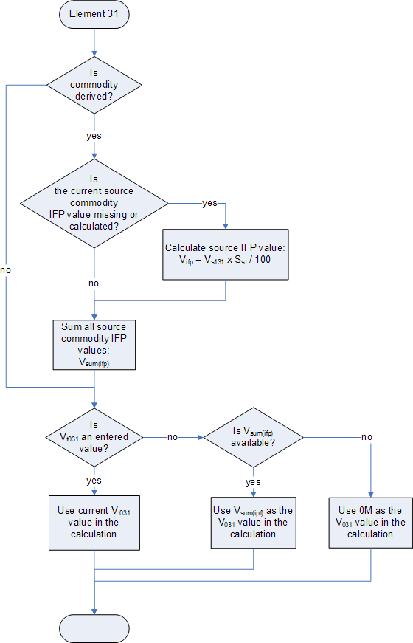

Element 41
This diagram shows the pre-processing applied to element 41 before the main production element calculation is performed.
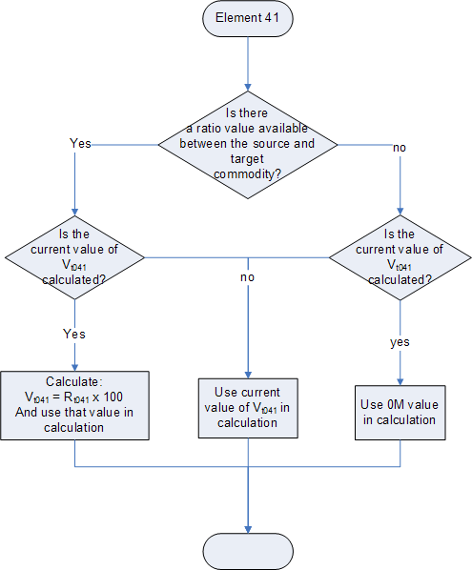

Production Elements
This diagram shows the calculation of the three production elements, 31, 41, and 51.

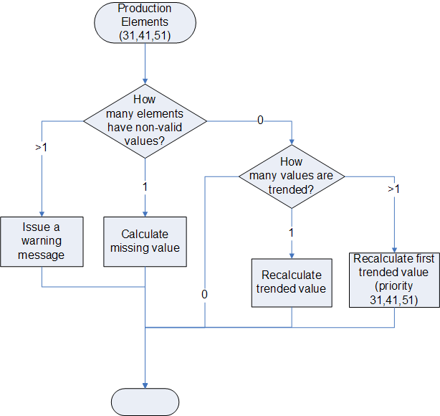

Element 61
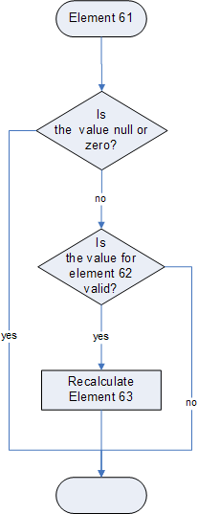

Element 66
This diagram shows the processing for element 66; the process is recursive, up to three levels deep, the Process child commodities sub-routine is called both from the main part of the flow and from the sub-routine itself.
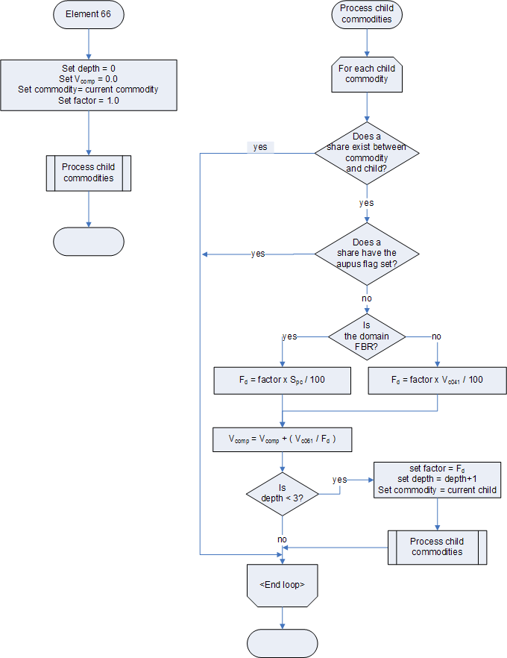

Element 111
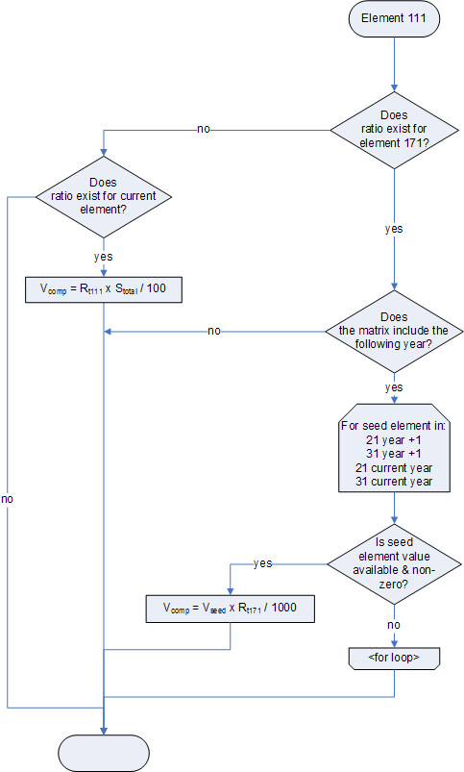

Annexes
- Aupus_Annex1_item_types.xls A list of item(commodity) types.
- Aupus_Annex2_elements.xls A list of the aupus elements.
- Aupus_Annex3_commodities.xls A list of FAOStat items(commodities).

In this section of the code the commodity codes are hard coded, as is the logic; the code contains the comment “hard coded because there are not shares defined for this commodity tree”.
The same section of code is used to calculate the value from supply in each case.
This commodity code is hard coded into the source code
The factors shown are hard coded, multiple times, with no explanatory comments
The factors shown are hard coded, multiple times, with no explanatory comments
The area and commodity codes are hard coded in the source
These ranges are hard coded

