OCN 750 - HW5

Maia Kapur

September 23, 2015

This is an R Markdown document. Markdown is a simple formatting syntax for authoring HTML, PDF, and MS Word documents. For more details on using R Markdown see <http://rmarkdown.rstudio.com>.

When you click the **Knit** button a document will be generated that includes both content as well as the output of any embedded R code chunks within the document. You can embed an R code chunk like this:

setwd("~/Dropbox/2015 Fall/OCN 750")  
solea = read.table("Solea.txt", header = TRUE)

##### Plot the raw data of sole presence/absence vs. salinity. Break the salinity data into four equally sized bins, and within each bin calculate the proportion of presences. Plot the binned proportions vs. the midpoints of the bins (e.g. if the bin is from 3 to 7, then 5 is the midpoint). Also calculate the standard error of the proportion for each bin, and plot that with error bars.

#define 8 bins, using a sequence of 4 breaks  
breaks = with(solea, seq(min(salinity), max(salinity), length = 5))  
#make a binning factor from logPar  
cut.sal = cut(solea$salinity, breaks = breaks)  
#calculate the proportion of presence by bin  
means = with(solea, tapply(Solea_solea, cut.sal, mean))  
#function for the standard error of a binary variable  
binomial.SE = function(x) sqrt((mean(x)*(1-mean(x)))/length(x))  
#calculate the standard error for each bin  
ses = with(solea, tapply(Solea_solea, cut.sal, binomial.SE))  
#plot the raw data  
plot(solea$Solea_solea ~ solea$salinity,   
 main = "proportional survivorship vs. salinity, solea",   
 ylab = "proportion of survivorship",   
 col = "lavenderblush3", pch = 19, col.main = "hotpink4")  
#plot the bin means  
points(means ~ breaks[1:4], pch = 19, ylim = c(0,1), xlim =  
range(solea$salinity))  
#plot the bin SEs  
segments(breaks[1:4], means+ses, breaks[1:4], means-ses)

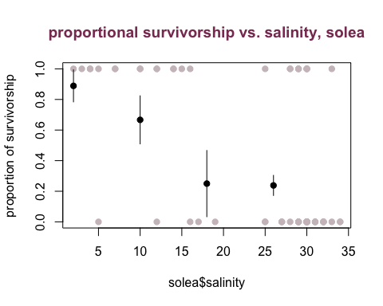 #####Fit a binomial glm to test whether presence/absence of sole is driven by salinity. #####Use curve() to plot the fitted logistic relationship on the same plot as the raw data.

##create binomial model  
mod = glm(Solea_solea ~ salinity, data = solea, family = binomial)  
summary(mod)

##   
## Call:  
## glm(formula = Solea_solea ~ salinity, family = binomial, data = solea)  
##   
## Deviance Residuals:   
## Min 1Q Median 3Q Max   
## -2.0674 -0.7146 -0.6362 0.7573 1.8997   
##   
## Coefficients:  
## Estimate Std. Error z value Pr(>|z|)   
## (Intercept) 2.66071 0.90167 2.951 0.003169 **   
## salinity -0.12985 0.03494 -3.716 0.000202 ***  
## ---  
## Signif. codes: 0 '***' 0.001 '**' 0.01 '*' 0.05 '.' 0.1 ' ' 1  
##   
## (Dispersion parameter for binomial family taken to be 1)  
##   
## Null deviance: 87.492 on 64 degrees of freedom  
## Residual deviance: 68.560 on 63 degrees of freedom  
## AIC: 72.56  
##   
## Number of Fisher Scoring iterations: 4

##define logistic function  
logistic = function(x) exp(x)/(1+exp(x))  
  
##plot the raw data and add on the fittedcurves  
plot(Solea_solea ~ salinity, data = solea,   
 main = "proportional survivorship vs. salinity, solea",   
 ylab = "proportion of survivorship", col = "cadetblue4",   
 pch = 19, col.main = "cadetblue3")  
curve(logistic(coef(mod)[1]+coef(mod)[2]*x), add = T, col = 'cadetblue3', lwd = 3)

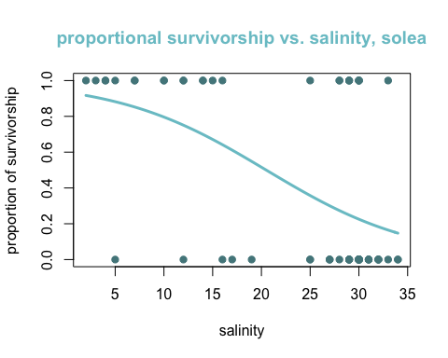 #####What is the effect of salinity on sole presence/absence? Would you consider it a strong effect or a weak effect? Why?

##It looks to be a gentle yet definite effect.   
##The model summary indicates a high AIC for the salinity variable.

##### Do a likelihood ratio test to see whether the effect of salinity is significant.

require(car)  
Anova(mod) ##it's significant

## Analysis of Deviance Table (Type II tests)  
##   
## Response: Solea_solea  
## LR Chisq Df Pr(>Chisq)   
## salinity 18.931 1 1.355e-05 ***  
## ---  
## Signif. codes: 0 '***' 0.001 '**' 0.01 '*' 0.05 '.' 0.1 ' ' 1

##### Examine a plot of residuals (deviance residuals or pearson residuals) vs. predicted values. How would you interpret this plot?

plot(residuals(mod, family = "pearson") ~ solea$salinity,   
 xlab = "salinity, raw values",   
 ylab = "pearson residuals", main = "Deviance Residuals vs. Predicted Values",   
 col = "darkorange2", col.main = "darkorange4")

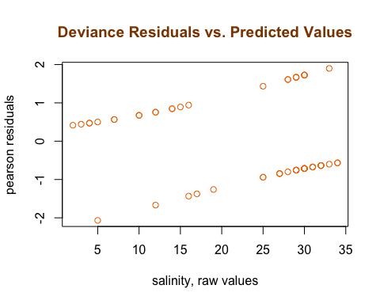

##This plot depics a quasi-linear trend in residual distribution, which is expected for log predictors.

##### Make an exploratory plot of proportion of survivors vs. sex*region.

hs = read.csv("~/Dropbox/2015 Fall/OCN 750/heat_shock_subset.csv")  
  
##aggregate data to find means  
means = aggregate(formula = proportion ~ sex + region, data = hs, FUN = mean)  
  
##calculate standard error for sex and region  
se = aggregate(formula = proportion ~ sex + region, data = hs, FUN = function(x)  
 sqrt(var(x)/length(x)) )  
  
##create a list that contains the values from the above functions  
mu = c(means$proportion)  
stderrs = c(se$proportion)  
  
##plot it  
require(ggplot2)  
  
ggplot(means, aes(x = region, proportion, fill = sex)) +  
 geom_bar(stat = "identity", position = "dodge") +  
 geom_errorbar(aes(ymax = mu + stderrs, ymin = mu - stderrs), position = "dodge") +  
 ggtitle("Proportion Surivorship by Sex and Region") +  
 xlab("Region") +  
 ylab("Proportion") +  
 scale_fill_brewer(palette = "YlOrRd")

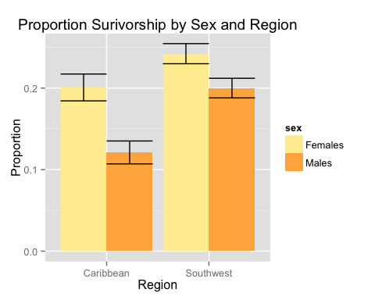

##### Fit a binomial glm where you test for effects of sex and region on the probability of surviving, as well as an interaction between sex and region. Remember there are two different ways to fit a binomial glm where n > 1. They are equivalent.

##for the binomial glm, you must have integer 0 or 1 values (1 = survived)  
##replace all non-zero values with 1  
hs$proportion[hs$proportion != 0] <- 1  
  
##fit binomial model for non-interaction  
hsmod.noint = glm(proportion ~ sex + region, data = hs, family = "binomial")  
hsmod.int = glm(proportion ~ sex * region, data = hs, family = "binomial")

##### Plot the fitted effects. How do you interpret the results?

require(effects)  
plot(allEffects(hsmod.noint), main = "Effect of Sex and Region on Proportion Survivorship")

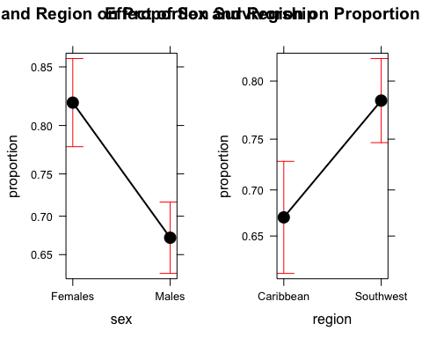

plot(allEffects(hsmod.int), main = "Interaction of Sex and Region on Proportion Survivorship")

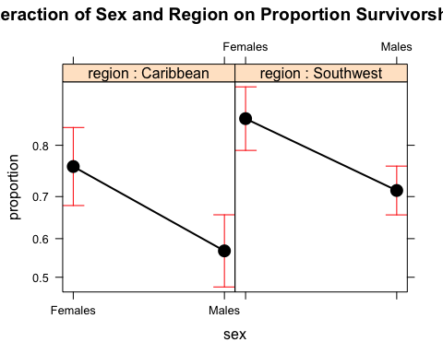

##There don't seem to be very different effects between the two groups; both have a lower prop. of male survivorship than female, and the SE overlaps both ranges.

##### Do a likelihood ratio test for the interaction between sex and region.

require(car)  
Anova(hsmod.int)

## Analysis of Deviance Table (Type II tests)  
##   
## Response: proportion  
## LR Chisq Df Pr(>Chisq)   
## sex 22.6834 1 1.91e-06 ***  
## region 10.5796 1 0.001143 **   
## sex:region 0.1355 1 0.712824   
## ---  
## Signif. codes: 0 '***' 0.001 '**' 0.01 '*' 0.05 '.' 0.1 ' ' 1

##### Oops, we didn't consider overdispersion. Fit the same model using the quasibinomial method. How big is the dispersion parameter?

require(car)  
##fit quasi-binomial lm  
hsqbin = glm(proportion ~ sex * region, data = hs, family = "quasibinomial")  
  
##define overdispersion parameter  
overdis = function(model) {  
 sum(residuals(model, type = "pearson")^2)/(length(model$y) - length(model$coefficients))  
}  
overdis(hsqbin) ##it's almost perfectly 1 (e.g. almost 0 overdisp.)

## [1] 1.005161

``` #####Test the interaction with the quasibinomial model, using the F-test that accounts for the dispersion parameter. How do you interpret this result, compared to the result from the first model?

Anova(hsqbin, test = 'F')

## Analysis of Deviance Table (Type II tests)  
##   
## Response: proportion  
## SS Df F Pr(>F)   
## sex 22.68 1 22.5669 2.418e-06 ***  
## region 10.58 1 10.5252 0.001228 **   
## sex:region 0.14 1 0.1348 0.713630   
## Residuals 779.00 775   
## ---  
## Signif. codes: 0 '***' 0.001 '**' 0.01 '*' 0.05 '.' 0.1 ' ' 1

plot(allEffects(hsqbin), main = "Effects plot for Q-Binom distribution, Sex x Region")

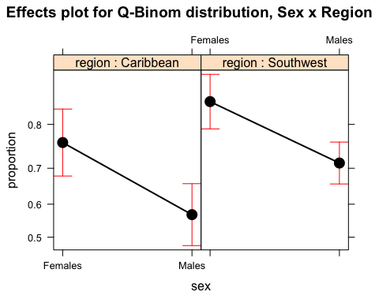

##this doesn't look very different from before -- likely cause overdispersion was so low

##### Test the main effects of the model (sex and region), using F-tests where the sex*region interaction is no longer in the 'full' model. What's your final take on these results? Are the results consistent with the researchers' hypothesis of local adaptation?

##For the interaction, Anova() compares the full model to a restricted model that has the interaction removed, and computes the likelihood ratio test. For the main effects (e.g. ‘logPar’), it first removes the interaction, and then compares the ‘full’ model with logPar to a restricted model that removes logPar. In other words, Anova() uses the model you give it to test the interaction, and it test the main effects assuming the interaction does not exist.  
Anova(hsqbin, test = 'F')

## Analysis of Deviance Table (Type II tests)  
##   
## Response: proportion  
## SS Df F Pr(>F)   
## sex 22.68 1 22.5669 2.418e-06 ***  
## region 10.58 1 10.5252 0.001228 **   
## sex:region 0.14 1 0.1348 0.713630   
## Residuals 779.00 775   
## ---  
## Signif. codes: 0 '***' 0.001 '**' 0.01 '*' 0.05 '.' 0.1 ' ' 1

##the Anova() reveals that indeed, the interaction is non-significant. Sex is the most significant driver of survivorship, with region contributing to a lesser extent. So, it's consistent insofar as region having a mild effect on surivorship, but across regions sex prevails.