University of Washington

School of Aquatic and Fisheries Sciences

1122 NE Boat St

Seattle, WA 98105

02 July, 2019

To the editorial board of *Fisheries Research:*

Thank you for the consideration of our paper, *Data driven approach reveals oceanographic features delineate growth zonation in northeast pacific sablefish.* This is a detailed, two-part work that presents a new tool to detect spatiotemporal breakpoints in fish size-at-age, which is then applied to length data from fishery-independent surveys of the valuable sablefish fishery from Alaska to southern California. The case study demonstrates that regions between which sablefish growth differs most can be described by major oceanographic currents, which suggests further impetus towards ecosystem-based management of such stocks. Finally, we anticipate that the tool will be useful for other fisheries scientists seeking a computationally minimal means of detecting changes in growth trends. To that end, we plan to incorporate edits from this peer-review process into an open source R package that readers can use on their own length datasets.

On behalf of my coauthors and myself, we appreciate your consideration of our work and look forward to your feedback.

Best

Maia Sosa Kapur

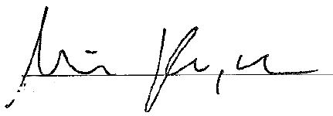

kapurm@uw.edu