Appendix – Details of the Individual-Based Model (IBM)

This Appendix describes the equations and assumptions used to generate the length at age datasets used in the simulation testing component of this study. The first section describes the generation of the observed data, and the second component details further how spatio-temporal variation is introduced. Table 1 provides parameter values used in the study.

# Generation of age-length data

The IBM is designed to mimic individual variation in growth for an exploited fishery. The model runs for 100 years, the latter 50 of which are subject to fishing mortality. Generally, all fish within each simulation are subject to the same baseline life history parameters, with two different growth regimes (defined by distinct values of the growth equation) assigned completely distinct latitudinal ranges or ranges with some overlap (see Assigning Spatio-temporal Variation, below).

## Growth

The growth module of the IBM itself implements a von Bertalanffy growth function with *L*1 and *L*2 as in Stock Synthesis (Methot and Wetzel, 2013).

Equation 1 $L_{∞}$ = $\frac{L_{1}+(L_{2}-L_{1})}{1-exp⁡(-K×(a_{1}-a_{2})}$

Where $L_{1,2}$ represents the length of a fish at age $a_{1,2}$, and K is the growth coefficient. The growth of an individual *i* in at age *a* is defined by: its length in the previous year and a growth increment *I* is subject to a bias-corrected lognormal error term ε (Equation 4):

Equation 2 $L_{i,a}=\left\{\begin{matrix}L_{1}ε & for a=1 \\ {(L}_{i,a-1}+I_{i,a-1})ε & for a>1\end{matrix}\right\}$

where

Equation 3 $I_{i,a}=L_{∞}-L_{i,a}(1-e^{K}$)

And

Equation 4 $ε \sim exp⁡(N\left(0,σ_{ε}\right)-\frac{{σ_{ε}}^{2}}{2}$

Similarly, individual fish weight at age is generated and monitored for consideration in the reproduction module (below). Fish weight is a power function dependent on length, as in

Equation 5 $W_{i,a}={aL_{i,a}}^{b}$

Where *a* and *b*  are parameters.

## Survival

The composition of the fishery in year *y* includes all surviving fish from recruitment to age A2 +1 (represented here as a plus group ${a_{2}}^{+}$). After recruitment, all fish are subject to natural mortality *M* and, if in the latter 50 years, fishing mortality.

Equation 6 $N_{y,a}=\left\{\begin{matrix}1 & for a=1 \\ N_{y,a-1}exp⁡(-Z_{y}) & for 2≤a≤ {a_{2}}^{+} \\ \frac{N_{{y,a_{2}}^{+}}}{1-exp⁡(-Z_{y})} & {{for a> a}_{2}}^{+}\end{matrix}\right\}$

Where *Z* is total mortality, the sum of natural mortality *M* and age-based selectivity *S* times fishing mortality *F* at year *y.*

Equation 7 $Z_{y}=\left\{\begin{matrix}M & for y <50 \\ M+F_{y}S_{i,a} & for y≥50\end{matrix}\right\}$

Where fishing mortality in a given year $F_{y}$ is drawn from a uniform distribution with bounds $μ_{F}$ and $μ_{F}+0.1$; $μ_{F}$ is one of 0.1, 0.2 or 0.3 for the entirety of a simulation (see Assigning Spatio-temporal Variation).

Equation 8 $F_{y}\sim U(μ_{F},μ_{F}+0.1)$

Equation 9 $S_{i,a}= \frac{1}{1+exp⁡(-\log\left(19\right)\left[\frac{a_{i}-a_{50}}{a_{95}-a_{50}}\right])}$

## Recruitment

Recruitment in the IBM is governed by a Beverton-Holt stock-recruitment function (Beverton and Holt, 1957), and a size-based maturity ogive which determines an individual’s probability of maturity $p_{i,a}$. Recruitment in a given year Ry happens at a midway point, and is subject to variation via a bias-corrected lognormal recruitment deviation $∂_{r,y}$

Equation 10 $p_{i,a}=\frac{1}{1+exp⁡(s(L_{i,a}-L_{50)}}$

Equation 11 ${SSB}_{y}=\left\{\begin{matrix}{{SSB}_{0}= R}_{0}0.5\sum_{1}^{a}{N_{a,y}W_{a,y}p_{i,a}} & for y=1 \\ 0.5\sum_{1}^{a}{N_{a,y}W_{a,y}p_{i,a}} & for y>1\end{matrix}\right\}$

Equation 12 $R_{y}=\frac{4hR_{0}{SSB}_{y-1}}{{SSB}_{0}\left(1-h\right)+{SSB}_{y-1}(5h-1)}exp⁡(∂_{r,y})$

Equation 13 $∂_{r,y}=N(0,σ_{r})-0.5\frac{{N(0,σ_{r})}^{2}}{2}$

# Assigning Spatio-temporal Variation

The simulation testing component of this study required generation of datasets that comprised variation in fish size-at-age across space and/or time. We used the strength of the fishing mortality vector (Equation 8) as a proxy for temporal changes in observed size-at-age. All simulated datasets only underwent fishing mortality for years 50 to 100. A simulation with a single temporal “breakpoint” would be assigned any two of “low”, “medium” or “high” fishing mortality levels for each of 25 years. These levels correspond to $μ_{F}$ of 0.1, 0.2 or 0.3, respectively, which defines the bounds of the uniform distribution from which a vector of length 25 is sampled. Figure 1 displays several sampled *F* vectors for scenarios with temporal breaks in fishing intensity.

To obtain spatial variation in length-at-age, we executed simulations using one of two growth “regimes” (see Table 1). The “latitude” column of a given length and age dataset was assigned based on this regime and dependent on the degree of spatial mixing in the desired data frame. For example, a scenario with a sharp break at 25 degrees latitude would be comprised of two growth regimes, with fish generated under Regime 1 randomly assigned coordinates between 0 and 25 degrees, and Regime 2 randomly assigned coordinates between 25 and 50 degrees. Spatially mixed scenarios would contain overlap in the degree ranges assigned to Regimes 1 and 2.

|  |  |  |  |
| --- | --- | --- | --- |
| Module | Parameter | Definition | Value |
| Growth | L1 | Size at age A1 (cm) | 62.7 (Regime 1)  50 (Regime 2) |
| Growth | L2 | Size at age A2 (cm) | 216.7 (Regime 1)  350 (Regime 2) |
| Growth | K | Growth coefficient | 0.258 (Regime 1)  0.45 (Regime 2) |
| Growth | A1 | Age at L1 (years) | 0 |
| Growth | A2 | Age at L2 (years) | 15 |
| Growth | $$σ_{ε}$$ | Lognormal growth error term | 0.025 |
| Growth | *a* | Multiplier of length-weight function | 1.35e-6 |
| Growth | *b* | Exponent of length-weight function | 3.427 |
| Survival | *a50* | Age at 50% selectivity | 2 |
| Survival | *a95* | Age at 95% selectivity | 4 |
| Survival | *M* | Natural mortality | 0.25 |
| Recruitment | *s* | Slope of maturity ogive | -0.1034 |
| Recruitment | L50 | Length at 50% maturity | 143.68 |
| Recruitment | *h* | Steepness of Beverton-Holt SRR | 0.9 |
| Recruitment | R0 | Maximum number of recruits per year | 12 |
| Recruitment | $$σ_{r}$$ | Variation in recruitment | 0.1 |

Table 1. Parameter symbols, definitions and values used in the simulation study.

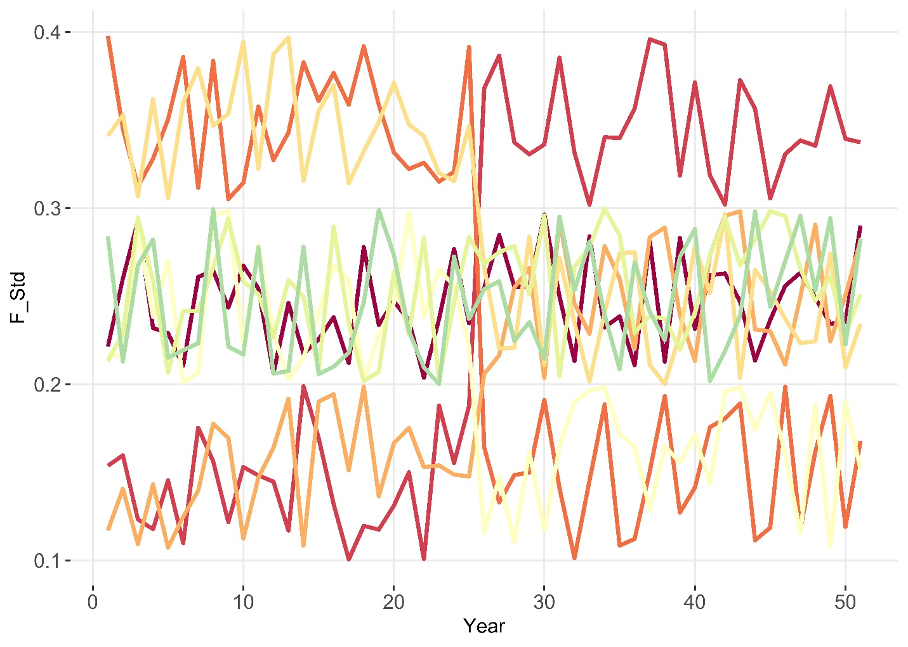

Figure 1. Sampled F vectors for individual simulation runs (years 0 – 50 refer to last 50 years of 100-year simulation, before which *F* is zero for all scenarios). A sharp jump or drop in F level means the specified intensity switched among one of “low”, “medium” and “high”. The green line depicts a trajectory which did not undergo a temporal shift in *F* and remained at the ‘medium’ level for all 50 years.

# References

Beverton, R.J.H., Holt, S.J., 1957. On the Dynamics of Exploited Fish Populations, Fisheries Investigations Series 2: Sea Fisheries. https://doi.org/10.1007/BF00044132

Methot, R.D., Wetzel, C.R., 2013. Stock synthesis: A biological and statistical framework for fish stock assessment and fishery management. Fish. Res. 142, 86–99. https://doi.org/10.1016/j.fishres.2012.10.012