Data driven approach reveals oceanographic features delineate growth zonation in NE pacific sablefish

Kapur, M., Haltuch, M., [others] Punt, A.E.

Keywords: growth, von Bertalanffy, ecosystem-based fisheries management, sablefish, spatial

# Abstract

Renewed interest in the estimation of spatial and temporal variation in fish body size is a result of computing advances and the development of spatially-explicit management frameworks. However, many attempts to quantify spatial structure or the distribution of traits utilize *a priori* approaches, which involve pre-designated geographic regions and thus cannot detect unanticipated spatial patterns. This study presents a new, data-driven method that evaluates the first derivative of the spatial smoothing term of a generalized additive model to identify spatial breakpoints in fish length at age. We use simulation testing to illustrate the robustness of the method across a variety of spatially-stratified age and length data sets, and apply it to survey data for Northeast (NE) Pacific sablefish (*Anoplopoma fimbria*). NE Pacific sablefish length-at-age increases with latitude, with three breakpoints associated with significant oceanographic and ecosystem features, which is consistent with work from the western United States; simulation testing illustrates the robustness of the method across scenarios related to spatially-complex growth data, including strict boundaries, overlapping zones and changes at the extreme of the range. This method has the potential to improve detection of large-scale spatial patterns in fish growth, and aid in the development of spatially-structured population dynamics models.

# 1 Introduction

Renewed interest in the development of spatially- and temporally-explicit management frameworks (e.g. Thorson et al., 2015) and advances in computing power have motivated efforts to quantify spatial variability in fish size for managed species, including Gulf Sheepshead (Adams et al., 2018) and northern rock sole (Hurst and Abookire, 2006), as well as groundfish off the US West Coast (Gertseva et al., 2017; James et al., 2002; Mason et al., 1983). Understanding demographic variation of this key trait (somatic growth) can improve the precision of fisheries assessments (Punt, 2003; Stawitz et al., 2019).

Fish somatic growth rates are typically modelled using the von Bertalanffy growth function (VBGF, von Bertalanffy, 1957) or an alternative functional form, with parameters estimated using model-fitting procedures. The spatial resolution of the resultant estimates is necessarily predicated on the aggregation of the data, which is often defined by survey stratification, political boundaries, and/or changes in sampling gear. For example, assessments of Alaska sablefish stocks estimated separate VBGF parameters for two periods of survey data based on the *a priori* hypothesis that changes in survey gear type would affect fish growth estimates from survey data (Echave et al., 2012; Hanselman et al., 2017; McDevitt, 1990), and imposed a time block between which estimates of the growth curve parameters were actually quite similar (see Table 3). More sophisticated approaches that utilize hierarchical Bayesian methods to estimate latitudinal and regional effects on length- or weight-at-age require a design matrix of dimensions dictated by pre-supposed zones (e.g. Adams et al., 2018). Such approaches are useful within a management context with rigid management boundaries, but do not represent the underlying growth process explicitly, and preclude the discovery of spatially-structured trends in fish size that do not match current management boundaries.

Attempts to quantify spatial variation in somatic growth typically face a trade-off between superimposing previous beliefs about stock structure (as in the Alaskan example above) or generating purely descriptive models of trait ‘gradients’ across regions or time periods, without a clear way to define significant break points within them (King et al., 2001). This presents a gap when developing population dynamics models that accurately represent the population structure of managed stocks. The ideal tool is a data-driven method that defines significant break points in fish size, which can then be used to aggregate data and estimate parameters of somatic growth. Our method, which evaluates the first derivative of smooth functions from a generalized additive model (GAM), meets this objective in a simple, rapid computational framework. The method does not require the specification of multiple error structures nor the construction of spatial meshes, which can be computationally expensive when large (Thorson, 2019a). The analysis of first derivatives in GAMs for change-point analysis has been recently used in terrestrial paleoecology (Simpson, 2018) and geophysics (Beck et al., 2018). The objective of this study was to develop a method for detecting change points in spatially- and temporally-structured fisheries growth data that minimizes the use of pre-supposed stratifications. This method has the potential to improve detection of large-scale patterns in fish growth, and aid in the development of spatially-structured population dynamics models. We use simulation to test the robustness of the method for length-at-age data of varied complexity, and present a case study application to northeast (NE) Pacific sablefish (*Anoplopoma fimbria).*

Sablefish are a highly mobile, long-lived, valuable groundfish that have high movement rates (10 – 88% annual movement probabilities across Alaska, Hanselman et al. 2015) and range from Southern California to the Bering Sea. Concurrent population declines across the entire range during the past few decades have increased concern about the status of sablefish and interest in the causes of the downward trend. Traditionally, sablefish stock assessment and management has occurred independently at regional scales, namely Alaska (AK), British Columbia (BC), and the US West Coast in the California Current (CC), assuming that these are closed stocks. However, recent genetic work has shown that NE Pacific sablefish are not genetically distinct between these traditional management areas (Jasonowicz et al., 2017), though there is evidence for differences in growth rate and size-at-maturity throughout the range (McDevitt, 1990). This suggests that the current delineation of assessment and management regions is incongruent with the stock’s actual spatial structure and motivates research that would enable the construction of a population dynamics model that represents the heterogeneity of sablefish growth throughout their range.

# 2 Methods

## 2.1 Method summary

The method involves fitting a Generalized Additive Model (GAM) using the mgcv package (Wood, 2011) in R (R Development Core Team, 2011) to the vector of observed lengths of fish of a single age as the response variable, predicted by separate smoothers for year, latitude, and longitude, i.e.

Equation 1

where µt represents the expected mean of fish length, which is a random variable of which we have *t* observations. The linear effects of latitude (), longitude () and year () are smooth functions. Latitude and longitude are fit as separate smoothers as the estimation of derivatives for a two-dimensional spline, and inference thereof, is too complex for the present application. *g* is an invertible, monotonic function that enables mapping from the response scale to the scale of the linear predictor, such as the natural logarithm. To simplify the analysis, we fit the GAM to data for a single age-class (e.g., age six for the simulated datasets), thus precluding the need to control for age or sex. Using fish of only a single selected age from all regions also minimizes the concern of differing survey selectivities between regions.

The first derivatives of the GAM with respect to latitude, longitude and year are evaluated to identify areas or periods (breakpoints) between which there is evidence for changes in fish length-at-age; which is taken as a proxy for spatiotemporal variation in fish growth. The equations below provide an example using latitude , but the process can be repeated for each smoother. The finite differences method (as in Simpson, 2018) approximates the first derivative of the spline generated from the GAM function. For instance, the vector of derivatives **G** for latitude is produced via the following (see Figures 2 and 3):

Equation 2

where is a vector of predicted lengths at latitudes , defined as ( = 0.001 in this analysis) with other effects (year, longitude) held constant. Vector **G** is of the same length of the observed dataset.

The uncertainty in derivative estimates are computed as:

Equation 3

where **V** is a 1x1 covariance matrix for each of parameters of the current GAM spline (typically just one); the square root provides the standard error for each derivative estimate of the spline. These steps are repeated for years and longitudes. For each parameter, we identify where the maximum absolute value of the first derivative is obtained; this is rounded to the nearest integer and defined as the “breakpoint” as long as its 95% confidence interval does not include zero. Figure 1 and Figure 2 illustrate the raw data, smoothers and first derivatives thereof for two sample datasets. Once identified, the raw length and age data (including all ages of fish) are re-aggregated to match the breakpoints and the parameters of the VGBF (Equation 4; *L∞* - asymptotic length, *k* - the rate at which asymptotic length is approached and *t0* - the estimated age at length zero) estimated using maximum likelihood (in this study using Template Model Builder; Kristensen et al., 2016 assuming that the error is normally distributed with zero mean and variance σ).

Equation 4

2)

For all runs, the initial values for the parameters were *t*0 = 0.1, = 0.1, with *L*∞ = 150cm, *k* = 0.1. The estimation procedure also calculates the predicted length at the endpoints of the estimated growth curve (Equation 5; the length at pre-specified minimum and maximum ages, *L*1, *L*2, which were 0 and 15 years in the simulation studies). These values and their standard errors are used in the evaluation of the method (see Section 2.3), as *L*∞ and *k* are typically negatively correlated.

## 2.2 Simulation testing

2.2.1 Outline and design

We conducted a simulation study to evaluate the performance of the proposed method, using datasets generated using an individual-based model (IBM, see Appendix for full details). The IBM is capable of mimicking individual characteristics by following the life history processes (survival, growth, and reproduction) of individual fish. We simulate spatial variation by generating length-at-age datasets under different growth ‘Regimes’ (defined as distinct *k,* and/or values, leading to varied ) and assign a range of latitudes to fish grown under each Regime. The IBM implements the VBGF using Schnute’s (1981) formulation, which requires *k*, *L*1, and *L*2, with computed as:

Equation 5 =

where represent the expected lengths of fish at ages , , and *k* is the Brody growth parameter. An individual fish’s annual growth increment is subject to a bias-corrected lognormal error term. Depending on the scenario, different growth Regimes are either assigned completely distinct spatial or temporal ranges, or spatial ranges with some overlap. Regime 1 refers to a central Pacific billfish-like species, where *L*1 = 62.69cm, = 216.72cm and *k* = 0.258yr-1; in Regime 2, which was designed to be of high contrast compared with Regime 1, *L*1= 50cm, = 350cm and *k* = 0.45yr-1; in Regime 3, which was designed to be low-contrast compared to Regime 1, =50cm, and *k* = 0.3 yr-1.

The simulation scenarios (Table 1) were designed to represent a variety of possible regimes in spatial growth variation, with one test of the ability to identify a temporal regime change in growth. Figure 1 shows a map of an example data set for each of the scenarios presented in Table 1. To simulate spatial zones, fish locations were sampled from a uniform distribution with boundaries specific to a certain growth Regime. In all except the final (break-at-edge, fifth row) and non-spatial scenarios, the latitude and longitude of fish grown under Regime 1 were sampled independently and at random from a uniform distribution between 0° and 25°; for simulations with spatial variation, fish grown under Regimes 2 and 3 have latitude and longitude sampled the same way from 25° to 50°. In the break-at-edge scenario, fish simulated under life history Regime 1 were assigned latitudes and longitudes sampled independently and at random from a uniform distribution from 1° to 49°, and those simulated under Regime 2 have coordinates sampled similarly with both latitude and longitude ranging from 49° to 50°. Under each scenario, we generated 100 replicate datasets, which averaged 439 age-six fish per dataset. Our final simulation scenario involved temporal changes in growth, with a change from growth Regime 1 to Regime 2 in year 50. This means that the growth increment generally increased for individuals whose lifespan covers this breakpoint, though note that the GAM is fit to fish of a fixed age. Fish locations for the temporal break scenario are sampled identically to the scenario without spatial variation.

## 2.2.2 Performance metrics

We used two performance metrics: 1) the proportion of simulations in which the correct spatial and/or temporal breakpoints were detected - we tabulated the number of times a breakpoint found using a GAM fit to a dataset matched the true latitude, longitude, year, or all; and 2) the coverage probabilities for the lengths for fish of two ages. For all but the scenario with overlapping ranges (Table 1, row 4), the GAM analysis must have detected the correct breakpoint to within integer accuracy to be counted as a match. For the scenario with overlapping ranges, the ‘true’ dataset contained fish grown under Regimes 1 and 2 in a shared region between 20° and 25° latitude and longitude, so the detected breakpoint was counted as an accurate match if it fell within this range.

For each simulation, after aggregating into GAM-designated spatiotemporal strata and estimating the growth curve, we determined whether the 95% confidence intervals of the estimated fish lengths at ages zero and fifteen (our and ) contained the true *L1* and *L2* values used in the IBM to generate fish from that region. For example, fish generated under Regime 1 and occupying latitudes and longitudes between 0° and 25° may have been re-aggregated via the GAM analysis into a *de facto* ‘Region’ ranging from 0° to 24° degrees for an “early” period of years 1 through 37; the parameters of the VBGF were estimated on this per-strata basis, and the endpoints of the estimated curve compared to those from which they were generated, in this case, Regime 1. Fits from the complementary *de facto* ‘Region’ ranging from 25° to 50°, or a “late” period, would be compared to whichever Regime generated the majority of fish therein – which could be Regime 1 if there was no spatial variation. An estimated endpoint from a GAM-defined Region was considered a match if the 95% confidence interval for it contained the true (mean) value; we tabulated the number of times the confidence interval contained *L1*, *L2* or both.

## 2.4 Application to Northeast Pacific Sablefish

We obtained fishery-independent length and age data from the Bering Sea, Aleutian Islands, and Gulf of Alaska Sablefish Longline Survey and the U.S. West Coast Groundfish Bottom Trawl Survey conducted annually by the Alaska Fisheries Science Center and Northwest Fisheries Science Center, respectively. We also obtained length and age records from the Canadian Department of Fisheries and Oceans, which has performed an annual trap-based survey since 1991. Data from each region included measured length, sex, age, and the starting latitude and longitude which determined the survey station. Due to computational constraints, and to avoid disproportionate influence of more heavily-sampled regions, we randomly subsampled 15,000 total records from each of the three management regions. The subsampling was random with respect to latitude, longitude, age and sex, using the sample_n function from the package dplyr (Wickham et al., 2019). This produced a data set with an average of 1315, 1283, and 65 ages 4, 6 and 30 sablefish of each sex from each region.

In constructing the GAM, we investigated the use of an AR1 temporal structure with lags of 1 to 3 years, but these models did not improve AICc over the initial model (without autoregressive structure). We fit the GAM and used the first-derivative method to identify spatial and temporal breakpoints for each sex separately, and also subset the data to explore breakpoint detection at several key ages: age 4 (before length-at-50%-maturity for both males and females in all regions), age 6 (after length-at-50%-maturity for both males and females in all regions) and age 30, roughly the length at which sablefish are expected to obtain their maximum length (Johnson et al., 2015). We then re-aggregated all data to match the breakpoints for which there was general agreement across these GAMs as well as an ecosystem-based breakpoint at 145°W. This latter breakpoint was determined by Waite and Mueter (2013) using cluster analysis to delineate unique regions of chlorophyll-*a* variability, which has been shown as nominally influential in the sablefish recruitment process (Shotwell et al., 2014) but by definition such an effect is not detectable in analysis of fish larger and/or older than recruits. The North Pacific Fishery Management Council uses this location (145°W), which is a hotspot of several seamounts, to dileniate a groundfish slope habitat conservation area (Siddon and Zador, 2018).

We employed a stepwise exploration of whether estimates of L∞ were significantly different between regions defined by detected breakpoints. This involved first aggregating and estimating the VBGF for ten unique spatio-temporal strata, defined by the breakpoints found for key ages selected for analysis using the GAM and the aforementioned ecosystem feature, for each sex. We then examined whether, for any temporally-split datasets from the same region (e.g., Region 1 female sablefish data before 2010 and after 2010), the 95% confidence intervals for L∞ overlapped. If they did, we pooled the data for that region and sex for all years. In the second step, we examined if spatially-adjacent regions (from any time period) for the same sex had 95% confidence intervals for L∞ that overlapped and combined regions for which this was the case on a by-sex basis. This stepwise approach reduces unnecessary partitioning of the data into spatiotemporal strata that do not ultimately result in different estimates of L∞. Once the most parsimonious structure was identified through this method, we generated predicted lengths-at-age for the entire dataset, stratified accordingly.

# 3 Results

## 3.1 Simulation Study

The simulation study demonstrated that the first-derivative method is able to detect both spatial breakpoints correctly, and did so more frequently than erroneous locations for all spatial scenarios except two: one with low contrast between growth regimes, and another where the high-contrast spatial break occurred near the edge of the study region at 49° latitude and longitude. Table 2 and Figure 4 indicate the coverage probabilities and proportion of simulations wherein the correct breakpoint was detected.

For all scenarios, the method obtained the highest coverage probability for the length at age zero (*L1*), at 89%-100% coverage for four scenarios and 49% in the scenario with overlap (Table 2; Figure 4). Coverage probabilities for length at age 15 (*L2*) were never greater than 39%. In terms of spatial breakpoint detection, there was not a strong difference in the method’s ability to correctly detect latitudinal vs. longitudinal breakpoints across scenarios, though it correctly detected both spatial breaks concurrently most often in the overlapping scenario (0.99 co-detection proportion), followed by the scenario with a symmetrical, high-contrast break at 25° (0.70 co-detection proportion). For the two scenarios with no spatial breaks, it only correctly detected this to be case in 63% of simulations; there was no discernable pattern to the spurious breakpoints identified in the remaining simulations. The method was completely unable to detect the true breakpoints for the scenario with a spatial break at 49°, assigning the break at 50° latitude and longitude in 100% of simulations. The resultant coverage probabilities were barely above zero, likely due to the high contrast in length-at-age between the two regions, which rendered estimates of the completely aggregated data uninformative. Similarly, all of the simulations under high contrast (Table 1, row 3) that detected the wrong breakpoint were incorrect by a single degree (assigning latitude and/or longitude to be 24° or 26°); 60% of inaccurate breakpoints detected in the low-contrast scenario also were only off by a single degree. Resultant coverage probabilities for both scenarios were much higher than in the break-at-edge case. The method obtained 80%-90% accuracy in correctly detecting the temporal breakpoint, which was nonexistent for most scenarios. Again, there was no discernable pattern to the spurious years assigned to scenarios without actual temporal variability.

## 3.2 Application to NE Pacific Sablefish

The latitude smoother suggested a generally increasing cline in length-at-age with latitude, with a significant breakpoint centered around 50˚N (approximately the northern end of Vancouver Island, Canada) detected when the GAM was fit for age four and six sablefish (Figures 6c and 7c). Both age six and age 30 female sablefish identified a breakpoint of 36˚N (approximately Monterey, CA, USA). These findings corroborate results in Gertseva et al. (2017). The temporal smoother did not exhibit a strong one-way trend, and was flat for age-30 fish of both sexes, though it did detect a break in 2009-2010 for both sexes of age 4 and 6 sablefish. For our first exploratory phase, we split the data into ten unique spatio-temporal strata for each sex: five regions discussed above (see Figure 8) defined by the detected breakpoints and the ecosystem-based break at 145˚W, each partitioned into two periods for data collected before and during or after 2010. Parameter estimation for this first step revealed that the 95% confidence intervals for *L∞* overlapped for males in all regions and for females in Regions 3, 4 and 5 (see Appendix Figure A13). For the second exploratory phase, all years of data were combined for these region-sex combinations where overlap was found, thus reducing the total number of spatio-temporal strata to 12 (Table 4). Once re-aggregated and re-estimated, we did not find overlapping confidence intervals for *L∞* for any adjacent regions (Appendix Figure A14), so this setup was retained as our final spatiotemporal stratification. The stratification consists of three regions bounded on their western border by a break at 130˚W; from south to north, these regions (labeled 1, 2 and 3 on Figure 8) are defined by latitudes 36˚N and 50˚N. These breaks correspond generally to Monterey, CA and the northern tip of Vancouver Island, BC. Region 4 consists of datapoints collected between 130˚W and the ecosystem break at 145˚W (roughly Cordova, AK). Datapoints collected to the west of the ecosystem break are assigned to Region 5.

# 4 Discussion

## 4.1 Caveats

A notable weakness of the GAM approach is the sensitivity to the penalty function, often referred to as λ, which controls the degree of smoothness of the spline and, when unchecked, can lead to overfitting. Since the purpose of this analysis was diagnostic (the detection of where the spline is changing the most), we were able to avoid undue influence from this parameter by a) selecting only the maximum first derivative and b) disregarding values whose confidence interval contained zero, which is common in highly curved splines. This still did not preclude detection of spurious spatial or temporal breaks in ~13% of simulations for which no variation in growth was present. However, some erroneous detection can be expected considering inherent noise in the datasets, and the fact that there is no minimum threshold for breakpoint detection; a single, small derivative that did not have a CI containing zero could be ‘picked’.

The procedure for deciding whether the method was accurate was inherently strict, in that simulations were determined inaccurate if the detected breakpoint varied by only one degree (with the exception of the overlapping scenario). As presented in Section 3.1, these near-misses characterized 100% of inaccurate detections in the high-contrast scenario, and 60% of detections in the low-contrast scenario; relaxing the matching criteria to include neighboring points would increase the performance for the spatial metrics by allowing more detected breakpoints to be counted as correct. The performance of the method is promising despite this strictness and the sensitivity of the absolute-value method.

We did not consider movement of fish between regions, which could reduce the performance of the method by including fish “grown” under one region into another region. The method was able to detect changes within such mixed zones provided that there were other, more homogeneous areas elsewhere in the study region. With these caveats in mind, we envision (and demonstrate) using the method as a tool to identify general regions and periods of change in fish length-at-age, which will necessarily be evaluated against pre-existing knowledge of the fish population and its ecosystem. Below, we discuss the results of the simulation study and provide further guidance on how the proposed method should be applied to new datasets.

## 4.2 Simulation study

Overall, the method performed best for both performance metrics for the overlapping scenario (which had the advantage of being ‘matched’ whenever the breakpoint fell within 20° to 25°). The most commonly detected breakpoint in latitude and longitude for that scenario, before rounding, was the midpoint of this range (22.5°), likely an artifact of the penalization function within the GAM, which seeks to minimize curvature on either side of a given knot (i.e., the breakpoint).

We observed a failure of the method to detect breakpoints at the edges, with a true break at 49° consistently being assigned 50°. In terms of fisheries management, this suggests that managers may need alternative tools to detect and appropriately consider variations in growth at the extremes of their spatial domain, or regime shifts occurring at the present moment. Such breakdown of detection methods at the margins of a series (at the edges of a study region, or at the end of a time-series) has been documented in Rodionov (2004). The same author developed a method using sequential t-tests to perform such edge-case detection, which has been applied to detect ecosystem regime shifts in the Bering Sea. It is noted that the t-test approach requires tuning by the researcher to control the level of significance that determines a regime shift (or breakpoint), presenting the same challenge encountered here of spurious and/or missed detections depending on the sensitivity of the statistical test applied (Rodionov and Overland, 2005). It is likely there are thresholds in or types of spatiotemporal growth variation that will be poorly detected by most methods, which is an area for future research.

Empirical work has suggested that somatic growth in fisheries follows ecosystem gradients (rather than management boundaries), and the ongoing emphasis on ecosystem-based fisheries management will hopefully involve the analysis of fish stocks at meaningful spatial scales, across which changes can be detected (Taylor et al., 2018). Absent an ecosystem-wide analysis, strong directional trends in any smoother (such as the positive trend with latitude observed here) or a breakpoint at the edge of the study region can be indicative of a change somewhere in the margins and aid the design of future surveys.

The method indicated tradeoffs between the accuracy of breakpoint detection and resultant coverage probabilities in the estimated growth curve, as well as large differences in the coverage probabilities of fish length at younger versus older ages. It is encouraging that the approach could correctly detect breakpoints in the scenario with overlapping ranges, which is likely more common for real-world fish populations. However, the assigned ‘zonation’ of these populations necessarily combined fish with contrasting growth curves into a single dataset for estimation, and resulted in a loss in accuracy (coverage probability) at the endpoints of the growth curve. We suggest the method be used as a guidance tool to identify general zones between which growth could vary, and not take the detected breakpoint itself as the absolute truth. Importantly, suggestions of spatial breakpoints produced by the method should necessarily be considered in the context of the ecosystem, and prior knowledge of how the fishery at hand responds to features (e.g., temperature, depth) which may vary with latitude and/or longitude. Below, we discuss the results found during the application to northeast Pacific sablefish, with respect to ecosystem concerns.

## 4.3 Northeast Pacific Sablefish

The evaluation of length-at-age for NE Pacific sablefish was motivated by the notion that sablefish growth may vary at a scale different to the present management boundaries. Estimates of the parameters of the growth curve for sablefish are usually based on survey data acquired from chartered commercial trawl or longline vessels (Table 4). It is preferable to obtain estimated growth parameters using data from a survey, because fishery-dependent information can be biased due to targeting or gear selectivity (Ricker, 1969). For this reason, it is curious that the model identified a unique spatial zone (Region 3, Figure 8) comprised exclusively of sablefish sampled in British Columbia (though not all BC data were encompassed by Region 3). As anticipated, *L*∞ estimated for this region for each sex was distinct from that for adjacent zones, but it is possible that the trap-based survey method, unique to BC, exhibits length-based selectivity currently unknown to (and not reflected in) in the current assessment (DFO, 2016), which induced this result. Selectivity, if determined, can be corrected for via a truncation in the normal distribution for fish obtained in that region; it is also assumed to be equal to one for all lengths in both the AK Federal (Hanselman et al., 2017) and the CC (Johnson et al., 2015) assessments so no truncation was performed. Researchers interested in using the method presented here are advised to consider carefully how biases in their data may emerge as erroneous breakpoints and resultant growth estimates when interpreting results.

It is evident from this and previous work (Echave et al., 2012; Gertseva et al., 2017; McDevitt, 1990) that there is some level of variation in sablefish growth, whether in the growth rates themselves or the spatiotemporal scale at which variation in growth occurs. Previous work with sablefish data has utilized an *a priori* method, wherein length and age data were aggregated into pre-hypothesized spatial zones and fitted VBGF curves were compared via Akaike’s Information Criterion. This ‘information-theoretic’ (Guthery et al., 2003) method is fairly straightforward computationally, and has been implemented separately for the California Current (Gertseva et al., 2017) and Alaska federal sablefish fisheries (Echave et al., 2012; McDevitt, 1990). The CC analysis identified a statistically significant break in von Bertalanffy growth parameters for sablefish at approximately 36° N, between Point Conception and Monterey, CA, with additional evidence for an increasing cline in *L*∞ with increasing latitude and a general increase in estimated *L*∞ and *L*2 for our more northerly regions. These three results mirror the trend in our latitudinal smoother (Figure 6 and 7) and our detected breakpoint at 50˚N (Figure 8). That work also found an increase in *k* estimates for areas sampled south of the Vancouver region (ca. 49˚N), which was posited to be the result of samples coming from the “southern end of a faster-growing northern stock”, a suggestion supported by our findings. Gertseva et al. (2017) described how sablefish have been shown to be highly migratory, with ontogenetic movements off the coastal shelf; such combined, complex life patterns could yield higher growth rates in northern regions that interact with a more generalized shelf-slope pattern of ontogenetic movement observed in groundfish overall.

For Alaska, a generalized linear model of length as a function of pre-specified zones and time blocks was used to diagnose a ‘regime change’ in sablefish growth occurring in 1995, though the authors explain this shift is possibly attributable to changes in sampling strategy that occurred in that year’s survey. In the recent AK sablefish assessments, the parameters of the VBGF are time-blocked accordingly (see Table 3) despite caution that the change is not inherent to the population, but likely an artifact of sampling methods. In our analysis (which included data for all regions), the first derivative did not contain zero in 1995 only for age-four fish, though it was not of greater magnitude than the derivative for 2010. This may be indicative of a change in selectivity for age four sablefish, rather than a change in growth.

There are several noteworthy trends in the stratified growth estimates (Figure 9) that motivate future research. Firstly, the *post hoc* incorporation of a spatial break at 145°W based on ecosystem data was not ruled out during the significance testing of *L*∞. This supports the notion that environmental features may engender variations in growth, and that the proposed method is amenable to improvements based on the incorporation of climate or ecosystem knowledge. In future, it is conceivable that the method could explicitly incorporate climactic data (such as temperature, or a factor for an ecological zone). Additionally, both latitudinal breakpoints are associated with significant oceanographic features, namely the start of the southern California Bight at Point Conception (~34°N) and the bifurcation of the North Pacific Current, which splits into the Alaska and California currents as it approaches the west coast of North America. The location of this bifurcation varies but is generally centered off southern British Columbia (Cummins and Freeland, 2007). Like the ecosystem split identified in the Gulf of Alaska, these oceanographic features lead to distinct zones of productivity (Kim et al., 2009; Mackas et al., 2011) which could influence resource availability and subsequent growth.

It appears that the temporal break in year 2010 was conserved (supported by significantly different *L*∞ estimates) only for female fish, and more so in the southerly regions (such as Regions 1 and 2, which are mostly comprised of CC data). Preliminary analyses of sablefish movement rates from tagging data indicate that male sablefish seem to move more frequently to and from sea mounts, which are clustered within the regions identified here. There are several possibilities for why female sablefish seem to exhibit finer spatiotemporal structure in growth. Older empirical work in Canada (Mason et al., 1983) that examined early life history of fishery-caught coastal sablefish observed a slight cline in mean fork length with increasing latitude, though the sex ratio within the study was biased towards females. That study suggested that selectivity for female sablefish may be higher due to higher congregating or feeding activity, in addition to the fact that females grow larger and are likely preferentially targeted in the commercial fishery. This could render females more sensitive to changes in fisher behavior such as the implementation of catch shares in 2011, which affected discard rates in many groundfish fisheries (Somers et al., 2018).

Consideration of temporal variation in sablefish growth is further complicated by the exploitation history of the fishery, which has steadily moved north- and west-ward over the last several decades, encountering ‘larger’ fish with subsequent expansion (Pacific Fisheries Management Council (PFMC), 2013) This suggests that differences in mean length across the region could be attributable to different degrees and durations of fishing pressure, and not inherent population differences alone. Importantly, the L∞ estimates for both sexes and regions show a decline from the ‘early’ to ‘late’ periods for many sexes (Appendix figure A14). Simulation work by Stawitz et al. (2015) sought to model growth anomalies in sablefish (among other groundfish) as a process driven by either annual variation, variation in initial length or among cohorts. Data were partitioned between the CC and two regions of Alaska, and it was determined that annual-scale anomalies were more pronounced in the CC whereas the initial normalized length within each cohort explained more variation in Alaska. A principal conclusion was that the form of growth variation differed among ecosystems, wherein the CC is a more climactically variable region, which could explain why annual deviates were best for fitting to this data. Such ecosystem-driven trends may be diluted when analyzing the data as a composite, as in our study; notably, our temporal smoother did not produce a distinct annual cyclic trend. Methods that consider the space and time components co-dependently (as in vectorized auto-regressive spatio-temporal models, Thorson, 2019a) may strengthen the ability to disentangle such trends, and also to consider covarying spatial effects (e.g. near- and offshore).

# Figures

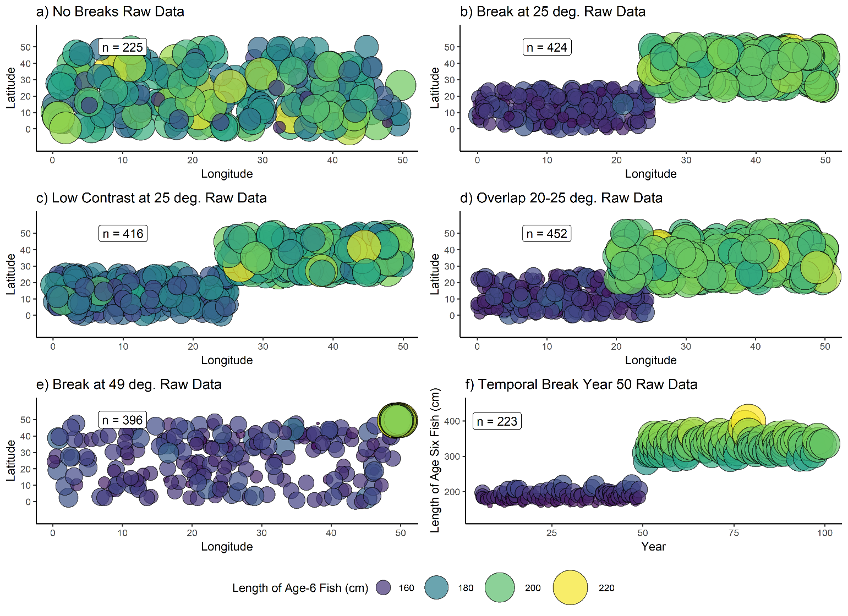

Figure 1. Example dataset for each tested spatial scenario in Table 1. For each scenario, points represent the length and location of a single simulated fish of age six. Fish locations (latitudes and longitudes) were sampled from a uniform distribution of the boundaries indicated in Table 1. Text labels indicate the number of individual fish in the sample.

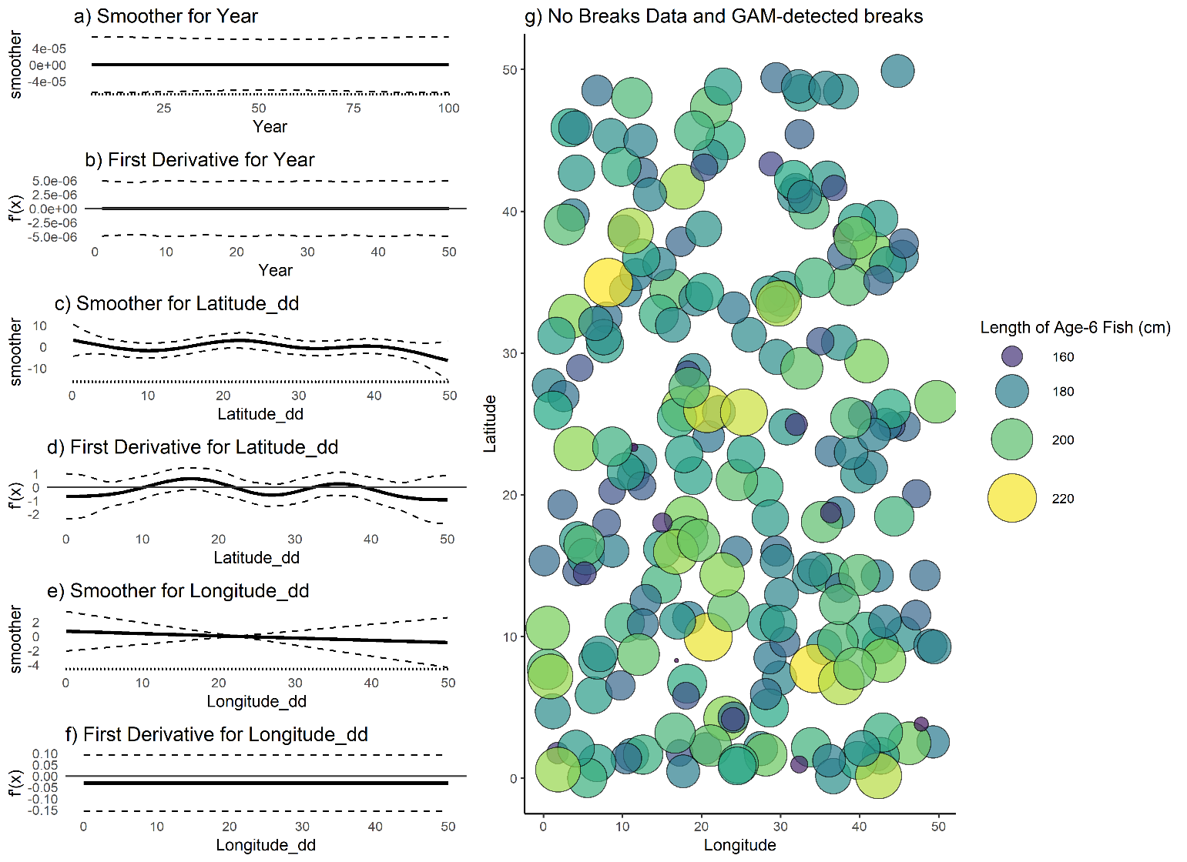

Figure 2. (a,c,e) raw value of GAM smoothers for Year, Latitude and Longitude; (b,d,f) mean (black line) and 95% CI (black dashed lines) of first derivative of the spatial smoothers; (g) map of age-6 fish for a single simulated dataset with no designated spatial or temporal breaks.

No break points were detected by the GAM.

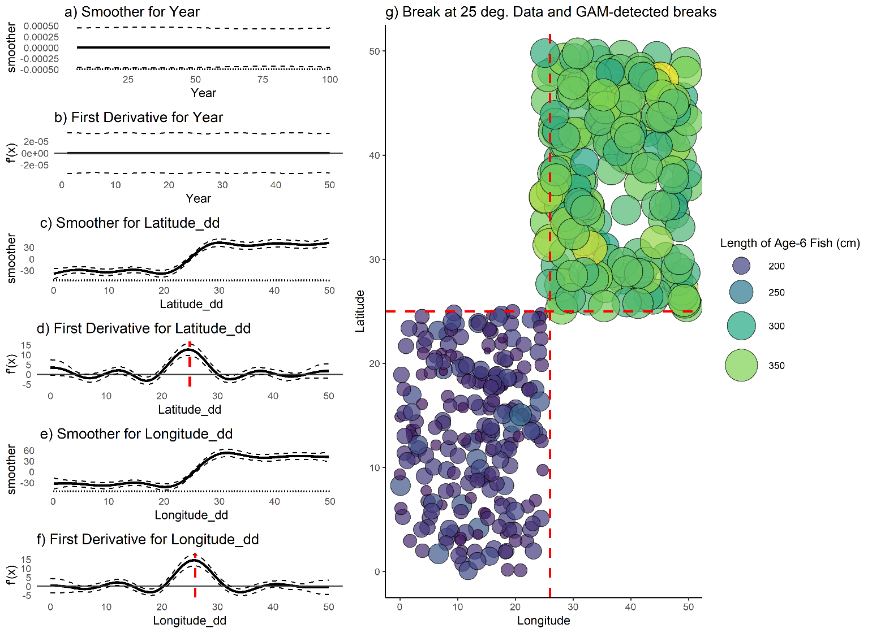

Figure 3. (a,c,e) raw value of GAM smoothers for Year, Latitude and Longitude; (b,d,f) mean (black line) and 95% CI (black dashed lines) of the first derivatives of the spatial smoothers; (g) map of age-6 fish for a single simulated dataset with a single, symmetrical break at 25° latitude and longitude. Vertical dashed red lines indicate detected break points, which are the maximum value obtained for this data set and do not have a confidence interval that contains zero.

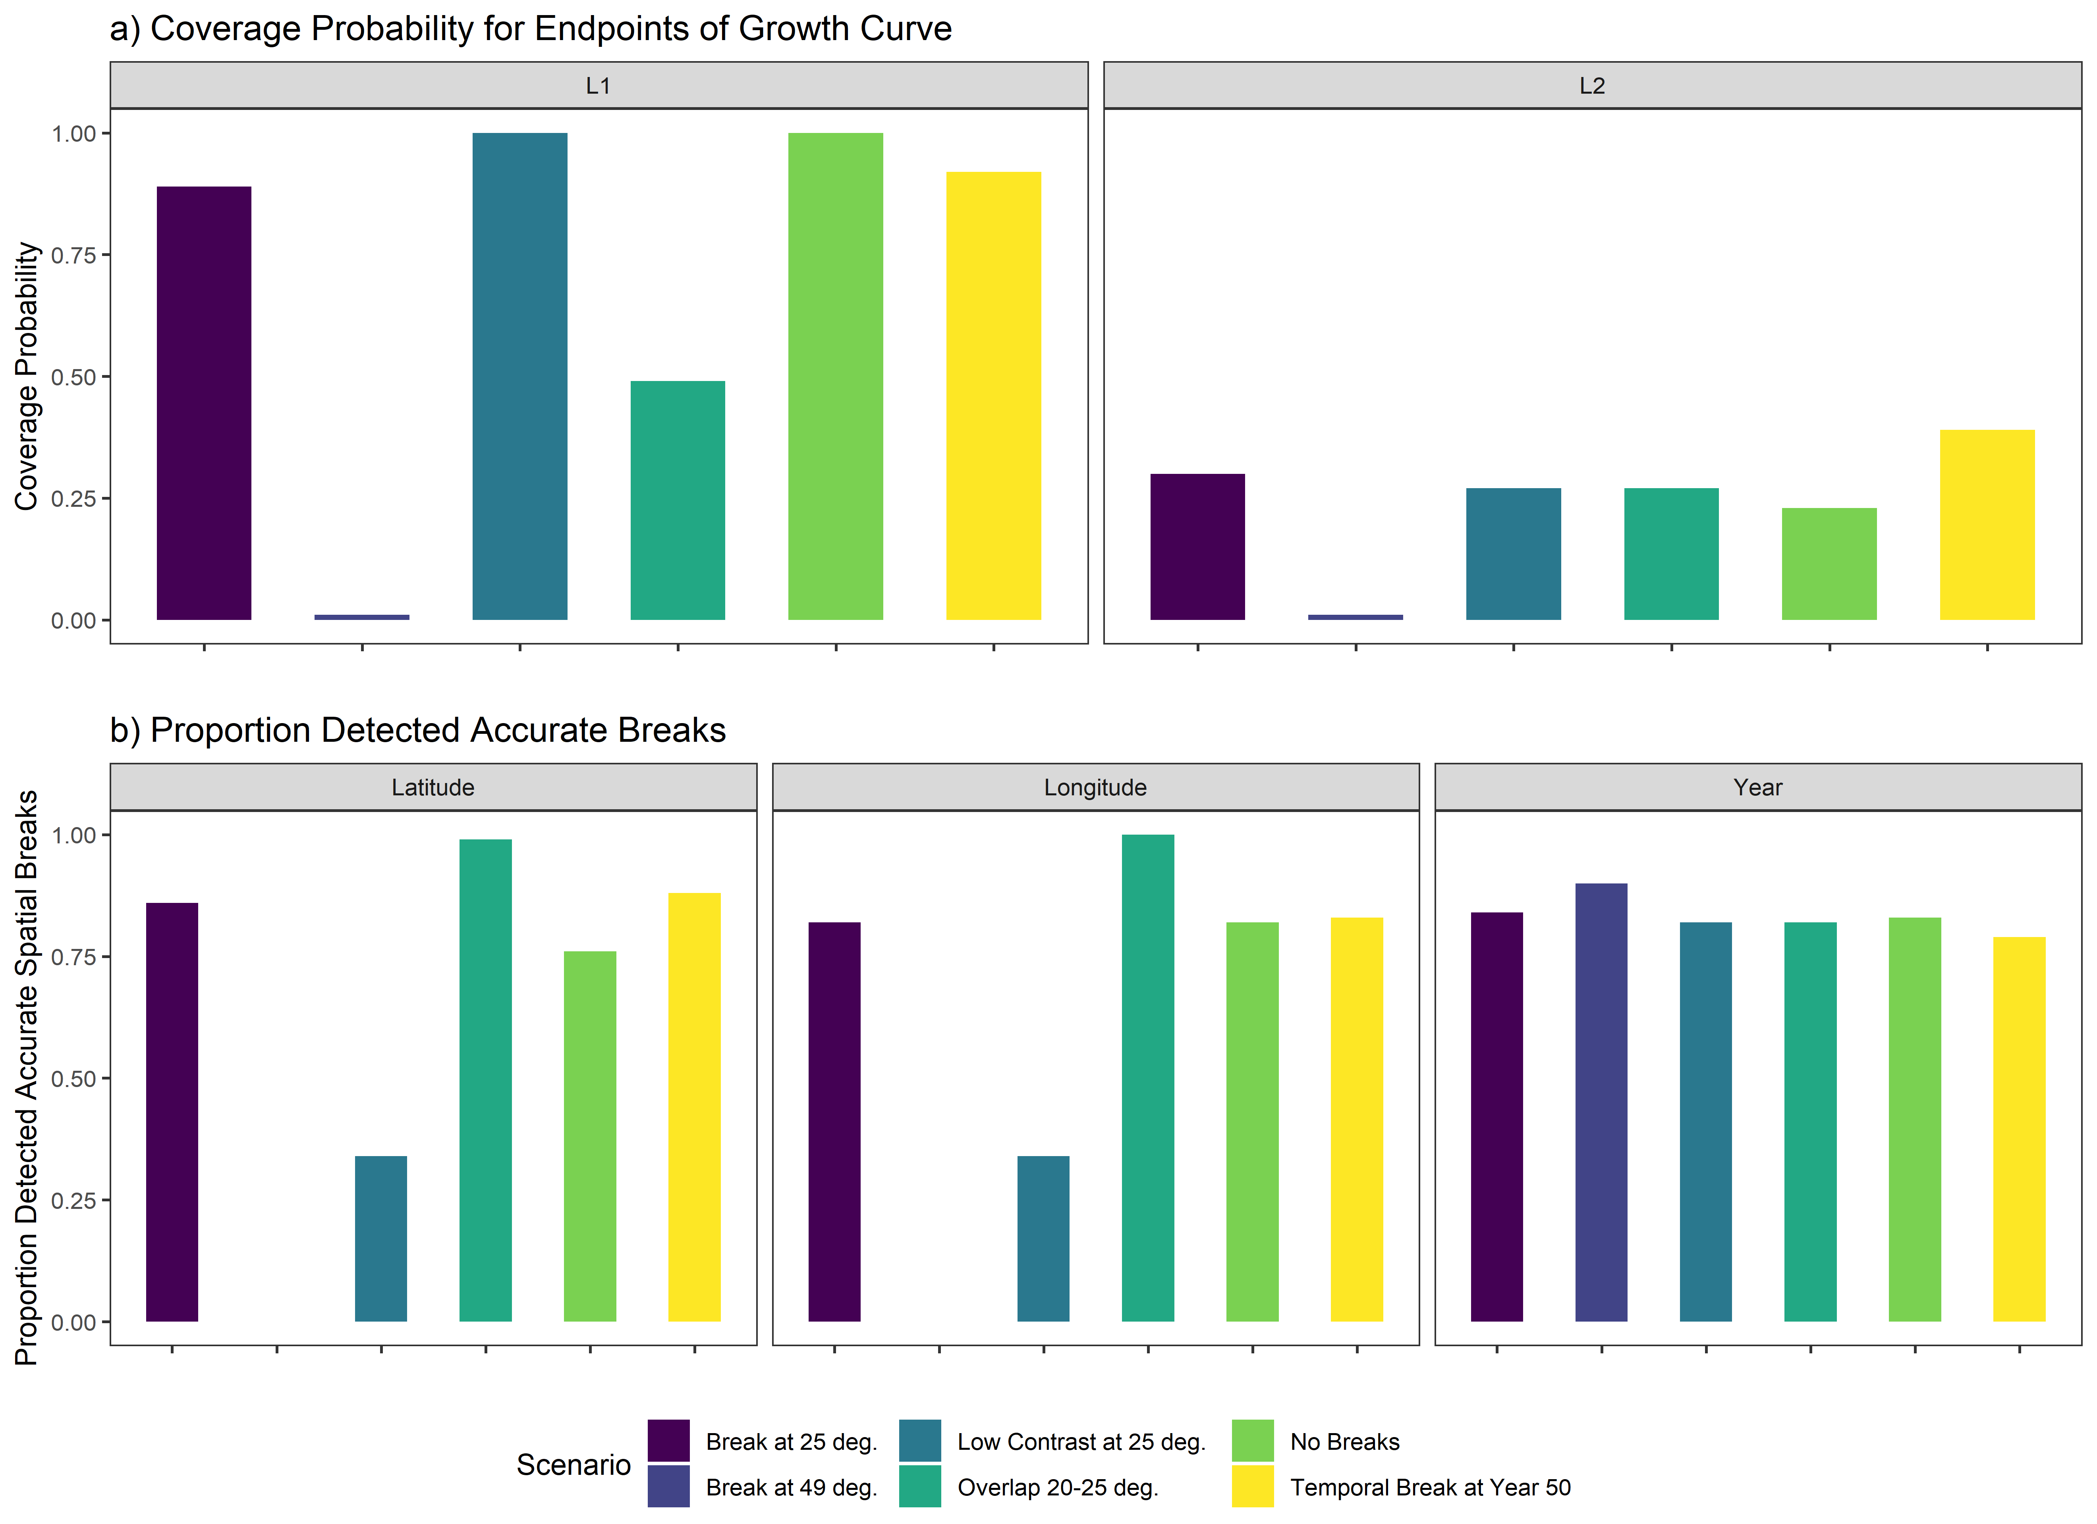

Figure 4. a) coverage probabilities for the endpoints of the growth curve, L1 (left) and L2 (right), and b) proportion of 100 simulations for each spatial scenario wherein the correct latitudinal breaks (left), or longitudinal breaks (center) or yearly break (right) were detected.

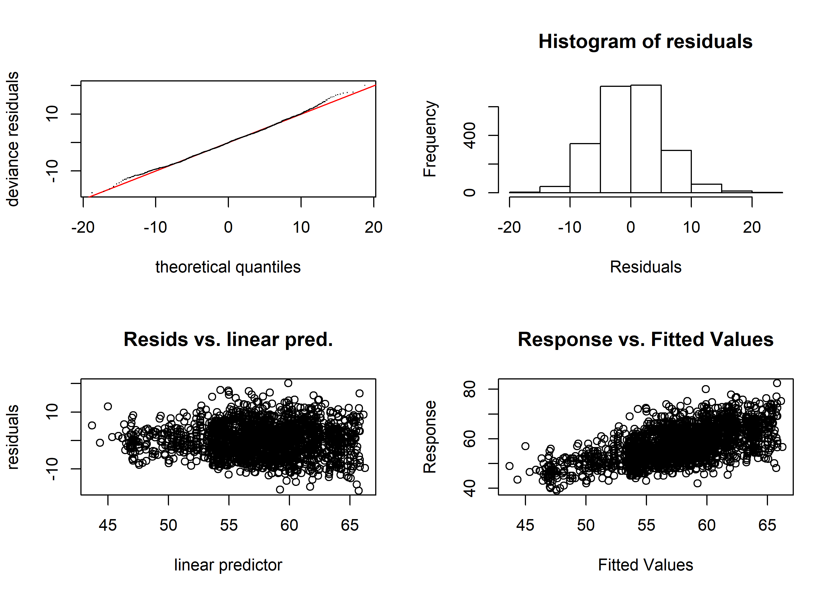

Figure 5. Diagnostic plots of best-fit GAM model for female age four sablefish. Clockwise from top left: quantile-quantile plot of deviance residuals; histogram of residuals; observed response values (lengths, in cm) vs predicted values, and model-predicted residuals vs linear predictor. See appendix for equivalent plots for other key ages and all sexes.

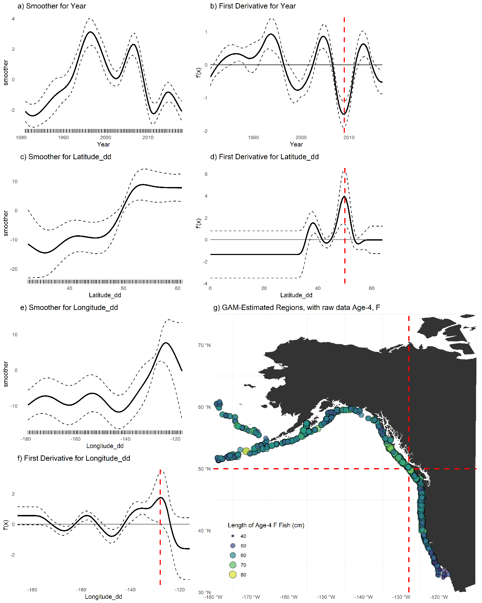

Figure 6. (a,c,e) Plots of smoothers for Year, Latitude, and Longitude, and first derivatives thereof for female age six sablefish (b,d,f). Red lines indicate latitudes or longitudes that produced the highest first derivative and had a confidence interval that did not include zero. g) map with model-detected breakpoints (red lines). See appendix for similar plots for different key ages and sexes.

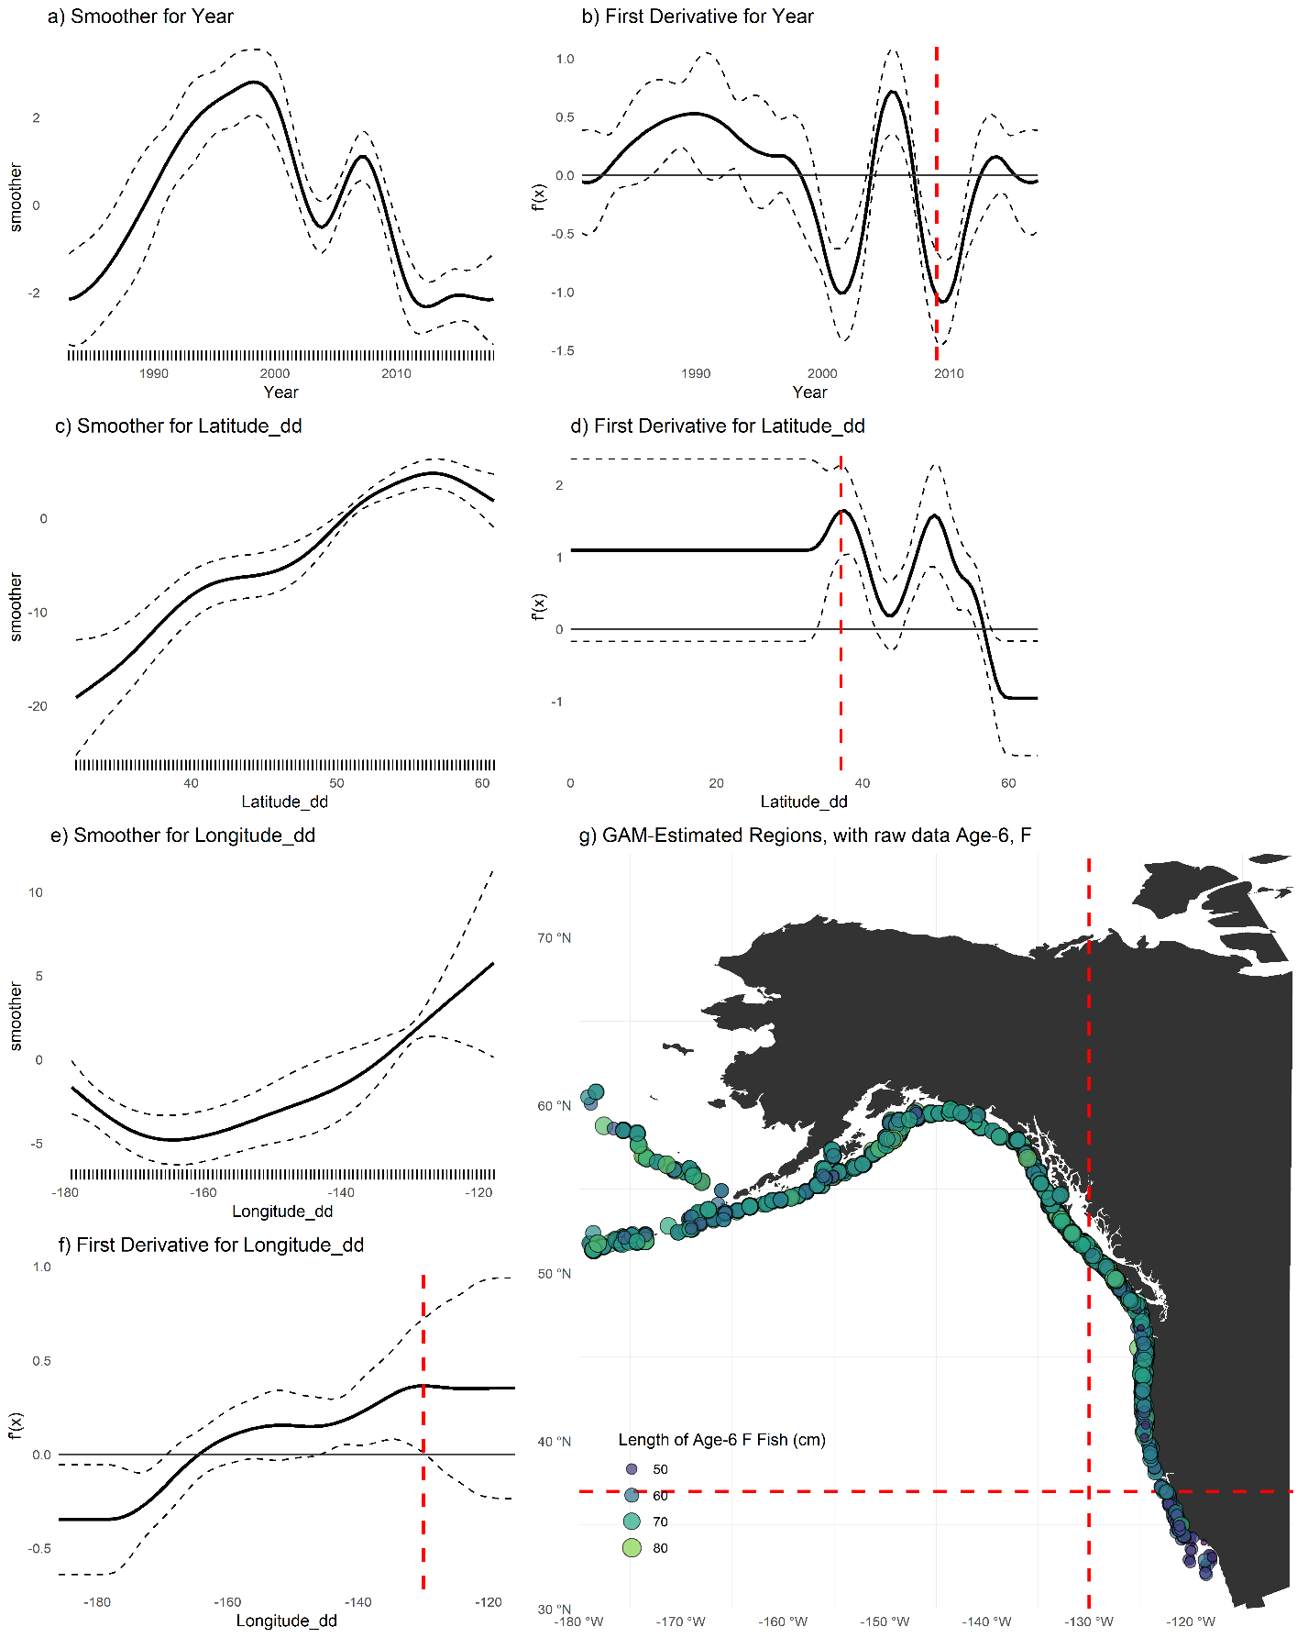

Figure 7 (a,c,e) Plots of smoothers for Year, Latitude, and Longitude, and first derivatives thereof for female age six sablefish (b,d,f). Red lines indicate latitudes or longitudes that produced the highest first derivative and had a confidence interval that did not include zero. g) map with model-detected breakpoints (red lines). See appendix for similar plots for different key ages and sexes.

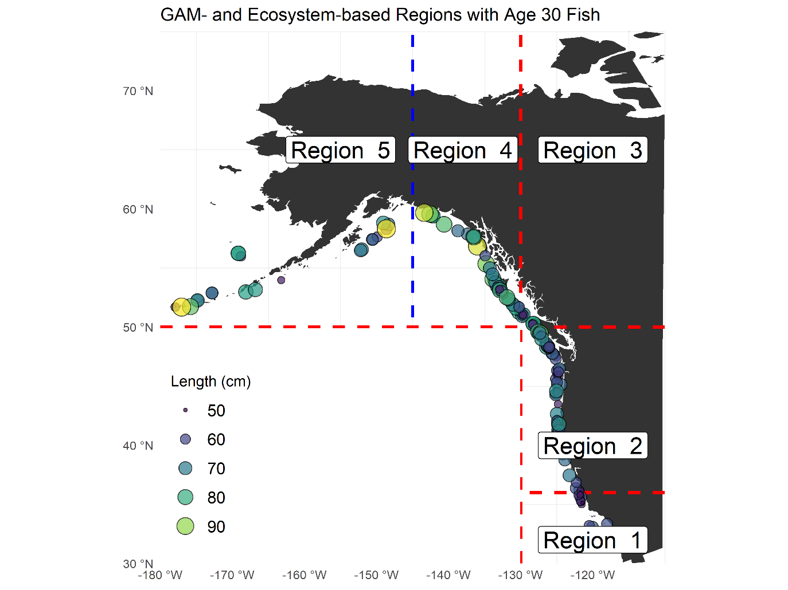

Figure 8. Method-detected breakpoints (red dashed lines) and ecosystem-based break (blue dashed lines) used to delineate growth regions for sablefish. For illustration, points are raw sablefish observations of both sexes at age 30 years.

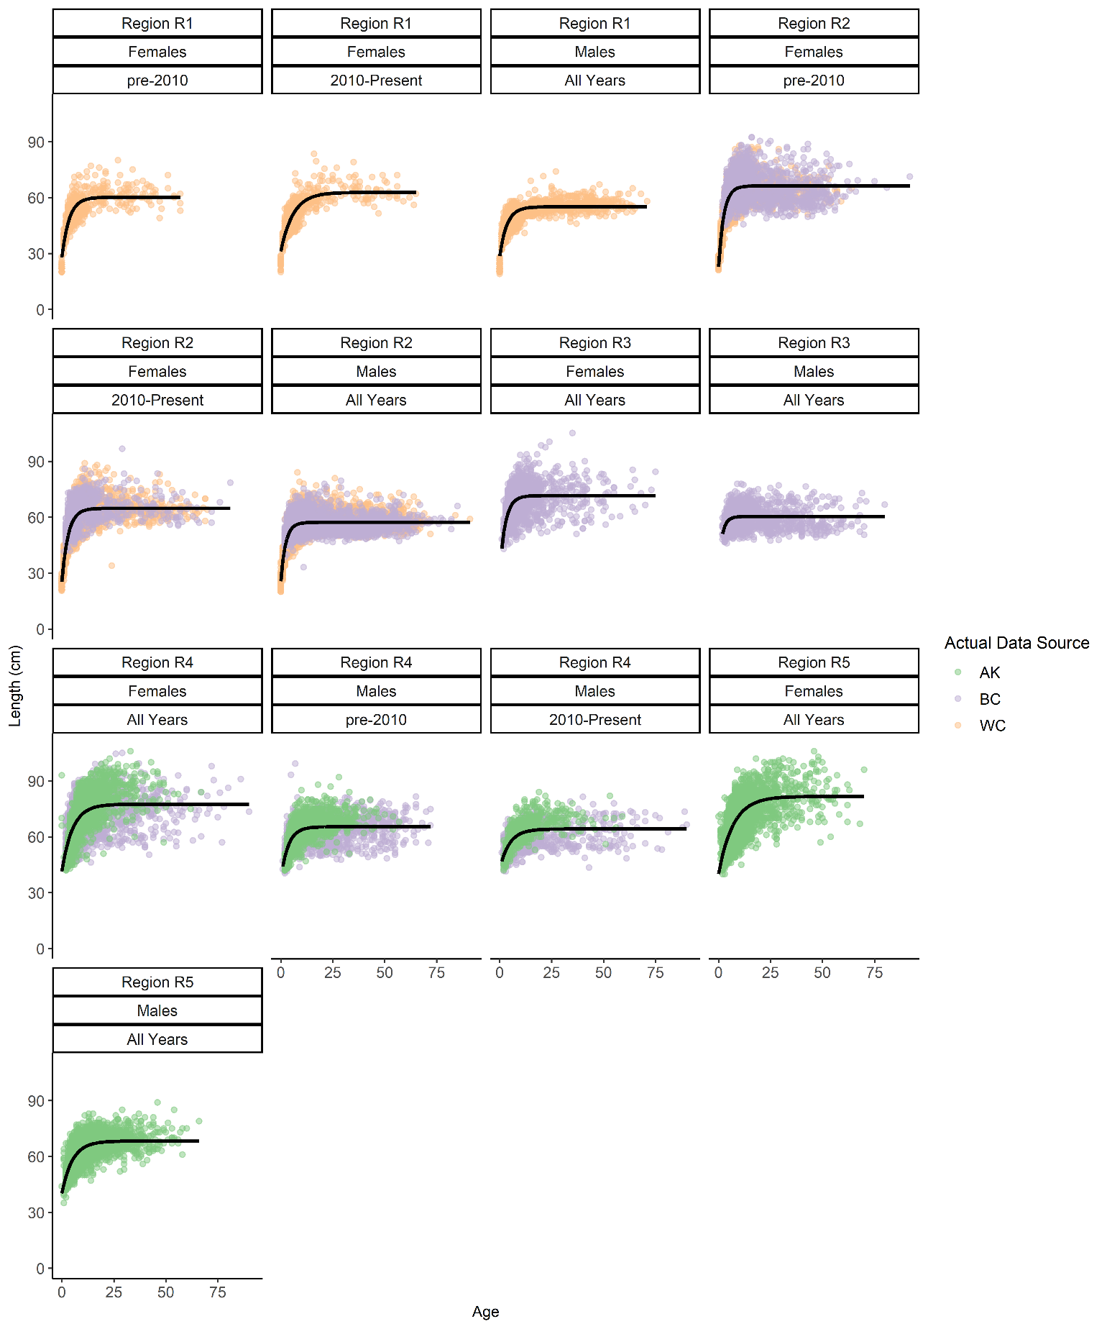

Figure 9. Fits of von Bertalanffy growth function (black lines) to data at final spatio-temporal aggregation. Points are raw survey data colored by their source.

# Tables

|  |  |
| --- | --- |
| **Scenario Description** | **Spatial Stratification** |
| No spatial breaks | Latitude and Longitude ~ U[0,50], all fish under Regime 1 |
| Single, spatial break in middle of range, with no overlap and strong contrast | Latitude and Longitude ~ U[0,25] under growth Regime 1;  Latitude and Longitude ~ U[25,50] under Regime 2 |
| Single, spatial break at 25 degrees with no overlap and reduced contrast | Latitude and Longitude ~ U[0,25] under growth Regime 1;  Latitude and Longitude ~ U[25,50] under Regime 3 |
| Single spatial break with some overlap | Latitude and Longitude ~ U[0,25] under growth Regime 1;  Latitude and Longitude ~ U[20,50] under Regime 2 |
| Single spatial break at edge of range with no overlap | Latitude and Longitude ~ U[0,49] under growth Regime 1;  Latitude and Longitude ~ U[49,50] under Regime 2 |
| Single temporal break at year 50 (of 100); no spatial variability | Latitude and Longitude ~ U[0,50], all fish under Regime 1 from years 0 to 49 and Regime 2 thereafter |

Table 1. Summary of simulation scenarios used to test the proposed method against various degrees of spatial growth variation, and a single temporal scenario.

|  |  |  |  |  |
| --- | --- | --- | --- | --- |
| **Scenario Description** | **True Break Points** | **Coverage probability for L1, L2** | **Proportion correct latitude, longitude, year** | **Proportion all three breakpoints correct** |
| No spatial breaks | None | 1, 0.23 | 0.76, 0.82, 0.83 | 0.51 |
| Single, spatial break in middle of range, with no overlap and strong contrast | 25° Latitude and 25° Longitude | 0.89, 0.30 | 0.86, 0.82, 0.84 | 0.58 |
| Single, spatial break at 25 degrees with no overlap and reduced contrast | 25° Latitude | 1, 0.27 | 0.34, 0.34 ,0.82 | 0.04 |
| Single spatial break with some overlap | Between 20° and 25° Latitude | 0.49, 0.27 | 0.99, 1.00, 0.82 | 0.81 |
| Single spatial break at edge of range with no overlap | 49° Latitude | 0.01, 0.01 | 0, 0, 0.9 | 0 |
| Single temporal break at year 50 (of 100); no spatial variability | Latitude and Longitude ~ U[0,50], all fish under Regime 1 from years 0 to 49 and Regime 2 thereafter | 0.92, 0.39 | 0.88, 0.83, 0.79 | 0.60 |

Table 2. Summary of true break points, coverage probabilities of the endpoints of the post-aggregation growth curves, and the proportion of simulations which detected the exact breakpoints each or all of the three smoothers. For the overlapping scenario (row 4), spatial breakpoints were considered a match if they fell within the true range.

|  |  |  |  |  |  |  |  |  |  |
| --- | --- | --- | --- | --- | --- | --- | --- | --- | --- |
| **Region** | **Survey Method** | **Sample size used in this analysis to fit GAM** | | **VBGF parameters from recent assessments** | | | | | |
| **M** | **F** | **L∞ (cm)** | | **k(years -1)** | | **t0 (years)** | |
| **M** | **F** | **M** | **F** | **M** | **F** |
| West Coast of US (Johnson et al., 2015) | Trawl on chartered commercial fishing vessels | 7778 | 7222 | 57 | 64 | 0.41 | 0.32 | 0 (fixed) | 0 (fixed) |
| British Columbia | Stratified trap survey | 6912 | 8088 | 68.99 | 72.00 | 0.29 | 0.25 | 32.50 | 32.50 |
| Alaska Federal (Hanselman et al., 2017) | Longline on chartered commercial fishing vessels | 6818 | 8182 | *67.8  ⁑65.3 | *80.2  ⁑75.6 | *0.29  ⁑0.28 | *0.22  ⁑0.21 | *⁑2.27 | *⁑1.95 |

Table 3. Overview of survey methods, data available and most recent VBGF parameters used for sablefish in stock assessments. *Time-blocked VBGF parameters for AK Federal assessment 1996-current; ⁑Time-blocked VBGF parameters for AK Federal assessment from 1960-1995 (Hanselman et al., 2017). *The WC assessment, which is written in Stock Synthesis, does not specify L∞ nor t0, but instead an age-length key (with values for minimum and maximum length and ages). Values were back-converted for presentation here.

|  |  |  |  |  |  |  |  |  |  |
| --- | --- | --- | --- | --- | --- | --- | --- | --- | --- |
| **Region** | **Sex** | **Period** | **Sample Size used to fit GAM** | **Estimated VGBF Parameters** | | | **Endpoints of growth curve** | | |
| **L∞ (cm)** | **k (years -1)** | **t0 (years)** | **L1 (cm)** | **L2 (cm)** |
| 1 | Female | Early | 616 | 60.44 | 0.29 | -2.15 | 27.85 | 60.43 |
| 1 | Female | Late | 699 | 62.86 | 0.16 | -4.31 | 31.78 | 62.63 |
| 1 | Male | All years | 1314 | 55.11 | 0.28 | -2.59 | 28.60 | 55.11 |
| 2 | Female | Early | 4913 | 66.28 | 0.41 | -1.00 | 22.31 | 66.28 |
| 2 | Female | Late | 3356 | 64.85 | 0.34 | -1.45 | 25.10 | 64.85 |
| 2 | Male | All years | 8871 | 57.33 | 0.44 | -1.32 | 25.34 | 57.33 |
| 3 | Female | All years | 1640 | 71.62 | 0.34 | -1.51 | 35.67 | 71.62 |
| 3 | Male | All Years | 1328 | 60.40 | 0.51 | -1.37 | 34.23 | 60.40 |
| 4 | Female | All years | 6384 | 77.63 | 0.20 | -3.51 | 39.46 | 77.54 |
| 4 | Male | All years | 3671 | 65.16 | 0.26 | -3.71 | 39.90 | 65.15 |
| 5 | Female | All years | 5884 | 81.61 | 0.14 | -4.85 | 40.47 | 81.02 |
| 5 | Male | All years | 4607 | 68.36 | 0.20 | -4.51 | 40.18 | 68.29 |

Table 4. Description of final spatio-temporal regions, and the sex-specific growth parameters estimated in the analysis. The Region column corresponds to regions depicted in Figure 8, with “early” period being observations before or during 2010, where applicable. Parameter estimates are those used to plot fitted curves in Figure 9.

# References

Adams, G.D., Leaf, R.T., Ballenger, J.C., Arnott, S.A., McDonough, C.J., 2018. Spatial variability in the growth of Sheepshead (Archosargus probatocephalus) in the Southeast US: Implications for assessment and management. Fish. Res. 206, 35–43. https://doi.org/10.1016/j.fishres.2018.04.023

Beck, K.K., Fletcher, M.S., Gadd, P.S., Heijnis, H., Saunders, K.M., Simpson, G.L., Zawadzki, A., 2018. Variance and Rate-of-Change as Early Warning Signals for a Critical Transition in an Aquatic Ecosystem State: A Test Case From Tasmania, Australia. J. Geophys. Res. Biogeosciences. https://doi.org/10.1002/2017JG004135

Cummins, P.F., Freeland, H.J., 2007. Variability of the North Pacific Current and its bifurcation. Prog. Oceanogr. 75, 253–265. https://doi.org/10.1016/j.pocean.2007.08.006

DFO, 2016. A Revised Operating Model for Sablefish (Anoplopoma Fimbria) in British Columbia, Canada.

Echave, K.B., Hanselman, D.H., Adkison, M.D., Sigler, M.F., 2012. Interdecadal Change in Growth of Sablefish (*Anoplopoma fimbria*) in the Northeast Pacific Ocean. Fish. Bull. 110, 361–374.

Gertseva, V., Matson, S.E., Cope, J., 2017. Spatial growth variability in marine fish: Example from Northeast Pacific groundfish. ICES J. Mar. Sci. 74, 1602–1613. https://doi.org/10.1093/icesjms/fsx016

Guthery, F.S., Burnham, K.P., Anderson, D.R., 2003. Model Selection and Multimodel Inference: A Practical Information-Theoretic Approach. J. Wildl. Manage. https://doi.org/10.2307/3802723

Hanselman, D.H., Heifetz, J., Echave, K.B., Dressel, S.C., Jech, J.M., 2015. Move it or lose it: movement and mortality of sablefish tagged in Alaska. Can. J. Fish. Aquat. Sci. 72, 238–251. https://doi.org/10.1139/cjfas-2014-0251

Hanselman, D.H., Lunsford, C.R., Rodgveller, C.J., 2017. Assessment of the sablefish stock in Alaska in 2017. Stock Assess. Fish. Eval. Rep. Groundf. Resour. Gulf Alaska 576–717.

Hurst, T.P., Abookire, A.A., 2006. Temporal and spatial variation in potential and realized growth rates of age-0 year northern rock sole. J. Fish Biol. 68, 905–919. https://doi.org/10.1111/j.0022-1112.2006.00985.x

James, M.K., Armsworth, P.R., Mason, L.B., Bode, L., 2002. The structure of reef fish metapopulations: modelling larval dispersal and retention patterns. Proc. Biol. Sci. 269, 2079–2086. https://doi.org/10.1098/rspb.2002.2128

Jasonowicz, A.J., Goetz, F.W., Goetz, G.W., Nichols, K.M., 2017. Love the one you’re with: genomic evidence of panmixia in the sablefish ( *Anoplopoma fimbria* ). Can. J. Fish. Aquat. Sci. 74, 377–387. https://doi.org/10.1139/cjfas-2016-0012

Johnson, K.F., Rudd, M.B., Pons, M., Akselrud, C.A., Lee, Q., Haltuch, M.A., Hamel, O.S., 2015. Status of the U.S. sablefish resource in 2015.

Kim, H.J., Miller, A.J., McGowan, J., Carter, M.L., 2009. Coastal phytoplankton blooms in the Southern California Bight. Prog. Oceanogr. 82, 137–147. https://doi.org/10.1016/j.pocean.2009.05.002

King, J.R., McFarlane, G.A., Beamish, R.J., 2001. Incorporating the dynamics of marine systems into the stock assessment and management of sablefish. Prog. Oceanogr. 49, 619–639. https://doi.org/10.1016/S0079-6611(01)00044-1

Kristensen, K., Nielsen, A., Berg, C., Skaug, H., Bell, B., 2016. TMB: Automatic Differentiation and Laplace Approximation. ournal Stat. Softw. 70, 1–21. https://doi.org/10.18637/jss.v070.i05

Mackas, D.L., Thomson, R.E., Galbraith, M., 2011. Changes in the zooplankton community of the British Columbia continental margin, 1985-1999, and their covariation with oceanographic conditions. Can. J. Fish. Aquat. Sci. 58, 685–702. https://doi.org/10.1139/f01-009

Mason, J.C., Beamish, R.J., McFarlane, G.A., 1983. Sexual Maturity, Fecundity, Spawning, and Early Life History of Sablefish ( Anoplopoma fimbria ) off the Pacific Coast of Canada. Can. J. Fish. Aquat. Sci. https://doi.org/10.1139/f83-247

McDevitt, M., 1990. Growth Analysis of Sablefish From Mark-Recapture Data From the Northeast Pacific. University of Washington.

Pacific Fisheries Management Council (PFMC), 2013. Pacific Coast Fishery Ecosystem Plan for the U.S. Portion of the California Current Large Marine Ecosystem. Pacific Fish. Manag. Counc. 7700 NE Ambassad. Place, Suite 101, Portland, Oregon. 97220.

Punt, A.E., 2003. The performance of a size-structured stock assessment method in the face of spatial heterogeneity in growth. Fish. Res. 65, 391–409. https://doi.org/10.1016/j.fishres.2003.09.028

R Development Core Team, R., 2011. R: A Language and Environment for Statistical Computing, R Foundation for Statistical Computing. https://doi.org/10.1007/978-3-540-74686-7

Ricker, W., 1969. Effects of size-selective mortality and sampling bias on estimates of growth, mortality, production and yield. J. Fish. Res. Board Canada. https://doi.org/10.1139/f69-051

Rodionov, S., Overland, J.E., 2005. Application of a sequential regime shift detection method to the Bering Sea ecosystem. ICES J. Mar. Sci. 62, 328–332. https://doi.org/10.1016/j.icesjms.2005.01.013

Rodionov, S.N., 2004. A sequential algorithm for testing climate regime shifts. Geophys. Res. Lett. 31, 2–5. https://doi.org/10.1029/2004GL019448

Schnute, J., 1981. A Versatile Growth Model with Statistically Stable Parameters. Can. J. Fish. Aquat. Sci. 38, 1128–1140. https://doi.org/10.1139/f81-153

Shotwell, S.K., Hanselman, D.H., Belkin, I.M., 2014. Toward biophysical synergy: Investigating advection along the Polar Front to identify factors influencing Alaska sablefish recruitment. Deep. Res. Part II 107, 40–53. https://doi.org/10.1016/j.dsr2.2012.08.024

Siddon, E., Zador, S., 2018. Ecosystem Status Report 2018: Eastern Bering Sea.

Simpson, G.L., 2018. Modelling palaeoecological time series using generalized additive models. bioRxiv. https://doi.org/10.1101/322248

Somers, K.A., Pfeiffer, L., Miller, S., Morrison, W., 2018. Using Incentives to Reduce Bycatch and Discarding: Results Under the West Coast Catch Share Program. Coast. Manag. 46, 621–637. https://doi.org/10.1080/08920753.2018.1522492

Stawitz, C.C., Essington, T.E., Branch, T.A., Haltuch, M.A., Hollowed, A.B., Spencer, P.D., 2015. A state-space approach for detecting growth variation and application to North Pacific groundfish. Can. J. Fish. Aquat. Sci. 72, 1316–1328. https://doi.org/10.1139/cjfas-2014-0558

Stawitz, C.C., Haltuch, M.A., Johnson, K.F., Sciences, F., Fisheries, N., Marine, N., Service, F., Oceanographic, N., 2019. How does growth misspecification affect management advice derived from an integrated fisheries stock assessment model ? Fish. Res. 213, 12–21. https://doi.org/10.1016/j.fishres.2019.01.004

Taylor, B.M., Brandl, S.J., Kapur, M., Robbins, W.D., Johnson, G., Huveneers, C., Renaud, P., Choat, J.H., 2018. Bottom-up processes mediated by social systems drive demographic traits of coral-reef fishes. Ecology 99, 642–651. https://doi.org/10.1002/ecy.2127

Thorson, J.T., 2019a. Guidance for decisions using the Vector Autoregressive Spatio-Temporal (VAST) package in stock, ecosystem, habitat and climate assessments. Fish. Res. 210, 143–161. https://doi.org/10.1016/j.fishres.2018.10.013

Thorson, J.T., 2019b. Guidance for decisions using the Vector Autoregressive Spatio-Temporal (VAST) package in stock, ecosystem, habitat and climate assessments. Fish. Res. https://doi.org/10.1016/j.fishres.2018.10.013

Thorson, J.T., Skaug, H.J., Kristensen, K., Shelton, A.O., Ward, E.J., Harms, J.H., Benante, J.A., Inouye, B.D., 2015. The importance of spatial models for estimating the strength of density dependence. Ecology 96, 1202–1212. https://doi.org/10.1890/14-0739.1

von Bertalanffy, L., 1957. Quantitative Laws in Metabolism and Growth. Q. Rev. Biol. https://doi.org/10.1086/401873

Waite, J.N., Mueter, F.J., 2013. Spatial and temporal variability of chlorophyll-a concentrations in the coastal Gulf of Alaska, 1998-2011, using cloud-free reconstructions of SeaWiFS and MODIS-Aqua data. Prog. Oceanogr. 116, 179–192. https://doi.org/10.1016/j.pocean.2013.07.006

Wickham, H., Francois, R., Henry, L., Muller, K., 2019. dplyr: A Grammar of Data Manipulation.

Wood, S.N., 2011. Fast stable restricted maximum likelihood and marginal likelihood estimation of semiparametric generalized linear models. J. R. Stat. Soc. Ser. B Stat. Methodol. https://doi.org/10.1111/j.1467-9868.2010.00749.x