*Model Approach (Option B: “A Priori”)*

The simulation workflow was designed to compare four hypotheses regarding the spatial stratification of VBGF growth parameters *k*, $L_{∞}$ and $t_{0}$. The general framework was an information-theoretic (IT) approach (Guthery et al., 2003), which has been used in other spatial growth studies where *a priori* hypotheses of spatial breaks are present (e.g. Gertseva et al., 2017; Williams et al., 2012).

A description of each simulation and its respective hypothesis is in Table 2. Our models were instantiated using Template Model Builder (Kristensen et al., 2016) wherein we executed a maximum of 1000 iterations. Initial parameter values for all models tested were t0 = 0, s0 = 0.1, s1 = 1, with L∞ = 70, K = 0.

We investigated four hypotheses of spatial stratification for the sablefish stock (Table 2). The first was a completely mixed scenario, wherein single parameter estimates were obtained for the entire dataset. The next hypothesis represents the current management paradigm, where each of the three regions’ survey data is used to generate three separate estimates of VBGF parameters. We next generated VBGF parameters at spatial breaks proposed from the literature, where researchers have either examined this same data at the regional scale (Gertseva et al., 2017) or used other tools, such as tagging information, to suggest different stratification regimes (Echave et al., 2012; McDevitt, 1990). Our final hypothesis tested estimated VBFG parameters at the stratification levels enabled by the survey structure. Each scenario required the re-aggregation of the data into strata’. The selectivity corrections described above were applied to the appropriate data points regardless of subsequent grouping, as they are a result of the data collection protocol.

Previous investigations of Alaskan sablefish have indicated that growth parameters have changed between the periods 1985-1994 and 1995-2004 (Echave et al., 2012). For that reason, this analysis excluded survey data collected before 1995 from the Alaskan longline survey.

Code to complete the simulations is available at <http://github.com/mkapur/sab-growth>. We evaluated the performance of each model based on the overall Akaike Information Criterion (AIC) and the difference between currently-used growth parameters and those estimated by the respective approaches.

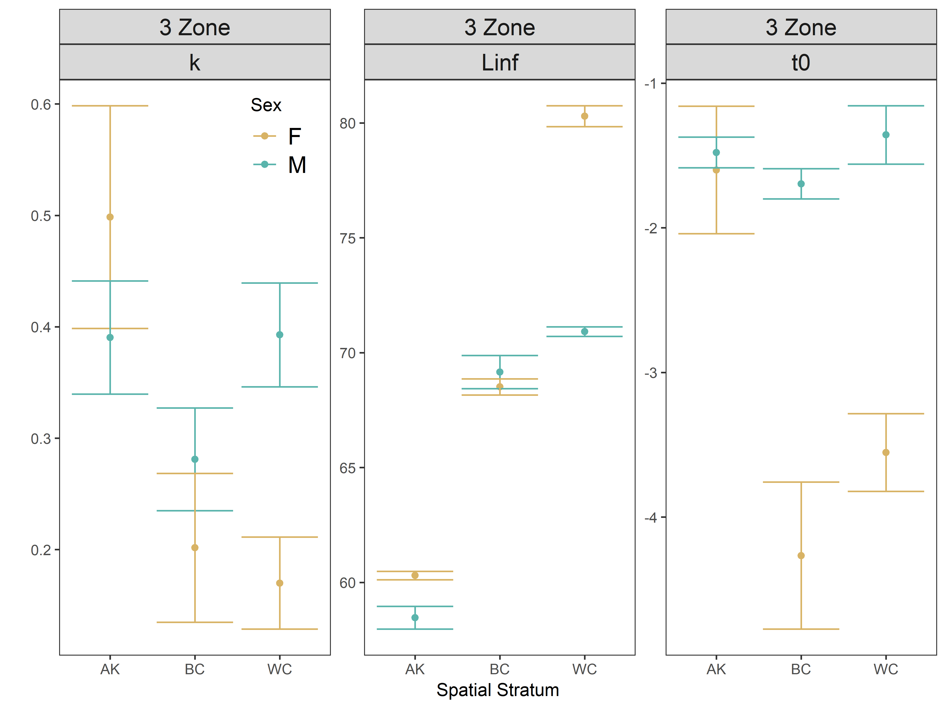

Figure 4. Comparative boxplots of estimated VBGF parameters for varying strata and sex at all/best-fit model.

|  |  |  |  |
| --- | --- | --- | --- |
| Spatial stratification hypothesis | Description of breaks | | |
| West Coast | British Columbia | Alaska |
| Uniform across entire range | Data from all regions pooled by sex | | |
| Regional boundaries | Pooled survey data from entire US west coast | Pooled survey data from British Columbian coast | Pooled survey data from federal Alaska waters |
| Proposed breaks from literature | Monterey-Conception, 36˚N (Gertseva et al., 2017); two strata total | Patterns in sablefish recruitment, growth and the movement of tagged fish indicate the presence of northern and southern stocks in B.C. waters that mix off north western Vancouver Island (Haist et al., 2005); two strata total | Six regions: Southeast, Kodiak, Chirikof, Shumagin, Eastern Bering Sea, Aleutian Islands (Echave et al., 2012) |
| Individual strata as available in survey | Three depths (shallow [< 200m], medium [between 200 and 300m], deep [between 300 and 550m]) at two spatial strata (North or South of 42˚ North); six strata total | Thirty-two unique geographic areas | Eleven unique geographic areas |

Table 2. Description of 4 simulations used in comparison, from lowest to highest resolution. Currently, the federal Alaskan assessment uses growth estimates derived from survey data aggregated at the identified spatial strata from the literature.