Spatiotemporal trends in relative abundance for Northeast Pacific Sablefish

A working paper in support of operating model development

Kapur, M.1, Berger, A., Connors, B., Fenske, K., Haltuch, M., Hanselman, D., Rodgers, L., and Punt, A. E.1

1 University of Washington, School of Aquatic and Fisheries Sciences. 1122 NE Boat St, Seattle WA 98105

**Keywords:** spatio-temporal, index of abundance, catch per unit effort, fishery survey

# Abstract

Stock assessments typically involve the use of fish abundance surveys, which are conducted in the Northeast Pacific by government agencies at the corresponding regional management scale. For sablefish, a highly valuable groundfish species, the management structure is separated into three broad jurisdictions and sampled by multiple, non-overlapping surveys which have attendant differences in sampling rates and catchability. Due to concurrent declines in sablefish abundance in all three regions, there is interest in developing a region-wide assessment model to support a management strategy evaluation for sablefish. This paper presents the construction of a range-wide estimate of relative abundance for sablefish using the ‘intercalibration’ (Thorson and Forrest, n.d.) approach on the pre-existing fishery independent surveys conducted by the United States and Canadian governments. The index suggests that biomass is greatest in Alaska. Though relative biomass has declined in all regions from a historical high over the past several decades, the model suggests an increase in abundance throughout the Eastern Bering Sea, though this estimate is provided with much uncertainty.Parameter estimates indicate variation in both encounter probabilities and capture rates among regions, the latter of which is likely a result of selectivity differences across surveys.

# Introduction

## Indices of abundance in stock assessment

Indices of abundance can be implemented in fishery stock assessments as information of the relative size of the fishery population. These are ideally sourced from a fishery-independent surveys and are used within an assessment framework to estimate quantities such as current abundance which are of interest to decisionmakers. Fisheries with adequate resources and managerial capacity, such as the valuable groundfish of the Northeast Pacific, are monitored via government-sponsored surveys. These surveys are statistically designed to produce a representative sample of the age, size (length or weight) composition and relative abundance of targeted stocks, and now typically occur on at least a biennial basis. Stock assessment scientists implement a variety of methods to ‘standardize’ raw observations, with the intent of reducing erroneous signals caused by survey implementation (i.e. time of year, vessel) and retaining “true” fluctuations in population abundance (Maunder, 2004). Occasionally, a given management region may have more than one survey which overlaps in space and/or time, and standardization of such models are typically done separately. For example, the 2019 benchmark assessment for sablefish off the West Coast of the U.S. conducted a spatio-temporal standardization of the recent groundfish bottom trawl survey, years 2003-2018, but did not update the standardization for the Triennial survey which overlapped geographically through 2003 (Haltuch et al., 2019).

## Spatial concerns

Many commercially valuable stocks, including sablefish, have a basin-wide distribution and spatial demographic variation which violate the management boundaries at which they are currently assessed (Kapur et al., 2019), posing a problem for the unbiased estimation of management quantities and reference points (Goethel and Berger, 2016). Concurrent declines in sablefish abundance have guided a concerted effort to develop a range-wide population model for this species, which necessitates the development of an index of abundance representative of the entire NE Pacific. An obvious hurdle in this effort is differences in sampling efficiency, also known as catchability, which varies across gear and operational protocols and results in different estimated proportions of local biomass captured by a survey operation. In the absence of such an index, assessment scientists could attempt to directly estimate separate catchabilities for individual surveys within a stock assessment model, though concurrently estimating selectivity and catchability for multiple areas (surveys) can prove unwieldy, leading to model instability if high (Punt, 2019).

Thorson & Forrest (in prep) present three traditional avenues to simultaneously analyze multiple surveys, which necessarily requires an estimate of differences in catchability. Analysts may either ignore these differences (thus assume that 100% of biomass is retained); use pre-existing stock assessment estimates of catchability, if available; or perform intercalibration surveys via gear experiments. A new option presented therein was to instead combine spatio-temporally adjacent (or, ideally, overlapping) surveys using a statistical method which estimates spatial and annual variation in fish density, deemed the “Calibration-by-Proximity method” (CBP). Their simulation study, which used the same fishery-independent surveys presented here for a different groundfish species, demonstrated that CBP presented unbiased estimates of catchability ratios between surveys and the resultant abundance of fish over time. This presents a useful tool for developing a fishery-independent index of abundance for sablefish, which are sampled by independent surveys which overlap in time throughout the northeast Pacific and overlap in space on an inter-regional basis.

The goal of this work was to implement the CBP method (detailed in Methods) to fishery-independent surveys of sablefish from the entire NE Pacific. Here, “range” is used to refer to the entire NE Paficic, spanning from California to the Eastern Bering Sea (EBS, Figure 1). “Region” pertains to the extant management regions within the range, at which stock assessment is currently conducted for sablefish at varying regularity: the California Current, the coast of British Columbia, and the entirety of Alaska. The CBP-derived index of relative abundance can be used to address two major research priorities for this population: 1) are the concurrent declines in abundance observed by independent assessments and a third-party survey “real”, and 2) does the implementation of a spatially-explicit range-wide model using this index modify management recommendations for the respective regional fisheries? The latter priority would necessarily be dealt with in a management strategy evaluation framework and is outside the scope of this paper.

# Methods

## Calibration by Proximity (CBP)

The CBP approach is implemented using the Vector Autoregressive Spatio-temporal (VAST) modeling package (Thorson, 2019) to predict biomass density (kg/km2) for individual combinations of locations (*s*) and years (*t*) within a given survey. One advantage of the VAST approach is that it enables un-sampled locations and/or years to be informed by locations and years where there is data, thus creating a smooth estimate of fish abundance (density) and extent (spatial distribution) through time. The model calculates the probability of the input biomass b at each unique location *i* using a delta method to predict encounter probability and positive catch rate , whereby:

Equation

where is observed biomass, and is the residual variance in positive catch rates. The model also enables one to specify a random effect for the survey vessel used, which was possible in our analysis for all surveys except the Alaska Domestic Longline. We used 250 spatial knots and specified a spatio-temporal effect for both positive catch rates and encounter probabilities. The total runtime of each model, including error estimation and bias correction, was between 2 and 3 hours. Convergence of each model was evaluated by the maximum gradient obtained and whether the Hessian matrix was invertible. Further detail of the VAST model implementation is available in Thorson (2019).

A principal assumption of the CBP approach is that true spatial variation in fish abundance is independent of survey sampling boundaries. Long-term tag-recapture experiments of sablefish throughout the NE Pacific have demonstrated that sablefish move readily across the entire range, with an average great-circle distance of 191 km (Hanselman et al., 2014). Additional genetic evidence supports the notion that sablefish are genetically homogenous, with no major detectable clusters that would suggest sub-stocks on the regional level (Jasonowicz et al., 2017). It is thus appropriate to assume that the imposed management breaks at which surveys are conducted are independent of sablefish abundance patterns, and that statistical intercalibration across these breaks would not be confounded with underlying population patterns. In other words, we do not expect differences in catchability between the survey regions to be an artifact of underlying (biological) population variation.

One important distinction is that the CBP method does not explicitly estimate spatial variation in catchability; instead, we specify a ‘reference survey’ for which relative catchabilities are estimated (as ratios). We used the Alaskan Domestic Longline survey as our reference survey. After parameter estimation, biomass is predicted for each location and year, and biomass is implicitly calculated using the relative catchability. This is achieved via a design matrix, whereby each row corresponds to a given sample *i.* Each row is a vector of zeroes except for the column corresponding to the survey from which that sample was obtained. The reference survey is fixed at zero throughout to ensure that both the annual intercepts and two catchability parameters (Lambda1 and Lambda2) for each survey remain identifiable; the resulting estimates can be interpreted as the log-ratio of expected density for each survey relative to the reference.

The reference survey affects the scale of each index (because indices are in units relative to the reference survey), and also affects the log-SE of the index (because that SE includes the imprecision of the estimated catchability ratio, which is more precise for some pairwise comparisons than others), but the trends are identical for different reference surveys, and the difference in scale is equal to the catchability ratio for the gears being interchanged as “reference”.

## Data sources and pre-processing

We used fishery-independent survey data provided by the National Oceanic and Atmospheric Administration (NOAA) and Department of Fisheries and Oceans (Canada). At the outset, there was a total of seven surveys across three regions, with varied coverage of years 1979-2018, and a depth range of 10 to 1500m. Stepwise additions of each fleet beginning with the West Coast trawl survey were undertaken to confirm model stabilization and scale correction within the CBP framework. These are the same survey datasets currently used in stock assessment modeling efforts for the respective regions; the spatial extent of the surveys includes the California Current (CC), west coast of British Columbia (BC), Gulf of Alaska (GOA), Eastern and some of the Northern Bering Sea (BS) and Aleutian Islands. We implemented time-blocks in a subset of the surveys where changes in gear or sampling methodology are likely to have led to intra-survey changes in catchability; these time blocks are identical to those used in the current assessments. The GOA trawl survey was filtered to only include gears at depths less than 700m and removed years 1985 and 1987 (D. Hanselman, pers. comm.). Before running the model, we divided all records of the response variable for all surveys by 1000, as the model tends to struggle with larger numbers (K.F. Johnson, pers. comm.). This may impact the scale of the resultant index but as it will be implemented as relative abundance in any future modeling work, we are unconcerned.

The surveys presented in Table 1 include all data considered for inclusion in the range-wide index. They do not necessarily have comparable effort units, particularly in the case of the British Columbia directed trap survey, which captures sablefish in traps and thus doesn’t explicitly record an “area swept” in square kilometers as do the others. The VAST-CBP method enables input of a value proportional to effort (in this case, number of traps) and continues to estimate two catchability coefficients (one for each linear predictor) as fixed effects. Under plausible generative processes, a linear transformation of units in the response (arising from mis-specifying area) are captured by a transformation of catchability coefficients. Despite this, a requirement for implementation of the delta method across all surveys is that input data contain “zero hauls”, records made (or backfilled) of locations and years where sets were cast but no sablefish obtained. Neither the BC trap data nor the EBS trawl data (contained the appropriate records at the time of this analysis and were therefore excluded.

The VAST method estimates relative catchability parameters for each of the surveys, and aggregates biomass outputs to user-defined regions, which correspond to the management zones: the EBS and Gulf of Alaska; British Columbia, and the California Current. The model also reports an aggregate index indicating the estimated trend in sablefish abundance for the region at large.

# Results

Table 1 summarizes the qualitative outcomes of the stepwise addition of survey data beginning with the California Current. The purpose of this exercise was to investigate whether estimated trends were stable and if they showed any concordance with pre-existing indices used in current assessments. While we did not expect our final index to be at the exact scale of the previous indices unstandardized with VAST (i.e. a summation of the three regions at each year), we were curious if the new index is able to mimic their trends. However, because the 2019 West Coast sablefish assessment did use VAST to standardize the WCGBTS data (2003 – 2018) we anticipated our index to roughly match both the scale and trend from that assessment for those years, which it did from the outset (Figure 3). Inclusion of the Triennial dataset also resulted in a similar trend to the standardized values used in the 2019 benchmark assessment for West Coast sablefish, though at a higher scale. We then added the BC Trawl dataset into the model, which estimated steep declines to nearly zero for that region for the entirety of the sampled period. Adding the AK Domestic Longline data as a reference fleet corrected both the trend and scale issues in British Columbia, though the interpolated early years (pre-2000) were very high for the Canadian survey. In addition, the AK Longline estimates presented a sharp peak in abundance in the Gulf of Alaska in 2010, out of sync with trends in any of the included datasets. Finally, we included the Gulf of Alaska trawl survey, retaining the AK Domestic Longline as the reference fleet and found that this smoothed the ‘spike’ from 2010 as well as the trends of both AK estimates, and did not affect the trend or scale of WC or BC. Attempts to fit this final model with the AK GOA Trawl as the reference fleet ran for over five hours and failed to converge.

Application of this model to sablefish suggests that relative abundance entered a range-wide phase of decline in the early 1990s, from levels to which it has not returned either at the regional or range-wide scale. However, in terms of more recent declines, the overall trend in relative abundance estimated here appears mixed. The Gulf of Alaska exhibits a continued decline over several decades, with small increases in both the California current and British Columbia. Density in the Eastern Bering Sea has increased dramatically in the last 5 years, a trend mirrored by the overall estimate (Figure 4).

Catchability estimates varied throughout the region, as expected. More variation was apparent in the Lambda2 variable, which is the catchability effect on capture rate. Estimates for Lambda1, the catchability effect for encounter probabilities (or expected number) were more negative for southerly regions.

# Discussion

We undertook this standardization effort for sablefish with the goal of developing a range-wide index that could be alternatively stratified to various spatial regions, and to investigate whether concurrent yet disparate reports of decline are evident when data are combined across the NE Pacific. Previous simulation results have indicated that proximal surveys are able to estimate catchability ratios via average differences in encounter-probability and positive catch-rate in overlapping locations and years and can provide accurate estimates of proportional biomass in given subregions across time.

An important consideration when combining disparate surveys is how variation in selectivity between surveys contributes to apparent differences in catchability. We anticipate the suite of survey gears included here to selectively capture sablefish, as reflected in the selectivity curves used in assessments; indeed, the model estimated greater variation across fleets in Lambda2, which pertains to the relative biomass-per-group for each survey. In Thorson et al. (in prep), estimation models applying the CBP approach on simulated data which varied length-at-50%-selectivity by survey, but not Lambda2 explicitly, obtained similar results.

In terms of geographic distribution, density maps (Figure 5) indicate a north-easterly shift in sablefish distribution in recent years. Interestingly, this pattern of ‘swapping’ biomass between the Gulf and EBS occurred twice: once to a minor extent around year 2000 and again around 2010. The latter time point corresponds to a detected breakpoint in growth rate estimates, after which sablefish growth parameters were estimated to be slightly lower in the western Gulf (Kapur et al., 2019). There are two potential dynamics which could lead to our observed biomass trends, neither of which can be definitively excluded by this analysis. The first, which is suggested by the density maps, is that fish have migrated from the GOA to the EBS over the last decade or so, leading to a sharp increase in the EBS. This would mean a positive change in the absolute number of individuals present in the EBS ecosystem at the expense of the GOA. Fitting the Eastern Bering Sea trawl data with zero-haul data included could further illustrate the validity of this point, if that survey also produces estimated increases on a similar timescale. Alternatively, considering recent demographic investigations of sablefish growth across ecosystems, it is also possible that oceanographic and/or fishery pressures lead to a decline in maximum size obtained by individual sablefish in the GOA, depressing biomass estimates after 2010. The aforementioned growth work did not observe a similar temporal breakpoint for sablefish growth west of 145’W, though sablefish obtain their largest size of the entire range in this area.

Future efforts for range-wide sablefish modeling should include the dis-aggregation (likely re-fitting) of these estimates to spatial scales concordant with demographic variation; implementation of the fitted indices into a range-wide assessment model with selectivity variation estimated; and completion of known data sources to include zero-hauls for inclusion in this fitting.

# Tables

|  |  |  |  |  |  |
| --- | --- | --- | --- | --- | --- |
| **Survey Code** | **Name** | **Region** | **Treatment** | **Design** | **Depth Range** |
| WCGBTS | West Coast Groundfish Bottom Trawl Survey; NWCBO in figures | West coast of US | Single Index | Random stratified Design | 55-1300m |
| Triennial | Triennial West Coast groundfish survey; AKSHLF in figures | West coast of US | Three Indices:  1. “Early”: 1983-1992  2. “Late”: 1995-2001  3. “Final”: 2004 | Transect based design | <500m |
| BC Trawl (Synoptic) | British Columbia trawl survey | British Columbia | Single index | Random stratified design |  |
| BC StRs | British Columbia standardized trap survey | British Columbia | **Not included due to absence of zeros** | Random stratified design | 150-1400m |
| GOA | Gulf of Alaska bottom trawl survey | Gulf of Alaska | Two Indices:   1. “Early” 1993 2. “Late” 1994-2017 | Random stratified design | 10-700m |
| AK_DOM_LL | Alaska domestic longline survey | Gulf of Alaska | Single index |  |  |
| EBS | Eastern Bering Sea bottom trawl survey | Eastern Bering Sea | **Not included due to absence of zeros** | Random stratified design | 50-300m |

*Table 1. Datasets considered for use in the analysis. Both the BC standardized trap survey and Eastern Bering Sea trawl surveys did not contain ‘zero-haul’ data and were not included in the standardization here.*

|  |  |  |  |
| --- | --- | --- | --- |
| **Survey Added or Changed** | **Reference Fleet** | **Model Converged** | **Observations** |
| WCGBTS | NA | yes | Scale and trend like 2019 assessment (which also used VAST) |
| + Triennial (early and late) | NA | yes | trend like 2019 Assessment; scale higher |
| + BC Trawl | NA | yes | BC low, declining trend for all years |
| +Alaska Domestic Longline | AK_DOM_LL | yes | BC trend and scale now matches during years of data, but pre-data years much higher; Gulf of Alaska has spike in year 2010, otherwise scale and trend constant |
| +Gulf of Alaska Trawl (early and late) | AK_DOM_LL | yes | BC and WC trend and scale similar; AK trend similar with high uncertainty in recent years |
| +Gulf of Alaska Trawl (early and late) | AK_GOA_TRAWL (late) | **no** | Attempted same model as above with alternative reference fleet; model ran for 5+ hours and failed to converge |

Table . Qualitative summary of stepwise addition of survey fleets. Each row indicates an additional fleet fit simultaneously with all fleets in previous rows. Where Reference Fleet is NA, catchability values were estimated directly for each fleet.

|  |  |  |  |  |
| --- | --- | --- | --- | --- |
| **Parameter** | **Description** | **Estimate** | **Std. Error** | **Survey, if applicable** |
| beta1_ft | Intercepts for year effect, encounter | 19.12857 | 8.770039 |  |
| lambda1_k | Effect of catchability covariates, encounter | -13.4695 | 1.059046 | NWCBO |
| lambda1_k | ̎ | -13.2059 | 1.072734 | Triennial Early |
| lambda1_k | ̎ | -12.4279 | 1.372962 | Triennial Late |
| lambda1_k | ̎ | -11.7003 | 1.019879 | BC Trawl |
| lambda1_k | ̎ | -10.16 | 0.99873 | GOA Trawl Early |
| lambda1_k | ̎ | -9.59959 | 0.936851 | GOA Trawl Late |
| L_omega1_z | Trimmed cholesky pointwise variance in spatial variation | 23.41802 | 1.826717 |  |
| L_epsilon1_z | Trimmed cholesky pointwise variance in spatio-temporal variatio | 0.731381 | 0.064407 |  |
| logkappa1 | Decorrelation rate | -5.93648 | 0.080378 |  |
| beta2_ft | Intercepts for year effect, capture | 4.722991 | 0.859791 |  |
| lambda2_k | Effect of catchability covariates, capture | -7.15328 | 0.280597 | NWCBO |
| lambda2_k | ̎ | -6.76498 | 0.291975 | Triennial Early |
| lambda2_k | ̎ | -7.33883 | 0.508601 | Triennial Late |
| lambda2_k | ̎ | -10.1322 | 0.216914 | BC Trawl |
| lambda2_k | ̎ | -5.00789 | 0.108529 | GOA Trawl Early |
| lambda2_k | ̎ | -4.56214 | 0.047845 | GOA Trawl Late |
| L_omega2_z | Trimmed cholesky pointwise variance in spatial variation | -6.60033 | 1.000941 |  |
| L_epsilon2_z | Trimmed cholesky pointwise variance in spatio-temporal variation | 0.869562 | 0.033042 |  |
| logkappa2 | Decorrelation rate | -4.62726 | 0.081579 |  |
| logSigmaM | Variance parameter for positive catch rates | 0.135615 | 0.004681 |  |

Table Summary of parameter estimates. Lamda1_k and Lambda2_k refer to the catchability covariates for both the encounter and capture rates respectively; in the calibration-by-proxy method these are log-ratios of expected numbers and biomass-per-group with respect to the reference fleet (AK_DOM_LL), which is taken to be zero.

# Figures

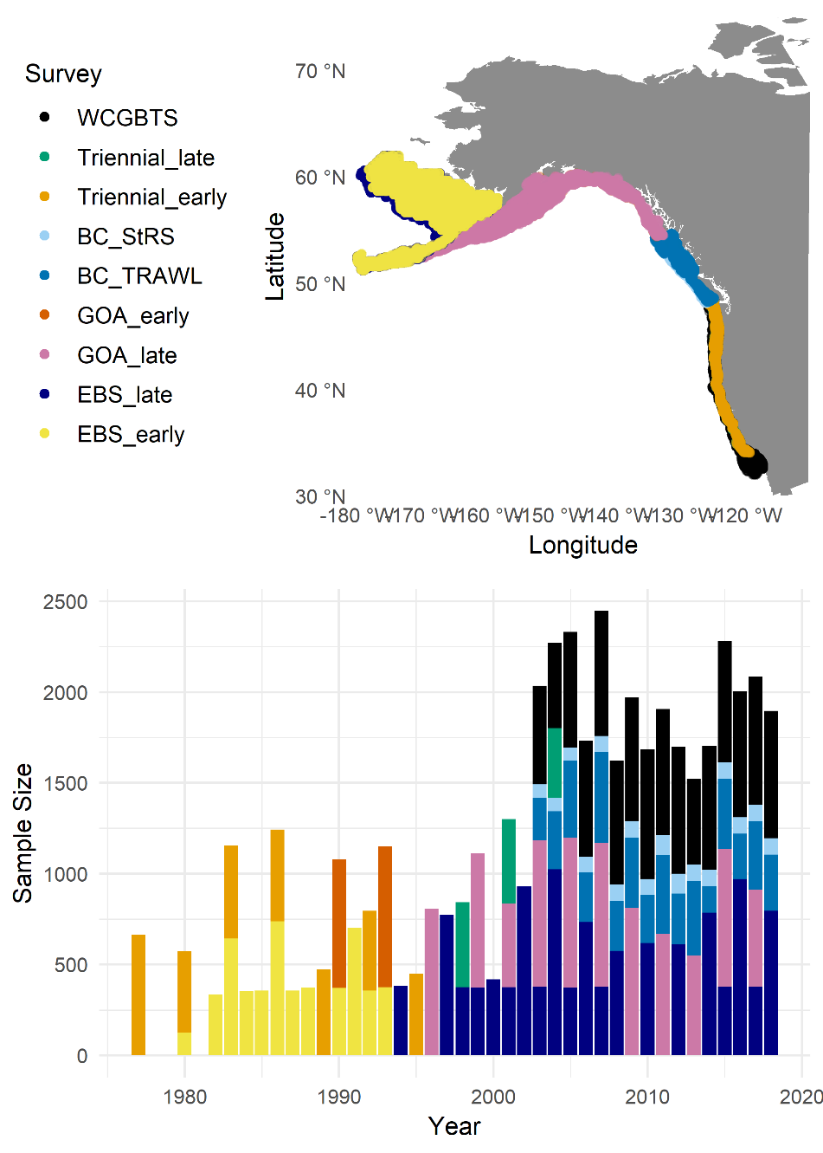

Figure . Map of sampling locations for each survey (top panel) and annual sample size for each survey (bottom panel), where color code (legend in top panel) is identical between both panels.

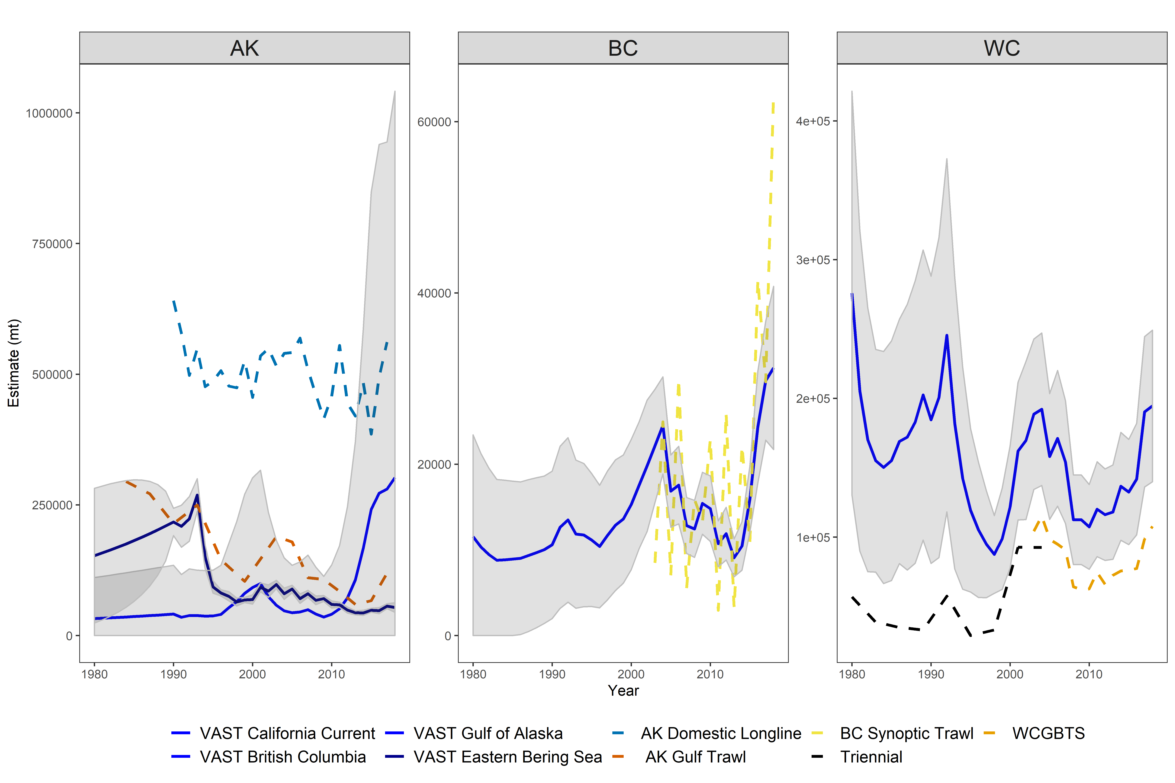

Figure . VAST model estimates (solid lines) by region (panels). Standard errors for VAST model fits are shown in grey; previous indices or data from respective regions shown in dashed lines. Only the NWCBO index (WCGBTS, light blue dashed line) has been standardized using VAST for assessment purposes.

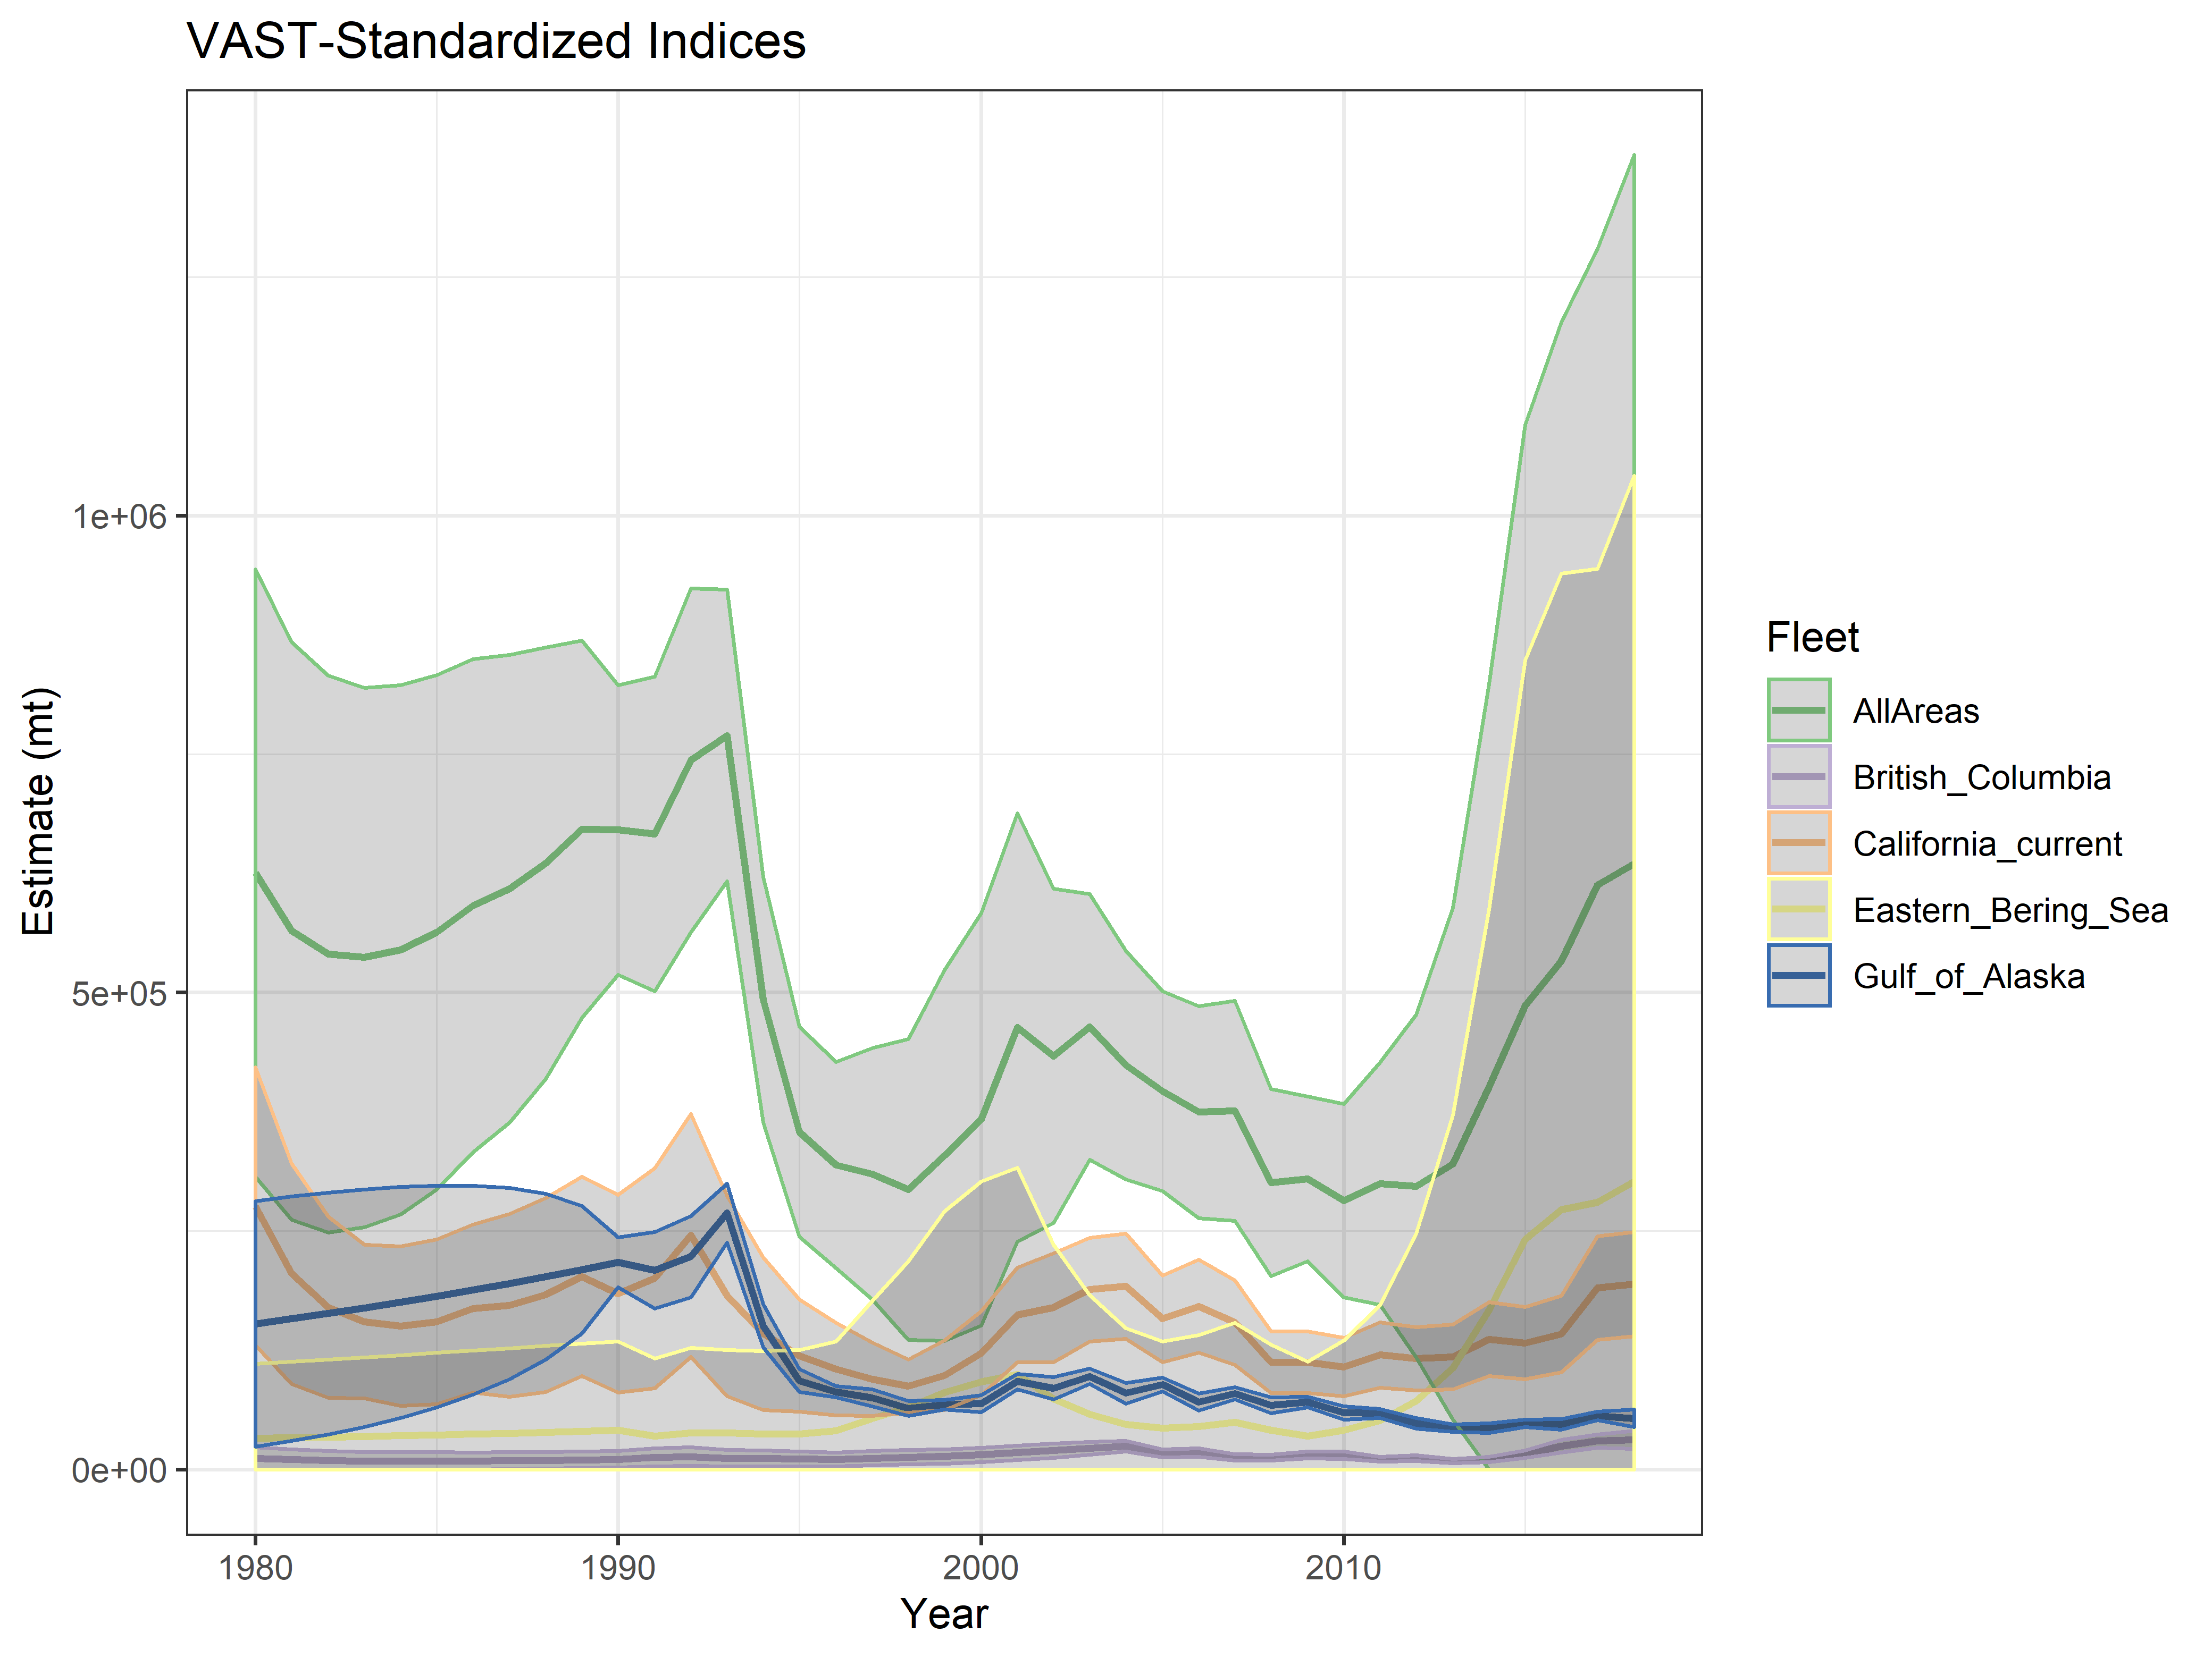

Figure . Time series of all VAST estimates, including the aggregated index (‘AllAreas’, green line).

Figure Spatial distribution of estimated relative abundance for modeled years.

# References

Goethel, D.R., Berger, A.M., 2016. Accounting for spatial complexities in the calculation of biological reference points: Effects of misdiagnosing population structure for stock status indicators. Can. J. Fish. Aquat. Sci. 74, 1878–1894. https://doi.org/10.1139/cjfas-2016-0290

Haltuch, M.A., Johnson, K.F., Tolimieri, N., Kapur, M.S., Castillo-Jordan, C., 2019. Status of the sablefish stock in US waters in 2019 7.

Hanselman, D.H., Heifetz, J., Echave, K.B., Dressel, S.C., 2014. Move it or lose it: Movement and mortality of sablefish tagged in Alaska. Can. J. Fish. Aquat. Sci. 72, 238–251. https://doi.org/10.1139/cjfas-2014-0251

Jasonowicz, A.J., Goetz, F.W., Goetz, G.W., Nichols, K.M., 2017. Love the one you’re with: Genomic evidence of panmixia in the sablefish (Anoplopoma fimbria). Can. J. Fish. Aquat. Sci. https://doi.org/10.1139/cjfas-2016-0012

Kapur, M., Haltuch, M., Connors, B., Rogers, L., Berger, A., Koontz, E., Cope, J., Echave, K., Fenske, K., Hanselman, D., Punt, A.E., 2019. Oceanographic features delineate growth zonation in Northeast Paci fi c sable fi sh. Fish. Res. https://doi.org/10.1016/j.fishres.2019.105414

Maunder, M.N., 2004. Standardizing catch and effort data : a review of recent approaches 70, 141–159. https://doi.org/10.1016/j.fishres.2004.08.002

Punt, A.E., 2019. Spatial stock assessment methods : A viewpoint on current issues and assumptions. Fish. Res. 213, 132–143. https://doi.org/10.1016/j.fishres.2019.01.014

Thorson, J.T., 2019. Guidance for decisions using the Vector Autoregressive Spatio-Temporal (VAST) package in stock, ecosystem, habitat and climate assessments. Fish. Res. 210, 143–161. https://doi.org/10.1016/j.fishres.2018.10.013

Thorson, J.T., Forrest, R.E., n.d. Calibration by proximity: The key to index-based inference about abundance and distribution for marine bioregions.