Figure X. Data input into simulations. In all plots, grey dots correspond to values used in area 1; blue dots correspond to values used in Area 2. A) Proportion of individuals at age which stay in their source area; there is no movement of age-0 recruits among areas; B) weight at age; C) maturity at age; S) fishery selectivity at age.

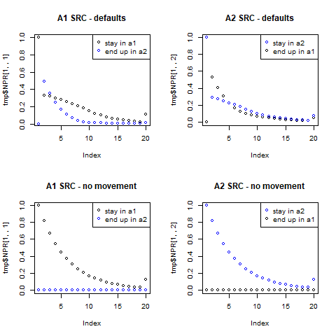

Figure X. Validating population dynamics. The top row illustrates the fate in numbers-at-age of individuals spawned in area 1 (left column) or spawned in area 2 (right column); the area they reside in at age is given by point colors (grey = in area 1, blue = in area 2). The bottom row indicates expected behavior in the absence of movement; no individuals spawned in A1 (bottom left) end up in Area 2, and vice versa.

Figure X. Total SSB (top panel) and total yield (bottom panel) given *F* levels in Area 1 and 2. Grey values indicate runs where yield, estimated recruitment, or SSB in any area were below zero.

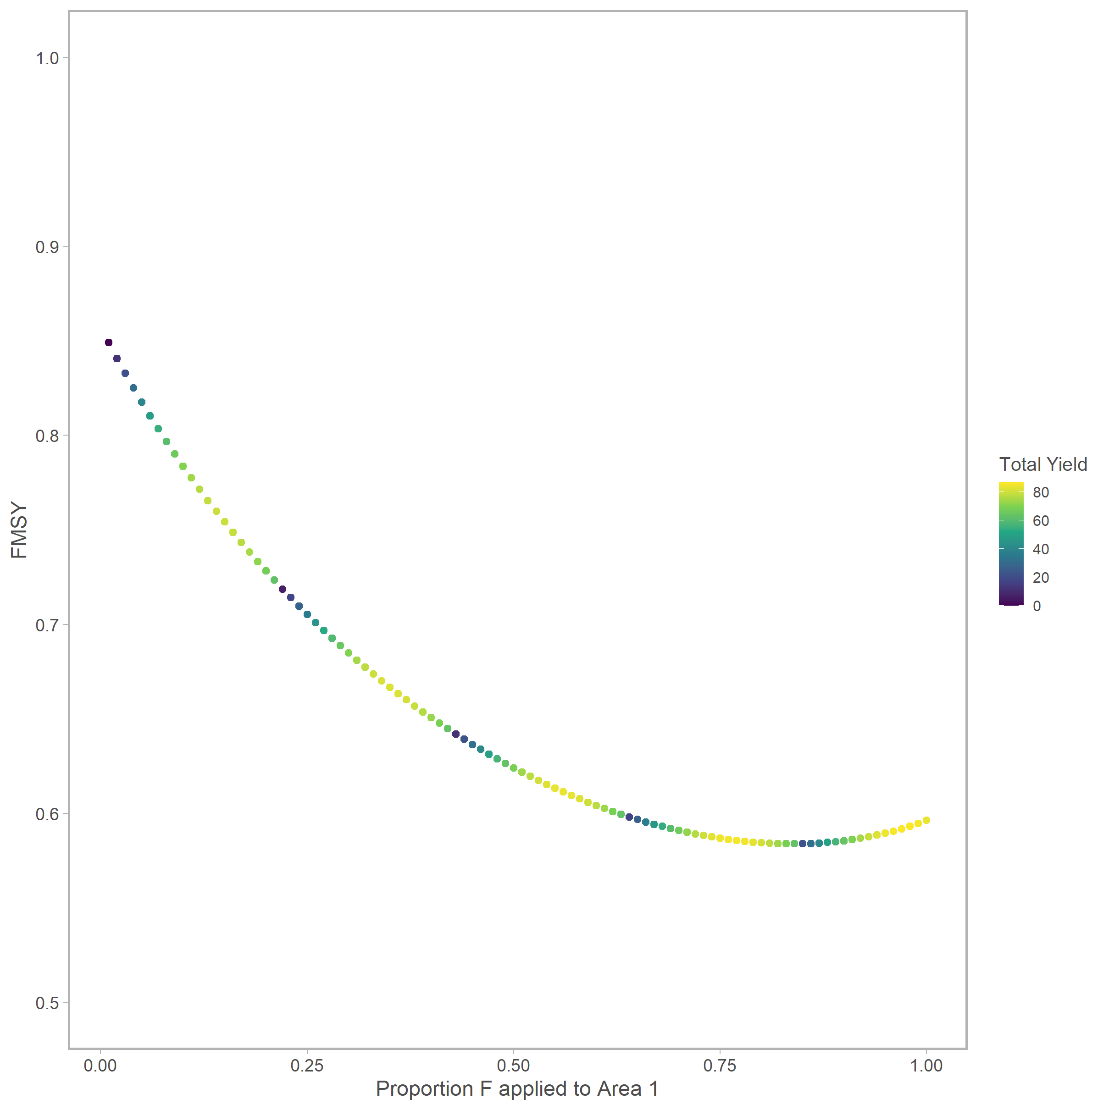

Figure X. FMSY given proportion F applied to area 1. The color of the points indicate the total yield obtained by each strategy.

**Other figures we might want**

* Comparison between global and this method
* Something regarding estimated rbar, rprop