Marco Karier

Assignment 4

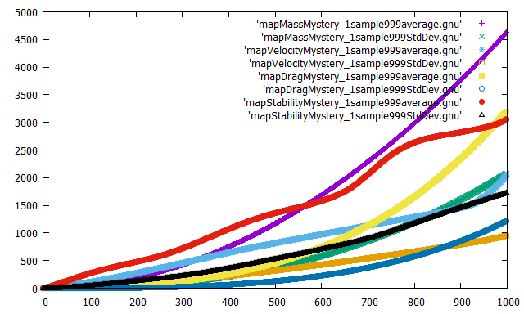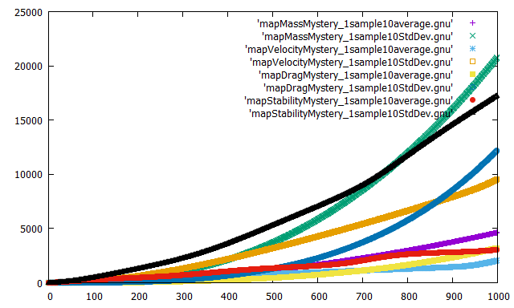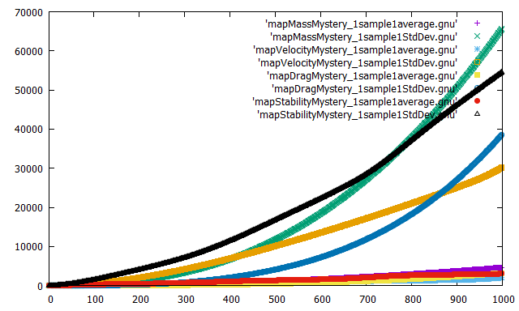***Mystery 1:***

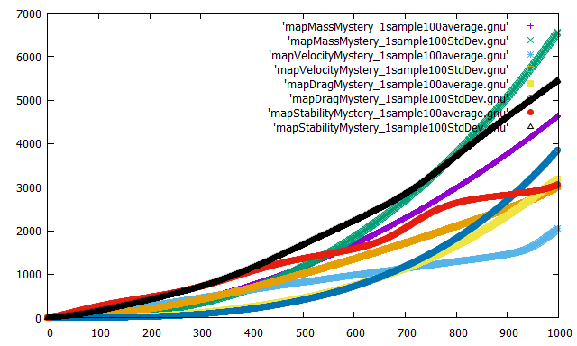

**MV:**

The mass is a straight line so there is no real sweet spot. Velocity is the blue line and is more parabolic. The only time those cross is at the start and the end so they don’t have a sweet spot.

**MD:**

The Mass and Drag also don’t have a sweet spot but the error for drag was consistently between 1 and 2 until gets to 900 yards then it exponentially gets worse.

**MS:**

stability looks more like a cosine or sine graph. It suggests to me that it might be trying to stabilize something. The further out that it goes the bigger the wave. The two graphs look close in the first 600 yards.

**VD:**

The velocity and drag are very similar. They are close in errors at the beginning until 400 yards, then they separate but looks like they emerge again a little bit before the 900 yards.

**VS:**

At the bottom of each wave of the stability graph it touches or almost touches the Velocity graph. I am not sure if that means that if the stability is really stabilizing, but it is running with out the need to stabilize then the graph would look like the velocity graph.

**DS:**

The drag and stability don’t seem to have anything in common. Drag has a low error at the beginning until 400 and is less then stability until 500 yards when they cross.

***Mystery 2:***

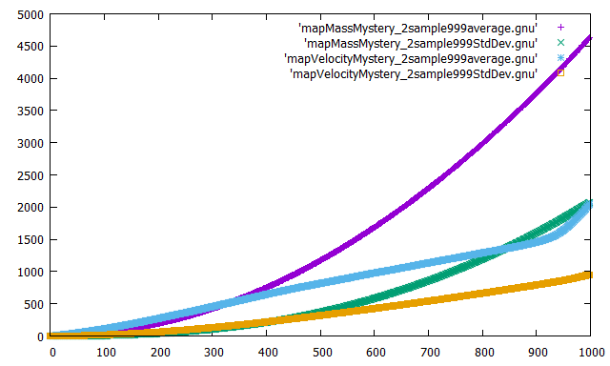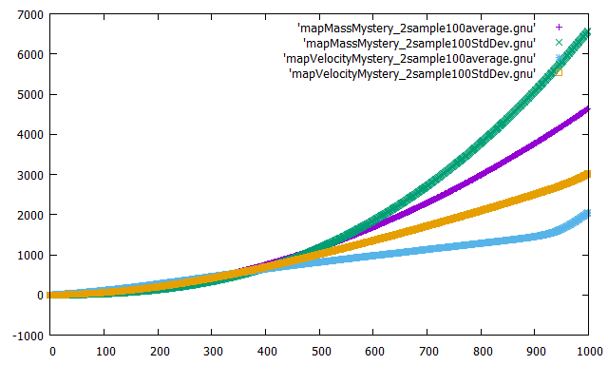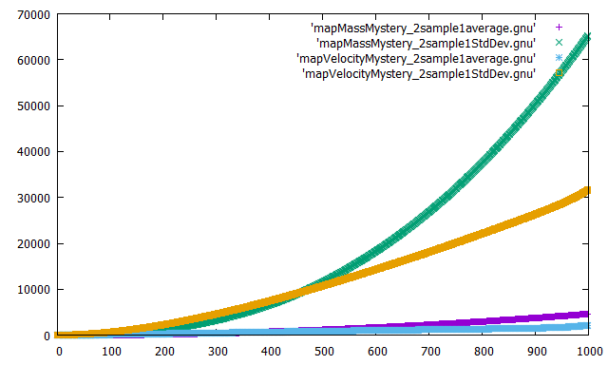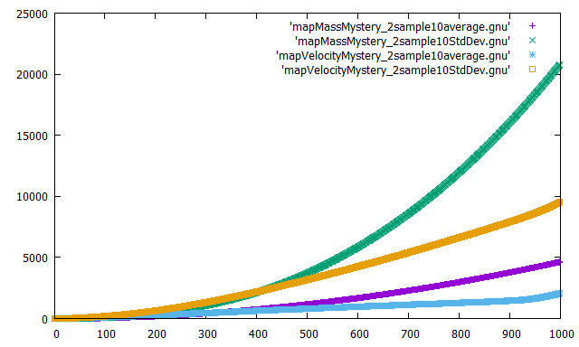

**MV:**

The mass and velocity are very like each other for about 400 yards. Although velocity stays consistent until about 900 yards. Mass looks like a thicker version of mystery 1 mass graph.

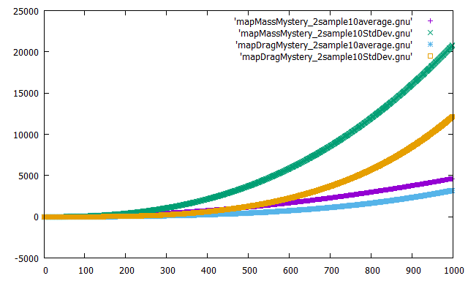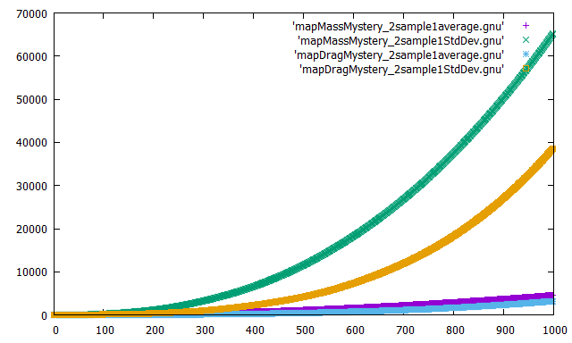

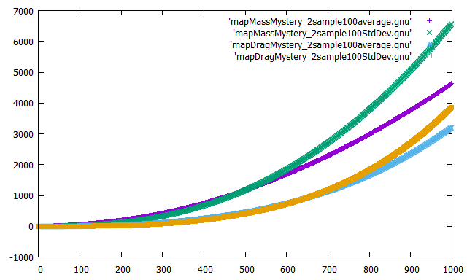

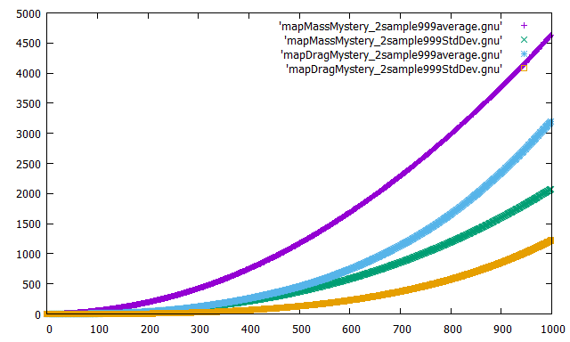

**MD:** The graph shows that Mass and Drag share almost the same curve. That suggests to me that there is something similar between the two that could be causing the same amount of errors. The only sweet spot is at the very beginning for the first 100 yards but after that it goes way out of control.

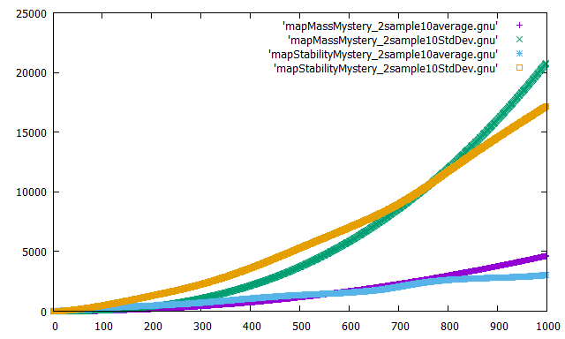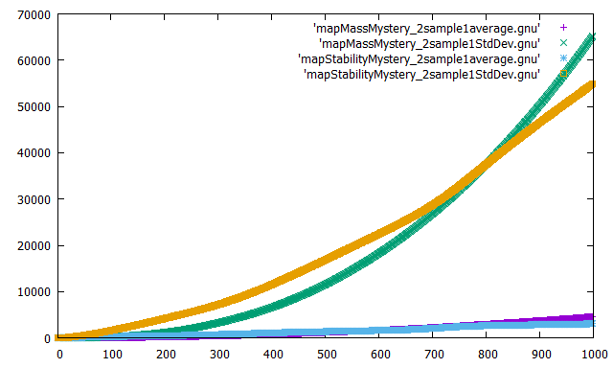

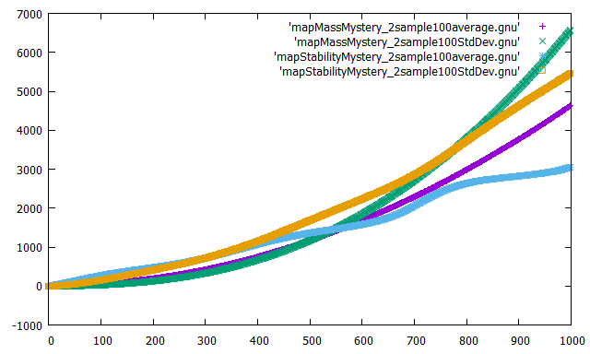

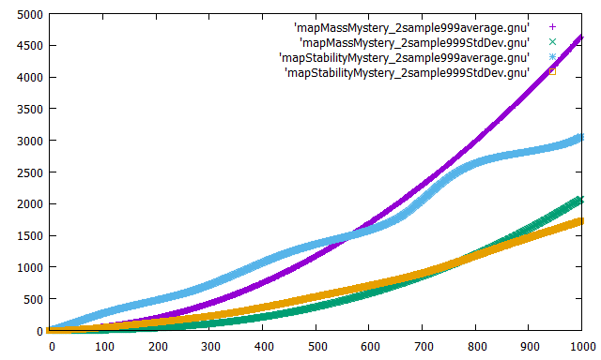

**MS:**

The Mass and Stability share a similar area for the first 400 yards. The only real sweet spot is around 200 yards then they both have had 0 error.

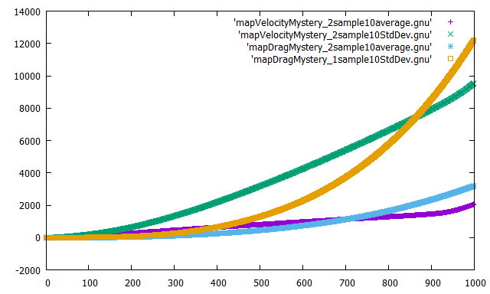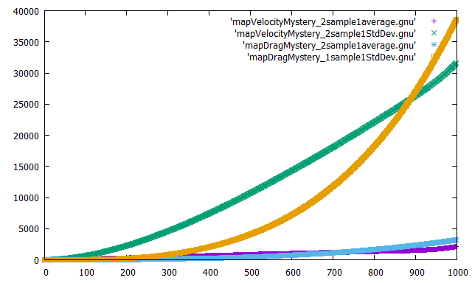

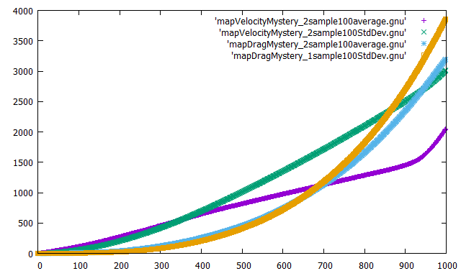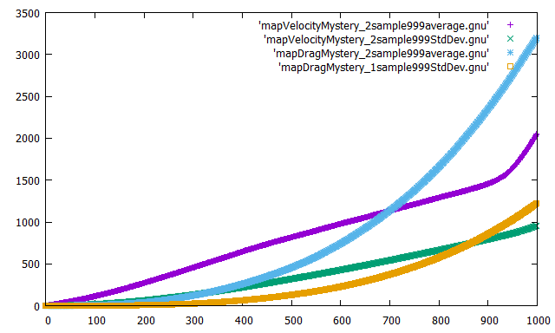

**VD:**

The Velocity was constant for a while until it reached 900 yards and then grows rapidly. While Drag grows slowly it holds the roughly the same amount of errors as Velocity. The sweet spot between the two looks like it is from 0 yards to 400 yards. Depending on where you look, the error can range from -2 to almost 4.

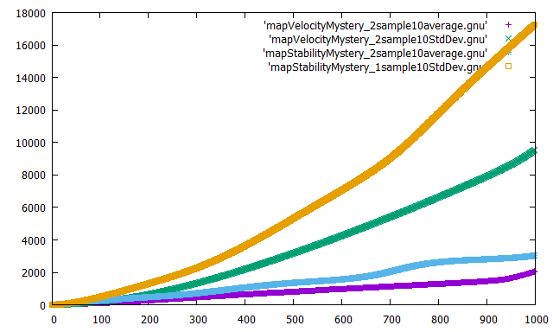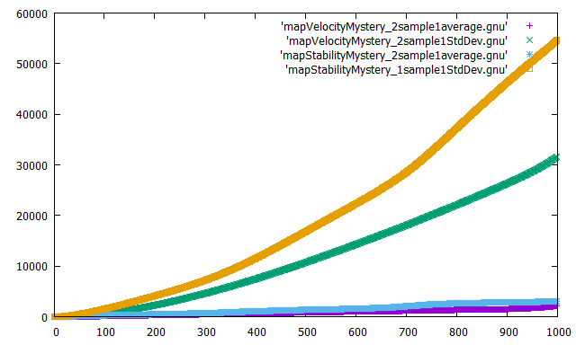

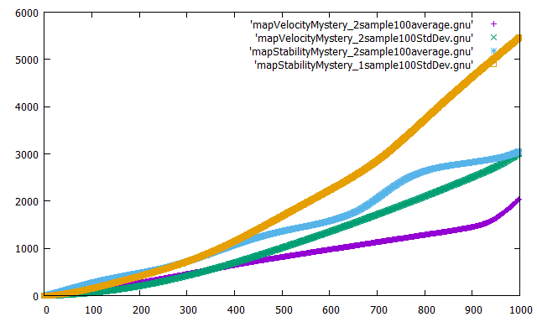

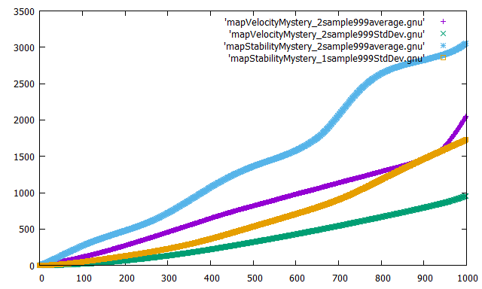

**VS:**

The graphs are very similar. They are close up until 600 yards. They have a sweet spot at 200, 550 and 900 yards. After 900 yards it looks like they both grow quickly. Although do to the pattern of Stability it could go down again.

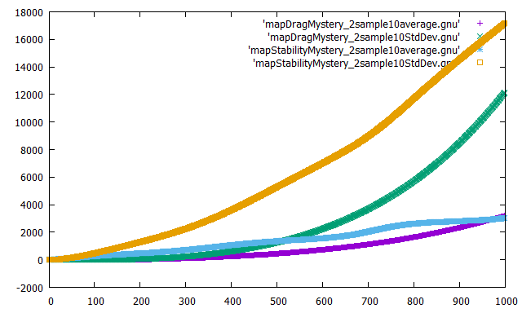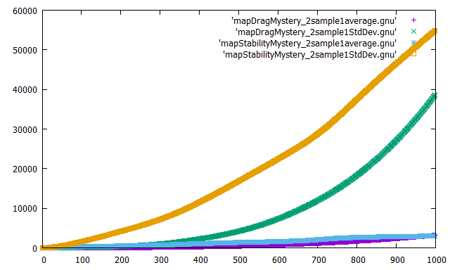

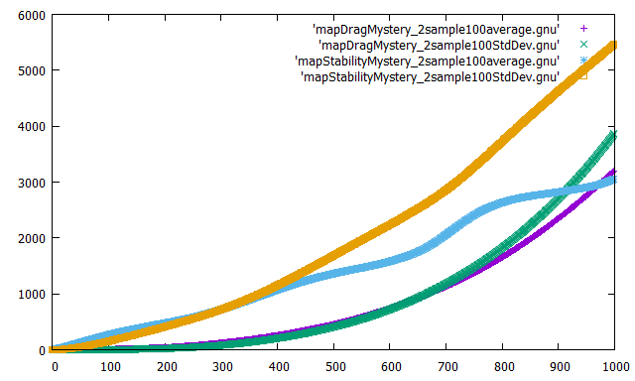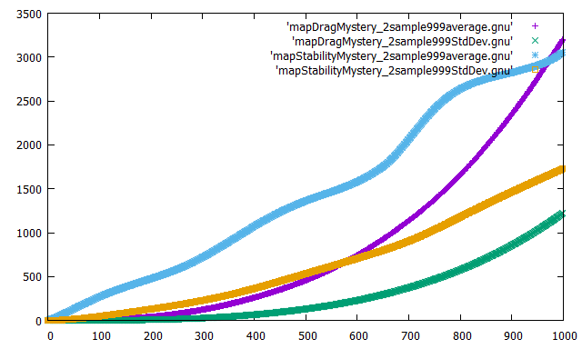

**DS:**

The graphs have a potential sweet spot until 600 yards. Other than that I don’t really notice to much about the graph. It doesn’t suggest a connection between Drag and Stability.

***Mystery 3:***

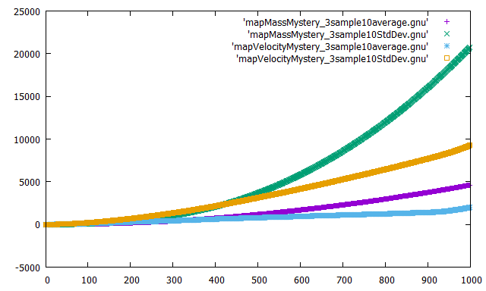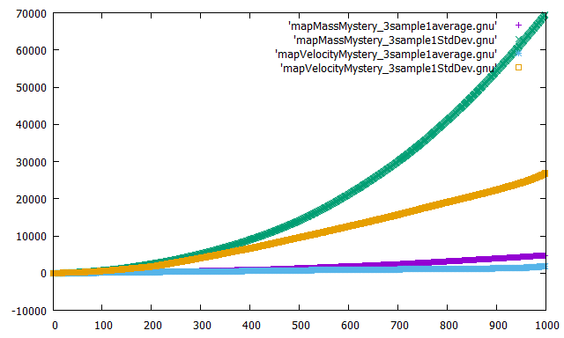

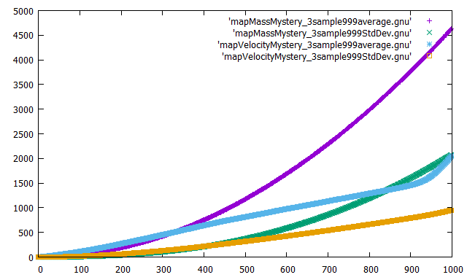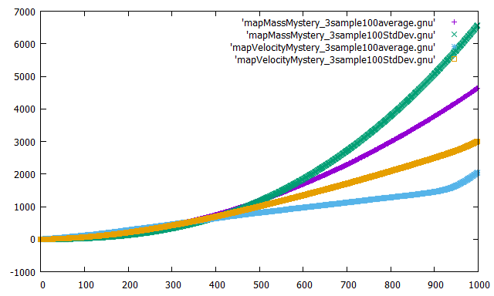

**MV:**

The Mass and volume are very similar. They have a sweet spot for about 500 yards when we have a small sample size. However, they both don’t do separate the more that the thing is called. I suspect there might be a static variable that gets worse the more that the system is called.

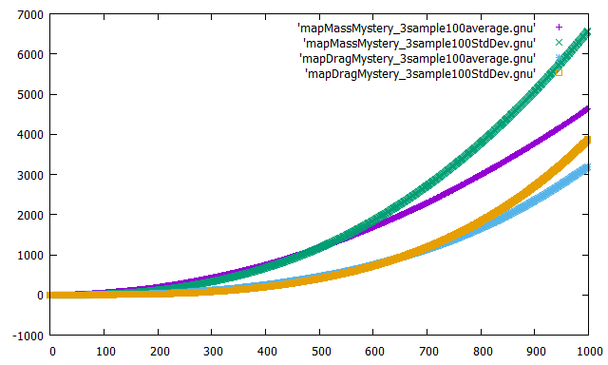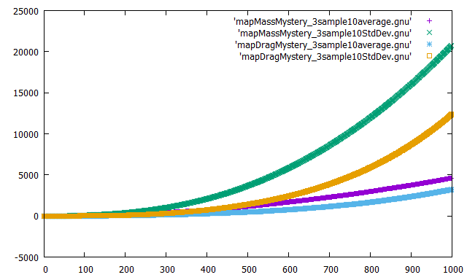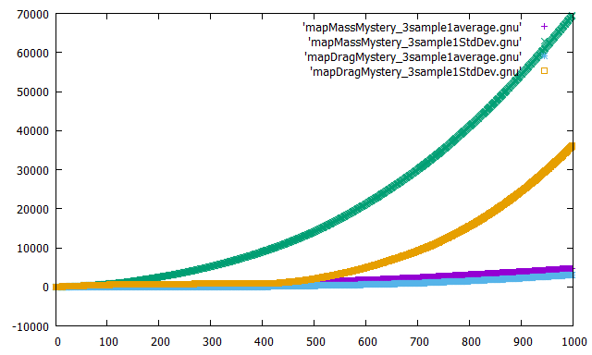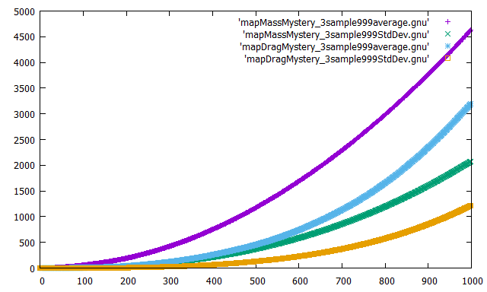

**MD:**

The data is not very consistent. I noticed that when the sample size is small again then Mass works well with no errors but gets worse the more it is called. Although Drag does that as well it is not as bad.

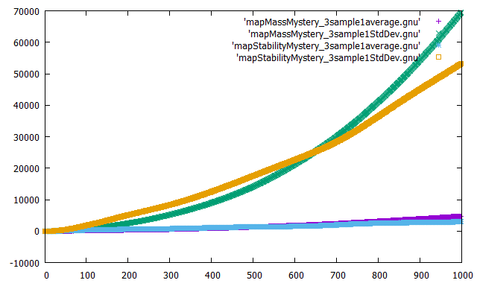 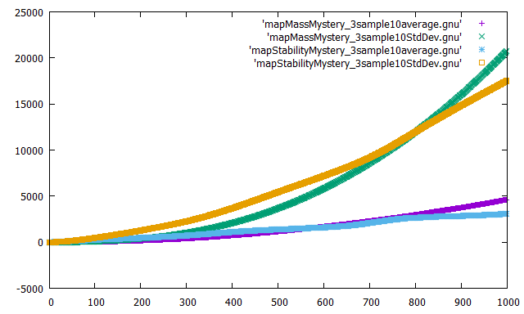

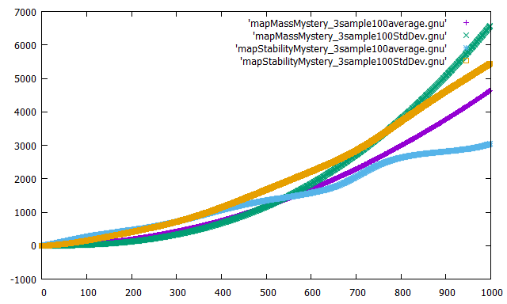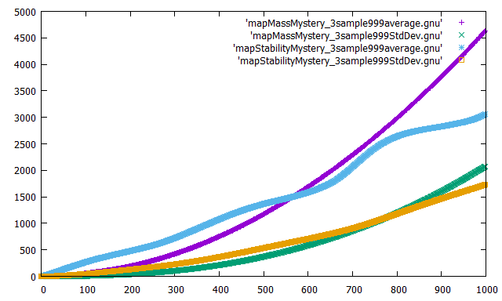

**MS:**

Stability gets worse rather quickly although it is not as bad with more runs which is the opposite of Mass. They have a potential sweet spot around 400 yards.

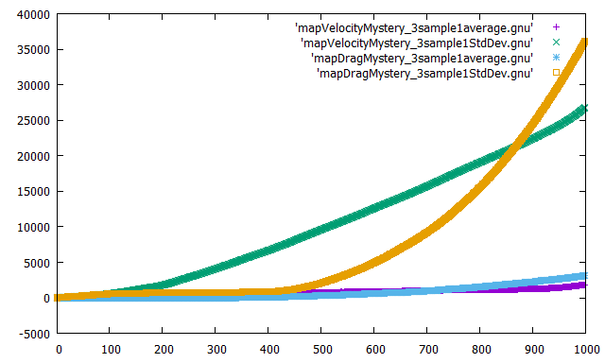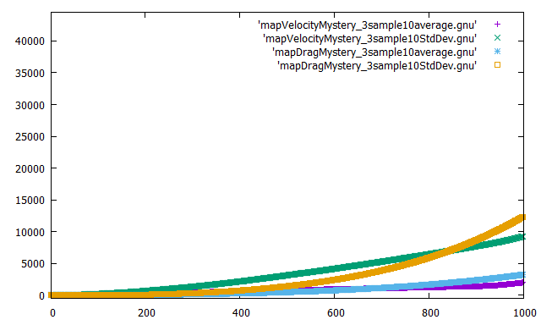

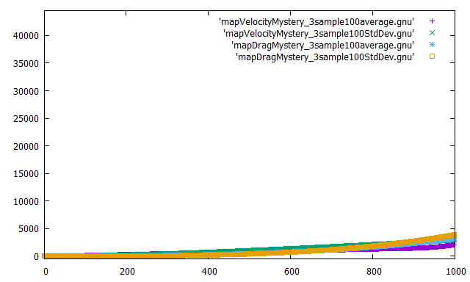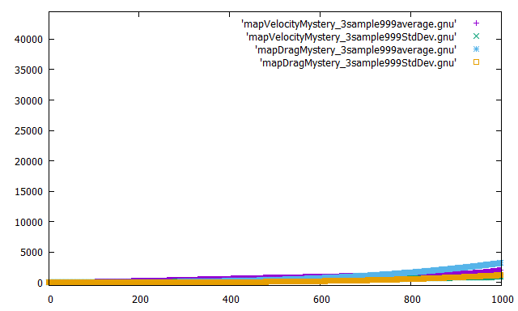

**VD:**

Velocity and drag are very similar. Have sweet spot until about 800 yards although it isn’t perfect and there is a significant error but not as bad as the others. It seems the standard deviation got better with more sample size so that suggests to me that is a very consistent method.

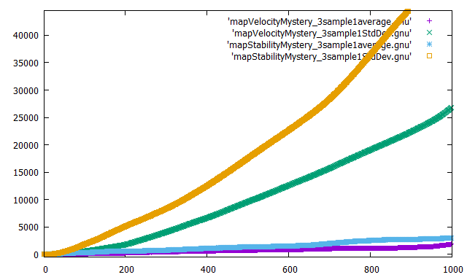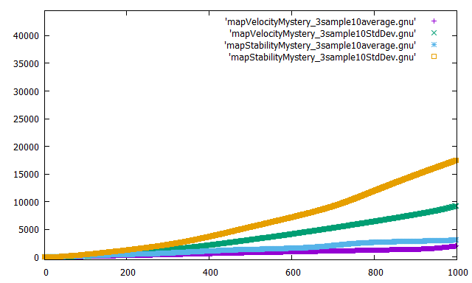

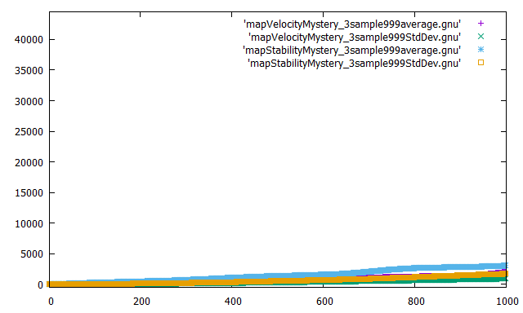

**VS:**

Velocity and Stability are very close and seemed constant. Although the sample of 100 does not seem consistent with the other samples. But the errors are very close.

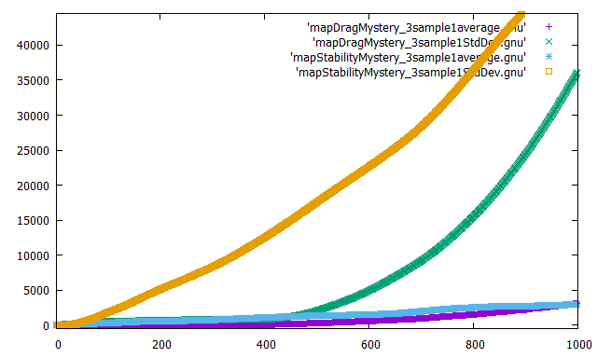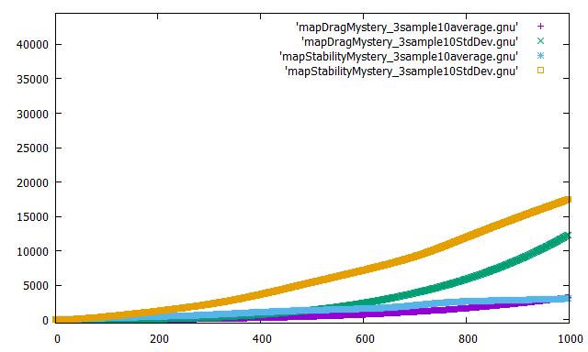

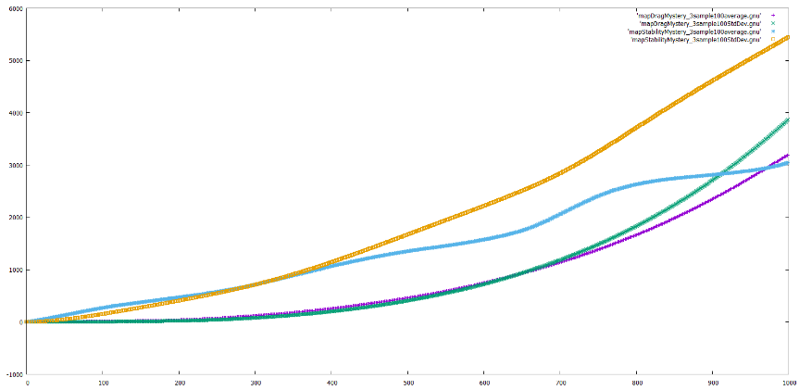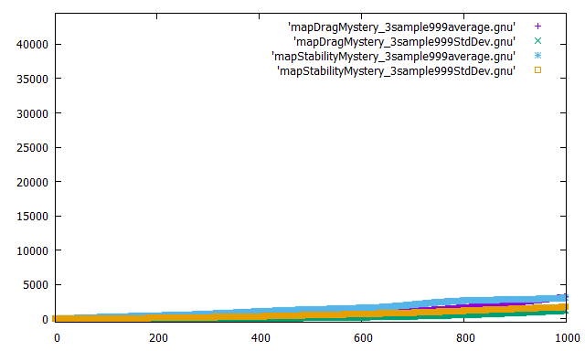

**DS:**

Drag and Stability are very similar which appears to be an improvement of the other mysterys. Although errors seem to get worse when in 100 samples but better in the other.