CSCD 439/539 GPU Computing Lab6

GPU Double Pointers and Text Processing

No Late Submissions are accepted. **Rules:** Your code must use C and CUDA C Language. If your program shows a compilation error, you get a zero for this lab assignment.

**Submission:** Wrap up all your **source files and other data files** into a single zip file. Name your zip file as *FirstInitialYourLastName*Lab6.zip. For example, if your legal name is Will Smith, you should name your zip file as wsmithlab6.zip. Please provide a simple makefile to compile your code into a target **lab6.**

**Before you leave the laboratory, please show the TA or the instructor how your program works, they will give you a score for this Lab assignment.**

**For archive purpose, please also submit your single zip file on EWU Canvas by following CSCD439-01 Course 🡪Assignments🡪Lab6🡪 Submit Assignment to upload your single zip file.**

**Problem Description:**

Based on the lecture notes and demo about double pointers on CUDA device, you are required to implement a simple word counting kernel. If the input is one line of text “good morning and I'm a good student!” ( strip the quotes ), the kernel will output an integer array,

g o o d m o r n i n g a n d I ' m a g o o d s t u d e n t !

0 0 0 0 1 0 0 0 0 0 0 0 1 0 0 0 1 0 1 0 1 0 1 0 0 0 0 1 0 0 0 0 0 0 0 1 0 0 0 0

The 1’s in the output array, specifies a **valid** delimiter that can be used separate English words. Note that if you have another input like “for you:: he ” (strip the quotes), the output should be like:

f o r y o u : : h e

0 0 0 1 0 0 0 1 0 0 0 0 1

Each thread in the grid should process only one character in the text. You have to implement the following features and answer the questions.

1, Read the provided code and comments, try to understand how all pointers to pointers are set up on cuda device. (This could be an exam question topic.)

2, Implement the empty device functions and the kernel function. After you correctly write your code, you program should output like the following.( Please do not change the main function, all has been set up.)

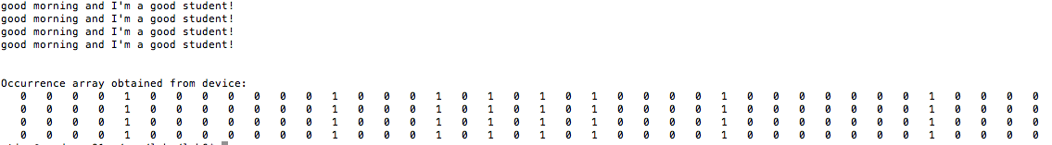

3, Describe how to set up the double pointer d_count_in on the device in the program?