Hillsborough County
Property Appraiser
Parcel layer shapefile documentation

This shapefile has been dissolved on “FOLIO” number to produce multipart polygons.
Parcels such as golf courses which consist of multiple polygons are represented as a single polygon and only one entry in the parcel.dbf. This prevents double, triple or even more counts for $ value and numeric fields when summing such values.

Document Updated on 7-25-2017

TABLE OF CONTENTS:

Disclaimer, use restrictions, errors, omissions 2
Downloading instructions, file names, currency 3
Projection 4
Data fields in the parcel.dbf 4
Condos and multi-story or multi-owner properties 6
Property Identification Number (STRAP and PIN) formats 7
Historic layer 8
Annotations (subdivisions, lot and block #) 8
Taxing District (table) 8
Other data available from this Office 9
Linking other data to the parcel shape file (via PIN) 10
(specific example on page 10 covers # of bedrooms, baths, stories
and # of units for apt buildings)
(example on page 12 covers structural elements: wall types,
roof types, flooring, plumbing, architectural style)
Data available from other Agencies 14
DOR Codes (table) 15

Data Disclaimer:

General Disclaimer:
All data is subject to change.

This data is compiled from the Mapping/GIS system and CAMA (Mass Appraisal) system. It is for assessment purposes only and is NOT A SURVEY and it is NOT A TAX ROLL. Data may be edited or omitted to produce better maps for assessment purposes. Some of the included information may have originated from other Agencies and we cannot be responsible for the accuracy or timeliness of that data. The Hillsborough County Property Appraiser shall be held harmless from any damages arising from the use of this data.

Users may redistribute this data, whether modified or not, but must delete all references to the Hillsborough County Property Appraiser's Office from the final product. Any modifications to the data by the receiving party are the sole responsibility of said party and in no way represent authorization by the Hillsborough County Property Appraiser's Office.

If more complete data is needed, please contact our customer service department for an assessment CD, available for $125. Phone 813-272-6100, email - custserv@hcpafl.org

Precise ownership, size, location cannot be determined from this data.

Data from other Agencies may be included (such as roads, site addresses, census tracts). This data is updated for our appraisal purposes only. We cannot be responsible for the accuracy or timeliness of this data. Please contact the responsible Agency to report errors or omissions.

Sales Information Disclaimer:
We receive sales data from the Clerk’s Office. Data is reviewed by our Office for accuracy before we accept it. Delays caused by title companies, the Clerk’s Office or our inability to verify sales is beyond our control. We cannot guarantee the timeliness or completeness of sales data.

The parcel.dbf contains over 480,000 records and the most recent qualified sale (free market, single parcel, non-barter sales) for a parcel that we have in our system. The allsales.dbf contains over 1.6 million records and contains all sales including unqualified (multi-parcel, barter/trade, title transfer, etc. sales). Please verify that the software you are using can import large files. Different versions of MS Excel have varied import limits. MS Excel 2010 currently imports up to 1,040,000 records and does not inform you of omitted records. We recommend using an appropriate database program to work with these files.

If you save historical copies of the data, please verify the file date to make sure you are working with the file corresponding to your timeframe of interest.

ERRORS:

For errors with spatial data (parcel size, shape and location) contact the GIS Department, Heather Lamond, 813-272-5265, lamondh@hcpafl.org or David Brzana, 813-276-8878, brzanad@hcpafl.org. Please include a folio number and a brief description of the error.

For errors with tabular data (values, classifications, legal descriptions, ownership, dates) and other information contact Customer Service, 813-272-6100.

DOWNLOADING INSTRUCTIONS:

Go to www.hcpafl.org
Click DOWNLOADS
Click GIS DATA (the blue striped area)

The following files are available for download:

FILE NAMES:

1) _Documentation.doc = this document
2) parcel_mm_dd_yyyy.zip = the parcel polygon shape file, where mm_dd_yyyy is the date of the shapefile (large file, approx. 200mb zipped; approx 535mb unzipped)
Zip also contains additional files to identify DOR and Sub-division codes.
3) historic_mm_dd_yyyy.zip = historic lot lines and some easements
4) annotations_mm_dd_yyyy.zip = annotations shape files (subs, plat book, lots, block)
5) dor code manual.pdf = in depth discussion of dor use codes, with photos, very useful
6) section_grid.zip = the section township range grid for Hillsborough County
7) water_mm_yyyy.zip = bodies of water, for cartographic purposes only
8) fema_yyyy.zip = FEMA flood map
9) roads_mm_yyyy.zip = road centerlines
10) allsales_mm_dd_yyyy.zip = all available sales
11) PARCEL_SPREADSHEET.xls = MS Excel file

“Double click” and “Save” a file or “Right click” a file and “Save As”

CURRENCY:

The shape files in this download are updated weekly, on Sunday morning.

PROJECTION:

The GIS data is held in Stateplane Coordinate System, NAD83 in feet and in its original status double precision. Shape automatically reverts to single precision. Zone 3626, Florida West, spheroid GRS1980.

From ArcMap 9.3:
Data Type: Shapefile Feature Class
Shapefile: parcel.shp
Geometry Type: Polygon

Projected Coordinate System: NAD_1983_StatePlane_Florida_West_FIPS_0902_Feet
Projection: Transverse_Mercator
False_Easting: 656166.66666667
False_Northing: 0.00000000
Central_Meridian: -82.00000000
Scale_Factor: 0.99994118
Latitude_Of_Origin: 24.33333333
Linear Unit: Foot_US

Geographic Coordinate System: GCS_North_American_1983
Datum: D_North_American_1983
Prime Meridian: Greenwich
Angular Unit: Degree

DATA FIELDS:
The parcel shapefile contains polygons. A “shapefile” is a series of files that can be used to draw geographic data in a software equipped to handle such files. One of the file components, “parcel_mm_dd_yyyy.dbf”, is a table of values.

The following information is available in the .dbf table for every current property in Hillsborough County:

TYPE Description of parcel, especially if parcel has no folio number
FOLIO parcel folio number (text field, full 10 digit folio number; no decimals or dashes)
ACREAGE area (calculated from the polygon, not based on the deed)
PIN property identification number (see below for description)
DOR_C dor property use code (see parcel_dor_names.dbf for descriptions); the primary use of the parcel
OWNER owner name
ADDR_1 owner mail address 1
ADDR_2 owner mail address 2
CITY owner mail city
STATE owner mail state
ZIP owner mail zip
COUNTRY owner mail country
SUB 3 character subdivision code (see parcel_sub_names.dbf for descriptions)
SITE_ADDR parcel site address (if available)(for multi-building parcels only 1 site address is
stored)(You may see some site addresses as “0 Kennedy Blvd”. Please ignore these if
you are using them for a mailing. We try to give you a complete site address but
sometimes we can’t determine the house number. You may also see site addresses for
vacant parcels (dor code 1000 for example). These may be incorrect or we may not
have updated our records. Please consider DOR codes if you are mailing to site
address.)
SITE_CITY parcel site city (Tampa, Plant City, Temple Terrace or Unincorporated)
SITE_ZIP parcel site zip
LEGAL1 legal description line 1 (50 characters max)
LEGAL2 legal description line 2 (50 characters max)
LEGAL3 legal description line 3 (50 characters max)
LEGAL4 legal description line 4 (50 characters max)
NBHC Neighborhood code
TAXDIST Millage/tax district (see below)
JUST market/just value (for non-greenbelted parcels, this is also the assessed value)
LAND value of land
BLDG value of all buildings on parcel
EXF value of all extra features on parcel (fences, dock, utility shed, pool)
ACT actual year built (if multiple buildings, building #1)
EFF year used to calculate depreciation
HEAT_AR heated sq feet (living area) of all buildings on a parcel
ASD_VAL assessed value (value of land & improvements, less any Save Our Homes 3% cap
or non-homestead 10% cap) (Note: Different taxing authorities use different
methods to calculate assessed value. There is no single value.)
TAX_VAL taxable value (asd_val less any exemptions, such as homestead, widow, disability)
This value is not applicable to school taxes as it includes the reduction for the additional $25,000 homestead exemption.

SD1 Special tax district
SD2 Special tax district
TIF Tax increment fund
MUNI A=Tampa, U=Unincorporated, T=Temple Terrace, P=Plant City
S_DATE sale date (qualified [free market] sales only since 1906)
VI vacant or improved at time of sale
AMT sale amount (qualified sales only)
STRAP unformatted PIN number, use this to link the shapefile to our
other data files on the MAF cd rom (see page 10)
DBA Doing Business As; business name
tBEDS total bedrooms for all buildings on parcel
tBATHS total bathrooms for all buildings on parcel
tUNITS total living units for all buildings on parcel
tSTORIES sum of all stories for all buildings on parcel (total number of floors for all
buildings)
tBLDGS total number of buildings on parcel
BASE year homestead approved (for residential) or year cap applied (non-residential)
“0” = no homestead or cap
Edit_dt date mapping polygon was last updated

ALSO included in the parcel zip:
Parcel_dor_names.dbf (FL DOR [Dept. of Revenue] property use codes and descriptions)
Parcel_sub_names.dbf (subdivision codes and names)

Multistory condo units are included as small 1 foot square polygons. See discussion below. Parcels such as water, r/w, closed r/w, landscape tracts, parks, water may not always be included.

The files contain only polygons, no arc attributes. These files should only be used for parcel analytical purposes.

NOTE: Sales are posted after we receive and review them from the Clerk’s Office. More sales data can be found at the HCPA FTP site in file allsales_MM_DD_YYYY.zip”. You may also sign up for custom emails from the Clerk’s Office if you want the data faster or have custom requirements.

If more complete data is needed, please contact Marilyn Martinez for an assessment CD, available for $125. Phone 813-276-8810, email - martinezm@hcpafl.org. (See page 10 for an example of one of the MAF tables and how to use it.)

CONDOS:

Multi-story and other multi-owner/multi-unit properties (co-ops) where we have no interior plats:

We draw a small 1 foot square polygon on the parcel layer for each unit/owner, including any common areas. The label point for these polygons contains FOLIO (the 10 digit folio number for the unit/owner, ex. 1174807202)

For example: Atrium on the Bayshore

We create a ‘header’ record for the condominium in our CAMA system (dor code = ‘HH’). This record serves as a placeholder only. We then create records for each unit using dor code = 0400 (condos). The folio number usually increments by .0002 for each unit.

Folio dor code sub code owner
1174807200 HH 3P3 XXXX Atrium on the bayshore a condominium
1174807202 0400 3P3 Smith, Joe
1174807204 0400 3P3 Smyth, Jane
.
.
1174807452 0400 3P3 Smythe, Jane
1174810000 HH 3P4 XXXX Bay Villa (the next condominium in folio # order)

We draw a polygon for the header record in the parcel layer (folio 1174807200). Then we add small polygons for each unit (folios 1174800002 – 1174807542). The small polygons are randomly located within the header polygon (unless space limitations require they be located nearby).

Below:
Polygon 1174807200 represents the legal boundary for Atrium on the Bayshore, a condominium.
The zoom view shows the 1 foot square polygons for the individual units, each having a unique folio number in the FOLIO field.
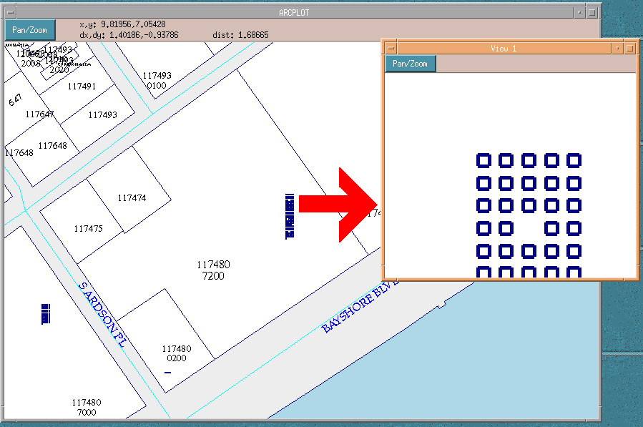

STRAP AND PIN NUMBER STRUCTURE:

Use the STRAP number to join the shapefile to other data files available from this Office.

Example STRAP:

2819163A3000034000040A

28 19 16 3A3 000034 000040 A
(Township) (Range) (Section) (Land Type-ID) (Block#) (Lot#) (Municipality)

The PIN number is formatted from the STRAP field for legibility. This is the parcel identifier that you will see on the website, TRIM notices, etc.

Example PIN:

A-16-28-19-3A3-000034-00004.0

A 16 28 19 3A3 000034 00004.0
(Municipality) (Section) (Township) (Range) (Land Type-ID) (Block# ) (Lot#)

The MUNICIPALITY CODE indicates whether the property is located in a city or unincorporated county. The code for the City of Tampa is "A", for the City of Temple Terrace "T" and for the City of Plant City "P". All unincorporated county is coded with "U".

The SECTION-TOWNSHIP-RANGE

The Land Type-ID is to further identify the type of land. All platted Subdivisions and Condominiums have been assigned an ID number. This number may be a combination of numbers and letters, such as "3A3". Not all property in the county is platted. For all unplatted, metes and bounds described lands a Land Type-ID of "ZZZ" has been assigned. This way, one look at the PIN number can tell you whether it is platted or unplatted land.

The BLOCK# is 6 digits and will hold the Block Number in platted Subdivisions or Building Number in a Condominium. For unplatted land having a Land Type-ID of "ZZZ" the BLOCK# will carry a uniquely assigned number.

The LOT# is 6 digits and will hold the Lot Numbers in Platted Subdivisions or Unit Numbers in a Condominium. For all unplatted land having a Land Type-ID of "ZZZ" the LOT# will carry a uniquely assigned number.

HISTORIC LAYER:

The historic shape file contains arc features representing historic lot lines, easements such as drainage, utility, ingress/egress, r/w and ownership hooks. We do not map all easements, generally only those over 15 feet. The "TYPE" field contains the following codes:

CE conservation easement
CS conservation setback
DE drainage easement
HIST historic lot line
HOOK ownership hook
IE ingress easement
UE utility easement
E non-specific, usually drainage or closed alley
GOV government lot line
S seawall
HRL property located under a raised highway
LRR light rail easement

ANNOTATION (Subdivisions, Plat Book, Lot #, Block #):

Sub_anno.shp subdivision names
Plb_anno.shp plat book and page
Block_anno.shp block numbers
Lot_anno.shp lot numbers

The actual information is stored in the TEXTSTRING field in each .dbf
In ArcMap:
For lot and block use horizontal placement
For sub and plb use parallel placement
For all annotations, place overlapping labels

TAX DISTRICTS:

PC – Plant City
TA – Tampa
TT – Temple Terrace
U – Unincorporated
(Tax districts are based on City boundaries.)

Other taxing districts such as CDD, TIF, Lighting Districts can be found in the special_districts_<date>.zip file.
OTHER DATA AVAILABLE FROM THIS OFFICE:

Please contact the Marilyn Martinez, 813-276-8810 for prices and availability.

Mass Appraisal Files (MAF) CD-rom (weekly)
The files on this CD are ASCII text dumps of select tables in the CAMA [Mass Appraisal system} database. Some of the tables contain over 450,000 records and require database software to view. Older versions of Excel won’t work. (For advanced users, see the discussion beginning on page 10 in this document for a sample of how to link this data to the shape file.) Different MAF files contain information such as full sales data, extra features (pools, patios), complete legal descriptions, land lines and values, building structure information (walls, roof), etc. Please call for documentation.

Certified Roll (October)
Tangible Roll (October)

Custom reports and data sets are available. Please call for prices, Mrilyn Martinez, 813-276-8810, martinezm@hcpafl.org

PARCEL LAYER ARCHIVES:

Please contact the GIS Department:
Heather Lamond, 813-272-5265, lamondh@hcpafl.org or David Brzana, 813-276-8878, brzanad@hcpafl.org.
We can upload these files to your ftp site at no charge,
Or
Send a blank DVD disk and self-addressed, postage paid return envelope
Or
Send a $5 check, payable to “Hillsborough County Property Appraiser’s Office”
To:
David Brzana
Hillsborough County Property Appraisers Office
16th Floor
601 E Kennedy Blvd
Tampa FL 33602

The October shape file most closely matches the Extended Tax Roll.
2016 October
2015 October
2014 October
2013 October
2012 October
2011 October
2010 October
2009 October
2008 October
2007 October
2006 October
2004 January

Older shape files have fewer fields in the .dbf.

LINKING MAF FILES TO THE SHAPE FILE:

Example 1:

These are ArcMap 9.3 instructions for relating .unl files to the parcel shape file.
In this example, I use the bld_ut_se.unl table which lists the number of bedrooms, bathrooms, stories, and for apartments the number of units.

1. download the monthly parcel shape file
2. unzip the .unl file and the corresponding .doc from the MAF CD
3. change the .unl to .txt
4. Start MS Access. FILE, NEW, BLANK DATABASE.
Design a new empty table based on the .txt file.
For this example: (using the bld_ut_se.unl table)

Field name Type Length Indexed
Strap text 50 yes (duplicates ok)
Bld_num number auto yes (duplicates ok)
Ln_num number auto yes (duplicates ok)
Tp text 50 no
Uts number auto no
Pts number auto no

5. Save the empty table as Table1. Answer NO to creating a primary key.
6. FILE, GET EXTERNAL DATA, IMPORT
Choose the bld_ut_se.txt file, IMPORT.
7. Choose DELIMITED, NEXT.
8. Choose OTHER, and enter the pipe character (shift \), click NEXT
9. Choose IN AN EXISTING TABLE: TABLE1
10. NEXT, FINISH

Below:
The bld_ut_se.txt file after download and unzip.

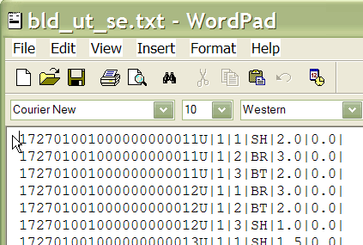
Below:
The bld_ut_se.txt file after importing into the Access table
The column names and types match the names in the bld_ut_se.doc
The “strap” field is used to link to the shapefile STRAP field.
Make sure the “strap” field is indexed!

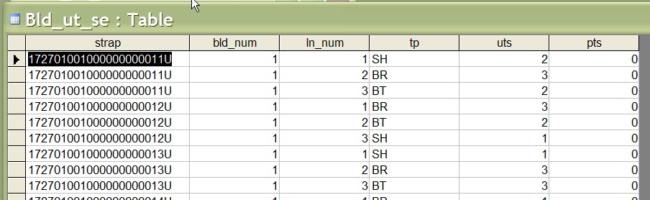

The bld_ut_se.unl file contains 1.3 million records. There may be many records in the .unl file for each record in the parcel shape file.

11. Export Table1 to bld_ut_se.dbf file (Dbase file version III).
The .dbf file will work much faster!
12. Relate the .dbf to the parcel layer using the STRAP field in the shapefile and the
STRAP field in the .dfb as the relate fields.

For this particular example, the bld_ut_se table contains the number of bedrooms, bathrooms, stories, wall height and for apartment buildings, the number of units.

In the above image, STRAP 17270100100000000011U has 1 building (the bld_num column = 1).
It has 3 entries for this building (ln_num column = 1-3).
For ln_num = 1: tp = SH and uts = 2 (a 2 story building)
For ln_num = 2: tp = BR and uts = 3 (3 bedrooms)
For ln_num = 3: tp = BT and uts = 2 (2 baths)

The actual list of tp codes can be found in the lu_strct_els.unl table.

Example 2:

Another popular question is for the structural element information (exterior wall type, roof type, floor covering, architectural style, quality, etc.)

Use the bld_cd_se.unl table and the bld_cd_se.doc description.

Here is the .unl file:

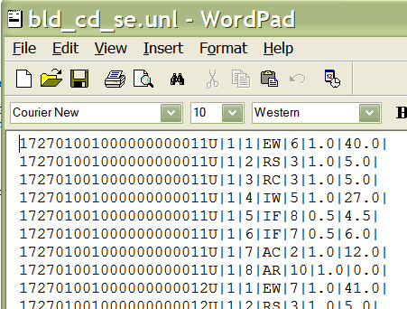

Strap(PIN) # 17270100010000000011U has 1 building (the second column = 1)
We have information about 8 different elements for this building (the third column = 1-8)
The element code is in columns 4 & 5.

So the first line indicates EW|6.
You can find this code in the lu_strct_els.unl file.
EW|6 = Exterior Wall frame stucco.

The second line indicates RS|3 = Roof structure gable.
And so on to line #8:
AR|10 = Architectural style contemporary multi-story

DOR (Florida Department of Revenue) USE CODES:

See list at end of this document.

This is the coded value for a property’s use (single family residential, townhouse, commercial, etc.). See Parcel_dor_names.dbf in the parcel_MM_DD_YYYY.zip for a complete list of current dor codes and short descriptions.

Download the DOR Code Manual.pdf from our ftp site for a more in-depth description of the codes. The pdf is located in the same directory as this documentation file.

(Use codes are based on zoning or “best and highest use” for the parcel)

Note:
(Vacant parcels, see 0000 0006 0040 1000 1005 10CO 4000 5000-6999 8200 9900)
(HH = Header code for sub or condo, NN = note, an historic reference to a parcel which no longer exists)

See list at end of this document.

SUB-DIVISION CODES:

See Parcel_sub_names.dbf in the parcel_MM_DD_YYYY.zip for a complete list of current sub codes and sub-division names.

DATA available from other agencies:

AERIALS
Hillsborough County Real Estate Dept: 272-5641
21st floor County Center, 601 E Kennedy Blvd.
2000 2002 2004 2006 2008 6” resolution full color ($20 per section?)
also has (1938, 66, 72, 79, 85, 88, 91, 94, 97)

Possibly USF Library 974-2721

Possibly USDA/Soil Conservation
Plant City 813-759-6450

Southwest Florida Water Management District
http://www.swfwmd.state.fl.us/data/gis/

ZONING
Plant City – Cathy Welsh, Plan Comm, cataniac@plancom.org
Temple Terrace - Gitfah Niles 989-7032 gniles@templeterrace.com
Tampa- Kerry Wright, 274-7307 kerry.wright@ci.tampa.fl.us
Hillsborough County – download from ftp.hillsboroughcounty.org/gis/pub

STREETS
City Tampa Streets
download street cover for entire county at:
http://www.tampagov.net/dept_geographic_information_systems/information_resources/Data_Downloads_and_Metadata/index.asp

Kerry Wright 274-7307
200 W Tyler, 4th Floor
Tampa FL 33602

County Streets
Paul Kranz, 911 Administration, 744-5911

DOR CODES LIST
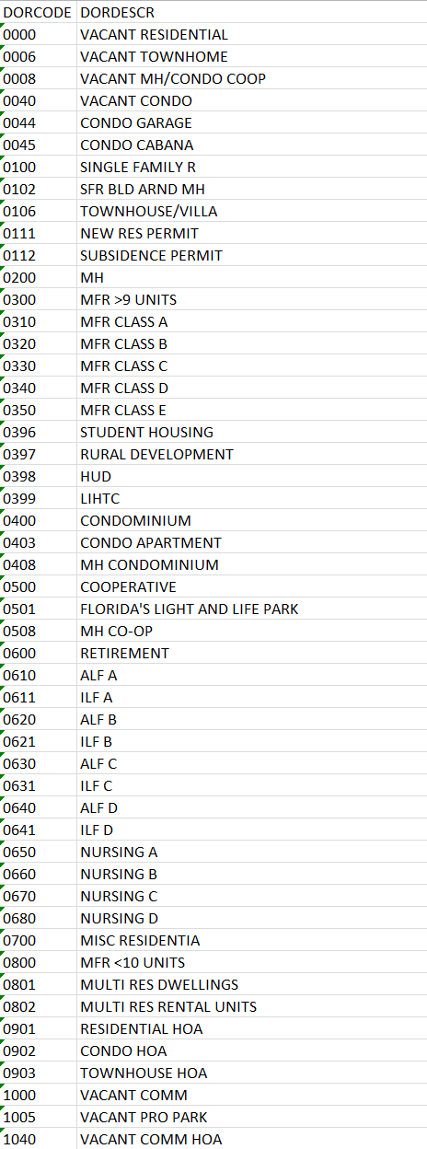
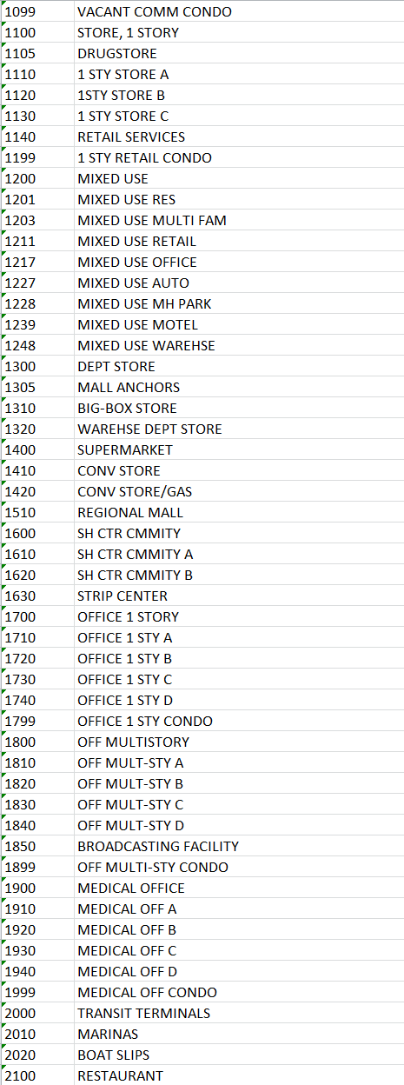
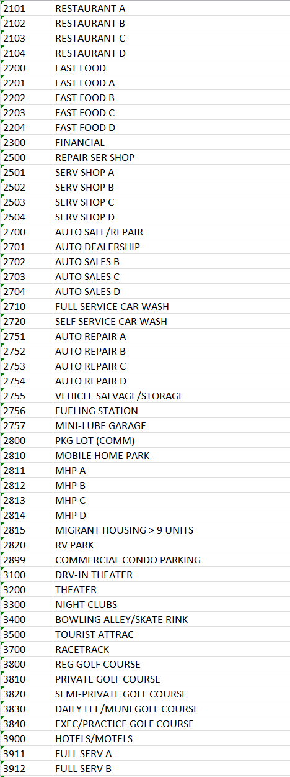
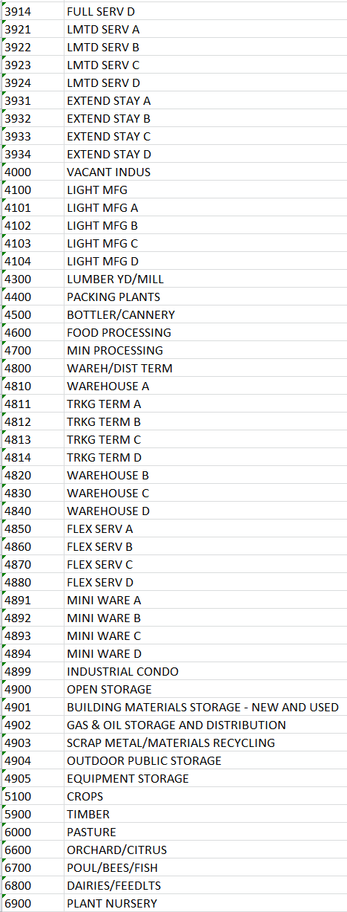
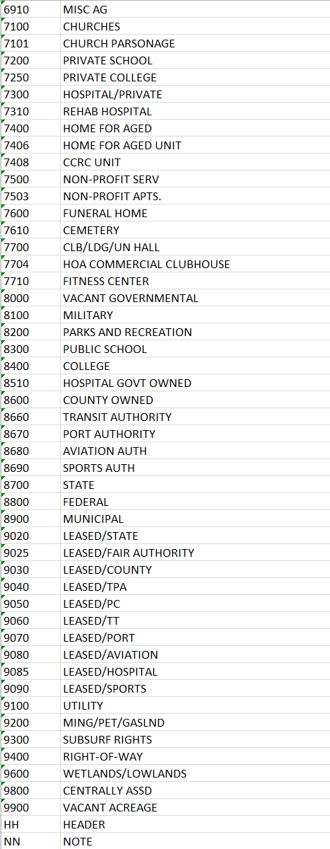
More descriptive text and photo examples can be found in the DOR_CODE_MANUAL.docx

