1. User Interface for Image Verification Web Application

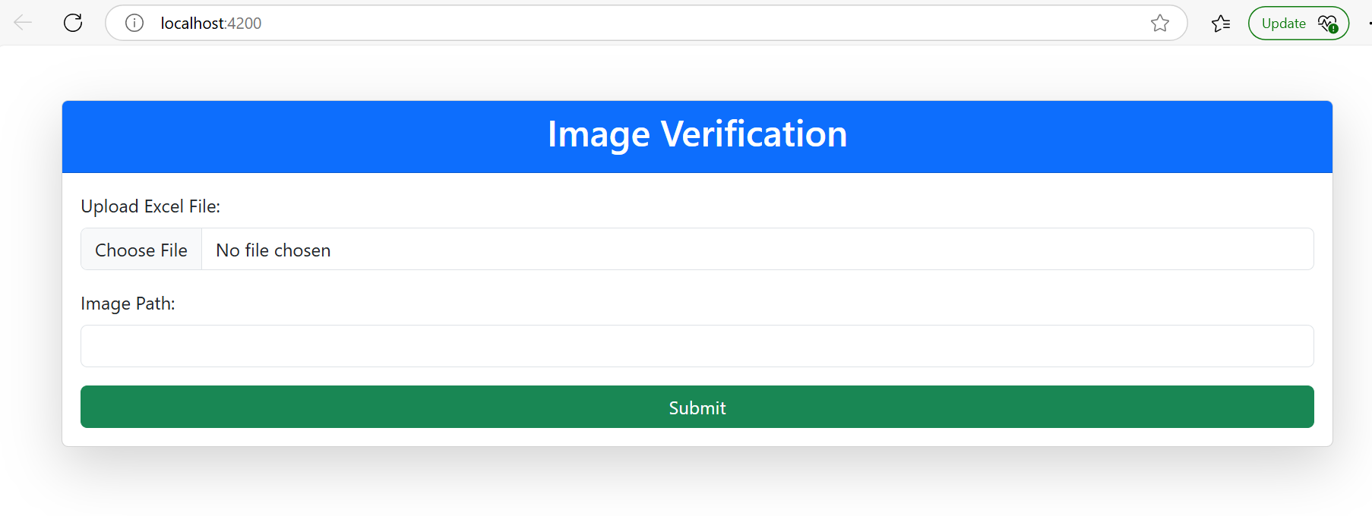

2. Content inside the excel file (Land’s of users)

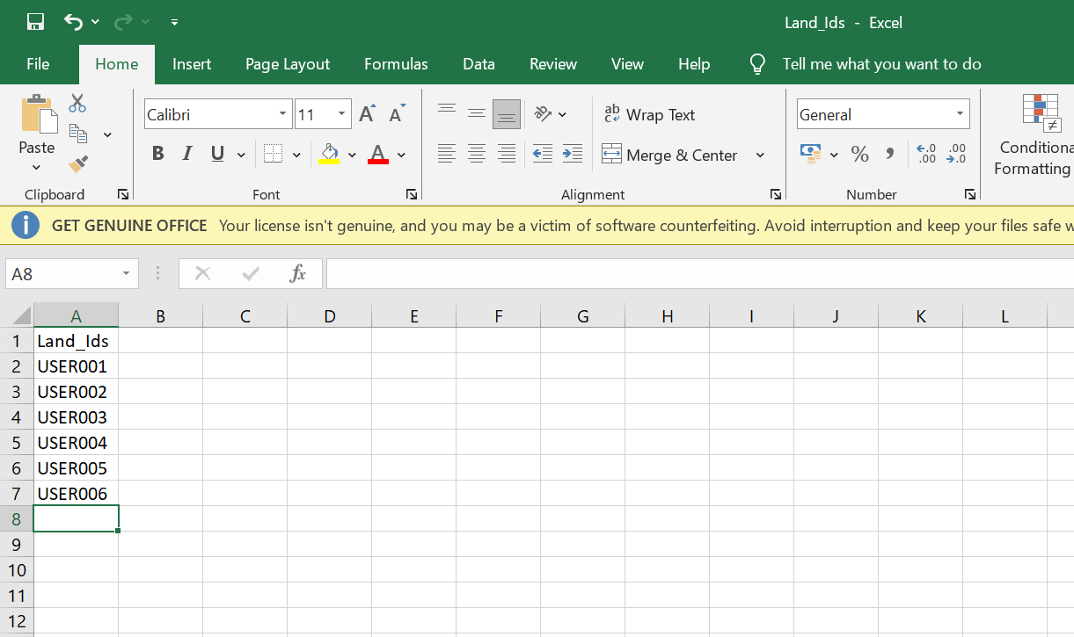

3. Images in the mentioned path

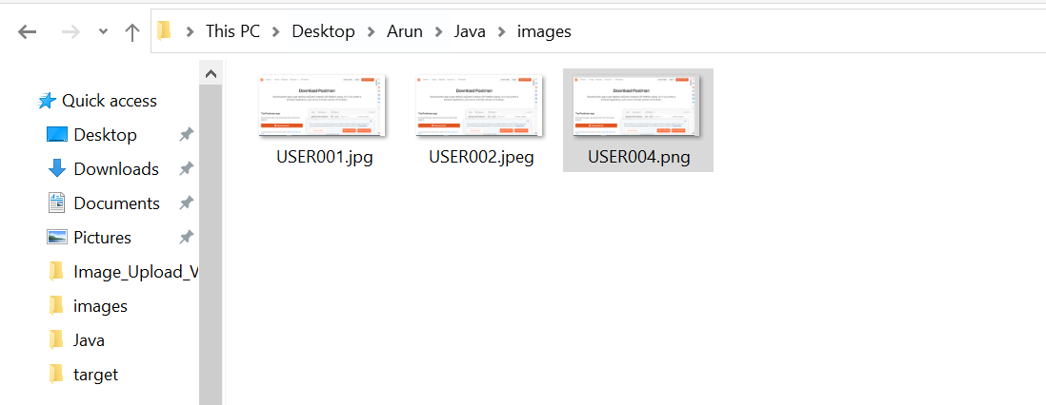

4.Post selecting the input from user, Image Verifier Web Application looks like below image.

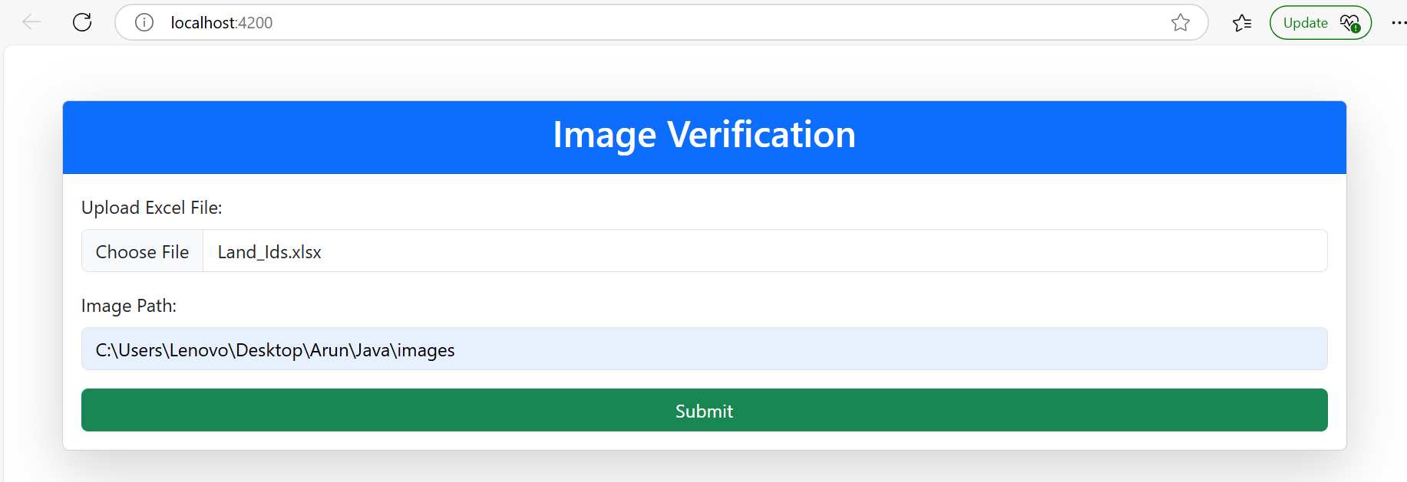

5. Once you submit the request with required inputs, you will get result screen along with download pdf option.

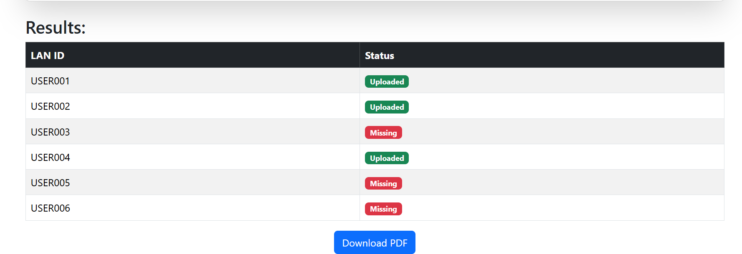

6.Once you download the PDF, content looks like below image.

