1. Successful Registration of two Microservices (Transaction and Account) to Eureka Server. All three Microservices (transaction-service,account-service and service-registory) running fine.

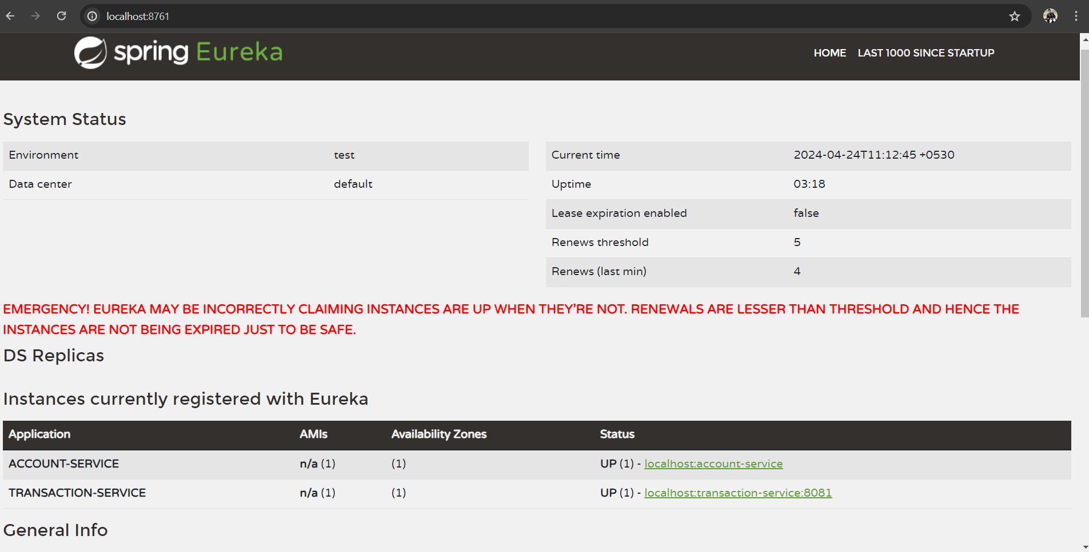

1. When you try to deposit, withdraw and transfer amount to the account which does not exists in the database, it will through account not found error.

Sending request from Postman Application

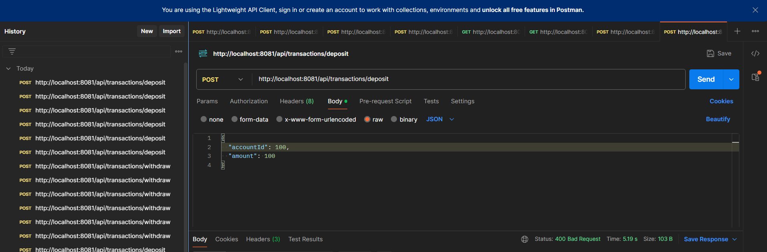

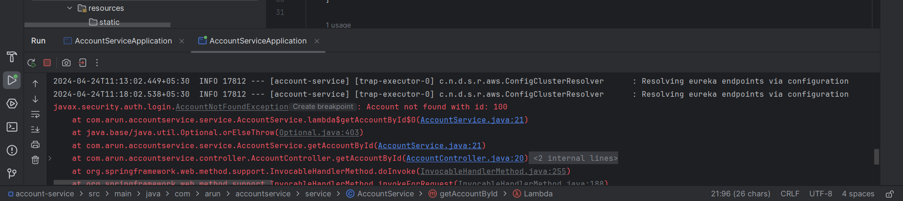

1. If you try to Deposit, Withdraw and Transfer the Invalid Amount, Application won’t allow you to Perform Operation.

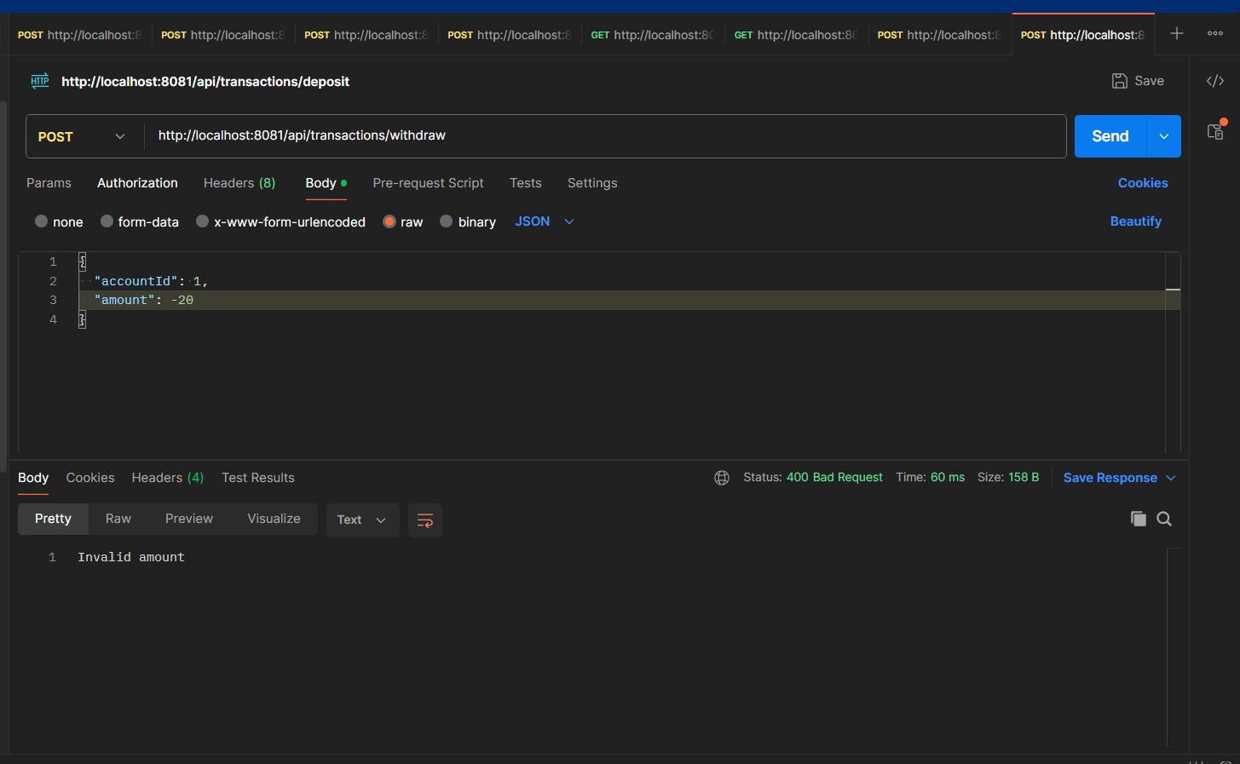

1. Deposit Amount to the Required Account and testing it in Postman App. You can able to see the current balance also in the result.

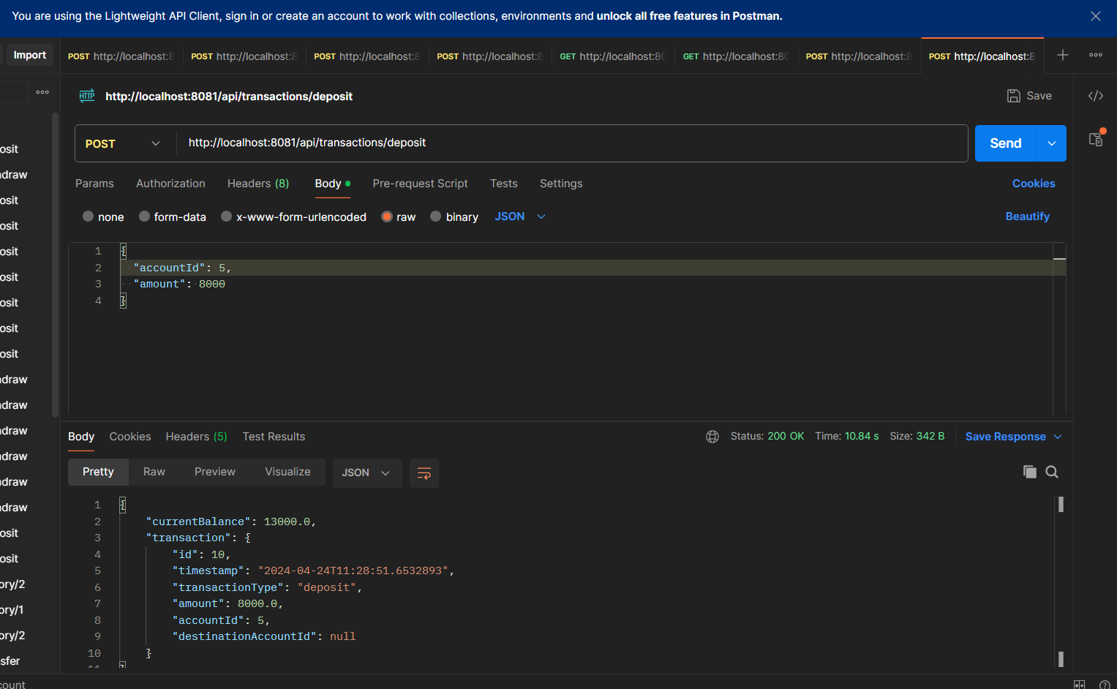

1. Withdraw Amount from the Required Account and testing it in Postman App. You can able to see the current balance also in the result.

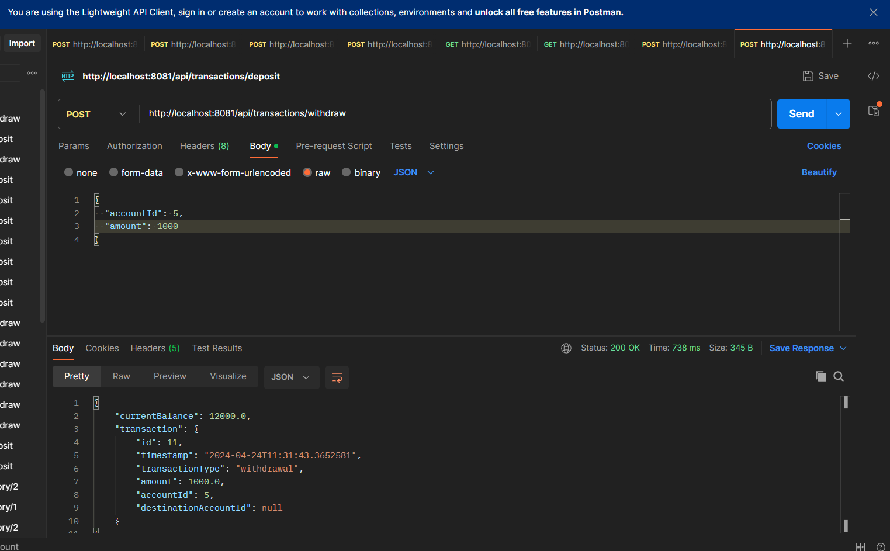

1. If withdraw amount is more than balance in the account it throw error and that error can handled by Exception Handling.

Here I am trying to withdraw 13000 from account id 5 which having current balance of 12000. Please see the output which showing error message and Http status code.

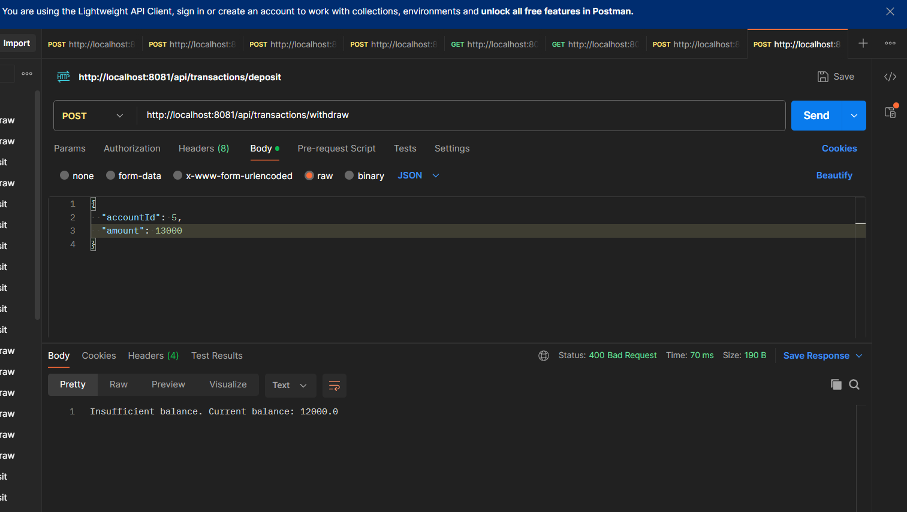

1. Transfer amount from Source Account to Destination Account. Validity check it will check source account balance before transferring. Once transferred it will show you destination account id in the result whom it transferred.

Successful transfer

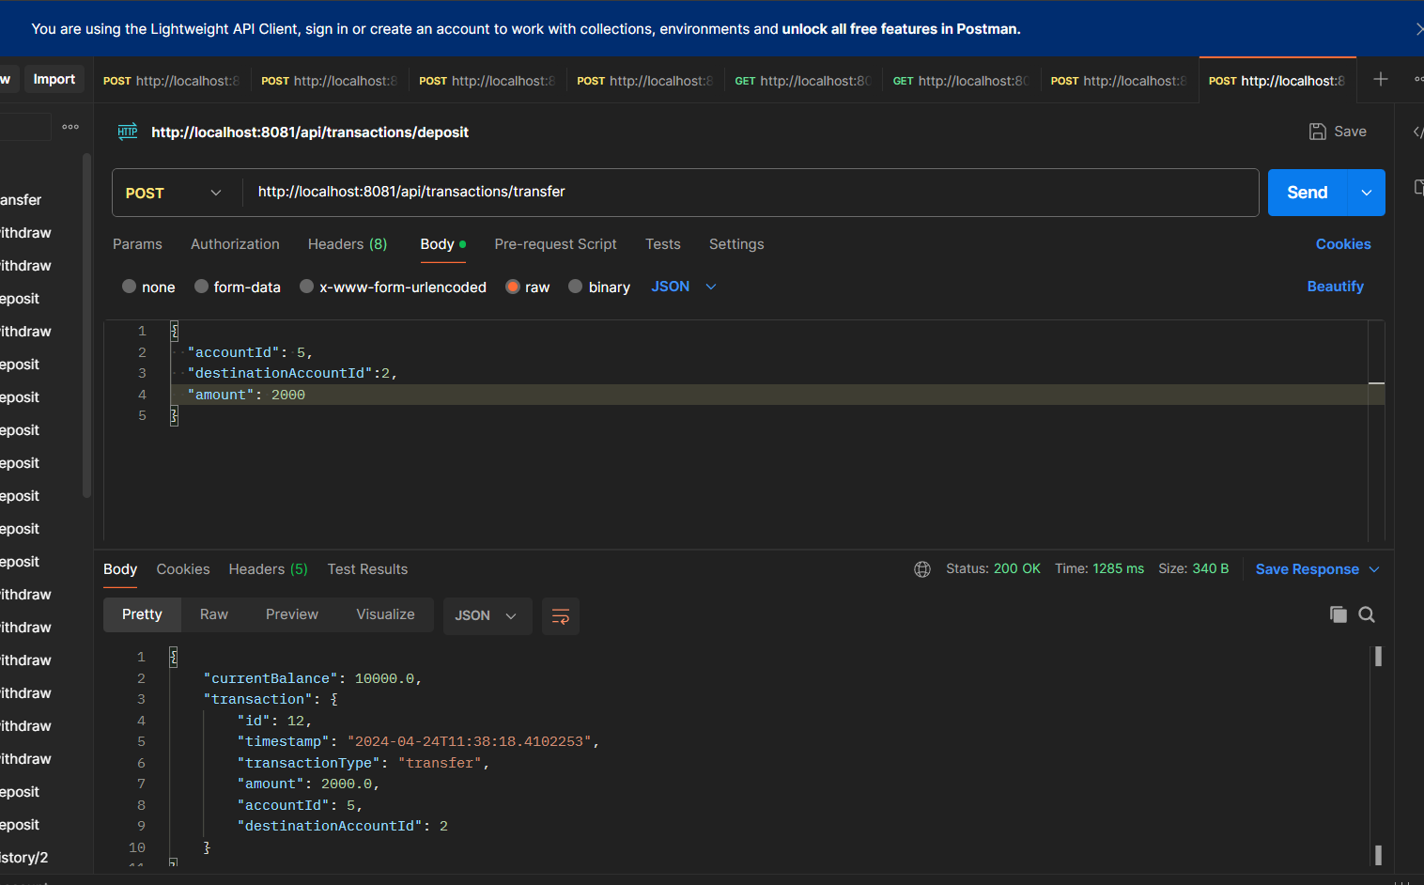

1. When I Try to send more amount than balance it will show below error. AccountId 5 has current balance of 10000 but I am trying to send 12000. Please check the screenshot.

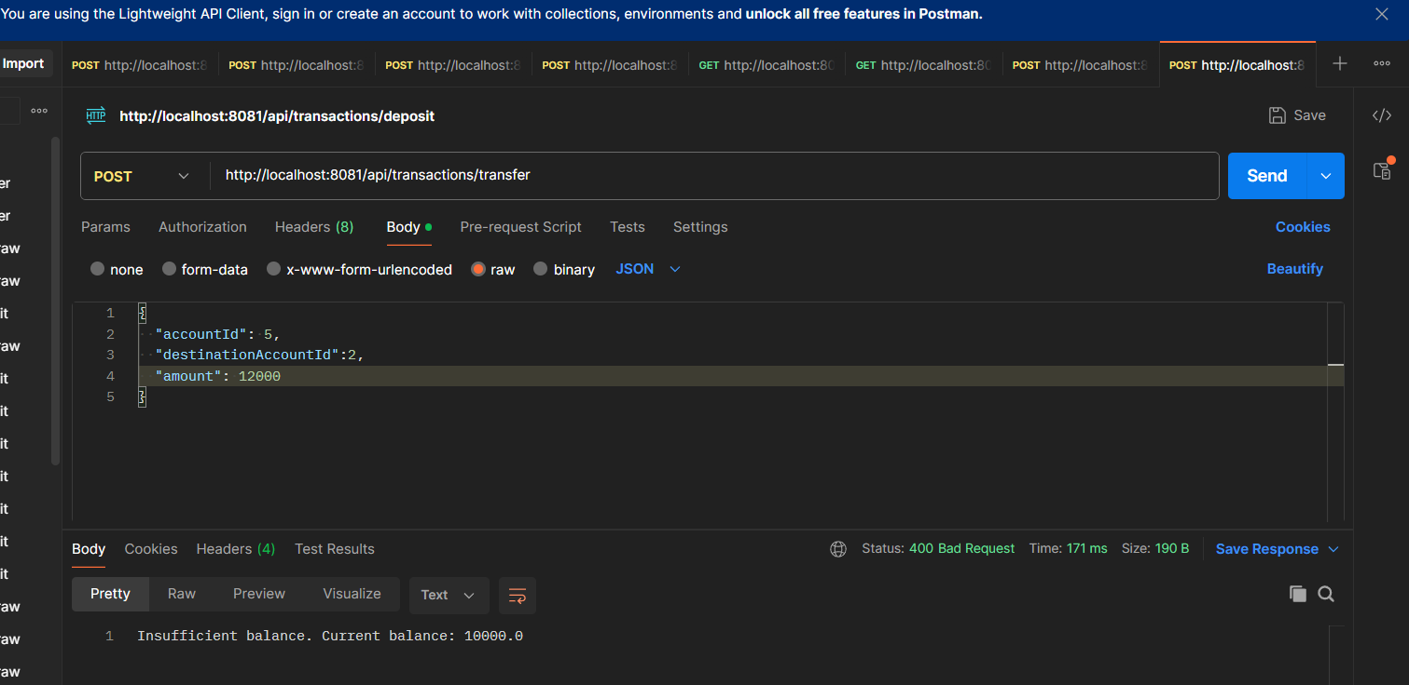

1. If Destination account is not existing one (in-correct one) still it will through error.

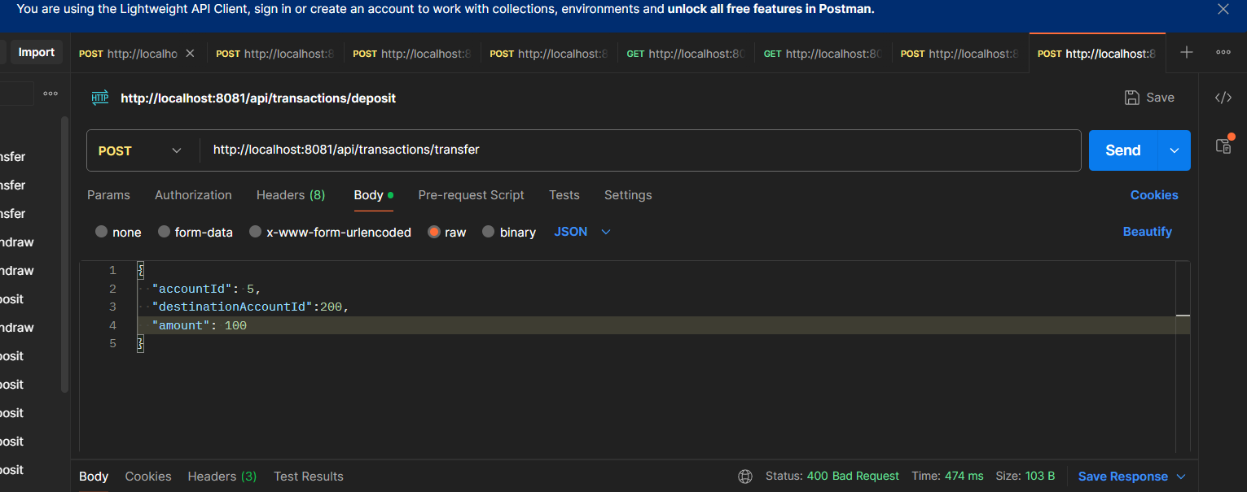

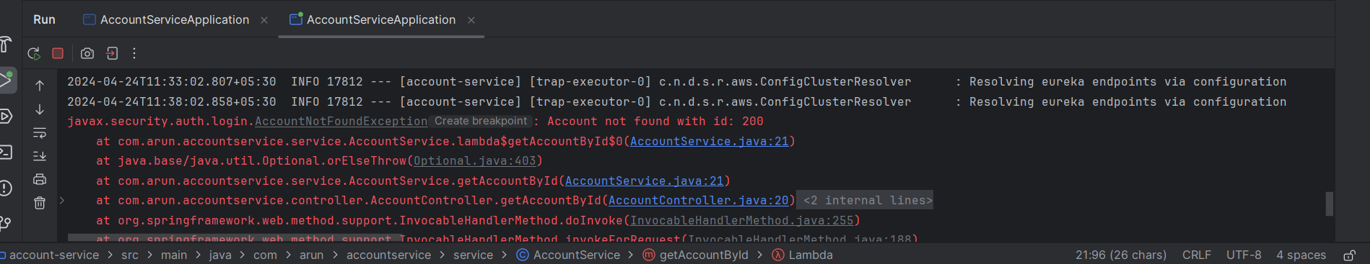

1. Now Fetching All Transactions in the descending order of their time and date of Required Account. It will all types of transaction made by the Required Account.

