Designing and Deploying Microsoft

2016

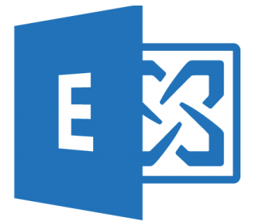

Submitted by: Submitted To:
Manpreet Kaur Mr. Alrick ParkiN
DATED: 1ST AUGUST 2019

CONTEST PAGE

Content Page

1. Introduction of the Exchange Server2016 ……………………………............2
2. Purpose of the Project………….……………………………….……………….2
3. Summary of the Project.……………………………...…………….……...........3
4. Task 1. Reimage the Hard Drive……………………………………………….4
5. Task 2. Install and configure domain controller………………. ……………...4
6. Task 3. Install Microsoft Exchange 2016…………………………………….…5
7. Task 4. Create Mailbox database ………………………………………….…. 7
8. Task 5. Create Send connector, external outlook……………………………...9
9. Task 6.a. Create OU in the Active Directory ………………………………….11
b. Create Security Group in EAC………………………………………12
10. Task 7. Create email address policies……………………………………….13
a. Create mailbox-enabled………………………………………………14
b. Create mail-enabled……………………………………………………15
11. Task 8. Creating users with login name and departments………………….18
12. Task 9. Created address lists………………………………………………….19
13. Task10. Create policy Lois Lane receives HR email’s copy.……………….20
14. Task11. Create mail-enabled public folder…………………………………....23
15. Task12. Create and assign permissions on the public folders………………27
16. Task13. a. Create policy on users not allowed to change password……….28
b. create policy users can access email from home……………….29
17. Task14. a. Create dynamic distribution groups.………………………………30
b. Assign Custom Attribute policy on three users………………….31
18. Task15. a. Create Retention policy……………………………………… ……32
b. Create Archive mailbox policy…………………………………….33
19. Task16. a. Create forwarding policy to monitor Mathew Perry’s email…....34
b. Create Litigation policy on the Mathew Perry’s mailbox……….35
20. Task17. Give full permission to user over the Mathew Perry’s mailbox ….36
21. Task18. Assign the memory limit on the mailbox database. ………………37
22. Task19. a. Create policy only engineers can send email in arfappc.net.…38
b. Create Internet-bound message policy………………………….38
23. Task20. Install the anti-spam agent on ExchA mail server…………………39
24. Task21. Create Virtual Hard Disk on the ExchA mail server……………….40
25. Task22. a. Create a virtual machine and install mailbox role……………...44
b. Create fault tolerance in event of ExchA server failure……......45
26. Conclusion……………………………………………………………………….50
27. References……………………………………………………………………….50

Introduction

Microsoft Exchange Server 2016 is the latest iteration of the Exchange Server messaging platform. Exchange Server 2016 includes several advanced features for organizations to have a resilient deployment of email across multiple customer sites. It is closely integrated into other products such as Office, Share Point, Skype for Business and Office 365, and it shares a similar interface to Exchange Server 2013. One big change in Exchange 2016 is a change in architecture. Whereas Exchange Server 2013 had two main roles (Mailbox and client Access), these are now merged into one role (Mailbox). That single role includes all the client access protocols, transport services, and unified messaging services. The main features of the Exchange Server 2016 are as:
- Advanced architectures
- Enhanced Reliability
- New Outlook Web App
- Faster Search
- Enhanced DLP (Data loss Prevention)
- Scalable eDiscovery
- Hybrid Improvement

Purpose
The main purpose of this project is to give students the opportunity to get hands-on experience in
Exchange Server 2016. It also gives them the experience to Setup and Configuring an Exchange Server from the scratch. It gives the experience to manage some of the new features that comes with Exchange Server 2016. Students get experience how to install Exchange 2016 mailbox role on server, create send connector, create mailbox database, create mail-enabled group in AD, Set the email format, create recipient object, create address list in Exchange Management Shell, create forwarding Rules, create transport rules, create DLP policy, create fault tolerant in the event of server failure.

SUMMARY OF THE PROJECT

In this project, student experience with Exchange Server 2016.Students experienced to Install and configure domain controllers. Students experienced to install Hyper-V on a host computer and created virtual machines. Students experienced to install the exchange mailbox roles on the virtual machine. Students experience to create mailbox databases, create send connector, create groups in the EAC, create address lists in EAC, create and working with public folders, create mailbox-enabled and mail-enabled emails format. Students experienced how to assign memory to the mailboxes, how to assign permission to users over the mailbox databases, create archive and litigation policy. Students experience to install anti-spam agents by using Exchange Management Shell, create VHDX, create backup. Students experience to create fault tolerant in the event of server failure.

Perform the following tasks:

- Reimage your classroom hard drive and configure the host OS with a computer name of yourlastnamePRJ (where yourlastname is your last name) and a unique static IP configuration for your classroom network.
Step:
- Reimage the Hard Drive and install Windows Server 2016.

- Brief information about the Host Computer is:

Computer Name : KaurPRJ
IP Address : 10.8.108.45
Subnet Mask : 255.255.255.0

- Configure your server as a domain controller for a new domain and new forest. Use the domain name projectXXX.com (where XXX is the number in the 4th octet of your unique classroom IPv4 address). Ensure that your computer is a global catalog and uses the highest domain and forest functional levels.
Step:

- Install Active Directory Domain Services.
- Promote Domain configuration and named Project45.com
- Static IP Address of the Domain is: 19.168.1.1

Screen shot of Local Host
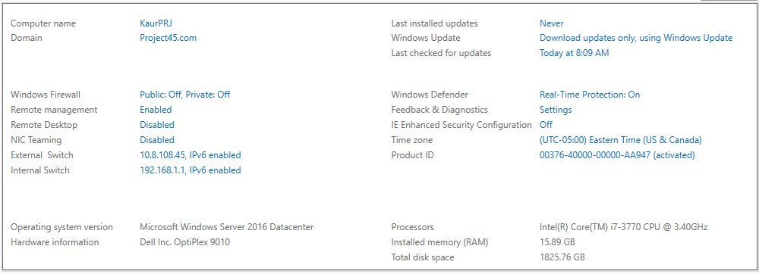

- Install Microsoft Exchange 2016 (mailbox role).

- Create new virtual machine with Windows Server 2016 Datacenter (With Desktop Experience).
- Brief information about ExchA is as follow as:
Computer Name : ExchA
IP Address : 192.168.1.2
Subnet Mask : 255.255.255.0
- Joined with the Domain.
- Install Exchange 2016 mailbox role on ExchA by follow these steps:

Step1: Install the .net framework (4.7.2)
Step2: Install visual C++ 2013
Step3: Install Unified Communication Managed API 4.0
Step4: Install Exchange Features.

Install-WindowsFeature Server-Media-Foundation, NET-Framework-45-Features, RPC-over-HTTP-proxy, RSAT-Clustering,
RSAT-Clustering-CmdInterface, RSAT-Clustering-Mgmt, RSAT-Clustering-PowerShell, WAS-Process-Model,
Web-Asp-Net45, Web-Basic-Auth, Web-Client-Auth, Web-Digest-Auth, Web-Dir-Browsing, Web-Dyn-Compression,
Web-Http-Errors, Web-Http-Logging, Web-Http-Redirect, Web-Http-Tracing, Web-ISAPI-Ext, Web-ISAPI-Filter,
Web-Lgcy-Mgmt-Console, Web-Metabase, Web-Mgmt-Console, Web-Mgmt-Service, Web-Net-Ext45, Web-Request-Monitor,
Web-Server, Web-Stat-Compression, Web-Static-Content, Web-Windows-Auth, Web-WMI, Windows-Identity-Foundation,
RSAT-ADDS
Step5: Mount ExchangeServer2016-x64-cu12
Step6: Extend Domain Schema by the following commands:

- Open the PowerShell with administrative privileges and navigate to the drive where Exchange setup files are located.
.\Setup /PrepareSchema /IAcceptExschangeServerLicenseTerms

Step7: Prepare Active Directory by the following commands:
.\Setup /PrepareAD /OrganizationName: KCSP /IAcceptExchangeServerLicenseTerms
.\Setup /PrepareAD /IAcceptExchangeServerLicenseTerms
.\Setup /PrepareAllDomains /IAcceptExchangeServerLicenseTerms

Step8: Install ExchangeServer2016-x64-cu12
- Reboot the system and open the following URL to validate your installation
https://ExchA/ecp

Screen shot of Exchange Admin Center on ExchA mailbox server
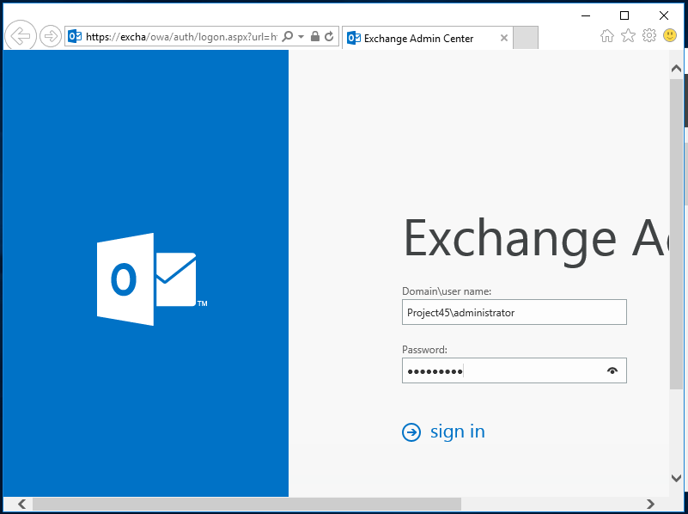

- Move the default mailbox database (and associated logs) to the C:\SAN\FirstMailboxDB folder. The default mailbox database will be used to host the mailboxes for the IT department as well as any public folders. Next, create 4 additional mailbox databases:
- Marketing Mailbox Database (in C:\SAN\SecondMailboxDB)
- Accounting Mailbox Database (in C:\SAN\ThirdMailboxDB)
- Engineering Mailbox Database A (in C:\SAN\FourthMailboxDB)
- Engineering Mailbox Database B (in C:\SAN\FifthMailboxDB)
Step:
- Create a folder named “SAN” in the C drive in the ExchA mail Server.
- Then under “SAN” folder create five more folder as below:
- FirstMailboxDB
- SecondMailboxDB
- ThirdMailboxDB
- FourthMailboxDB
- FifthMailboxDB

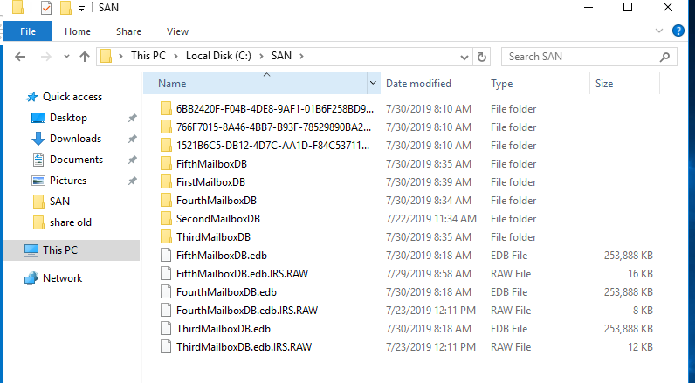
Screen shot of created five folder under “SAN” folder

- Create Four Mailbox database as below:
- Marketing Mailbox Database
- Accounting Mailbox Database
- Engineering Mailbox Database A
- Engineering Mailbox Database B

Step:
- Open the Exchange Admin Center and login as Administrator.

Server -> databases -> new -> specify the name of database “Marketing Mailbox Database “-> Browse Server “ExchA” -> Save.

Server -> databases -> new -> specify the name of database “Accounting Mailbox Database “-> Browse Server “ExchA” -> Save.

Server -> databases -> new -> specify the name of database “Engineering Mailbox Database A “-> Browse Server “ExchA” -> Save.

Server -> databases -> new -> specify the name of database “Engineering Mailbox Database B “-> Browse Server “ExchA” -> Save.

Screen shot of created mailbox databases
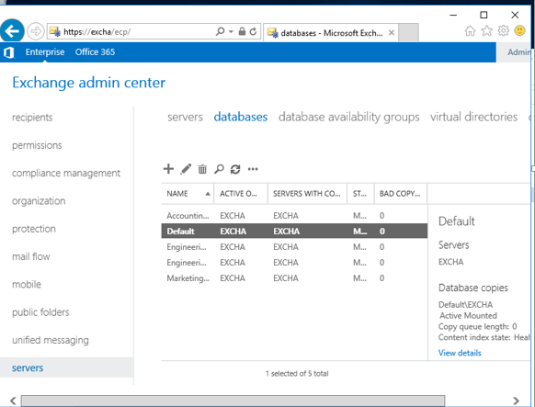

- Rename the automatically created Mailbox database” IT”.
- Move the default Mailbox database to the
C:\SAN\FirstMailboxDB
Step:
- Open the Exchange Management Shell and Run the following command:

Move-databasepath Default -Edbfilepath C:\Programfiles\Microsoft\ExchangeServer\V15\Mailbox\MailboxDatabase1721782852\MailboxDatabase1721782852.edb -logfolderpath C:\SAN\FirstMailboxDB

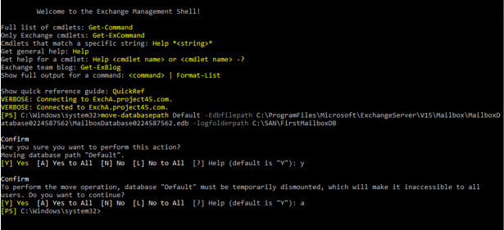
Screen shot of move the data of default database to the C:\SAN\FirstMailboxDB

List three reasons why creating different mailbox databases for different departments is good form within an organization:
Answer: A mailbox database is a unit of granularity where mailboxes are created and stored. A mailbox database is stored as an Exchange database (.edb).

Three reasons for creating different mailbox database for different departments in the organization is below:
- Redundancy: If Exchange determine the original message was lost in transit, the redundant copy of the transit is redelivered.
- Load Balancing: If two servers host different mailboxes, they will proxy traffic for each other when required. The mailbox serves hosting the active copy of the mailbox will serve the user accessing it, even if the user connects to another mailbox server.
- Recovery: If our mailbox is in a single database, the recovery of single file in the department taking a long time. It avoid the single failure server. Backup and restoring is very easy.

- Ensure that email can be forwarded to the Internet on your Exchange server. Also ensure that external Outlook Anywhere, OWA and ActiveSync clients can access the server.

- To ensure that email forwarded to the Internet on the Exchange Server ExchA:

- Create Send Connector
- Open the Exchange Admin Center Login as Administrator.
Step:

Mail flow -> Send connector -> add -> give the name for mailbox -> Select Internet option -> click MX record -> next -> next -> new -> on the add domain give * then Save -> next -> add -> Select ExchA ->add -> Ok -> Finish.

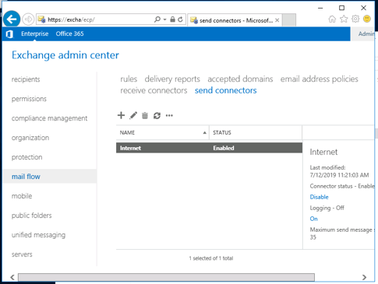
Screen shot of Send connector

- Configuring Outlook Anywhere, OWA and ActiveSync:

Step:
Server -> Virtual Directories -> Configured Exchange access domain -> add -> Select ExchA -> add -> ok -> Enter the domain Name “Project45.com” -> Save

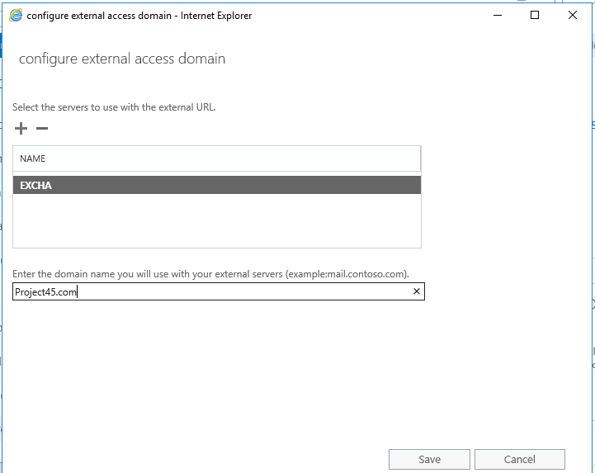
Screen shot of configure outlook Anywhere, WA and ActiveSync

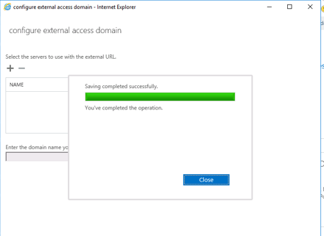

What did you have to configure in order to achieve Step 5 and why?
Answer: To achieve the above step we configured the following steps:

1.Created Send connector: To ensure that email can be forwarded to the internet I created the send connector. Send connectors control outgoing mail flow from the Exchange server.
2.Configure internal and external URL in exchange
3.Configured DNS Record for redirecting
4.Configure External access
a. Outlook anywhere
b. OWA
c. ActiveSync

- Create the following mail-enabled security groups in Active Directory:
- marketing
- accounting
- engineering
- Create Three Organization unit in the Domain:

- Accounting_OU
- Engineering_OU
- Marketing_OU

Steps:

Tools -> Active Directory Users and Computers -> Right click on the Project45.com and Select new -> Organization Unit.

Screen shot of Creating three OU in the domain
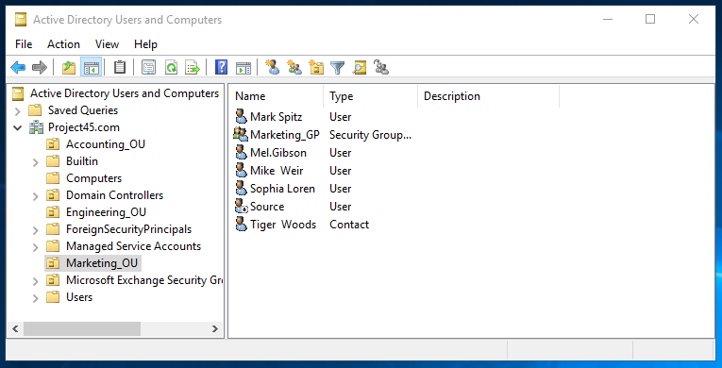

- Then Create Three Groups in the Exchange Admin Center:

1. Marketing_GP
2. Accounting_GP
3. Engineering_GP

Step:
- Open the Exchange Admin Center and login as administrator:

Recipients -> Groups -> new -> Security Group.

Screen shot of created three groups by using EAC
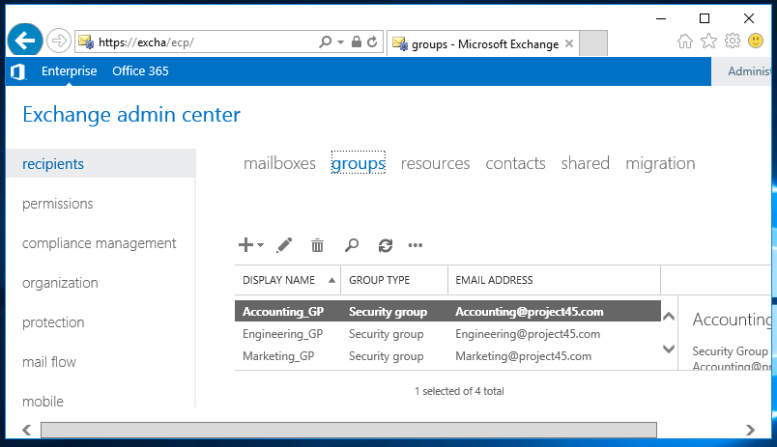
List two reasons why you would create a mail-enabled distribution group instead of a mail-enabled security group.
Answer: Following are reasons why we create mail-enabled distribution group instead of a mail-enabled security group
1) Distribution groups are simply designed for being mail-enabled. Distribution groups works with email clients. Distribution groups are for emailing people and security groups provide access.
2) Distribution groups are more meaningful in the Exchange environment. Distribution groups are less complicated. It eliminates several duplicate groups.

- Create the appropriate email address policies to ensure that:
  - All mailbox-enabled users receive an email address in the format firstname.lastname@projectXXX.com

- Create Mailbox-enabled Policy:

Step:
- Open the Exchange Admin Center and login as administrator.

Mail flow -> email address policies -> new -> Specify policy name “Mailbox-enabled” -> add -> Select Firstname.lastname@Projectxxx.com -> Save.

Screen shot of created mailbox-enabled policy
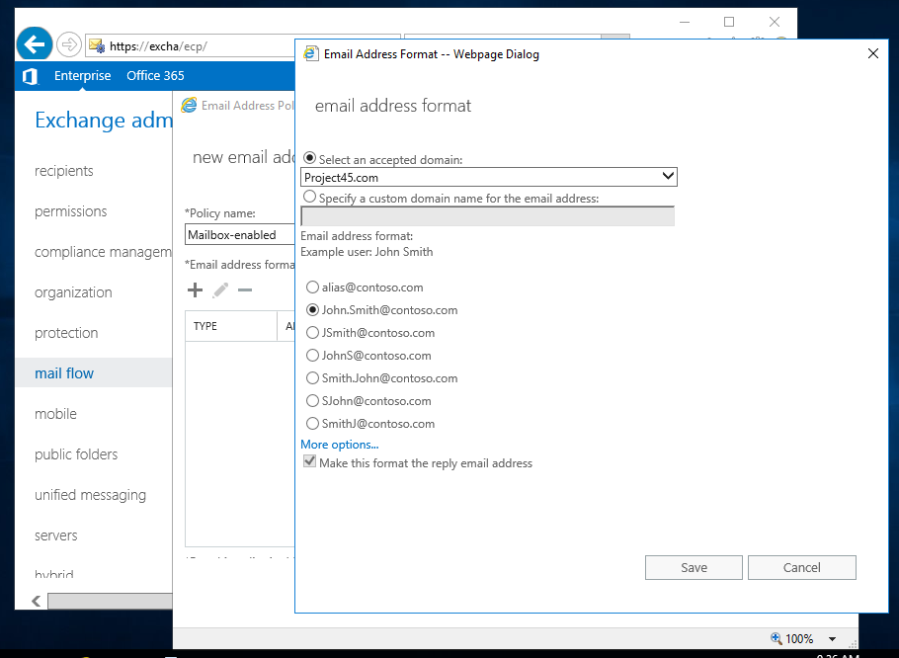
  - All mail-enabled users and mail-enabled contacts receive an email address in the format firstname.lastname-ext@projectXXX.com

- Create Mail-enabled policies:

Step:
Mail flow -> email address policies -> new -> Specify the policy name “Mail-enabled” -> add -> more options -> Select enter a custom address type -> Type “SMTP” -> Select email address parameters -> %g%s-ext@Project45.com -> Save -. Save.

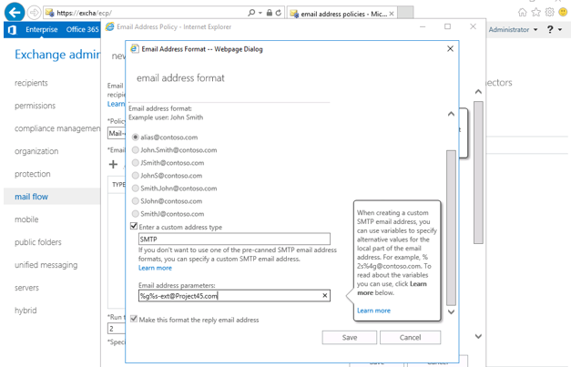
Screen shot of created mail-enabled policy
- Create the following recipient objects with the appropriate information and ensure that they are in the appropriate groups. The logon name and alias should be in the form firstname.lastname@projectXXX.com. Ensure that all marketing user mailboxes are in the Marketing Mailbox Database, all sales user mailboxes are in the Accounting Mailbox Database, and that engineering user mailboxes are evenly distributed between the two Engineering databases.

- Create the Users with the logon Name, Alias and their appropriate Mailbox Database:
- There are three types of users like Mailbox-enabled, Mail-enabled, Contact.
Step:
- Open the Exchange Admin Center and login as Administrator:

- Steps for Create Mailbox-enabled User
Recipients -> Mailbox -> add -> user mailbox.

- Steps for Create Mail-enabled User
Recipients -> Contacts -> add -> Mail user.

- Steps for Create Contact
Recipients -> Contacts -> add -> Mail Contact.

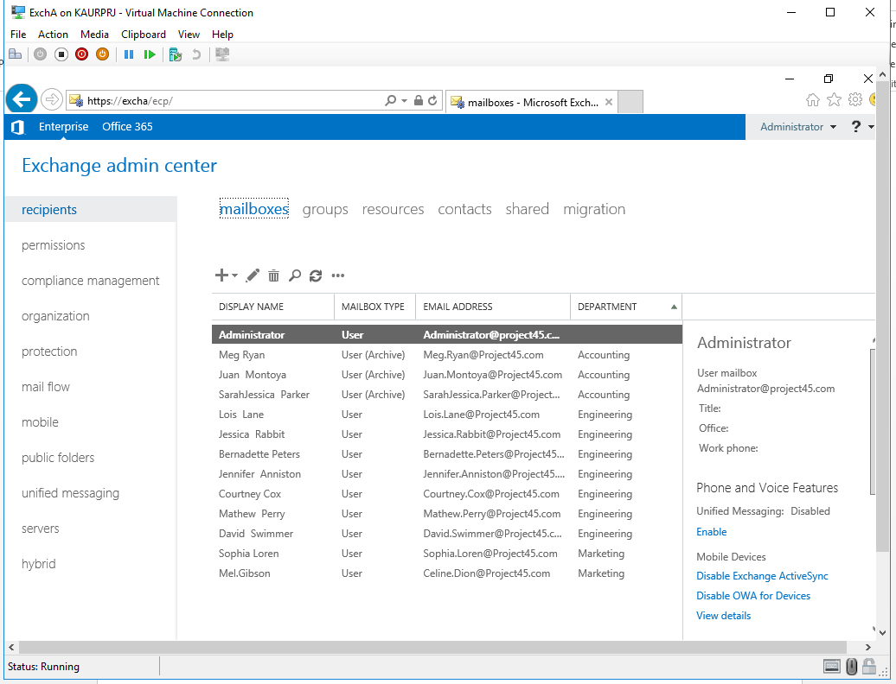
Screen shot of created mailbox database

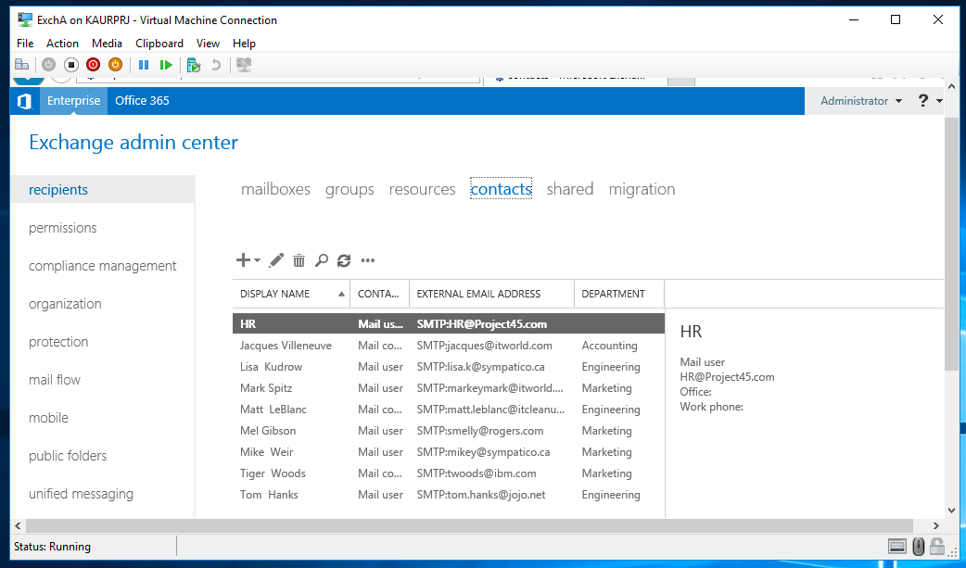

Sophia Loren | Mailbox-enabled | marketing
Mel Gibson | Mail-enabled (smelly@rogers.com) | marketing
Celine Dion | Mailbox-enabled | marketing
Mike Weir | Mail-enabled (mikey@sympatico.ca) | marketing
Mark Spitz | Mail-enabled (markeymark@itworld.com) | marketing
Tiger Woods | Contact (twoods@ibm.com) | marketing
Meg Ryan | Mailbox-enabled | accounting
Jacques Villeneuve | Contact (jacques@itworld.com) | accounting
Juan Montoya | Mailbox-enabled | accounting
Sarah Jessica Parker | Mailbox-enabled | accounting
Lois Lane | Mailbox-enabled | engineering
Jessica Rabbit | Mailbox-enabled | engineering
Tom Hanks | Mail-enabled (tom.hanks@jojo.net) | engineering
Bernadette Peters | Mailbox-enabled | engineering
Jennifer Anniston | Mailbox-enabled | engineering
Courtney Cox | Mailbox-enabled | engineering
Lisa Kudrow | Mail-enabled (lisa.k@sympatico.ca) | engineering
Mathew Perry | Mailbox-enabled | engineering
Matt LeBlanc | Contact (matt.leblanc@itcleanup.com) | engineering
David Swimmer | Mailbox-enabled | engineering

- Create address lists for the marketing, accounting and engineering departments.

- Create three address lists:

- Marketing
- Accounting
- Engineering

Steps:
- Open the Exchange Admin Center and login as Administrator

Organization -> address lists -> new -> specify the name “Marketing” -> Save.
Organization -> address lists -> new -> specify the name “Accounting” -> Save.
Organization -> address lists -> new -> specify the name “Engineering” -> Save.

Screen shot of created address list
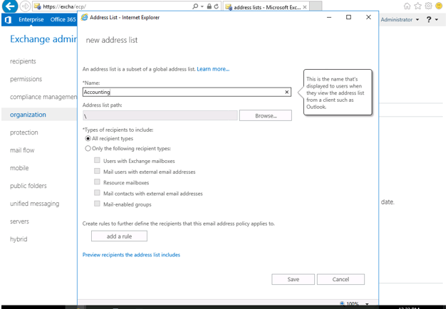

Briefly describe the difference an address list and a mail-enabled group.
Answer:
Address lists are subsets of recipients that are grouped together in one list, which makes them easier to find by users.
A mail-enabled group can be used to distribute messages as well as to grant access permissions to resources in Active Directory.
The main difference between an address list and a mail-enabled group is that an
address Lists changes and updates automatically when new members are added or
modified while changes in mail-enabled groups done in Active Directory manually.

- Ensure that Lois Lane also receives any email sent to the following email address:
HR@projectXXX.com

- First, Create HR User

- Open the Exchange admin Center and login as Administrator
Step:

Recipients -> Mailbox -> User mailbox.

- Ensure Lois Lane receives HR email
Step:

Mail flow -> Rules -<> Create new rule -> specify the name “Received by ‘HR’ -. BCC to “Lois Lane” -> apply this rule if…. Choose the recipients is….type “HR@Project45.com -> add -> ok -> ‘Do the following’ choose BCC message to -> Select ‘Lois lane’ -> add -> ok -. Save.

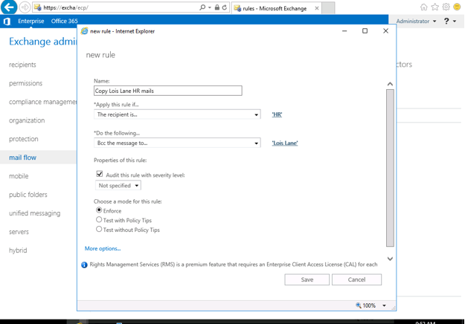
Create Rule For Lois Lane receives HR@project45.com

- Create a new mail-enabled public folder that can be read by all users but can only be managed by Courtney Cox (and Administrator for testing). The public folder should be accessed using the following email addresses:

- feedback@projectXXX.com
- productA@projectXXX.com
- productB@projectXXX.com
- productC@projectXXX.com

  - Firstly, Create Public folder mailbox
Step:
- Open the Exchange Admin Center and login as Administrator.

Public folders -> public folder mailboxes -> new public folder mailbox -> specify the Name “Source” -> browsing the Organization unit -> browsing the Mailbox database -> save.

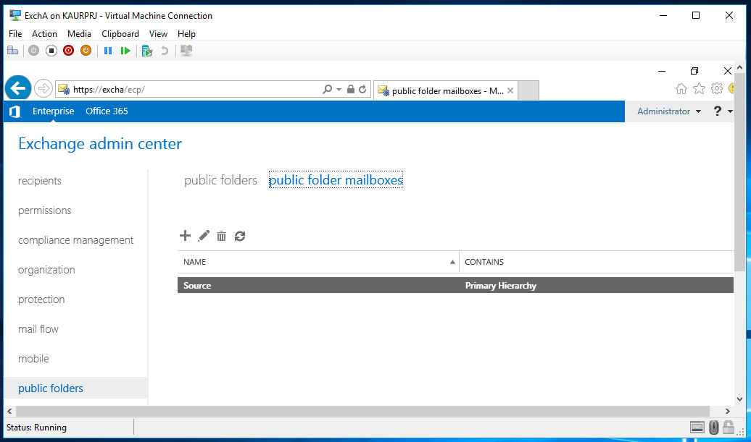
Screen shot of created public folder mailbox

- Then Create public folder.
Step:

Public folders -> public folder -> new public folder -> Specify the name of the folder -> Save.

- To give the Full permission to ‘Courtney Cox’ over these three public folders
Step:
Public folders -> public folders -> Manage -> add -> Browse User Name “Courtney Cox” -> ok -> Set the Permission level “Owner” -> Save -> Save.

- To give the permission to Administrator for testing
Step:
Public folders -> Public folders -> Manage -> add -> Browse the user Name “Administrator” -> Ok -> Set the Permission -> Save -> save.

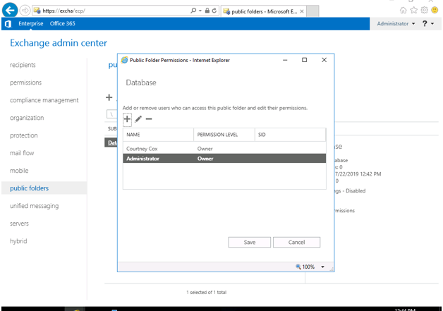
Screen shot of assigned permission to Country Cox and Administrator

- Create Email address use to accessed public folder
Step:
Public folders -> public folders ->edit -> email address -> add -> Specify the email address “fedback@Project45.com” -> Ok -> Save.

Public folders -> public folders ->edit -> email address -> add -> Specify the email address “productA@Project45.com” -> Ok -> Save.

Public folders -> public folders ->edit -> email address -> add -> Specify the email address “productB@Project45.com” -> Ok -> Save.

Public folders -> public folders ->edit -> email address -> add -> Specify the email address “productC@Project45.com” -> Ok -> Save.
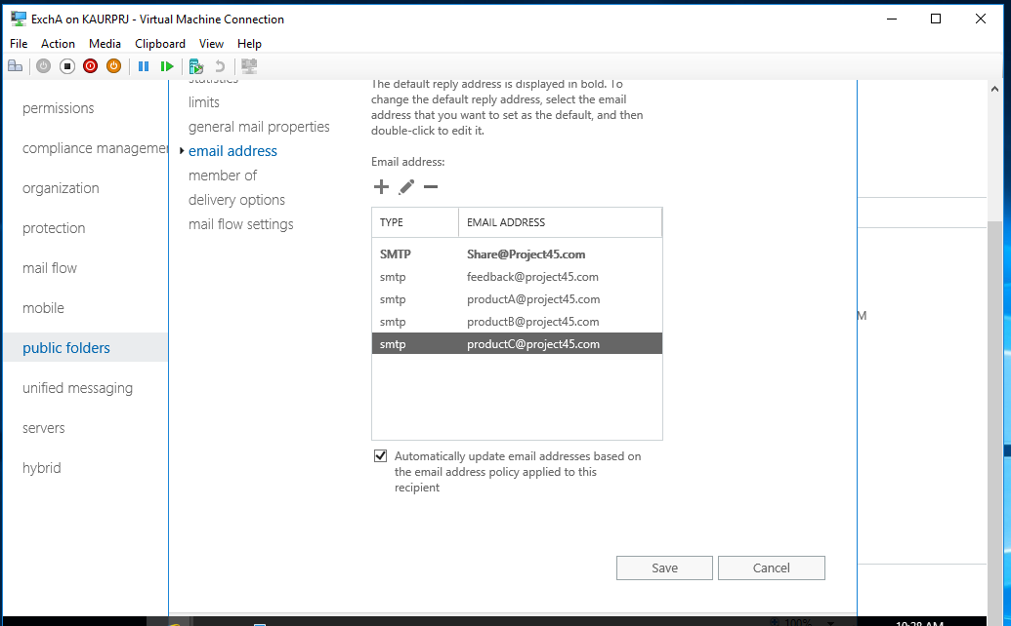
Screen shot of create email addresses

- Create a new public folder called Forum. Forum should contain the following subfolders that will contain post items (projectC should only contain Calendar items). Ensure that Administrator has full control over all these folders. Also ensure that Lois Lane and Jessica Rabbit have full control over these folders; all other engineers should be able to post and reply to posts, but not have the ability to remove items.
- projectA
- projectB
- projectC

- Create Public folder named “Forum”
Step:
- Open the Exchange Admin Center and login as Administrator.

Public folders -> public folders -> add -> Specify the name of the folder “Forum” -> Save.

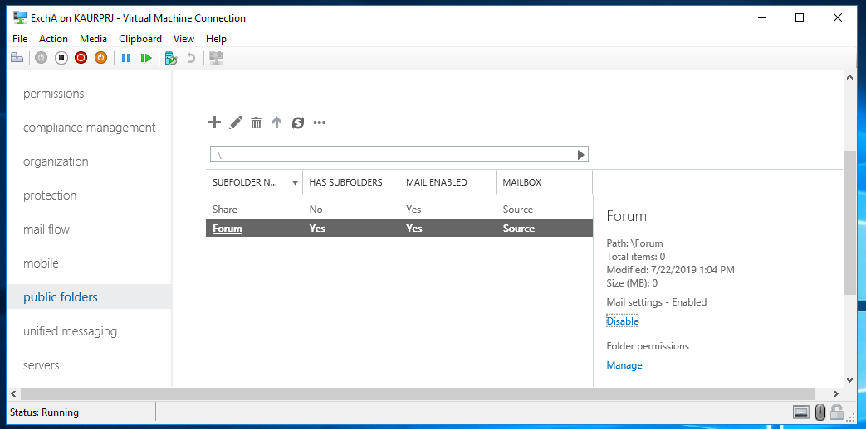
Screen shot of created ‘Forum’ folder

- Then Create Three Subfolder under the “forum” public folder.
1. projectA
2. projectB
3. projectC
Step:

Public folders -> public folders -> click on the “Forum” public folder -> new public folder -> specify the name of the folder “projectA” -> Save.

Public folders -> public folders -> click on the “Forum” public folder -> new public folder -> specify the name of the folder “projectB” -> Save

Public folders -> public folders -> click on the “Forum” public folder -> new public folder -> specify the name of the folder “projectC” -> Save

Screen shot of subfolders
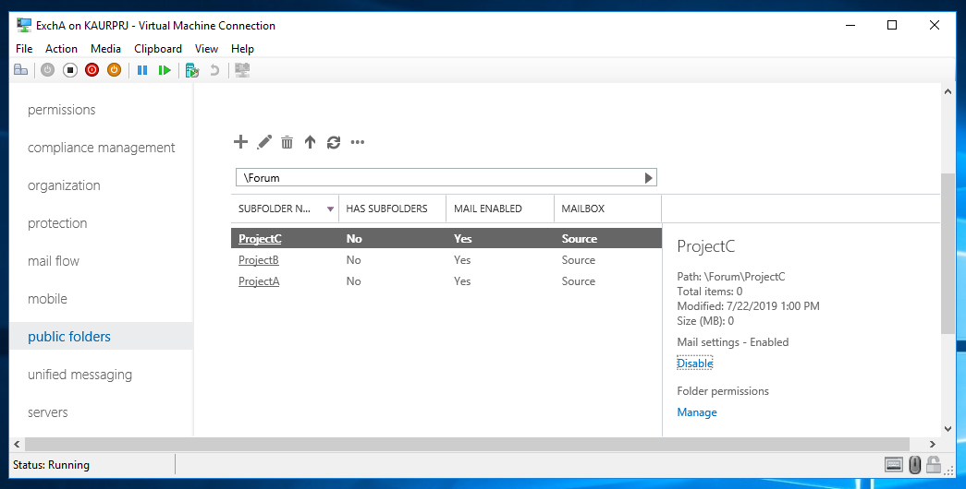
- Ensure that Lois Lane full control on these three folders.
Step:

Public folders -> public folders -> click on ‘Forum’ folder -> Select ‘projectA’ -> Manage -> add -> Browse ‘Lois Lane’ -> Ok -> Set permission -> Save -> Save.

Public folders -> public folders -> click on ‘Forum’ folder -> Select ‘projectB’ -> Manage -> add -> Browse ‘Lois Lane’ -> Ok -> Set permission -> Save -> Save.

Public folders -> public folders -> click on ‘Forum’ folder -> Select ‘projectC’ -> Manage -> add -> Browse ‘Lois Lane’ -> Ok -> Set permission -> Save -> Save.

- Ensure that Jessica Rabbit full control on these three folders.
Step:

Public folders -> public folders -> click on ‘Forum’ folder -> Select ‘projectA’ -> Manage -> add -> Browse ‘Jessica Rabbit’ -> Ok -> Set permission -> Save -> Save.

Public folders -> public folders -> click on ‘Forum’ folder -> Select ‘projectB’ -> Manage -> add -> Browse ‘Jessica Rabbit’ -> Ok -> Set permission -> Save -> Save.

Public folders -> public folders -> click on ‘Forum’ folder -> Select ‘projectC’ -> Manage -> add -> Browse ‘Jessica Rabbit’ -> Ok -> Set permission -> Save -> Save.

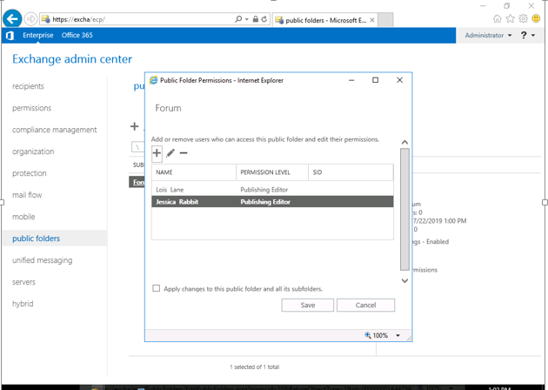
Screen shot of Assign full permission to Lois Lane and Jessica

- Create a Policy that Engineers able to post and reply to post over these folders but not able to delete any item.
Step:

Public folders -> public folders -> click on ‘Forum’ folder -> Select ‘projectA’ -> Manage -> add -> Browse ‘Engineering_GP’ -> Ok -> Set permission -> Save -> Save.

Public folders -> public folders -> click on ‘Forum’ folder -> Select ‘projectB’ -> Manage -> add -> Browse ‘Engineering_GP’ -> Ok -> Set permission -> Save -> Save.

Public folders -> public folders -> click on ‘Forum’ folder -> Select ‘projectC’ -> Manage -> add -> Browse ‘Engineering_GP’ -> Ok -> Set permission -> Save -> Save.

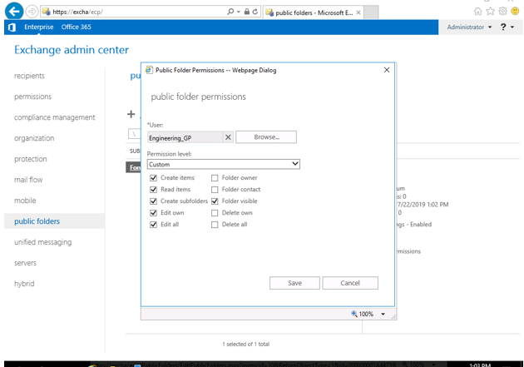
Screen shot of created policy engineering group not able to delete

- Ensure that engineering users can access their email from home using Outlook Anywhere and OWA only. Also ensure that engineering users are not allowed to change their password using OWA.

- Create a policy for the users not allowed to change the password
Step:
- Open the Exchange Admin Center and login as Administrator.

Permission -> Outlook Web App policies -> new -> specify the policy name -> Security deselect “change password” -> Save.

Screen shot of create a policy on password
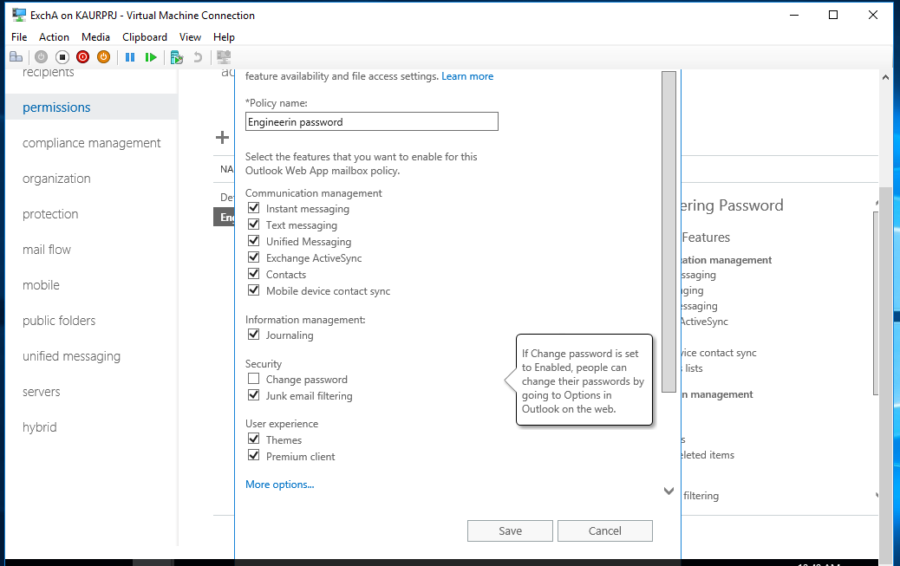

- Then apply that policy on the engineering users
Step:
Recipients -> Mailboxes -> Select all ‘Engineering’ users -> more option -> Outlook on the web -> Assign a policy -> on the ‘Outlook Web App mailbox policy’ Browse policy “engineering password” ->Save.

Screen shot of created policy on the engineering users
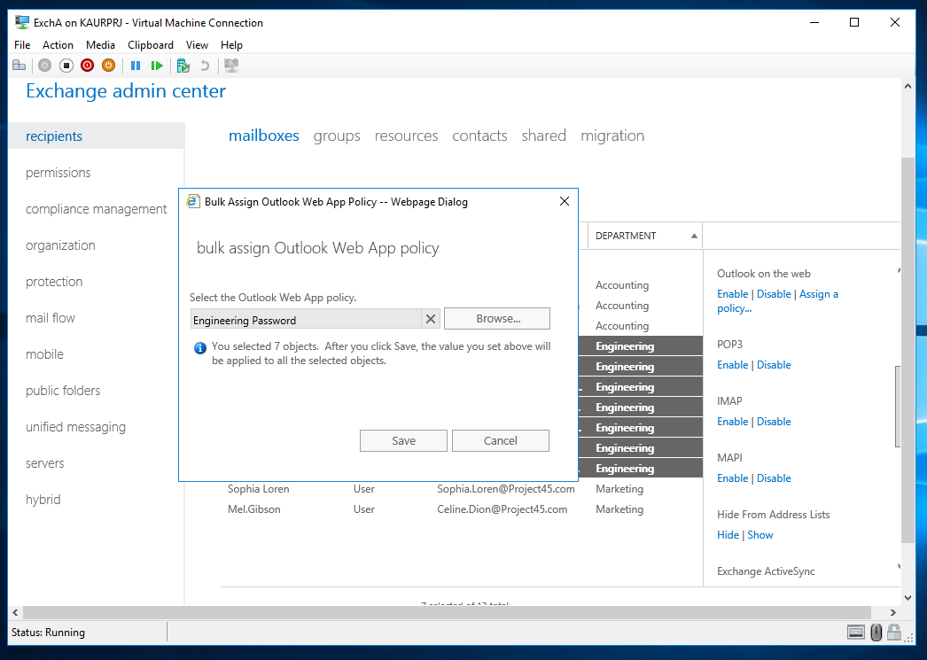

- Create a policy that engineering users can access from home:
Step:

Server -> Virtual directories -> owa (Default Web site) -> configure external access domain -> add -> select Server ‘ExchA’ -> add -> Ok -> enter domain “mail.Project45.com” -> Save

Screen shot of created policy user can access from home
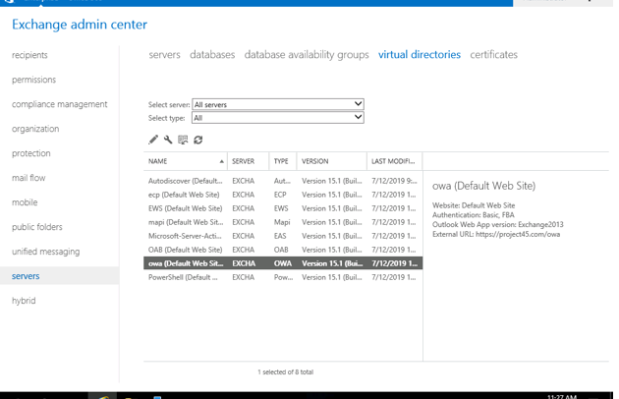

- Create a dynamic distribution group (teamleads@projectXXX.com) that includes anyone who has Custom Attribute 1 equal to the value “teamlead” – next, ensure that Lois Lane, Tom Hanks and David Swimmer are teamleads and receive email sent to this group.

- Create a dynamic distribution group
Step:
- Open the Exchange Admin Center and login as Administrator

Recipients -> groups -> new -> Dynamic distribution group -> specify the name ‘teamleads’ -> Browse Organization unit -> add rule -> custom attribute1 -> enter word “teamleads” -> Ok -> Save -> Save.

Screen shot created Dynamic distribution Group
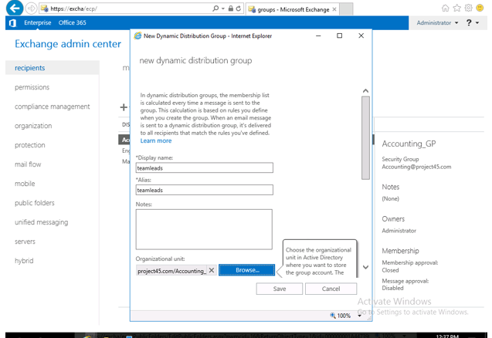

- Ensure that Lois Lane and David Swimmer teamleads and receive email sent to ‘teamleads’ group
Step:
Recipients -> mailboxes -> select users “Lois Lane” and “David Swimmer” -> more option -> custom Attributes -> update -> edit -> type “teamleads” -> Ok -> Save.

Screen shot of Custom Attribute policy
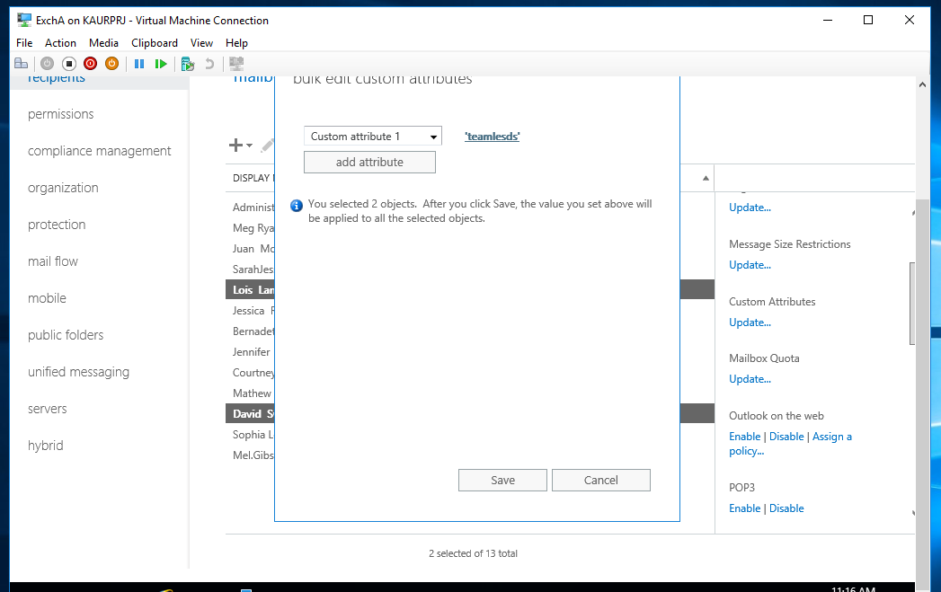

- Ensure that Tom Hank teamleads and receive email sent to ‘teamleads’ group
Step:

Recipients -> Contacts -> Select user “Tom Hank” -> edit -> more options -> Custom attributes -> edit ->specify the name of attribute “attribute1” -> Ok -> Save

Screen shot of Custom Attribute policy
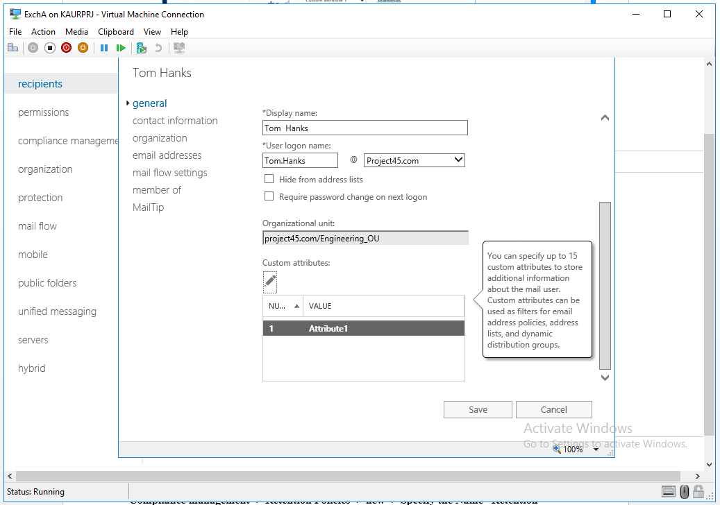

- Ensure that all accounting mailbox users have an archive mailbox, and that they can apply a retention tag to custom folders within their primary mailbox that forces Exchange to move items older than 5 years to a folder of the same name in their archive mailbox.

- Firstly, Create a Retention Tag
Step:
- Open the Exchange Admin Center and login as Administrator.

Compliance management -> Retention Policies -> new -> Specify the Name “Retention policy” -> Retention Tag -> add -> Select Personal 5years option -> add -> ok -> Save.

Screen shot of Retention policy
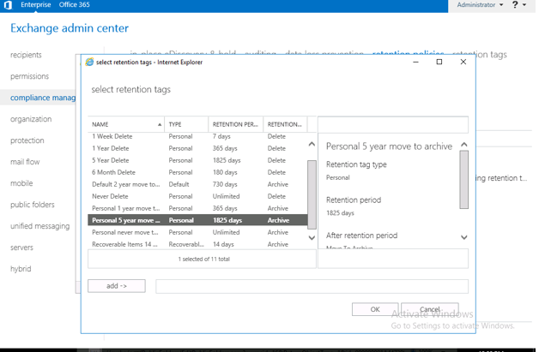

- Ensure that all accounting mailbox users have an archive mailbox
Step:
Recipients -> mailboxes -> Select ‘accounting mailbox’ users -> more options -> Archive……. choose “Enable” -> Browse “Accounting mailbox Database” -> Ok -> Save.

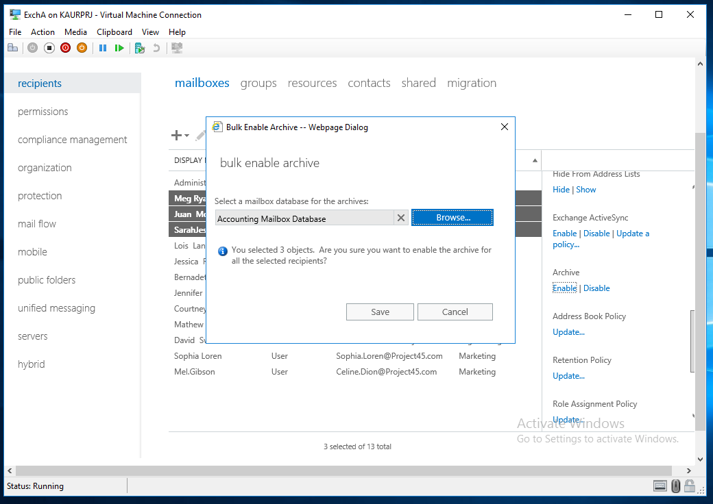
Screen shot of archive mailbox

- Monitor Mathew Perry’s email by forwarding copies of his email to a test account of your choice. Also ensure that items in Mathew Perry’s mailbox that are deleted or modified are kept in a hidden litigation hold folder within his mailbox.

- Create a forwarding rule for Mathew Perry’s email

Step:

Mail flow -> rules -> new Rule -> Select “Mathew Perry” as a sender is -> add -> Ok -> Bcc the message to “Administrator” -> add -> Ok -> Ok -> Save.

Screen shot of forwarding rule
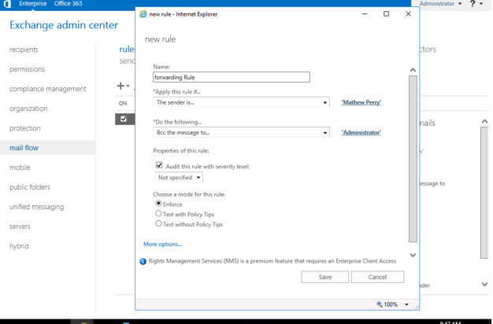
- Create Litigation Policy
Step:
Recipients -> mailboxes -> Select “Mathew Perry” -> edit -> mailbox features -> litigation hold: enabled -> enable -> Save -> Save.

Screen shot of Litigation policy
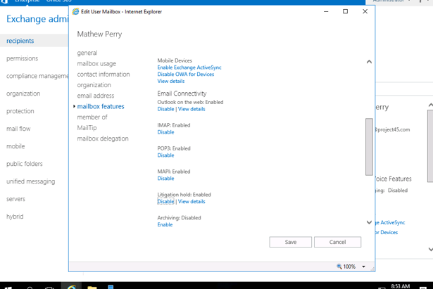

List two disadvantages of using litigation holds on a mailbox:
Answer:
1. Increase the cost for the organization due to the manual efforts to copy messages. It can’t place other holds.

2.It preserves all items. End users may be asked to preserve email by not deleting any messages. However, users can still delete email knowing or inadvertently.

Next, explain why eDiscovery holds are preferred to litigation holds:
Answer:
In-Place eDiscovery allows you to search mailbox data across your Exchange organization, preview search results, copy search results to a Discovery mailbox, or export the results to a PST file .eDiscovery is better because you can specify what you want to hold, you can also search items in single or multiple mailboxes.

What role must you be a member of in order to perform an eDiscovery hold?
Answer:
1.If you want users to be able to use Exchange Server 2016 In-place eDiscovery, you first need to add them to the Discovery management role group. Members of the Discovery Management role group have Full Access mailbox permissions to the defaults discovery mailbox which is called Discovery Search Mailbox.
2. Add the users to the Administrator audit logging.

- Give Administrator and Lois Lane full access to Mathew Perry’s mailbox.

- Give the full access to the Administrator and Lois Lane over the Mathew Perry’s mailbox
Step:

- Open the Exchange Admin Center and login as Administrator.

Recipients -> mailboxes -> Select “Mathew Perry” -> edit -> mailbox delegation -> full access -> add -> Select ‘Administrator’ -> add -> Ok -> then again full access -> add -> Select ‘Lois Lane’ -> add -> Ok -> Save.

Screen shot of assign permission to administrator and Lois Lane over Mathew
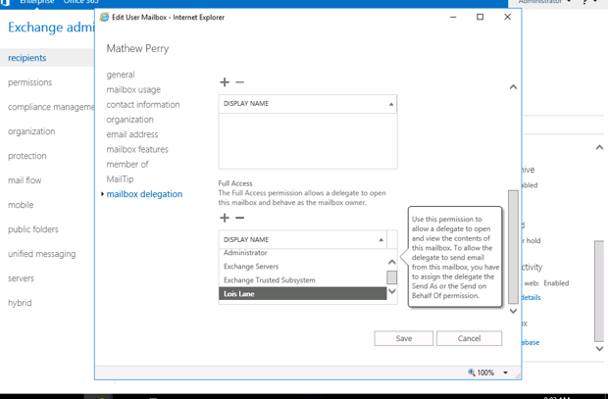

List three different situations in which you would need to give full access permission on a mailbox to another user.
Answer:
There are many situations in which permissions to another user’s mailbox should be granted on Exchange Server:
1. Sometimes it is for monitoring purposes.
2. Sometimes in order to send emails on behalf of someone else.
3. Sometimes to check specific kind of email with specific word, or during email migration process.

List two different situations in which you would need to give Send As permission on a mailbox to another user.
Answer:
1. To redirect email: - If you need to allow another user to send messages under the name of the other mailbox, you can grant ‘Send as’ permission.
2.User is Away: - For example personal assistant and manager. A personal assistant can send Email to another recipient, using the identity of his manager.

Briefly describe the difference between Send as and Send on Behalf permission.
Answer:
Both Send on Behalf and Send as are similar permissions, however, there is one difference between these two permissions. Send As is sending email on behalf of another user to send as another user, where Send on behalf mean using their account to send email an email message arrives, the email message that is being sent on behalf of the mailbox owner is displayed, whereas
send.

- Ensure that all IT and engineering mailboxes have a limit of 1GB. All other mailboxes should have a limit of 500MB. Sophia Loren must have a mailbox limit of 700MB.

- Ensure that IT mailboxes have limit of 1GB
Step:
- Open the Exchange Admin Center and login as Administrator.

Server -> database -> Select ‘Engineering IT’ -> edit -> limits -> Put the value ‘1GB’ -> Save.
- Ensure that Engineering mailboxes have limit of 1GB
Step:

Server -> database -> Select ‘Engineering Mailbox A’ -> edit -> limits -> Put the value ‘1GB’ -> Save.

Server -> database -> Select ‘Engineering Mailbox A’ -> edit -> limits -> Put the value ‘1GB’ -> Save.
- Ensure that other mailboxes ‘Accounting’ have limit of 5000 MB
Step:
Server -> database -> Select ‘Accounting Mailbox’ -> edit -> limits -> Put the value ‘0.5GB’ -> Save.
- Ensure that Sophia Lore ’Marketing Mailbox’ have limit of 7000 MB
Step:

Server -> database -> Select ‘Marketing Mailbox’ -> edit -> limits -> Put the value ‘0.7GB’ -> Save.

Screen shot of assign Limit to Mailbox
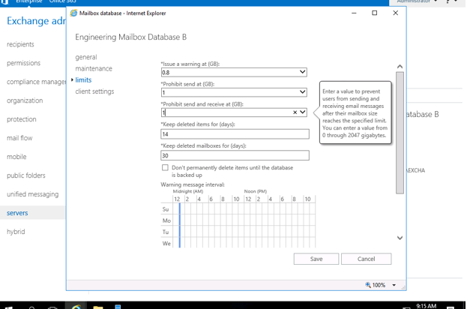

- Ensure that all engineers can only send email internally and to users in the arfappc.net domain (no other Internet mail allowed!). Any Internet-bound messages from the accounting department should include a legal disclaimer of your choice.

- Ensure that all engineers can only send email and to users in the ‘arfappc.net’ domain
Step:
- Open the Exchange Admin Center and login as Administrator.

Mail flow -> Rules -> Create a new rule -> specify the name ‘Received from a member of Engineering_GP’-> Apply the rule if…. The sender ….is a member of this group -> Select ‘Engineering_GP’ -> add -> Ok -> Do the following Block…. Block the message -> The recipient is…. Reject the message with explanation…...-> type “Outside mail not allowed” -> Except if …. domain is …. “arfappc.net-> The recipient is located ……is external/internal -> Inside the organization -> Save.

Screen shot of create policy on the ‘arfappc.net’ domain
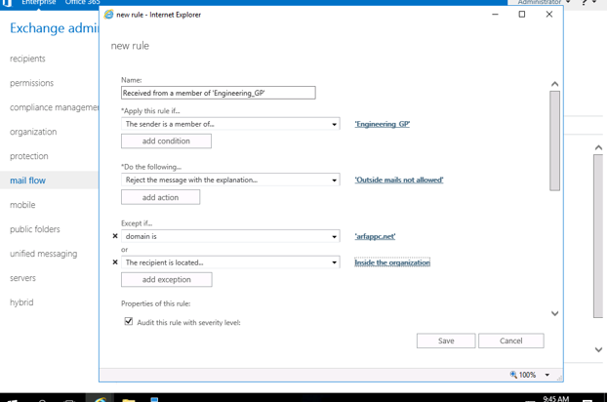

- Create Internet-bound messages
Step:

Mail flow -> Rules -> create a new rule -> specify the name ‘Internet-bound message’ -> Apply this rule -> The sender is located…”Outside the organization” -> add condition -> The sender is member of this group -> Select ‘Accounting _GP’ -> Do the following -> Append the disclaimer -> put the message “Internet-bound message from the accounting department is a legal disclaimer-> choose “Wrap” -> Except if ….The sender is located…..”Inside the Organization” -> add Exception… The sender’s domain is…. arfappc.net -> Save.

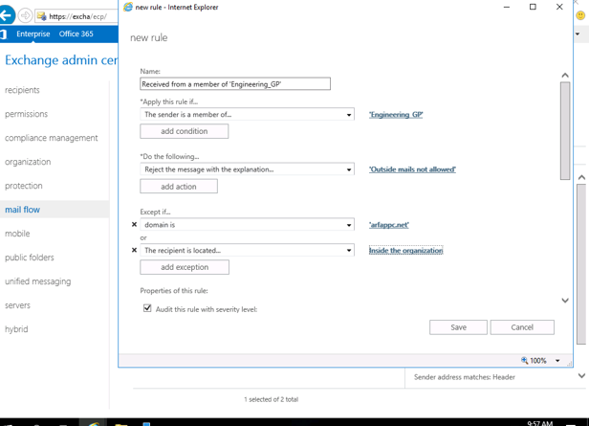
Screen shot of create Internet-Bound message
- Install the anti-spam agents on your mailbox server and ensure that the SCL threshold is set to 7. Add the xen.spamhaus.org RBL provider to your anti-spam sender filter configuration.

Install the anti-spam agents on ExchA Mailbox server, SCL threshold is set to 7 and add xen.spamhaus.org
Step:

- Open the Exchange Management Shell on the ExchA mailbox server.
- Run the Following commands in the Exchange Management Shell

& $env:ExchangeInstallPath\Scripts\Install-AntiSpamAgents.ps1

Set-ContentFilterConfig -BypassedSenderDomains xen.spamhaus.org

Set-ContentFilterConfig -SCLDeleteThreshold 7

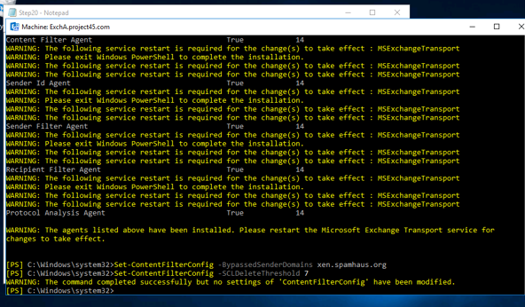
Screen shot of install Anti-spam

Briefly describe what setting the SCL threshold to 7 will achieve:
Answer:
A message with an SCL value is moved to the junk Email folder by the junk email rule. The maximum value is 9, and the default value is 5 which means that messages with an SCL value 7 or higher are moved to the Junk email folder, and messages with an SCL value of 5 or lower are delivered to the inbox. It means setting the threshold to 7 would make any message that has equal value 7 to send a non-delivery report to the sender and the message would be rejected.

- Create a new 75GB vhdx file that is mounted to X:\. Schedule full backups of all of your databases and logs to X:\ each day at 11:00pm. Also ensure that your databases can be overwritten by a restore process.

- Create the Virtual Hard Disk on the ExchA mail server
Step:

ExchA -> Right click on the ExchA and choose ‘Settings’ -> SCSI controller -> Hard drive …. ExchA -> New

Screen shot of create VHDX
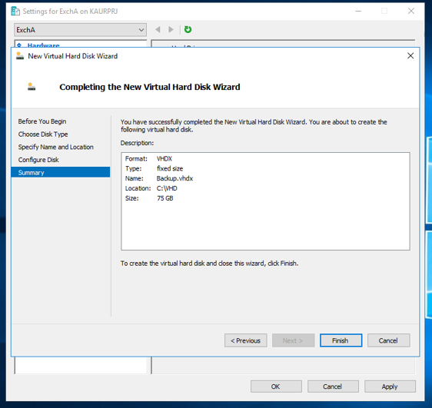

- After that using Disk Management mounted the disk to X:\

Screen shot of mounted the disk to X:\
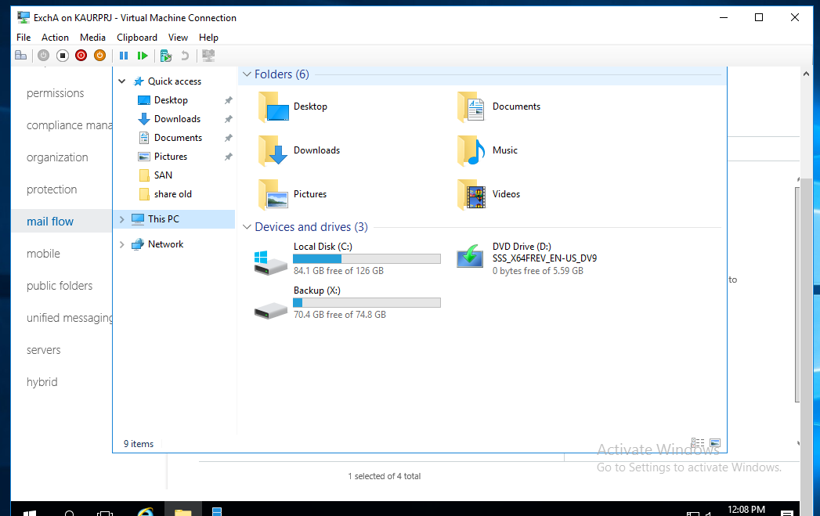

- Install Windows Server Backup features

- To create backup first install backup features on the mail server. By using Add\role features install the windows server backup on the ExchA mail server.
- Schedule full backup of all ExchA database
Step:

ExchA -> Tool -> Windows Server Backup -> Right click on the ‘Local Backup’ -> Choose ‘Backup Schedule’ -> click on the ‘Backup Schedule’.

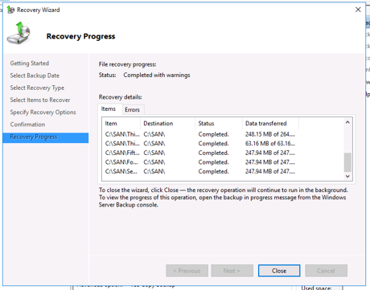
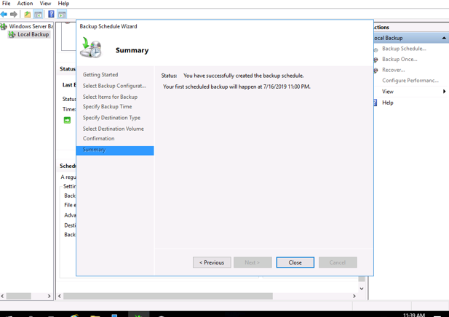
Screen shot of Backup

Detail the steps/commands that you should perform in order when several users from the same department receive errors in their MUA that indicate corruption:

PROBLEM:

Engineering department is not able to access internet. MUA gives an error which indicating that the users can’t communicate with the Exchange Server

TROUBLSHOOTING:

1.I have checked the IP address using ‘IP CONFIG’ command in the command
prompt for the machine and noticed that they are all correct.
a. DNS is correctly configured.
b. Mask is correctly configured.
c. IP addresses are correctly configured.
Therefore, all the department shares one-point failure which is the switch of the department. When it was checked I noticed that it was not working mean it was dead.

SOLUTION:

I replaced the switch and correctly configured it according to the network infrastructure plan.

TESTING

1. After applying the solution, the MUA as well as everything related to the connectivity (internet, intranet, exchange, resources etc.) were working fine and the problem was solved.

- Create a virtual machine on an internal virtual switch (192.168.1.0) that also has a network interface connected to your external virtual switch. Deploy another Exchange 2016 server on this virtual machine that provides complete fault tolerance for your existing Exchange mailbox databases and services in the event of a failure.

- Create new virtual machine with Windows Server 2016 Datacenter (With Desktop Experience).

- Brief information about ExchB is as follow as:

Computer Name : ExchB
IP Address : 192.168.1.3
Subnet Mask : 255.255.255.0

- Joined with the Domain.
- Install Exchange 2016 mailbox role on ExchA by follow these steps:

Step1: Install the .net framework (4.7.2)
Step2: Install visual C++ 2013
Step3: Install Unified Communication Managed API 4.0
Step4: Install Exchange Features.
Install-WindowsFeature Server-Media-Foundation, NET-Framework-45-Features, RPC-over-HTTP-proxy, RSAT-Clustering,
RSAT-Clustering-CmdInterface, RSAT-Clustering-Mgmt, RSAT-Clustering-PowerShell, WAS-Process-Model,
Web-Asp-Net45, Web-Basic-Auth, Web-Client-Auth, Web-Digest-Auth, Web-Dir-Browsing, Web-Dyn-Compression,
Web-Http-Errors, Web-Http-Logging, Web-Http-Redirect, Web-Http-Tracing, Web-ISAPI-Ext, Web-ISAPI-Filter,
Web-Lgcy-Mgmt-Console, Web-Metabase, Web-Mgmt-Console, Web-Mgmt-Service, Web-Net-Ext45, Web-Request-Monitor,
Web-Server, Web-Stat-Compression, Web-Static-Content, Web-Windows-Auth, Web-WMI, Windows-Identity-Foundation,
RSAT-ADDS

Step5: Mount ExchangeServer2016-x64-cu12
Step6: Extend Domain Schema by the following commands:
Open the PowerShell with administrative privileges and navigate to the drive where Exchange setup files are located.
.\Setup /PrepareSchema /IAcceptExschangeServerLicenseTerms
Step7: Prepare Active Directory by the following commands:
.\Setup /PrepareAD /OrganizationName: KCSP /IAcceptExchangeServerLicenseTerms
.\Setup /PrepareAD /IAcceptExchangeServerLicenseTerms
.\Setup /PrepareAllDomains /IAcceptExchangeServerLicenseTerms
Step8: Install ExchangeServer2016-x64-cu12

- Reboot the system and open the following URL to validate your installation
https://ExchB/ecp

- Ensure that Mailbox databases are fault tolerant in the event of ExchA server failure.
Step:

  - Add private virtual switch for DAG traffic on the 172.16.0.0 network (do not register these connections in DNS)
Step:
- Create private virtual switch in the Virtual Switch Manager
- For Server ExchA
- On the ExchA in the settings add private virtual switch and Rename the Switch “Virtual Private Switch” and Assign the IP address 172.16.0.1
- Deselect the DNS option.
- For Server ExchB
- On the ExchB in the settings add private virtual switch and Rename the Switch “Virtual Private Switch” and Assign the IP address 172.16.0.2
- Deselect the DNS option.
  - Add the Exchange Trusted Subsystem to the domain Administrators group
Login the Domain controller
Step:
Tools -> Active Directory Users and Computers -> expand your domain” Project45.com” -> double click on the ‘Bultin’ folder -> double click on the Administrator -> Members -> add -> In the ‘Enter the object name to select’ pane type “Exchange Trusted Subsystem” -> Checkname ->
Ok.
  - Create and share C:\Witness (Everyone = FC) on the host OS
Login the Domain Controller
Step:
- Open the file explorer and create a folder in the C drive named “Witness” and share this folder and give full control.
  - Add a DAG (choose Witness server and folder, NO shared IP)
- Open the Exchange Admin ang Login as Administrator.
Step:
Server -> database availability groups -> new.

  - Add ExchA and ExchB to the DAG (auto chooses DAG network)
- Open the Exchange Admin ang Login as Administrator.
Step:
Server -> database availability groups -> Manage DAG membership -> edit -> Select ExchA, ExchB -> add -> ok -> Save.

Screen shot of add ExchA and ExchB to the DAG
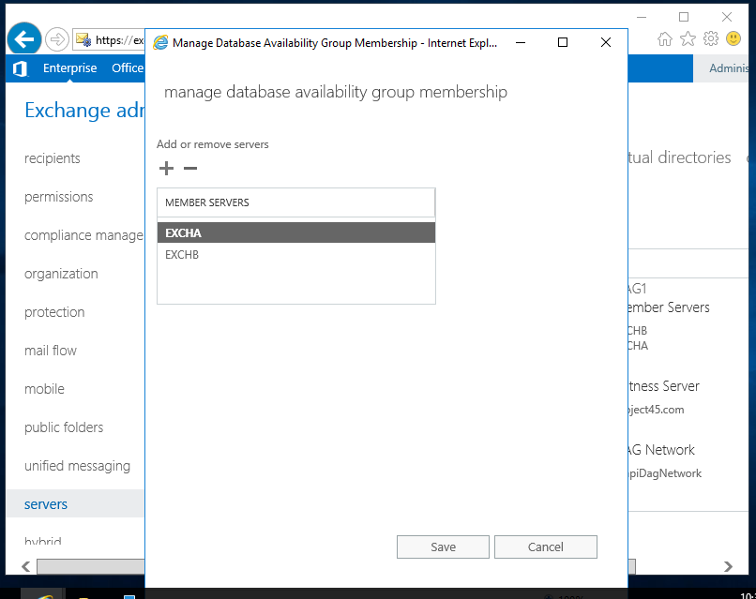

- After add DAG to ExchA and ExchA the resulted shown as:

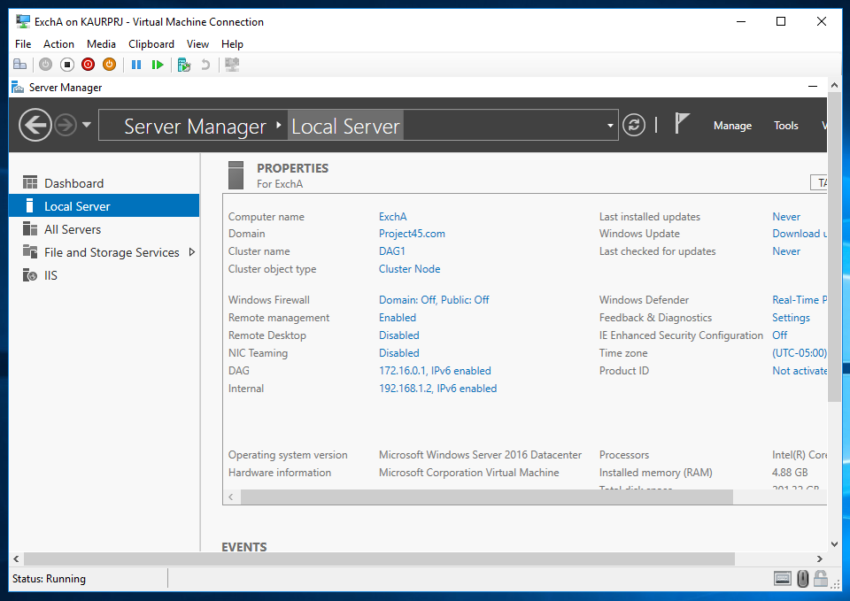
Screen shot of ExchA mail server after DAG

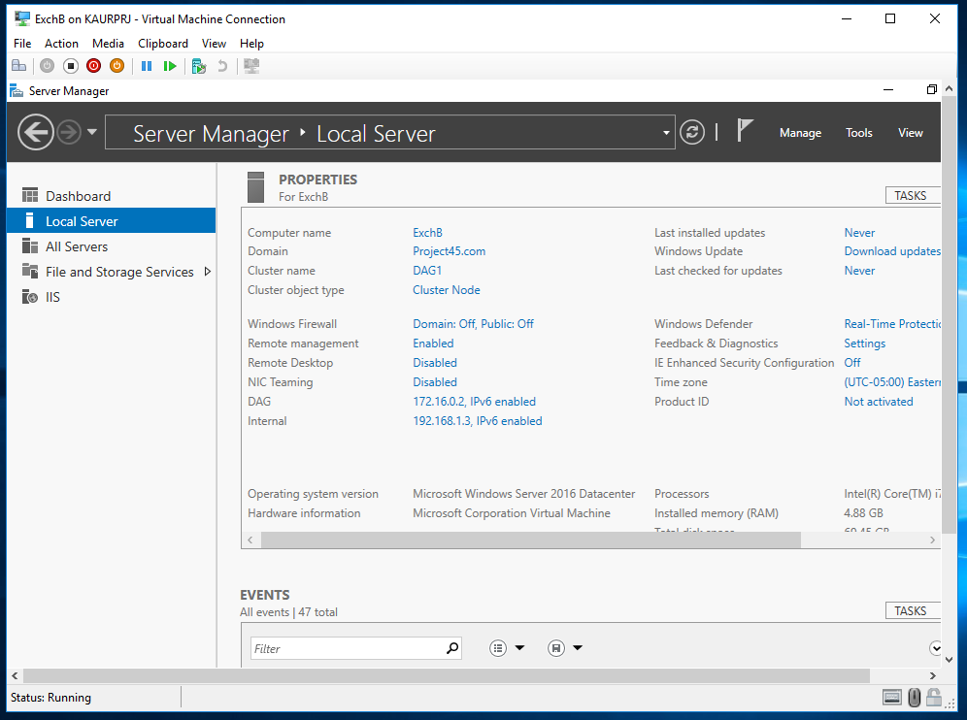
Screen shot of ExchB mail server after DAG

  - Run Add-MailboxDatabaseCopy as necessary
Login ExchA as domain\administrator.
Step:
- Open the Exchange Management Shell
- Run the following command:
Add-MailboxDatabaseCopy
Then fill the following field
Identity: Marketing Mailbox Database
MailboxServer: ExchA
- Run the following command:
Add-MailboxDatabaseCopy
Then fill the following field
Identity: Marketing Mailbox Database
MailboxServer: ExchB
- Run the following command:
Add-MailboxDatabaseCopy
Then fill the following field
Identity: Accounting Mailbox Database
MailboxServer: ExchA
- Run the following command:
Add-MailboxDatabaseCopy
Then fill the following field
Identity: Accounting Mailbox Database
MailboxServer: ExchB
- Run the following command:
Add-MailboxDatabaseCopy
Then fill the following field
Identity: Engineering Mailbox Database A
MailboxServer: ExchA

- Run the following command:
Add-MailboxDatabaseCopy
Then fill the following field
Identity: Engineering Mailbox Database A
MailboxServer: ExchB
- Run the following command:
Add-MailboxDatabaseCopy
Then fill the following field
Identity: Engineering Mailbox Database B
MailboxServer: ExchA
- Run the following command:
Add-MailboxDatabaseCopy
Then fill the following field
Identity: Engineering Mailbox Database B
MailboxServer: ExchB

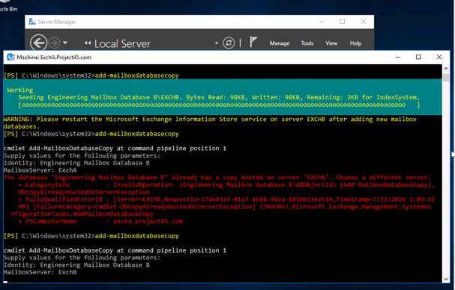
Screen shot of add mailbox database to ExchA mail server

Detail the Exchange features that you had to configure in order to provide this functionality and why:

Answer:

To Configure Exchange features on the Virtual machine ExchB I performed the following steps:
1. Install the.net framework (4.7.2).
2. Install visual C++2013
3. Install Unified Communication Management API 4.0
4. Install Exchange Feature
5. Extend Domain Schema
6. Prepare Active Directory

To provide complete fault tolerance for Exchange mailbox database in the event of Server failure we need to add DAG to our Exchange server. Implementing DAGs (database availability groups) is a major feature that solve the problem of downtime when it becomes to the database server. This is a database-to-database replication. To add the DAG to the Exchange server, require the following steps:

1. Add the Exchange Trusted Subsystem to the domain Administrator group.
2. Create ‘Witness’ folder in C:\ in the DC.
3. Add a DAG (choose Witness server and folder)
4. Add ExchA and ExchB to the DAG by using Exchange Admin Center.
5.Run ‘Add-MailboxDatabaseCopy ’command in the Exchange Management Shell to create replication.

DAG provides automates recovery at the database level after a database, server or network failure.

Conclusion

Successful completion of the project. In this project, the system was reimaged using software from the Trios college website. Configured the host computer as Domain Controller. Two Virtual machines were created in the Hyper-V: one is ExchA and other one is ExchB. IP addresses were statically assigned to the virtual machines and join these two servers with Domain Controller. Installed Exchange 2016 mailbox role on ExchA and ExchB. created send connector, created mailbox database, created mail-enabled group in AD, Set the email format, created recipient object, created address list in Exchange Management Shell, created forwarding Rules, created transport rules, created DLP policy, created fault tolerant in the event of server failure.

Administrator credentials: Administrator
Password: Secret555

REFERENCES

Mastering Microsoft exchange Server 2016
https://docs.microsoft.com

