16.Optimized Bubble Sort (Early Stop)
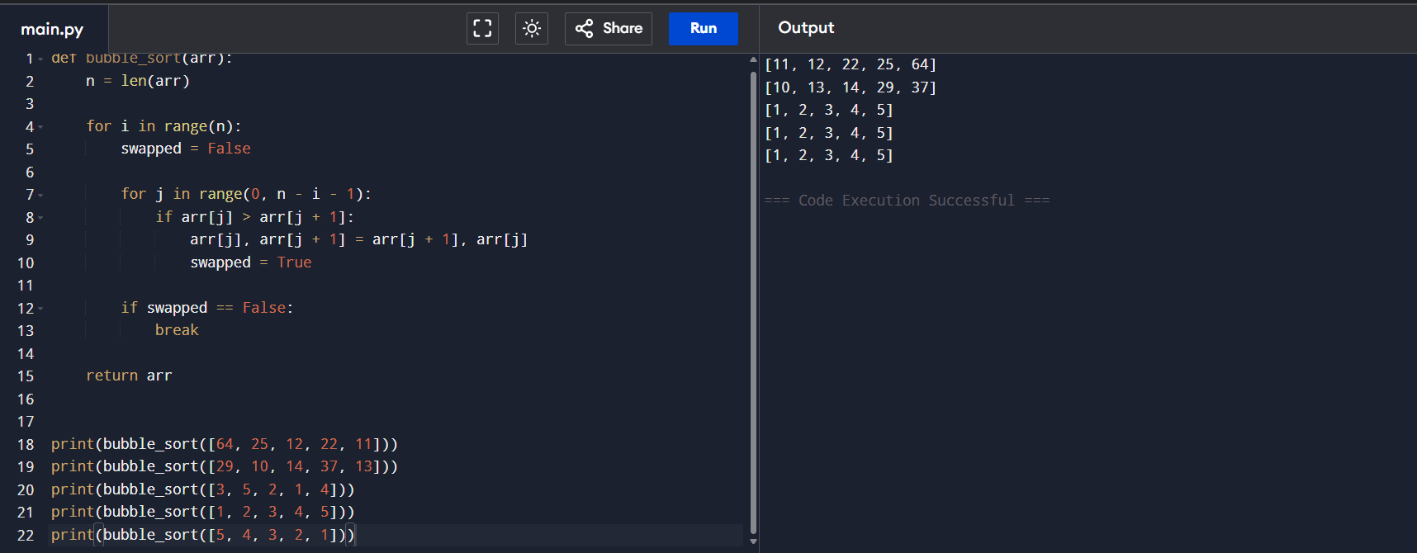
17. Insertion Sort with Duplicates
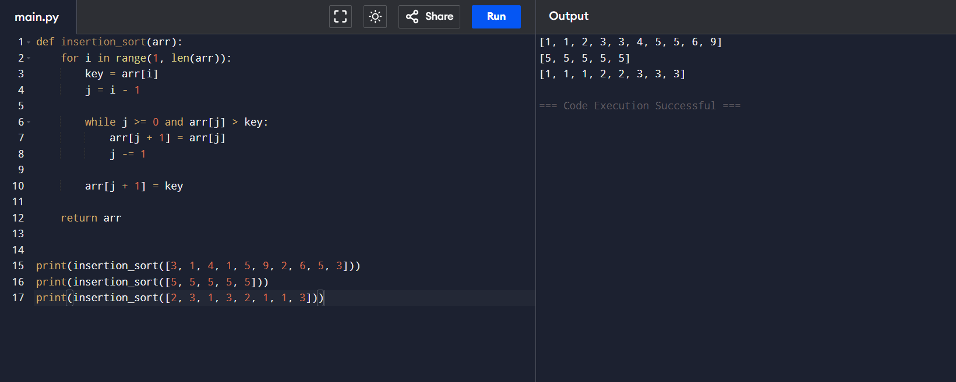

18. Kth Missing Positive Number
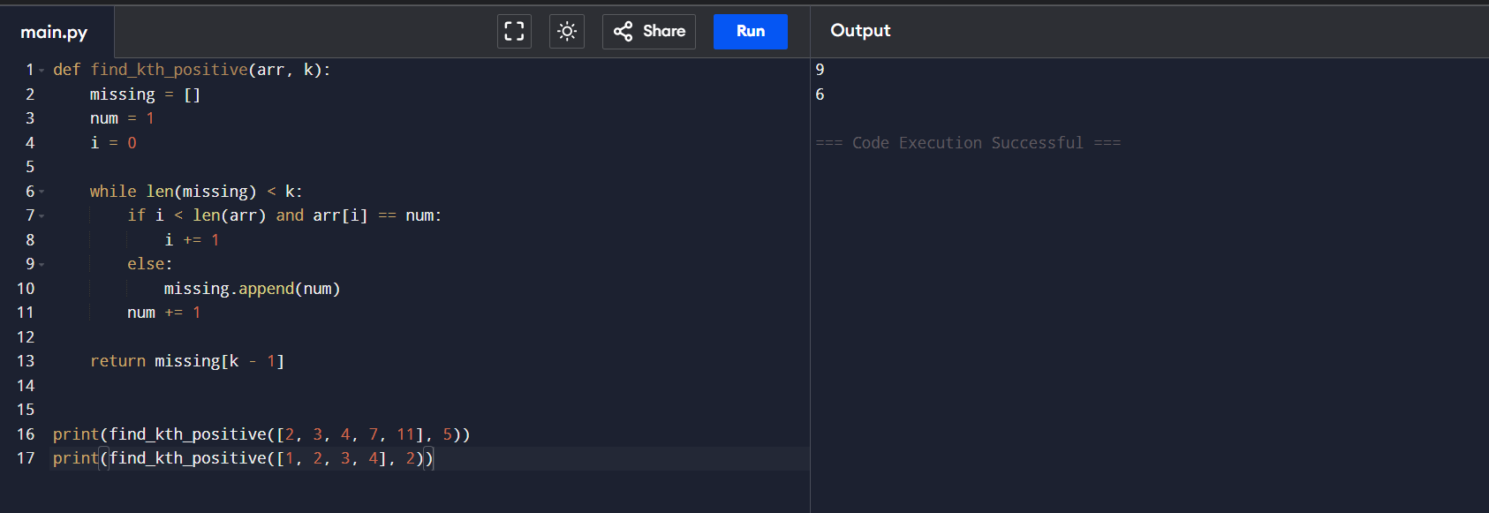
19. Find Peak Element
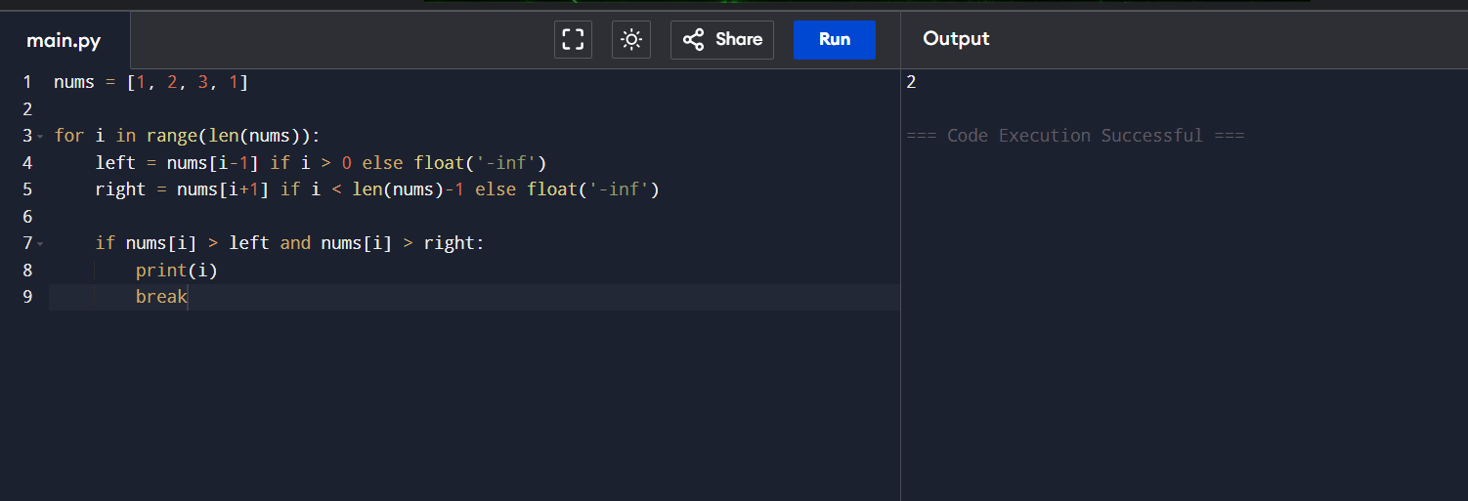
20. Needle in Haystack
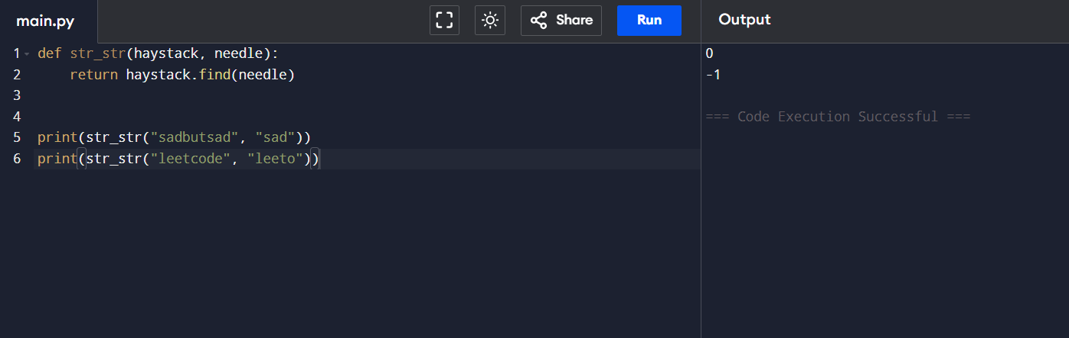

21. Median of Medians Algorithm
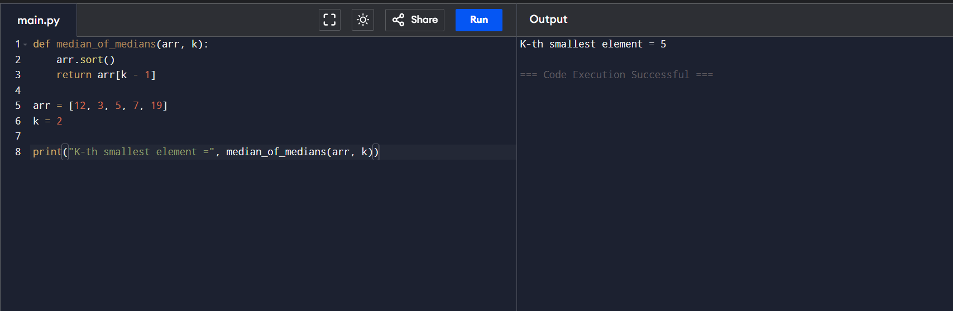22. Function median_of_medians(arr, k)
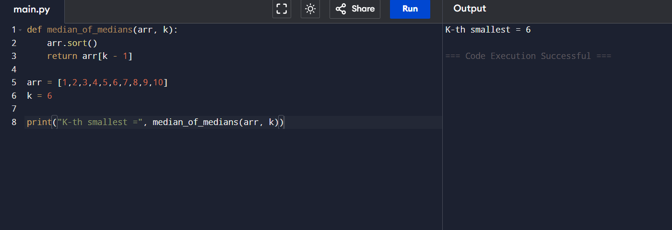
23. Strassen Matrix Multiplication
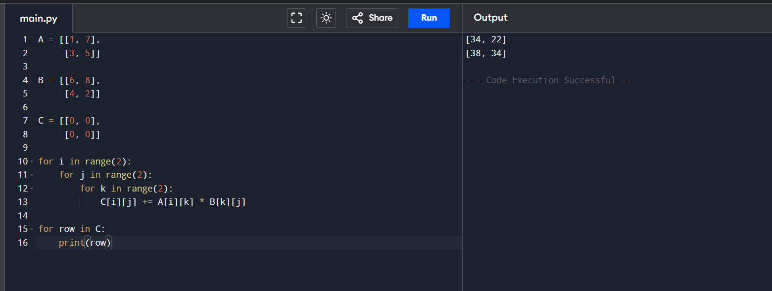

24. Maximum Number of Coins You Can Get
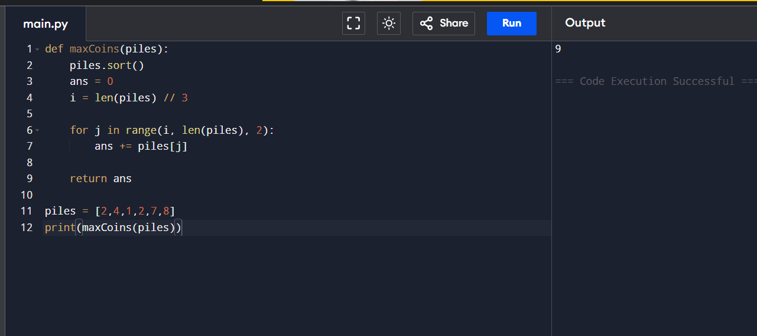
25. Four Sum Count
