

***E-PROJECT***



**GROUP MEMBERS**

Submitted to:

**Sir Ubaid Salim**

Student1491446 Muhammad Kaif

Student1490635 Abdul Samad

Student1488972 Nawabzada

Student 1490625 Abeer

Student1413834 Sultan



**INDEX OF CONTENT**

|  |  |
| --- | --- |
| **TOPICS** | **Pg.no** |
| **ACKNOWLEDGEMENT** | **3** |
| **INTRODUCTION** | **4** |
| **PROBLEM STATEMENT** | **5** |
| **HARDWARE AND SOFTWARE REQUIREMENTS** | **6** |
| **COLORS AND BRANDING** | **7** |
| **GROUP WORK FLOW** | **8** |
| **WEBSITE MODEL SCREENSHOTS** | **9** |
| **CODING SCREENSHOTS** | **14** |
| **CONCLUSION** | **16** |



**ACKNOWLEDGMENT**

We would like to express our heartfelt gratitude for the opportunity to work on this project as part of our second semester in Dynamic Website Development at Aptech Learning Institute. This project has been a valuable learning experience, allowing us to apply and enhance our skills in real-world scenarios. A special thanks to our faculty teacher, Sir Ubaid Salim, for his constant guidance, encouragement, and support throughout the project. His expertise and insights have been instrumental in our development and success.



**INTRODUCTION**

Welcome to Arts an stationery shop which sells stationery products like gift articles, greeting cards, wallets, office files, dolls, beauty products and etc. This web application is build with HTML, CSS, JavaScript, Bootstrap, PHP my MySQL. This app consist of pages like Home, Products, About us, Contact us and Admin panel and this app also have user authentication module. The color schemes used in this app are two different shades purple: #649da1 and #8f6f9e which represents the accent of a stationery shop.



**PROBLEM STATEMENT**

Our client is a retail dealer of various products like gift articles, dolls, files, etc. The customers usually visit the shop in order to purchase the products. He has a huge variety of products at his shop. Also as there is an increase in the demand of these products and as well as there is a huge variety of combinations and products available, and as the number of retail dealers are increasing day by day, it has become difficult to withheld in the market and as well to retain the customers.

Also as they don’t keep track of the products, it is hard to find how many products are available in the shop.

***Proposed Solution :*** –

In order to cope up in this competitive world, and to retain the customers, to automate the process, our client wants an application to be built meeting the current technology trend where the customers can place their order through online by sitting at their office/home, and providing the products as per the orders received by the dealer at the door steps of the customer.

He says that he wants that the application should hold the details of the products in detail like price, description of the product and each product is allocated with a unique 7 digit product id which includes 2 digit product code and 5 digit product number. Also he says that for fetching the details of the products, the customer need not be the registered one, but for placing an order one has to be the registered user of the site.

After placing an order, the dealer would dispatch the order as per the type of delivery that the customer has chosen. He says that the application should generate a unique 16 digit order number (includes the type of the delivery (1 digit) that the user has opted for, Product id (7 digit), and the order number (8 digit)) as soon as the order is placed by the customer.

For the order which is placed through the credit card payment or through cheque, the payment should be cleared first and then only the product will be dispatched to the customer’s premises. Also he has provided an option like if the customer is not satisfied by the product then the customer can either replace it (new product will not be sent) or he can return it back with in a week days time, so that he can get back his money which he has paid for that product. Also the warranty card will also be provided for the products which have some warranty.

The dealer alone should be able to update the details of the employees, products and their details, and he can check the orders that are received based on the date, order type (delivery) and he alone has the right to create an employee profile like username or login id and the password. The employee should only be able to change his password, and he can check the details of the orders so that the products can be dispatched as per the customer’s request and that they can be delivered in time.

Also he says that there should be an option on the web site where the customer can send their feedbacks regarding the services that they attain from them.

**►Non-Financial :**

* The dealer alone can manage the details of the products, employees and as well he can check the details of the orders, stock details, feedbacks and FAQ’s from the customers.
* The employee will only be able to change his/her password, and check and update the details of the orders and the delivery reports
* The details of the products, employees, orders, delivery/dispatching details and as well that of the customers, are needed to be maintained using the help of the database.
* Also the customer should be able to check the details of the order that he/she has placed.
* An advanced search option so as to fetch the details with an ease is to be implemented.
* The registered customers should alone be able to manage his/her account, orders placed by them and can check the details of the products while the non registered customers can only be able to check or fetch the details of the products and register with the site
* The application should be automated, so that the details like the number of products that are available with them, dispatched details like when the product has been dispatched, the payment details, and the delivery details can be attained at an ease.
* The details of the payments at the time of placing an order should be captured in details based on the type of payment/dispatch that the customer is willing to have like the detailed description of the payments (credit card details if the payment is through the credit card, and cheque details if the payment is through cheque.
* The customer can only be able to cancel the order provided that the product is not dispatched from the dealer’s premises.

**►Financial :**

* For the customers who have placed an order for which the payment type is either through cheque or through credit card, only after the clearance of the payment the products will be dispatched.
* If the order placed is through VPP, the customer is needed to make the payment at the time of delivery at their premises.
* If the customer is not satisfied with the product then he can either place a request for replacing the product or he can return the product, so that he/she can get the payment back, provided the product is returned with in the week days time from the time of the delivery of the product at the customer’s premises.

***Functional Requirements : –***

* Maintaining the details of the Employees, product details, stock details, order, and delivery details of the products and that of the customers are to be maintained with the help of the database.

There should be separate login for Admin, Employees and for the customer.



**HARDWARE AND SOFTWARE REQUIREMENTS**

**Hardware**

* A minimum computer system that will help you access all the tools in the courses is a Pentium 166 or better
* 128 Megabytes of RAM or better

**Software**

* PHP
* MySQL
* PERL
* Apache



**COLORS AND BRANDING**

The color combination of #649da1 and #8f6f9e for the Arts stationery shop website brings a modern and elegant touch with shades of purple. These colors are soft yet professional, creating a calm and inviting atmosphere that reflects the creativity and organization associated with a stationery shop. The cooler tone of #649da1 adds a refreshing, tranquil vibe, while the deeper hue of #8f6f9e adds warmth and sophistication, making the overall design both visually appealing and representative of the shop's essence.

**COLOR CODES:**

PURPLE: #649DA1

ORANGE: #FFBD59

**BRANDING:**





**GROUP WORK FLOW**

|  |  |  |  |
| --- | --- | --- | --- |
| **No.** | **Task** | **Days taken** | **Team member** |
| **1** | **Project Idea discussion** | **2** | **Muhammad Kaif and Abdul Samad** |
| **2** | **Home page and functionality** | **3** | **Abdul Samad** |
| **3** | **Products pages and functionality** | **3** | **Muhammad Kaif** |
| **4** | **About page** | **2** | **Abeer** |
| **5** | **Contact Page** | **1** | **Nawabzada** |
| **6** | **User authentication** | **2** | **Abdul Samad** |
| **7** | **Admin Panel and functionality** | **3** | **Muhammad kaif** |
| **8** | **Testing** | **2** | **Muhammad Kaif and Abdul Samad** |
| **9** | **Documentation** | **1** | **Muhammad Kaif** |



**WEBSITE MODEL SCREENSHOTS**

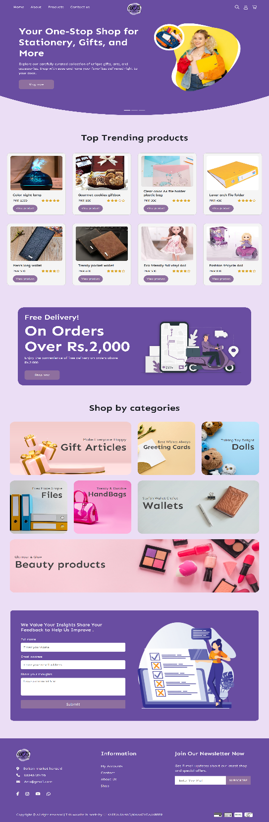



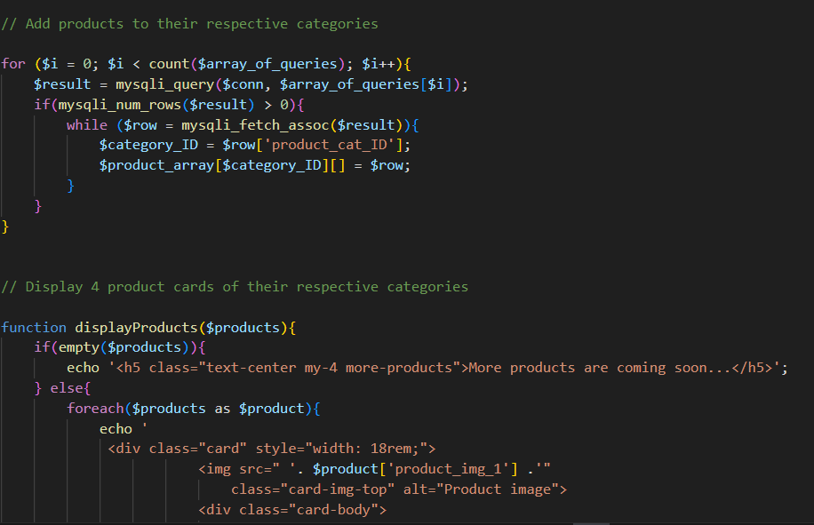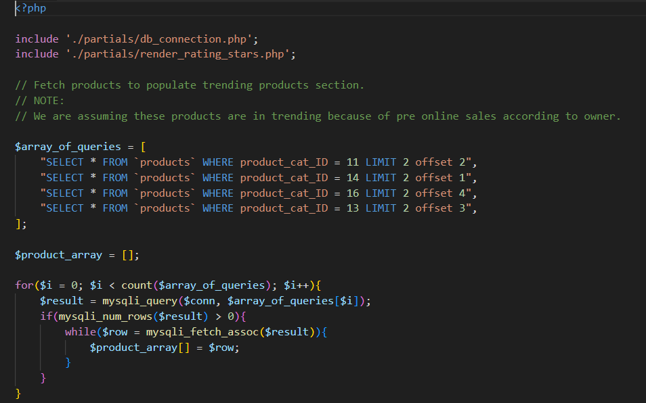**Coding screenshots**

**CONCLUSION**

In conclusion, this arts eCommerce website project has been a highly enriching experience that allowed us to gain practical knowledge in building a modern, dynamic website. Through this project, we learned how to integrate various web development technologies, including HTML, CSS, JavaScript, PHP, and MySQL, to create a seamless and user-friendly platform. It taught us the importance of responsive design, database management, and the functionality needed to handle real-world eCommerce transactions. This project not only improved our technical skills but also deepened our understanding of developing interactive, user-centric websites that meet today's digital standards.