Page 43

Vision for Surrey 2030 –
Evidence base​


1

Page 44
Summary

This evidence base informs the Vision for Surrey 2030 by presenting a picture of what life in Surrey is like and the challenges within the county. The evidence is a snapshot of data from an array of quantitative sources such as Surrey-I, governmental statistics and NOMIS. This informs the outcomes set out within the vision by identifying the key issues around the themes of ‘people’ and ‘place’ in Surrey.

People

Our population continues to grow and is predicted to age as time goes on. But the current population is largely healthy and active and comprised of a highly skilled workforce that is supported by good performing schools. Overall, educational attainment is positive however there are significant disparities for deprived children and those with additional needs. There are increasing demands on services for vulnerable adults and children, and children with additional needs. Pockets of deprivation exist across the county, and foodbank usage has risen.

Place

Housing is increasingly expensive which exacerbates the challenge to respond to the growing need for affordable housing – especially for residents on low incomes. Surrey’s economy is strong and is proving to be a popular place for businesses, which contributes to many residents’ high and increasing earnings and disposable income. However, growth appears to be stagnating in some places. Our county is well regarded as a nice place to live, with good access to green spaces and woodland. But homelessness, fuel poverty and crime are increasing, and there is dissatisfaction with the county’s road network.

2

A growing and ageing population
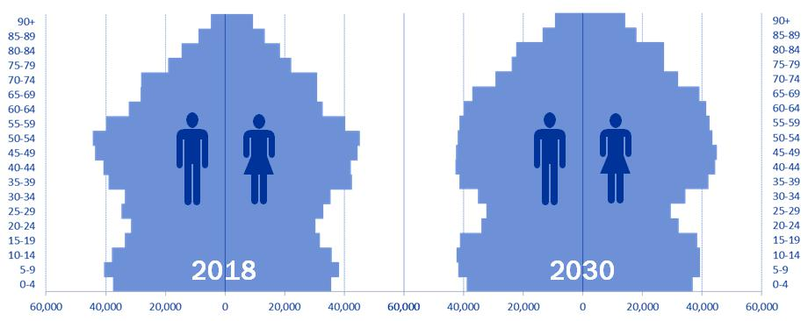

Page 45

Source: Surrey-i (Office for National Statistics)

The latest data shows Surrey’s population is growing rapidly, with more people living longer and consistently high birth rates. For instance, by 2030, Surrey’s population is expected to grow from an estimated 1,194,500 in 2018 to 1,264,000, and over 22% of residents will be aged 65 and over (compared to 19% in 2018).

Surrey is also becoming more ethnically diverse. According to census records, between 2001 and 2011 there was a 28.8% increase of Non-White British and Mixed/Multiple Ethnicity residents living in the county.

Highly skilled working population

Over half (50.1%) of Surrey’s working age population (16 – 64 year olds) hold a degree-level qualification. This greatly exceeds the England average of 38%. In addition, the proportion of people in Surrey holding lower-level or no qualifications continued to decrease over the last decade.

 | 60%
 | 50%
46Page | 40%
46Page | 30%
 | 20%
 | 10%
 | 0%
 | 2007 | 2008 | 2009 | 2010 | 2011 | 2012 | 2013 | 2014 | 2015 | 2016 | 2017
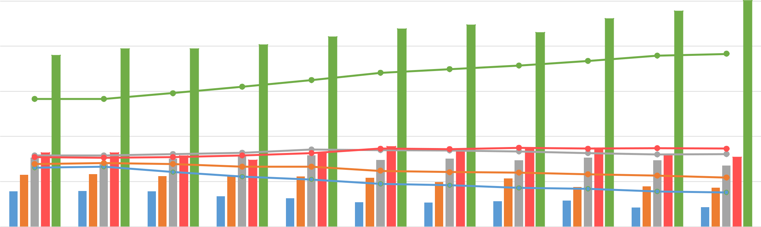

No qualifications (Surrey) |  | NVQ1 only (Surrey) |  | NVQ2 only (Surrey) |  | NVQ3 only (Surrey) |  | NVQ4 & above (Surrey)
No qualifications (England) |  | NVQ1 only (England) |  | NVQ2 only (England) |  | NVQ3 only (England) |  | NVQ4 & above (England)
 |  |  |  |  |  |  | 4
Source: Annual Population Survey (2017)

Falling employment

The employment rate has marginally decreased over time but fell particularly in the last year. However, this is not reflective of the unemployment rate which has also decreased. There has been a reduction in the amount of out-of-work benefit claimants over time, but there has been an increase particularly over the last 3 years.

Page 47

85 |  | Employment rate |  | 82.4
 |  |  | 81.4 | 82.4
 | 80 |  | 81.4 |  | 79.8
 | 80 | 79.9
80
75
 |  | Surrey | South East | Great Britain
70
Source: Nomis 2013/14 |  | 2014/15 | 2015/16 | 2016/17 | 2017/18
 |  | Unemployment rate
8 | 7.2
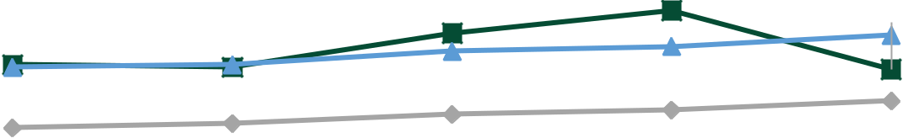
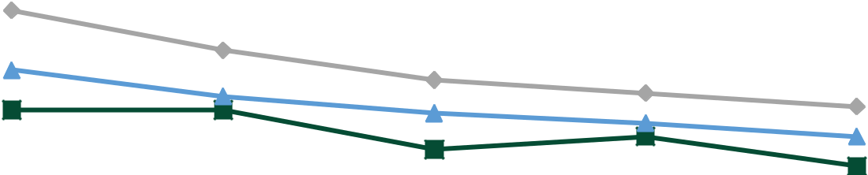

6 | 5.4
6 |  |  |  | 4.3
 | 4.2 |  |  | 4.3
4 |  |  |  | 3.4
4 |  |  |  | 2.5
2 |  | Surrey | South East | Great Britain
 | Source: Nomis | Surrey | South East | Great Britain
0

Out-of-work claimant count (Universal

Credit & Job Seekers Allowance)

6995
 | 4895 |  | 5065 | 5280
 |  | 4270
2013/14 | 2014/15 | 2015/16 | 2016/17 | 2017/18
Source: Nomis |  |  |  | 5

2013/14 2014/15 2015/16 2016/17 2017/18

High performing schools but some pupils being left behind

94% | Surrey schools rated
94% | ‘good’ or ‘outstanding
Source: Child First: Commissioning intentions for Surrey (2017)

Average Attainment 8 score declined slightly but Surrey pupils continue to outperform against South East and England peers.

Page | 100.0
Page | 90.0
48 | 80.0
48 | 70.0
 | 60.0 | 52.8 | 51.0 |  | 48.5 |  | 50.0 |  |  | 47.4 | 44.6
 | 50.0
 | 40.0
 | 30.0
 | 20.0
 | 10.0
 | 0.0
 | 0.0 |  | 2015/16 |  |  |  |  |  |  | 2016/17
 |  |  |  | Surrey |  | South East |  |  | England


Source: Department for Education (2017). Attainment 8 measures average achievement of pupils for up to eight qualifications including English, maths, three further English Baccalaureate qualifications and three further GCSE or non-GCSE qualifications. Decline in performance was expected because of change to 9 – 1 GSCE grading system.

In spite of Surrey schools’ strong educational performance, deprived pupils and those with additional needs are far less likely to do as well at school as their peers.

50 |  | 52.7
50 | 47.4
 |  |  | 34.4 | 36.9
 |  |  | 34.4 |  | 33.2
All pupils | Boys | Girls | Free school | Disadvantaged | Special
(Surrey) |  |  | meals |  | Educational

Needs (SEN)
Source: Department for Education (2017) ^{support}

6

Growing Educational Health and Care plans (EHCP) and
Special Educational Needs (SEN) support

While remaining consistently higher than the South East and England, the number of pupils with a statement or EHCP maintained by Surrey has increased (5,631 – 7,710).

Page | Percentage of children with statements or
49 | EHC plans in Surrey schools
 | 3.3
 | 3.1
 | 3.1
 | 2.9
 | 2.9
 | 2.8
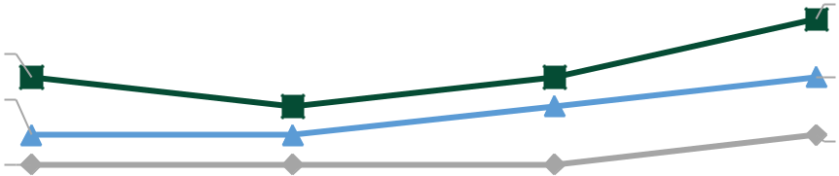

Contrary to regional and national trends, the proportion of pupils in Surrey that require SEN support has increased – now equivalent to the national percentage. This marks an increase from 21,540 to 22,745 pupils.

Percentage of pupils with SEN support

12.6
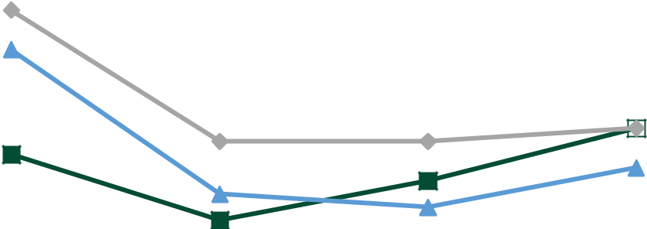

12.3

 | 11.7
11.5 | 11.4

2015 | 2016 |  |  |  |  | 2017 |  | 2018 | 2015 | 2016 |  |  |  |  | 2017 |  | 2018
Source: Department |  |  |  |  |  |  |  |  | Source: Department |  |  |  |  |  |  |  | 7
for Education |  |  |  | Surrey |  | South East |  | England | for Education |  |  |  | Surrey |  | South East |  | England

More children in need but fewer subject to protection plans

Despite having fewer looked after children (LAC) per 10,000 children, the number has increased from 795 to 870 (2013/14 – 16/17). This increase is a similar rate to the South East region.

Source: Surrey-i

 | 60 |  |  |  | 60
 | 48 |  |  |  | 52
50Page | 31 |  |  |  | 34
50Page |  | Surrey | South East | England
 | 2013/14 | 2014/15 |  | 2015/16 | 2016/17

Furthermore there has been considerable increase in the number of unaccompanied asylum seeking (UASC) children.
- Source: Surrey-i

In contrast to the South East and England, the number of children subject to a Child Protection Plan (CPP) has decreased (925 – 843).

CPP per 10,000

42.1 | 43.3
42.1 | 41.3
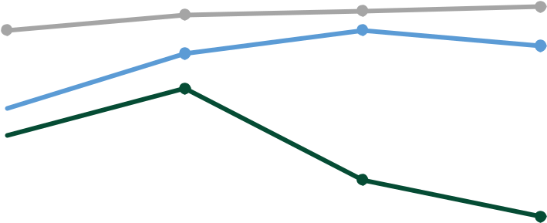

38.1
36.7

150

140


32.5

- ₆₀

50

0

2010/11 2011/12 2012/13 2013/14 2014/15 2015/16 2016/17

2013/14 | 2014/15 |  |  | 2015/16 |  |  | 2016/17
Source: Surrey-i |  | Surrey |  | South East |  |  |  | England | 8

Page 51
Healthy and active lives

- The percentage of physically active adults (150+ minutes of activity per week) in Surrey is
70.3% (2016/17). This is greater than the South East (68.9%) and England (66%) averages.

- The percentage of physically inactive adults (less than 30 minutes of activity per week) in Surrey is 18.6% (2016/17). This is less than the South East (19.3%) and England averages (22.2%).

- 10.9% of Surrey’s adult population smoke (2017). The prevalence is lower than the figures for the South East (13.7%) and England (14.9%).

- The number of hospital admissions for alcohol related conditions has increased: 1,520 per 100,000 (2010/11) to 1,813 per 100,000 (2016/17). Surrey has performed consistently better
than national trends but has fluctuated compared to South East trends.

Source: Public Health England

9

Living longer

Surrey residents tend to live long and healthy lives, exceeding the national average for both males and females.

Page 52

Living for longer

Source: Surrey-i

Living healthy lives for longer

(the average number of years that an individual is expected to live in a state of self-assessed good or very good health)

Source: Surrey-i

Life Expectancy at Birth:
males (2014 – 16)


vs

Surrey England

Healthy Life Expectancy at Birth: males (2014 – 16)


vs

Surrey England

Life Expectancy at Birth: females (2014 – 16)


vs
Surrey England

Healthy Life Expectancy at Birth:
females (2014 – 16)


vs
Surrey England

10

Fewer reported long-term disabilities but predicted increases in
learning disabilities and mental health problems

Surrey residents aged (16–64) are less likely to have a long-term disability which affects day-to-day activities or the amount of work they can do, compared to the South East or England (2017/18).


Page Surrey South East England

53 Source: Surrey-i

However, the number of working aged residents predicted to have learning disabilities is projected to increase by 5% by 2030 (17,139 – 17,916).
20000 ₁₇₁₃₉ 17361 17654 ¹⁷⁹¹⁶

15000

10000

5000

0

2017 2020 2025 2030

Source: Projected Adult Needs and Service Information

- The percentage of people reporting a long-term mental health problem (2016/17) is 4.6%. The percentage for the South East is 5.4% and for England is 5.7%.

Source: Public Health England

- Hospital admissions for mental health conditions (2016/17) = 85.7 per 100,000, South East = 82 per 100,000, England = 81.5 per 100,000.
Source: Public Health England

- 113,848 Surrey residents (2017) aged 18-64 are predicted to have a common mental disorder. This is projected to increase by 4%, to 118,446 (2030).

Source: Public Health England

11

Page 54
‘Affluent’ Surrey has pockets of deprivation

The 25 most deprived
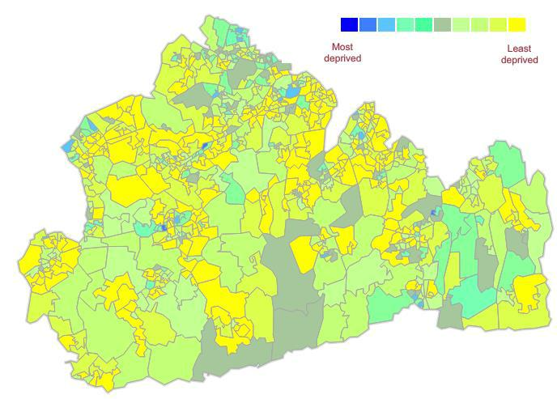
neighbourhoods in
Surrey, according to
the Indices of
Multiple Deprivation
(2015), are also
within the third most
deprived areas in the
county.

- neighbourhoods across Surrey rank among the worst third of areas in the country for children aged under the age of

- that live low
^{income households.} Source: Ministry of Housing, Communities & Local Government

12

Rising foodbank usage

Page 55

The number of three-day emergency food supplies distributed by Trussell Trust foodbanks in Surrey has more than doubled. The increase well exceeds Surrey’s South East neighbours. Latest figures also show that 2 in 5 emergency food supplies are for children.

Percentage change: Trussell Trust 3-day food supplies

provided - South East

Berkshire | -19%
East Sussex
East Sussex |  |  |  |  |  |  |  |  | 36%
Hampshire | -4%
Isle of Wight | -21%
Kent
Kent |  |  |  |  |  |  | 25%
Oxfordshire
Oxfordshire |  |  |  |  |  | 4%
Surrey |  |  |  |  | 111%
West Sussex
West Sussex |  |  |  |  |  |  |  | 30%

Number of three day food supplies 2013/14 – 2016/17 14331
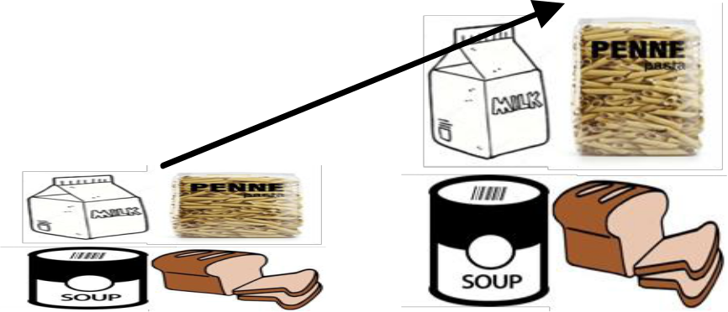

111%

6787

2 in 5 emergency food bank supplies are for children


13

Page 56
A socially mobile county

The Social Mobility Commission’s
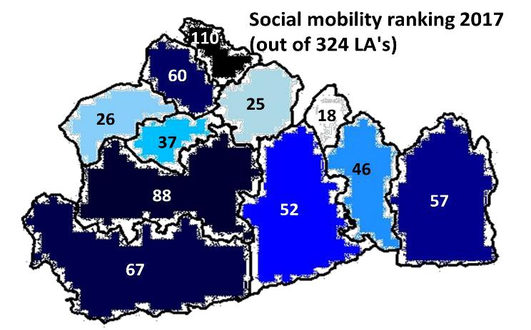

‘State of the nation’ report suggests that residents in Surrey have positive social mobility outcomes– meaning, residents from a poor background have good prospects for moving up a social hierarchy.

Surrey’s local authorities had a combined average ranking of 53rd of 324 (1st being the highest).

Epsom & Ewell, Elmbridge and Surrey Heath are ranked in the top 10% of local authorities in the country. Woking, Reigate & Banstead, Mole Valley, Tandridge and Runnymede ranked in the top
20% 14
Expensive housing

The median house price in Surrey is £430,000 following

The gap between median earnings and house price has

a 35% increase over the last 4 years. This increase

increased by 37% (9 to 11.9) and continues to exceed both

exceeds both the rate in England and the South East

the England and South East average.

(24% and 34% respectively).

Page |  |  | Median House Price |  |  |  | Ratio: median earnings to median house price |  |  |  |  | 11.9
57 |  |  |  |  |  |  |  |  |  |  |  | 11.9
57 | £500,000 |  |  |  |  | £430,000 | 12.0
 | £450,000 |  |  |  |  | £430,000 |  |  |  |  |  | 9.8
 | £450,000 |  |  |  |  |  | 10.0 |  |  |  |  | 9.8
 | £400,000 |  |  |  |  |  | 10.0
 | £400,000 |  |  |  |  |  |  |  |  |  |  | 7.9
 | £350,000 | £317,500 |  |  |  | £315,000 |  |  |  |  |  | 7.9
 | £350,000 | £317,500 |  |  |  | £315,000 | 8.0
 | £300,000 | £235,000 |  |  |  | £234,000
 | £250,000 | £235,000 |  |  |  | £234,000 | 6.0
 | £250,000 | £188,000
 | £200,000 | £188,000
 | £200,000 |  |  |  |  |  | 4.0
 | £150,000 |  |  |  |  |  | 4.0
 | £100,000 |  |  |  |  |  | 2.0 | England |  | South East | Surrey
 |  |  | England | South East | Surrey |  |  | England |  | South East | Surrey
 | £50,000 |  | England | South East | Surrey
 | £50,000 |  |  |  |  |  | 0.0
 | £0 |  |  |  |  |  | 0.0
 | £0 |  |  |  |  |  | 2012 | 2013 | 2014 | 2015 | 2016 | 2017
 |  | 2013 | 2014 | 2015 | 2016 | 2017
 | Source: Surrey-I |  |  |  |  |  | Source: Surrey-I
 | Source: Surrey-I |  |  |  |  |  | Source: Surrey-I |  |  |  |  | 15
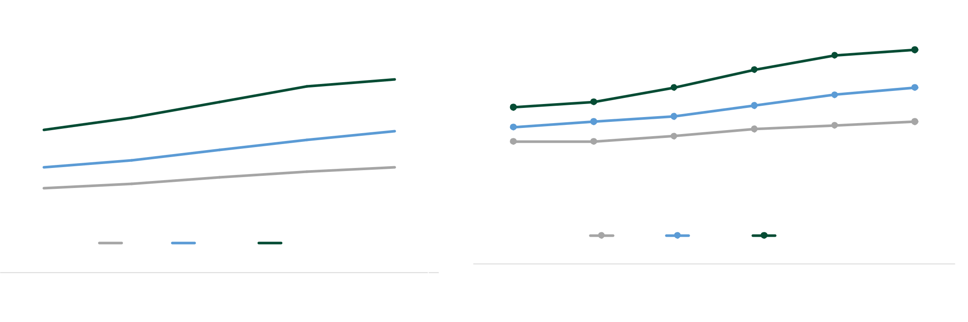

Projected increase in housing constructions but constraints on
the infrastructure to support it

There has been approximately 10,040 new dwellings built in Surrey comprised of a 23% (2240 – 2760) increase in the number of dwellings completed. However both overall and tenure figures have fluctuated over time.
Number of dwellings completed and tenure over time

Page | 3500
58 | 3000
 | 2500 |  |  |  |  |  |  | 850 | 540
 | 2000 | 300
 | 2000 |  |  |  | 590
 | 1500
 | 1000 | 1940 |  |  |  |  |  | 2020 | 2220
 | 1000 |  |  |  | 1580 |  |  | 2020
 | 500
 | 0
 |  | 2013/14 |  |  | 2014/15 |  |  | 2015/16 | 2016/17
 |  |  |  | Private |  |  | Housing Association & Local Authority
 |  |  |  | Enterprise
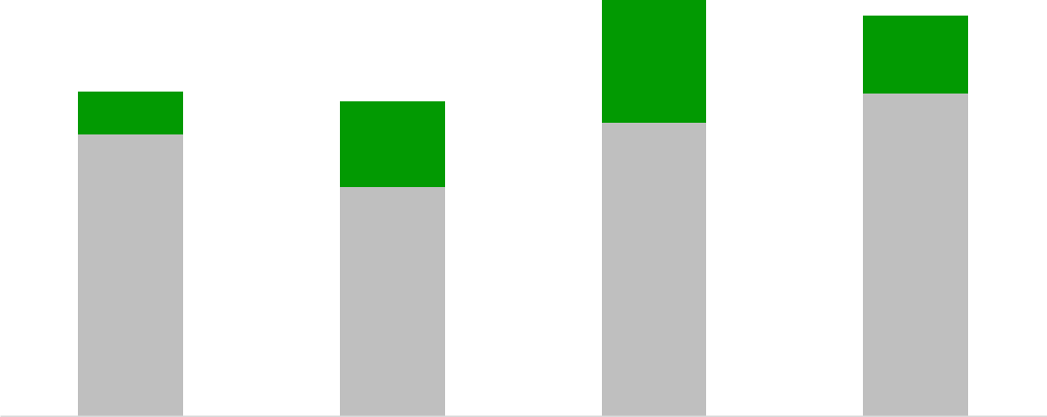

- Between 2015 – 2030 Surrey authorities planned to deliver on average 3,137 dwellings per year. This comes to a total of 47,053 dwellings to 2030.

- Delivering the infrastructure to support growth was identified to cost at least £5.37 billion to 2030. However when considering the amount of potential funding, there is a projected minimum gap in infrastructure funding of £3.2 billion between 2015 to
2030.

Source: Surrey Infrastructure Study

Source: Ministry of Housing Communities and Local Government ₁₆

Falling social accommodation waiting lists but challenges around affordable housing need remain

Social accommodation waiting lists have decreased by
24% but there has been some fluctuation.

Despite decreasing at a steady rate, the number of residents claiming housing benefit living in private accommodation has remained relatively consistent with the length of social accommodation waiting lists. This may relate to the affordable housing completions as people on waiting lists often have to reside in private accommodation until a form of social housing is available.

17067
 | 14333 | 15009
 | 14333 |  | 12888
2014 | 2015 | 2016 | 2017

Source: Ministry of Housing, Communities & Local Government

Housing Benefit recipients - type

of accommodation

33532 | 33448 | 33160 | 32496

¹⁶⁵¹⁵ ¹⁵⁸⁴⁷ 14918 ₁₄₂₀₂

Social Rented Accommodation

Private Rented Accommodation

2014 2015 2016 2017

Affordable housing

 | completions
 |  | 927
 | 806
517 |  |  | 536
2013/14 | 2014/15 | 2015/16 | 2016/17

Source: Ministry of Housing, | Source: Surrey-i
Communities & Local Government | Source: Surrey-i
Communities & Local Government | 17

Page 59

Page 60
Increasing homelessness

The number of residents in temporary accommodation has increased by 33% and the overall reduction in preventions may suggest there is a challenge in responding to the increase.
Temporary Accommodation _{Homelessness Prevention}

 |  | 787 | 829
 | 707 | 787 | 2807 | 2682 |  | 2524
 | 707 |  |  |  | 2281 | 2524
624 |  |  |  |  | 2281
 |  |  | 2013/14 | 2014/15 | 2015/16 | 2016/17
2013/14 | 2014/15 | 2015/16 | 2016/17
 |  |  | Source: Ministry of Housing, Communities & Local Government
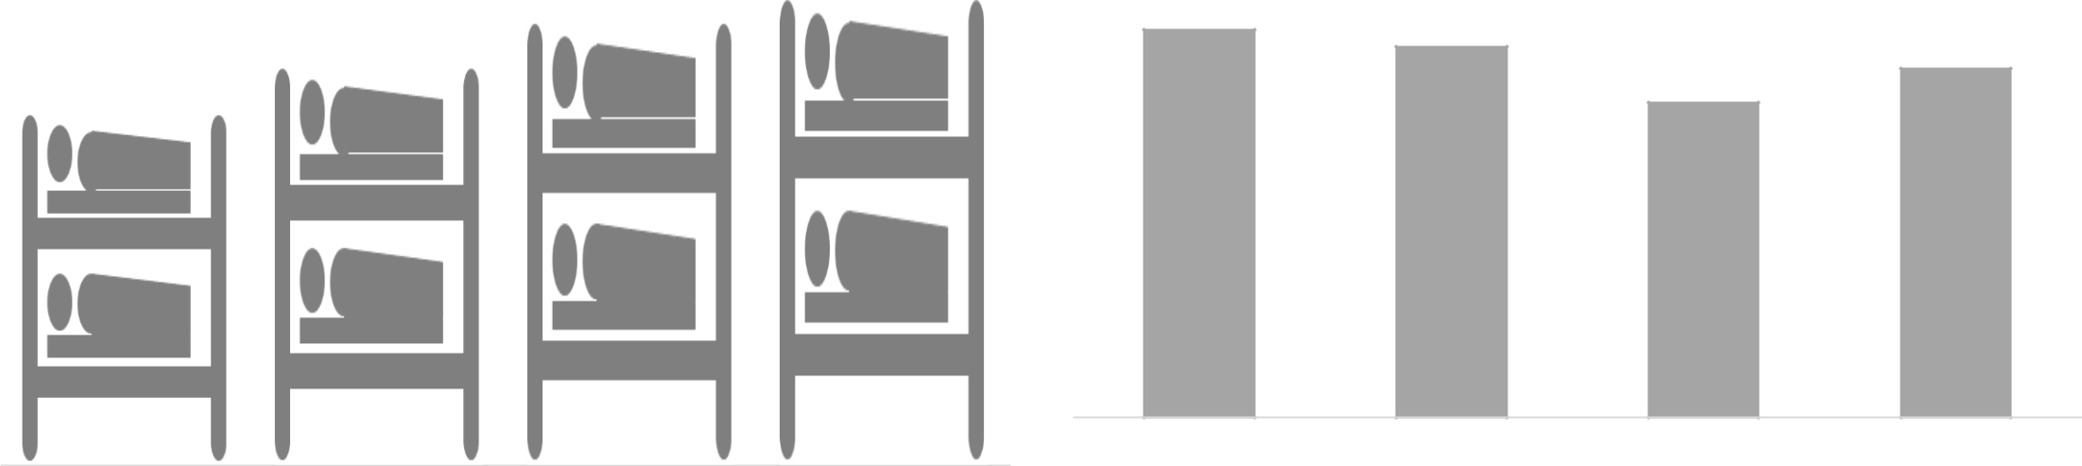
Source: Ministry of Housing, Communities & Local Government | 18

Increasing fuel poverty

Page 61

Although the rate in Surrey has remained lower than the South East and England average, the proportion of fuel poor households has increased. This marks an increase from an estimated 34,424 to 39,022 households.

12% | 11.0% | 11.1%
 | 10.6%
10% | 9.4% | 9.0%
 | 8.3% | 8.1%
 | 7.7% | 8.1%
8% | 7.7%
8% | 7.3%


6%

4%
Surrey | South East | England
2%
0%
2014 | 2015 | 2016

19

Source: Department for Business, Energy & Industrial Strategy

A strong economy but divergence between the East and West

Productivity growth has continued to increase (£28,701 - £34,070 gross value added (GVA) per head of population), remaining consistently better than the South East and England averages. However, growth in East Surrey appears to be stagnating.

Page | £40,000 |  |  | GVA per head of population
Page | £38,000
62 | £38,000 |  |  |  |  |  |  | £35,935
 | £36,000 |  |  |  |  |  |  | £35,935
 | £36,000 |  |  |  |  |  |  | £34,070
 | £34,000 |  |  |  | £32,861
 | £32,000 |  |  |  | £31,776
 | £32,000 |  |  |  |  |  |  | £30,422
 |  | £29,472 |  |  | £29,649 |  |  | £30,422
 | £30,000 | £29,472 |  |  | £29,649
 | £30,000 | £28,701 |  |  |  |  |  | £28,506
 | £28,000 | £27,185 |  |  | £26,295 |  |  | £27,060
 | £26,000 | £24,421 |  |  | £24,705
 | £24,000 | £22,866
 | £22,000 |  | Surrey | East Surrey | West Surrey | South East | England
 | £20,000
 | Source: Surrey-I | 2010 | 2011 | 2012 | 2013 | 2014 | 2015 | 2016
 | Source: Surrey-I |  |  |  |  |  |  | 20
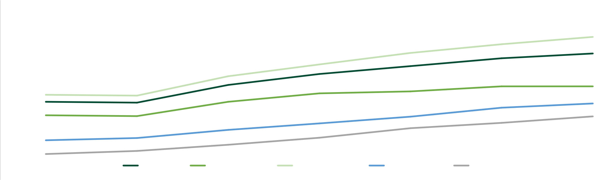
High and increasing earnings

Residents’ median weekly earnings have continued to increase. This is reflected in Surrey’s

high disposable household income (£27,865 per head per year) which has increased at a greater rate than the South East and England.

Median weekly earnings (full time workers) Disposable household income per head

Page |  |  |  | £668 | £680 | £30,000
63 | £650 | £646 | £653 | £615 | £620 | £25,000
63 | £578 | £591 | £598 | £615 | £620 | £25,000
 |  |  |  |  |  | £20,000
 |  |  |  |  |  | £15,000
 |  |  |  |  |  | £10,000
 |  |  |  |  |  | £5,000 | Surrey | South East | England
 | 2013 | 2014 | 2015 | 2016 | 2017 | £0
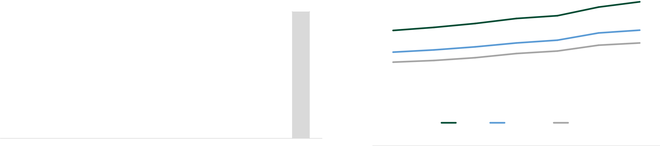
 | Median weekly earnings - workplace-based |  | Median weekly earnings - residence-based | 2010 | 2011 | 2012 | 2013 | 2014 | 2015 | 2016

Source: Surrey-I | Source: Surrey-I

21

An attractive place for businesses

The number of active enterprise per 10,000 population has remained considerably higher than the South East and England, with business births exceeding business deaths each year.

Page 64

Active enterprises per 10,000 population

700

600
500
400
300
200
100 | Surrey |  | South East |  | England
0
2010 | 2011 | 2012 | 2013 | 2014 | 2015 | 2016


Source: Surrey-I

Active enterprises percentage annual

change

7
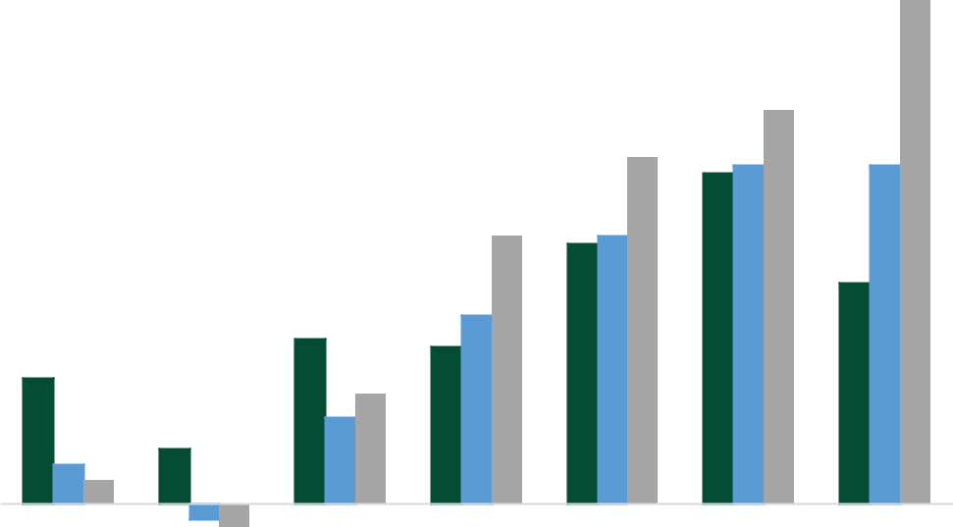

6

5

4

3

2

1

0
2010 2011 2012 2013 2014 2015 2016
-1

Source: Surrey-I |  | Surrey |  | South East |  | England | 22

A mixed workforce from inside and outside of the county

57.5% of our residents work in Surrey and almost a quarter are working in a London borough. Of the people that work in Surrey, around 16% live in a London borough and 24% live elsewhere.

Workplace of Surrey residents

65Page | 57.5%


 |  |  | 23.2%
 |  | 8.5% |  | 9.3%
 |  |  |  |  | 1.5%
 | Work in Surrey | No fixed | Working in a | Working in | Working
 |  | workplace | London borough another SE county |  | elsewhere
Office for National Statistics 2011 |  |  |  | or unitary
 |  |  |  | authority




Place of residence of people who work in Surrey

60.6%


 |  | 20.0%
 | 15.7%
 |  |  | 3.6%
Live in a Surrey | Live in a London | Live in another South | Live elsewhere in the
 | borough | East county or unitary | UK
 |  | authority | 23




Rising crime and growing resident concerns

14%

Increase in the number of crimes recorded in Surrey – second highest rate of increase in the South East between March 2017 and March 2018.

The number of recorded crimes has increased across Surrey and the South East. Surrey has seen a greater than regional average increase in recorded burglary, criminal damage and drug offences, and significant increases in robbery and violent crime.
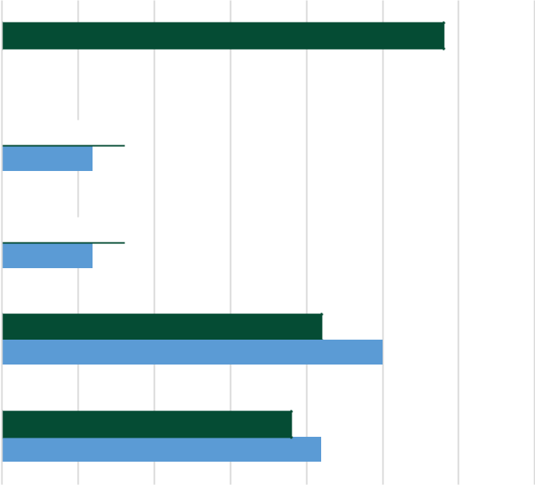

Residents’ concerns with the levels of crime appear to be growing,
particularly with crimes such as burglary, drug dealing and vandalism.
66PageConcern with physical attacks and violence has not increased despite
an increase in the number of violent crimes recorded.
30% |  | 25%
25% |  | 25%
25% | 19%
20% | 19% | 17% | 16%
 |  | 13% | 16%
15% |  | 13% | 11%
10% |  | 5% | 5%
5% |  | 5% | 5%
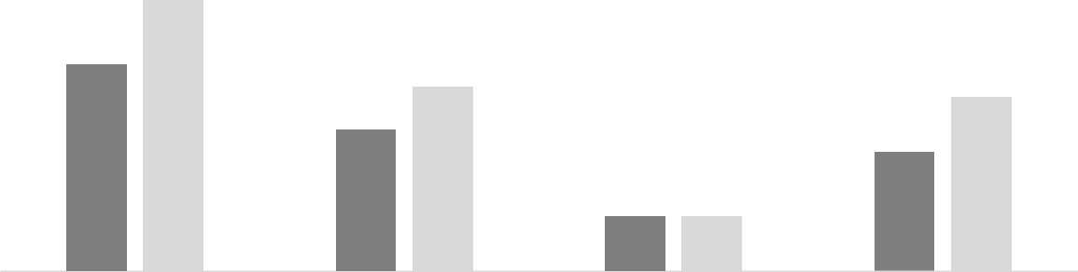

0%

Drug offences

Criminal damage and arson

Burglary

Robbery

Violent crime

 2%

 8%
6%

8%
6%

29%

21%
25%

19%
21%

Burglary Drug dealers Physical attacks Vandalism/damage

% feel it is a fairly or very big issue (Apr 2017)

% feel it is a fairly or very big issue (Apr 2018)
Source: Surrey Residents Survey (2018)

0% | 5% |  | 10% |  | 15% | 20% | 25% | 30% | 35%
 |  | Surrey |  | South East |  |  |  | 24
Source: Office for National Statistics (2018) |  |  |  |  |  |  |  | 24

Anti-social behaviour (ASB) has fallen over the last decade

While other types of crime have been increasing, the rate of anti-social behaviour (ASB) in Surrey has decreased, reflecting national and regional trends. The number of incidents fell from over 64,000 in 2007/8 to just over 25,000 in 2017/18.

 | 100
 | 90
 | 80
Page | 70
Page | 60
67 | 50
 | 40
 | 30 | 28
 | 20 | 21
 | 10
 | 0
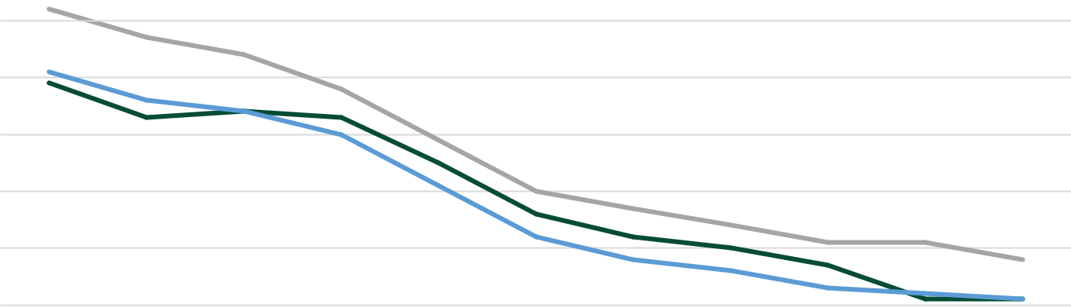
2007/08 2008/09 2009/10 2010/11 2011/12 2012/13 2013/14 2014/15 2015/16 2016/17 2017/18

Surrey (offences per 1000 people) |  | South East (offences per 1000 people)
England (offences per 1000 people)

Source: Office for National Statistics (2018)

Spelthorne recorded the highest rate of ASB (27 per 1000 people) in 2017/18 while Waverley recorded the lowest (17 per 1000 people).
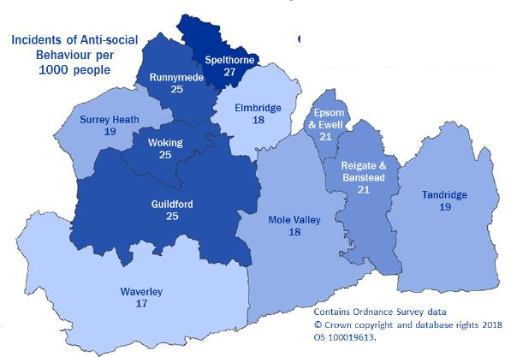

25

Domestic abuse is a growing problem

In the year ending 31 March 2016, there were nearly 14,500 incidents of domestic abuse recorded by Surrey Police – an increase of 4.5% on the previous year. Reported incidents of domestic abuse are significantly more prevalent in Reigate and Banstead and Spelthorne. Over 45% of incidents involved children in some way.

Domestic Abuse victims in Surrey (2015/16)
Page | 26,000 | 15,000
Page | Women and girls | Men and boys

While the number of domestic abuse incidents has gone up, the rate of offences per 1,000 people remains lower than the South East and England
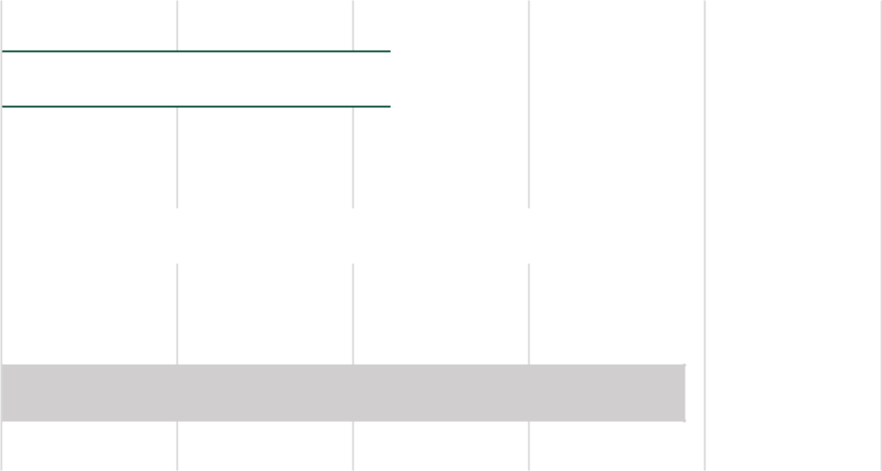

68 | aged 16 -59 | aged 16 -59
 | Source: Surrey-i (2017)
 | A review in 2015 found | 3,837
domestic abuse was a factor in |  | 3,837
 | 1/3 | New referrals to domestic abuse
 | 1/3 | outreach services (2015/16) -
of Surrey child protection plans. 7.4% increase on previous year

Source: Surrey-i (2017) Source: Surrey-i (2017)
Surrey  11

South East  15.1

England

0 | 5 |  |  | 10 |  | 15
 |  |  | England |  | South East |  | Surrey

19.4

20 25

26

Residents rely on highways and railways to get to work

Page 69

Figures from the 2011 census show that Surrey’s residents rely more heavily on the

local rail network than the national or regional average, with 13.5% of working adults taking the train to work.

Use of urban rail, buses or taxis are all below the national average.

By comparison, 62.6% of residents drive or are passengers within a car or van for their daily commute – this being above the national average.

2.2% of residents use a bicycle for their commute, and 8.6% travel on foot.

Surrey Residents' Use of Public Transport for Commuting to Work

16

14
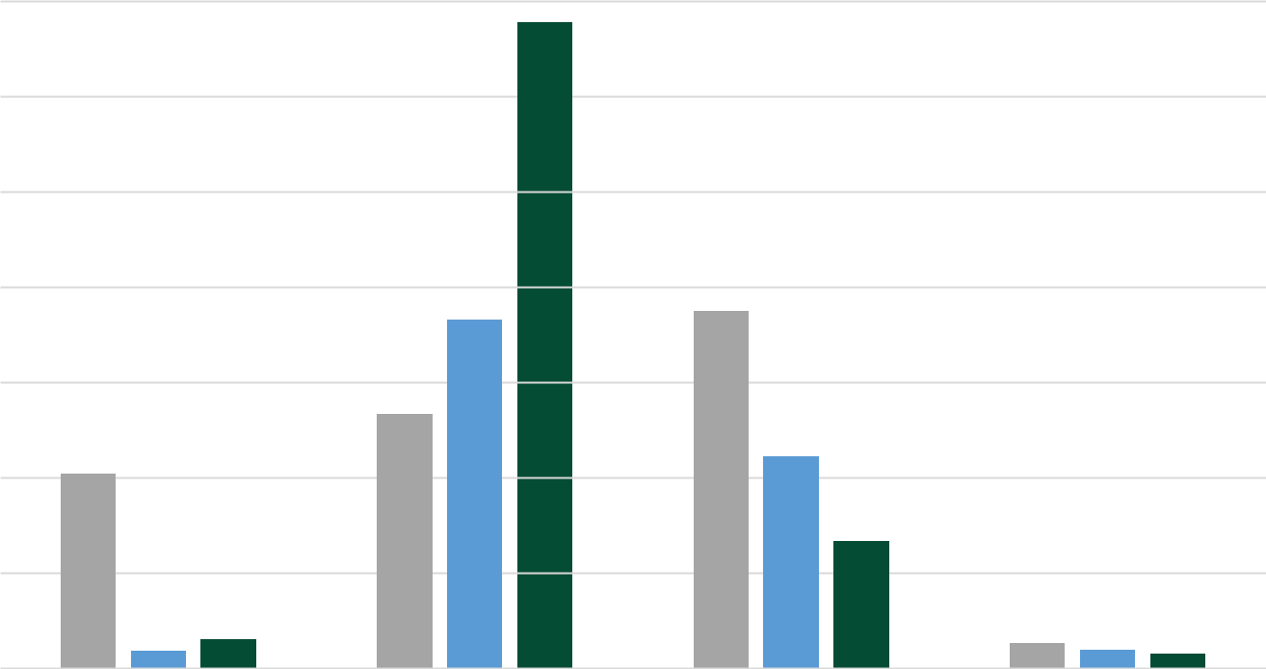

12

10

% | 8
 | 6
 | 4

2

0

Underground, Metro, |  | Train |  | Bus, Minibus or |  |  | Taxi
Light Rail or Tram |  |  |  |  |  | Coach
 |  | England |  | South East |  | Surrey

Source: Office for National Statistics (2011)
27

Busier roads
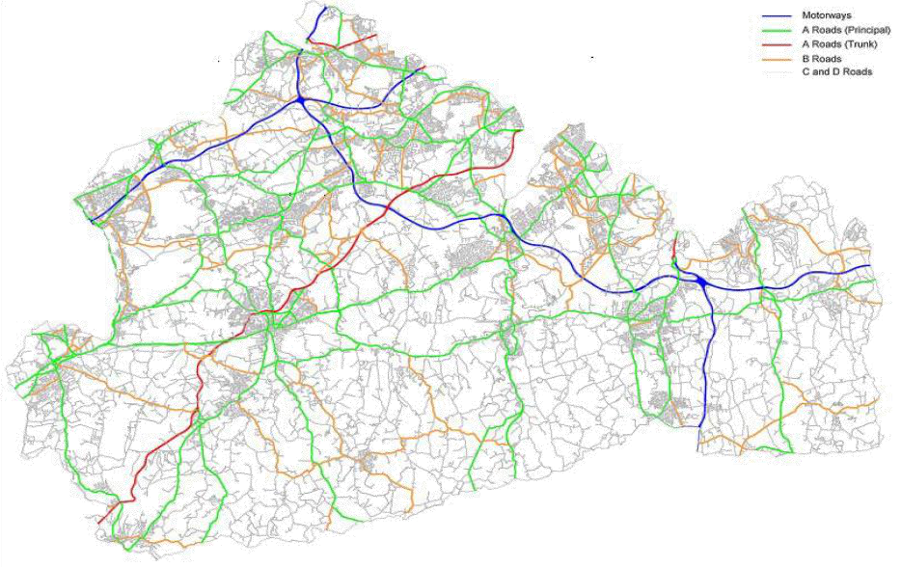

Surrey has 3,452 miles of road, including Motorways,

Principal & Trunk A roads, B Roads and C & D roads.

Page 70

Over the last 10 years
there have been an
additional 23,428
vehicles registered
and licensed within
the county.

Source: Surrey-I

Number of Licensed Vehicles in Surrey

800000
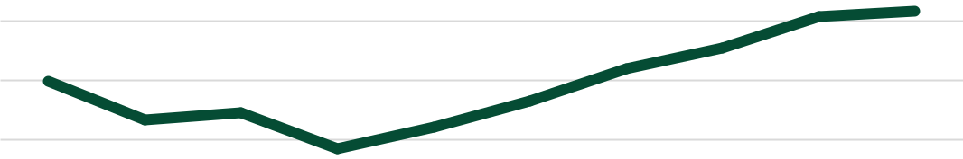

780000

760000

740000

720000

700000

2008 2009 2010 2011 2012 2013 2014 2015 2016 2017
28

Surrey’s road network is amongst the busiest in the country

The average number of the number of vehicles passing a point in the road network each day in Surrey is significantly higher than the South East average, and almost double the national average of traffic.

Page |  | Average Daily Flow - Number of Vehicles
71
71 | 8000
Vehicles | 8000
Vehicles | 6000
of | 7000
of | 4000
Number | 4000
 | 5000
 | 3000
 | 2010 |  | 2011 |  | 2012 |  | 2013 | 2014 |  | 2015 | 2016 | 2017
 |  |  |  | England |  |  | South East |  |  | Surrey

Throughout this decade, the volume of traffic on Surrey roads has increased significantly. There were 431 million more vehicle miles travelled on Surrey’s roads in 2017 compared with 2010.

Volume of Traffic

 | 8900
 | 8800
Miles | 8700
Miles | 8600
Vehicle | 8600
Vehicle | 8400
Million | 8500
Million | 8200
 | 8300
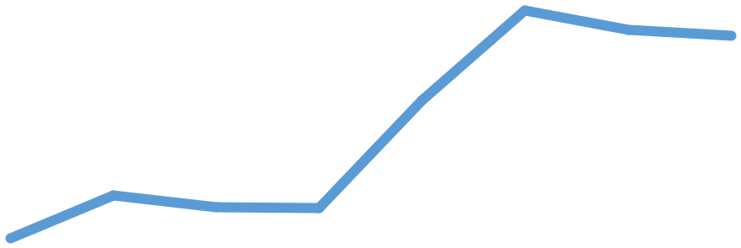

8100

8000

2010 | 2011 | 2012 | 2013 | 2014 | 2015 | 2016 | 2017
 |  |  |  |  |  | 29

Source: Surrey-I Source: Surrey-I

Greener roads


Page 72

Between 2005 and 2016, CO2 levels across the whole of Surrey’s road network have been falling year-on-year.


2005 | Road Type | 2016
1,210.7 kt CO2 | Motorways | 1,043.0 kt CO2
1,11,218.2 kt CO2 | A Roads | 1,144.6 kt CO2
926.1 kt CO2 | Minor Roads | 869.9 kt CO2

Whilst the roads clean up, Surrey’s diesel railways have emitted more CO2 between the same time period:
41.7 kt CO2 in 2005 rose to 42.5 kt CO2 in 2016.

Source: Surrey -I

30

Residents have mixed feelings towards Surrey’s roads

Residents on Road Maintenance

40
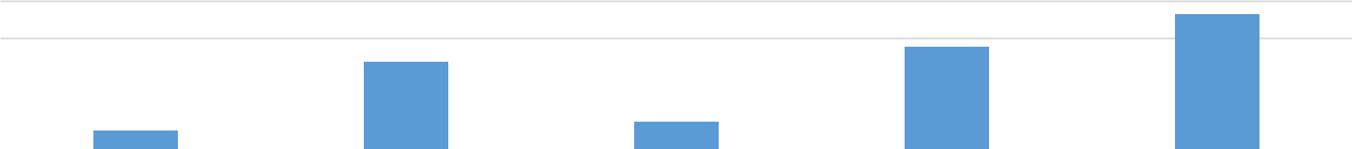

30

% | 20
 | 10
 | 0
 | 0 | Very Satisfied | Fairly Satisfied | Neiter Satisfied or | Fairly Dissatisfied | Very Dissastisfied
Source: Surrey-I |  |  |  | Dissatisfied

Page |  | Residents on Congestion Management
Page | 40
73 | 40
73 | 30
%20
 | 10
 | 0




Very Satisfied | Fairly Satisfied | Neiter Satisfied or | Fairly Dissatisfied | Very Dissastisfied
Source: Surrey-I |  | Dissatisfied

Residents on Vehicle Parking

60

40
%
20
0
0 | Very Satisfied | Fairly Satisfied | Neiter Satisfied or | Fairly Dissatisfied | Very Dissastisfied
Source: Surrey-I |  |  | Dissatisfied

Surrey’s road network is regularly a high priority topic for residents.

Recent results from the annual Surrey
Residents’ Survey show that 28.6% of

respondents were satisfied with road maintenance. 63.9% of respondents , however, were dissatisfied.

43% of respondents were satisfied with road congestion management, opposed to 41.5% that were dissatisfied.

Finally, on vehicle parking 49.4% of respondents were satisfied with vehicle parking in the county, though 39.5% were dissatisfied with this.

31

More waste disposed through bins, less in Community Recycling Centres

Tonnage of Waste in Surrey by Disposal

600,000

500,000

 |  |  | 406,459 | 413,917
 |  | 389,002 | 406,459
400,000 | 387,183 | 389,002 | 388,924
400,000 | 372,974
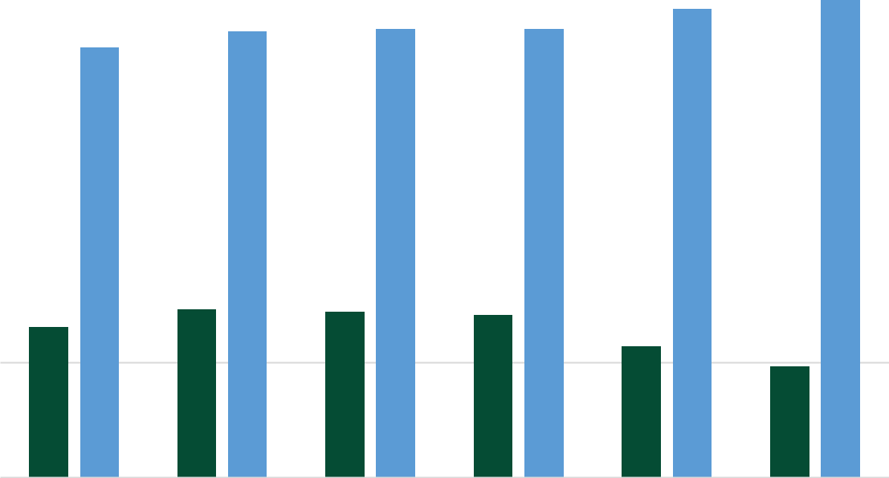

Page
74Tonnes | 300,000
 | 200,000
 | 145,589 |  | 143,872 | 140,509
 | 130,323
113,649
95,846
100,000

0

2012/13 2013/14 2014/15 2015/16 2016/17 2017/18

Waste from Community Recycling Centres

Waste from Kerbside Collection

Total

Source: Department for Environment, Food & Rural Affairs

Over the past six years Surrey has seen both a rise and fall in the tonnage of waste disposed of by residents.

Tonnage of waste collection from kerbside bin collections has risen almost every year. Almost 41,000 additional tonnes of waste were collected in 2017/18 when compared to 2012/13.

However, waste being deposited at Community Recycling Centres (CRCs) has been declining over the same period. CRCs received nearly 34,500 fewer tonnes of waste in 2017/18 when compared to 2012/13.

The total of household waste being recycled has increased overall, but there has been some fluctuation in the last two years.

Percentage of total household waste recycled
_{52.1} _{51.5} 53.2 55 ^{57.7} 54.3

2012/13 2013/14 2014/15 2015/16 2016/17 2017/18

Most residents happy in their communities but do not feel able to affect local decisions

A majority of Surrey residents say they are satisfied with their neighbourhood as a place to live, believe there is a strong sense of community and people from different backgrounds get on well together.

However, some residents do not influence local decisions that affect there are enough opportunities to making.

feel they are able to them, nor do they think influence local decision

Page 75

100% | 93%
80% | 78%
60% | 68%
40%
20%
0%
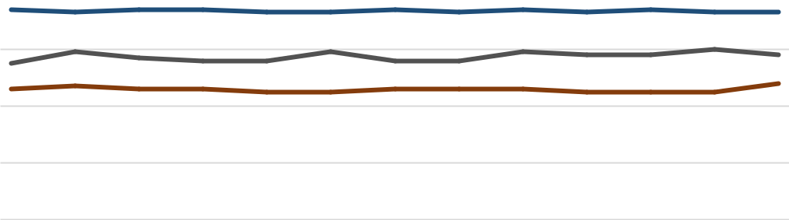

100%
80%
60%
60% |  |  |  |  |  |  |  |  |  |  |  |  |  |  |  |  |  |  | 33%
40%
20%
0%
0% | Apr-15 | Jun-15 | Aug-15 | Oct-15 | Dec-15 | Feb-16 | Apr-16 | Jun-16 | Aug-16 | Oct-16 | Dec-16 | Feb-17 | Apr-17 | Jun-17 | Aug-17 | Oct-17 | Dec-17 | Feb-18 | Apr-18

% agree they can influence decisions in their local area


Apr-18 |  |  |  |  |  |  |  |  |  |  |  |  |  |  |  |  |  | Feb-18
 |  |  |  |  |  |  |  |  |  |  |  |  |  |  |  |  | Dec-17
 |  |  |  |  |  |  |  |  |  |  |  |  |  |  |  | Oct-17
 |  |  |  |  |  |  |  |  |  |  |  |  |  | Aug-17
 |  |  |  |  |  |  |  |  |  |  |  |  | Jun-17
 |  |  |  |  |  |  |  |  |  |  |  | Apr-17
 |  |  |  |  |  |  |  |  |  |  | Feb-17
 |  |  |  |  |  |  |  |  |  | Dec-16
 |  |  |  |  |  |  |  |  | Oct-16
 |  |  |  |  |  |  |  | Aug-16
 |  |  |  |  |  |  | Jun-16
 |  |  |  |  |  | Apr-16
 |  |  |  |  | Feb-16
 |  |  |  | Dec-15
 |  |  | Oct-15
 |  | Aug-15
 | Jun-15
Apr-15

- satisfied with their neighbourhood as a place to live

- agree there is a strong sense of community in their area

- agree people from different backgrounds get on well together

2015

2016

2017

0% 20%
36%

35%

33%

40% 60% 80% 100%

Source: Surrey Residents Survey

% satisfied with opportunities for decision making | 33

Page 76
Residents have good access to woodland spaces

In Surrey | By comparison,
In Surrey | in England
25.3% of | in England
25.3% of | 16.8% live
people live | 16.8% live
within 500 | within 500
metres of | metres of
accessible | accessible
woodland area | woodland area
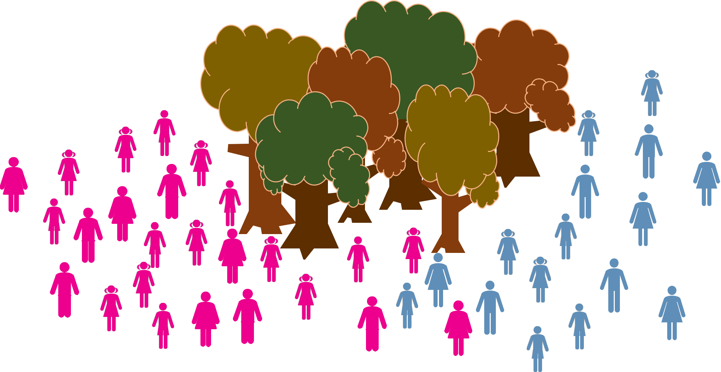

Source: Surrey-I

78.9% of residents are satisfied with maintenance of Surrey’s countryside ₃₄

