UML Lab – Use Cases and UML (EduLink)
Effat University · CS3151 Software Engineering · Dr. Passent Elkafrawy
Name (ID): ______________________ · Oct 11, 2026

D1. Actors and Use Case List
EduLink has eight actors (six human roles and two external systems) and 18 goal-level use cases, 12 of them rated Must.
Actor cards
Actor | Description | Triggers / interests | Challenges | Persona
Principal | Manages the school; authenticated staff | Monitor performance and teacher activity from one place | Follows every teacher individually | Principal
Teacher | Teaches classes; authenticated staff | Record attendance and grades fast, post assignments, spot struggling students | Paper sheets, repeated data entry, slow parent contact | Sara
Student | Learner; authenticated user | Solve assignments and quizzes, follow own grades, attendance and timetable | Work spread across platforms | Student
Parent | Guardian linked to one or more students | Follow child’s progress, get absence alerts, pay fees | Low technical skill, uses a phone, cannot visit the school | Mohammed
Administrator | Administrative staff | Enroll students, build the timetable, track fees, produce reports | Late-found timetable clashes, manual reports | Nora
IT Support | Maintains the platform | Manage accounts and roles, backups, security | Keeping sensitive data safe | IT support group
Payment Gateway | External system | Process card, Mada and Apple Pay payments | Declines and timeouts | not a persona
Notification Service | External system (push and SMS) | Deliver alerts to phones | Delivery failures | not a persona
Use case list (priority: M = Must, S = Should, C = Could, W = Won’t for now)
ID | Use case | Primary actor | Goal / outcome | Priority
UC1 | Log In | All human actors | User is authenticated with the role’s permissions | M
UC2 | Record Attendance | Teacher | Class attendance saved and visible | M
UC3 | Notify Parent of Absence | Notification Service | Parent alerted of an absence | M
UC4 | Enter Grades | Teacher | Grades saved, averages calculated, struggling students flagged | M
UC5 | Post Assignment | Teacher | Assignment visible to the class | M
UC6 | Submit Assignment | Student | Submission confirmed before the deadline | M
UC7 | Take Quiz | Student | Quiz submitted and auto-graded | S
UC8 | View Grades and Attendance | Student, Parent | Current academic status shown | M
UC9 | Pay Fees Online | Parent | Fee paid and receipt issued | M
UC10 | Track Fee Payments | Administrator | Outstanding balances known | M
UC11 | Enroll Student | Administrator | Student record created | M
UC12 | Build Timetable | Administrator | Clash-free timetable published | M
UC13 | Generate Reports | Administrator, Principal | Attendance and performance report produced | S
UC14 | View Dashboard | Principal | School performance at a glance | S
UC15 | Message Between Parent and Teacher | Parent, Teacher | Message delivered and answered | S
UC16 | Manage Accounts and Roles | IT Support | Accounts created, disabled, roles assigned | M
UC17 | Back Up and Restore Data | IT Support | Data protected and recoverable | S
UC18 | Choose Interface Language | All human actors | Arabic or English interface remembered | C
A mobile app for students and a school-bus tracking module are Won’t for now.
Traceability (use case to user stories in Lab 3 and functional requirements)
Use case | User stories | Functional requirements
UC1 Log In | US-20 | FREQ-31, FREQ-32
UC2 Record Attendance | US-04 | FREQ-05, FREQ-06
UC3 Notify Parent of Absence | US-11 | FREQ-17, FREQ-18
UC4 Enter Grades | US-05 | FREQ-07, FREQ-08
UC5 Post Assignment | US-06 | FREQ-09, FREQ-10
UC6 Submit Assignment | US-09 | FREQ-13, FREQ-14
UC7 Take Quiz | US-09 | FREQ-15
UC8 View Grades and Attendance | US-10, US-13 | FREQ-16, FREQ-21, FREQ-22
UC9 Pay Fees Online | US-12, US-22 | FREQ-19, FREQ-20, FREQ-35
UC10 Track Fee Payments | US-19 | FREQ-30
UC11 Enroll Student | US-16 | FREQ-25, FREQ-26
UC12 Build Timetable | US-08, US-17 | FREQ-12, FREQ-27, FREQ-28
UC13 Generate Reports | US-18 | FREQ-29
UC14 View Dashboard | US-01, US-02, US-03 | FREQ-01, FREQ-02, FREQ-03, FREQ-04
UC15 Message Between Parent and Teacher | US-07, US-15 | FREQ-11, FREQ-24
UC16 Manage Accounts and Roles | US-20, US-23 | FREQ-31, FREQ-32, FREQ-36
UC17 Back Up and Restore Data | US-21 | FREQ-33, FREQ-34
UC18 Choose Interface Language | US-14 | FREQ-23

D2. Use Case Specifications
Record Attendance is the core happy-path case and Pay Fees Online is the complex case with payment failures; both are written fully dressed after the brief specs for all 18.
Brief specifications
Use case | Primary actor | Preconditions | Postconditions | Main success scenario
UC1 Log In | Any user | Account exists and is active | User authenticated with the role’s permissions | User enters credentials (staff also give a second factor); system opens the role’s home page
UC2 Record Attendance | Teacher | Teacher logged in; period on today’s timetable | Attendance saved for the period | Teacher opens the period, marks absent or late students, saves
UC3 Notify Parent of Absence | Notification Service | A student is marked absent | Parents of the student notified | System sends a push notification; SMS if the push fails
UC4 Enter Grades | Teacher | Teacher logged in; assessment exists | Grades saved, averages updated, alerts raised | Teacher enters scores; system recalculates averages and flags large drops
UC5 Post Assignment | Teacher | Teacher logged in | Assignment visible to the class | Teacher enters title, description, due date and attachment, then publishes
UC6 Submit Assignment | Student | Student logged in; assignment open | Submission stored and confirmed | Student uploads a file; system confirms with a time stamp
UC7 Take Quiz | Student | Quiz published and open | Quiz submitted, score stored | Student answers within the time limit; system auto-grades
UC8 View Grades and Attendance | Student, Parent | Logged in; parent linked to the child | Data displayed | User selects child and term; system shows grades and attendance
UC9 Pay Fees Online | Parent | Logged in; child linked; outstanding fee | Payment recorded, balance updated, receipt issued | See the fully dressed specification below
UC10 Track Fee Payments | Administrator | Administrator logged in | Balance list shown or exported | Administrator filters by grade; system lists outstanding balances
UC11 Enroll Student | Administrator | Administrator logged in | Student record created | Administrator enters the required fields; system validates and saves
UC12 Build Timetable | Administrator | Classes, teachers and rooms exist | Clash-free timetable published | Administrator assigns periods; system warns on double bookings; administrator publishes
UC13 Generate Reports | Administrator, Principal | Logged in | Report file produced | User picks scope and format; system generates a PDF or Excel file
UC14 View Dashboard | Principal | Principal logged in | Dashboard shown | Principal opens the dashboard; system shows attendance rate and grade average per class
UC15 Message Between Parent and Teacher | Parent, Teacher | Both logged in; parent linked to a student of that teacher | Message delivered | Sender writes a message; system delivers it; the reply appears in the same thread
UC16 Manage Accounts and Roles | IT Support | IT logged in with a second factor | Account created or disabled, role set | IT creates or disables an account and assigns one of the six roles
UC17 Back Up and Restore Data | IT Support | IT logged in | Backup exists or data restored | System backs up daily; IT restores a chosen backup when needed
UC18 Choose Interface Language | Any user | None | Language saved | User switches between Arabic and English; system remembers the choice
Fully dressed: UC2 Record Attendance (primary case)
Field | Content
Use case | UC2 Record Attendance
Activity name | Record Attendance
Primary actor | Teacher
Stakeholders and interests | Teacher (record the class in under a minute); Parent (hear about an absence quickly); Administrator and Principal (reliable attendance data); Student (correct record)
Preconditions | Teacher is authenticated (UC1); the period is on today’s timetable and assigned to the teacher; the class list is loaded
Postconditions | Attendance of every student in the period is saved with date and time; it is visible to administrators, parents and students within 1 minute; each absent student triggers UC3
Main scenario | 1) Teacher opens today’s periods. 2) Teacher selects a period. 3) System lists the class’s students, all set to present. 4) Teacher marks absent or late students. 5) Teacher saves. 6) System stores the records and confirms. 7) System starts UC3 for each absent student.
Extensions | 2a) Period is not assigned to the teacher: system refuses and explains. 5a) Connection lost on save: system keeps the entries on screen and offers retry. 6a) Attendance for this period already exists: system shows it and lets the teacher edit; every edit is logged.
Special requirements | A class of 30 recorded in under 1 minute (FREQ-05); saved attendance visible within 1 minute (FREQ-06); every access and edit logged (FREQ-36)
Constraints | Only the assigned teacher, or an administrator, can record attendance for a period
Open issues | How long after a period may a teacher still correct attendance? How is a student who arrives after saving handled?
Fully dressed: UC9 Pay Fees Online (complex and edge case)
Field | Content
Use case | UC9 Pay Fees Online
Activity name | Pay Fees Online
Primary actor | Parent
Stakeholders and interests | Parent (quick, safe payment without visiting the school); Administrator (accurate balances and receipts); Payment Gateway (valid charge); School (fees collected on time)
Preconditions | Parent is authenticated (UC1); the child is linked to the parent; at least one outstanding fee exists
Postconditions | Payment recorded; the student’s balance updated; receipt issued; parent notified. On a decline or no response, the balance is unchanged.
Main scenario | 1) Parent opens Fees and selects a child. 2) System shows outstanding fees, due dates and payment history. 3) Parent selects a fee and a payment method (Mada, credit card or Apple Pay). 4) System shows the amount summary. 5) Parent confirms. 6) System sends the payment request to the gateway. 7) Gateway approves. 8) System records the payment, updates the balance and generates the receipt. 9) System sends a confirmation notification and shows the receipt.
Extensions | 2a) No outstanding fee: system shows “No outstanding fees” and the case ends. 7a) Gateway declines: system shows the reason; 7a1) parent retries, or 7a2) chooses another method (back to step 3), or 7a3) cancels and the case ends. 7b) Gateway gives no response: system marks the payment pending, leaves the balance unchanged and asks the parent to check the status later. 9a) Push notification fails: the receipt stays available in the payment history.
Special requirements | Mada, credit card and Apple Pay accepted (FREQ-19); receipt within 10 seconds of approval (FREQ-19); card details are handled by the gateway and not stored by EduLink (design decision)
Constraints | Only a parent linked to the child, verified by an administrator, may pay that child’s fees (FREQ-22)
Open issues | Are partial payments or instalments allowed? How are refunds handled? How long may a payment stay pending?

D3. Use Case Diagram
All 18 use cases sit inside one system boundary, with six human roles on the left and two external systems on the right.
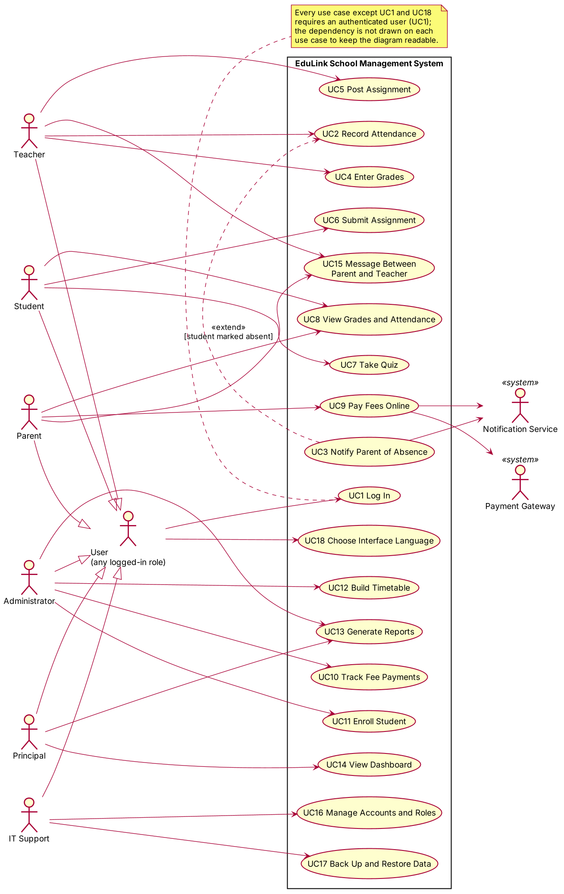
Use case diagram of EduLink with six human actors, two external systems and 18 use cases
- Generalization: the six roles all specialize “User”, so Log In (UC1) and Choose Interface Language (UC18) are drawn once for all of them.
- Extend: Notify Parent of Absence (UC3) extends Record Attendance (UC2) only when a student is marked absent.
- External systems: the Payment Gateway takes part in Pay Fees Online (UC9); the Notification Service takes part in UC3 and UC9.
- Login: every use case except UC1 and UC18 needs a logged-in user; the note in the diagram says so instead of drawing 16 more lines.

D4. Activity Diagram: Pay Fees Online
Pay Fees Online is the most complex case because it has three outcomes after the gateway answers (approved, declined, no response) and three steps that run in parallel once a payment is approved.
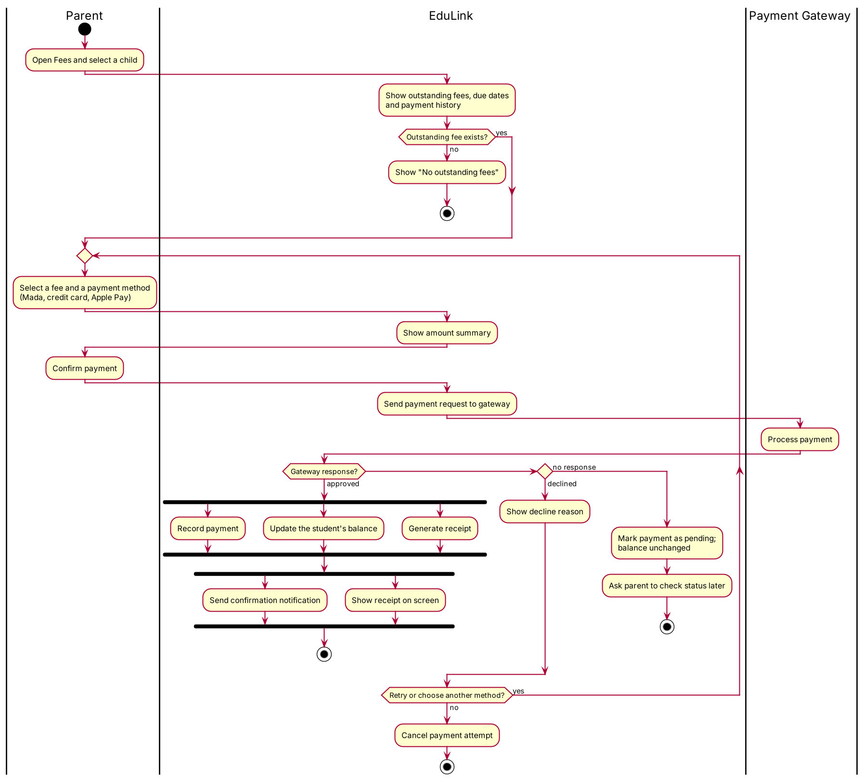
Activity diagram of Pay Fees Online with swimlanes for Parent, EduLink and Payment Gateway
- Guards match the extensions in D2: no outstanding fee (2a), declined (7a) and no response (7b).
- Parallel steps: recording the payment, updating the balance and generating the receipt run together; the notification and the on-screen receipt then run together.
- Loop: after a decline the parent can retry or choose another method, or cancel and end.

D5. Sequence Diagram: Pay Fees Online (main success)
The numbers on the messages are the step numbers of the main success scenario of UC9 in D2.
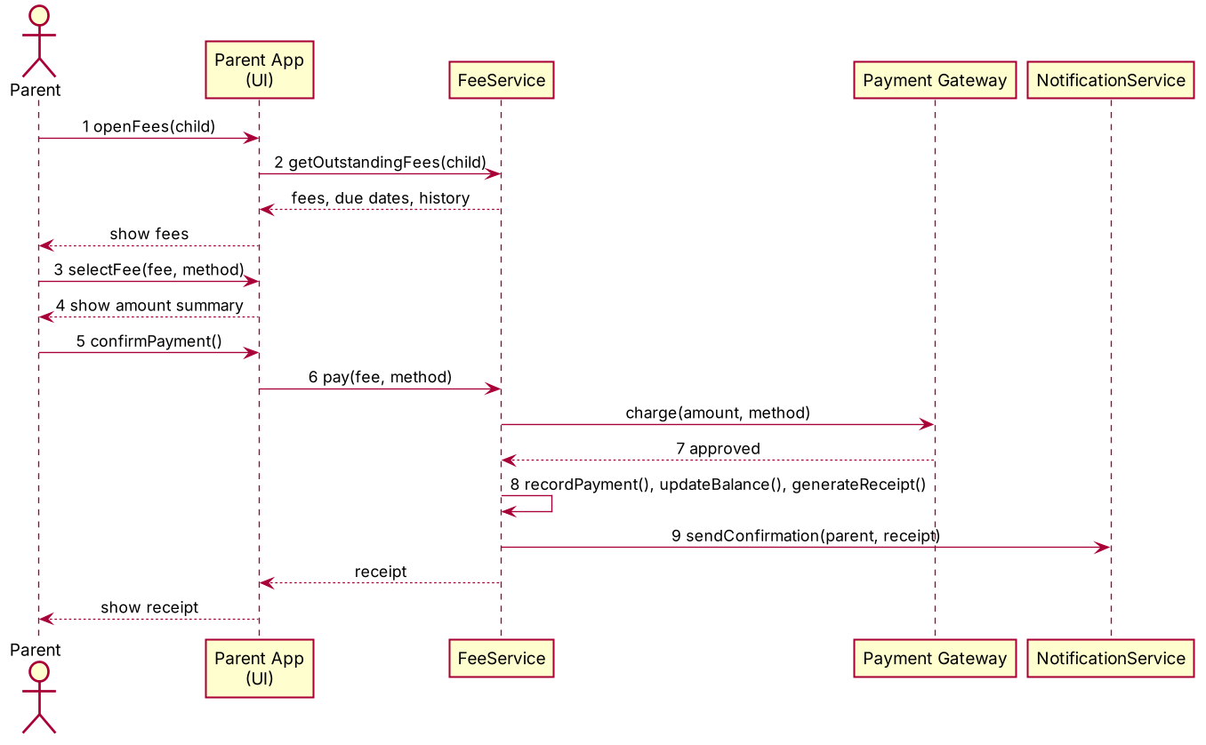
Sequence diagram of the main success scenario of Pay Fees Online
Step 8 is one self-message because recording the payment, updating the balance and generating the receipt are the parallel steps shown in the activity diagram; the notification (step 9) goes to the Notification Service while the receipt returns to the app.

D6. Domain Model (Class Diagram)
The model has 18 domain classes drawn from the nouns in the user stories and use cases, with no screens or database tables.
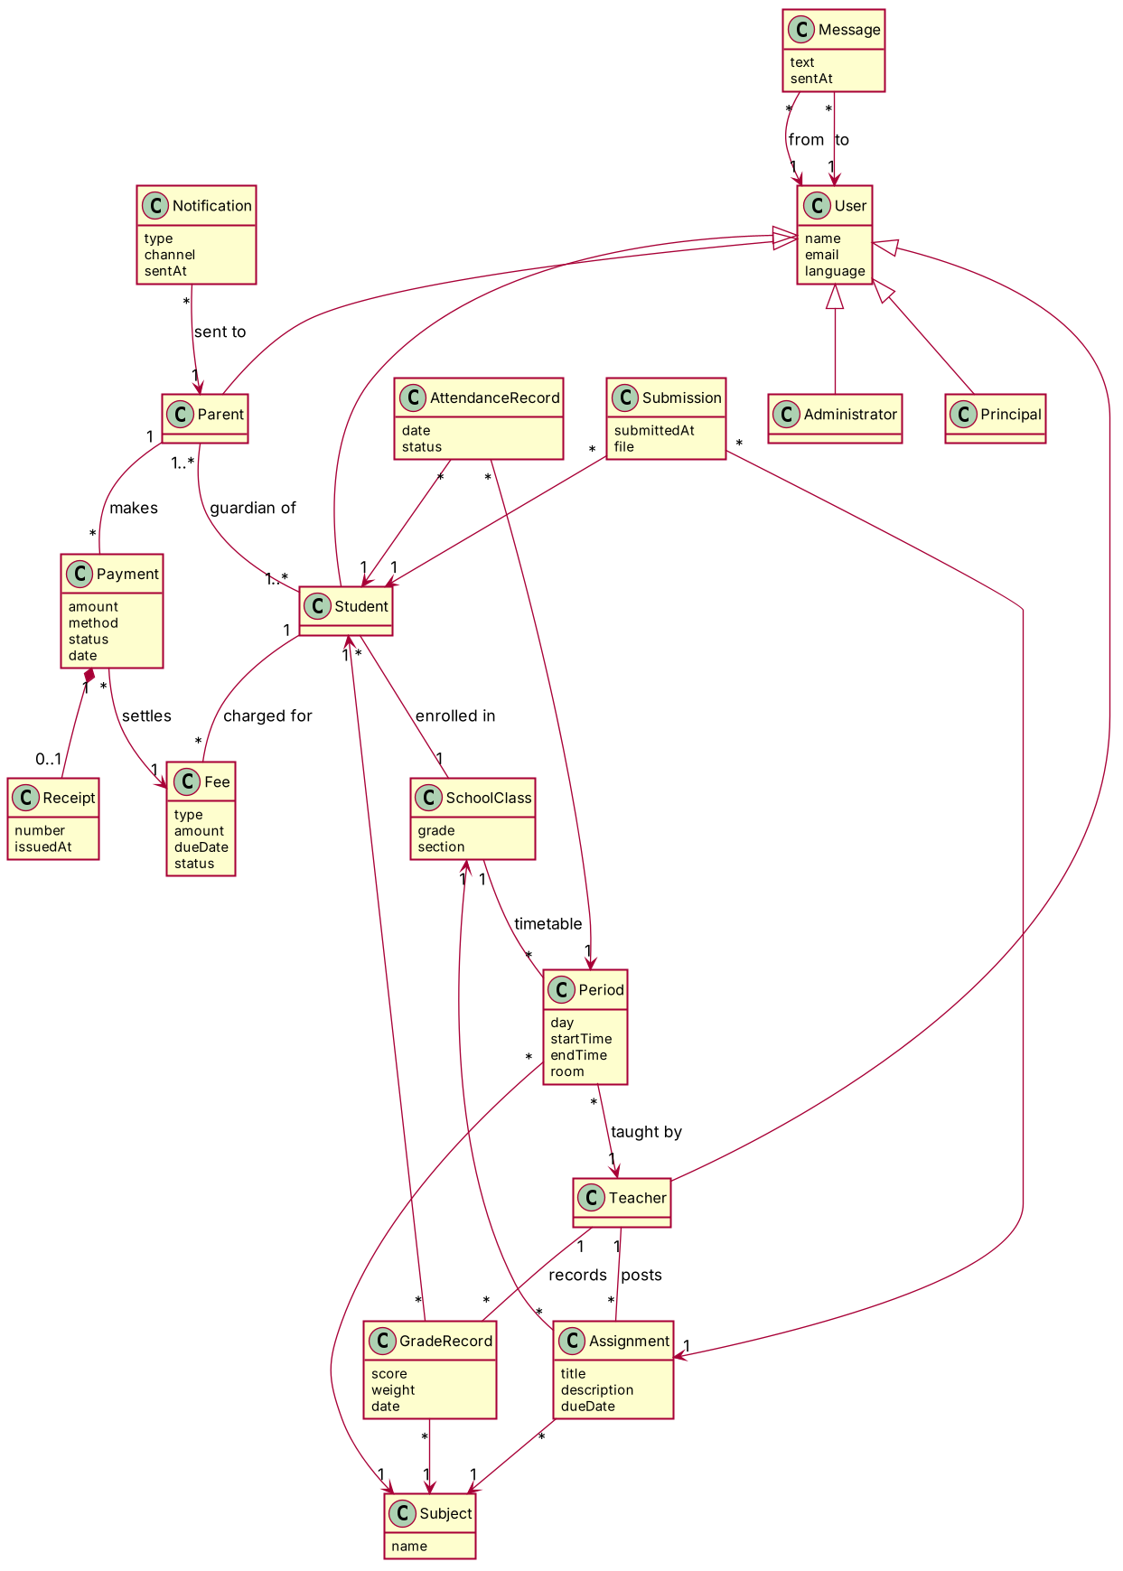
Domain model class diagram of EduLink
- Users: Student, Parent, Teacher, Administrator and Principal all specialize User; a Parent has one or more children and a Student has one or more guardians.
- Teaching: a SchoolClass has many Periods, each for one Subject and one Teacher; AttendanceRecords belong to a Student and a Period.
- Learning: a Teacher posts Assignments for a class and subject; a Student’s Submission belongs to one Assignment; GradeRecords belong to a Student and a Subject.
- Fees: a Student is charged Fees; a Parent makes Payments that settle a Fee, and a Payment has at most one Receipt.
- Communication: Notifications go to Parents; Messages have one sender and one recipient User.

D7. Consistency Checklist and Peer Review
Three of the five consistency checks pass and two pass in part: extension 9a of UC9 is not drawn as a branch, and two names differ between the use cases and the model.
Consistency checklist (our own check)
Check | Result | Evidence or note
Every use case traces to at least one actor and appears in the Use Case Diagram | Pass | All 18 use cases (UC1 to UC18) are in D3; UC1 and UC18 connect through the User generalization; UC3’s primary actor is the Notification Service
Sequence Diagram messages align with the Main Success Scenario | Pass | Messages 1 to 9 in D5 are steps 1 to 9 of UC9 in D2
Activity Diagram branches match the Extensions and guards | Partly | 2a, 7a (retry, other method, cancel) and 7b are branches in D4; extension 9a (push fails, receipt stays in history) is not drawn
All domain classes appear in at least one use case or sequence, with consistent names | Partly | Fee, Payment, Receipt, Notification, Parent and Student appear in UC9 and D5; others appear in UC2 to UC8 and UC11 to UC16. The use cases say “grades” and “timetable” where the model says GradeRecord and Period
Non-functional constraints in the use cases appear as notes | Pass | Time limits, accepted payment methods and logging appear under Special requirements in both fully dressed use cases
Peer-review sheet (to be completed by the reviewing team)
Reviewing team: ______ Reviewed team: EduLink Date: ______
Criterion | Met? (Yes / Partly / No) | Comment
Actors cover all personas and external systems
Use case names are goal-level and unambiguous
Includes and extends are used sparingly and correctly
Activity and Sequence diagrams match the narratives
Class diagram avoids UI and database details; multiplicities make sense
Clear preconditions, postconditions and success guarantees
Consistency across all artifacts
Clarity, readability and professional style

