CANDIDATE NUMBER – 25188871
CASA0007 Quantitative Methods – Article

Gentle Density, Rough Reality
Quantitative Analysis of Additional Dwelling Unit Permits in Toronto, Canada

Additional dwelling units (ADUs) are not always ‘the low-hanging fruit’ in addressing the housing crisis. A quantitative look at ADU permits between 2022 and 2025 in Toronto hints that ADU growth is based on momentum and spillovers, while there are barriers preventing its uptake elsewhere.

As the name suggests, ADUs are dwelling units that exist in addition to the primary residence on a residential lot, making them usually smaller. ADUs promise to deliver more housing stock for cheap (relative to new apartment complexes) without radically changing the built character of a neighbourhood, hence the term ‘gentle density’ that is often associated with ADU developments. Additionally, it offers homeowners an opportunity to monetise their asset by converting parts of their property into dwellings for rent. This would make ADUs an easy win for everyone, especially considering the dual crisis of cost-of-living and housing unaffordability in Canada that exacerbated post-pandemic. Legislation permitting ADUs picked up steam in Toronto from late 2017 onwards, following earlier adopters like California.

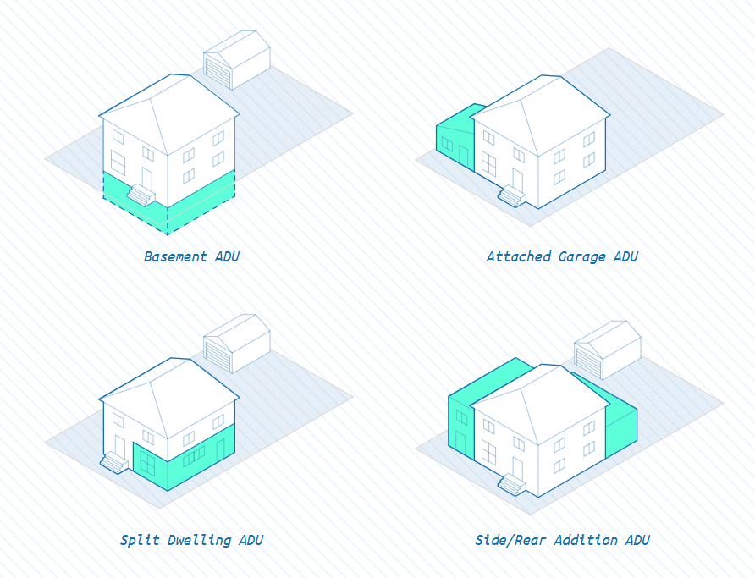
In Toronto, ADUs consist of two main typologies. The first type is known as ‘secondary suites’, which are ADUs that are attached to the primary residence, as shown in Figure 1. The second type is known as ‘laneway / garden / rear-yard suites’. Basically, these are ADUs that are detached from the primary residence but still on the same lot (Figure 2). Since 2025, Toronto has also allowed for multiplex conversions up to sixplexes on one lot in some areas but permit data on this is not readily available yet.
Figure 1: Typologies of 'secondary suites' (attached ADUs) that are common in Toronto
(Credits: School of Cities)
Figure 2: Typologies of ‘laneway / garden / rear-yard suites' (detached ADUs) that are common in Toronto (Credits: School of Cities)
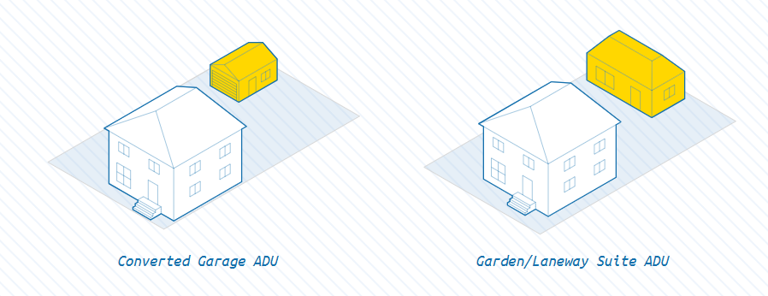
Focusing on both active and completed ADU permits that were issued between 2022 and 2025, it shows that permit activity is steadily rising (Figure 3), continuing the trend from before COVID-19. However, they show clustering in some areas, with the densest cluster of 562 permits located west of Downtown Toronto, stretching all the way to High Park and Lawrence Avenue (Figure 4). Although there is a larger cluster of 643 permits, it spans a much larger area from the Don River all the way to Scarborough. Conspicuously, there is little ADU permit activity, and therefore no clusters identified, in Midtown Toronto.
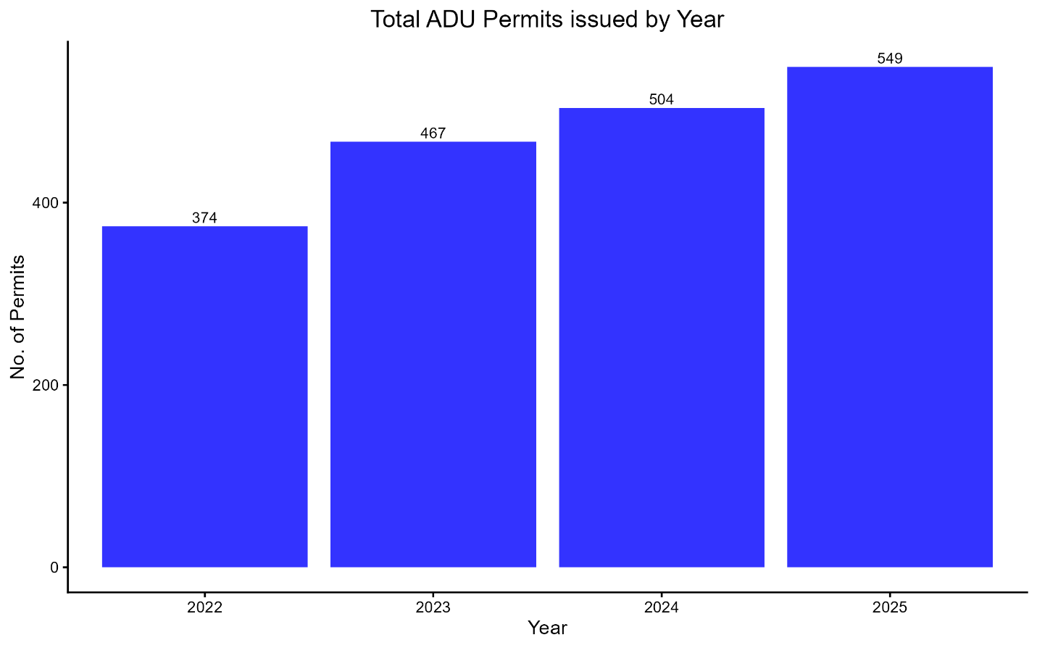
Figure 3: Bar chart of Total ADU Permits issued by the City of Toronto per year, 2022-2025

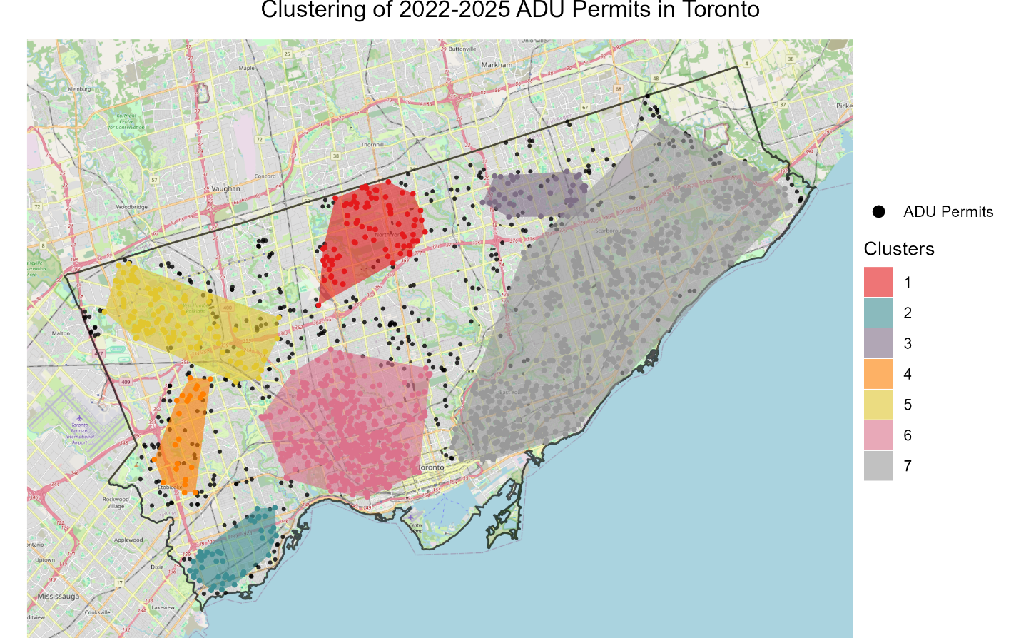
25 permits
45 permits
643 permits
562 permits
40 permits
83 permits
118 permits
Figure 4: Map of 2022-2025 ADU Permit Clusters identified using HDBSCAN Analysis (minimum point = 19), with count of permits per cluster

Therefore, what could explain this high clustering of ADU activity in Toronto? What factors may be associated with ADU rates in Toronto Neighbourhoods?

Through simple regression, it is found that a neighbourhood’s non-car accessibility, housing typology mix, dwellings’ construction period as well as its rates of young dependents and single parents explain the greatest amount of variance in log-transformed ADU rates (Table 1). However, when controlling for influence from surrounding neighbourhoods, the relationship between non-car accessibility and log-transformed ADU rates become insignificant (Table 2).

What this means is that neighbourhoods with high ADU rates are also neighbourhoods that have:
- More single-detached and duplex homes
- More homes built before 1960
- Lower proportions of young dependents
- Higher proportions of single parent households
- Surrounding neighbourhoods with similarly high ADU rates

While subject to further analysis, these patterns could reflect limited familiarity of homeowners, builders and/or planners in Toronto when initiating, planning and/or approving ADU projects. This is likely the case when looking at detached ADUs. Prior to 2022, such ADUs must be adjacent to laneways, which are more common in older neighbourhoods. This is where the ‘laneway suite’ label came from. After 2022, that restriction was removed and detached ADUs could be built anywhere on the same lot, thus the additional labels of ‘garden / rear-yard suite’. This should make detached ADUs possible even in newer neighbourhoods. However, by 2024, only six detached ADUs of the ‘garden / rear-yard’ variant have been built, suggesting that the increase over the years is mostly powered by secondary and laneway suites.

Additionally, they could imply that households with fewer young dependents could spare more space for ADU conversions. Meanwhile, the promise of additional rental income from ADUs, coupled with the likelihood that single parent households may rely more on community childcare facilities (thus requiring less living space), may explain the positive non-linear relationship between single parents and ADU rates.

These patterns differ from Californian cities, where it was found that ADUs were happening in ‘diverse, transit-accessible neighbourhoods where… homeowners… still have a mortgage’. This is because rates of visible minority or owners with mortgages did not record significant relationships with ADU rates across Toronto Neighbourhoods (Table 1). Perhaps, among other things, a cancelling-out effect is going on where despite the benefits, there are structural barriers that constrain the uptake of ADUs by homeowners, especially visible minority homeowners, which is also a concern in California.

When looked together with the cluster map, the patterns may suggest a causal pathway where surrounding neighbourhood’s activity is the factor that influences a neighbourhood’s ADU rates, moderated in clustering intensity by non-car accessibility. The largest cluster in the east with 643 permits spans across a transit desert that is served by just one subway line. Meanwhile, the densest cluster with 562 permits is in some of the most transit-accessible parts of Toronto, with two subway lines and numerous streetcar routes currently serving the area. Therefore, even though there is a lot of ADU permit activity going on in the east that are near enough to each other to be identified as one cluster, they are not as densely located as the ones in downtown. This means the growth of ADUs in Toronto could be due to diffusion, learning-by-seeing, or other unmeasured-but-spatially-patterned factors, which intensifies when there is good transit accessibility. Non-car accessibility alone cannot be taken as a factor because Midtown Toronto is also well served by public transit, but no clusters are identified there.

To an extent, the City may have acknowledged some of these patterns and are working to address them. On top of approving for ADUs of up to sixplexes on one lot, the City has also published pre-approved ADU plans that homeowners and builders could easily adopt, and has undertaken demonstration projects to showcase the models. However, these projects are in areas where clusters have been identified, potentially further localising ADU permit activity in the future.

Table 1: Summary of OLS Regressions of predictors on log-transformed ADU rates [log1p(adu_rate)], with the estimate and p-value of each factor
 | Model 1 | Model 2 | Model 3 | Model 4 | Model 5 | Model 6 | Model 7 | Model 8
Constant | 0.322 *** | 0.322 *** | 0.322 *** | 0.449 | 0.516 *** | -1.184 | -4.190 *** | -0.072
 | (0.000) | (0.000) | (0.000) | (0.530) | (0.00) | (0.668) | (0.000) | (0.645)
Non-Car Accessibility (PC) | 0.032 . | 0.083 *** | 0.080 *** | 0.045 . | 0.049 * | 0.068 ** | 0.081 *** | 0.068 **
 | (0.100) | (0.000) | (0.000) | (0.090) | (0.048) | (0.010) | (0.000) | (0.004)
Single-Det / Duplex (PC) |  | 0.114 *** | 0.114 *** | 0.113 *** | 0.116 *** | 0.089 *** | 0.103 *** | 0.122 ***
 |  | (0.000) | (0.000) | (0.000) | (0.000) | (0.000) | (0.000) | (0.000)
Semi-Det/Row vs Single-Det (PC) |  | 0.028 . | 0.030 . | 0.024
 |  | (0.079) | (0.055) | (0.164)
Row vs Semi-Det (PC |  | 0.011
 |  | (0.521)
Before-60s Period (PC) |  | 0.061 ** | 0.056 *** | 0.098 *** | 0.076 *** | 0.082 *** | 0.081 *** | 0.091 ***
 |  | (0.001) | (0.001) | (0.000) | (0.000) | (0.000) | (0.000) | (0.000)
60s-80s Period (PC) |  | 0.006
 |  | (0.710)
% of Older Dependents |  |  |  | -0.001
 |  |  |  | (0.813)
% of Younger Dependents |  |  |  | -0.018 . | -0.014 * | -0.030 ** | -0.033 *** | -0.022 ***
 |  |  |  | (0.058) | (0.029) | (0.005) | (0.000) | (0.000)
% of Movers from within Canada, past five yrs (LT) |  |  |  | -0.037
 |  |  |  | (0.777)
% of Movers from Overseas, past five years (LT) |  |  |  | -0.001
 |  |  |  | (0.981)
% of Visible Minority (LT) |  |  |  | 0.070
 |  |  |  | (0.371)
2-person vs Larger Families (PC) |  |  |  |  |  | 0.205 ** | 0.192 **
 |  |  |  |  |  | (0.005) | (0.006)
% of Couples-with-Children Household Type (LT) |  |  |  |  |  | 0.991 *** | 0.976 ***
 |  |  |  |  |  | (0.001) | (0.000)
% of Single Parent Household Type (LT) |  |  |  |  |  | 0.416 ** | 0.489 *** | 0.237 ***
 |  |  |  |  |  | (0.001) | (0.000) | (0.000)
% of Owners with Mortgages |  |  |  |  |  | 0.002
 |  |  |  |  |  | (0.346)
% of Owners with Unaffordable Mortgage (LT) |  |  |  |  |  | -0.063
 |  |  |  |  |  | (0.515)
% of Households in Unsuitable Housing (LT) |  |  |  |  |  | -0.100 . | -0.048
 |  |  |  |  |  | (0.077) | (0.258)
2019 Median After-Tax Income (LT) |  |  |  |  |  | -0.256
 |  |  |  |  |  | (0.156)
GINI Index (LT) |  |  |  |  |  | 0.008
 |  |  |  |  |  | (0.941)
N = 157
Adj R-squared | 0.011 | 0.294 | 0.300 | 0.315 | 0.305 | 0.424 | 0.426 | 0.382
*** p < 0.001; ** p < 0.01; * p < 0.05; . p < 0.1; PC = Predictor generated from a Principal Components Analysis; LT = Predictor is log-transformed
Table 2: Summary of direct and indirect impacts of predictors on log-transformed ADU rates [log1p(adu_rate)] in from spatial lag modelling based on queen's contiguity rule
 | Direct Impact Estimate (SD) | Indirect Impacts Estimate (SD) | Total P-value
Non-Car Accessibility (PC) | 0.025 (0.021) | 0.044 (0.041) | 0.255
Single-Det / Duplex (PC) | 0.092 (0.015) | 0.158 (0.055) | 0.000
Before-60s Period (PC) | 0.069 (0.015) | 0.119 (0.046) | 0.000
% of Younger Dependents | -0.018 (0.006) | -0.030 (0.015) | 0.010
% of Single Parent Household Type (LT) | 0.146 (0.048) | 0.250 (0.113) | 0.007
Rho value = 0.675, p-value = 0.000
PC = Predictor generated from a Principal Components Analysis; LT = Predictor is log-transformed

ADU rates are calculated based on proportion of ADUs out of the total housing stock in each Toronto Neighbourhood that can have ADUs (single-detached, semi-detached, row houses and duplexes).
OLS regression modelling between 13 predictors (that can roughly be classified into four categories – Accessibility, Building Stock Characteristics, Neighbourhood Demographics and Housing Pressures) and log-transformed ADU rates [log1p(adu_rate)] was conducted. Some of the predictors (accessibility measures, housing typologies, periods of construction, census family types and census family size) were further compressed using Principal Components Analysis. The modelling was built in an iterative manner to maximise adjusted R-square values while adhering to the five assumptions of OLS regression. See Table 1 and Technical Appendix.
Spatial lag modelling was conducted based on the set of predictors used in the final OLS regression model, and the influence is split between the how the predictor affects log-transformed ADU rates just in the neighbourhood and for surrounding neighbourhoods as well. See Table 2 and Technical Appendix.

