# Data Utility Implementation

## Purpose:

1. To define the data utility to fill the attribute named Related CN on WTPart with related CN where this WTPart is resulting object.

## Code Preparation:

1. Create a class and extend Default Data Utility as shown below.

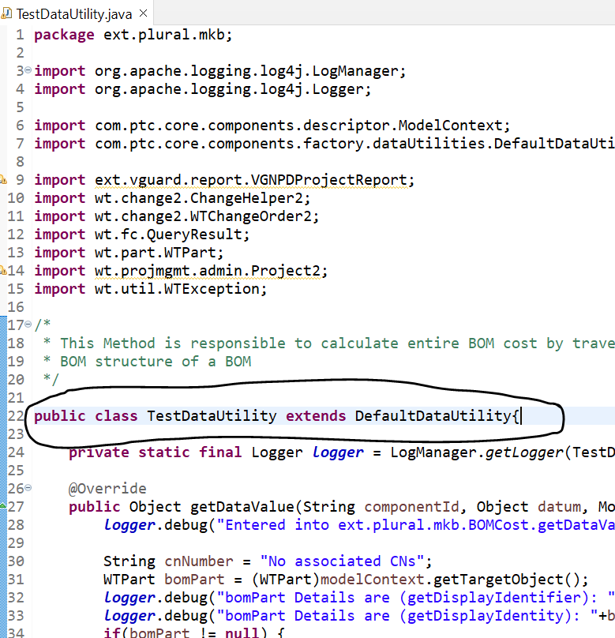

1. Implement the logic as per the business requirements.

## Create Attribute:

1. Created the below attribute.

1. Added the DataUtility ID in Layouts.

## Register Data Utility.

1. Added the below properties in site.xconf.

<Service name="com.ptc.core.components.descriptor.DataUtility">

<Option serviceClass="ext.plural.mkb.TestDataUtility" requestor="java.lang.Object" selector="RelatedCN" cardinality="duplicate" targetFile="codebase/service.properties"/>

</Service>

<Service name="com.ptc.core.components.descriptor.DataUtility">

<Option serviceClass="ext.plural.mkb.TestDataUtility" requestor="java.lang.Object" selector="IBA|RelatedCN" cardinality="duplicate" targetFile="codebase/service.properties"/>

</Service>

## Validations

1. Stop Windchill, clean cache and start Windchill.
2. Below is the result of the above implementation.

