RESTful Web Service/REST APIs

Reference Article:
https://www.ptc.com/en/support/article/CS254366

Introduction
- REST: Representational State Transfer.
- REST (Representational State Transfer) is a client-server application development pattern, in which client applications manipulate domain objects provided by a server, via the verbs defined in the HTTP protocol e.g. POST, PUT, GET, etc
- RESTful applications are stateless: the application service does not hold state information and clients maintain all states.
- A RESTful service can be accessed from clients that support making HTTP requests and allow parsing of the response being returned from the service.

Windchill REST Services
- Windchill REST is a module in Windchill
- Its releases are different from Windchill ones
- WRS update is a part of the CPS installation
- Identify current WRS version from Windchill Version

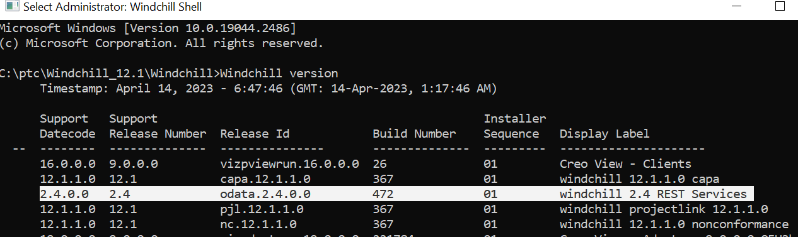

- Install WRS release compatible with Windchill release.
- WRS is available in two implementations: Legacy WRS based on RestEasy, and WRS based on OData.
- PTC encourages customers to use the OData implementation.
- WRS are versioned, PTC keeps old versions of each Domain for backward compatibility. Use new versions to leverage the new features and the new endpoints, but you can combine different versions
- Only endpoints of installed modules will be displayed, for instance, if SIM/MPMLink/PartsLink/SUMA are not installed, you won't see or fetch their endpoints
- WRS is very powerful, once you create a Soft Type, its endpoints get exposed with zero configuration. In addition, the framework is open for customization.
- WRS uses the following verbs:

- Get: Retrieving data
- Post: Create operations
- Patch: Update operations
- Delete: Delete operations

- Only Get endpoints are idempotent.

