**Question 1:** [cd95a2eb-2cca-4eab-bbc7-e08a65f26539]

Write SQL statement to create one database with the given name “ERD_PE” then to create in this database all tables derived from the given ERD diagram with appropriate attributes, primary keys and foreign keys.

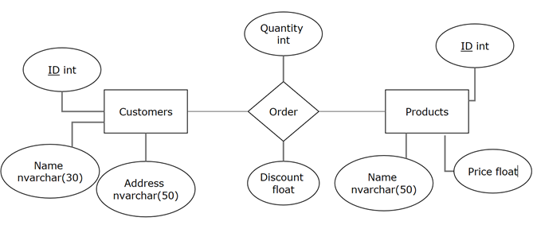

Picture 1.1