Stat545.com Practice

## Chapter 5 R Markdown

This is a practice R Markdown document and used for running chapter 5 examples.  
First, let’s start by investigating the power of tidyverse and tibbles.

library(tidyverse)

## ── Attaching packages ───────────────────────────────────────────────────── tidyverse 1.3.0 ──

## ✓ ggplot2 3.2.1 ✓ purrr 0.3.3  
## ✓ tibble 2.1.3 ✓ dplyr 0.8.3  
## ✓ tidyr 1.0.0 ✓ stringr 1.4.0  
## ✓ readr 1.3.1 ✓ forcats 0.4.0

## ── Conflicts ──────────────────────────────────────────────────────── tidyverse_conflicts() ──  
## x dplyr::filter() masks stats::filter()  
## x dplyr::lag() masks stats::lag()

library(gapminder)  
str(gapminder)

## Classes 'tbl_df', 'tbl' and 'data.frame': 1704 obs. of 6 variables:  
## $ country : Factor w/ 142 levels "Afghanistan",..: 1 1 1 1 1 1 1 1 1 1 ...  
## $ continent: Factor w/ 5 levels "Africa","Americas",..: 3 3 3 3 3 3 3 3 3 3 ...  
## $ year : int 1952 1957 1962 1967 1972 1977 1982 1987 1992 1997 ...  
## $ lifeExp : num 28.8 30.3 32 34 36.1 ...  
## $ pop : int 8425333 9240934 10267083 11537966 13079460 14880372 12881816 13867957 16317921 22227415 ...  
## $ gdpPercap: num 779 821 853 836 740 ...

class(gapminder)

## [1] "tbl_df" "tbl" "data.frame"

head(gapminder)

## # A tibble: 6 x 6  
## country continent year lifeExp pop gdpPercap  
## <fct> <fct> <int> <dbl> <int> <dbl>  
## 1 Afghanistan Asia 1952 28.8 8425333 779.  
## 2 Afghanistan Asia 1957 30.3 9240934 821.  
## 3 Afghanistan Asia 1962 32.0 10267083 853.  
## 4 Afghanistan Asia 1967 34.0 11537966 836.  
## 5 Afghanistan Asia 1972 36.1 13079460 740.  
## 6 Afghanistan Asia 1977 38.4 14880372 786.

tail(gapminder)

## # A tibble: 6 x 6  
## country continent year lifeExp pop gdpPercap  
## <fct> <fct> <int> <dbl> <int> <dbl>  
## 1 Zimbabwe Africa 1982 60.4 7636524 789.  
## 2 Zimbabwe Africa 1987 62.4 9216418 706.  
## 3 Zimbabwe Africa 1992 60.4 10704340 693.  
## 4 Zimbabwe Africa 1997 46.8 11404948 792.  
## 5 Zimbabwe Africa 2002 40.0 11926563 672.  
## 6 Zimbabwe Africa 2007 43.5 12311143 470.

as_tibble(iris)

## # A tibble: 150 x 5  
## Sepal.Length Sepal.Width Petal.Length Petal.Width Species  
## <dbl> <dbl> <dbl> <dbl> <fct>   
## 1 5.1 3.5 1.4 0.2 setosa   
## 2 4.9 3 1.4 0.2 setosa   
## 3 4.7 3.2 1.3 0.2 setosa   
## 4 4.6 3.1 1.5 0.2 setosa   
## 5 5 3.6 1.4 0.2 setosa   
## 6 5.4 3.9 1.7 0.4 setosa   
## 7 4.6 3.4 1.4 0.3 setosa   
## 8 5 3.4 1.5 0.2 setosa   
## 9 4.4 2.9 1.4 0.2 setosa   
## 10 4.9 3.1 1.5 0.1 setosa   
## # … with 140 more rows

names(gapminder)

## [1] "country" "continent" "year" "lifeExp" "pop" "gdpPercap"

Note that lenght command returns the number of columns NOT the number of rows

length(gapminder)

## [1] 6

nrow(gapminder)

## [1] 1704

ncol(gapminder)

## [1] 6

dim(gapminder)

## [1] 1704 6

Let’s make a plot with base R graphics 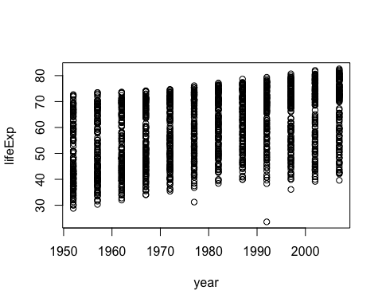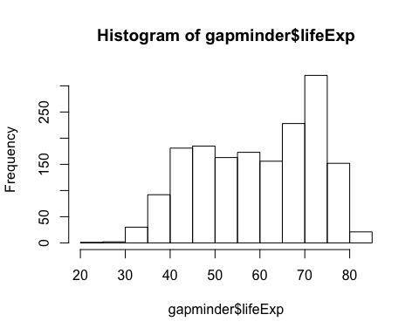

Ok, why does the histogram look like it does?

summary(gapminder$year)

## Min. 1st Qu. Median Mean 3rd Qu. Max.   
## 1952 1966 1980 1980 1993 2007

table(gapminder$year)

##   
## 1952 1957 1962 1967 1972 1977 1982 1987 1992 1997 2002 2007   
## 142 142 142 142 142 142 142 142 142 142 142 142

class(gapminder$year)

## [1] "integer"

So that was an integer.  
What about other variables in the dataset? Let’s pick a categorical one.  
*note that this paragraph contains line breaks -which means TWO spaces at the end*  
*Does it look like it in the rendered doc?*  
**Still not for some reason…**

class(gapminder$continent)

## [1] "factor"

summary(gapminder$continent)

## Africa Americas Asia Europe Oceania   
## 624 300 396 360 24

levels(gapminder$continent)

## [1] "Africa" "Americas" "Asia" "Europe" "Oceania"

nlevels(gapminder$continent)

## [1] 5

barplot(table(gapminder$continent))

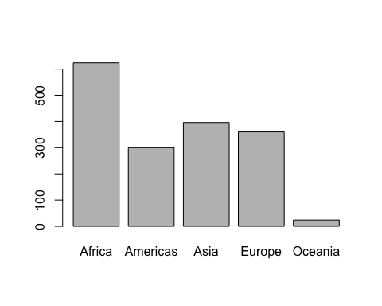 Don’t forget that R is storing those levels as integers i.e. ‘1’, ‘2’, ‘3’, etc under the hood!!! This will trip up unwary programmers, so don’t forget to properly care for your factors. *note that this paragraph was written without line breaks, does it make a difference to the final formatting?*

Here is a much nicer ggplot graph

## we exploit the fact that ggplot was installed and loaded via the tidyverse  
p <- ggplot(filter(gapminder, continent != "Oceania"),  
 aes(x = gdpPercap, y = lifeExp)) # just initializes  
p <- p + scale_x_log10() #log the x axis the right way  
p + geom_point() #scatterplot

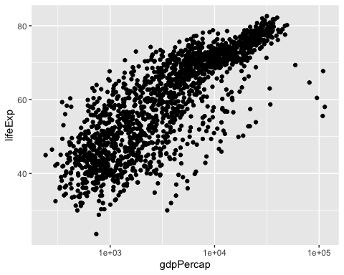

p + geom_point(aes(color = continent)) #map the continents to color

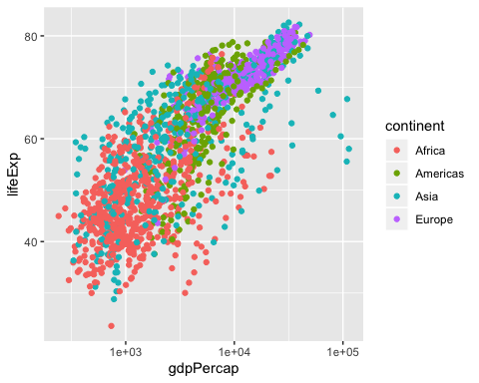

p + geom_point(alpha = (1/3), size = 3) +  
 geom_smooth(lwd = 3, se = F)

## `geom_smooth()` using method = 'gam' and formula 'y ~ s(x, bs = "cs")'

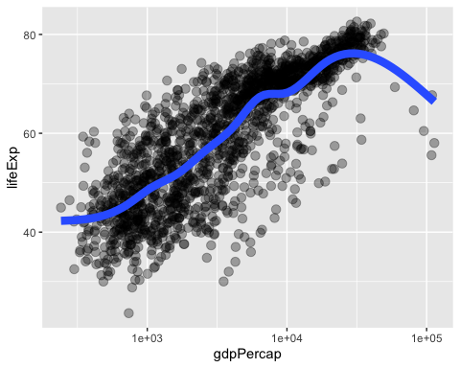

p + geom_point(alpha = (1/3), size = 3) +   
 facet_wrap(~continent) +  
 geom_smooth(lwd = 3, se = F)

## `geom_smooth()` using method = 'loess' and formula 'y ~ x'

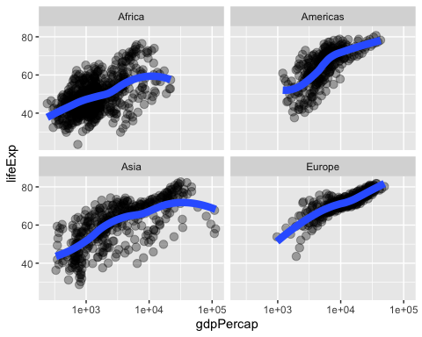 That’s a wrap for Chapter 5 and practicing with R markdown!!