Community-level Energy Business Assessment

Source of information
(MV Staff, Village committee, trade organization, etc):

Country:
MV Cluster / Village:
Name of Community:

Population (of entire community):

Population (of “population centre” if one exists):

List all businesses that use or rely upon energy
(electricity, fuels, firewood for cooking, etc.) in the table below

Name of Business | Type of Business | Location of Business | Primary energy type consumed | Energy Survey administered?  (check here if so)
Add additional pages to this table, if necessary.
Grid: For each existing grid connected community list the following:

Name of the Community | Year Connected | Number of HHs Connected | Number of Businesses | Number of all other institutions | Number of water pumping sites | Number of Transformers

Other grid related questions:

- Connection Costs
  - Fee (initial charge to government and to the utility)
  - Wiring and other equipment (in household)
  - Deposit
  - Other costs
- Subsidies: Are there any government, MFI, MVP (or other) programs to subsidize and support the connection costs
- Tariff Structure (please describe the tariff structure applicable in the community for different consumption levels, are there any lifeline rates)
  - What are the different usage / subscription levels
  - What is the cost of each level (see example below)

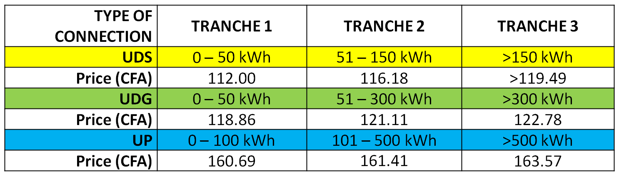
Water pumping systems:

Village name | Number of working water pumps | Typical power rating (HP or KVA) | High / Low power rating | Typical number of hrs of usage per week | Typical amount of money spent per week | Notes

Systems for agriculture / processing / other multi-function platforms:

Village name | Number of working Systems | Typical power rating (HP or KVA) | High / Low power rating | Typical number of hrs of usage per week | Typical amount of money spent per week | Notes

Health institutions:

Village name | Institution Name | Type of system (solar/Diesel  /grid) | Power rating  (HP or KVA) | Typical number of hrs of usage per week | Typical amount of money spent per week | Notes

Educational Institutions:

Village name | Institution Name | Type of system (solar/Diesel  /grid) | Power rating  (HP or KVA) | Typical number of hrs of usage per week | Typical amount of money spent per week | Notes

Other Institutions (community centers, government buildings, etc.):

Village name | Institution Name and type | Type of system (solar/Diesel  /grid) | Power rating  (HP or KVA) | Typical number of hrs of usage per week | Typical amount of money spent per week | Notes

